**6. Write a shell script to display first 20 terms of Fibonacci series.**

#!/bin/bash

echo "How many number of terms to be generated ?"  
  read n  
function fib  
{  
  x=0  
  y=1  
  i=2  
  echo "Fibonacci Series up to $n terms :"  
  echo "$x"  
  echo "$y"  
  while [ $i -lt $n ]  
  do  
      i=`expr $i + 1 `  
      z=`expr $x + $y `  
      echo "$z"  
      x=$y  
      y=$z  
  done  
}  
r=`fib $n`  
echo "$r"

**Output:**

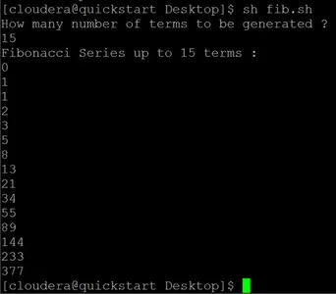

8. Write a shell script to check the user is login or not and say hello.

#!/bin/bash

echo enter username

read name

who > test

if grep $name test

then

echo logged in

else

echo not logged in

fi

**Output:**

$ enter username

$ test

$ test tty1 2019-02-21 10:56 (:0)

$ test pts/0 2019-02-21 10:57 (:0)

$ test pts/1 2019-02-26 19:19 (:0)

$ logged in

9. Write a shell script to calculate factorial of a number.

#!/bin/bash

echo "Enter a number"

# Read the number

read num

fact=1

for((i=2;i<=num;i++))

{

fact=$((fact * i))

}

echo $fact

**Output:**

Enter a number

5

120

Enter a number

7

5040

Enter a number

4

24

11. Develop a C Program In Linux to find out 20 terms of Fibonacci series.

#include<stdio.h>

#include<conio.h>

int main()

{

int first_number = 0, second_number = 1, third_number, i, number;

printf("Enter the number for fibonacci series:");

scanf("%d",&number);

printf("Fibonacci Series for a given number:");

printf("\n%d %d", first_number, second_number); //To print 0 and 1

for(i = 2; i < number; ++i) //loop will starts from 2 because we have printed 0 and 1 before

{

third_number = first_number + second_number;

printf(" %d", third_number);

first_number = second_number;

second_number = third_number;

}

return 0;

}

**Output:**

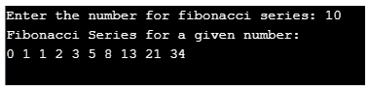

12. Develop a C Program In Linux to calculate factorial of a number.

#include <stdio.h>

int main() {

int n, i;

unsigned long long fact = 1;

printf("Enter an integer: ");

scanf("%d", &n);

// shows error if the user enters a negative integer

if (n < 0)

printf("Error! Factorial of a negative number doesn't exist.");

else {

for (i = 1; i <= n; ++i) {

fact *= i;

}

printf("Factorial of %d = %llu", n, fact);

}

return 0;

}

**Output:**

Enter an integer: 10

Factorial of 10 = 3628800