Algorithms_Data Structures

Exercise 1: Inventory Management System

import java.util.HashMap;

class Product {
int productId;
String productName;
int quantity;
double price;

public Product(int productId, String productName, int quantity, double price) {
this.productId = productId;
this.productName = productName;
this.quantity = quantity;
this.price = price;
}

@Override
public String toString() {
return "Product ID: " + productId + ", Name: " + productName +
", Quantity: " + quantity + ", Price: ₹" + price;
}
}

public class InventoryManagementSystem {
private HashMap<Integer, Product> inventory = new HashMap<>();

public void addProduct(Product p) {
inventory.put(p.productId, p);
System.out.println("Added: " + p);
}

public void updateProduct(int productId, int quantity, double price) {
Product p = inventory.get(productId);
if (p != null) {
p.quantity = quantity;
p.price = price;
System.out.println("Updated: " + p);
} else {
System.out.println("Product not found!");
}
}

public void deleteProduct(int productId) {
Product removed = inventory.remove(productId);
if (removed != null)
System.out.println("Deleted: " + removed);
else
System.out.println("Product not found!");
}

public void displayInventory() {
System.out.println("\nCurrent Inventory:");
for (Product p : inventory.values()) {
System.out.println(p);
}
}

public static void main(String[] args) {
InventoryManagementSystem ims = new InventoryManagementSystem();

ims.addProduct(new Product(101, "Laptop", 10, 55000));
ims.addProduct(new Product(102, "Mouse", 50, 500));
ims.updateProduct(101, 8, 54000);
ims.deleteProduct(102);
ims.displayInventory();
}
}

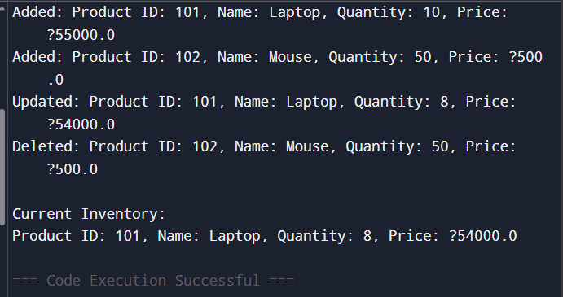

Exercise 2: E-commerce Platform Search Function

import java.util.Arrays;
import java.util.Comparator;

public class Product {

int productId;
String productName;
String category;

Product(int productId, String productName, String category) {
this.productId = productId;
this.productName = productName;
this.category = category;
}

void display() {
System.out.println(
"ID: " + productId +
", Name: " + productName +
", Category: " + category);
}

// Linear Search
public static Product linearSearch(Product[] products, int id) {
for (Product product : products) {
if (product.productId == id) {
return product;
}
}
return null;
}

// Binary Search
public static Product binarySearch(Product[] products, int id) {
int low = 0;
int high = products.length - 1;

while (low <= high) {
int mid = low + (high - low) / 2;

if (products[mid].productId == id) {
return products[mid];
}

if (products[mid].productId < id) {
low = mid + 1;
} else {
high = mid - 1;
}
}

return null;
}

public static void main(String[] args) {

Product[] products = {
new Product(105, "Laptop", "Electronics"),
new Product(102, "Shoes", "Fashion"),
new Product(108, "Phone", "Electronics"),
new Product(101, "Watch", "Accessories"),
new Product(110, "Headphones", "Electronics")
};

int searchId = 108;

System.out.println("Linear Search:");
Product result1 = linearSearch(products, searchId);

if (result1 != null)
result1.display();
else
System.out.println("Product not found.");

Arrays.sort(products,
Comparator.comparingInt(p -> p.productId));

System.out.println("\nBinary Search:");

Product result2 = binarySearch(products, searchId);

if (result2 != null)
result2.display();
else
System.out.println("Product not found.");
}
}
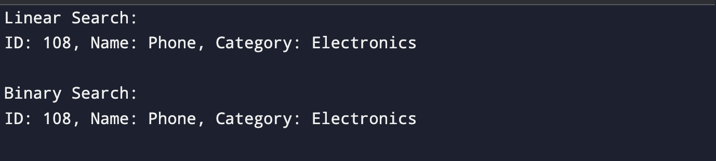
Exercise 3: Sorting Customer Orders
import java.util.Arrays;

class Order {
int orderId;
String customerName;
double totalPrice;

public Order(int orderId, String customerName, double totalPrice) {
this.orderId = orderId;
this.customerName = customerName;
this.totalPrice = totalPrice;
}

@Override
public String toString() {
return "Order ID: " + orderId + ", Customer: " + customerName + ", Total Price: ₹" + totalPrice;
}
}

public class SortingCustomerOrders {

public static void bubbleSort(Order[] orders) {
int n = orders.length;
for (int i = 0; i < n - 1; i++) {
for (int j = 0; j < n - i - 1; j++) {
if (orders[j].totalPrice > orders[j + 1].totalPrice) {
Order temp = orders[j];
orders[j] = orders[j + 1];
orders[j + 1] = temp;
}
}
}
}

public static void quickSort(Order[] orders, int low, int high) {
if (low < high) {
int pi = partition(orders, low, high);
quickSort(orders, low, pi - 1);
quickSort(orders, pi + 1, high);
}
}

private static int partition(Order[] orders, int low, int high) {
double pivot = orders[high].totalPrice;
int i = low - 1;
for (int j = low; j < high; j++) {
if (orders[j].totalPrice <= pivot) {
i++;
Order temp = orders[i];
orders[i] = orders[j];
orders[j] = temp;
}
}
Order temp = orders[i + 1];
orders[i + 1] = orders[high];
orders[high] = temp;
return i + 1;
}

public static void main(String[] args) {
Order[] orders = {
new Order(101, "Amit", 2500),
new Order(102, "Riya", 1200),
new Order(103, "Karan", 4800),
new Order(104, "Sneha", 3100)
};

System.out.println("Original Orders:");
Arrays.stream(orders).forEach(System.out::println);

bubbleSort(orders);
System.out.println("\nSorted by Bubble Sort:");
Arrays.stream(orders).forEach(System.out::println);

Order[] orders2 = {
new Order(101, "Amit", 2500),
new Order(102, "Riya", 1200),
new Order(103, "Karan", 4800),
new Order(104, "Sneha", 3100)
};

quickSort(orders2, 0, orders2.length - 1);
System.out.println("\nSorted by Quick Sort:");
Arrays.stream(orders2).forEach(System.out::println);
}
}
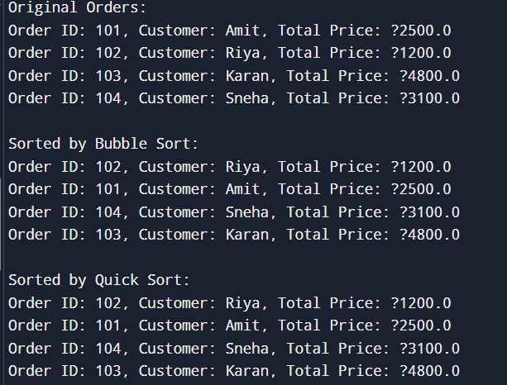

Exercise 7: Financial Forecasting

public class FinancialForecast {

public static double forecast(double value,
double[] rates,
int year) {

// Base case
if (year == rates.length) {
return value;
}

value = value * (1 + rates[year]);

return forecast(value, rates, year + 1);
}

public static void main(String[] args) {

double initialValue = 10000;

double[] growthRates = {
0.10, 0.08, 0.12, 0.09, 0.11
};

double result = forecast(initialValue, growthRates, 0);
System.out.printf(
"Predicted Future Value = $%.2f",
result
);
}



