Supporting Information for

**TXSELECT: A Web-Based Decision Support System for Regional Assessment of Potential E. coli Loads Using a Spatially Explicit Modeling Approach**

Shubham Jain1, Raghavan Srinivasan2*, Thsomas J. Helton3, and Raghupathy Karthikeyan4

1 Water Management and Hydrological Science, Texas A&M University, TX 77840, USA

2 Texas A&M AgriLife Research, Temple, TX 76502, USA

3 Texas State Soil and Water Conservation Board, Temple, TX 76504, USA

4 Department of Agricultural Sciences, Clemson University, SC 29634, USA

*Corresponding author. E-mail: [r-srinivasan@tamu.edu](mailto:r-srinivasan@tamu.edu);

Contributing authors: [shubhamjain0915@tamu.edu](mailto:shubhamjain0915@tamu.edu); [thelton@tsswcb.texas.gov](mailto:thelton@tsswcb.texas.gov); [rkarthikeyan@clemson.edu](mailto:rkarthikeyan@clemson.edu)

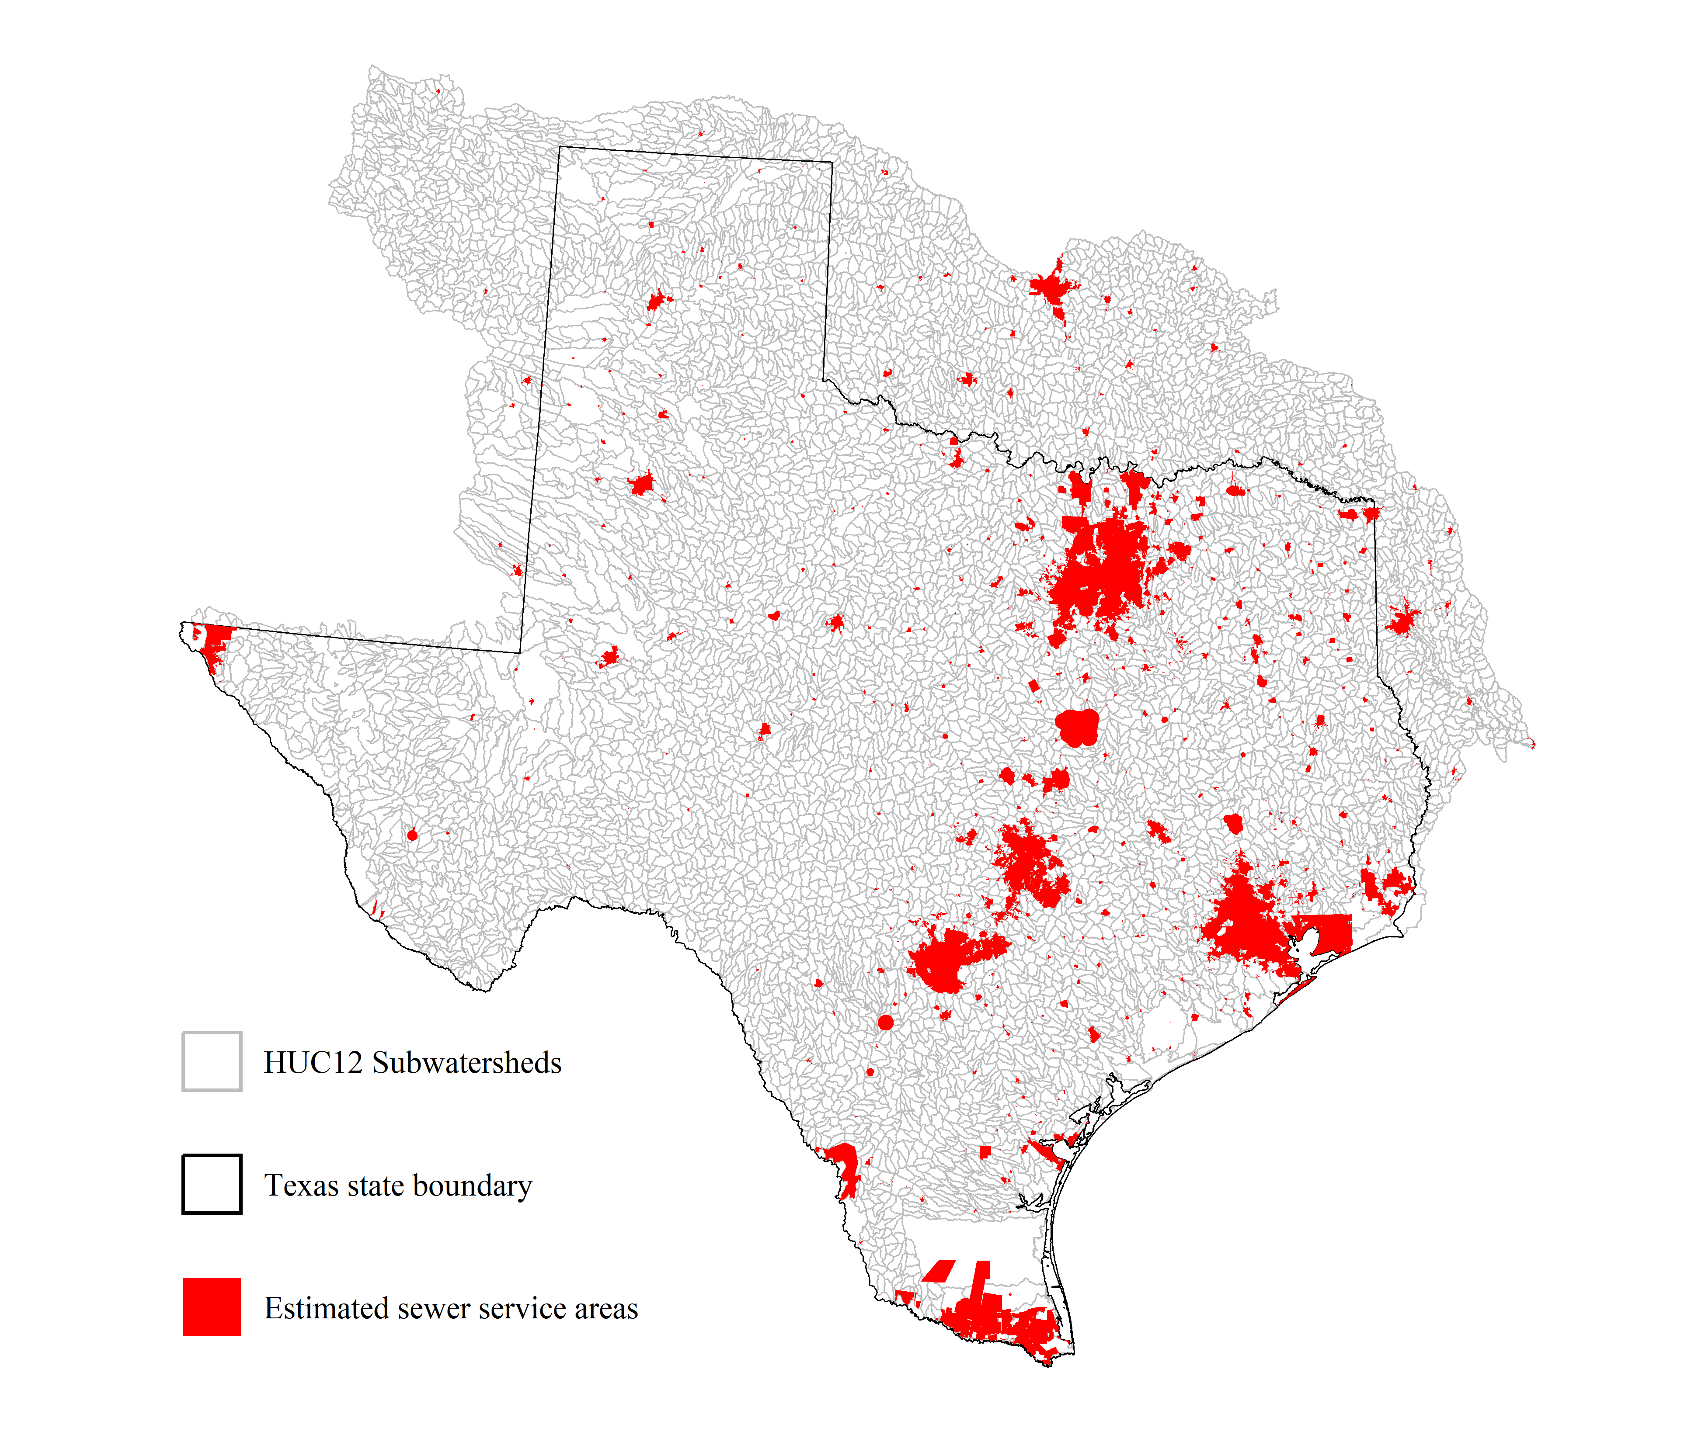

**Figure S1.**Map showing estimated sewer service areas based on Certificate of Convenience and Neccessity (CCN) boundaries (Public Utility Commission of Texas, 2024), and urban area boundaries (USCB, 2020).

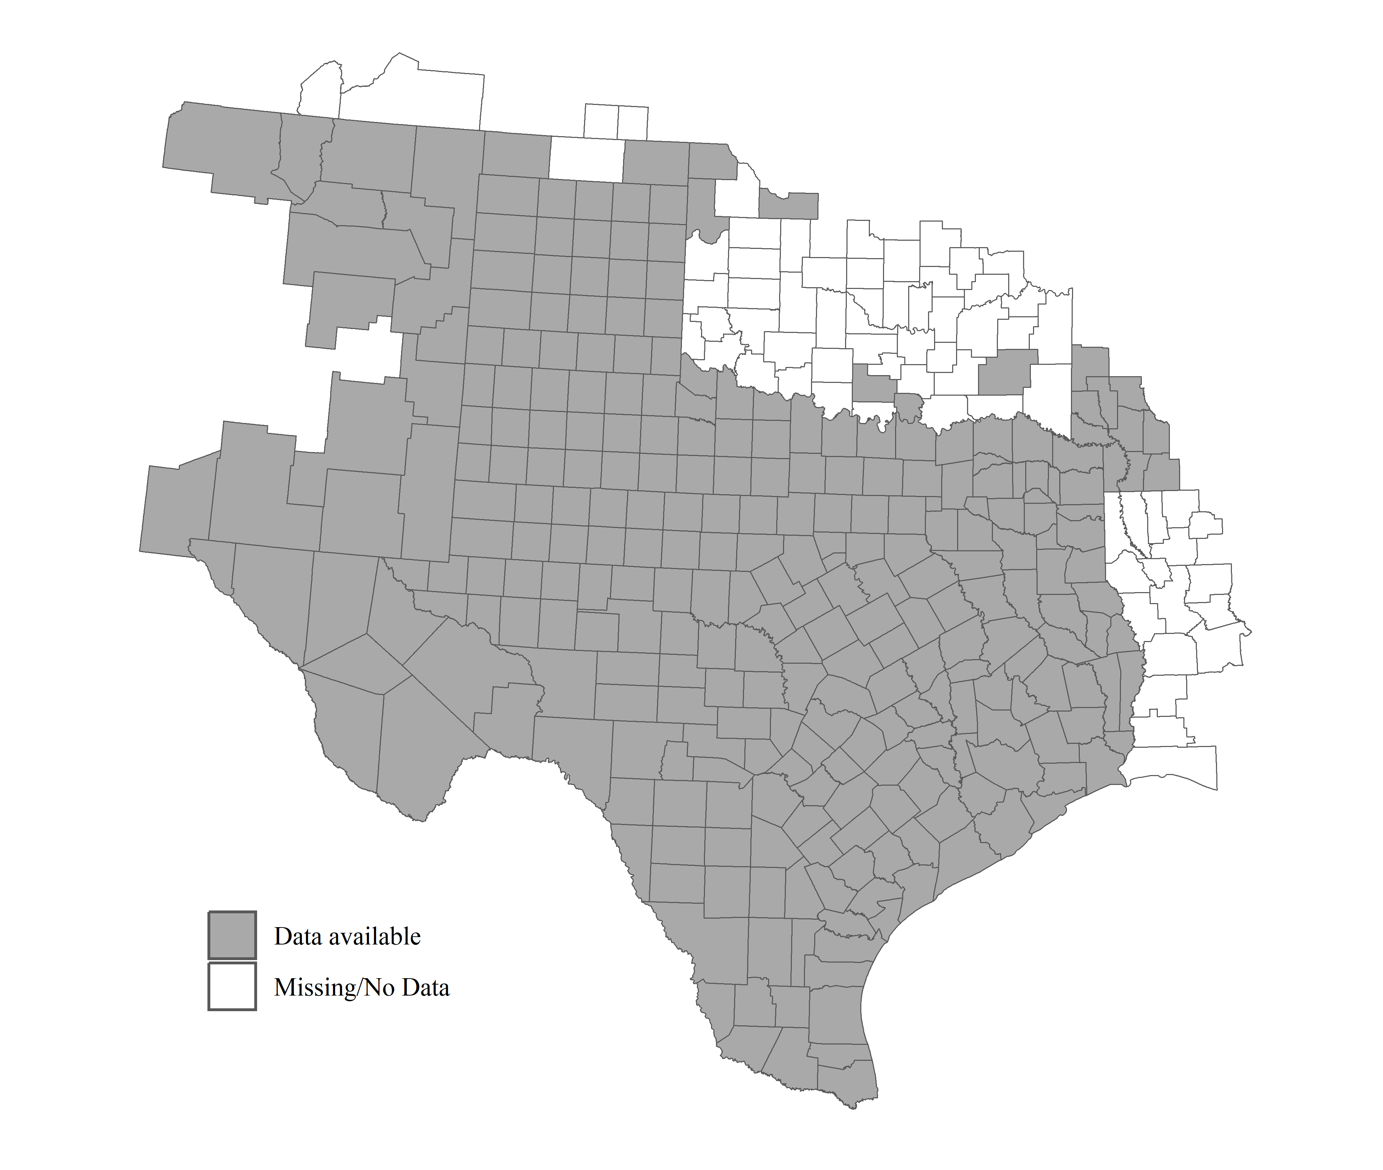

**Figure S2.** Map showing counties in TXSELECT where 911 address points are available, to estimate counts of On-Site Sewage Facilities (OSSFs).

**Table S1.** Default deer densities based on US EPA Level III ecoregions within the study area.

|  |  |  |
| --- | --- | --- |
| **Ecoregion Code** | **US EPA Level III Ecoregion** | **Density (Deer/1000 acres)** |
| 10.2.4 | Chihuahuan Desert | 37 |
| 13.1.1 | Arizona/New Mexico Mountains | 0 |
| 6.2.14 | Southern Rockies | 0 |
| 8.3.7 | South Central Plains | 19 |
| 8.3.8 | East Central Texas Plains | 46 |
| 8.4.7 | Arkansas Valley | 20 |
| 8.4.8 | Ouachita Mountains | 20 |
| 9.2.4 | Central Irregular Plains | 20 |
| 9.4.1 | High Plains | 27 |
| 9.4.2 | Central Great Plains | 39 |
| 9.4.3 | Southwestern Tablelands | 39 |
| 9.4.5 | Cross Timbers | 59 |
| 9.4.6 | Edwards Plateau | 147 |
| 9.4.7 | Texas Blackland Prairies | 9 |
| 9.5.1 | Western Gulf Coastal Plain | 23 |
| 9.6.1 | Southern Texas Plains/Interior Plains and Hills with Xerophytic Shrub and Oak Forest | 29 |

**References**

Public Utility Commission of Texas. (2024). *CCN Mapping Information. PUC CCN Water and Sewer GIS Shapefiles*. <https://www.puc.texas.gov/industry/water/utilities/gis.aspx>

USCB. (2020). United States Census Bureau. 2020 TIGER/Line Shapefiles (machine‐readable data files).