**Interest Calculator**

### A Project Work

*Submitted in the partial fulfillment for the award of the degree of*

# BACHELOR OF ENGINEERING

### IN

### CSE (Internet of Things)

### Submitted by:

### Shubham Jain

### 18BCS4501

### Under the Supervision of:

### Akhwinder Kaur



# APEX INSITUTE OF TECHNOLOGY

### CHANDIGARH UNIVERSITY, GHARUAN, MOHALI - 140413,

**PUNJAB**

#### July 2019

**DECLARATION**

I, **‘Shubham Jain’**, student of **‘Bachelor of Engineering in CSE (IOT)’**, **session: 2018 - 2019**, Apex Institute of Technology, Chandigarh University, Punjab, hereby declare that the work presented in this Project Work entitled ‘**Interest Calculator’** is the outcome of our own bona fide work and is correct to the best of our knowledge and this work has been undertaken taking care of Engineering Ethics. It contains no material previously published or written by another person nor material which has been accepted for the award of any other degree or diploma of the university or other institute of higher learning, except where due acknowledgment has been made in the text.

#### Date: 15 July 2019

**Place: Chandigarh University**

### (Shubham Jain) Candidate UID: 18BCS4501

ii

**CERTIFICATE**

This is to certify that the work embodies in this dissertation entitled ***‘Interest Calculator’*** being submitted by **Shubham Jain (18BCS4501)** for partial fulfillment of the requirement for the award of **Bachelor of Engineering** in ***CSE (IOT)*** discipline to Apex Institute of Technology, Chandigarh University, Punjab during the academic year 2018 - 2019 is a record of Bonafede piece of work, undertaken by Akhwinder Kaur

### Approved and Supervised by

**(Akhwinder Kaur)**

iii

**ABSTRACT**

In this project we are going to discuss about how to calculate interest based on the type of the account and the status of the account holder. The rates of interest changes according to the amount (greater than or less than 1 crore), age of account holder (General or Senior citizen) and number of days if the type of account is FD or RD.

**Acknowledgement**

* ***Save’s time***: It can be done by just sitting at the home.
* ***Enquiry than on site enquiry***: Onsite enquiry takes a lot of time of the customer as well as the employee.
* ***Up-to-date****:* Interest can be changed wherever and whenever.
* ***Portable***: Could be done anywhere at any time.
* ***Faster****:* Calculation can be done quickly and without any hesitation.

iv

# Table of Contents

|  |  |  |
| --- | --- | --- |
|  | Title Page | i |
|  | Declaration of the Student | ii |
|  | Certificate of the Guide | iii |
|  | Abstract | iv |
|  | Acknowledgement | iv |
|  |
|  |
|  |
| **1.** | **INTRODUCTION** | **1** |
|  | * 1. Problem Definition   2. Project Overview | 1  1 |
| **2.** | **LITERATURE SURVEY** | **4** |
|  | * 1. Feasibility Study | 4 |
| **3.** | **SYSTEM ANALYSIS & DESIGN** | **5** |
|  | * 1. Requirement Specification   2. Pseudo Code | 5  5 |
| **4.** | **OUTPUTS** | **10** |
| **5.** | **CONCLUSIONS** | **12** |
| **6.** | **REFERENCES** | **12** |

**INTRODUCTION**

**1.1**

**Problem Definition**

The following Java program has been created to calculate interest based on the type of the account and the status of the account holder. The rates of interest changes according to the amount (greater than or less than 1 crore), age of account holder (General or Senior citizen) and number of days if the type of account is FD or RD.

**1.2**

**Project Overview**

Some sample rates are given in the below tables:

Rate of FD interest for amounts below 1 Crore:

|  |  |  |
| --- | --- | --- |
|  | Current Rates of interest | |
| Maturity Period | General | Senior Citizen |
| 7 days to 14 days | 4.50 | 5.00 |
| 15 days to 29 days | 4.75 | 5.25 |
| 30 days to 45 days | 5.50 | 6.00 |
| 45 days to 60 days | 7 | 7.50 |
| 61 days to 184 days | 7.50 | 8.00 |
| 185 days to 1 year | 8.00 | 8.50 |

Rate of FD interest for amounts above 1 Crore:

|  |  |
| --- | --- |
| Maturity Period | Interest Rate |
| 7 days to 14 days | 6.50 |
| 15 days to 29 days | 6.75 |
| 30 days to 45 days | 6.75 |
| 45 days to 60 days | 8 |
| 61 days to 184 days | 8.50 |
| 185 days to 1 year | 10.00 |

1

Rate of RD interests:

|  |  |  |
| --- | --- | --- |
|  | Current Rates of interest | |
| Maturity Period | General | Senior Citizen |
| 6 months | 7.50 | 8.00 |
| 9 months | 7.75 | 8.25 |
| 12 months | 8.00 | 8.50 |
| 15 months | 8.25 | 8.75 |
| 18 months | 8.50 | 9.00 |
| 21 months | 8.75 | 9.25 |

SB Account interest rates:

|  |  |
| --- | --- |
| Type of Account | Interest Rate |
| Normal | 4% |
| NRI | 6% |

Sample class structure is given below:

|  |
| --- |
| Account (Abstract) |
| **double** interestRate |
| **double** amount |

|  |
| --- |
| FDAccount |
| **double** interestRate |
| **double** amount |
| **int** noOfDays |
| ageOfACHolder |
| **abstract double**  calculateInterest() |

2

|  |
| --- |
| SBAccount |
| **double** interestRate |
| **double** amount |
| **abstract double**  calculateInterest() |

|  |
| --- |
| RDAccount |
| **double** interestRate |
| **double** amount |
| **int** noOfMonths; |
| **double**  monthlyAmount; |
| **abstract double**  calculateInterest() |

Also, method overriding has been used here.

3

**LITRATURE SURVEY**

**2.1**

**Feasibility Study**

* Github.com
* Coursehero.com
* Computerscijournal.org
* Code-project.org
* Geeksforgeeks.com

4

**SYSTEM ANALYSIS & DESIGN**

**3.1**

**Requirement Specification**

The program has been coded under the given condition:

1. Separate classes have been created for the different types of accounts.
2. All classes are derived from an abstract class named ‘Account’ which contains a method called ‘calculateInterest’.
3. Implementation of the calculateInterest method according to the type of the account, interest rates, amount and age of the account holder.
4. If the user is entering any invalid value (For e.g. Negative value) in any fields, user defined exception is raised.

**3.2**

**Pseudo Code**

**1.**

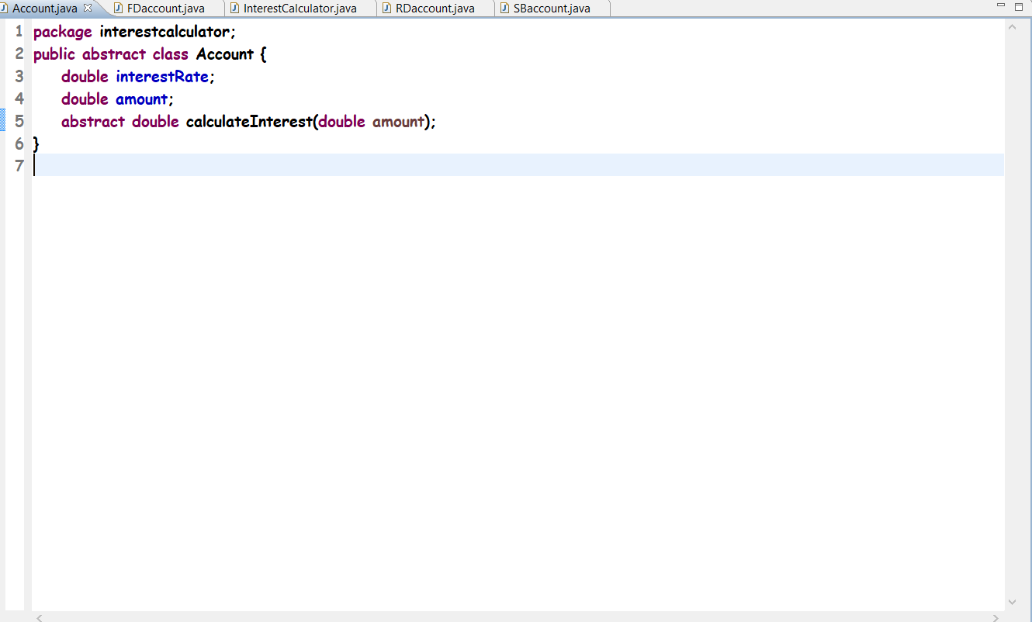

5

**2.**

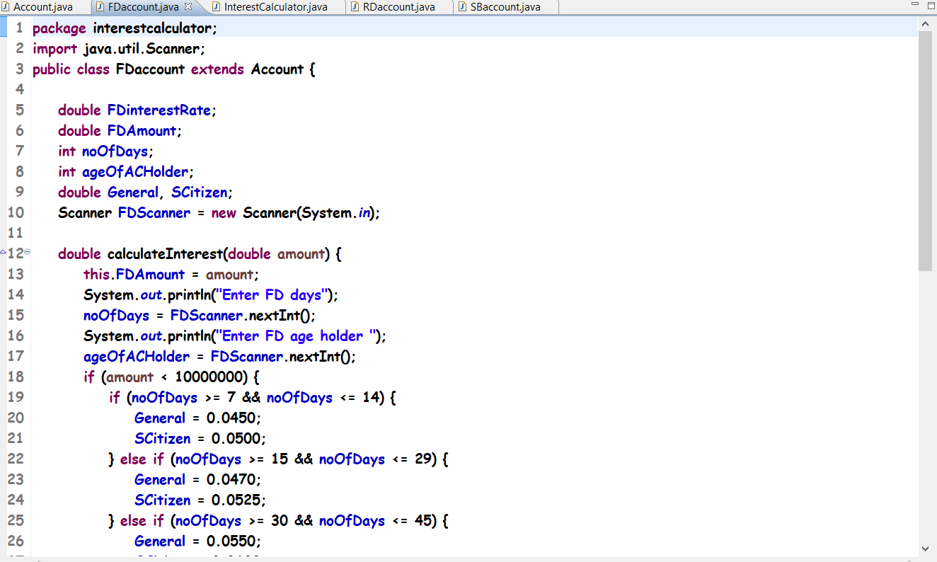

**3.**

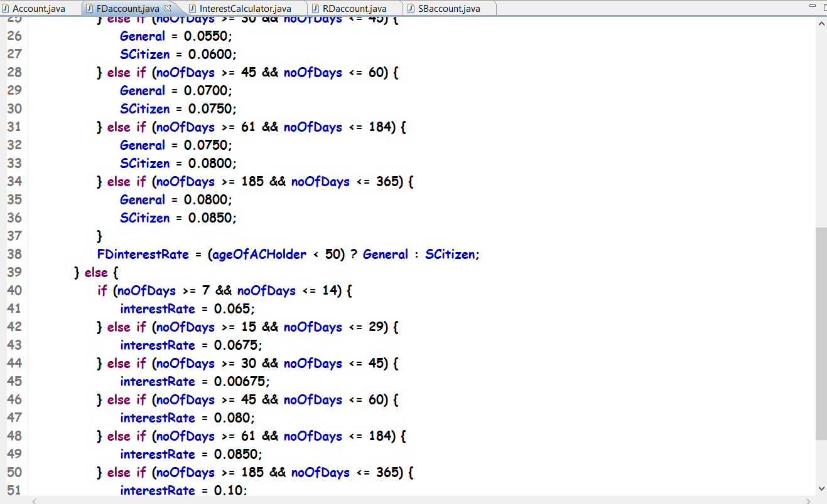

6

**4.**

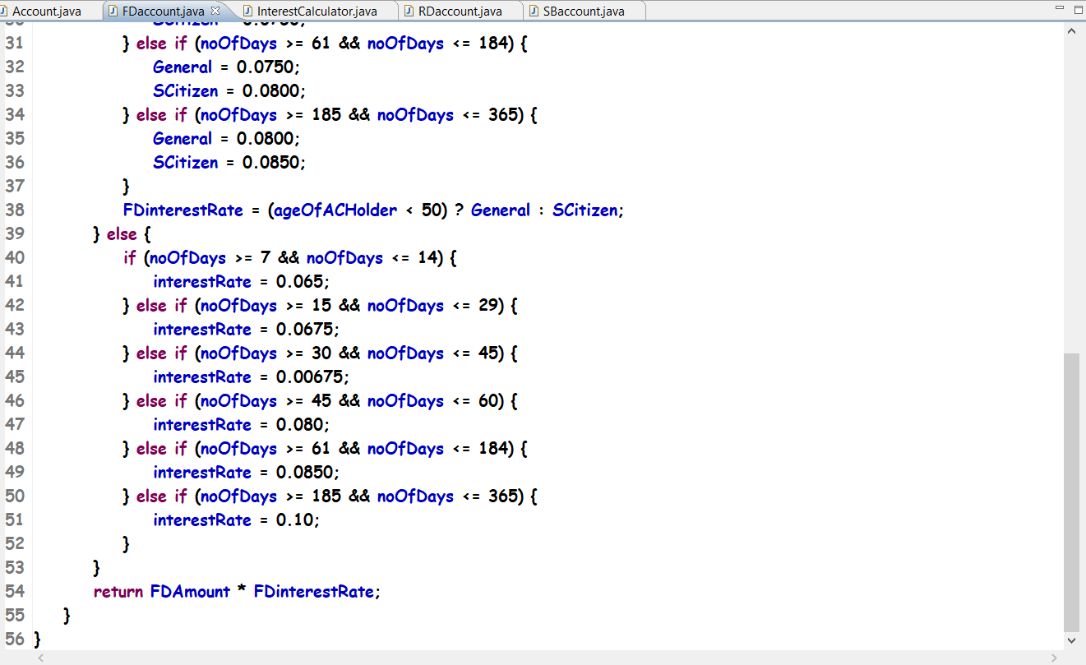

**5.**



7

**6.**

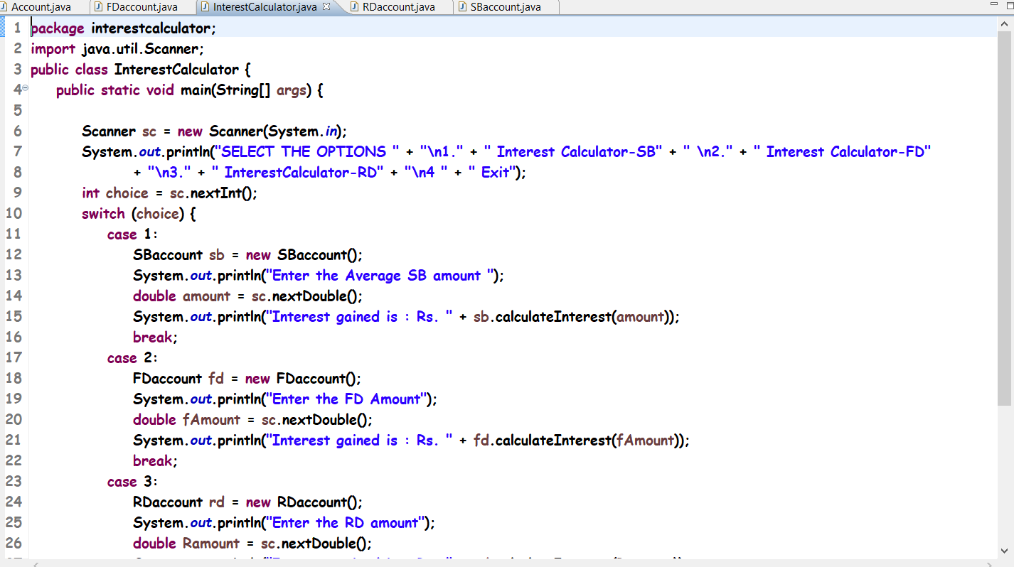

**7.**

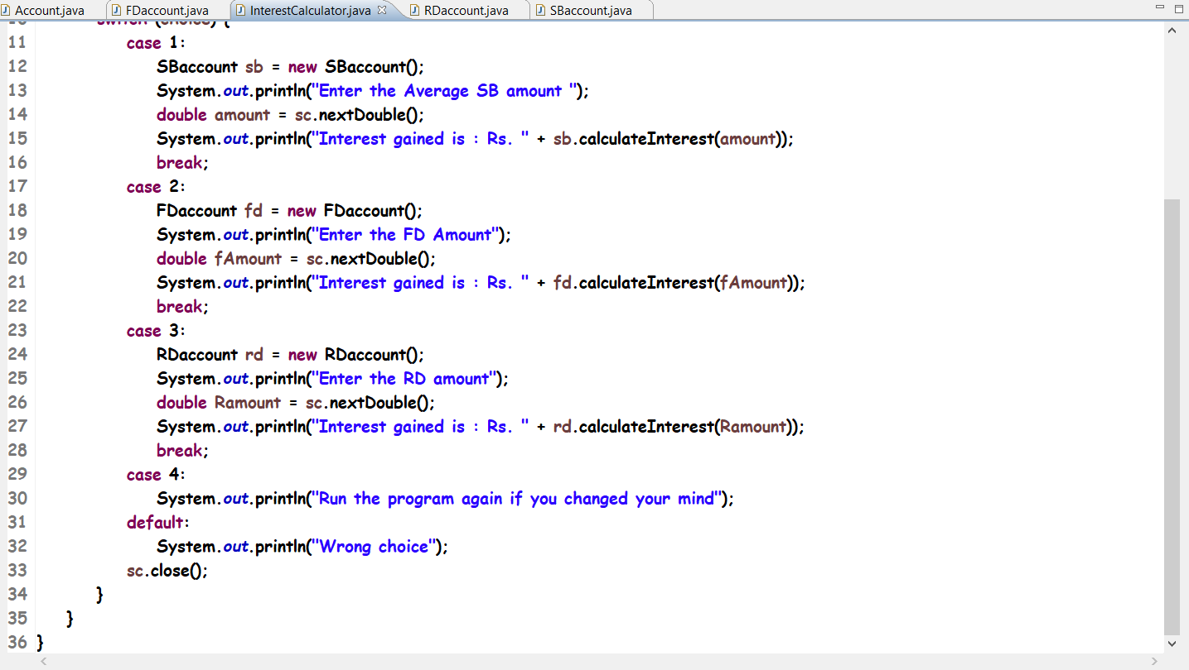

8

**8.**

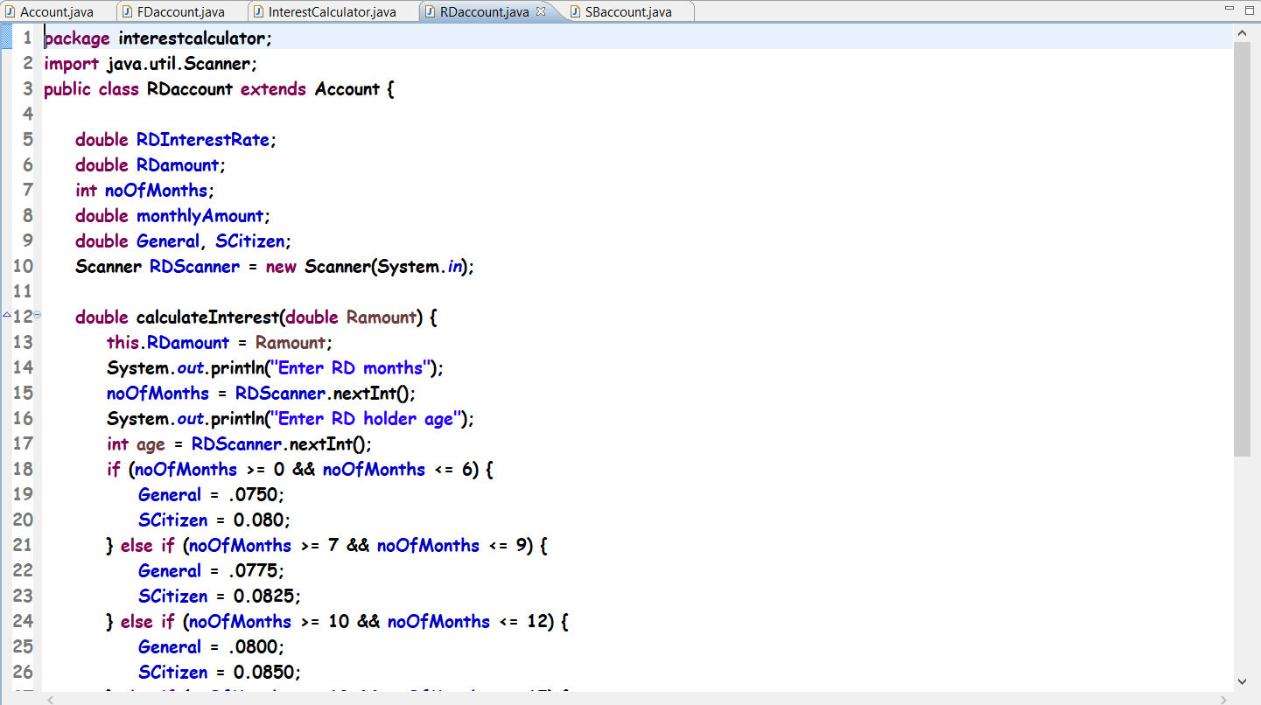

**9.**

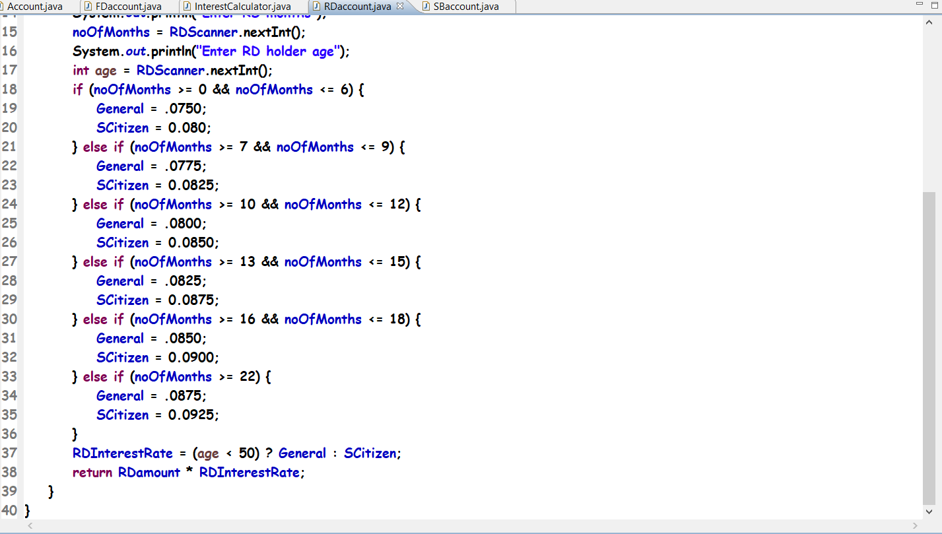

9

**10.**

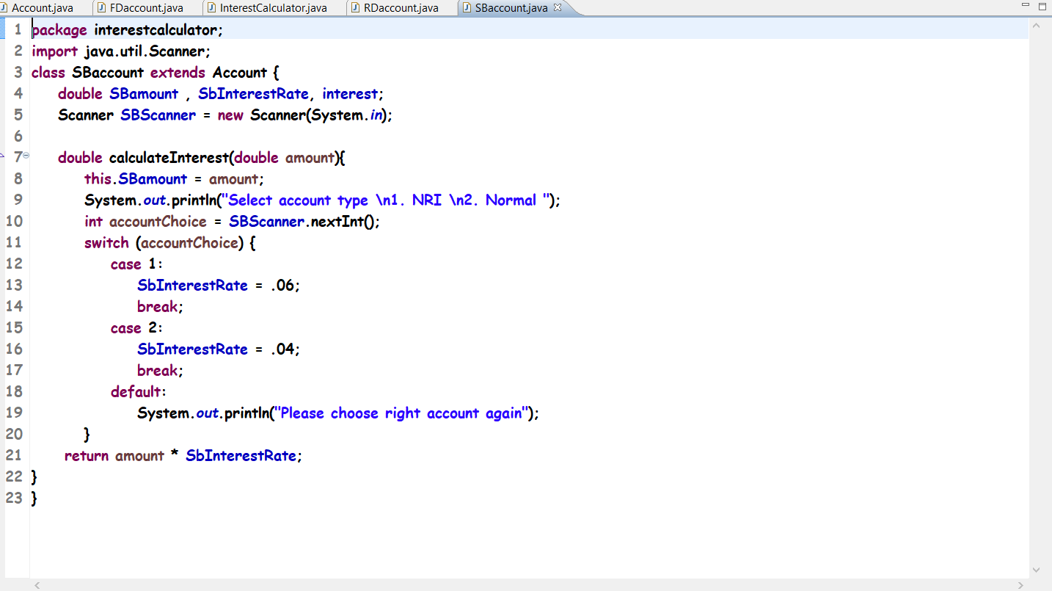

**OUTPUTS**

**1.**

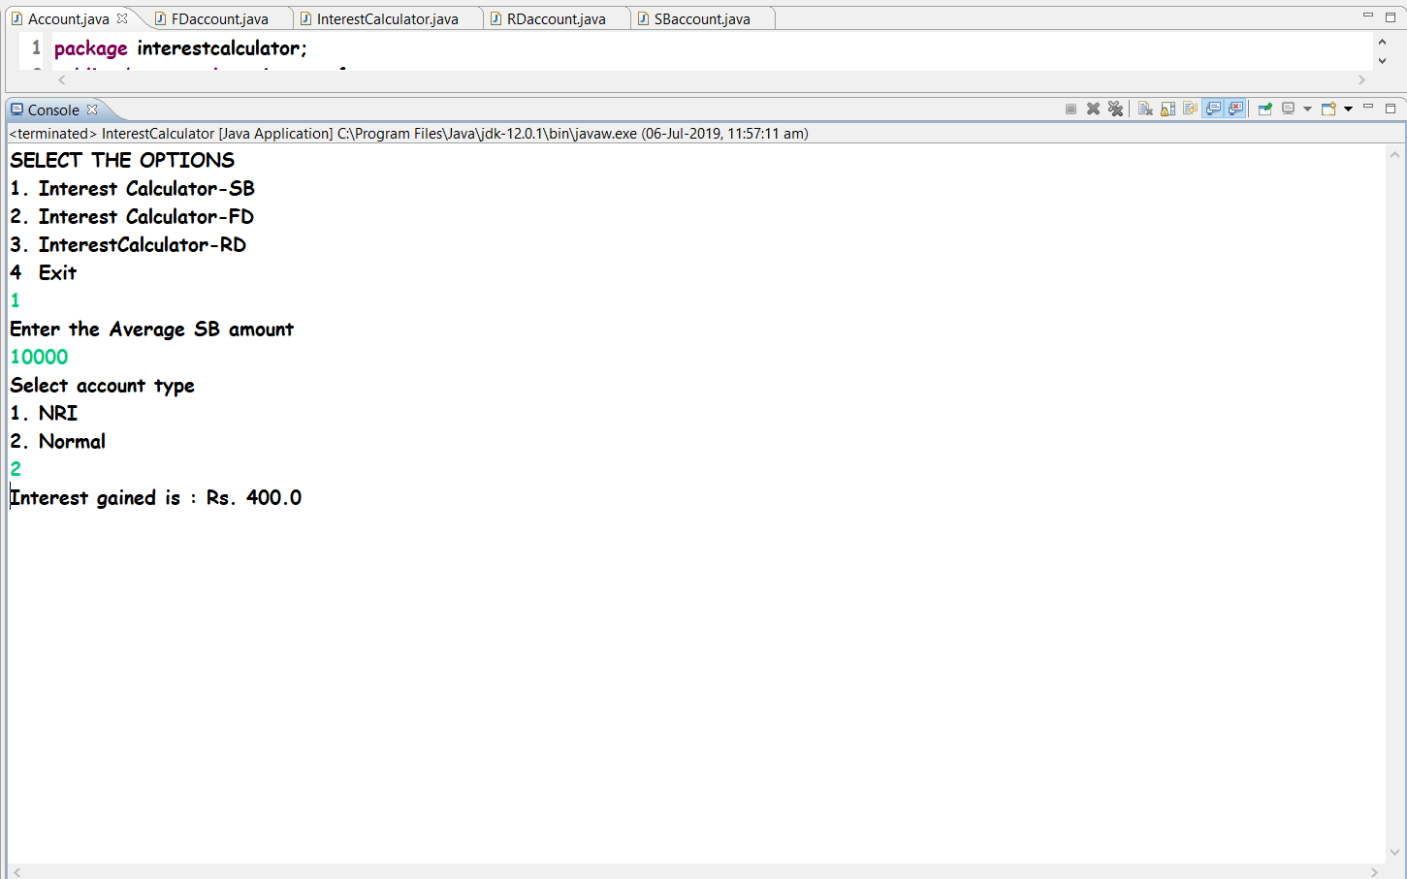

10

**2.**

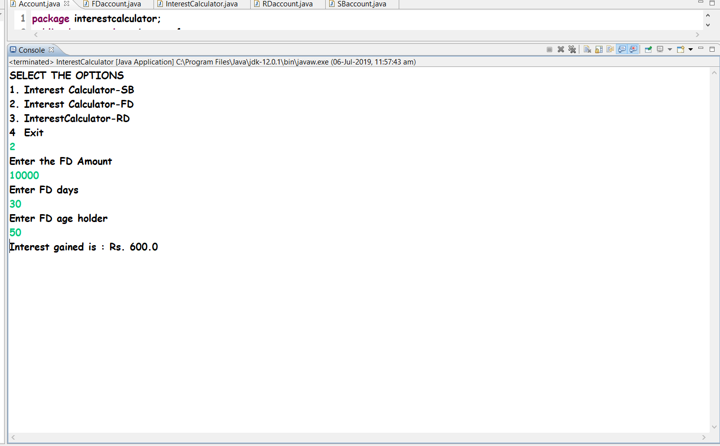

**3.**

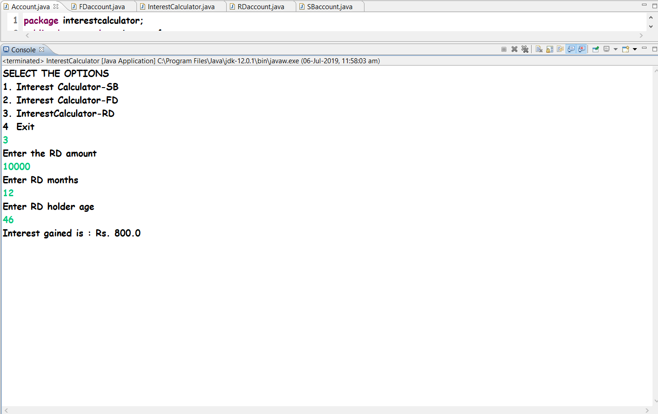

## 11

## Conclusion

Through this we can calculate interest based on the type of the account and the status of the account holder. The rates of interest changes according to the amount (greater than or less than 1 crore), age of account holder (General or Senior citizen) and number of days if the type of account is FD or RD through this project, by filling up the proper details and the information required by this software. This software will verify the different details that is entered by the user at the time it is required. If the details entered are correct then the software will show correct amount, this will make the process of calculating interest much more easier and customers can have a proper idea about their money.

The program can be used in bank systems to calculate and modify the interest rate as per the bank policy and guide the customers upon their needs. Also, the program can be integrated to bank apps or over its sites so that customers have an easy to calculate the interest.

**REFRENCE**

* **TEXT BOOK:** ANSHUMAN SHARMA
* **SITE:** GITHUB
* VARIOUS EXAMPLE FROM DIFFERENT SITES

12