**Exercise- Introduction To Html Css**

**1.How are inline and block elements different from each other?**

Answer - In short, block level elements such as <p>, <div>, <section>, etc. expand to fill all the horizontal space available.

This means that the element following the block level element will display below that block level element.

Inline level elements are just that - inline. They take up only the horizontal space that is required based on their contents and applied CSS rules (padding, margin, etc).

**2.Explain the difference between visibility:hidden and display:none**

Answer -

Display:none property removes the elements from the normal flow of the page allowing other elements to fill in.

visibility:hidden leaves the element in the normal flow of the page such that is still occupies space.

Here is the example of both the property-

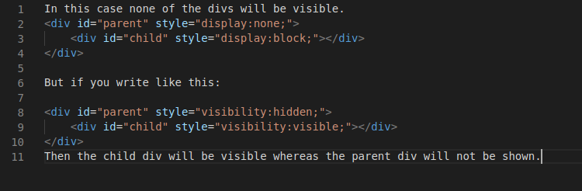

**3. Explain the clear and float properties.**

The CSS float property specifies how an element should float.

The float property can have one of the following values:

* left - The element floats to the left of its container
* right - The element floats to the right of its container
* none - The element does not float (will be displayed just where it occurs in the text). This is default
* inherit - The element inherits the float value of its parent

The CSS clear property specifies what elements can float beside the cleared element and on which side.

The clear property can have one of the following values:

* none - Allows floating elements on both sides. This is default
* left - No floating elements allowed on the left side
* right- No floating elements allowed on the right side
* both - No floating elements allowed on either the left or the right side
* inherit - The element inherits the clear value of its parent

**4. Explain difference between absolute, relative,fixed and static.**

**Answer -**

* Static - this is the default value, all elements are in order as they appear in the document.Static positioned elements are not affected by the top, bottom, left, and right properties. An element with is not positioned in any special way; it is always positioned according to the normal flow of the page.
* Relative - the element is positioned relative to its normal position.When you set the position *relative to an element*, without adding any other positioning attributes (top, bottom, right, left) nothing will happen. When you add an additional position, such as left: 20px the element will move 20px to the right from its normal position.
* Absolute - the element is positioned absolutely to its first positioned parent.The positioning is done relative to the first relatively (or absolutely) positioned parent element. In the case when there is no positioned parent element, it will be positioned related directly to the HTML element.
* Fixed - the element is positioned related to the browser window.An element with position:fixed; is positioned relative to the viewport, which means it always stays in the same place even if the page is scrolled. The top, right, bottom, and left properties are used to position the element.

5. Write the HTML code to create a table in which there are 4 columns( ID , Employee Name, Designation, Department) and at least 6 rows. Also do some styling to it.

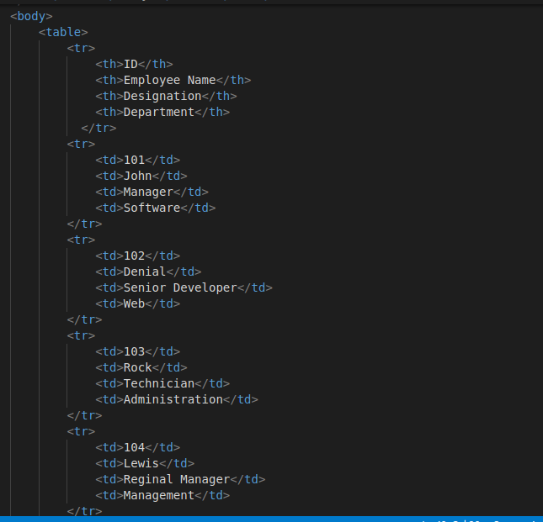

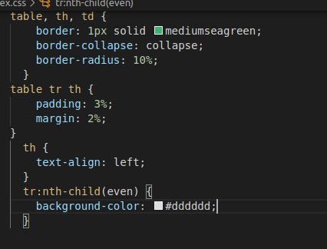

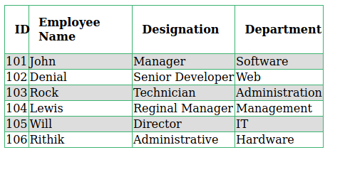

6. Why do we use meta tags?

Answer - These are the meta tags uses in html5 for different purpose..

<head>

<meta charset="UTF-8">

<meta name="description" content="Free Web tutorials">

<meta name="keywords" content="HTML,CSS,XML,JavaScript">

<meta name="author" content="John Doe">

<meta name="viewport" content="width=device-width, initial-scale=1.0">

</head>

Metadata is data (information) about data.

The <meta> tag provides metadata about the HTML document. Metadata will not be displayed on the page, but will be machine parsable.

Meta elements are typically used to specify page description, keywords, author of the document, last modified, and other metadata.

The metadata can be used by browsers (how to display content or reload page), search engines (keywords), or other web services.

**7. Explain box model.**

**Answer -** All HTML elements can be considered as boxes. In CSS, the term "box model" is used when talking about design and layout. The CSS box model is essentially a box that wraps around every HTML element. It consists of: margins, borders, padding, and the actual content. For Ex -

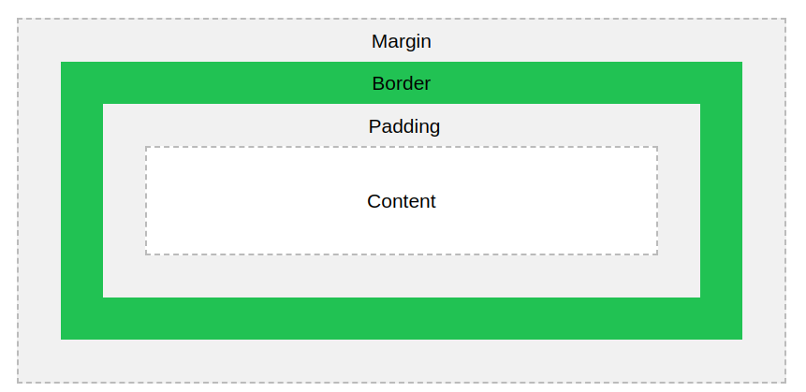

8. What are the different types of CSS Selectors?

Answer - In css there are different type of css selectors available these are -

1. Universal Selector-Selects all child elements under the parent element. Here style is applied to every element under the parent element. Its weight is more and to be used with care.
2. Class selector - Selects specified CSS class applied elements on the page. CSS class selector name starts with “.” followed by name.
3. Id Selector - Selects element which has a specified ID name. CSS ID selector name starts with “#” followed by name.
4. Element Selector - Select elements based on element type. We directly use it without any notation .
5. Descedent Selector - Selects all specified descendant child elements under the parent element.
6. Child Selector - Selects all specified immediate child elements under the parent element.

9. Define Doctype.

Answer - <!Doctype Html> is used in html page to represent this page is written in Html5.The <!DOCTYPE> declaration must be the very first thing in your HTML document, before the <html> tag.Always add the <!DOCTYPE> declaration to your HTML documents, so that the browser knows what type of document to expect.

For ex - first line is doctype i.e. document type

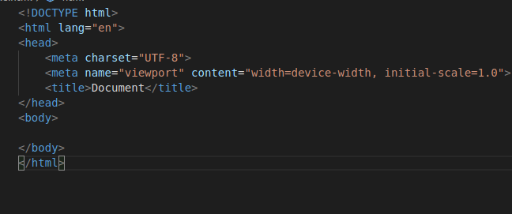

10. Explain 5 HTML5 semantic tags.

Answer -

<article>

<aside>

<details>

<figcaption>

<footer>

<header>

<main>

<mark>

<nav>

<section>

<summary>

<time>

These are the semantic tags which was added in html5.Elements such as <header>, <nav>, <section>, <article>, <aside>, and <footer> act more or less like <div> elements.

Lets check this picture in which a complete layout is present using all semantic tags.

