Java practical-2

Q.1 Write a java program that uses nested if statements to check if x is greater than 5 and if y is greater than 2. If both conditions are met, print 'x is greater than 5, and y is also greater than 2.' If x is not greater than 5, print 'x is not greater than 5.?

Q.2 write a java program , countSquares(n), that returns the count of perfect squares less than or equal to n (n>1) .?

Q.3 W.A.P to check perfect square of given number in java ?

Q.4 W.A.P to find LCM of two number in java ?

Q.5 W.A.P to print pattern given below in java ?

a.

**\*\*\*\***

**\*\*\*\***

**\*\*\*\***

**\*\*\*\***

b.

**\***

**\*\***

**\*\*\***

**\*\*\*\***

**\*\*\*\*\***

c.

*

**

***

****

*****

d.

**\***

**\*\*\***

**\*\*\*\*\***

**\*\*\*\*\*\*\***

**e .**

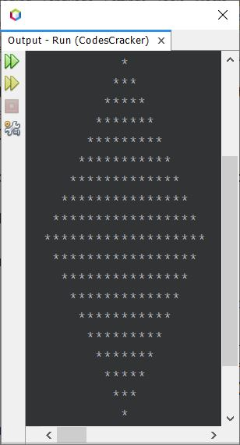

**f.**

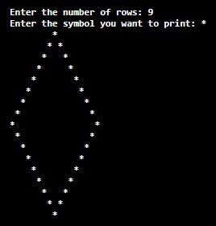

g.

*****

*****

*****

*****

*****

**h.**

A B C D E

F G H I J

K L M N O

P Q R S T

U V W X Y

**i.**

**1**

**1 1**

**1 2 1**

**1 3 3 1**

**1 4 6 4 1**

**1 5 10 10 5 1**

**j.**

**\*\*\*\*\*\*\*\*\*\*\*\*\*\*\*\***

**\* * \***

**\* * \***

**\*\*\*\*\*\*\*\*\*\*\*\*\*\*\*\***

**\* * \***

**\* * \***

**\*\*\*\*\*\*\*\*\*\*\*\*\*\*\*\***

**j.**

**0**

**010**

**01210**

**0123210**

**012343210**