Project Report on

<WOMEN SECURITY WEBSITE>

**Minor Project**

Integrated Master of Computer Application (IMCA)

By

<Praful Patel, Harshal Yesikar >

<Enrolment number – 0810CA18DD26, 0810CA19DD18>

<6th Semester>

Under the supervision of

<Professor- HARSHA CHOUHAN >



IPS Academy Indore

School of Computers

RAJIV GANDHI PROUDYOGIKI VISHWAVIDHYALAYA, BHOPAL

2022

**CERTIFICATE**

The is to certify that **<PRAFUL PATEL, HARSHAL YESIKAR><0810CA18DD26 , 0810CA19DD18>,** of Integrated Master of Computer Application (IMCA**), SOC IPS ACADEMY** has successfully completed their **<6th Semester>** minor project entitled **<WOMEN SECURITY WEBSITE>**, under the guidance of <**Professor- HARSHA CHOUHAN**> as a part of fulfilment of academic curriculum.

**External Examiner Internal Examiner**

**Date Date**

Director

IPS Academy Indore

School of Computers

**Acknowledgement**

The satisfaction that accompanies that the successful completion of any task would be incomplete without the mention of people whose ceaseless corporation made it possible whose constant guidance and encouragement crown all efforts with success.

We are grateful to our guide **<Professor- HARSHA CHOUHAN>** for the guidance, inspiration and constructive suggestions that helpful us in preparation of this project.

We also thanks who have helped in successful completion of the project.

Date: Student Name

Praful Patel, Harshal Yesikar

Place: IPS Academy Indore <Enrollment No.>

0810CA18DD26, 0810CA19DD18

IMCA-6th Semester

**INDEX**

1. **INTRODUCTION**

**\*PROJECT INTRODUCTION**

**\*PROBLEM DEFINITION**

**\*MOTIVATION**

**\*OBJECTIVE**

**\*PROPOSED SOLUTION**

1. **SPECIFICATION**

**\*PLATFORM SPECIFICATION**

**\*TOOLS AND TECHNOLOGY**

**\*SOFTWARE SPECIFICATION**

**\*SCOPE AND MARKETING**

1. **BACKGROUND RELATED WORK**

**\*EXISTING SYSTEM**

**\*PROPOSED SYSTEM**

**\*SCOPE OF PROPOSED SYSTEM**

1. **SYSTEM ANALYSIS AND DESIGN**

**\*FEASIBILITY STUDY**

**\*TECHNICAL FEASIBILITY**

**\*ECONOMICAL FEASIBILITY**

**\*OPERATIONAL FEASIBILITY**

1. **REQUIREMENTS**

**\*FUNCTIONAL REQUIREMENT**

**\*NON-FUNCTIONAL REQUREMENT**

1. **SCREENSHOTS**
2. **IMPLEMENTATION**
3. **DATABASE DESCRIPTION**
4. **DFD MODEL**
5. **CONCLUSION**

**INTRODUCTION**

**Introduction**- This application designed to provide security to women main purpose of this application to provide the awareness on the time of critical situation for women. Generally you can active this service by clicking on ACTIVE SERVICE button. When you clicking on this button service get activate and know whenever you click on VOLUME key it open a new window and send SMS to those contact which you saved at the time of registration the SMS contain your message and your current location.

This application is provide deactivate service also when we fill secure this application is mainly required correct information to fill otherwise this app will not work correctly.

**Problem definition**- Women security is one of the major issue of the society today. Every women has the right to be secure in this world for this their security is very much important so the only thing that we can do for them is by making them aware about their problem for this we are here trying to reach them to provide them help.

**Motivation-**This website will help the women by boosting up her confidence level by providing her some techniques which will help them to become physically healthy and so what they can learn self defence also.

**Objective**-The main objective of this project is provide highly reliable security system for the safety of women.

The proposed system is based advanced sensors, Microcontroller and GSM.

We are giving attention on building an effective, fast and needful system to make the women of India feel safe and empowered.

Our platform will act as a 24/7 active help and companion for women so that they don’t ever feel that they are alone in the middle of a crisis situation.

It will unite and enable the citizens of India and the police to work towards a common problem. This tool will act as eyes and ears for the police and help them in preventing crimes against women. This tool has been designed in such a way that it covers the various situations a woman can be stuck in like when she is alone or when she is in a crowded place or when she is in a public transport etc. everything will be included there.

So that we can help any women in her panic situation and can save her.

**Proposed solution-** The working of the system will be well planned and organized. The data will be stored properly in data stores, which will help in retrieval of information as well as its storage. The main proposed solution of this website is will be not only they provide a result or solution to the linking problem which is mentioned about it will provide a status report which will give a proposed solutions to this problem.

The main solution of this project will be that we will try to make this website more and more user friendly so that it will more and more beneficial for others.

**SPECIFICATION**

**Platform Specification-**

* Web
* Android

**Tools and technology -**

Front End: HTML , CSS, JavaScript

Back End: PHP , MYSQL

**Software specification-**

**HTML**:HTML or **Hypertext Markup Language** is the standard markup language used to create web pages.HTML is written in the form of HTML elements consisting of tags enclosed in angle brackets (like <html>). HTML tags most commonly come in pairs like <h1> and </h1>, although some tags represent empty elements and so are unpaired, for example <img>. The first tag in a pair is the start tag, and the second tag is the end tag (they are also called opening tags and closing tags). Though not always necessary, it is best practice to append a slash to tags which are not paired with a closing tag.The purpose of a web browser is to read HTML documents and compose them into visible or audible web pages. The browser does not display the HTML tags, but uses the tags to interpret the content of the page. HTML describes the structure of a website semantically along with cues for presentation, making it a markup language rather than a programming language.HTML elements form the building blocks of all websites. HTML allows images and objects to be embedded and can be used to create interactive forms. It provides a means to create structured documents by denoting structural semantics for text such as headings, paragraphs, lists, links, quotes and other items. It can embed scripts written in languages such as JavaScript which affect the behavior of HTML web pages.

**CASCADING STYLE SHEETS (CSS):** It is a style sheet language used for describing the look and formatting of a document written in a markup language. While most often used to style web pages and interfaces written in HTML and XHTML, the language can be applied to any kind of XML document, including plain XML, SVG and XUL. CSS is a cornerstone specification of the web and almost all web pages use CSS style sheets to describe their presentation.CSS is designed primarily to enable the separation of document content from document presentation, including elements such as the layout, colors, and fonts.This separation can improve content accessibility, provide more flexibility and control in the specification of presentation characteristics, enable multiple pages to share formatting, and reduce complexity and repetition in the structural content.

**MySQL**:

MySQL is developed, distributed, and supported by Oracle Corporation. MySQL is a database system used on the web it runs on a server. MySQL is ideal for both small and large applications. It is very fast, reliable, and easy to use. It supports standard SQL. MySQL can be compiled on anumber of platforms. The data in MySQL is stored in tables. A table is a collection of related data, and it consists of columns and rows. Databases are useful when storing information categorically.

**FEATURES OF MySQL**:

Internals and portability:

• Written in C and C++.

• Tested with a broad range of different compilers.

• Works on many different platforms.

• Tested with Purify (a commercial memory leakage detector) as well as with Val grind, a GPL

tool.

• Uses multi-layered server design with independent modules.

**WHY TO USE MySQL**:

• Leading open source RDBMS

• Ease of use – No frills

• Fast

• Robust

• Security

• Multiple OS support

• Free

• Technical support

• Support large database– up to 50 million rows, file size limit up to 8 Million TB

**PHP:**

• PHP is an acronym for "PHP Hypertext Preprocessor"

• PHP is a widely-used, open source scripting language

• PHP scripts are executed on the server

• PHP costs nothing, it is free to download and use

**WHY PHP?**

• PHP runs on various platforms (Windows, Linux, Unix, Mac OS X, etc.)

• PHP is compatible with almost all servers used today (Apache, IIS, etc.)

• PHP supports a wide range of databases

**Scope and marketing-** Scope of the project is very broad in terms of other tracking system. It is a online system .That can be used in security world of women. It helps to efficiently increase the security and safety of women. Women Safety Software Market is growing at a moderate pace with substantial growth rates over the last few years and is estimated that the market will grow significantly in the forecasted period.

**BACKGROUND AND RELATED WORK**

**Existing system-** There is a variety of application for women protection when they are in dangerous situation. The disadvantages of using previous applications are they only send the alert messages to the saved contacts. Because of previous systems there is less possibilities of overcome the dangerous situations of women. Previous applications also have google location tracking system for to track the women location but it has not specific range.

**Proposed system** - The proposed system will be implemented with the help of android application. Also sends messages and alert sound to the saved contacts in the application and police station. Which also show the location of the victim with the help of GOOGLE GEO LOCATION tracker system? Which also make sound in guardian mobile when his/her mobile in silent mode.

To develop a system for android users for keeping track through several applications. This application uses GOOGLE GEO LOCATION for identifying the location of the person in trouble and the system can be divided into two modules:

**Scope of proposed system-** The scope is simply all the work that needs to be done in order to achieve a project's objectives. In other words, the scope involves the process of identifying and documenting specific project goals, outcomes, milestones, tasks, costs, and timeline dates specific to the project objectives.

**SYSTEM ANALYSIS AND DESIGN**

**Feasibility study**- The assessment is based on outline design of system requirements in terms of Input , Processes , Output , Fields , Programs and Procedures.

Purpose of this consultancy is to provide the sound basis for developing the project concept, by identifying project preconditions, opportunities and risks for its implementation.

Feasibility study Determines and confirms whether

1. The needs for women’s security movements exist.

2. The planned project can help to work efficiently with the resources and measures.

**Technical feasibility-** Technical feasibility is to determine is to determine that whether this project has the ability to handle the completion of the software , in terms of software , hardware, personal or expertise.

**Economical feasibility-** Economic feasibility is to determine the most frequently used method for evaluating the effectiveness of a new system. The procedure is to determine the benefits that are expected.

**Operational feasibility**- Operational feasibility is a measure of how well the proposed system solves the problem and how it takes advantage of opportunities identified during scope definition and how it satisfies the requirements identified in the requirement analysis phase

**Non functional requirement-** Non functional requirements describe the capability and constraints of women security website that will enhance its functionality.

**Functional requirement-** These are the requirements that the end user specifically demands as basic facilities that this women security system should offer.

**SCREEN SHOTS**

**\*Home page**

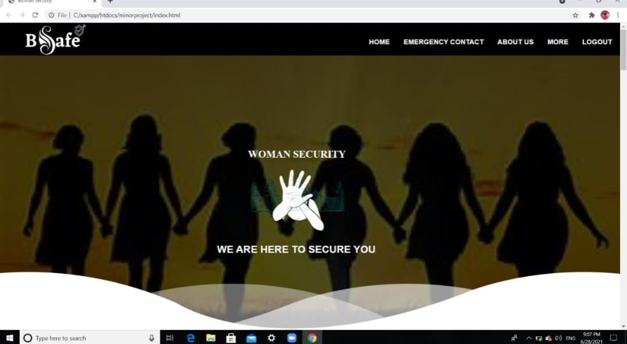

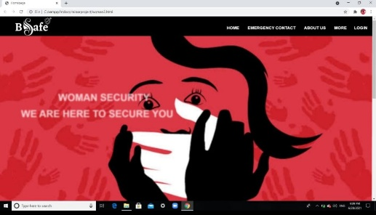

\***Login page**

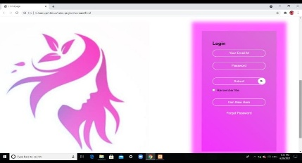

**\*About us**

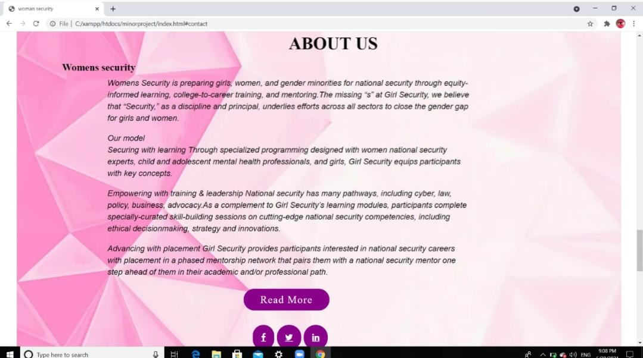

**\*Emergency contact details**

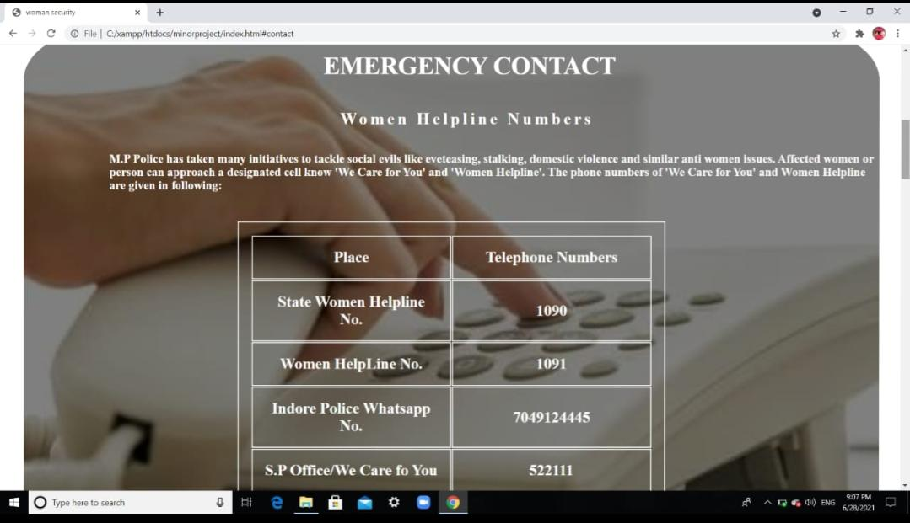

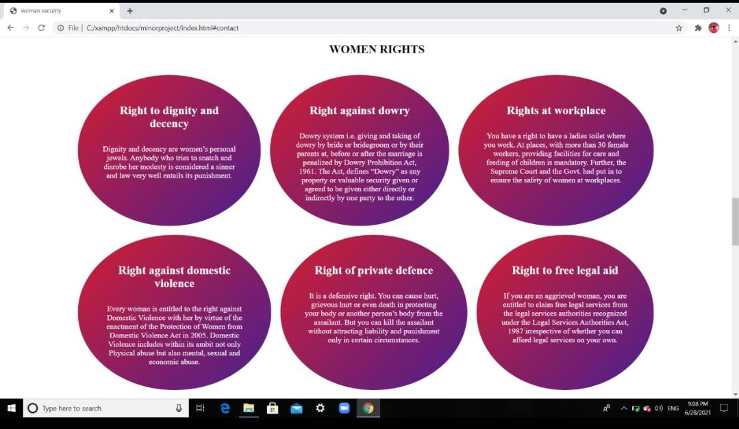**\*Women’s right**

**\*Self defence actions**

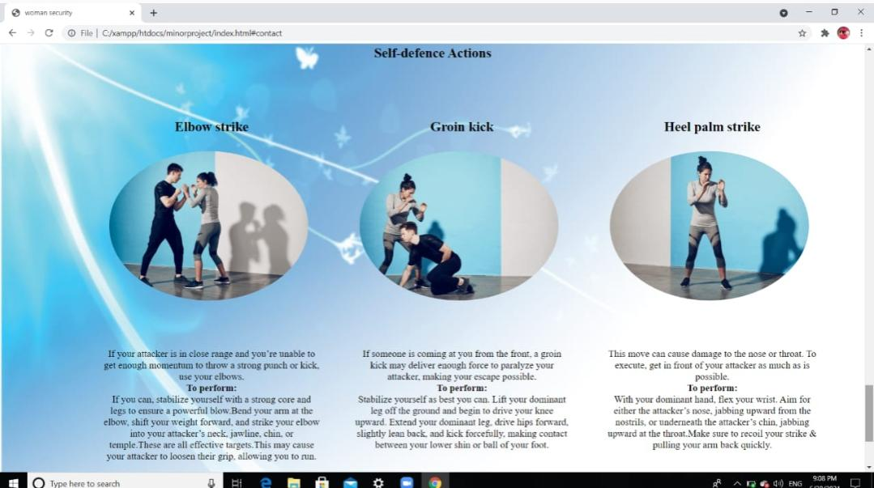

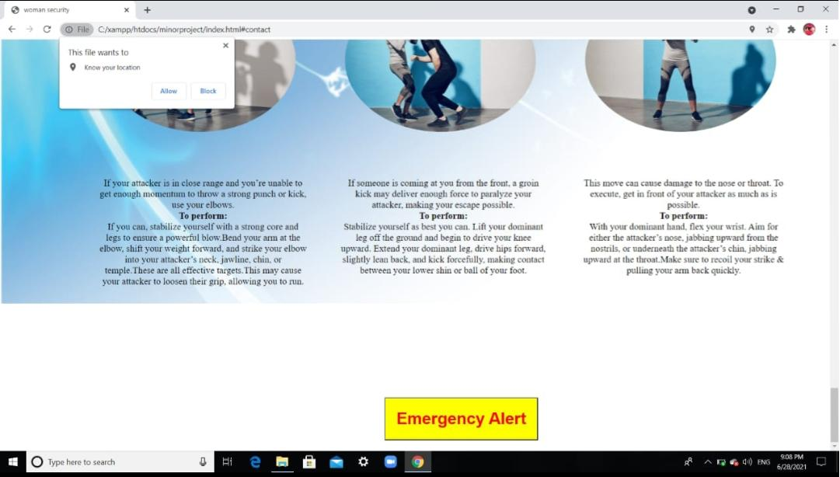

**\*Emergency alert**

**IMPLEMENTATION**

**Implementation** is the stage of the project when the theoretical design is turned out into a working system. Thus, it can be considered to be the most critical stage in achieving a successful new system and in giving the user, confidence that the new system will work and be effective. The implementation stage involves careful planning, investigation of the existing system and it’s constraints on implementation, designing of methods to achieve changeover and evaluation of changeover methods.

**\*Coding**

**Woman2.php**

**<?php**

**include 'databaseconn.php';**

**?>**

**<!DOCTYPE html>**

**<html>**

**<head>**

**<title>Homepage</title>**

**<meta charset="utf-8">**

**<style>**

**\*{**

**margin: 0;**

**padding: 0;**

**box-sizing: border-box;**

**font-family:sans-serif;**

**}**

**header**

**{**

**background-image: url(ss.jpg);**

**height: 100vh;**

**background-position: center;**

**background-size: cover;**

**}**

**nav{**

**background-color: black;**

**width: 100%;**

**height: 80px;**

**}**

**nav img{**

**width: 10%;**

**height: 100%;**

**margin-left: 60px;**

**}**

**nav ul{**

**float: right;**

**}**

**nav ul li**

**{**

**display: inline-block;**

**line-height: 75px;**

**margin-right: 10px;**

**color: white;**

**}**

**nav ul li a{**

**color: white;**

**font-size: 17px;**

**display: block;**

**padding: 10px;**

**font-family: sans-serif;**

**font-weight: bold;**

**}**

**nav li a{**

**color: white;**

**text-decoration: none;**

**font-size: 90%;**

**font-weight: bold;**

**}**

**a:hover{**

**color: orange;**

**border-bottom: 2px solid orange;**

**transition: all 0.5s ease-in;**

**padding: 2px 0;**

**}**

**ul li ul{**

**position: absolute;**

**top: 60px;**

**display: none;**

**visibility: hidden;**

**}**

**ul li:hover> ul,**

**ul li:focus-within > ul,**

**ul li ul:hover{**

**visibility: visible;**

**opacity: 1;**

**display: block;**

**padding: 0px;**

**margin-right: 40px;**

**}**

**ul li ul li{**

**clear: both;**

**width: 50%;**

**}**

**.main h2{**

**padding-top: 20px;**

**margin-left: 5%;**

**font-size: 30px;**

**color: white;**

**font-family: sans-serif;**

**font-weight: bold;**

**}**

**.main h1{**

**margin-top: 15%;**

**margin-left: 15%;**

**font-size: 30px;**

**color: white;**

**font-weight: bold;**

**}**

**.sp{**

**color: white;**

**font-size: 40px;**

**font-weight: bold;**

**animation: animate 1s linear finite;**

**}**

**@keyframes animate{**

**0%**

**{**

**opacity: 0;**

**transform: rotateX(90deg);**

**filter: blur(10px);**

**}**

**100%**

**{**

**opacity: 1;**

**transform: rotateX(0deg);**

**filter: blur(0);**

**}**

**}**

**section{**

**position: relative;**

**width: 100%;**

**height: 100vh;**

**display: flex;**

**margin-bottom: 40px;**

**}**

**section .imgbox{**

**position: absolute;**

**margin-top: 5%;**

**width: 50%;**

**height: 100%;**

**}**

**section .imgbox:before{**

**content: "";**

**position: absolute;;**

**top: 0;**

**left: 0;**

**width: 100%;**

**height: 100%;**

**background: linear-gradient(225deg,#e91e63,#03a9f4);**

**z-index: 1;**

**mix-blend-mode: screen;**

**}**

**section .imgbox img{**

**position: absolute;**

**top: 0;**

**left: 0;**

**width: 100%;**

**height: 100%;**

**object-fit: cover;**

**}**

**.content-box{**

**width: 100%;**

**height: 110%;**

**font-family: sans-serif;**

**display: flex;**

**justify-content: center;**

**margin-left: 60%;**

**margin-top: 8%;**

**}**

**.cards{**

**width: 380px;**

**height: 90%;**

**box-shadow: 0 0 10px 20px #ff66ff;**

**perspective: 1000px;**

**}**

**.inner-box{**

**position: relative;**

**width: 100%;**

**height: 100%;**

**transform-style: preserve-3d;**

**transition: transform 1s;**

**}**

**.card-front,.card-back{**

**position: absolute;**

**width: 380px;**

**height: 100%;**

**background-position: center;**

**background-size: cover;**

**background: linear-gradient(225deg,#da70d6,#f433ff);**

**padding: 55px;**

**box-sizing: border-box;**

**backface-visibility: hidden;**

**}**

**.card-back{**

**transform: rotateY(180deg);**

**}**

**.card h2{**

**font-weight: normal;**

**font-size: 24px;**

**text-align: center;**

**font-weight: bold;**

**}**

**.input-box{**

**width: 100%;**

**background: transparent;**

**border:2px solid #fff;**

**margin: 10px 0;**

**height: 40px;**

**border-radius: 20px;**

**padding: 0 20px;**

**box-sizing: border-box;**

**outline: none;**

**text-align: center;**

**color: #fff;**

**margin-top: 20px;**

**}**

**::placeholder{**

**color: #fff;**

**font-size: 17px;**

**}**

**button{**

**width: 100%;**

**background: transparent;**

**border: 2px solid #fff;**

**margin: 35px 0 20px;**

**height: 40px;**

**font-size: 17px;**

**border-radius: 20px;**

**padding: 0 20px;**

**box-sizing: border-box;**

**outline: none;**

**color: #fff;**

**cursor: pointer;**

**}**

**.submit-btn{**

**position: relative;**

**}**

**.submit-btn::after{**

**content: '\27a4';**

**color: #333;**

**line-height: 35px;**

**font-size: 17px;**

**height: 35px;**

**width: 38px;**

**border-radius: 50%;**

**position: absolute;**

**background: #fff;**

**right: -1px;**

**top: -1px;**

**}**

**.btn{**

**border: 2px solid #fff;**

**border-radius: 20px;**

**}**

**span{**

**font-size: 17px;**

**margin-left: 10px;**

**}**

**.card .btn{**

**margin-top: 70px;**

**}**

**.cards a{**

**color: #fff;**

**text-decoration: none;**

**display: block;**

**text-align: center;**

**font-size: 17px;**

**margin-top: 10px;**

**}**

**</style>**

**</head>**

**<body>**

**<header>**

**<nav>**

**<img src="besafe1.png">**

**<ul>**

**<li><a class="active">HOME</a></li>**

**<li><a>EMERGENCY CONTACT</a></li>**

**<li><a>ABOUT US</a></li>**

**<li><a>MORE</a>**

**<li><a href="#login">LOGIN</a>**

**</li>**

**</ul>**

**</nav>**

**<div class="main">**

**<h1><span class="sp">WOMAN SECURITY</span></h1>**

**<h2><span class="sp">WE ARE HERE TO SECURE YOU</span></h2>**

**</div>**

**</header>**

**</section>**

**<section id="login">**

**<div class="imgbox">**

**<img src="safe.jpg">**

**</div>**

**<div class="content-box">**

**<div class="cards">**

**<div class="inner-box" id="card">**

**<div class="card-front">**

**<h2>Login</h2>**

**<form action="login.php" method="POST">**

**<input type="email" name="email" class="input-box" placeholder="Your Email Id" required>**

**<input type="password" name="password" class="input-box" placeholder="Password" required>**

**<button type="submit" name="login" class="submit-btn">Login</button>**

**<input type="checkbox"><span>Remember Me</span>**

**</form>**

**<button type="button" class="btn" onclick="openRegister()">I'am New Here</button>**

**<a href="">Forget Password</a>**

**</div>**

**<div class="card-back">**

**<h2>Register</h2>**

**<form action="register.php" method="POST">**

**<input type="text" name="Name" class="input-box" placeholder="Your Name" required>**

**<input type="contact" name="Contact" class="input-box" placeholder="Your Phone No." required>**

**<input type="email" name="Email" class="input-box" placeholder="Your Email Id" required>**

**<input type="password" name="Password" class="input-box" placeholder="Password" required>**

**<input type="password" name="Cpassword" class="input-box" placeholder="Confirm password" required>**

**<button type="submit" name="Submit" class="submit-btn">Submit</button>**

**<input type="checkbox"><span>Remember Me</span>**

**</form>**

**<button type="button" class="btn" onclick="openLogin()">I've and Account</button>**

**<a href="">Forget Password</a>**

**</div>**

**</div>**

**</div>**

**</div>**

**</section>**

**<script>**

**var card = document.getElementById("card");**

**function openRegister(){**

**card.style.transform = "rotateY(-180deg)";**

**}**

**function openLogin(){**

**card.style.transform = "rotateY(0deg)";**

**}**

**</script>**

**</body>**

**</html>**

**Index.html**

**<!DOCTYPE html>**

**<html lang="en">**

**<head>**

**<meta charset="utf-8">**

**<title>woman security</title>**

**<link href="font-awesome-4.6.3/css/font-awesome.min.css" rel="stylesheet">**

**<link rel="stylesheet" type="text/css" href="style.css">**

**<script src="https://maps.googleapis.com/maps/api/js?key=YOUR_API_KEY&callback=initMap"**

**type="text/javascript"></script>**

**<script>**

**function showPosition() {**

**if(navigator.geolocation) {**

**navigator.geolocation.getCurrentPosition(function(position) {**

**var positionInfo = "Your current position is (" + "Latitude: " + position.coords.latitude + ", " + "Longitude: " + position.coords.longitude + ")";**

**document.getElementById("result").innerHTML = positionInfo;**

**});**

**} else {**

**alert("Sorry, your browser does not support HTML5 geolocation.");**

**}**

**}**

**</script>**

**</head>**

**<body>**

**<header>**

**<nav>**

**<img src="besafe1.png">**

**<ul>**

**<li><a class="active">HOME</a></li>**

**<li><a href="#contact">EMERGENCY CONTACT</a></li>**

**<li><a href="#about">ABOUT US</a></li>**

**<li><a>MORE</a>**

**<ul class="dropdown">**

**<li><a href="#right">Women Rights</a></li>**

**<li><a href="#self">Self-Protection</a></li>**

**</ul></li>**

**<li><a href="logout.php">LOGOUT</a></li>**

**</ul>**

**</nav>**

**<div class="main">**

**<h3>WOMAN SECURITY</h3>**

**<img src="logo3.png">**

**<h2>WE ARE HERE TO SECURE YOU</h2>**

**</div>**

**</header>**

**<section class="contact" id="contact">**

**<div class="number">**

**<div class="emer">**

**<h1>EMERGENCY CONTACT</h1>**

**</div>**

**<div class="helpline">**

**<h3>Women Helpline Numbers</h3>**

**<p>M.P Police has taken many initiatives to tackle social evils like eveteasing, stalking, domestic violence and similar anti women issues. Affected women or person can approach a designated cell know 'We Care for You' and 'Women Helpline'. The phone numbers of 'We Care for You' and Women Helpline are given in following:</p>**

**<table class="table">**

**<tr>**

**<th>Place</th>**

**<th>Telephone Numbers</th>**

**</tr>**

**<tr>**

**<td>State Women Helpline No.</td>**

**<td>1090</td>**

**</tr>**

**<tr>**

**<td>Women HelpLine No.</td>**

**<td>1091</td>**

**</tr>**

**<tr>**

**<td>Indore Police Whatsapp No.</td>**

**<td>7049124445</td>**

**</tr>**

**<tr>**

**<td>S.P Office/We Care fo You</td>**

**<td>522111</td>**

**</tr>**

**<tr>**

**<td>Mahila Thana</td>**

**<td>2499816</td>**

**</tr>**

**</table>**

**</div>**

**</div>**

**</section>**

**<section class="columns" id="right">**

**<div class="rights">**

**<div class="col">**

**<h1>WOMEN RIGHTS</h1>**

**</div>**

**<div class="row">**

**<div class="column">**

**<h2>Right to dignity and decency</h2>**

**<p>Dignity and decency are women’s personal jewels. Anybody who tries to snatch and disrobe her modesty is considered a sinner and law very well entails its punishment. </p>**

**</div>**

**<div class="column">**

**<h2>Right against dowry</h2>**

**<p>Dowry system i.e. giving and taking of dowry by bride or bridegroom or by their parents at, before or after the marriage is penalized by Dowry Prohibition Act, 1961. The Act, defines “Dowry” as any property or valuable security given or agreed to be given either directly or indirectly by one party to the other.</p>**

**</div>**

**<div class="column">**

**<h2>Rights at workplace </h2>**

**<p>You have a right to have a ladies toilet where you work. At places, with more than 30 female workers, providing facilities for care and feeding of children is mandatory. Further, the Supreme Court and the Govt. had put in to ensure the safety of women at workplaces.</p>**

**</div><br>**

**<div class="column">**

**<h2>Right against domestic violence </h2>**

**<p>Every woman is entitled to the right against Domestic Violence with her by virtue of the enactment of the Protection of Women from Domestic Violence Act in 2005. Domestic Violence includes within its ambit not only Physical abuse but also mental, sexual and economic abuse. </p>**

**</div>**

**<div class="column">**

**<h2>Right of private defence </h2>**

**<p>It is a defensive right. You can cause hurt, grievous hurt or even death in protecting your body or another person’s body from the assailant. But you can kill the assailant without attracting liability and punishment only in certain circumstances.</p>**

**</div>**

**<div class="column">**

**<h2>Right to free legal aid</h2>**

**<p>If you are an aggrieved woman, you are entitled to claim free legal services from the legal services authorities recognized under the Legal Services Authorities Act, 1987 irrespective of whether you can afford legal services on your own.</p>**

**</div>**

**</div>**

**</div>**

**</section>**

**<section class="container" id="about" style="margin-top: 60%;">**

**<div class="content-section">**

**<div class="title">**

**<h1>About Us</h1>**

**</div>**

**<div class="content">**

**<h3>Womens security</h3>**

**<p>Womens Security is preparing girls, women, and gender minorities for national security through equity-informed learning, college-to-career training, and mentoring. The missing “s” at Girl Security, we believe that “Security,” as a discipline and principal, underlies efforts across all sectors to close the gender gap for girls and women.</p>**

**<p>Our model<br>**

**Securing with learning Through specialized programming designed with women national security experts, child and adolescent mental health professionals, and girls, Girl Security equips participants with key concepts. <br>**

**<p>Empowering with training & leadership National security has many pathways, including cyber, law, policy, business, advocacy.As a complement to Girl Security’s learning modules, participants complete specially-curated skill-building sessions on cutting-edge national security competencies, including ethical decision making, strategy and innovations.</p>**

**<p>Advancing with placement Girl Security provides participants interested in national security careers with placement in a phased mentorship network that pairs them with a national security mentor one step ahead of them in their academic and/or professional path. </p>**

**<br>**

**<div class="button">**

**<a href='#'> Read More </a>**

**</div>**

**</div>**

**<div class="social">**

**<a href="#" class="fa fa-facebook"></a>**

**<a href="#" class="fa fa-twitter"></a>**

**<a href="#" class="fa fa-linkedin"></a>**

**</div>**

**</div>**

**</section>**

**<section class="side" id="self">**

**<div class="head">**

**<h1> Self-defence Actions</h1>**

**</div>**

**<div class="container-section">**

**<div class="row1">**

**<div class="description-container">**

**<h2>Elbow strike</h2>**

**<img src="https://thumbs.gfycat.com/FrenchFatGalapagosmockingbird-max-1mb.gif" alt="" class="img-responsive floating-image right">**

**<p> If your attacker is in close range and you’re unable to get enough momentum to throw a strong punch or kick, use your elbows.<br><b>To perform:</b><br> If you can, stabilize yourself with a strong core and legs to ensure a powerful blow. Bend your arm at the elbow, shift your weight forward, and strike your elbow into your attacker’s neck, jawline, chin, or temple. These are all effective targets. This may cause your attacker to loosen their grip, allowing you to run.</p>**

**</div>**

**<div class="description-container">**

**<h2 >Groin kick</h2>**

**<img src="https://thumbs.gfycat.com/MetallicBoilingGermanshorthairedpointer-max-1mb.gif" alt="" class="img-responsive floating-image left">**

**<p>If someone is coming at you from the front, a groin kick may deliver enough force to paralyze your attacker, making your escape possible.<br><b>To perform:</b><br>Stabilize yourself as best you can.**

**Lift your dominant leg off the ground and begin to drive your knee upward.**

**Extend your dominant leg, drive hips forward, slightly lean back, and kick forcefully, making contact between your lower shin or ball of your foot.</p>**

**</div>**

**<div class="description-container">**

**<h2 >Heel palm strike</h2>**

**<img src="https://thumbs.gfycat.com/InnocentImpassionedBrocketdeer-max-1mb.gif" alt="" class="img-responsive floating-image right">**

**<p>This move can cause damage to the nose or throat. To execute, get in front of your attacker as much as is possible.<br><b>To perform:</b><br>With your dominant hand, flex your wrist.**

**Aim for either the attacker’s nose, jabbing upward from the nostrils, or underneath the attacker’s chin, jabbing upward at the throat.Make sure to recoil your strike & pulling your arm back quickly.</p>**

**</div>**

**</div>**

**</div>**

**</div>**

**</section>**

**<section class="location">**

**<div id="result">**

**<!--Position information will be inserted here-->**

**</div>**

**<button type="button" onclick="showPosition();">Show Position</button>**

**</section>**

**</body>**

**</html>**

**Login.php**

**<?php**

**$con = mysqli_connect('localhost','root','','woman') or die('connection error');**

**if (isset($_POST['Submit']));**

**include 'databaseconn.php';**

**{**

**$_email = $_POST['email'];**

**$_password = $_POST['password'];**

**$sql = "select Password from registration where (Password =\'$_password\',Email =\'$_email\')";**

**$result = mysqli_query($con, "SELECT * FROM registration") or die ("Query Failed");**

**// print mysqli_num_rows($result);**

**if(mysqli_num_rows($result) > 0){**

**while ($row = mysqli_fetch_assoc($result)) {**

**session_start();**

**$_SESSION["email"] = $row['email'];**

**$_SESSION["password"] = $row['password'];**

**header("Location:index.html");**

**}**

**}else{**

**echo "Email and Password are not matched";**

**}**

**}**

**?>**

**Logout.php**

**<?php**

**include 'databaseconn.php';**

**session_start();**

**session_unset();**

**session_destroy();**

**header("Location: woman2.php");**

**?>**

**Register.php**

**<?php**

**session_start();**

**$connect = mysqli_connect('localhost','root','','woman') or die('connection error');**

**if(isset($_POST['Submit'])){**

**$name = $_POST['Name'];**

**$contact = $_POST['Contact'];**

**$email = $_POST['Email'];**

**$password = $_POST['Password'];**

**$query = "INSERT INTO registration (Name,Contact,Email,Password) VALUES (\"$name\",\"$contact\",\"$email\",\"$password\")";**

**$insert = mysqli_query ($connect, query);**

**print '<script> alert ("'. $insert .'")</script>';**

**if ($insert)**

**{**

**echo '<script> alert ("Registration sucessfully")</script>';**

**}**

**else**

**{**

**echo '<script> alert("Registration Unsuccessfully")</script>';**

**}**

**}**

**?>**

**DATABASE DISCRIPTION**

**DATABASE DISCRIPTION:** We are using xampp server for mysql and apache for executing the php code for backend work. In this project the data base name is Women's security.

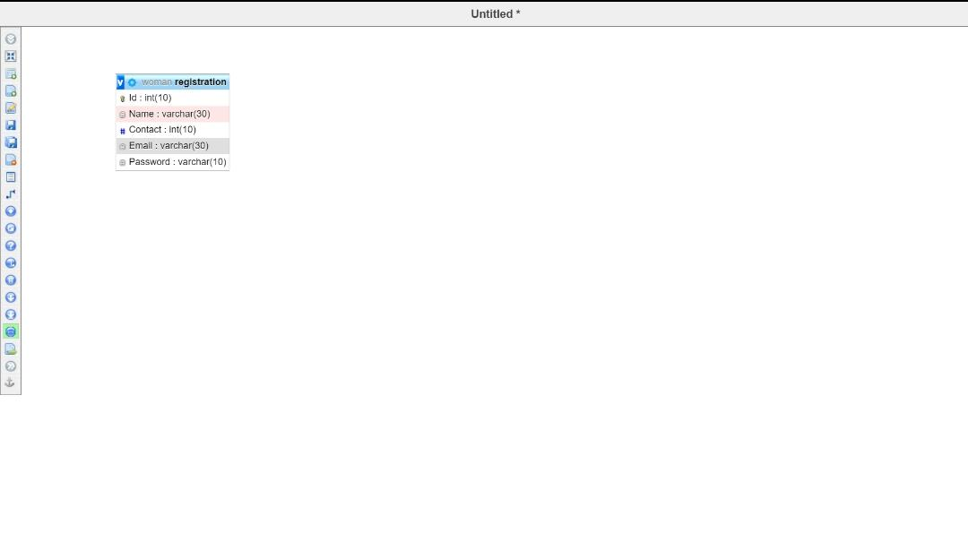

**DFD MODEL**

**Username, password**

User and help provider data store

User

**Latitude , longitude**

Location data

**Latitude , longitude**

Help Provider

**CONCLUSION**

**O**ur website is about women security this website will provide help to secure a women who is in danger and needs help to be secure so our website will provide help to these women we tried to secure them and try to put a step forward for women. This website help the women to know their rights their importance and will also help women to learn self defence.