URBAN AIR QUALITY ANALYTICS
Mumbai Air Quality Index Monitoring and Machine-Learning Analysis
Data Visualization Mini Project | Project Report
TEAM CONTRIBUTIONS
Raghav Chandak (I012) — Ideation, presentation and report preparation
Shubham Jatania (I034) — Power BI dashboard and visual analytics
Kabir Goswami (I026) — Machine-learning notebook and model pipeline

Dataset coverage used in the final Power BI export: 07 May 2018 – 01 July 2020
Prepared using station-day air-quality observations, a Random Forest regression workflow, and an interactive Power BI dashboard.

Abstract
Urban air pollution is a multi-pollutant problem whose measurements can be difficult to interpret without analytical tools. This project builds an end-to-end workflow for exploring historical Air Quality Index (AQI) observations for monitoring stations identified as being in Mumbai. The workflow combines data cleaning and quality checks, exploratory data analysis (EDA), a Random Forest regression model, evaluation of held-out predictions, and a single-page Power BI dashboard. The final dashboard dataset contains 3,872 station-day records from 10 station IDs between 07 May 2018 and 01 July 2020. The observed mean AQI is 103.1, the median is 90.5, and the maximum is 323. The model export contains 775 rows with predictions; its stored test prediction errors yield MAE ≈ 8.05 AQI points and RMSE ≈ 12.27 AQI points. These metrics describe same-day AQI estimation from pollutant measurements, not a validated future forecast. Because AQI is calculated from pollutant concentrations, the modelling setup has a target-construction dependency and should be interpreted as a demonstration pipeline rather than an independent early-warning system. The provided final CSV contains Mumbai records only; it does not support a valid Mumbai-versus-Navi Mumbai comparison.

Keywords
Air Quality Index, Mumbai, exploratory data analysis, Random Forest regression, Power BI, environmental analytics, data visualization

1. Problem Statement
Air-quality data are collected across monitoring stations and include multiple pollutants, missing readings, timestamps and station metadata. A raw table does not readily communicate where and when air quality is relatively worse, which pollutant measurements co-vary with AQI, or how close a regression model's estimates are to observed AQI. The project addresses the need for a reproducible workflow that transforms station-day observations into understandable visual evidence and a baseline machine-learning evaluation.
The practical question is: how can historical AQI and pollutant readings for available Mumbai monitoring stations be cleaned, explored, visualised and used to demonstrate a regression-based AQI estimation workflow, while clearly communicating data coverage and modelling limitations?

2. Objectives and Contributions
- Prepare a consistent station-day dataset by checking data types, dates, missing values, station metadata and coordinate provenance.
- Conduct EDA on AQI distribution, category counts, station-level averages, time trends and pollutant relationships.
- Train a Random Forest regression baseline using available pollutant columns and a chronological train/test split.
- Evaluate held-out predictions using MAE and RMSE and visualise actual-versus-predicted values and residuals.
- Build an interactive Power BI page with KPI cards, time trend, station ranking, AQI category distribution, map, pollutant analysis and model performance.
- Document coverage limitations and avoid making unsupported comparisons for Navi Mumbai where observations are absent.

3. Dataset and Scope
The final CSV used for the dashboard is derived from the Air Quality Data in India dataset associated with the Kaggle collection by rohanrao, joined to station metadata and an external coordinate table. The exported file includes station identifiers, dates, pollutant measurements (including PM2.5, PM10, NO, NO2, NOx, NH3, CO, SO2 and O3), AQI, AQI category, station details, coordinates, engineered calendar fields, and prediction/error columns.
Final dashboard rows | 3,872 station-day records
Station IDs | 10
Date range | 07 May 2018 to 01 Jul 2020
Cities represented in final CSV | Mumbai
Mean / median AQI | 103.1 / 90.5
Maximum AQI | 323
Mean PM2.5 / PM10 | 36.67 / 90.36 (source units as supplied)
Rows with model predictions | 775
Important scope note: although the broader project title refers to Mumbai and Navi Mumbai, the final exported file has 3,872 rows with city = Mumbai and no Navi Mumbai observations. Station metadata may list Navi Mumbai stations, but station coordinates alone do not create observations. Consequently, this report does not claim a two-city comparison. Some coordinate values in the coordinate table were marked approximate/locality-level; geographic interpretation should respect that provenance.

4. Existing Research and Background

4.1 AQI as a communication index
India's Central Pollution Control Board (CPCB) describes AQI as a communication tool that compresses multiple pollutant measurements into a single index value, category and colour. The Indian framework uses six categories—Good, Satisfactory, Moderate, Poor, Very Poor and Severe—and considers pollutant-specific sub-indices; the maximum valid sub-index determines the overall AQI. This makes category distribution and temporal visualisation useful for communicating monitoring results, while reminding analysts that the final AQI can be driven by different pollutants at different times.

4.2 Health relevance of air pollution
The World Health Organization's 2021 global air quality guidelines synthesise evidence on particulate matter (PM2.5 and PM10), ozone, nitrogen dioxide, sulphur dioxide and carbon monoxide. WHO notes that evidence of health impacts exists at lower concentrations than previously understood. This reinforces the value of transparent pollutant monitoring; however, the present project analyses monitoring data and does not estimate health outcomes or causal effects.

4.3 Machine learning for air-quality analysis
A 2023 survey by Méndez, Merayo and Núñez reviews 155 studies on machine-learning methods for air-quality forecasting published across 2011–2021. More recent reviews also discuss Random Forest and gradient-boosted trees as useful methods for structured multivariate data, while deep-learning approaches such as LSTM are often considered when temporal sequences and forecasting are central. The literature also identifies recurring challenges: heterogeneous data, generalisation across locations, model interpretability, uncertainty and inconsistent evaluation. This project adopts Random Forest as a practical baseline because it can model nonlinear interactions in tabular pollutant data and supplies feature-importance estimates.

4.4 Positioning of this project
The project is an applied educational pipeline rather than a novel AQI algorithm. Its contribution is the integration of data preparation, EDA, a reproducible regression baseline and a dashboard intended for interactive exploration. The main methodological caveat is that pollutant concentrations are inputs used to calculate AQI under the CPCB framework. Estimating AQI from same-day pollutant inputs can therefore reproduce a target constructed from those inputs; it is not equivalent to forecasting AQI before the pollutant measurements are known.

5. Methodology

5.1 Data ingestion and preprocessing
- Load the station-day pollutant table and station metadata, then join on StationId where applicable.
- Parse the observation date and enforce numeric types for AQI, pollutant measurements, coordinates and prediction-error fields.
- Inspect duplicate keys, missingness and invalid numeric values. Missing pollutant readings are not treated as zero.
- Join station coordinates by station ID/name and retain coordinate provenance notes; approximate points are not presented as survey-grade positions.
- Create derived date attributes such as year, month, quarter, day of week, weekend and season for EDA and dashboard filters.
- Keep the final analysis within the observations actually present. No synthetic Navi Mumbai readings are added.

5.2 Exploratory data analysis
EDA examines the overall AQI distribution, counts by AQI category, mean AQI by station, monthly AQI trend and relationships between particulate matter and AQI. The final exported category counts are: Good = 771; Satisfactory = 1,411; Moderate = 1,357; Poor = 314; Very Poor = 19. These are station-day record counts, not counts of unique calendar days.
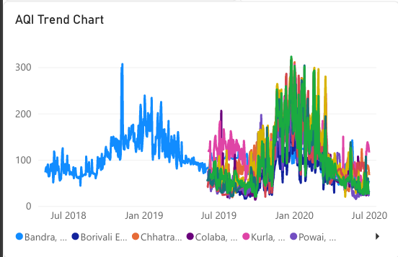

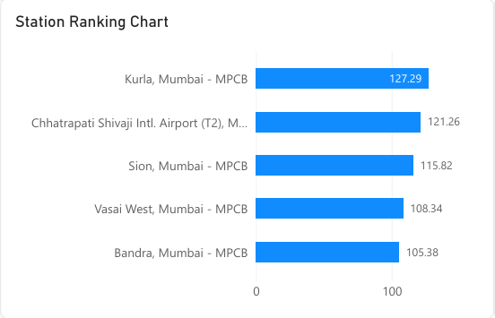

5.3 Model selected and implementation
The implemented model is a RandomForestRegressor from scikit-learn. A Random Forest trains an ensemble of decision trees on bootstrapped samples and combines their predictions, which generally helps capture nonlinear relationships and reduces the variance of an individual tree. The workflow uses pollutant columns as predictors and AQI as the regression target. A chronological split places earlier observations in the training partition and later observations in the test partition, which is more appropriate for time-indexed data than a fully random split. Missing predictor values are imputed using training-set medians within a preprocessing/model pipeline. Feature importance is extracted from the fitted forest.
The exported model_split field indicates 3,097 training rows and 775 test rows. The prediction fields are present for 775 rows. The model is an AQI estimation demonstration using same-day pollutant measurements; it is not a next-day forecasting model because future timestamps are not the target and no forecast horizon is defined.

5.4 Evaluation
Using the prediction/error values in the supplied export, MAE is approximately 8.05 AQI points and RMSE is approximately 12.27 AQI points over 775 rows with predictions. MAE is the mean absolute difference between actual and predicted AQI. RMSE is the square root of the mean squared residual and penalises larger errors more strongly. These figures should be rechecked after any changes to the notebook, split, predictors or data types. They are not comparable to a future forecasting benchmark unless the evaluation protocol is redesigned accordingly.

5.5 Power BI dashboard
The single-page report is designed around a quick-read KPI row and supporting analytical visuals. Recommended elements include average AQI, maximum AQI, average PM2.5 and the count of station-day records with AQI above 200; an AQI trend line; a Top-N station ranking; a map using latitude/longitude; an AQI category distribution; an actual-versus-predicted scatter plot; and a PM2.5-versus-AQI scatter plot. Date, station and category slicers enable users to explore subsets. A date dimension should relate to the fact table using unique date keys rather than a repeated Year column.

6. Graphical Abstract / Architecture
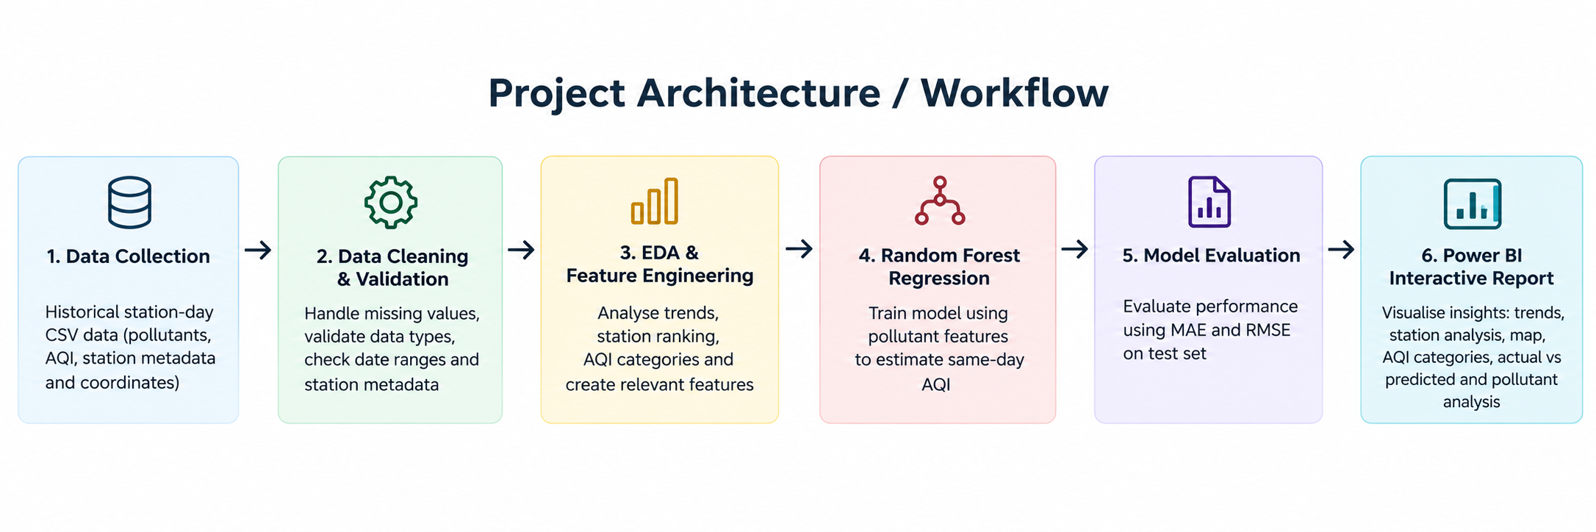
Figure: End-to-end flow from historical station-day data through validation, EDA and Random Forest regression to held-out evaluation and Power BI reporting. The dashboard is an output/communication layer; it does not replace validation of the underlying data or model.

7. Results and Discussion
The final dashboard export contains 3,872 observations across 10 station IDs. The mean AQI is 103.1, the median is 90.5, and the maximum is 323. Mean PM2.5 is 36.67 and mean PM10 is 90.36 in the units supplied by the dataset. 43.6% of records fall in Moderate or worse categories based on the exported aqi_category labels; 333 station-day records have AQI greater than 200.
Kurla is the highest by mean AQI among the stations in the exported file (approximately 127.3), followed by Chhatrapati Shivaji Intl. Airport (T2), Mumbai - MPCB (121.3); Sion, Mumbai - MPCB (115.8). These rankings describe this dataset and period only; differences can be influenced by station coverage, missing readings and temporal availability. They should not be interpreted as causal evidence about emission sources.
The stored model predictions yield MAE ≈ 8.05 and RMSE ≈ 12.27 AQI points on 775 predicted rows. The result demonstrates how a regression pipeline can be evaluated and surfaced in a dashboard. Because same-day pollutant values are used to estimate an AQI constructed from pollutant values, apparent accuracy can overstate practical forecasting usefulness. A future forecasting experiment should predict AQI at a later time using only information available before that forecast timestamp.

8. Team Contributions
Member | Assigned contribution | Workstream details
Raghav Chandak (I012) | Ideation, presentation and report preparation | Project framing, presentation narrative, report organisation and communication of objectives, methodology, results and limitations.
Shubham Jatania (I034) | Power BI dashboard | Dashboard layout, KPI cards, interactive slicers, trend and station visuals, category analysis, geographic view and model-output visualisation.
Kabir Goswami (I026) | ML notebook | Data pipeline, preprocessing, Random Forest regression, chronological evaluation, error metrics, feature importance and export of Power BI-ready prediction data.
Note: This contribution table reflects the team allocation supplied for this report; it is not an independent audit of individual commits or effort.

9. Limitations
- Geographic coverage: the final CSV contains Mumbai records only. It does not contain historical observations for the identified Navi Mumbai station IDs, so a city-to-city comparison cannot be supported.
- Date coverage: the final export covers 7 May 2018 to 1 July 2020, not the entire 2015–2020 span of the broader source dataset.
- Missingness and station coverage: pollutant measurements and observations are not uniformly complete across stations or dates. Averages may be affected by availability patterns.
- Coordinate precision: some station coordinates are approximate locality-level points and require official verification before precise spatial claims.
- Target dependency / leakage risk: AQI is computed from pollutant concentrations. Using same-day pollutants to estimate AQI creates a close mathematical dependency and is not an independent forecast.
- Limited validation: a single chronological holdout is useful as a baseline, but repeated time-based validation, uncertainty estimates and comparisons against simple baselines are not included in the headline results.
- No causal interpretation: the analysis describes patterns and associations; it does not identify pollution sources or establish health effects.
- Model portability: a model trained on these observations may not generalise to different cities, stations, seasons or sensor regimes.

10. Conclusion
This project demonstrates an end-to-end environmental analytics workflow that turns historical station-day air-quality data into a cleaned analytical dataset, exploratory visuals, a Random Forest regression baseline and an interactive Power BI report. The exported data show a mean AQI of about 103.1, with observations distributed across Good, Satisfactory, Moderate, Poor and Very Poor categories. The model evaluation provides a concrete example of measuring regression error and displaying predicted versus observed values. The principal value of the work is the integration of data preparation, analysis, modelling and communication in one reproducible workflow, together with explicit disclosure of coverage and model limitations.

11. Future Scope
- Acquire verified historical Navi Mumbai station observations from MPCB/CPCB or another documented source and perform a like-for-like comparison with harmonised station/date coverage.
- Redesign the ML task as a genuine forecast (for example, next-day AQI) with lagged pollutant/AQI features and strictly time-respecting validation.
- Compare Random Forest with persistence/seasonal-naive baselines, linear regression, gradient boosting and sequence models such as LSTM where data volume supports them.
- Add weather variables (wind speed/direction, temperature, humidity, rainfall), traffic or land-use context when data quality and provenance permit.
- Use rolling-origin validation, station-level holdouts, confidence intervals and model-drift checks to assess robustness.
- Improve explainability with permutation importance or SHAP, and distinguish predictive association from causal attribution.
- Automate data refresh, quality alerts and Power BI reporting while retaining a clear record of source version, transformations and coordinate provenance.

References
- Central Pollution Control Board (CPCB). About National Air Quality Index (AQI). https://www.airquality.cpcb.gov.in/ccr_docs/About_AQI.pdf
- World Health Organization (WHO). WHO global air quality guidelines: particulate matter (PM2.5 and PM10), ozone, nitrogen dioxide, sulfur dioxide and carbon monoxide (2021). https://www.who.int/publications/i/item/9789240034228/
- Méndez, M., Merayo, M. G., & Núñez, M. (2023). Machine learning algorithms to forecast air quality: a survey. Artificial Intelligence Review, 56, 10031–10066. https://link.springer.com/article/10.1007/s10462-023-10424-4
- Machine learning for air quality prediction and data analysis: Review on recent advancements, challenges, and outlooks. Science of the Total Environment (2025). https://www.sciencedirect.com/science/article/pii/S0048969725022338
- Rohan Rao. Air Quality Data in India (2015–2020), Kaggle dataset (source dataset used as a starting point; final export is a filtered/processed subset). https://www.kaggle.com/datasets/rohanrao/air-quality-data-in-india
- scikit-learn developers. RandomForestRegressor documentation. https://scikit-learn.org/stable/modules/generated/sklearn.ensemble.RandomForestRegressor.html
- Microsoft Learn. Power BI documentation. https://learn.microsoft.com/power-bi/

