Second International Conference on Civil Engineering Innovative Development in Engineering Advances

(ICC IDEA-2025)

Development and Use of Grasscrete Pavement Unit with Carbon Sequestration
Shubham Jhaª, K. S. Satyanarayanan^{b},
ª PG Student, Department of Civil Engineering, SRM Institute of Science and Technology, SRM Nagar, Kattankulathur - 603203, India.
Email id: sj5774@srmist.edu.in
^{b} Professor, Department of Civil Engineering, SRM Institute of Science and Technology, SRM Nagar, Kattankulathur - 603203, India.
Email id: satyanak@srmist.edu.in

Abstract

This study explores Grasscrete as an innovative and sustainable building material that integrates concretes structural strength with environmental benefits by incorporating green vegetation into its open-cell structure. Grasscrete minimizes concrete usage, enhances rainwater absorption, reduces urban heat, and supports carbon sequestration by promoting plant growth. This study focuses on developing Grasscrete pavement units with key aspect: carbon sequestration. Additionally, the response of the materials to elevated temperatures (100°C to 600°C) was studied to assess their performance under extreme conditions. A comprehensive methodology was used while material selection, preparation of elephant grass powder, and designing different concrete mix with varying percentage of grass powder (2%, 5%, and 10%) with industrial by-products such as glass powder, GGBS and limestone powder. By using limestone powder, it not only increased the workability and filler properties of the mix but also contributed to CO₂ reduction by adding these supplementary materials, the use of cement per cubic meter was reduced by 50%, significantly lowering the overall carbon footprint and promoting sustainable construction practices. After analysing three groups of Concrete mixes with 2%, 5%, and 10% grass powder demonstrated varying compressive strengths over time. The 2% mix (Group 1) achieved the strength of 64.10 N/mm² at 28 days. The 5% mix (Group 2) achieved the strength of 36.64 N/mm² at 28 days, while the 10% mix (Group 3) reached
60.21 N/mm² at 28 days. The concrete mix design was compared with conventional M60 concrete, demonstrating approximately 32% lower embodied energy. This reduction is attributed to the use of sustainable components such as recycled materials and industrial byproducts, showcasing their potential for eco-friendly construction applications.

Keywords: Carbon Sequestration, Grasscrete, Medicinal Plants, Permeable Pavement, Sustainable Concrete, Urban Cooling
- Introduction

Grasscrete is an innovative and eco-friendly concrete system that integrates voids filled with grass and clay, promoting natural drainage and sustainability. Unlike traditional pavements, Grasscrete allows vegetation to grow within its grid-like structure, offering both strength and environmental benefits. It is widely used in sidewalks, parking lots, drainage systems, embankments, and emergency access lanes due to its durability and permeability. One of its key advantages is its ability to reduce urban heat, support groundwater recharge, and improve air quality by encouraging plant growth. With a permeability rate of up to 80%, Grasscrete minimizes surface runoff, reduces flood risks, and alleviates pressure on urban drainage systems[1]. Additionally, it regulates temperature by preventing heat buildup, thereby mitigating the urban heat island effect. The integration of vegetation within the pavement structure can lower surface temperatures by 10-15°C compared to traditional asphalt. Furthermore, Grasscrete’s ability to trap pollutants before they reach groundwater improves water quality, making it an excellent choice for sustainable urban development. Structurally, Grasscrete is designed to provide the same load-bearing capacity as traditional concrete while offering added environmental advantages. Its open-cell structure allows for flexibility, reducing the likelihood of cracks and improving long-term durability. It is resistant to damage from ground movement and requires minimal maintenance, making it a cost-effective solution for urban infrastructure. Grasscrete also supports biodiversity by creating microhabitats within its structure, further enhancing urban greenery. In addition to prior work, recent studies have explored the long-term performance of eco-concretes in tropical climates, highlighting the benefits of natural fiber integration and pozzolanic additives for strength gain and environmental performance.

To enhance sustainability, Grasscrete incorporates supplementary cementitious materials such as glass powder, ground granulated blast furnace slag (GGBS) [2], and limestone powder, reducing its carbon footprint. Research into its structural and thermal performance focuses on its stability under elevated temperatures ranging from 100°C to 600°C. These studies highlight its potential in reducing embodied energy and improving environmental resilience. Previous research has explored various materials to enhance Grasscrete’s mechanical properties. Studies show that adding recycled PET fibers [3] and waste glass improves its structural performance while reducing CO₂ emissions. Additionally, elephant grass ash (EGA) has been identified as a viable supplementary cementitious material, enhancing long-term strength and hydration reactions. Compared to traditional concrete, Grasscrete offers significant environmental benefits, including carbon sequestration, stormwater management, and temperature regulation. Its combination of strength, permeability, and sustainability makes it an effective alternative for modern urban infrastructure, promoting green spaces while maintaining structural integrity [4].
This study aims to develop sustainable Grasscrete pavement units incorporating elephant grass powder to enhance carbon sequestration. The scope includes designing concrete mixes with 2%, 5%, and 10% grass powder and evaluating their compressive strength under different curing periods and elevated temperatures.
- Material and Methods
The flowchart shown below outlines the systematic process used in this study to develop and test a sustainable pavement mix. We began with a thorough literature review to identify effective, eco-friendly materials. Then we selected and evaluated materials such as glass powder, GGBS [2], micro silica, M-sand, and elephant grass powder to determine their suitability for replacing a significant portion of traditional cement. Using these materials, we developed and optimized a concrete mix designed to be both environmentally friendly and structurally sound. The mix was then cast into 100 mm x 100 mm x 100 mm cube specimens and cured according to standard procedures. After curing, the specimens underwent rigorous testing for compressive strength, water absorption, modulus of elasticity, thermal behavior [5], and overall durability. The test results made further refinements to the mix, demonstrating that the optimized design meets both performance and sustainability criteria for modern infrastructure applications.
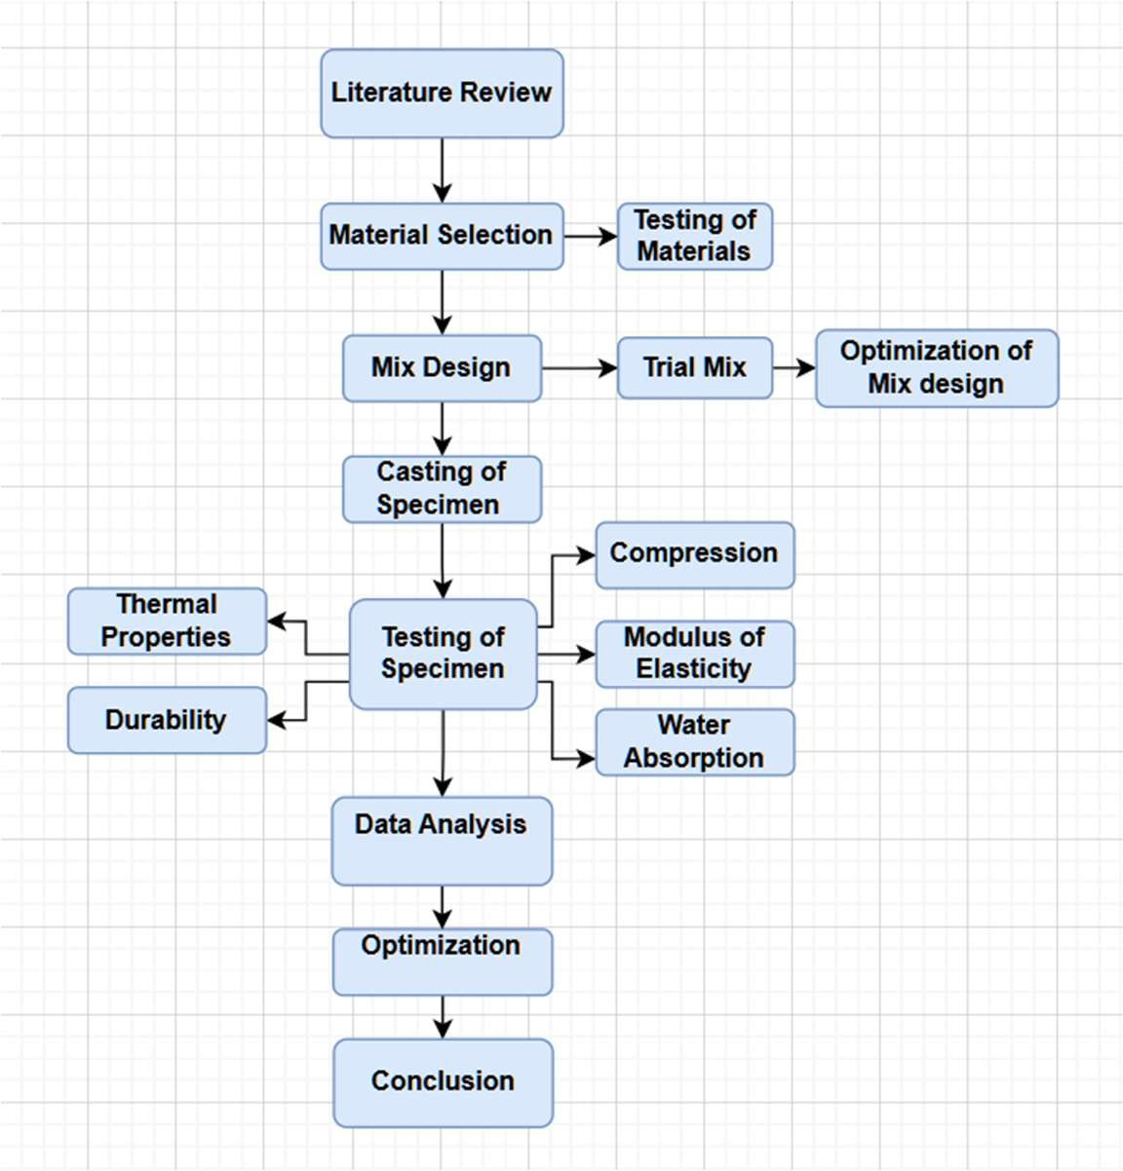
Fig1. shows the flowchart of the research methodology through which the objectives of this study were achieved

  - Experimental Work
The Grasscrete pavement units in this study were developed using 100 mm × 100 mm × 100 mm cube specimens to assess their performance characteristics. These cubes were cast using a sustainable concrete mix designed to balance mechanical strength, environmental sustainability, and durability. The mix incorporated 40% cement as the primary binder, with the remaining 60% of the cementitious content replaced by supplementary materials, including glass powder (20%), Ground Granulated Blast Furnace Slag (15%), limestone powder (10%), and varying proportions of grass powder (2%, 5%, and 10% for Groups 1, 2, and 3, respectively).

Additionally, silica fume (5%) was added to enhance strength and durability. Fine aggregate was replaced with manufactured sand (M-sand) at 700 kg/m³ to improve sustainability and uniformity [6]. A water content of 125 liters per cubic meter was maintained, achieving a water-to-cementitious ratio of 0.25, which provided the necessary workability for casting. The grass powder, prepared by drying at 140°C and grinding into fine particles, contributed to the ecological benefits of the mix while maintaining adequate compressive strength. The 100 mm cube specimens were cast in three groups, with nine specimens in each group, to analyze the effect of varying grass powder content on the mechanical properties of the pavement units. The cubes were subjected to standard curing procedures for 7, 14, and 28 days to evaluate compressive strength over time. Testing was conducted using a Compression Testing Machine (CTM), with controlled loading to ensure precision. These 100 mm cube specimens served as a representation of the Grasscrete pavement unit's performance, with results indicating that the optimized mix design successfully combined structural strength with environmental sustainability. The findings demonstrate that Grasscrete pavement units are suitable for sustainable infrastructure [7], offering benefits such as water permeability, carbon sequestration, and reduced urban heat while maintaining the structural integrity required for pedestrian and light vehicular applications.
The mix design reduces environmental impact by substituting 60% of the Ordinary Portland Cement (OPC) with supplementary cementitious materials, using 40% OPC at 200 kg/m³, while the remaining 300 kg/m³ is replaced by alternative materials. M-sand is used at 700 kg/m³. M-sand, produced by crushing rocks to create a uniform particle size, is a sustainable alternative to river sand, offering reliable quality for concrete, brickwork, and road construction. The mix incorporates 5% micro silica, at 25 kg/m³, replacing a portion of the cementitious material. Micro silica, a byproduct generated while manufacturing of silicon and ferrosilicon alloys, contains fine spherical particles that significantly enhance the concrete's strength and durability due to its pozzolanic properties [8]. Auramix 450, a polycarboxylate superplasticizer, is used at 0.9% of total cementitious material. It improves workability by reducing the water-to-cement ratio and preventing segregation and bleeding, while maintaining concrete aesthetics. Its high compatibility with various cements ensures a smooth mix with excellent flow properties [9]. Quicklime (50 kg/m³) is used at 10% of total cementitious material. It reacts exothermically with water, producing calcium hydroxide that enhances bonding characteristics in the mix. Ground Granulated Blast Furnace Slag (GGBS), comprising 15% of the cementitious material (75 kg/m³), improves the strength and durability of the concrete. As a by-product of the steel industry, it provides a sustainable and effective solution for enhancing composite materials. Recycled glass powder, derived from waste bottles [4], is used to improve concrete strength and reduce permeability. Glass powder (specific gravity 2.5, 35 microns) contains silica (70- 75%) and contributes to enhanced mechanical properties. The powder is derived from recycled glass, which helps minimize waste and supports sustainable construction practices. Incorporating elephant grass powder at 2%, 5%, and 10% (based on weight) [9] contributes to the mix's sustainability. The powder, derived from fine ground, oven-dried elephant grass, enhances the concrete's structure and strength. With a specific gravity of 1.4, it improves bonding and reduces the reliance on traditional cement. Its rich cellulose, hemicellulose, and lignin content reinforce the concrete, further reducing carbon emissions [10].
XRF testing has been conducted to analyze the chemical composition of key materials such as Microsilica, GGBS, and shown in Fig 2.
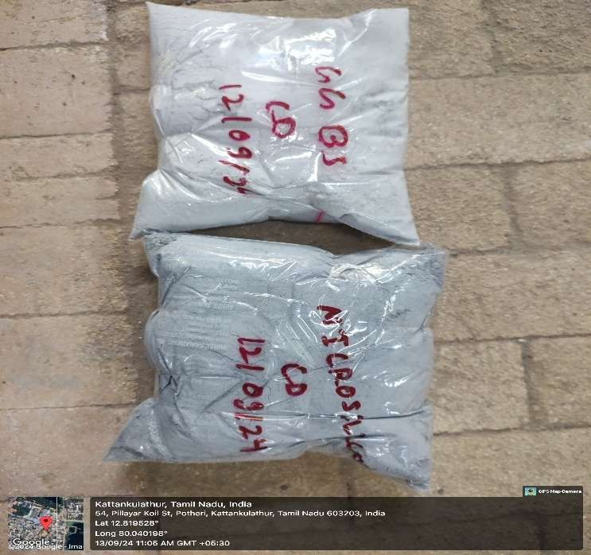
Fig 2. Sample Collection For XRF

The results are shown in Table 2.1,2.2. This mix design prioritizes sustainability by incorporating recycled materials, reducing cement consumption, and enhancing the overall performance of the concrete, all while minimizing environmental impact.

Table 2.1 XRF Result of Quicklime

Oxide Components | Chemical Formula | Weight Percentage (%)
Calcium Oxide | CaO | 94.5
Silicon Dioxide | SiO₂ | 1.0
Aluminium Oxide | Al₂O₃ | 0.5
Iron Oxide | Fe₂O₃ | 0.3
Magnesium Oxide | MgO | 1.2
Sodium Oxide | Na₂O | 0.2
Potassium Oxide | K₂O | 0.1
Sulphur Trioxide | SO₃ | 0.3
Titanium Dioxide | TiO₂ | 0.1
Loss on Ignition | - | 1.8
Total | - | 100

Table 2.2 XRF Result of GGBS

Oxide Components | Chemical Formula | Weight Percentage (%)
Silicon Dioxide | SiO₂ | 34.5
Calcium Oxide | CaO | 36.2
Aluminum Oxide | Al₂O₃ | 12.3
Magnesium Oxide | MgO | 8.1
Iron Oxide | Fe₂O₃ | 1.4
Sulfur Trioxide | SO₃ | 2.5
Other Oxides | - | 5.0
Total | - | 100

Here Compression Testing Machine (CTM) as shown in Fig 3 below with a capacity of 2000 kN has been used in testing compressive strength for various materials. Here by applying 0.50 kN/mm²/s controlled loads [11]

to samples were tested, enabling precise measurements to compressive forces. By conducting tests on a series of samples, applying incremental loads until failure occurs.
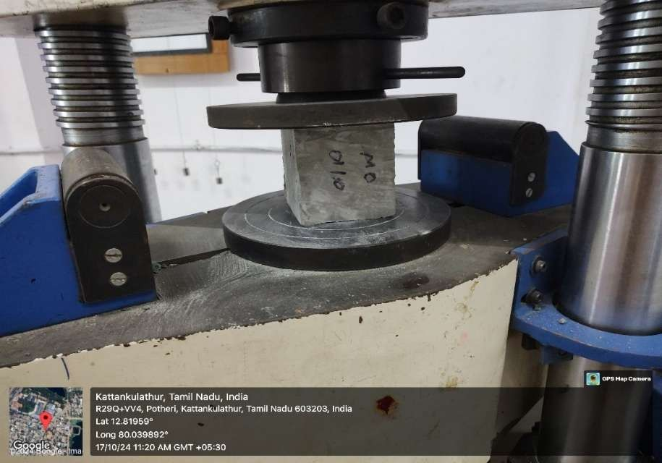
Fig 3. Testing of Specimen

The data collected is divided into three groups, as shown in Table 2.3 for Group 1, Table 2.4 for Group 2, and Table 2.5 for Group 3. Each table displays varying values of compressive strength for the respective groups. In Fig 4, these values are compared to provide a visual representation of how each group performs under different structural loads. This comparison allows us to understand the effectiveness of the different materials and mix designs used in the study [12]. By observing the variations in compressive strength, we can gain valuable insights into which combinations of materials and mix designs offer the best performance [13]. This information is critical in the material selection process, as it helps ensure that the selected materials meet the required standards and regulations. Ultimately, this analysis contributes to making informed decisions that improve the overall integrity, while maintaining its durability, and strength of the concrete used in construction projects.

Table 2.3 Compression Strength Value for Group 1

Sr No. | Weight (KG) | Compressive strength (N/mm²) | Days
1. | 2.15 | 48.12
2. | 2.25 | 49.69 | 7 Days
3. | 2.25 | 48.31
Total Average |  | 48.70
4. | 2.25 | 59.72
5. | 2.20 | 59.28 | 14 Days
6. | 2.15 | 58.72
Total Average |  | 59.24
7. | 2.20 | 62.96
8. | 2.15 | 64.81 | 28 Days
9. | 2.15 | 64.54
Total Average |  | 64.10

Table 2.4 The Compression Strength Value for Group 2

Sr No. | Weight (KG) | Compressive strength (N/mm²) | Days
1. | 2.10 | 25.37
2. | 2.10 | 23.66 | 7 Days
3. | 2.15 | 23.99
Total Average |  | 24.34
4. | 2.05 | 29.56
5. | 2.10 | 29.90 | 14 Days
6. | 2.20 | 28.86
Total Average |  | 29.44
7. | 2.10 | 37.62
8. | 2.00 | 36.20 | 28 Days
9. | 2.10 | 36.10
Total Average |  | 36.64

Table 2.5 The Compression Strength Value for Group 3

Sr No. | Weight (KG) | Compressive strength (N/mm²) | Days
1. | 2.00 | 40.12
2. | 2.05 | 40.82 | 7 Days
3. | 2.00 | 39.98
Total Average |  | 40.30
4. | 2.05 | 52.21
5. | 2.10 | 53.70 | 14 Days
6. | 2.00 | 52.40
Total Average |  | 52.77
7. | 2.10 | 61.20
8. | 2.00 | 59.61 | 28 Days
9. | 2.10 | 59.82
Total Average |  | 60.21

- Results
After analysing the three group of data as shown in Table 2.3, 2.4 and 2.5, where Group 1 consist of 2% grass powder, Group 2 consist of 5% grass powder and Group 3 consist of 10% grass powder, representing different concrete mix designs, reveal a consistent trend of increasing compressive strength with longer curing times. However, the materials exhibit distinct strength levels and rates of strength gain. Group 1 consistently shows the highest compressive strength, reaching 64.10 N/mm² at 28 days, suggesting a high-grade material or optimized mix. Similarly Group 2 shows the lowest strength values, peaking at 36.64 N/mm² at 28 days, Group 3 with an increase in strength at 28 days, reaching 60.21 N/mm², the variation in compressive strength [14] across different grass powder percentages can be explained by the interaction of the powder with the cement matrix. The 2% grass powder resulted in a high strength of 64 N/mm², likely to be because of increment of other cementitious material bonding without compromising the mix. In contrast, the 5% inclusion led to a significant drop to 30 N/mm², indicating that powder can create a more porous structure, reducing cohesion.

However, the 10% level regained strength at 60.21 N/mm², suggesting that a higher concentration may improve packing density and microstructural benefits [15], highlighting that to achieve optimal results, the grass powder content must be optimized. All compared values are shown in Fig 4 as given below.
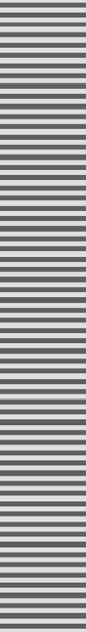

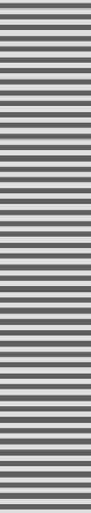
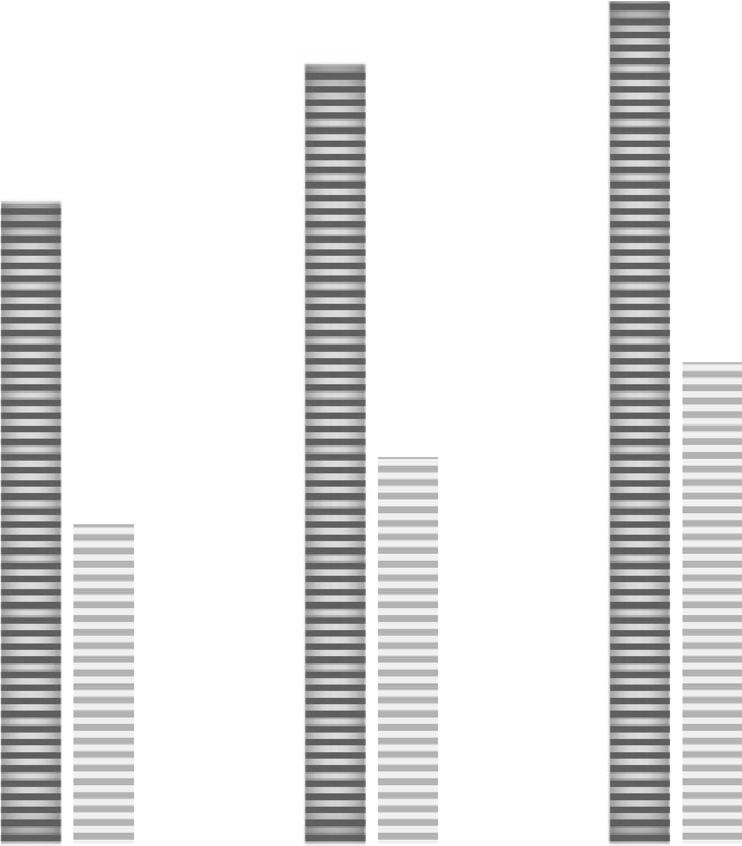
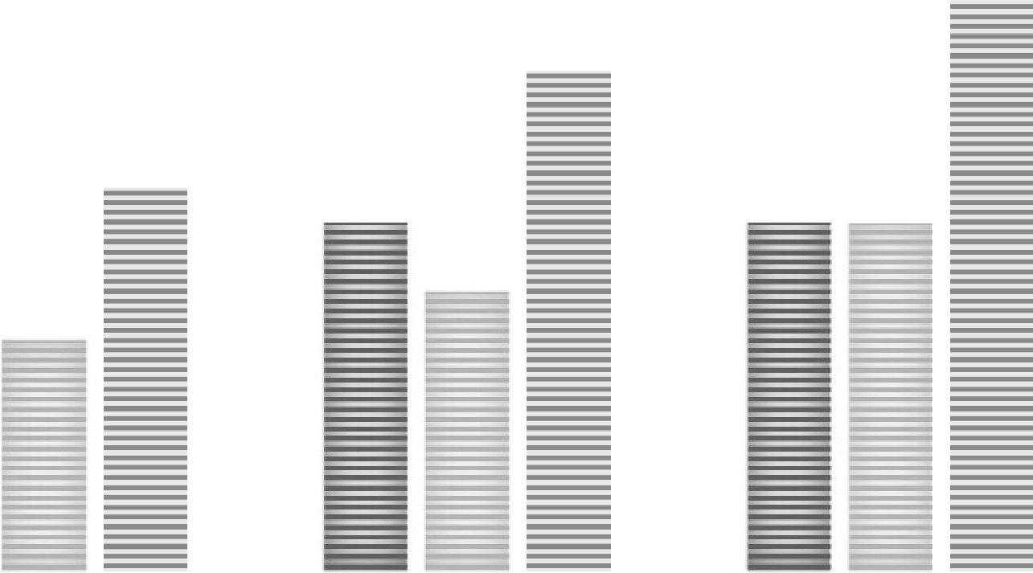
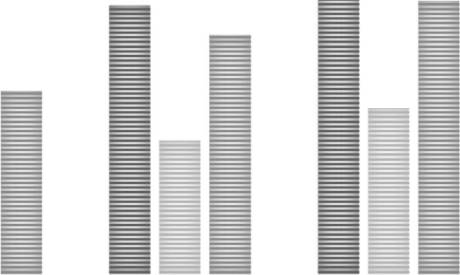
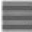


7 Days 14 Days 28 Days
24.3
29.4
36.6
40.3
52.7
48.7
60.2
59.2
64.1
70
60
50
40
30
20
10
0
COMPRESSIVE STRENGTH
Group-1 Group-2 Group-3

Fig 4. Comparison of compressive strength value
- Recommendation and Conclusion

• Grasscrete with 2% elephant grass powder achieved the highest compressive strength (64.10 N/mm² at 28 days).
• The inclusion of 60% supplementary materials significantly reduced cement usage and carbon footprint.
• The 10% grass powder mix regained strength due to improved particle packing.
• The developed mix design supports sustainable infrastructure development for light-load applications.

- Limitations

This study is limited to evaluating the mechanical and environmental performance of Grasscrete pavement units under controlled laboratory conditions. Factors such as real-world environmental impacts, long-term durability under varying weather conditions, and load-bearing capacity in high-traffic areas were not extensively analyzed. Additionally, while the study focused on carbon sequestration benefits, a detailed life- cycle assessment of Grasscrete’s long-term CO₂ absorption was not conducted. The reliance on supplementary cementitious materials, such as GGBS and glass powder, also requires further exploration regarding their availability and economic feasibility for large-scale applications.

- Future Scope

Future research should focus on assessing the long-term durability and performance of Grasscrete pavements in real-world conditions, including their resistance to extreme weather, erosion, and sustained traffic loads. Expanding studies on Grasscrete’s carbon sequestration potential over extended periods will provide a more comprehensive understanding of its environmental benefits. Additionally, optimizing the mix design to further enhance strength while maintaining sustainability should be explored. Large-scale pilot projects in urban infrastructure can help evaluate practical implementation challenges and economic feasibility, paving the way for wider adoption of Grasscrete in sustainable construction.

Acknowledgements
The authors would like to thank SRM Institute of Science and Technology for providing necessary infrastructure and facilities for the successful completion of the work.

- References
- López, L., Dessì, P., Cabrera-Codony, A., Rocha-Melogno, L., Kraakman, N., Balaguer, M., & Puig, S. (2024). Indoor CO2 direct air capture and utilization: Key strategies towards carbon neutrality. Cleaner Engineering and Technology, 20, 100746. https://doi.org/10.1016/j.clet.2024.100746
- Koňáková, D., Pommer, V., Šádková, K., Záleská, M., Böhm, M., Keppert, M., & Vejmelková, E. (2024). Heat-resistant composites based on ternary binders with a low cement content: Characterization and performance. Developments in the Built Environment, 18, 100400.
https://doi.org/10.1016/j.dibe.2024.100400

- Gu, J., Guo, F., Peng, X., & Wang, B. (2023). Green and Sustainable Construction Industry: A systematic literature review of the contractor’s green construction capability. Buildings, 13(2), 470.
https://doi.org/10.3390/buildings13020470

- Althoey, F., Awoyera, P. O., Inyama, K., Khan, M. A., Mursaleen, M., Hadidi, H. M., & Najm, H. M. (2022). Strength and microscale properties of bamboo fiber-reinforced concrete modified with natural rubber latex. Frontiers in Materials, 9. https://doi.org/10.3389/fmats.2022.1064885
- Boscaro, F., & Flatt, R. J. (2022). A method for the mix design of low carbon concrete towards industrial production. Materials and Structures, 55(8). https://doi.org/10.1617/s11527-022-02040-5
- Kiani Mavi, Reza & Gengatharen, Denise & Mavi, Neda & Hughes, Richard & Campbell, Alistair & Yates, Ross. (2021). sustainability Sustainability in Construction Projects: A Systematic Literature Review. Sustainability. 13 10.3390/su13041932.
- Seyedabadi, M. R., Eicker, U., & Karimi, S. (2021). Plant selection for green roofs and their impact on carbon sequestration and the building carbon footprint. Environmental Challenges, 4, 100119.
https://doi.org/10.1016/j.envc.2021.100119
- Zaid Ali Hasan, Mohammed Salah Nasr, Mohammed Kareem Abed, Properties of reactive powder concrete containing different combinations of fly ash and metakaolin,Materials Today: Proceedings,Volume 42, Part 5,2021,Pages 2436-2440,ISSN 2214-7853, https://doi.org/10.1016/j.matpr.2020.12.556.
- Nair, J. J., Shika, S., & Sreedharan, V. (2020). Biochar amended concrete for carbon sequestration. IOP Conference Series Materials Science and Engineering, 936(1), 012007. https://doi.org/10.1088/1757- 899x/936/1/012007
- Kua, H. W., & Choo, S. Y. G. (2018). The use of Biochar-Coated lime plaster pellets for indoor carbon dioxide sequestration. In Elsevier eBooks (pp. 305–317). https://doi.org/10.1016/b978-0-12-811729- 3.00017-0
- Krishna, B. V., & Reddy, E. R. (2018). Applications of green materials for the preparation of eco-friendly bricks and pavers. International Journal of Engineering & Technology, 7(3.29), 75.
https://doi.org/10.14419/ijet.v7i3.29.18465

- Cordeiro, G. C., & Sales, C. P. (2016). Influence of calcining temperature on the pozzolanic characteristics of elephant grass ash. Cement and Concrete Composites, 73, 98–104. https://doi.org/10.1016/j.cemconcomp.2016.07.008
- Suhaimi, M. M., Leman, A., Afandi, A., Hariri, A., Idris, A. F., Dzulkifli, S. M., & Gani, P. (2017). Effectiveness of indoor plant to reduce CO2in indoor environment. MATEC Web of Conferences, 103, 05004. https://doi.org/10.1051/matecconf/201710305004

- Kushartomo, W., Bali, I., & Sulaiman, B. (2015). Mechanical Behavior of Reactive Powder Concrete with Glass Powder Substitute. Procedia Engineering, 125,617–622.https://doi.org/10.1016/j.proeng.2015.11.082
- Nakanishi, E. Y., Frías, M., Martínez-Ramírez, S., Santos, S. F., Rodrigues, M. S., Rodríguez, O., & Savastano, H. (2014). Characterization and properties of elephant grass ashes as supplementary cementing material in pozzolan/Ca(OH)2 pastes. Construction and Building Materials, 73, 391–398. https://doi.org/10.1016/j.conbuildmat.2014.09.078


Page 1 of 13 - Cover Page Submission ID trn:oid:::1:3154194648

N Parthasarathi

1

 Quick Submit  Quick Submit
SRM Institute of Science & Technology

Document Details

Submission ID trn:oid:::1:3154194648

9 Pages

2,659 Words

15,478 Characters
Submission Date
Feb 13, 2025, 12:23 PM GMT+5:30

Download Date
Feb 13, 2025, 12:45 PM GMT+5:30

File Name Shubham_jha-1.pdf
File Size
238.6 KB

7% Overall Similarity
The combined total of all matches, including overlapping sources, for each database.

Match Groups
 14 Not Cited or Quoted 6%
Matches with neither in-text citation nor quotation marks

3 Missing Quotations 1%
Matches that are still very similar to source material

0 Missing Citation 0%
Matches that have quotation marks, but no in-text citation


0 Cited and Quoted 0%
Matches with in-text citation present, but no quotation marks

Top Sources

4% |   Internet sources
3% |   Publications
1% |  Submitted works (Student Papers)

Integrity Flags
0 Integrity Flags for Review

Our system's algorithms look deeply at a document for any inconsistencies that would set it apart from a normal submission. If we notice something strange, we flag it for you to review.

A Flag is not necessarily an indicator of a problem. However, we'd recommend you focus your attention there for further review.
No suspicious text manipulations found.

Match Groups
 14 Not Cited or Quoted 6%
Matches with neither in-text citation nor quotation marks

3 Missing Quotations 1%
Matches that are still very similar to source material

0 Missing Citation 0%
Matches that have quotation marks, but no in-text citation


0 Cited and Quoted 0%
Matches with in-text citation present, but no quotation marks

Top Sources

4% |   Internet sources
3% |   Publications
1% |  Submitted works (Student Papers)

Top Sources
The sources with the highest number of matches within the submission. Overlapping sources will not be displayed.
1
Internet
www.ijrets.com <1%
2
Internet

ijournalse.org <1%
3
Student papers

Liverpool John Moores University <1%
4
Publication

Yuan Jia, Junwei Zhu, Enci Zhao, Jingxi Zhang, Shibo Li, Yaoting Jiang, Tingting Zha… <1%
5
Internet

repositorio.uchile.cl <1%
6
Publication

Weerachart Tangchirapat, Rak Buranasing, Chai Jaturapitakkul. "Use of High Fine… <1%
7
Student papers

University of Technology, Sydney <1%
8
Internet

studentsrepo.um.edu.my <1%
9
Internet

vocal.media <1%
10
Internet

researchnow.flinders.edu.au <1%

11
Publication
Kaviya Saravanan, Rajeshkumar Viswanathan, Vinoth Sivakumar, Bragadeeswara… <1%
12
Publication

Rokiah Othman, Khairunisa Muthusamy, Mohd Arif Sulaiman, Youventharan Dur… <1%
13
Internet

acspublisher.com <1%
14
Publication

Prashant Lahre, Kundan Meshram, Umank Mishra, Ahmed Zubair Jan, Ashhad Im… <1%

Abstract



This study explores Grasscrete as an innovative and sustainable building material that integrates concretes structural strength with environmental benefits by incorporating green vegetation into its open-cell structure. Grasscrete minimizes concrete usage, enhances rainwater absorption, reduces urban heat, and supports carbon sequestration by promoting plant growth. This study focuses on developing Grasscrete pavement units with key aspect: carbon sequestration. Additionally, the response of the materials to elevated temperatures (100°C to 600°C) was studied to assess their performance under extreme conditions. A comprehensive methodology was used while material selection, preparation of elephant grass powder, and designing different concrete mix with varying percentage of grass powder (2%, 5%, and 10%) with industrial by-products such as glass powder, GGBS and limestone powder. By using limestone powder, it not only increased the workability and filler properties of the mix but also contributed to CO₂ reduction by adding these supplementary materials, the use of cement per cubic meter was reduced by 50%, significantly lowering the overall carbon footprint and promoting sustainable construction practices. After analysing three groups of Concrete mixes with 2%, 5%, and 10% grass powder demonstrated varying compressive strengths over time. The 2% mix (Group 1) achieved the strength of 64.10 5% mix (Group 2) achieved the strength of 36.64
N/mm² at 28 days. The
N/mm² at 28
days,
the
N/mm² at 28 days. The
4
4
while 10% mix (Group 3) reached 60.21 concrete mix design was compared with conventional M60 concrete, demonstrating approximately 32% lower embodied energy. This reduction is attributed to the use of sustainable components such as recycled materials and industrial byproducts, showcasing their potential for eco-friendly construction applications.
Keywords: Carbon Sequestration, Grasscrete, Medicinal Plants, Permeable Pavement, Sustainable Concrete, Urban Cooling
- Introduction

Grasscrete is an innovative and eco-friendly concrete system that integrates voids filled with grass and clay, promoting natural drainage and sustainability. Unlike traditional pavements, Grasscrete allows vegetation to grow within its grid-like structure, offering both strength and environmental benefits. It is widely used in sidewalks, parking lots, drainage systems, embankments, and emergency access lanes due to its durability and permeability. One of its key advantages is its ability to reduce urban heat, support groundwater recharge, and improve air quality by encouraging plant growth. With a permeability rate of up to 80%, Grasscrete minimizes surface runoff, reduces flood risks, and alleviates pressure on urban drainage systems[1]. Additionally, it regulates temperature by preventing heat buildup, thereby mitigating the urban heat island effect. The integration of vegetation within the pavement structure can lower surface temperatures by 10-15°C compared to traditional asphalt. Furthermore, Grasscrete’s ability to trap pollutants before they In addition to prior work, recent studies have explored the long-term performance of eco-concretes in tropical climates, highlighting the benefits of natural fiber integration and pozzolanic additives for strength gain and environmental performance.




reach groundwater improves water quality, making it an excellent choice for sustainable urban development. Structurally, Grasscrete is designed to provide the same load-bearing capacity as traditional concrete while offering added environmental advantages. Its open-cell structure allows for flexibility, reducing the likelihood of cracks and improving long-term durability. It is resistant to damage from ground movement and requires minimal maintenance, making it a cost-effective solution for urban infrastructure. Grasscrete also supports biodiversity by creating microhabitats within its structure, further enhancing urban greenery. To enhance sustainability, Grasscrete incorporates supplementary cementitious materials such as [2], limestone powder,
glass powder, ground granulated blast furnace slag (GGBS)
and
10



reducing its carbon footprint. Research into its structural and thermal performance focuses on its stability under elevated temperatures ranging from 100°C to 600°C. These studies highlight its potential in reducing embodied energy and improving environmental resilience. Previous research has explored various materials to enhance Grasscrete’s mechanical properties. Studies show that adding recycled PET fibers [3] and waste glass improves its structural performance while reducing CO₂ emissions. Additionally, elephant grass ash (EGA) has been identified as a viable supplementary cementitious material, enhancing long-term strength and hydration reactions. Compared to traditional concrete, Grasscrete offers significant
environmental benefits, including carbon sequestration, stormwater management, and
9
Its combination of strength, permeability, and sustainability makes it an effective alternative for modern urban infrastructure, promoting green spaces while maintaining structural integrity [4].
temperature regulation.
- Material and Methods
The flowchart shown below outlines the systematic process used in this study to develop and test a sustainable pavement mix. We began with a thorough literature review to identify effective, eco-friendly materials. Then we selected and evaluated materials such as glass powder, GGBS [2], micro silica, M-sand, and elephant grass powder to determine their suitability for replacing a significant portion of traditional cement. Using these materials, we developed and optimized a concrete mix designed to be both environmentally friendly and structurally sound. The mix was then cast into



cured according to standard procedures. After curing, the specimens underwent rigorous testing for compressive strength, water absorption, modulus of elasticity, thermal behavior [5], and overall durability. The test results made further refinements to the mix, demonstrating that the optimized design meets both performance and sustainability criteria for modern infrastructure applications.
100 mm x 100 mm x 100 mm cube specimens and
8
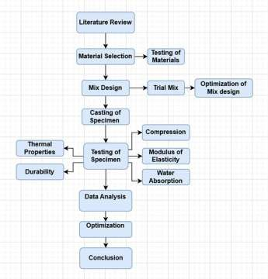



Fig1
shows the flowchart of the research methodology through which the objectives of this study were achieved.
2


Page 6 of 13 - Integrity Submission Submission ID trn:oid:::1:3154194648







Experimental Work
2.1.
2
13
Grasscrete pavement units in this study were developed using
The
100 mm × 100 mm × 100 mm cube specimens






to assess their performance characteristics. These cubes were cast using a sustainable concrete mix designed to balance mechanical strength, environmental sustainability, and durability. The mix incorporated 40% cement as the primary binder, with the remaining 60% of the cementitious content replaced by supplementary materials, including glass powder (20%), Ground Granulated Blast Furnace Slag (15%), limestone powder (10%), and varying proportions of grass powder (2%, 5%, and 10% for Groups 1, 2, and 3, respectively). Additionally, silica fume (5%) was added to enhance strength and durability. Fine aggregate was replaced with manufactured sand (M-sand) at 700 kg/m³ to improve sustainability and uniformity [6]. A water content of 125 liters per cubic meter was maintained, achieving a water-to-cementitious ratio of 0.25, which provided the necessary workability for casting. The grass powder, prepared by drying at 140°C and grinding into fine particles, contributed to the ecological benefits of the mix while maintaining adequate compressive strength. The 100 mm cube specimens were cast in three groups, with nine specimens in each group, to analyze grass powder mechanical properties the pavement units. The cubes were subjected to standard curing procedures 14, to evaluate over time. Testing was conducted using a Compression Testing Machine (CTM), with controlled loading to ensure precision. These 100 mm cube specimens served as a representation of the Grasscrete pavement unit's performance, with results indicating that the optimized mix design successfully combined structural strength with environmental sustainability. The findings demonstrate that Grasscrete pavement units are suitable for sustainable infrastructure [7], offering benefits such as water permeability, carbon sequestration, and reduced urban heat while maintaining the structural integrity required for pedestrian and light vehicular applications.
the effect of varying
content on the
of
for 7,
and 28 days
compressive strength
11
14



The mix design reduces environmental impact by substituting 60% of the Ordinary Portland Cement (OPC) with supplementary cementitious materials, using 40% OPC at 200 kg/m³, while the remaining 300 kg/m³ is replaced by alternative materials. M-sand is used at 700 kg/m³. M-sand, produced by crushing rocks to create a uniform particle size, is a sustainable alternative to river sand, offering reliable quality for concrete, brickwork, and road construction. The mix incorporates 5% micro silica, at 25 kg/m³, replacing a portion of the cementitious material. Micro silica, a byproduct generated while manufacturing of silicon and ferrosilicon alloys, contains fine spherical particles that significantly enhance the concrete's strength and durability due to its pozzolanic properties [8]. Auramix 450, a polycarboxylate superplasticizer, is used at 0.9% of total cementitious material. It improves workability by reducing the water-to-cement ratio and preventing segregation and bleeding, while maintaining concrete aesthetics. Its high compatibility with various cements ensures a smooth mix with excellent flow properties [9]. Quicklime (50 kg/m³) is used at 10% of total cementitious material. It reacts exothermically with water, producing calcium hydroxide that enhances bonding characteristics in the mix. Ground Granulated Blast Furnace Slag (GGBS), comprising 15% of the cementitious material (75 kg/m³), improves As a product of steel industry, it provides a sustainable and effective solution for enhancing composite materials. Recycled glass powder, derived from waste bottles [4], is used to improve concrete strength and reduce permeability. Glass powder (specific gravity 2.5, 35 microns) contains silica (70-75%) and contributes to enhanced mechanical properties. The powder is derived from recycled glass, which helps minimize waste and supports sustainable construction practices. Incorporating elephant grass powder at 2%, 5%, and 10% (based on weight) [9] contributes to the mix's sustainability. The powder, derived from finely ground, oven-dried elephant grass, enhances the concrete's structure and strength. With a specific gravity of 1.4, it improves bonding and reduces the reliance on traditional cement. Its rich cellulose, hemicellulose, and lignin content reinforce the concrete, further reducing carbon emissions [10].
the strength and durability of the concrete.
by-
the
1

XRF testing has been conducted to analyze the chemical composition of key materials such as Microsilica, GGBS, and shown in Fig 2.
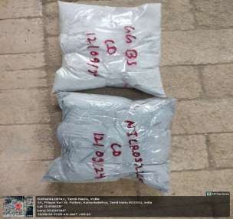
Fig 2. Sample Collection For XRF

The results are shown in Table 2.1,2.2. This mix design prioritizes sustainability by incorporating recycled materials, reducing cement consumption, and enhancing the overall performance of the concrete, all while minimizing environmental impact.

Table 2.1 XRF Result of Quicklime

Oxide Components Chemical Formula Weight Percentage (%)



3
94.5
1.0

0.5
Calcium Oxide
CaO
Silicon Dioxide
SiO₂
Aluminium Oxide
Al₂O₃

0.3
Iron Oxide
Fe₂O₃
Magnesium Oxide
MgO
1.2



6

0.1
Sodium Oxide
Na₂O
0.2
Potassium Oxide
K₂O
Sulphur Trioxide SO₃ 0.3
Titanium Dioxide TiO₂ 0.1
Loss on Ignition - 1.8
Total - 100

Table 2.2 XRF Result of GGBS



Oxide Components Chemical Formula Weight Percentage (%) Silicon Dioxide SiO₂ 34.5
Oxide
Al₂O₃
MgO
Oxide
O₃
12
Calcium Oxide CaO 36.2
Aluminum 12.3
Magnesium Oxide
8.1
Iron Fe₂ 1.4
Sulfur Trioxide SO₃ 2.5
Other Oxides - 5.0
Total - 100

Here Compression Testing Machine (CTM) as shown in Fig 3 below with a capacity of 2000 kN has been used in testing compressive strength for various materials. Here by applying 0.50 kN/mm²/s controlled loads [11] to samples were tested, enabling precise measurements to compressive forces. By conducting tests on a series of samples, applying incremental loads until failure occurs.
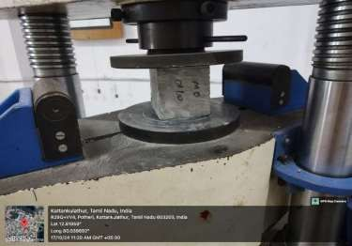
Fig 3. Testing of Specimen




The data collected is divided into three groups, as shown in Table 2.3 for Group 1, Table 2.4 for Group 2, and Table 2.5 for Group 3. Each table displays varying values of compressive strength for the respective groups. In Fig 4, these values are compared to provide a visual representation of how each group performs under different structural loads. This comparison allows us to understand the effectiveness of the different materials and mix designs used in the study [12]. By observing the variations in compressive strength, we can gain valuable insights into which combinations of materials and mix designs offer the best performance [13]. This information helps ensure that selected materials meet required standards and regulations. Ultimately, this analysis contributes to making informed decisions that improve the overall integrity, while maintaining its durability, and strength of the concrete used in construction projects.
is critical in the material selection process, as it
the
the
7

Table 2.3 Compression Strength Value for Group 1

Sr No. | Weight (KG) | Compressive strength (N/mm²) | Days
1. | 2.15 | 48.12
2. | 2.25 | 49.69 | 7 Days
3. | 2.25 | 48.31
Total Average |  | 48.70
4. | 2.25 | 59.72
5. | 2.20 | 59.28 | 14 Days
6. | 2.15 | 58.72
Total Average |  | 59.24
7. | 2.20 | 62.96
8. | 2.15 | 64.81 | 28 Days
9. | 2.15 | 64.54
Total Average |  | 64.10

Table 2.4 The Compression Strength Value for Group 2

Sr No. | Weight (KG) | Compressive strength (N/mm²) | Days
1. | 2.10 | 25.37
2. | 2.10 | 23.66 | 7 Days
3. | 2.15 | 23.99
Total Average |  | 24.34
4. | 2.05 | 29.56
5. | 2.10 | 29.90 | 14 Days
6. | 2.20 | 28.86
Total Average |  | 29.44
7. | 2.10 | 37.62
8. | 2.00 | 36.20 | 28 Days
9. | 2.10 | 36.10
Total Average |  | 36.64

Table 2.5 The Compression Strength Value for Group 3

Sr No. | Weight (KG) | Compressive strength (N/mm²) | Days
1. | 2.00 | 40.12
2. | 2.05 | 40.82 | 7 Days
3. | 2.00 | 39.98
Total Average |  | 40.30
4. | 2.05 | 52.21
5. | 2.10 | 53.70 | 14 Days
6. | 2.00 | 52.40
Total Average |  | 52.77
7. | 2.10 | 61.20
8. | 2.00 | 59.61 | 28 Days
9. | 2.10 | 59.82
Total Average |  | 60.21

- Results
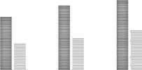
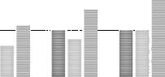
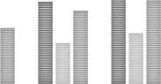



After analysing the three group of data as shown in Table 2.3, 2.4 and 2.5, where Group 1 consist of 2% grass powder, Group 2 consist of 5% grass powder and Group 3 consist of 10% grass powder, representing different concrete mix designs, reveal a consistent trend of increasing compressive strength with longer curing times. However, the materials exhibit distinct strength levels and rates of strength gain. Group 1 consistently shows the highest compressive strength, reaching 64.10 N/mm² at 28 days, suggesting a high-grade material or optimized mix. Similarly Group 2 shows the lowest strength values, peaking at 36.64 N/mm² at 28 days, Group 3 with an increase in strength at 28 days, reaching 60.21 N/mm², the variation in compressive strength [14] across different grass powder percentages can be explained by the interaction of the powder with the cement matrix. The 2% grass powder resulted in a high strength of 64 N/mm², likely to be because of increment of other cementitious material bonding without compromising the mix. In contrast, the 5% inclusion led to a significant drop to 30 N/mm², indicating that powder can create a more porous structure, reducing cohesion. However, the 10% level regained strength at 60.21 N/mm², suggesting that a higher concentration may improve packing density and microstructural benefits [15], highlighting that to achieve optimal results, the grass powder content must be optimized. All compared values are shown in Fig 4 as given below.
Group-1 Group-2 Group-3
70
60
50
COMPRESSIVE STRENGTH
59.2
64.1
60.2
48.7
52.7
40.3
36.6
24.3
29.4
0
7
5




compressive value
Days
14 Days
28 Days
Fig 4. Comparison of
strength
40
30
20
10
1

Recommendation and
4.
Conclusion
In conclusion highlights potential of Grasscrete pavement units as a sustainable alternative to conventional concrete, integrating structural strength with environmental benefits such as carbon sequestration and urban cooling. The experimental results demonstrate that incorporating elephant grass powder in varying percentages affects compressive strength, with the 2% mix achieving the highest strength while the 10% mix showed regained performance. The use of supplementary cementitious materials like GGBS and glass powder significantly reduces cement consumption and the overall carbon footprint, making Grasscrete a viable solution for eco-friendly construction. Based on these findings, it is recommended to further optimize the mix design to achieve the best balance between strength and sustainability. Long-term durability studies should be conducted to evaluate Grasscrete’s performance under different environmental conditions. Additionally, large-scale implementation in urban infrastructure projects such as sidewalks, parking lots, and drainage systems can help promote sustainability in construction. Further research is also needed to quantify the long-term carbon sequestration potential of Grasscrete and assess its economic feasibility compared to traditional concrete solutions.
the study
the

- Limitations

This study is limited to evaluating the mechanical and environmental performance of Grasscrete pavement units under controlled laboratory conditions. Factors such as real-world environmental impacts, long-term durability under varying weather conditions, and load-bearing capacity in high-traffic areas were not extensively analyzed. Additionally, while the study focused on carbon sequestration benefits, a detailed life-cycle assessment of Grasscrete’s long-term CO₂ absorption was not conducted. The reliance on supplementary cementitious materials, such as GGBS and glass powder, also requires further exploration regarding their availability and economic feasibility for large-scale applications.
- Future Scope
Future research should focus on assessing the long-term durability and performance of Grasscrete pavements in real- world conditions, including their resistance to extreme weather, erosion, and sustained traffic loads. Expanding studies on Grasscrete’s carbon sequestration potential over extended periods will provide a more comprehensive understanding of its environmental benefits. Additionally, optimizing the mix design to further enhance strength while maintaining sustainability should be explored. Large-scale pilot projects in urban infrastructure can help evaluate practical implementation challenges and economic feasibility, paving the way for wider adoption of Grasscrete in sustainable construction.

