Introduction

The main aim of this project is provide fun and easy way to play the hangman game. Hangman is a word guessing game in which one player give the word to guess and other player have to guess the whole word within the given number of chances. The maximum number of chances given to a player is six, if the player complete the word before losing all his chances he will win the game and if he lose all his chances without completing the word, he will lose the game. Each time when he lose his chance one body organ of a man is created and when the guesser makes enough incorrect guesses to create whole hanged man stick figure then the guesser will lose the game

Objective

The main objective of this project is to provide traditional way of playing hangman game, to create a program for which contain graphical user interface for playing the game. In this game the computer will chose any random word from the list and the player or guesser have to guess the whole word before he lose all is chance.

Source code

from tkinter import *

import random

from tkinter import messagebox

window = Tk()

val=StringVar()

s=0

foo = ['always', 'believe', 'always', 'strong', 'affect']

#random chosing of string

asd=random.choice(foo)

for a in asd:

s=s+1

#storing first and last character of string in variable

first=asd[:1]

second=a

#calculating lenght

lenght=len(asd)

lenght2=lenght

total=0

count=0

count2=0

count3=0

#function call

def check():

global total

global count

global count2

global count3

global lenght2

ex=val.get()

count2=0

#checking wheather the string has th character or not

count=asd.find(ex)+1

if (count>0):

count2=asd.count(ex)

lenght2=lenght2-count2

#creating hangman

if(count==0):

count3=count3+1

if(count3==1):

can.create_arc(40,10,80,50, start=90, extent=359,width=8)

elif(count3==2):

can.create_line(60,50,60,100, width=8 )

elif(count3==3):

can.create_line(60,100,20,140, width=8)

elif(count3==4):

can.create_line(60,100,100,140, width=8)

elif(count3==5):

can.create_line(60,50,20,90, width=8)

elif(count3==6):

can.create_line(60,50,100,90, width=8)

messagebox.showinfo("Title","YOU LOSE")

total=total+count2

if(total==lenght):

messagebox.showinfo("Title","YOU WIN")

#gui elements

window.title("HANGMAN GAME")

root= Frame(window)

l1=Label(root,text="WELCOM TO HANGMAN GAME", fg="red")

l1.config(width=70)

l1.config(font=("Courier",44))

l2=Label(root,text="Your word start from")

l2.config(font=("Arial",30))

l6=Label(root,text=first, fg="green")

l6.config(font=("Arial",20))

l3=Label(root,text="Your word end with")

l3.config(font=("Arial",30))

l7=Label(root,text=second, fg="green")

l7.config(font=("Arial",20))

l4=Label(root,text="Total number of words")

l4.config(font=("Arial",30))

l8=Label(root,text=lenght, fg="green")

l8.config(font=("Arial",20))

l5=Label(root, text="ENTER A CHARACTER")

l5.config(font=("Arial",30))

e1=Entry(root, textvariable = val)

bn=Button(root,text="check", command=check)

can=Canvas(root,width=200, height=200)

root.pack()

l1.pack()

l2.pack()

l6.pack()

l3.pack()

l7.pack()

l4.pack()

l8.pack()

l5.pack()

e1.pack()

bn.pack()

can.pack()

can.create_line(60,10,180,10, fill="red", width=8 )

can.create_line(180,9,180,190, fill="red", width=8 )

root.mainloop()

Screenshots of GUI

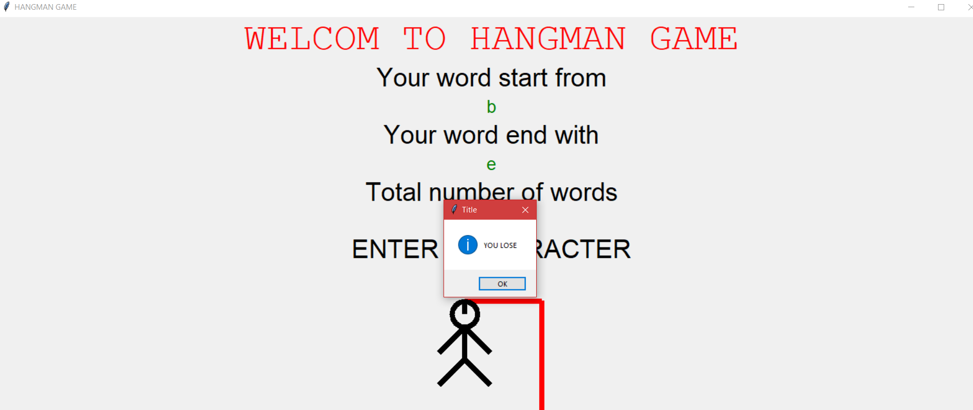

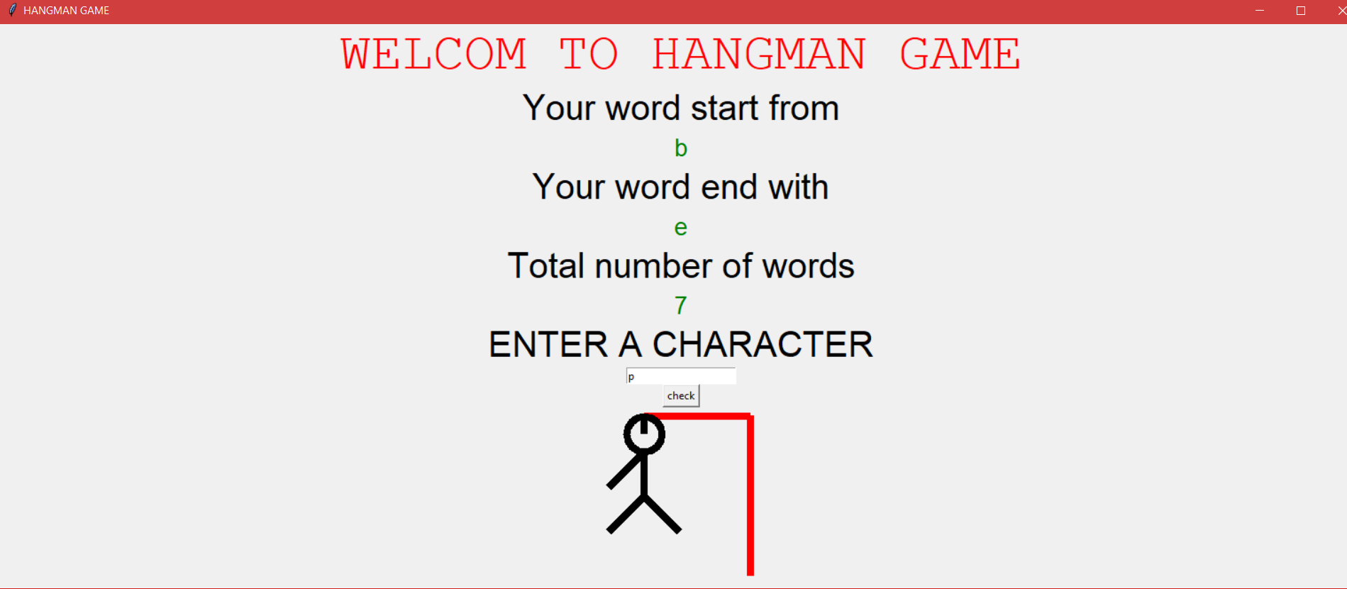

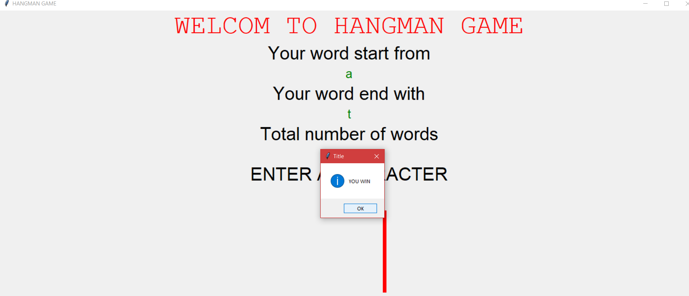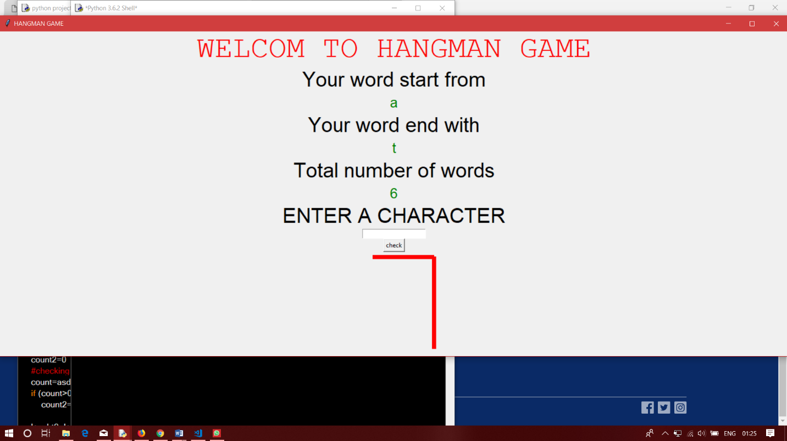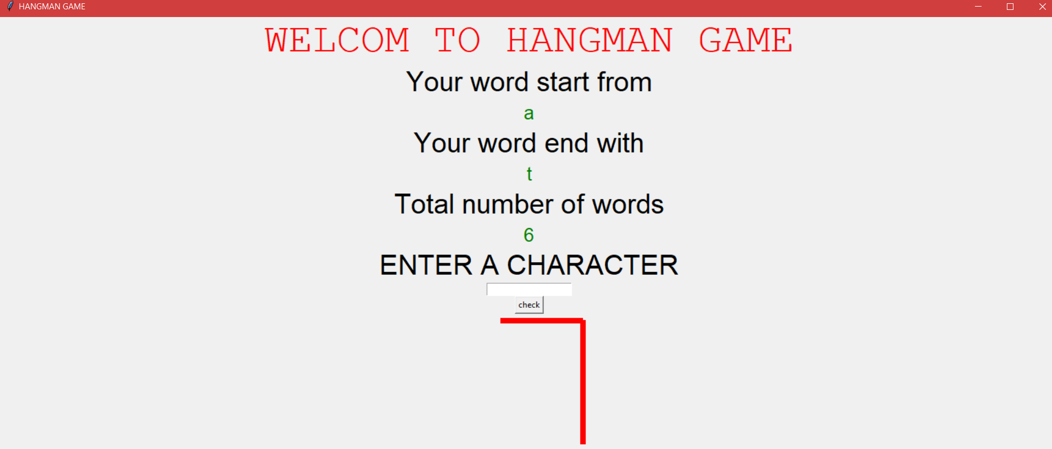

Result

This will help players to enjoy game related to word. This will also help players to learn new words.

It will increase players vocabulary and interest in reading and writing.

It is a great way to relive stress and allow mind a chance to relax, without diverting into complete mindlessness.

References

<http://stackoverflow.com>

<http://www.wb3school.com>

<http://www.codeacademy.com>

Introduction to programming using python