DBMS Mini Project

Wine Cellar Inventory Management

OUTPUT: -

Admin: -

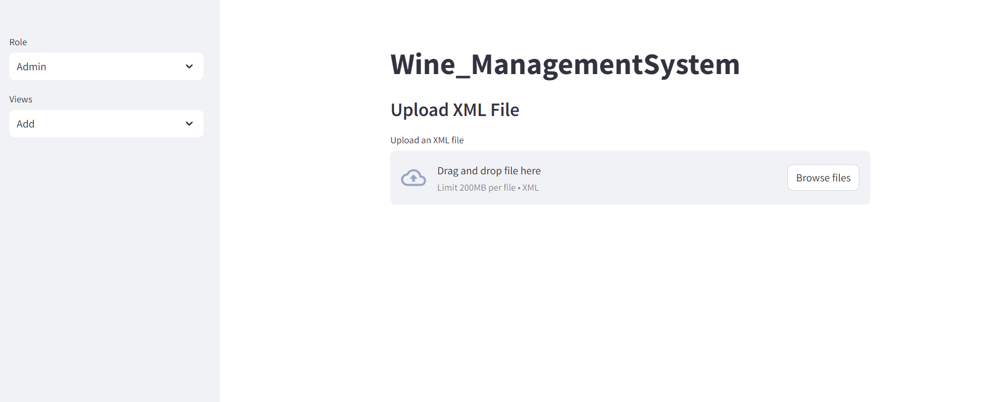

Admin inserts the details of the entire system

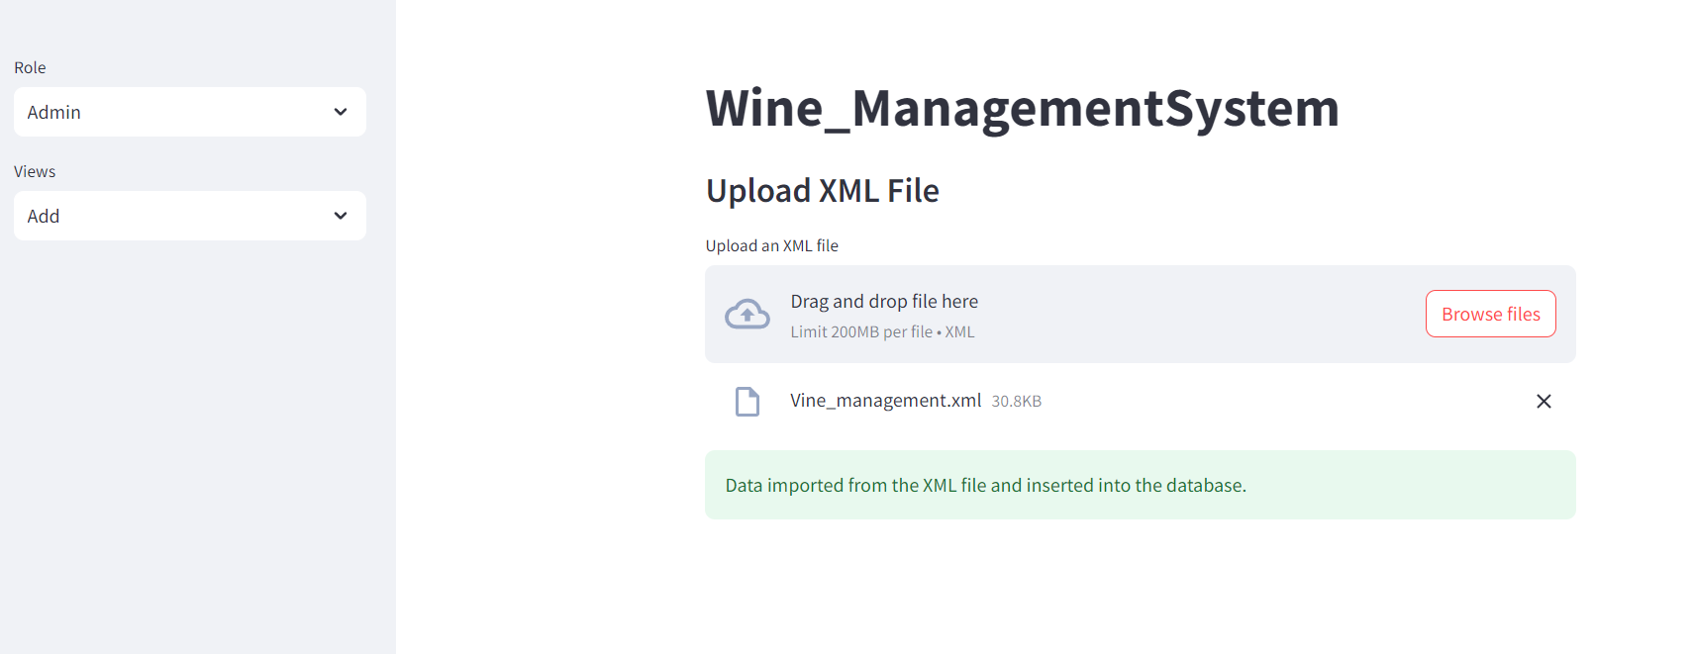

Customer Data: -

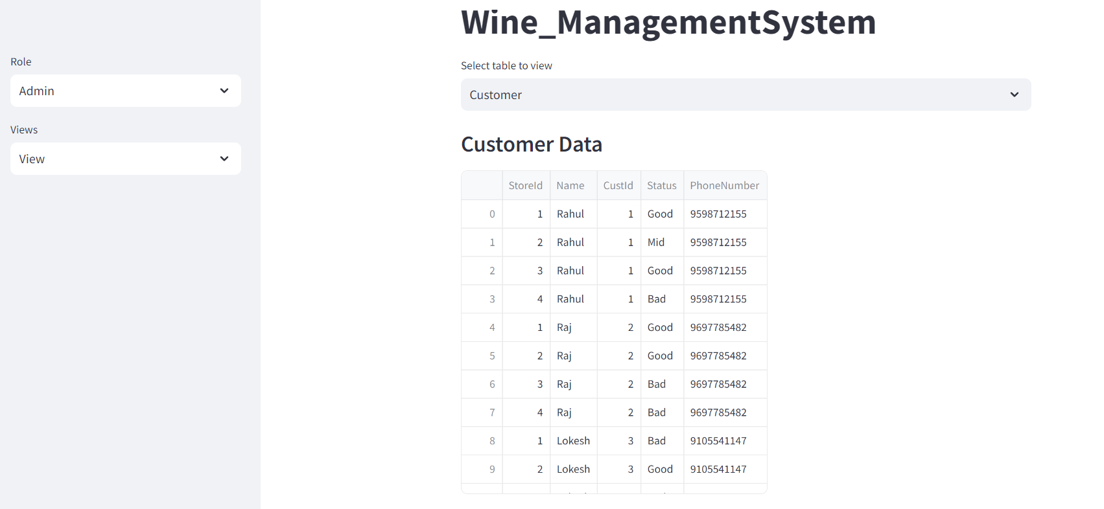

All available Wine bottles: -

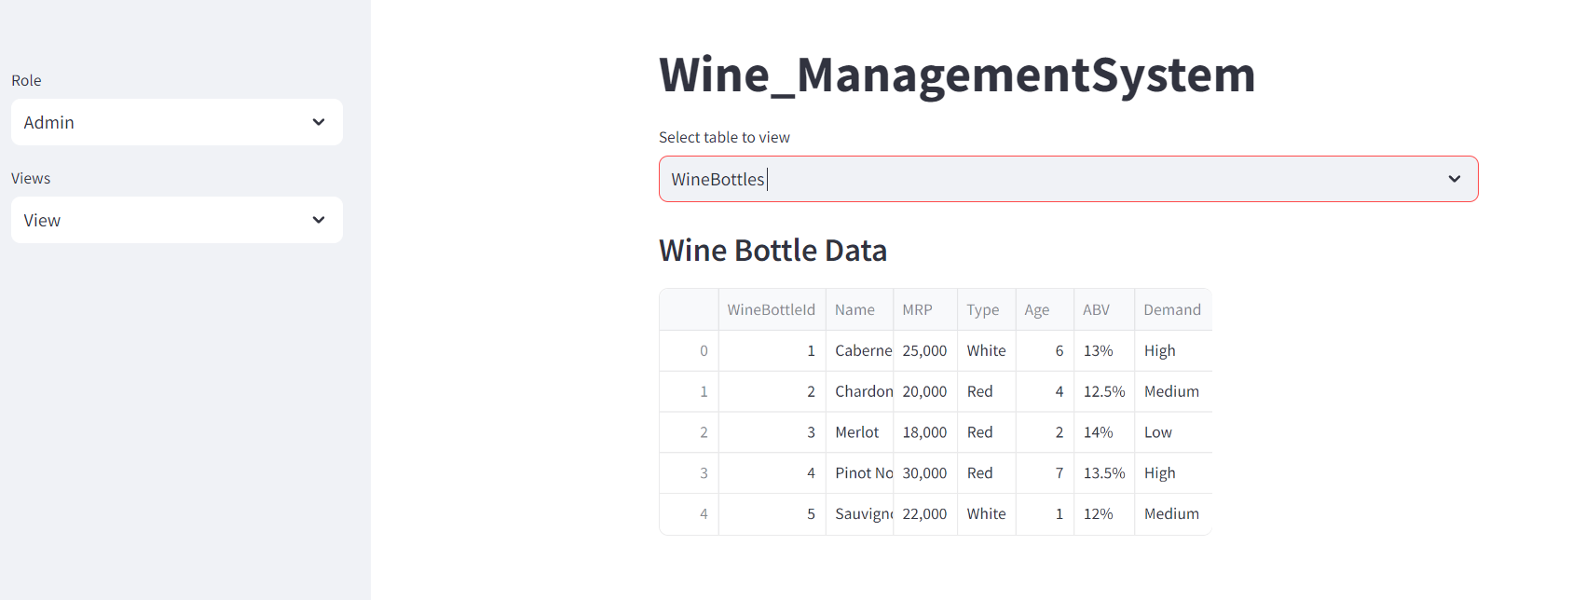

Top 3 manufacturers with most storage capacity: -

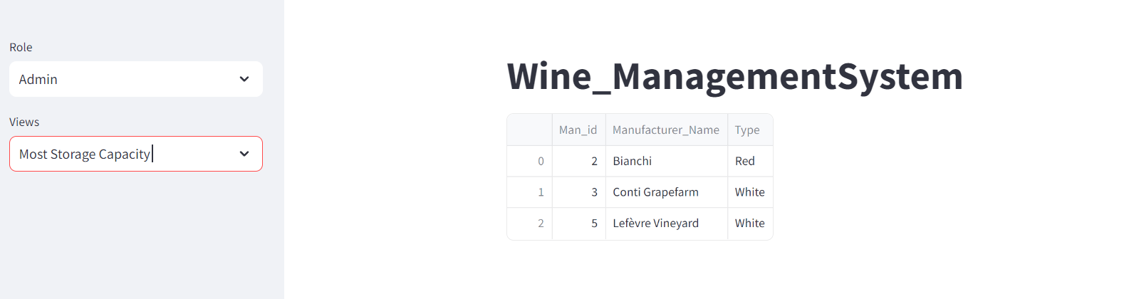

Customer: -

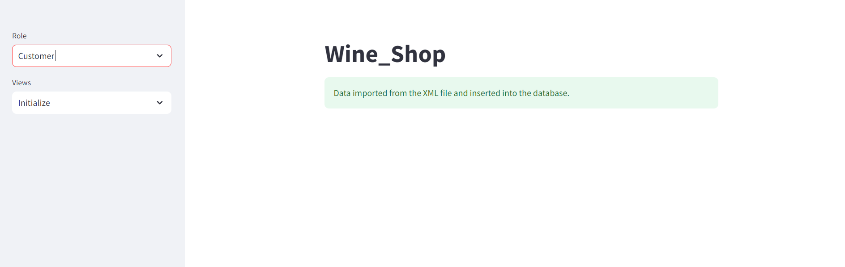

Wine Bottles available during shopping: -

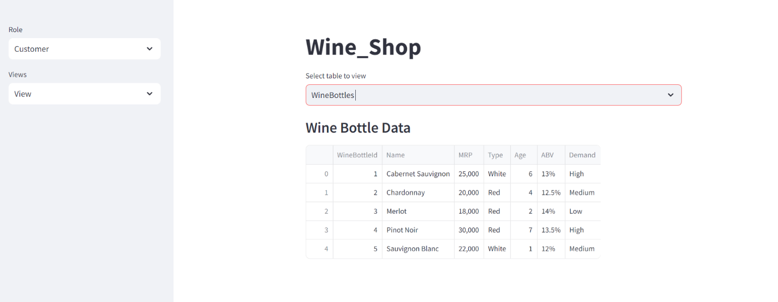

Stores to buy from: -

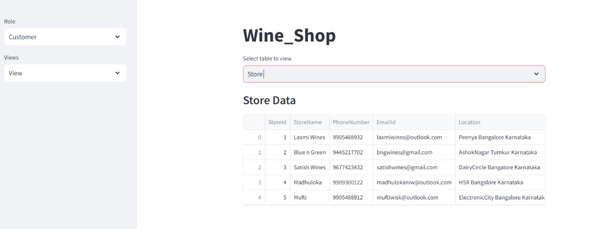

Cart data: -

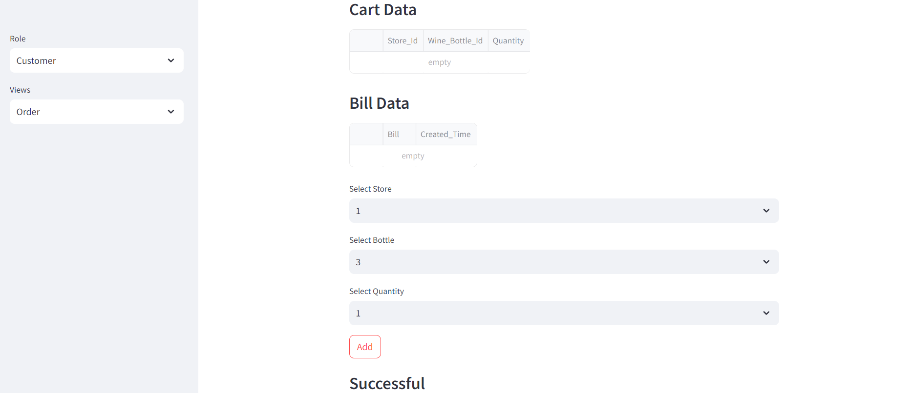

Adding one Merlot: -

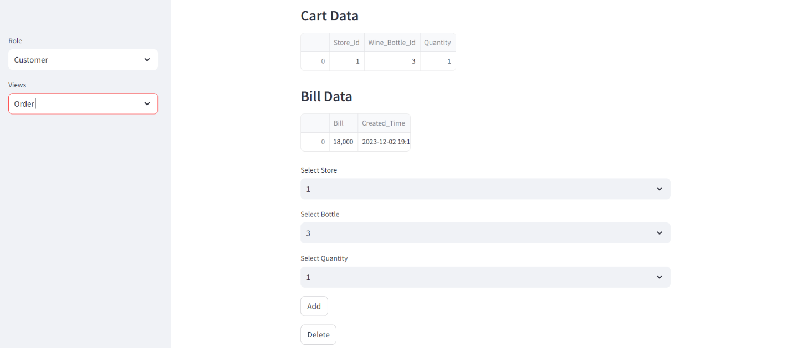

Trying to remove more than in the cart: -

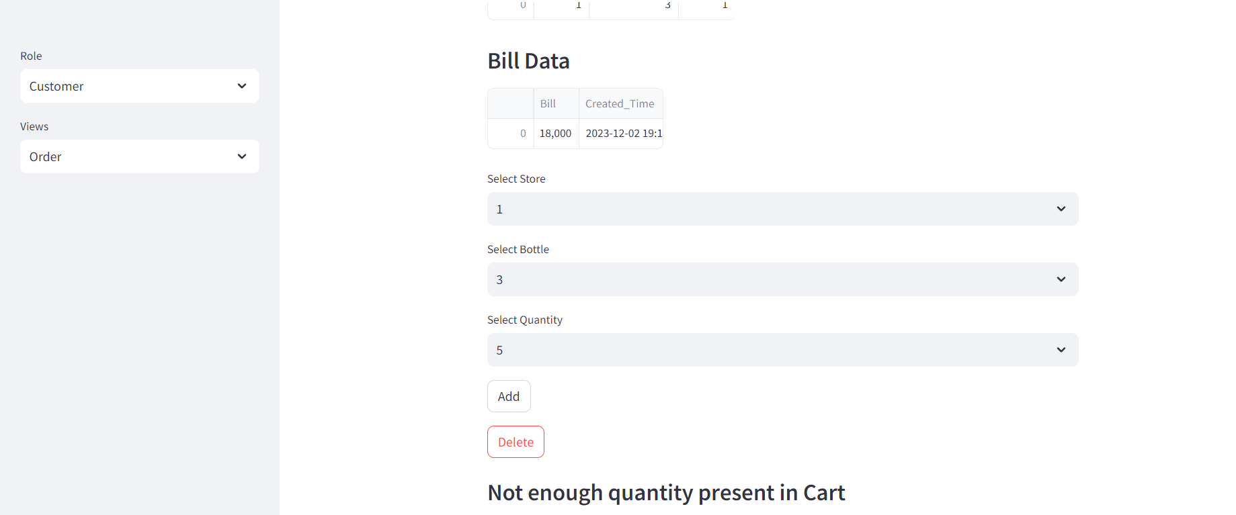

Auto Generated Bill: -

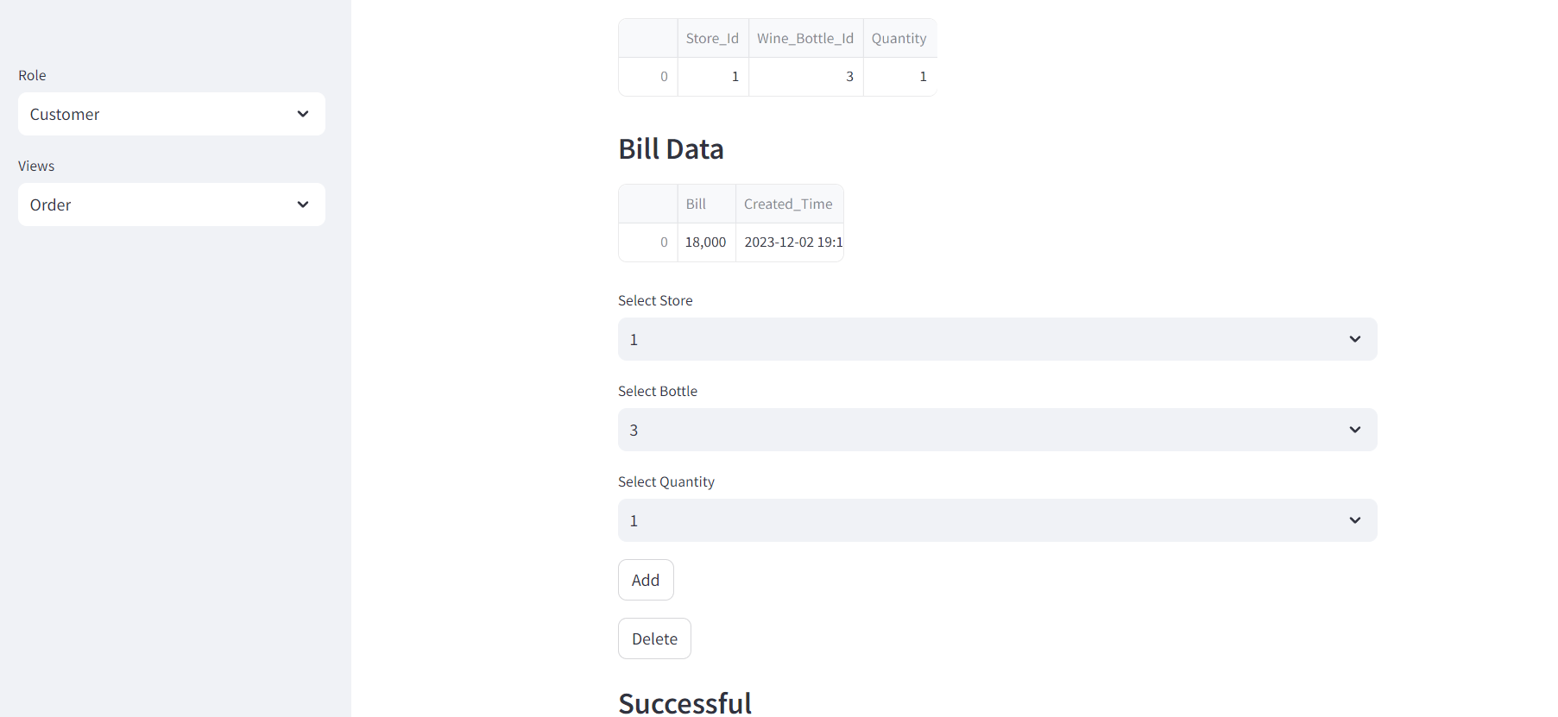

Evaluation Query(Manufacturers of bottles in Cart): -

