Assignment -

Name- Shubham Jalindar Kadam

1)program to find greater number using if-else.

using System;

namespace HelloWorld

{

class Program

{

static void Main(string[] args)

{

Console.Write("Enter First Number = ");

int num1 = int.Parse(Console.ReadLine());

Console.WriteLine("Enter Second Number = ");

int num2 = Convert.ToInt32(Console.ReadLine());

if (num1 < num2)

{

Console.WriteLine("First Number is Greater");

}

else if (num1 > num2)

{

Console.WriteLine("Number second is greater");

}

else

{

Console.WriteLine("Both Numbers are equal");

}

Console.ReadLine();

}

}

}

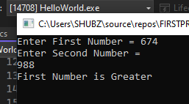

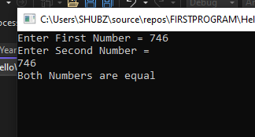

2)program to find leap year using if-else.

using System;

namespace HelloWorld

{

internal class LeadYear

{

public static void Leap()

{

Console.Write("Enter Year : ");

int Year = int.Parse(Console.ReadLine());

if (((Year % 4 == 0) && (Year % 100 != 0)) || (Year % 400 == 0))

{

Console.Write("{0} is a Leap Year.", Year);

}

else

{

Console.Write("{0} is not a Leap Year.", Year);

}

Console.ReadKey();

}

}

}

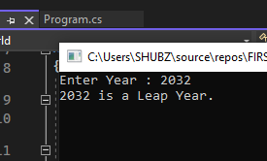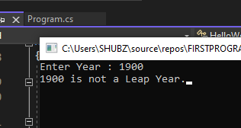

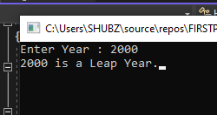 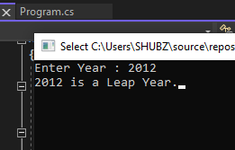

3) Program to print maximum among three numbers using if-else.

using System;

namespace HelloWorld

{

class Program

{

static void Main(string[] args)

{

Console.Write("Enter first number num1 : ");

int num1 = int.Parse(Console.ReadLine());

Console.Write("Enter second number num2 : ");

int num2 = int.Parse(Console.ReadLine());

Console.Write("Enter third number num3: ");

int num3 = Convert.ToInt32(Console.ReadLine());

if (num1 > num2)

{

if (num1 > num3)

{

Console.Write("Num1 is greater");

}

else

{

Console.Write("Num3 is greater");

}

}

else if (num2 > num3)

{

Console.Write("Num2 is greter");

}

else

{

Console.Write("Num3 is greater");

}

Console.ReadLine();

}

}

}

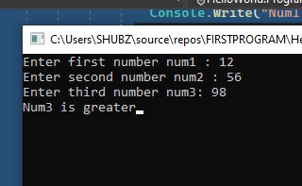

4).program to find given number is divisible by 3 or not using if-else

using System;

namespace HelloWorld

{

class Program

{

static void Main(string[] args)

{

Console.Write("Enter the Number = ");

int num1 = int.Parse(Console.ReadLine());

if (num1 % 3 == 0)

{

Console.WriteLine("number is divisible by 3");

}

else

{

Console.WriteLine("number not divisible by 3");

}

Console.ReadLine();

}

}

}

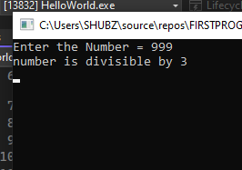

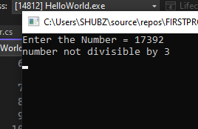

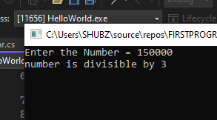

5)program to design simple calculator using switch case.

using System;

namespace HelloWorld

{

class Program

{

static void Main(string[] args)

{

int result;

Console.Write("Enter First Number = ");

int num1 = int.Parse(Console.ReadLine());

Console.Write("Enter Second Number = ");

int num2 = Convert.ToInt32(Console.ReadLine());

Console.Write("Enter the Symbol +, -, \*, /, ");

string symbol = Console.ReadLine();

switch (symbol)

{

case "+":

result = num1 + num2;

Console.WriteLine("Addition is = " + result);

break;

case "-":

result = num1 - num2;

Console.WriteLine("Addition is = " + result);

break;

case "\*":

result = num1 \* num2;

Console.WriteLine("Addition is = " + result);

break;

case "/":

result = num1 / num2;

Console.WriteLine("Addition is = " + result);

break;

default:

Console.WriteLine("Enter Correct Symbol");

break;

}

Console.ReadLine();

}

}

}

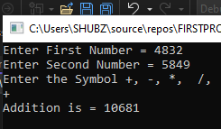

6) Write a Program Find out Students Grades using Switch Case.

using System;

namespace HelloWorld

{

internal class StudentGrade

{

public static void Grade()

{

Console.WriteLine("Enter the Marks = ");

int marks = int.Parse(Console.ReadLine());

char grade;

switch (marks / 10)

{

case 9:

grade = 'A';

Console.WriteLine("Student Grade is : {0}", grade);

break;

case 8:

grade = 'B';

Console.WriteLine("Student Grade is : {0}", grade);

break;

case 7:

grade = 'C';

Console.WriteLine("Student Grade is : {0}", grade);

break;

case 6:

grade = 'D';

Console.WriteLine("Student Grade is : {0}", grade);

break;

case 5:

grade = 'E';

Console.WriteLine("Student Grade is : {0}", grade);

break;

default:

Console.WriteLine("Student Fail");

break;

}

Console.ReadLine();

}

}

}

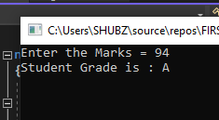 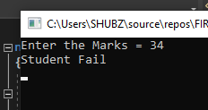

7) program for hotel menu driven using switch case.