**Practical No. :-09**

**Aim:-** Understanding buffer overflow & format string attacks

1. Buffer overflow format









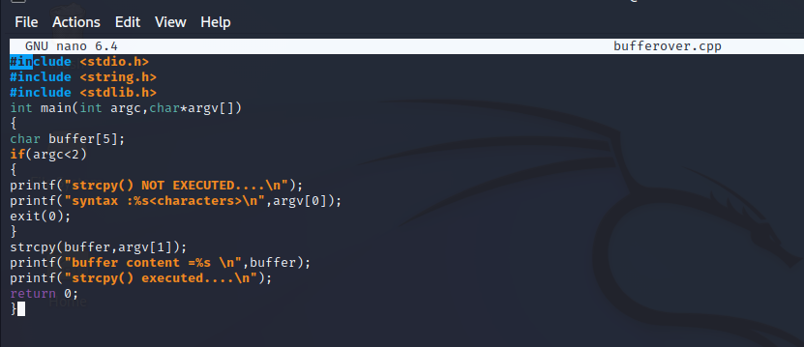

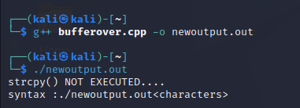 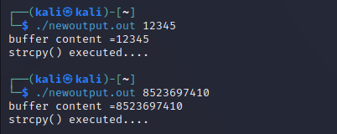

1. String format



