MTech PROJECT REPORT AND USER GUIDE
EVTWIN (eVideo)
Real-Time Electric Vehicle Digital Twin with Black Box, BMS Intelligence and Cloud Telemetry
Simulation of an e-bike powertrain (BLDC motor, buck converter, 13S10P battery pack) in MATLAB R2024b, Simulink, Simscape Electrical and Simscape Battery, with automatic data acquisition, a 1 ms Black Box recorder, verification checks and a one-click run script.
Document version 1.0
9 October 2026
Project model: BLDCSpeedControl_EV_Layout_v2.slx | Data system: EV_DAQ_Builder_V7 | Runner: RunAll
Status: simulation only (no physical hardware was built)
Contents

If the list above is empty or shows no page numbers, right-click it in Word and choose Update Field.

1. Summary
EVTWIN (project name eVideo) is a simulation-based digital twin of an electric two-wheeler (e-bike) powertrain. The twin reproduces the battery pack, the DC-DC buck converter, the three-phase inverter, the brushless DC (BLDC) motor, the controller and the vehicle load. Around the model sits an automatic data acquisition (DAQ) system and a Black Box recorder that save what happened during a run in the same way a real vehicle recorder would, so that a failure can be analysed afterwards.
This document explains the whole project from the idea to the result, in this order: the problem and objectives, the digital twin concept, the system architecture, the plant model and its parameters, the data acquisition and the Black Box, the verification checks, the results of the reference run, the step-by-step user guide for the group, the open points and the references.
Where the project stands (9 October 2026)
Done and working: plant model with battery pack; speed control with I²t current limiter; 9 logged signals and a signal map; 1 ms Black Box with 8 channels (301 × 8 samples per 0.3 s run); live telemetry line every 0.1 s of simulation time; full data archive per run; about 25 automatic V&V checks; one-click RunAll.m that finds its own path.
Verified in the reference run: final speed 2942 rpm (target 2950, window 2900-3000); torque per amp 0.108 N·m/A against the datasheet 0.107; wheel speed, battery voltage sag and SOC change consistent with the physics (section 8).
Open: the battery current of the Black Box and of the archive differ by about 3.4 A in the last 20 ms (13.8 %); temperature and the speed reference are not logged; the BMS/VMS intelligence, the cloud (MQTT) layer and the validation against real e-bike data are planned and not yet built (section 10).

2. Background and problem statement

2.1 The problem
Electric two-wheelers and cars are becoming common, but three practical gaps remain, especially for the Indian market:
- No black box. When an EV accident or battery fire happens, no record of battery voltage, current, temperature, motor and speed is available. The root cause stays unknown and investigations and insurance claims are delayed.
- No real-time health monitoring. Owners, fleet managers and service centres usually see only the state of charge (SOC, %). Problems are discovered after a breakdown.
- No cloud history. There is no central record across vehicles that can tell which vehicles are degrading, which charging stations cause problems or which driving style abuses the battery.

2.2 The idea
EVTWIN addresses the three gaps in one integrated system: a digital twin of the vehicle that mirrors its electrical and mechanical behaviour, a black box that records the data around an incident, intelligence that estimates battery and vehicle health, and cloud telemetry that keeps the history. The long-term target is a low-cost implementation (below Rs 5,000) based on a small microcontroller and a few sensors. In this MTech project everything is demonstrated by simulation; no physical hardware is built.

2.3 Objectives
- Build a physically consistent simulation of an e-bike powertrain with a realistic battery pack.
- Record the important signals automatically with a Black Box that behaves like a real event recorder (fixed sample time, fixed channels, no manual steps).
- Prove that the recorded data is correct with automatic verification and validation (V&V) checks and a clear PASS / WARN / FAIL report.
- Make the whole system reproducible: any group member can run it with one command and get the same result and the same log.
- Prepare the data and the structure for the next layers: SOC and SOH estimation, risk and maintenance prediction, and cloud telemetry.

2.4 Scope
Table 1. What is inside and outside the scope of this work
Area | In scope (this report) | Planned / outside
Vehicle plant | Battery, buck converter, inverter, BLDC motor, controller, gearbox, wheel load (Simscape) | Real e-bike measurements
Data acquisition | 9 logged signals, signal map, LIVE telemetry, data archive, Black Box (8 channels, 1 ms) | Temperature and speed-reference logging
Verification | About 25 V&V checks in the builder, 14 run checks in RunAll | Validation against real data (MAE, RMSE)
Intelligence | SOC by Coulomb counting check, offline state-space identification of the Black Box data | SOH, fire-risk and maintenance prediction (ML)
Cloud | Not built | MQTT telemetry with security, fleet history
Hardware | Not built (simulation only) | Microcontroller prototype, cost target below Rs 5,000

3. The digital twin concept

3.1 What is a digital twin
A digital twin is a virtual representation of a physical product that is connected to it by data. Grieves and Vickers describe three parts: the physical product, the virtual product, and the data connection between them [1]. NASA and the US Air Force used the idea to describe an ultra-realistic, continuously updated simulation of a vehicle that mirrors the life of its physical twin [2].
In practice a digital twin is useful when it can answer questions that the real asset cannot answer easily: what is happening inside the battery right now, what happened one second before a failure, and what will happen if the load or the temperature changes.

3.2 Model, shadow and twin
Kritzinger et al. separate three levels according to the direction of the data flow [3]. The levels are useful to state honestly where this project stands.
Table 2. Levels of integration between the physical asset and its digital counterpart
Level | Data flow | Status in this project
Digital model | No automatic data exchange; the model is run by hand | Reached: the Simscape plant model
Digital shadow | Data flows automatically from the asset to the model / storage | Reached in simulation: the plant model feeds the DAQ, Black Box and archive automatically. For a real vehicle the sensor stream would replace the simulated plant
Digital twin | Data flows both ways: the model also influences the asset | Planned: analytics results (alerts, limits) fed back to the controller

3.3 Battery digital twins in the literature
Battery digital twins are an active research topic. Li et al. present a cloud battery management system as a digital twin that estimates SOC and state of health (SOH) online [4]. Wu et al. discuss how models, data and artificial intelligence can be fused for smart battery management [5]. Fuller et al. review the enabling technologies and open problems of digital twins in general [6]. The key issues of lithium-ion battery management in electric vehicles (state estimation, balancing, thermal management and safety) are reviewed by Lu et al. [7]. EVTWIN follows the same architecture on a small scale and adds the Black Box recorder as a first-class part of the twin.

3.4 How the concept maps to this project
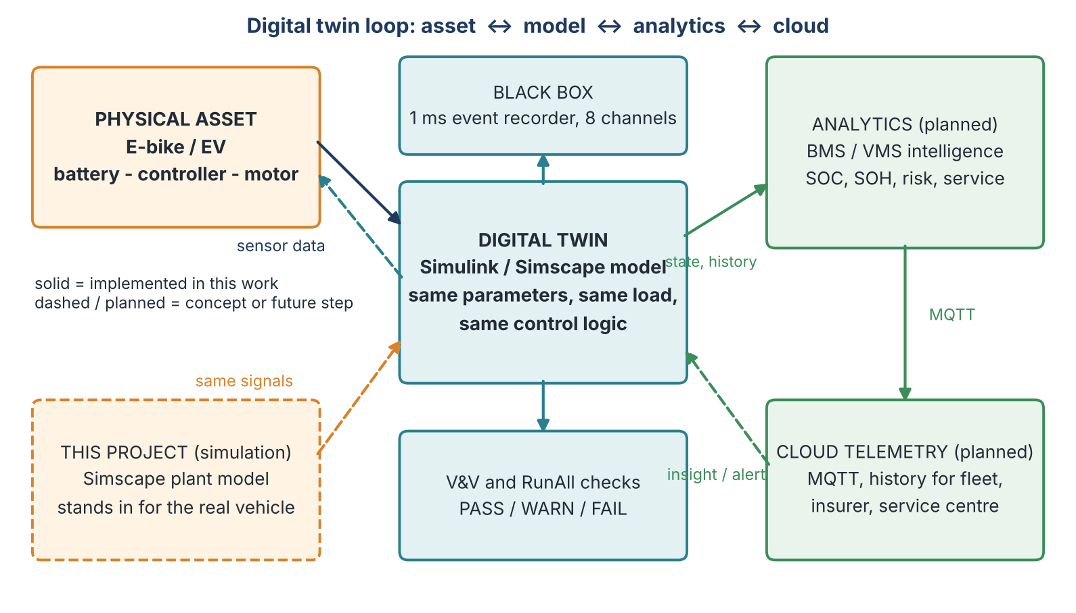
Figure 1. Digital twin loop of EVTWIN. Solid boxes are implemented in this work; "planned" boxes are the next layers.
Table 3. Digital twin elements and their implementation
Element | In EVTWIN | Where
Physical asset | E-bike powertrain (battery, controller, motor). Replaced by the detailed Simscape plant in this work | BLDCSpeedControl_EV_Layout_v2.slx
Virtual model | Same parameters, load profile and control logic as the real vehicle would have | BLDCSpeedControlData.m, Signal Editor input
Data connection | To Workspace blocks, LIVE tap, Black Box, hooks that start and stop logging | EV_DAQ_Builder_V7.m
Recorder | EV_BlackBox subsystem, 8 channels at 1 ms | Inside the model; log EV_BlackBox_log
Verification | V&V rows and RunAll checks | Builder and RunAll.m
Analytics | SOC check, state-space identification; SOH and risk models planned | Builder (SysID); future work
Cloud | Planned MQTT telemetry | Future work

4. System architecture
The system has five layers. Each layer only depends on the layer below it, so a layer can be replaced (for example the simulated plant by real sensors) without changing the layers above.
Table 4. Layers of the EVTWIN system
Layer | Function | Main files / blocks
1. Plant | Physics of the vehicle: battery, buck converter, inverter, motor, gearbox, load | BLDCSpeedControl_EV_Layout_v2.slx, Batteries2_lib.slx
2. Parameters and scenario | All numbers and the load profile; reproducible for every user | BLDCSpeedControlData.m, BLDCSpeedControlInput.mat
3. Data acquisition | Logging of 9 signals, signal map, LIVE telemetry, hooks, archive | EV_DAQ_Builder_V7.m
4. Black Box | 1 ms recorder with 8 channels in a dedicated subsystem | EV_BlackBox subsystem, EV_BlackBox_log
5. Verification and run control | V&V rows, RunAll checks, logs, one-click start | RunAll.m, results/ folder

5. The plant model

5.1 Origin of the model
The model is built on the MathWorks "BLDC Speed Control" example [8]. That example drives a BLDC motor with an ideal torque source as load, a DC-DC buck converter that sets the DC-link voltage, a three-phase inverter commutated from Hall signals, and a PI cascade with an outer speed loop and an inner DC-link voltage loop. For EVTWIN the project added: a lithium-ion battery pack, a gearbox and wheel with vehicle inertia, an I²t motor-current limiter, a realistic load profile, and the whole DAQ and Black Box system. The general theory of BLDC drives is given by Krishnan [9].

5.2 Power path and control path
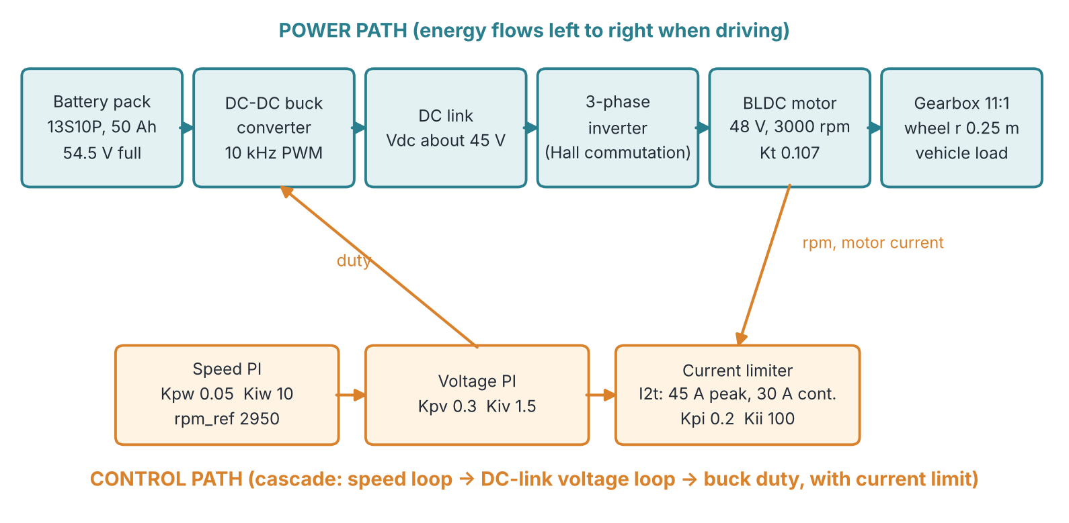
Figure 2. Power path (top) and control path (bottom) of the model. The speed loop sets a voltage demand, the voltage loop sets the buck duty, and the limiter protects the motor.
The battery feeds the buck converter. The buck converter lowers the voltage to the DC-link voltage (about 45 V in the reference run). The inverter commutates the three motor phases from the Hall signals. The motor drives the wheel through an 11:1 gearbox. The controller compares the measured speed with the reference, produces a voltage demand, regulates the DC-link voltage with the buck duty, and limits the motor current: 45 A for a limited time, then 30 A continuous, according to an I²t budget.

5.3 Parameters
All parameters live in one file, BLDCSpeedControlData.m. It is run automatically when the model loads. To change the behaviour edit that file, never the model blocks.
Table 5. Motor (datasheet APBA80L048030-EB) and effective torque constant
Parameter | Symbol / name | Value | Note
Rated voltage | Vmotor_nom | 48 V | datasheet
Rated speed | rpm_nom | 3000 rpm | datasheet
Torque constant | Kt | 0.107 N·m/A | datasheet
Continuous current | I_cont | 30 A | datasheet
Peak current | I_peak | 45 A | limiter ceiling (datasheet 40 A, 45 A used)
Pole pairs | p | 4 | example value, check datasheet
Stator resistance | Rs | 0.1 Ω | example value, check datasheet
Stator inductance | Ls / Ms | 8e-5 H / 1e-5 H | example values, check datasheet
Rotor inertia | Jm | 0.002 kg·m² | example value, check datasheet
Block-to-model factor | kappa | 0.72 | estimated from scope data
Back-EMF table amplitude | Ke_ph = Kt / kappa | 0.1486 V·s/rad | set into the BLDC block
EMF at 600 rpm | emf_max_ev | 9.34 V | derived
Flux linkage | psim | 0.01702 Wb | scaled with Ke

The battery is a 13 series × 10 parallel pack of 5 Ah cells = 50 Ah, built with Simscape Battery (Battery Builder) [10]. The open-circuit voltage window is about 45.4 V (SOC 0) to 54.5 V (SOC 100 %) and the pack resistance is about 0.011 Ω. The supplied library pack used 27 Ah cells; the capacity is overridden to 5 Ah per cell, so the cell resistance is still that of the 27 Ah cell. A physically exact 50 Ah pack would be rebuilt in Battery Builder (see section 10).
Table 6. Controller, limiter, reference and load
Parameter | Name | Value
Fundamental sample time | Ts | 5 µs
Inner control sample time (PWM period) | Tsc | 100 µs (10 kHz)
Speed PI | Kpw / Kiw | 0.05 V/rpm / 10 V/(rpm·s)
Voltage PI | Kpv / Kiv | 0.3 / 1.5
DC-link / speed PI upper limit | Vdc | 48 V
Speed target | rpm_ref | 2950 rpm (window 2900-3000 rpm)
Reference ramp | rpm_ramp | 13000 rpm/s (reaches 2950 rpm at 0.227 s)
Run length | t_stop | 0.3 s
I²t budget | Emax = (I_peak² - I_cont²)·t_peak | 1125 A²s (t_peak = 1 s)
Limiter PI | Kpi / Kii | 0.2 V/A / 100 V/(A·s)
Lowest voltage ceiling | Vlim_min | 2 V
Current measurement filter | T_Ifilt | 2 ms
Final load torque | T_load_end | 3.18 Nm (1 kW at 3000 rpm)
Torque available at I_cont | T_cap_cont = Kt·I_cont | 3.21 Nm

Table 7. Drivetrain and derived values
Parameter | Value | How obtained
Gear ratio | 11 | parameter
Wheel radius | 0.25 m | parameter
Wheel mass | 1.5 kg | parameter
Wheel inertia | 0.0469 kg·m² | J_wheel = 0.5·m·r²
Total inertia at the motor shaft | 0.00239 kg·m² | Jm + J_wheel / 11²
Wheel speed at target | 268.2 rpm = 28.08 rad/s | 2950 / 11
Vehicle speed at target | 25.3 km/h | 28.08 · 0.25 · 3.6
Ideal no-load speed | 4284 rpm | Vdc / Kt
Current needed for the ramp | 30.4 A | J_tot · (13000·2π/60) / Kt
Largest ramp using 90 % of I_cont | 11556 rpm/s | derived
Current for full load | 29.7 A | 3.18 / 0.107

5.4 Key equations
Load torque at 1 kW: T = P / w = 1000 / (3000 * 2*pi/60) = 3.18 N*m
Torque constant: Ke_ph = Kt / kappa = 0.107 / 0.72 = 0.1486 V*s/rad
Shaft inertia: J_tot = Jm + J_wheel/N^2 = 0.002 + 0.0469/121
= 0.00239 kg*m^2
Current for ramp: I = J_tot * (d rpm/dt * 2*pi/60) / Kt = 30.4 A
(at 13000 rpm/s)
I^2 t budget: Emax = (I_peak^2 - I_cont^2) * t_peak = 1125 A^2 s
Buck (ideal): Vdc = D * Vbat, Ibat = D * Idc (D = duty ratio)
Coulomb counting: SOC(t) = SOC(0) - (1/C) * integral( I dt )
For the buck converter relations and the effect of switching ripple on measured values see Erickson and Maksimovic [11]. Coulomb counting for SOC (and SOH from the capacity ratio) is described by Ng et al. [12]; model-based alternatives such as the extended Kalman filter are given by Plett [13] and are candidates for the planned analytics layer.

5.5 Run timeline
Table 8. Scenario of one 0.3 s run
Time | Event
0 s | Rest. Battery at full charge (about 54.5 V, SOC 100 %), speed 0
0 to 0.227 s | Speed reference ramps at 13000 rpm/s up to 2950 rpm; the controller accelerates the motor and the wheel inertia
0.23 s | Load torque (Signal Editor profile Test_1) starts to ramp
0.28 s | Load reaches 3.18 Nm (1 kW at about 3000 rpm); the speed dips and recovers
0.30 s | End of run (t_stop). Black Box has 301 samples

5.6 Calibration of the torque constant (kappa)
An early version of the parameter file set the back-EMF amplitude to Kt/2 = 0.0535 V·s/rad. The scope data then showed only about 0.038 N·m per amp instead of the datasheet 0.107. The effective torque constant of the Simscape BLDC block is about 0.71-0.72 times the table amplitude, so the amplitude is now Kt divided by kappa. After the correction the reference run gives 3.54 Nm / 32.86 A = 0.108 N·m/A. The correction is applied again by the InitFcn hook before every run, so the Simscape block always reads the right values.

6. Data acquisition and Black Box

6.1 Signals
The builder looks for ten signals. Eight are available in the model and are mapped; two do not exist in the model and are listed as NOT_AVAILABLE. Missing signals are never invented.
Table 9. Signal map
Signal | Logging block | Unit | Status
rpm | log_rpm | rpm | PASS
rpm_ref | - | rpm | NOT_AVAILABLE
torque | log_Tq_meas | Nm | PASS
imotor (filtered motor current) | log_Idc_f | A | PASS
vbatt (pack voltage) | log_vcell | V | PASS
ibatt (pack current) | log_icell | A | PASS
soc | log_soc | - | PASS
temperature | - | °C | NOT_AVAILABLE
vdc (DC-link voltage) | log_Vdc_m | V | PASS
omega_wheel | log_omega_wheel | rad/s | PASS

The motor-current signal log_Idc_f is the controller estimate max|i_abc| passed through a 2 ms low-pass filter. It is not a measured DC-link current. This matters when the DC-link power is compared with the battery power (section 7).

6.2 Hooks, LIVE telemetry and archive
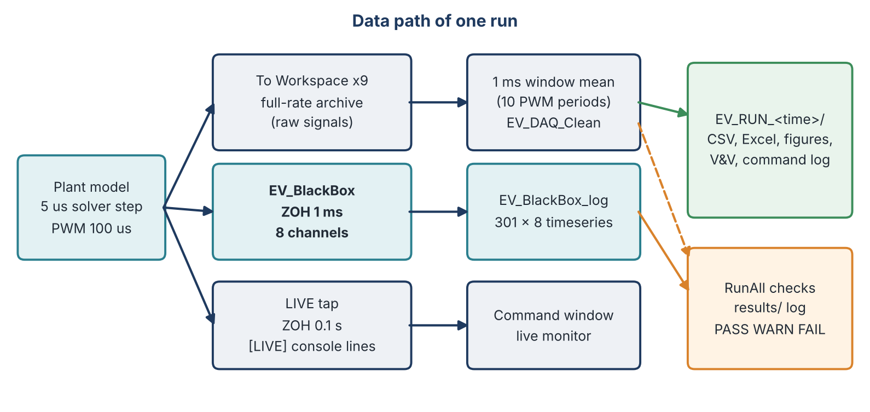
Figure 3. Data path of one run. The plant feeds three taps: full-rate logging, the Black Box and the LIVE tap.
- InitFcn / StartFcn / StopFcn hooks are written into the model by the builder. StartFcn prepares paths and parameters, enforces the stop time and starts the command-window capture. StopFcn harvests the logs and builds the archive. Older hooks are removed so that no stale call remains.
- LIVE tap: a zero-order hold block with a 0.1 s sample time fires an event, and one [LIVE] line is printed every 0.1 s of simulation time (not wall-clock time). The values are instantaneous samples.
- Archive: every run creates a new folder EV_RUN_<date>_<time>/ that is never overwritten. It contains the raw data, the cleaned 1 ms data, parameters, logging audit, V&V results, signal map, group summary, event log, command log, live telemetry, an Excel summary, and figures (speed, battery voltage and current, motor current, SOC, DC link). Large CSV files are split into parts below 20 MB with a manifest.

6.3 The Black Box
The Black Box is a subsystem named EV_BlackBox inside the model. It reads eight signals through Goto/From tags, samples them with a zero-order hold of 1 ms and writes them to the workspace variable EV_BlackBox_log as a timeseries. The column names are stored in the UserData of the block. One 0.3 s run gives 301 samples × 8 channels. The first row is the state at t = 0 and the last row is the state at t = 0.3 s.
Table 10. Black Box channels
Column | Name | Meaning | Unit
1 | Vbatt_V | Battery pack terminal voltage | V
2 | Ibatt_A | Battery pack current (negative = discharge) | A
3 | SOC | State of charge (1 = 100 %) | -
4 | RPM_rpm | Motor speed | rpm
5 | Idc_f_A | Filtered motor current (controller estimate) | A
6 | Vdc_m_V | Measured DC-link voltage | V
7 | omega_wheel | Wheel angular speed (verified as rad/s) | rad/s
8 | Torque_Nm | Measured motor torque | Nm

Current behaviour of the recorder
The Black Box records continuously during the whole run. A true event-triggered freeze with a pre-event and post-event window (as in a vehicle event data recorder) is planned together with the fault scenarios in section 10.

6.4 Switching ripple, aliasing and averaging
The buck converter switches at 10 kHz (period 100 µs). A sample time of 1 ms is exactly 10 switching periods, so a point sample taken every millisecond always hits the same phase of the switching cycle. The measured battery current then does not show the true average. This happened in an earlier version of the builder (point-sampled battery current of 43.9 A where the true mean was about 24 A, giving an efficiency of 41 % instead of about 74 %).
The archive (EV_DAQ_Clean) now uses the exact mean over the 1 ms window (10 whole PWM periods) for every logged signal. The Black Box, being a plain zero-order hold of the raw signal, is still a point sample. This is the most likely reason for the larger ripple of the Black Box battery current (section 8). The proper cure is a 1 ms averaging block in front of the Black Box hold; this is a model change and is listed in section 10.

6.5 Offline system identification
After every run the builder can identify a linear state-space model from the Black Box data (EV_DAQ_Builder_V7('SysID')). The method is the N4SID subspace algorithm [14], in the framework of general system identification [15]. The matrices (A, B, C, D) and the input and output labels are stored in the workspace as EV_BB_A, EV_BB_B, EV_BB_C, EV_BB_D, EV_BB_InputLabels and EV_BB_OutputLabels. This gives a compact "black-box model" of the battery and powertrain behaviour that can later be used for prediction and for a lightweight on-board twin.

7. Verification and validation
Verification asks whether the model and the logging are built correctly. Validation asks whether the model represents the real vehicle. In this work all checks are verification checks against physics, the datasheet and independent calculations. Validation against real e-bike data is a future step.

7.1 Builder V&V rows
Table 11. Main V&V rows written by EV_DAQ_Builder_V7 after each run
ID | What is checked
VV-000 | The run reached t_stop (incomplete runs are reported as INCOMPLETE, not as a misleading FAIL)
VV-003 | Peak motor current against the 45 A limiter (with a small overshoot margin)
VV-008 / VV-023 | Average motor current against I_cont (VV-023 only in the hold window after the load step)
VV-009 / VV-016 | Efficiency between 0 and 100 % (power-based and energy-based)
VV-010 | SOC at t = 0 equals the initial SOC
VV-011 | SOC drop equals the Coulomb count of the battery current (ratio 0.8-1.25)
VV-012 | Battery power against DC-link power, Vdc·Idc / Pbatt between 0.85 and 1.02
VV-013 / VV-014 | Cell voltage at most 4.2 V; the 13 series groups equal within 10 mV
VV-017 / VV-018 | Torque and mechanical power at the end of the run (about 3.18 Nm, about 1 kW)
VV-019 | Torque per amp = 0.107 N·m/A within 5 %
VV-020 / VV-021 | Maximum |Ibat| and maximum pack voltage per cell on the raw 5 µs data
VV-022 | I²t above I_cont against the datasheet budget
VV-024 | DC-link to battery power ratio judged per phase (the current is a filtered estimate)

7.2 RunAll checks
RunAll.m repeats the most important checks on the data of the run that has just finished and adds the comparison of the Black Box with the archive. Each check ends as PASS, WARN or FAIL.
Table 12. Checks performed by RunAll (step 9)
Check | Rule | If not met
Black Box size | 301 × 8 samples (1 ms, t_stop = 0.3 s) | FAIL
Black Box NaN | No NaN values | FAIL
Reached t_stop | Last time equals t_stop | FAIL
Initial state | SOC above 0.999, speed 0, battery voltage 45-55 V | FAIL
Final speed | Inside 2900-3000 rpm | FAIL
Torque per amp | 0.107 N·m/A ± 5 % (last 10 ms) | WARN
Peak motor current | At most 1.1 × I_peak | FAIL
Motor current vs I_cont | Mean of the last 20 ms at most 30 A | WARN
SOC vs Coulomb count | Ratio 0.8-1.25 | WARN
Black Box vs archive: motor current | Within 2 % | FAIL
Black Box vs archive: battery voltage | Within 0.2 V | FAIL
Black Box vs archive: speed | Within 0.5 % | FAIL
Black Box vs archive: battery current | Within 10 % | WARN
Power balance (Black Box and archive) | Pdc / Pbatt between 0.85 and 1.02 | WARN

7.3 What the checks found and fixed (history)
The V&V system found real faults in earlier versions. The table summarises the main ones, because they explain why the present data can be trusted.
Table 13. Root causes found and corrected (builder versions V7 to V7.6, and the latest release)
Fix | Problem found | Correction
A, B | Pack logs are arrays (13 voltages, 130 currents, 130 SOC) stored as r × c × N; reading them as N × m mixed samples of different times (SOC(0) = 99.999 %, no voltage sag) | Read the array with its real time axis; battery current = sum of the 130 cell currents / 13
C, D, E | No checks for SOC, cell voltages and efficiency | Added VV-010 to VV-016
F | Load profile could differ from 1 kW | Signal profile rewritten and read back before every run
G | Torque per amp too low (0.038 and later 0.113) | kappa calibrated (0.72); Kt check VV-019
I | Stale hooks calling a file that does not exist | All old hooks removed, hooks written once
K | Aliasing of the 10 kHz PWM in the 1 ms grid (43.9 A instead of about 24 A) | Exact 1 ms window mean for the archive
M | Limits judged on averaged data only | Checks on the raw 5 µs data (VV-020, VV-021)
Q | Motor current is a filtered estimate, so the DC-link power ratio varied per phase | Description corrected; per-phase check VV-024
T | Silent start failure: with an invalid block parameter the model did not compile and nothing was printed | Compile check first; Simulink error printed; run not started
V | LIVE values are point samples on the same switching phase | Labelled "_inst"; 1 ms window means given next to them
BB | Black Box wiring error "port handle does not belong to any object" | Goto/From tags; Goto created in the system of the nested signal; every line checked
Latest | Group use: backup copies created in the model folder; one function (evRunAll) keeps the path of one PC | Backup-file creation removed; RunAll.m finds its own folder (RunAll does not use evRunAll)

8. Results of the reference run
The numbers below come from the run of 9 October 2026 (setup report 13:31:30). The run length was 0.3 s of simulation time. A second run was started at 13:59:30; its output had not been copied into the report at the time of writing.

8.1 Start and end of the Black Box record
Table 14. First and last rows of EV_BlackBox_log
Channel | t = 0 | t = 0.3 s
Vbatt_V | 54.47 | 54.177
Ibatt_A | -0.0011 | -26.165
SOC | 1 | 0.99998
RPM_rpm | 0 | 2942
Idc_f_A | 0 | 32.855
Vdc_m_V | 2.7e-16 | 44.754
omega_wheel (rad/s) | 0 | 28.008
Torque_Nm | -2.6e-30 | 3.5406

8.2 Consistency with the physics
Table 15. Independent checks on the last Black Box row
Check | Calculation | Result | Verdict
Speed target | 2942 rpm against 2950 rpm | -8 rpm (-0.27 %), inside the 2900-3000 rpm window | PASS
Torque per amp | 3.5406 Nm / 32.855 A | 0.1078 N·m/A (datasheet 0.107) | PASS
Wheel speed | 2942 rpm = 308.09 rad/s; divided by 11 | 28.008 rad/s (logged 28.008) | PASS
Battery voltage sag | 54.47 V - 54.177 V, at 26.165 A | 0.293 V, which gives 0.0112 Ω (pack about 0.011 Ω) | PASS
Buck duty | 44.754 V / 54.177 V | D = 0.826; D · 32.9 A = 27.1 A, close to the battery current of 26.2-27.0 A | PASS
SOC change | about 26 A for part of 0.3 s on 50 Ah | about 2e-5, logged SOC 0.99998 | PASS
Initial state | SOC 1, speed 0, Vbatt 54.47 V | as expected for a full pack at rest | PASS
Mechanical power | 3.5406 Nm × 308.09 rad/s | 1091 W (target about 1 kW) | PASS
Power balance at the last sample | Pdc = 44.754 × 32.855 = 1470 W; Pbatt = 54.177 × 26.165 = 1418 W | ratio 1.04, slightly above the 1.02 limit; the motor current is a 2 ms filtered estimate and the values are single samples (see 8.4) | WARN

8.3 Black Box against the archive
Table 16. Mean over the last 20 ms (21 samples, 1 ms spacing, in both records)
Quantity | Black Box | Archive | Difference | Verdict
Motor current (A) | 31.475 | 31.505 | -0.09 % | PASS
Battery voltage (V) | 54.161 | 54.198 | -0.038 V | PASS
Battery current (A) | -27.608 | -24.257 | +13.8 % (3.35 A) | WARN
Std of battery current (A) | 3.367 | 1.184 | Black Box ripple is 2.8 times larger | INFO

8.4 Interpretation
- The simulation is physically consistent. Speed, torque per amp, wheel speed, voltage sag, duty ratio and SOC all agree with independent hand calculations.
- The Black Box records correctly. The sample count, the spacing, the start state and the end state are right, and three of the four compared channels match the archive within 0.1 %.
- One channel is open: the battery current. The mean differs by 3.35 A and the ripple is 2.8 times larger. The ripple fits the explanation of section 6.4 (point sample against exact window mean). The mean should not differ that much if only the ripple were different, so the tap points of the two records have to be compared.
- Which record is closer to the physics? For an ideal buck converter the battery current is about D · Idc, i.e. close to 26 A at the end of the run for the Black Box motor current of 31.5 A. The archive mean of 24.3 A is below this value and the Black Box mean of 27.6 A is above it by an amount that losses can explain. This points to the Black Box, but it is only an indication. The decisive check is the window power balance that RunAll now prints for both records.
- Motor current at the end is about 33 A, above the continuous rating of 30 A but well below 45 A. The load only reached 3.18 Nm at 0.28 s, the speed is still 8 rpm below the target, and the torque (3.54 Nm) is above the load value because the controller is still recovering. A longer hold phase would show whether the current settles at about 29.7 A.
- Ramp warning. The ramp of 13000 rpm/s needs 30.4 A, 0.4 A above I_cont. It is accepted for this run. Setting rpm_ramp to 11500 rpm/s or less removes the warning if t_stop is increased to at least 0.31 s.

9. User guide: how the group runs the project

9.1 Quick start
- Copy the whole project folder to your PC (OneDrive or any path; nothing is hard-coded).
- Open MATLAB R2024b and open RunAll.m.
- Press Run, or type RunAll in the Command Window.
You do not need to set a path or edit a file. RunAll finds the folder, sets the MATLAB path, loads everything, runs the simulation and prints the result.

9.2 Files
Table 17. Project files
File | Purpose | Required
RunAll.m | One-click runner (the file you run) | Yes
EV_DAQ_Builder_V7.m | Builds logging, LIVE tap and Black Box; archive; V&V | Yes
BLDCSpeedControl_EV_Layout_v2.slx | Main model | Yes
BLDCSpeedControlData.m | All parameters | Yes
BLDCSpeedControlInput.mat | Signal Editor input (load torque profile Test_1) | Yes
Batteries2_lib.slx | Battery pack library | Yes
Batteries2.slx | Battery example model | Optional
*.slxc | Simulink cache, created by MATLAB | Automatic
results/ | RunAll log (.txt) and result struct (.mat) of each run | Created by RunAll
EV_RUN_<time>/ | Full data archive of one run | Created by the builder

9.3 Requirements
- MATLAB R2024b (other releases give a warning; the model may not open in older ones).
- Simulink, Simscape, Simscape Electrical, Simscape Battery.
- Windows with Microsoft Excel installed, only for the Excel files of the archive. The simulation itself does not need Excel.

9.4 What RunAll does
Table 18. Steps of RunAll
Step | Action
1 | Finds the project folder (where RunAll.m is), changes into it, sets the MATLAB path (run archives left out), opens the log file
2 | Checks the required files; prints FOUND or MISSING; stops with a clear message if one is missing
3 | Checks the MATLAB release and the Simulink / Simscape products
4 | Runs BLDCSpeedControlData.m and prints the key values
5 | Closes an old copy of the model and reloads it from disk; clears results of an earlier run
6 | Calls the builder: model fix (buck snubber exclude) and DAQ setup (LIVE tap, Black Box, hooks, model saved)
7 | Compile check; if the model does not compile the error is printed and the run does not start
8 | Starts the simulation; [LIVE] lines every 0.1 s of simulation time; progress line every 5 s
9 | Verifies the result (section 7.2) and prints the summary

Options:
RunAll % normal run
RunAll('Fixes', false) % skip the buck snubber model fix
RunAll('Timeout', 1800) % wait at most 1800 s of wall time (default 3600)
A 0.3 s simulation takes about 3 minutes of wall time; the archive step adds time. At the end the summary reads, for example, SUMMARY PASS n WARN n FAIL n, followed by one of three results: all checks passed, OK with warnings, or n checks failed.

9.5 Reading the results by hand
bb = EV_BlackBox_log; % timeseries, 301 x 8
mdl = 'BLDCSpeedControl_EV_Layout_v2';
lab = get_param([mdl '/EV_BlackBox'], 'UserData'); % column names
disp(array2table(bb.Data([1 end],:), 'VariableNames', lab)) % first, last row
C = EV_DAQ_Clean; % cleaned 1 ms archive table
EV_DAQ_Builder_V7 % setup and run
EV_DAQ_Builder_V7('Run', false) % setup only
EV_DAQ_Builder_V7('PostProcess') % archive data in the workspace
EV_DAQ_Builder_V7('BlackBox') % build or verify the Black Box
EV_DAQ_Builder_V7('BlackBox','remove') % remove the Black Box
EV_DAQ_Builder_V7('SysID') % offline system identification

9.6 Troubleshooting
Table 19. Common problems
Message or problem | What to do
MISSING <file> in step 2 | Copy that file into the folder of RunAll.m and run again
Cannot find the model, or a folder window opens | RunAll.m is not in the model folder; move it there or select the folder
Model ... is still running | Press STOP in Simulink, wait for Ready, run again
Compile check FAIL | Read the Simulink message; usually a missing product or a different MATLAB release
The simulation never started | Open the Simulink Diagnostic Viewer; a block parameter is invalid
Excel errors in the archive step | Excel is missing or the system is not Windows; the CSV and MAT data are still written
Model will not open | Use MATLAB R2024b
Message "timeseries Variable Editor will be removed" | Harmless MATLAB notice

Backups
The builder no longer creates *_backup_before_DAQ.slx or *_before_stepN.slx, and it saves the model in the snubber fix only when a change is made. Keep your own backup by copying the project folder or by using Git.

10. Limitations, open points and future work
The table separates what is a known limitation of the present model from what is planned. Planned items are not part of the results of this report.
Table 20. Open points
Item | Why it matters | Planned action
Battery current mismatch (Black Box vs archive) | The recorder must agree with the archive; mean differs 3.35 A | Compare tap points; add a 1 ms averaging block before the Black Box hold; read the window power balance of RunAll
Temperature not modelled or logged | Fire and overheating risk cannot be predicted without it | Add a cell and pack thermal model and log temperature as a Black Box channel
Speed reference not logged | Tracking error cannot be computed from the record | Add a logging block for rpm_ref
Motor datasheet fields are example values (p, Rs, Ls, Ms, Jm) | Dynamic behaviour depends on them | Fill from the datasheet or measure; re-check Kt and kappa
Pack uses 5 Ah cells with the resistance of the 27 Ah cell | Capacity is right, cell resistance is not exact | Rebuild the pack in Battery Builder with a physically exact 50 Ah pack
Run of 0.3 s only | SOC changes by about 2e-5; SOH and ageing cannot be seen | Longer or time-scaled drive-cycle scenarios; ageing model
Motor current above I_cont at the end | Run ends before steady state | Longer hold phase; or lower load or ramp
Black Box is continuous, not event-triggered | A real recorder freezes a window around an incident | Trigger on overcurrent, low voltage, over-temperature; keep a pre- and post-event buffer
No fault scenarios yet | The twin is tested only on a normal drive | Scenario blocks: overload, short, low SOC, cell imbalance, sensor fault
BMS / VMS intelligence | Core of the project idea | SOC (Coulomb counting, observer such as EKF), SOH (capacity ratio), risk and maintenance prediction
Cloud telemetry | Fleet history and remote access | MQTT messages from the twin to a broker with transport security [16]; dashboard
Validation with real data | Verification alone does not prove the model matches a real vehicle | Compare with measurements of a real e-bike; report MAE and RMSE
Hardware concept | Cost target below Rs 5,000 | Describe the microcontroller and sensor set; build only if required

10.1 Suggested next steps in order
- Close the battery-current mismatch and confirm the second run (13:59) with RunAll.
- Add temperature and speed-reference logging; extend the Black Box to ten channels.
- Add event triggering and three fault scenarios; show that the Black Box records the moments before and after the event.
- Add SOC and SOH estimation on the Black Box data and compare with the model values (MAE, RMSE).
- Add the MQTT telemetry chain as a simulated publisher and a local broker; then the dashboard.
- Validate against real e-bike measurements if available.

11. Glossary
Table 21. Terms and abbreviations
Term | Meaning
BLDC | Brushless DC motor, commutated electronically
BMS / VMS | Battery management system / vehicle monitoring system
Black Box | Recorder that keeps the data around an incident for later analysis
Buck converter | DC-DC converter that lowers the voltage; here 10 kHz PWM
DAQ | Data acquisition
Digital twin | Virtual representation of a physical asset connected to it by data
DC link | Voltage between the buck converter and the inverter
EDR | Event data recorder
I²t | Thermal budget of a current: the square of the current multiplied by the time
Kt | Torque constant of the motor in N·m per amp
kappa | Ratio of the effective torque constant of the Simscape BLDC block to the table amplitude (0.72)
MAE / RMSE | Mean absolute error / root-mean-square error, used to compare twin and measurement
MQTT | Lightweight publish/subscribe protocol for telemetry
N4SID | Subspace method for identifying state-space models
OCV | Open-circuit voltage of the battery
PWM | Pulse-width modulation
SOC / SOH | State of charge / state of health (capacity ratio present to rated)
V&V | Verification and validation
ZOH | Zero-order hold, a sample-and-hold block

12. References
Every journal reference below was checked against its DOI record on 9 October 2026. Items marked "(book)" are textbooks without a web link. The numbers follow the order of first citation in the text.
[1] Grieves, M. and Vickers, J. (2017). Digital Twin: Mitigating Unpredictable, Undesirable Emergent Behavior in Complex Systems. In: Kahlen, F.-J., Flumerfelt, S., Alves, A. (eds) Transdisciplinary Perspectives on Complex Systems. Springer, Cham, pp. 85-113. https://doi.org/10.1007/978-3-319-38756-7_4
[2] Glaessgen, E. H. and Stargel, D. S. (2012). The Digital Twin Paradigm for Future NASA and U.S. Air Force Vehicles. 53rd AIAA/ASME/ASCE/AHS/ASC Structures, Structural Dynamics and Materials Conference, Honolulu, HI, AIAA Paper 2012-1818. https://ntrs.nasa.gov/citations/20120008178
[3] Kritzinger, W., Karner, M., Traar, G., Henjes, J. and Sihn, W. (2018). Digital Twin in manufacturing: A categorical literature review and classification. IFAC-PapersOnLine 51(11), 1016-1022. https://doi.org/10.1016/j.ifacol.2018.08.474
[4] Li, W., Rentemeister, M., Badeda, J., Jost, D., Schulte, D. and Sauer, D. U. (2020). Digital twin for battery systems: Cloud battery management system with online state-of-charge and state-of-health estimation. Journal of Energy Storage 30, 101557. https://doi.org/10.1016/j.est.2020.101557
[5] Wu, B., Widanage, W. D., Yang, S. and Liu, X. (2020). Battery digital twins: Perspectives on the fusion of models, data and artificial intelligence for smart battery management systems. Energy and AI 1, 100016. https://doi.org/10.1016/j.egyai.2020.100016
[6] Fuller, A., Fan, Z., Day, C. and Barlow, C. (2020). Digital Twin: Enabling Technologies, Challenges and Open Research. IEEE Access 8, 108952-108971. https://doi.org/10.1109/ACCESS.2020.2998358
[7] Lu, L., Han, X., Li, J., Hua, J. and Ouyang, M. (2013). A review on the key issues for lithium-ion battery management in electric vehicles. Journal of Power Sources 226, 272-288. https://doi.org/10.1016/j.jpowsour.2012.10.060
[8] MathWorks. BLDC Speed Control (Simscape Electrical example documentation). The project model is based on this example. https://www.mathworks.com/help/sps/ug/bldc-speed-control.html
[9] Krishnan, R. (2010). Permanent Magnet Synchronous and Brushless DC Motor Drives. CRC Press, Boca Raton. (book)
[10] MathWorks. Create Battery Pack (Simscape Battery documentation, Battery Builder workflow). https://www.mathworks.com/help/simscape-battery/create-battery-pack.html
[11] Erickson, R. W. and Maksimovic, D. (2020). Fundamentals of Power Electronics, 3rd edition. Springer, Cham. (book) https://doi.org/10.1007/978-3-030-43881-4
[12] Ng, K. S., Moo, C.-S., Chen, Y.-P. and Hsieh, Y.-C. (2009). Enhanced coulomb counting method for estimating state-of-charge and state-of-health of lithium-ion batteries. Applied Energy 86(9), 1506-1511. https://doi.org/10.1016/j.apenergy.2008.11.021
[13] Plett, G. L. (2004). Extended Kalman filtering for battery management systems of LiPB-based HEV battery packs. Journal of Power Sources 134(2), 252-261. https://doi.org/10.1016/j.jpowsour.2004.02.031
[14] Van Overschee, P. and De Moor, B. (1994). N4SID: Subspace algorithms for the identification of combined deterministic-stochastic systems. Automatica 30(1), 75-93. https://doi.org/10.1016/0005-1098(94)90230-5
[15] Ljung, L. (1999). System Identification: Theory for the User, 2nd edition. Prentice Hall, Upper Saddle River. (book)
[16] OASIS (2019). MQTT Version 5.0, OASIS Standard. https://docs.oasis-open.org/mqtt/mqtt/v5.0/mqtt-v5.0.html

