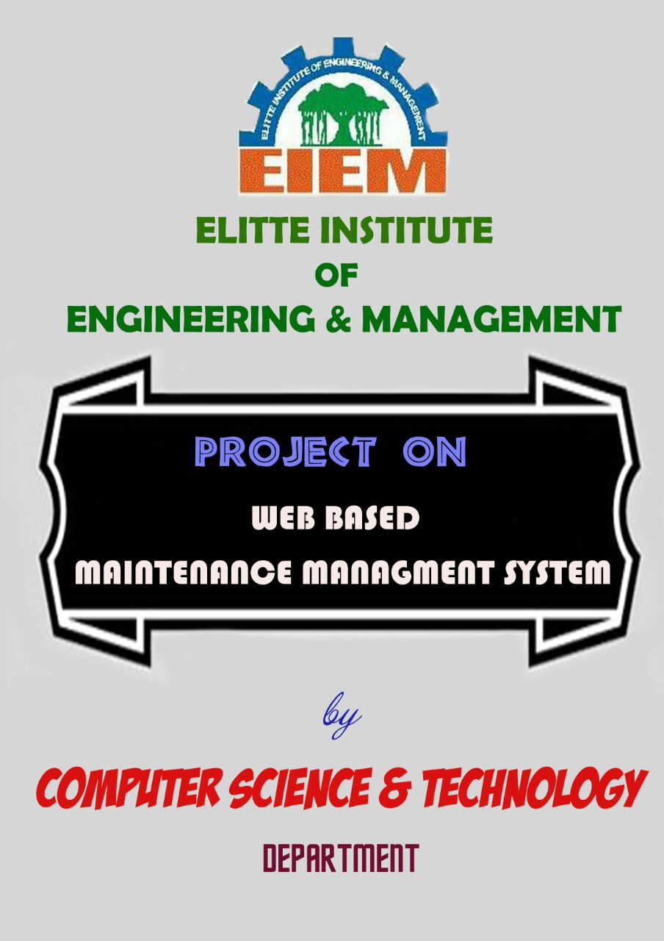

WEB BASED MAINTENANCE MANAGEMENT SYSTEM

A PROJECT REPORT

Submitted by

Subham Khan Reg no: D131490133

Animesh Dutta Chowdhury Reg no: D121359613

Sourav Mitra Reg no: D121359602

Md. Sohel Rana Reg no: D131490124

Somnath Rakshit Reg no: D131490132

Swasti Sundar Chanda Reg no: D131490127

Pratyush Bir Reg no: D121359564

Dilip Majhi Reg no: D121359599

Subhankar Gayen Reg no: D121359571

Somnath Banik Reg no: D121359612

Shilpi Debnath Reg no: D121359578

Pampa Sarkar Reg no: D121359586



In partial fulfillment for the award of the diploma
Elitte Institute of Engineering and Management

[ISO Certified 9001 : 2008, Affiliated to W.B.S.C.T.E, Approved by A.I.C.T.E]
Karnamadhabpur (Near mohispota), Ghola (Sodepur), Kolkata- 700113

DEPARTMENT OF COMPUTER SCIENCE & TECHNOLOGY

CERTIFICATE

This is to recognize and certify that Subham Khan (Registration No- D131490133), Animesh Dutta Chowdhury (Registration No- D121359613), Sourav Mitra(Registration No- D121359602), Md. Sohel Rana(Registration No- D131490124), Somnath Rakshit(Registration No- D131490132), Swasti Sundar Chanda(Registration No- D131490127), Pratyush Bir (Registration No- D121359564), Dilip Majhi(Registration No- D121359599), Subhankar Gayen (Registration No- D121359571), Somnath Banik(Registration No- D121359612), Shilpi Debnath (Registration No- D121359578), Pampa Sarkar (Registration No- D121359586) Students of Diploma in Computer Science and Technology of PART III SEM II of Elitte Institute of Engineering and Management, Session 2012-2015, have successfully completed their dissertation “WEB BASED MAINTENANCE MANAGEMENT SYSTEM”, under the guidance and supervision of the undersigned, which is submitted for the partial fulfillment of the degree of Diploma in Computer Science and Technology

The project, that has span through out their final year, has got the expected involvement from their and I personally believe that the kind of devotion, sincerity and regularity they have shown, will add value to their merit.

I wish them all the success in future.

--------------------------------------------------------- ---------------------------------------------------------
Ms. Srabanti Chakraborty Mr. Sumit Samanta
(Project Guide) Assistant Professor &
Lecturer in C.S.T Department Head of the Department of
Elitte Institute of Engineering and Management Computer Science & Technology
Elitte Institute of Engineering and Management

---------------------------------------------------------- ---------------------------------------------------------
Prof. Md. Ismail Prof. Anjan Kar
Mentor Principal Principal
Elitte Institute of Engineering and Management Elitte Institute of Engineering and Management

SCOPE OF PROJECT

- Less work outages
- Better accountability
- Less overtime
- Keep the Lab materials information

ACKNOWLWDGEMENT

I deem it pleasure to acknowledge my deep sense of gratitude to a number of people contributed to this effort of mine. I will try my best to mention all them here appropriately.

First of all I’d like to thank our Hon’ble principal sir Prof. Anjan Kar, Mentor Principal sir Prof. Md. Ismail, Hon’ble Director sir Mr. Bazlul Haque,Hon’ble secretory sir Mr.Sajal Ghosh and Hon’ble sir Mr.Sankar Roy for their kind cooperation and giving this opportunity to complete the project with proper infra structure..

I gratefully acknowledge the resourceful guidance, active supervision and constant encouragement of our project guide Ms. Srabanti Chkraborty, Lecturer of Computer Science and Technology Department, Elitte Institute of Engineering and Management, who despite of her other commitments could make time to help me
in preparing this project . I do convey my sincere thanks and gratitude to our project guide.

I also take the opportunity to express my grateful thanks to our respected sir Mr.Durga Sankar Das, Web Manager EIEM for his sincere and active cooperation to complete this project

I am also greatly indebted to our respected sir Mr. Biswajit Dutta, Manager Logistic and Maintenance Dept for giving his valuable suggestions to complete this project in time.

I also wish to reciprocate in full measure the kindness shown by all my respective departmental faculties and our respected H.O.D.

I would like to thank all my project team members for their cooperation, participation and suggestion throughout the project.

I would also like to thank all the GROUP D and HOUSE KEEPING staffs of Lab1 and Lab2 for their cooperation and support throughout the project.

Finally I want to pay my heartiest regard and thank to all my family members and co-friends, who have encouraged and inspired us in successfully completing this project.

CONTENTS

- Abstract
- Introduction
- Requirement Specification
- ERD
- DFD
- Data Ditionary
- Screen Shots
- Conclusion
- Limitation
- Bibliography

ABSTRACT

The need for a concrete system, whether manual or automated, is very important for the systematic approach to handle the various information and record of materials.

The project Web Based Maintenance Management System is an automation system of the materials concerned with locating, maintaining, updating management of materials of laboratory of an organization.
The Web Based Maintenance Management System may be used to automate lab equipment maintenance. Such a system contains the details of materials, there location, list of fault orders and then prompts vendors to pick the necessary items and provides them after repairing.
The project coverage area is the locating and monitoring all the materials of laboratory then sending them for repairing if necessary. This system also can generate reports.

The Software and Hardware requirements of the project:

- Intel Pentium III 833MHz
- 128 SD-RAM.
- Mozilla Firefox / Opera / Google Chrome / IE 9.0 or Above
- MY SQL

Main objectives of the Web Based Maintenance Management System are:

Department in-charge side:

- Department in charge can register all materials location wise.

- Department in charge can register the fault from any location they will get a fault ticket number.

- Department in charge can use the fault ticket and check the current status of the fault

- Department in charge can generate the time based maintenance report.

- Department in charge can check the current status of material at any time.

Maintenance Manager side:

- Maintenance Manager can be informed about the fault of any material of any department very easily.

- Maintenance Manager can monitor all the fault status.

- Maintenance Manager can generate monthly or weekly report for all departments.

- Maintenance Manager can generate the list of materials under the repair or breakdown.

- Maintenance Manager can check the current status of material department wise at any time.
INTRODUCTION

Web Based Maintenance Management System is a process for managing, locating repairing, updating the materials of a labotatory. In common usage, the term may also refer to just the software components.

The Web Based Maintenance Management System may be used to automate lab equipment maintenance.. Such a system contains a list of fault orders and then prompts vendors to pick the necessary items and provides them after repairing.

REQUIREMENT SPECIFICATIONS OF PROJECT REPORT

Hardware Requirement:

􀂷 Processor: - Intel Pentium III 833MHz
􀂷 RAM: - 128 SD-RAM.
􀂷 Hard Disk: -20 GB or above.
􀂷 Monitor: - 14” VGA.
􀂷 Mouse.
􀂷 Printer: - For print report or Bill.

Software Requirement:

􀂷 Operating system: - Windows 98/2002/NT.
􀂷 Front End: - PHP. (Professional Edition.)
􀂷 Back end: - MY SQL

OBJECTIVE

Department in-charge side

- Department in charge can register all materials location wise.

- Department in charge can register the fault from any location they will get a fault ticket number.

- Department in charge can use the fault ticket and check the current status of the fault

- Department in charge can generate the time based maintenance report.

- Department in charge can check the current status of material at any time.

Maintenance Manager side:

- Maintenance Manager can be informed about the fault of any material of any department very easily.

- Maintenance Manager can monitor all the fault status.

- Maintenance Manager can generate monthly or weekly report for all departments.

- Maintenance Manager can generate the list of materials under the repair or breakdown.

- Maintenance Manager can check the current status of material department wise at any time.

ENTITY RELETIONSHIP DIAGRAM

fault_id
i_location
fault
sl_no

fault _details
Fault_details

status_details
status_code

Contains
update_date

fault_id
update_by

Checks
Fault_master

authority
clear_date

user_id

Update
book_date

users_email
ct_nm

users_id
ct_code
ct_specification
Edits
Or
Adds

users_password
Users_master
cateagory_master

users_type
unit
ct_type
u_status



CONTEXT FREE DIAGRAM (0 Level DFD)

USER

ADMINISTRATOR

Get Fault
Ticket /Fault
Status
Updates

Check
Ducket Fault

WMMS

1^{ts} Level DFD

user_email,
password

WMMS
(2)

Login
(1)

Login

USER

user_master

Valid User login

Valid Admin login

Genaral Operation
(Fault Booking/ Fault status/ Ckacking)
(3.2)

ADMINISTRATION
(3.1)

2nd Level DFD

item_code, fault_details

Fault Booking
(3.2.1)

USER
fault_details
fault_id

fault_master

Fault status Checking
(3.2.2)

fault_id

USER

fault_details

User Creation
(3.1.1)

fault_master

user_id,
user_details
fault_id,
fault_status

Fault Checking
(3.1.3)

ADMINISTRATOR

fault_details

item_code, item_details

Item Cateagory
(3.1.2)

fault_master

fault_details

DATA DICTIONARY

- Store details about “users_master”
Field Name | Field Type | Constraint | Remarks
users_id | int(11) | Primary Key | Stores id of user
users_email | VARCHAR(255) |  | Stores email of user
users_password | VARCHAR(255) |  | Stores password of user
users_type | VARCHAR(255) |  | Stores type of user
u_status |  |  | Stores status of user
  tinyint(1)

- Store details about “register_user_master”
Field Name | Field Type | Constraint | Remarks
users_id |  | Primary Key | Stores id of users
  int(11)
first_name | VARCHAR(255) |  | Stores first name of register user
last_name | VARCHAR(255) |  | Stores last name of register user
u_dept | VARCHAR(255) |  | Stores department name of register user
last_log_in | VARCHAR(255) |  | Stores last login time of register user
address | VARCHAR(255) |  | Stores address of register user
sex | VARCHAR(255) |  | Stores sex of register user
date_of_birth | date |  | Stores date of birth of register user
phon_no |  |  | Stores phone no of register user
  int(10)
profile_pic | VARCHAR(255) |  | Stores profile image location of register user

- Store details about “cateagory_master”
Field Name | Field Type | Constraint | Remarks
ct_code | VARCHAR(255) | Primary Key | Stores code of Category
ct_nm | VARCHAR(255) |  | Stores name of Category
ct_specification | VARCHAR(255) |  | Stores specification of Category
ct_type | VARCHAR(255) |  | Stores type of Category
unit | VARCHAR(255) |  | Stores unit of Category

- Store details about “fault_master”
Field Name | Field Type | Constraint | Remarks
fault_id | int(11) | Primary Key | Stores id of fault item
status_code | VARCHAR(255) |  | Stores status code of fault item
status_details | VARCHAR(255) |  | Stores status details of fault item
update_date | VARCHAR(20) |  | Stores update date of fault
authority | VARCHAR(255) |  | Stores authority name of fault
update_by | VARCHAR(255) |  | Stores updater name of fault
user_id | int(11) |  | Stores id of user
book_date | VARCHAR(20) |  | Stores book date of fault
clear_date | VARCHAR(20) |  | Stores clear date of fault

- Store details about “fault_details”
Field Name | Field Type | Constraint | Remarks
fault_id | int(11) | Primary Key | Stores id of fault item
sl_no | VARCHAR(255) |  | Stores serial number of fault item
i_location | VARCHAR(255) |  | Stores location of fault item
fault | VARCHAR(255) |  | Stores topic of fault item
fault_details | VARCHAR(255) |  | Stores details of fault item

- Store details about “repair_master”
Field Name | Field Type | Constraint | Remarks
status_code | VARCHAR(255) |  | Stores status code of repair
status_de | VARCHAR(255) |  | Stores status details of repair

SCREEN SHOTS

SCREEN SHOT OF LOGIN PAGE:

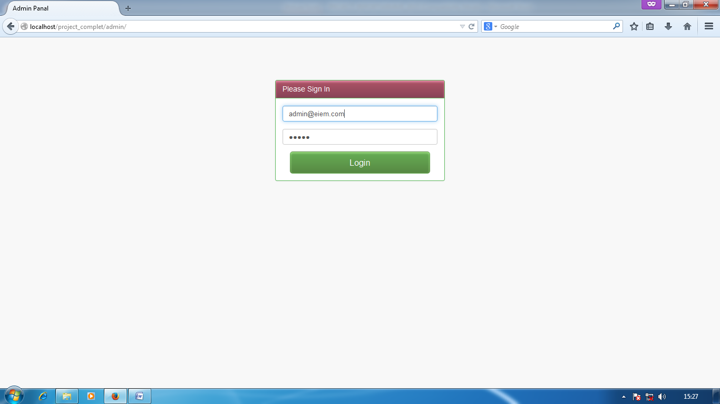

SCREEN SHOT OF CREATE A NEW USER:

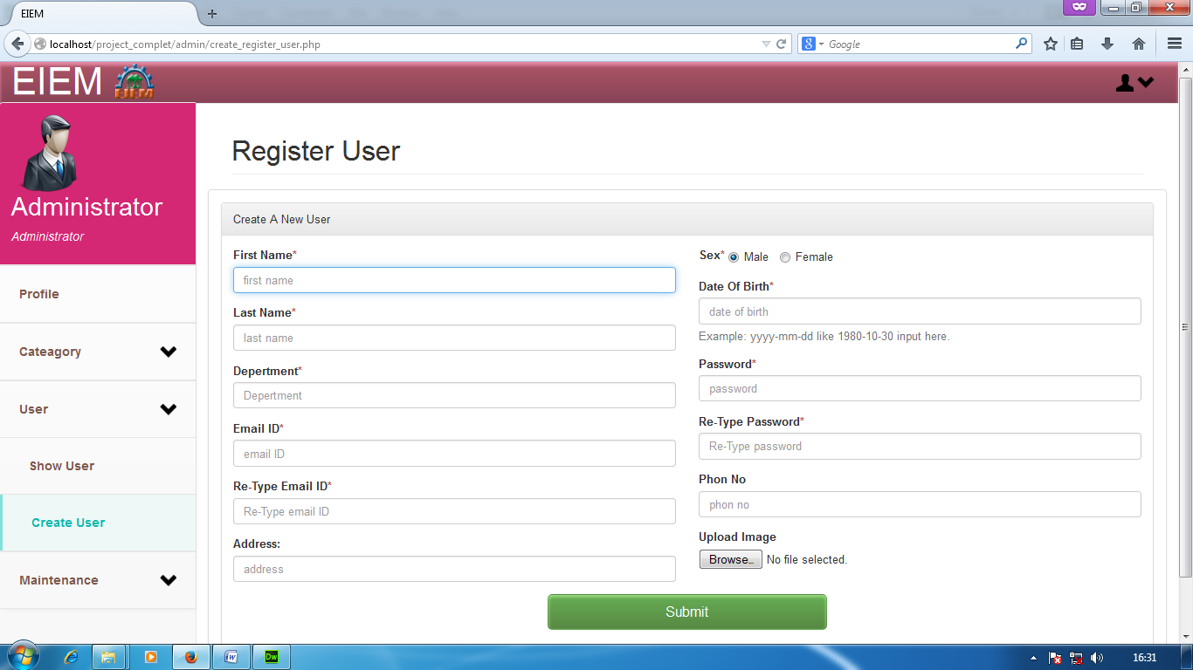
SCREEN SHOT OF USER LIST:

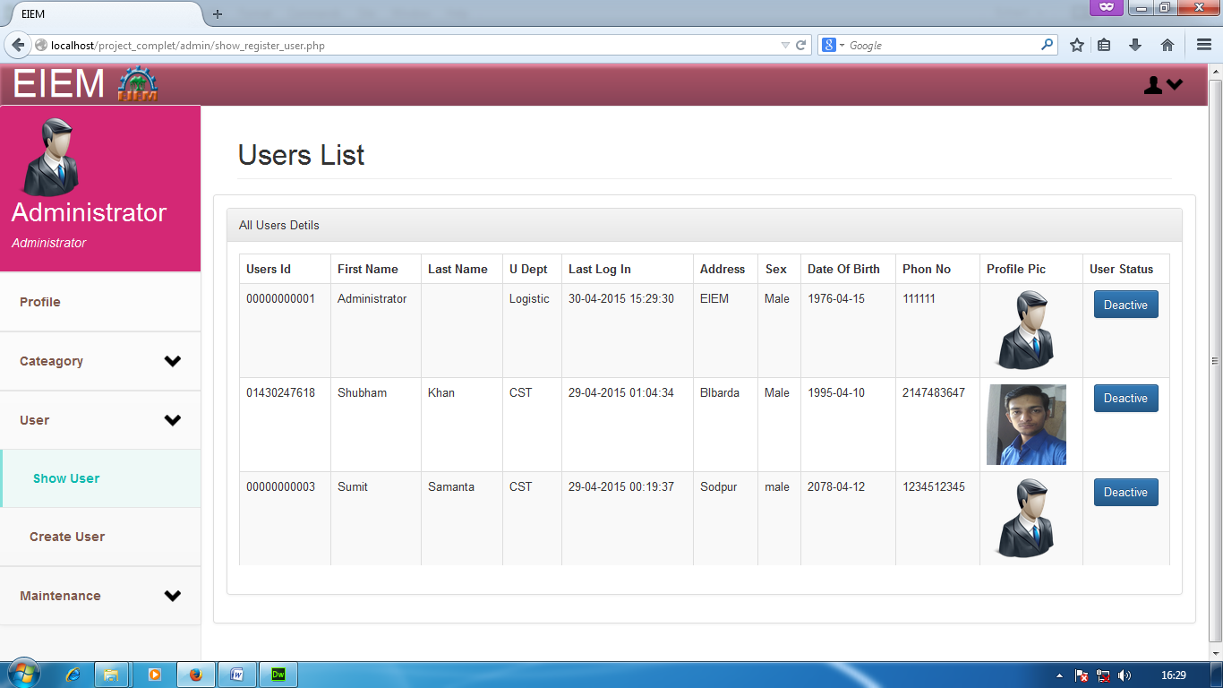

SCREEN SHOT OF USER DEATILS:

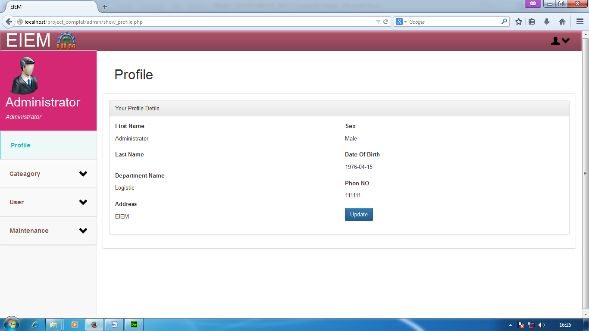
SCREEN SHOT OF USER DEATILS UPDATE:

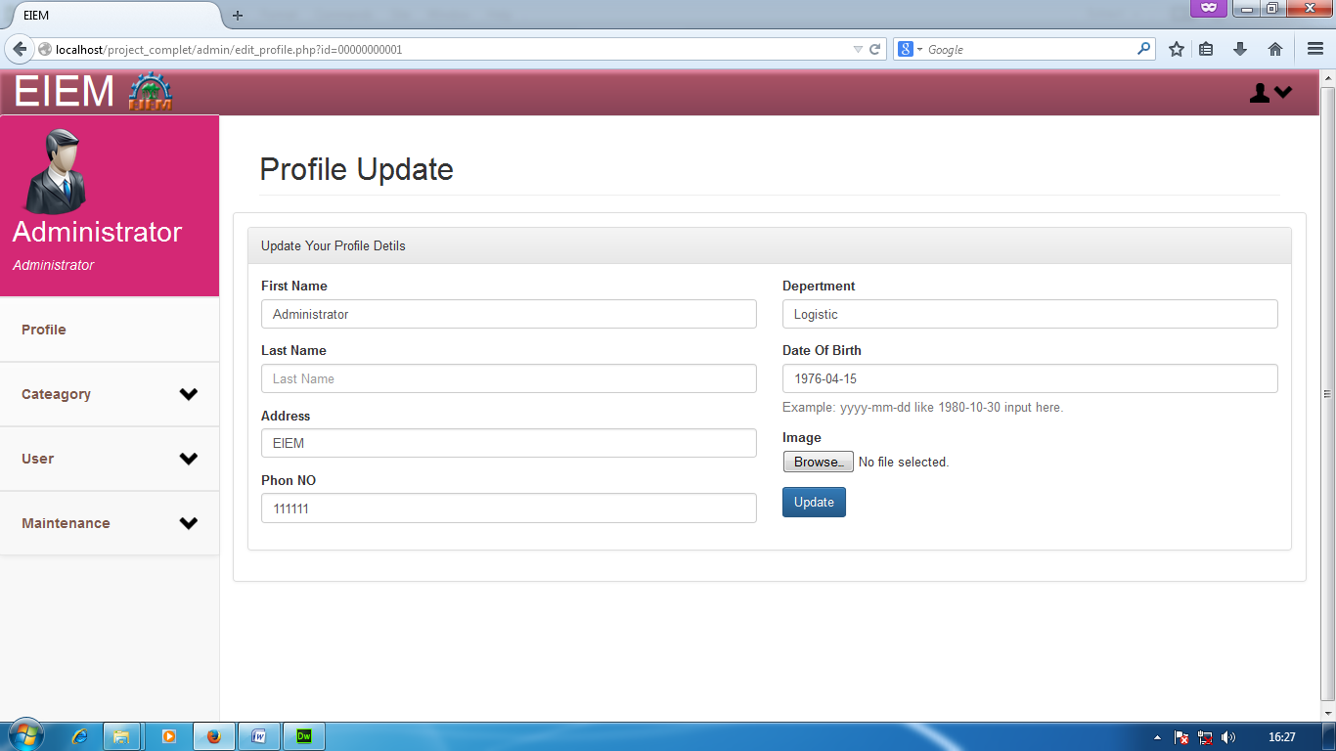

SCREEN SHOT OF USER CHANGE PASSWORD:

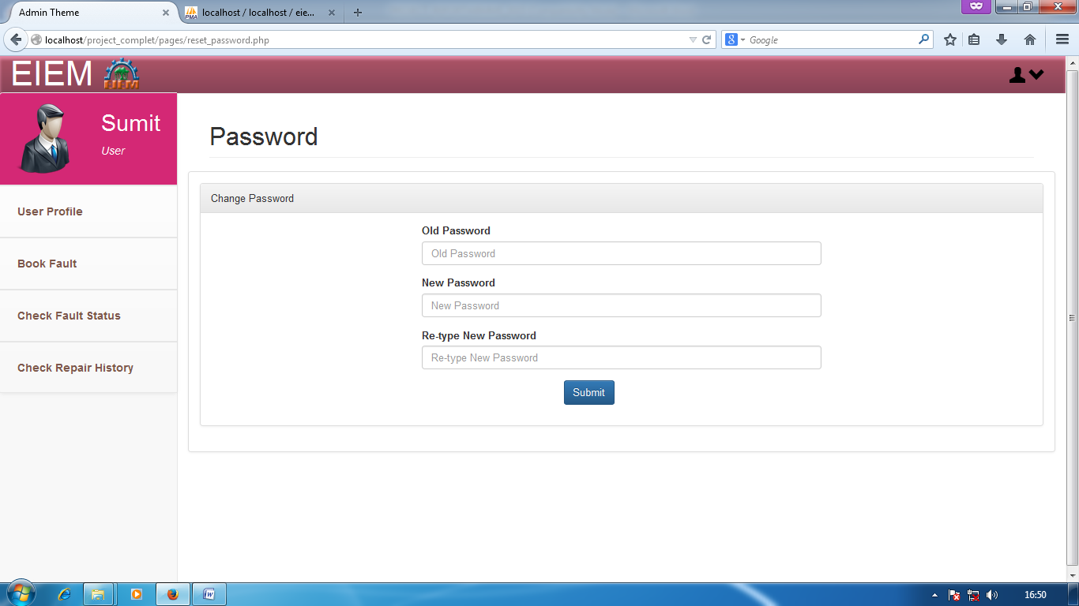
SCREEN SHOT OF NEW CATEAGORY ENTRY:

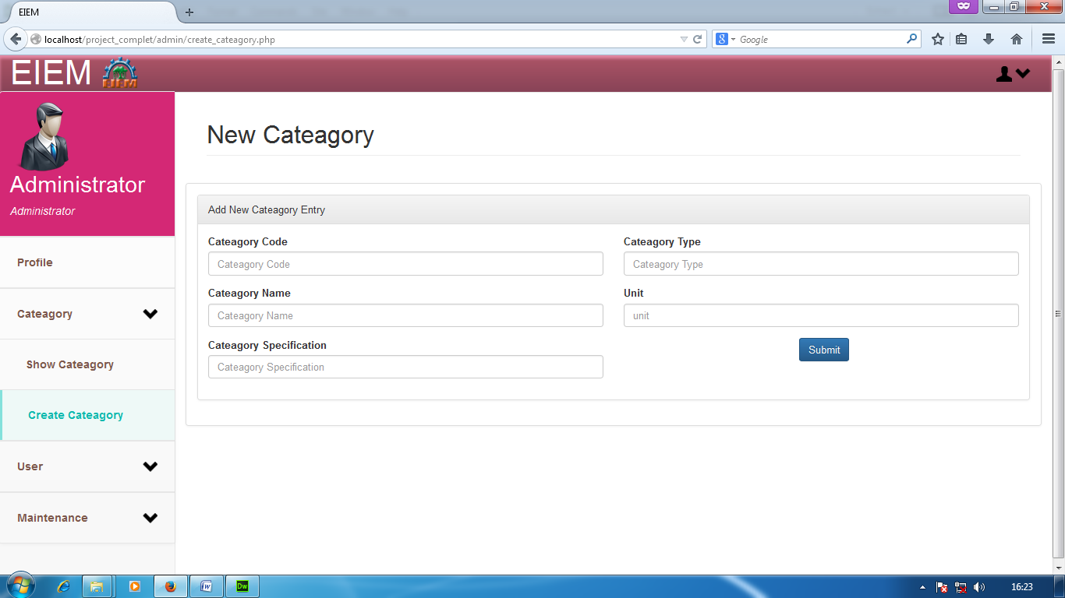

SCREEN SHOT OF SHOW CATEAGORY LIST:

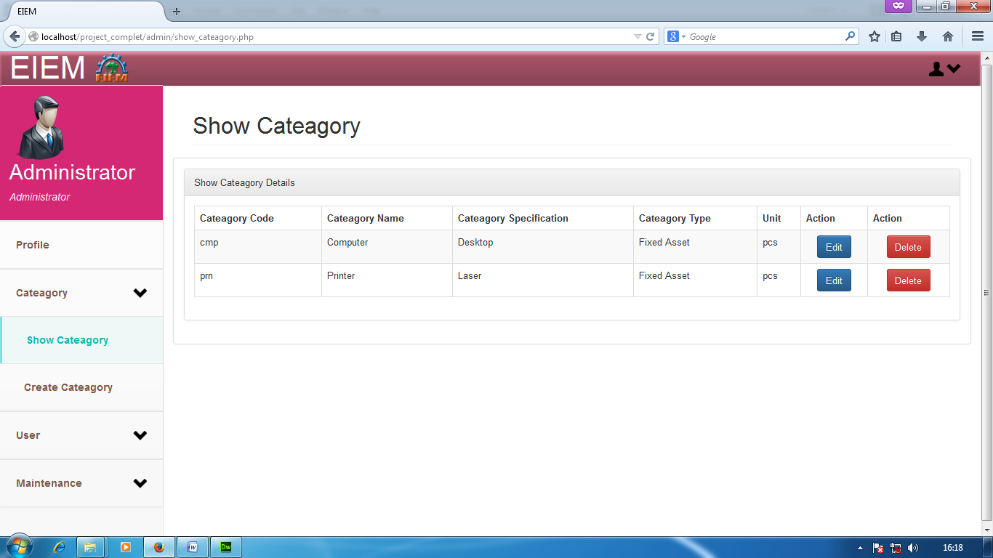
SCREEN SHOT OF UPDATE CATEAGORY DETAILS:

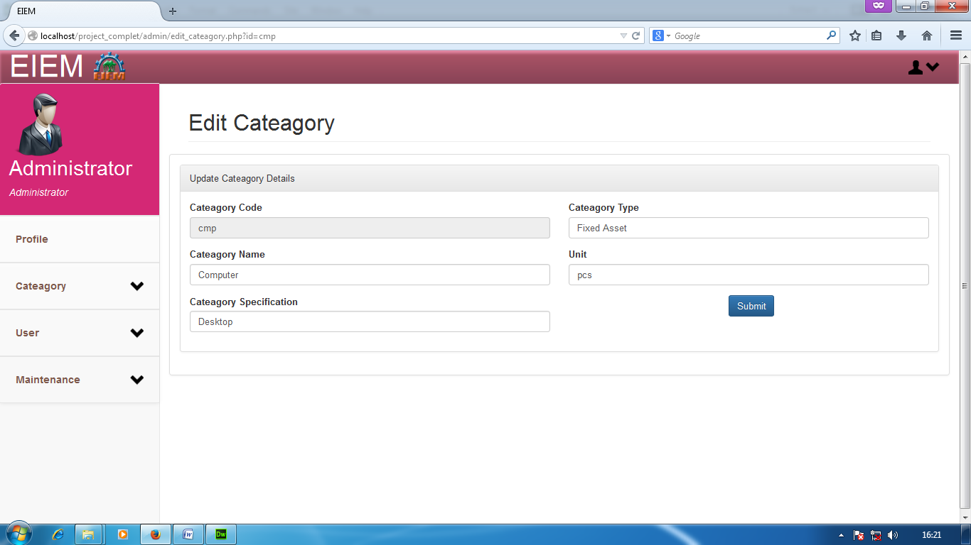

SCREEN SHOT OF SHOW FAULT LIST:

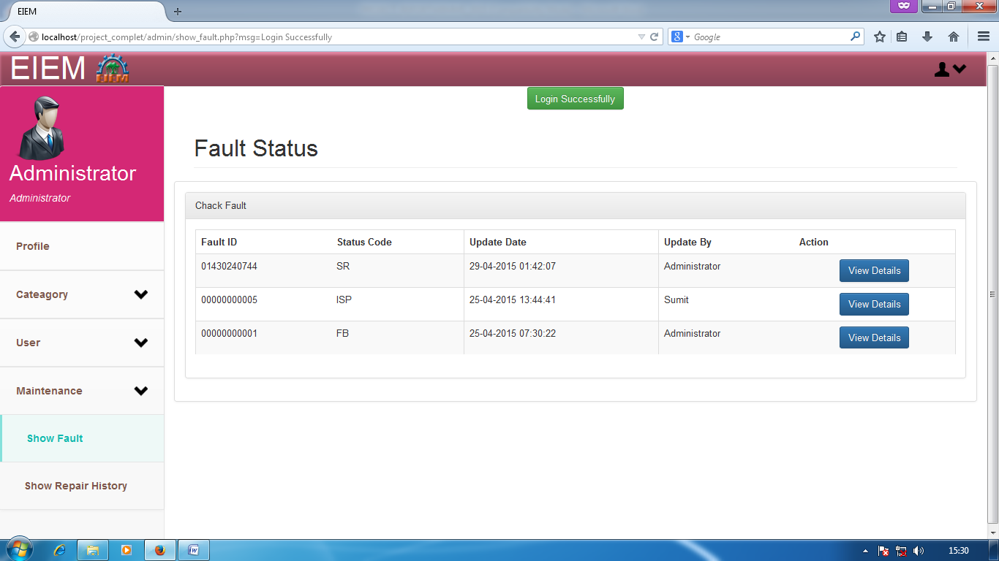
SCREEN SHOT OF SHOW FAULT DETAILS:

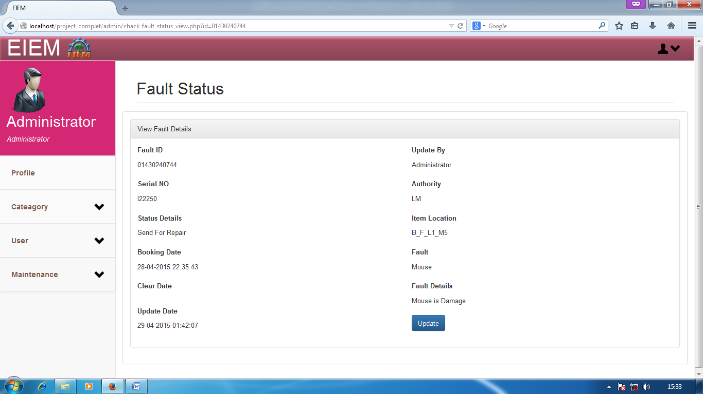

SCREEN SHOT OF UPDATE FAULT STATUS:

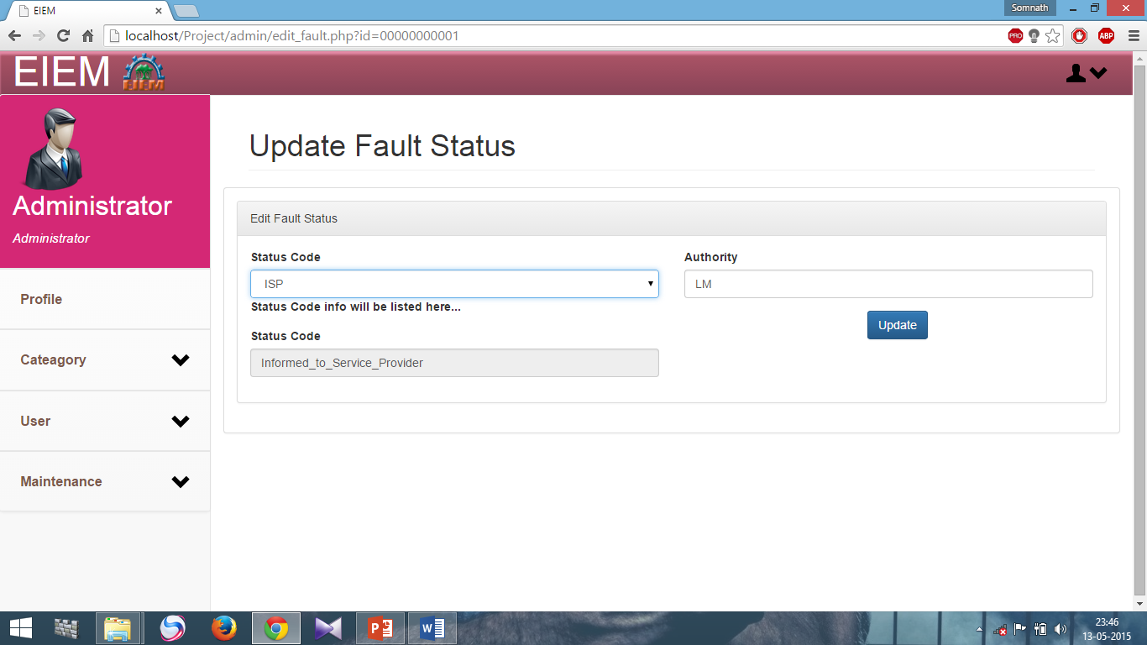
SCREEN SHOT OF REPAIR LIST:

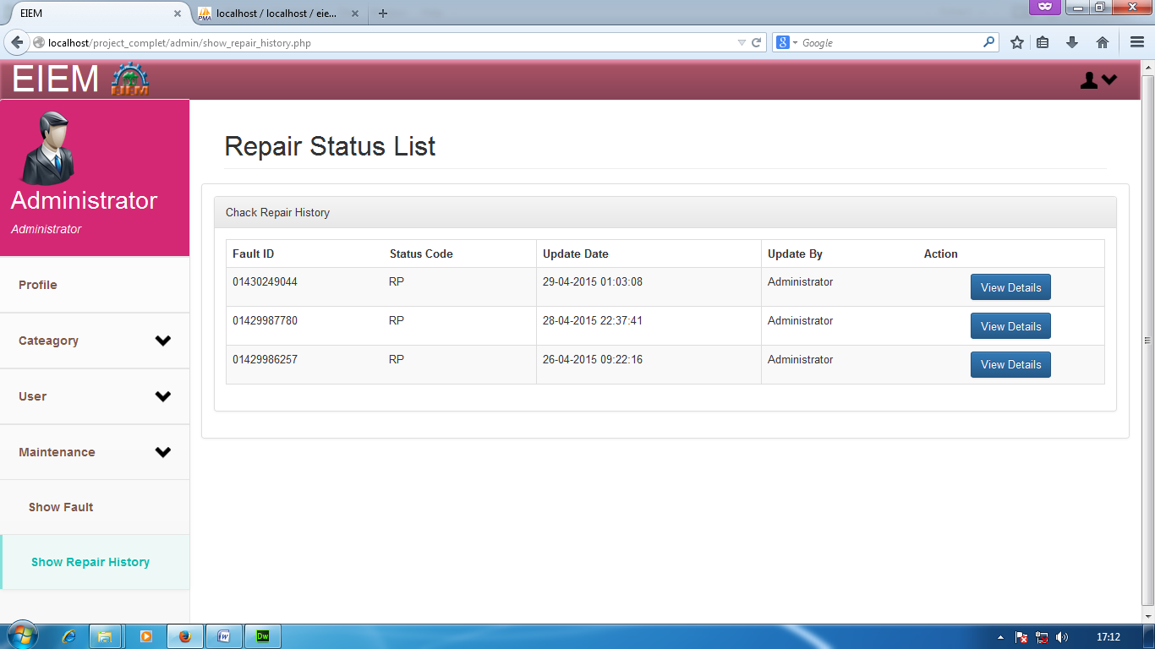

SCREEN SHOT OF REPAIR DETAILS:

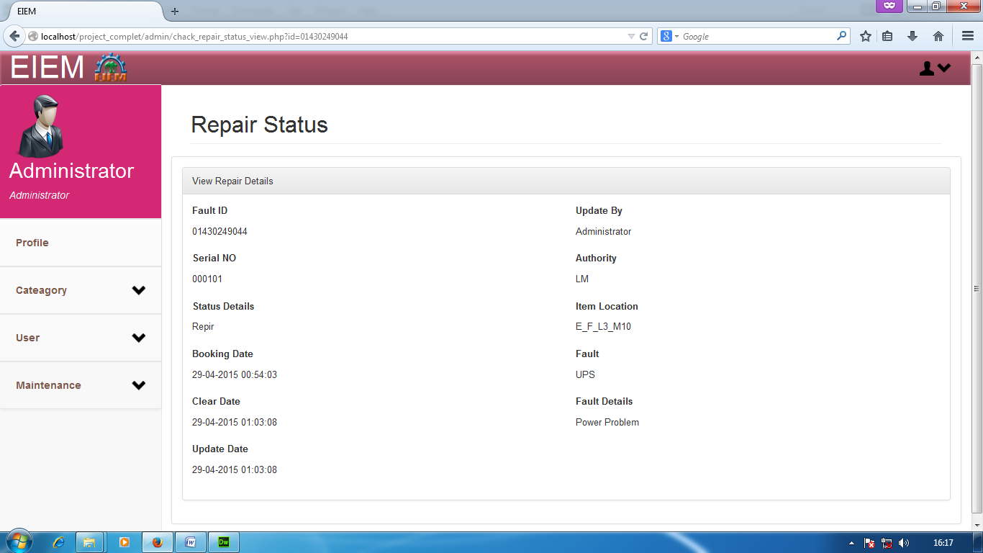
SCREEN SHOT OF FAULT BOOKING IN SEARCH ITEM:

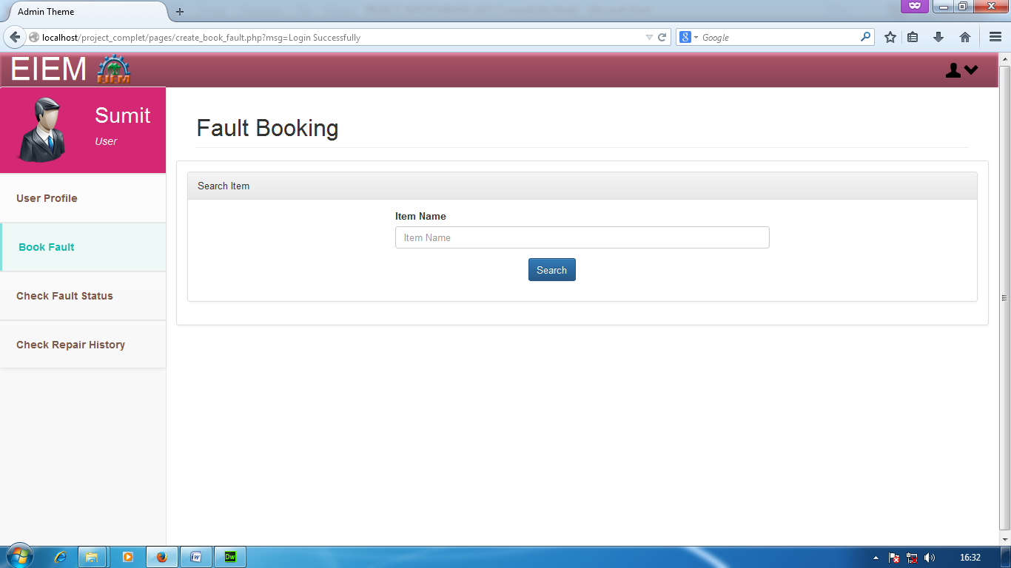

SCREEN SHOT OF FAULT BOOKING IN SELECT FAULT ITEM:

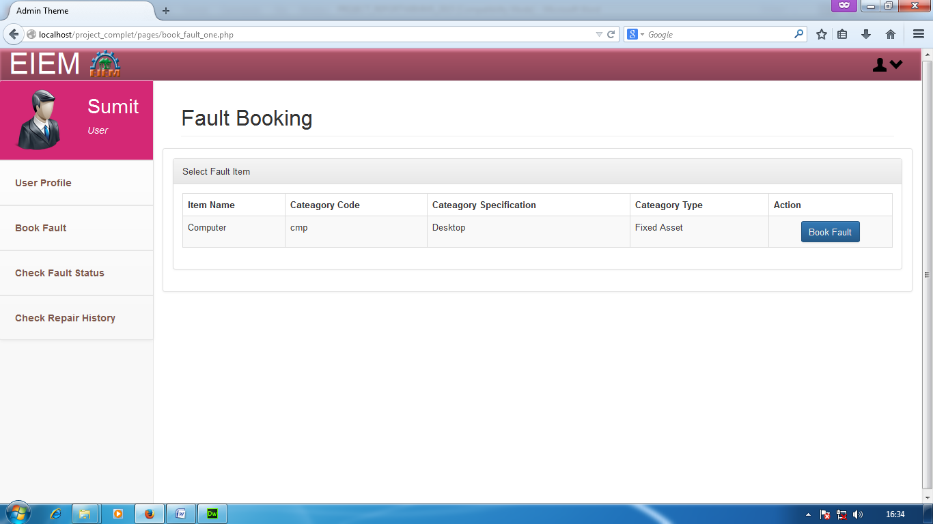
SCREEN SHOT OF FAULT BOOKING IN FAULT ENTRY:

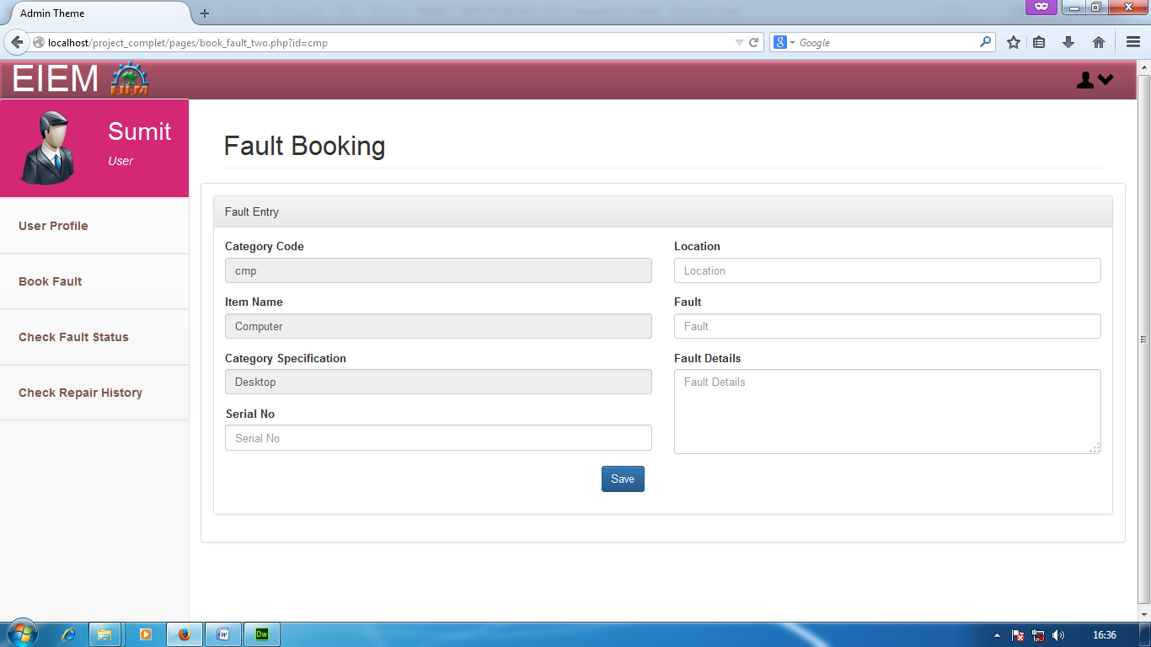

SCREEN SHOT OF FAULT STATUS CHECKING LIST:

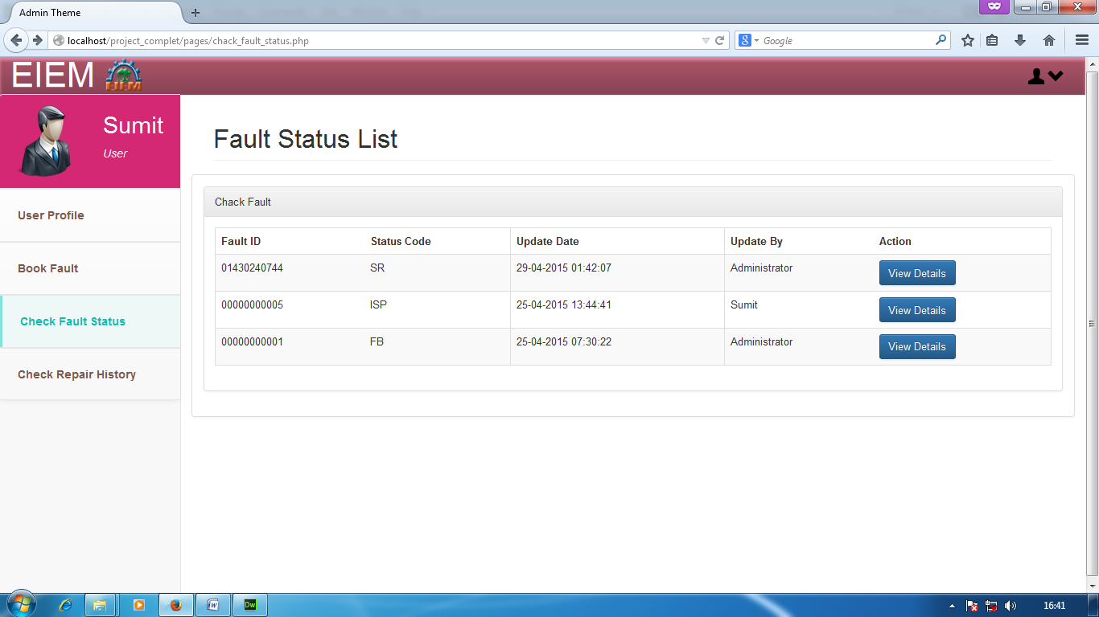
SCREEN SHOT OF FAULT STATUS DETAILS:

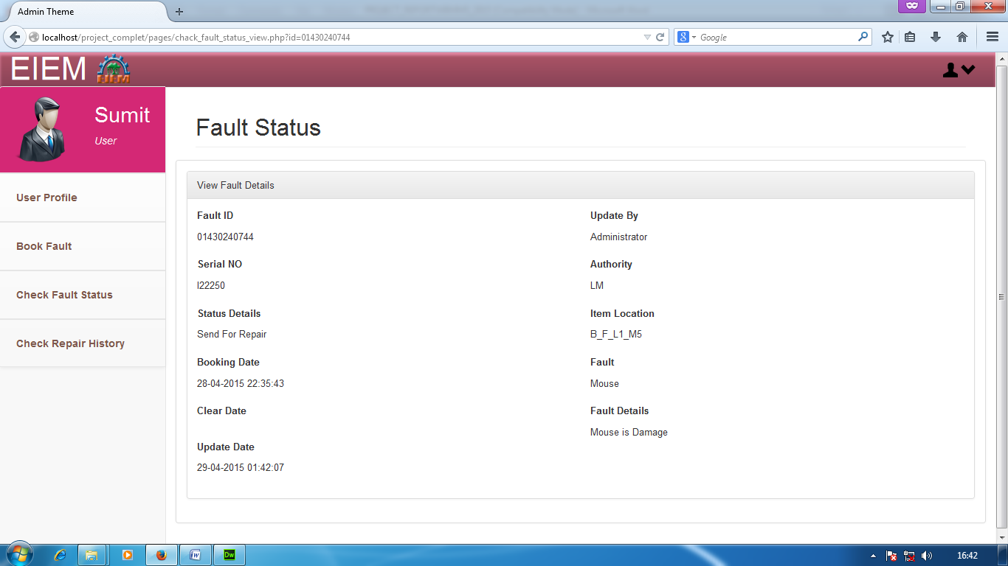

SCREEN SHOT OF REPAIR STATUS CHECKING LIST:

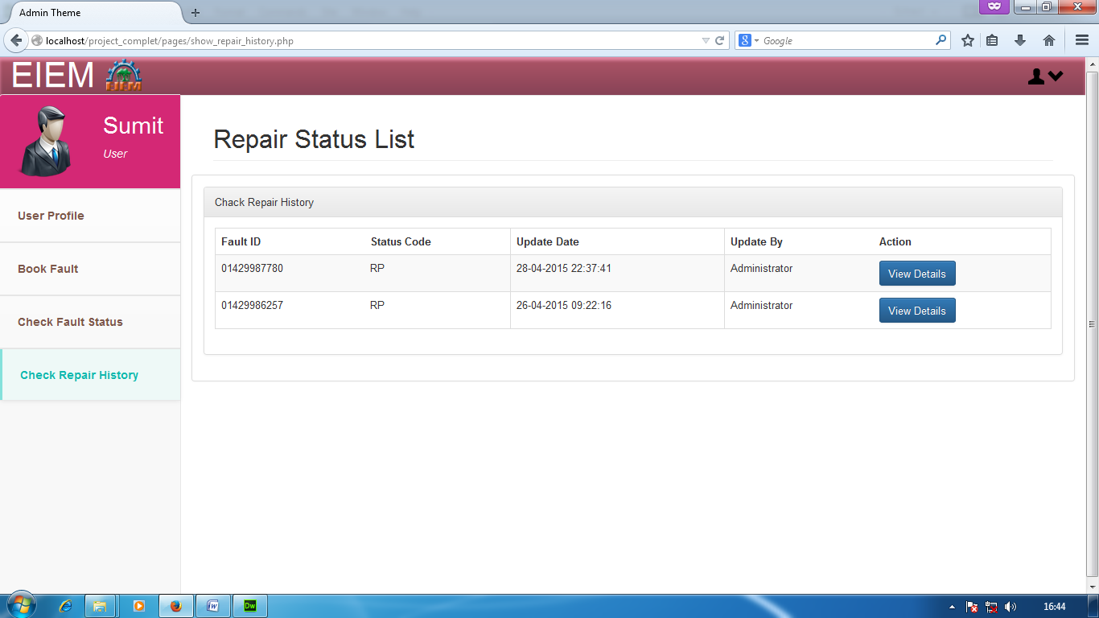
SCREEN SHOT OF REPAIR STATUS DETAILS:

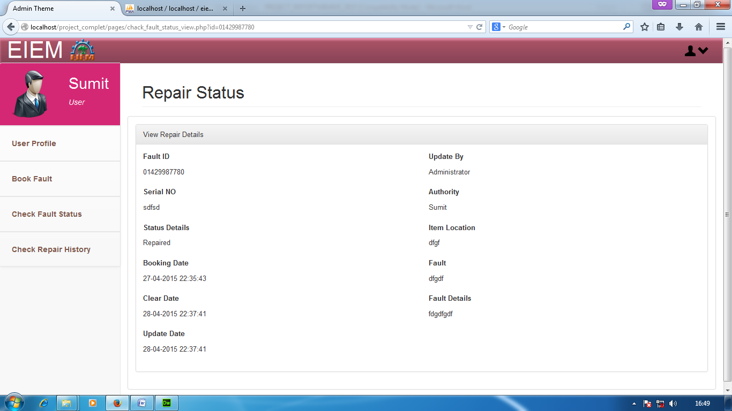

CONCLUSION

The project Web Based Maintenance System is an automation system of the materials concerned with locating, maintaining, updating management of materials of laboratory of an organization.

The project coverage area is the locating and monitoring all the materials of laboratory then sending them for repairing if necessary. This system also can generate reports.

As a conclusion part it is clear that the applications of the software can be a very user friendly approach and can be a remedy of a tedious manual file management system.

LIMITATION OF THE PROJECT

There are some limitations in the project. The following are the limitations of the project

- Location details are not maintained, floor wise or building wise.
- Printed form reports are not maintained.
- Details of vendors are not maintained.
- No details of repair history are not maintained.

BIBLIOGRAPHY

- www.php.net
- www.getbootstrap.com
- Google Search Engine

