QUICK-TRANSFER

A JAVA BASED FILE TRANSFER SOFTWARE

**FEATURES**

* User Friendly GUI
* Multiple Files Sharing
* Secure Group Sharing
* End to End Encryption
* Works Seamlessly well on Wi-Fi and Ethernet
* ‘Share Me’ Feature – Quick Transfer Web
* Easy to use than Windows & Linux Native File Transfer Feature
* Say No to Username and Passwords
* Quickly Connect to Other PCs
* No Charges and Much More...

**Sender Side:**

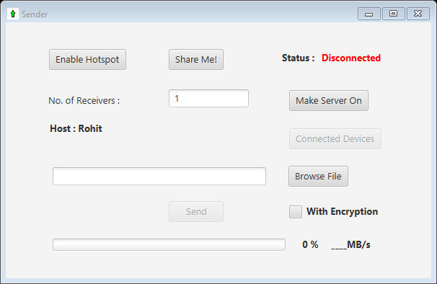

Description:

* Enable Hotspot: Laptop users can enable their hotspot and create network anywhere and share their data.
* Share me: Share **‘QT_setup’** to receiver if he/she doesn’t already have it through **QT-web** by clicking on **‘Share Me!’** and putting **“<sender’s hostname>:6789”** or **“<sender’s_ip>:6789”** in receiver’s browser.
* Make Server On: Start waiting for receivers to connect.
* With Encryption: End to end encryption, For security you can make this on and send files. (May slow down transfer speed).
* Browse Files: You can select files to send.

Steps:

1. Enable hotspot or Connect to Ethernet/Other wireless network.
2. Enter number of receivers and click on Make Server On.
3. Tell your Hostname to receivers to enter.
4. Wait for **Waiting…** changes to **Connected**.
5. Then select receivers after they are connected to you, by clicking on Connected Devices.
6. Select your files and choose appropriate option for Encryption*.
7. And Click on Send.

*Encryption: End to end DES encryption is used for transferring confidential files. Encryption may affect transfer speed.

**Receiver Side:**

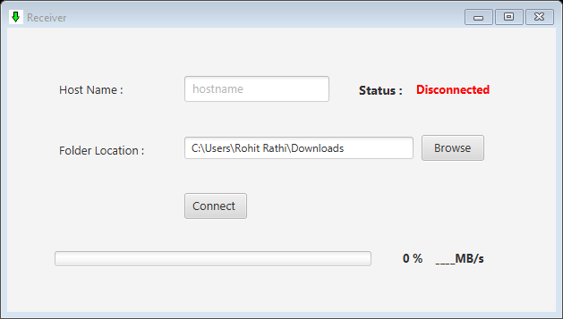

Steps:

1. Hostname: Enter sender’s Hostname/IP address here.
2. Folder location: Choose your folder’s location where you want to receive files.
3. Then After conforming Hostname/IP address click on Connect.
4. Wait for Disconnected changes to Connected.