QUICK-TRANSFER

# A JAVA BASED FILE TRANSFER SOFTWARE

**FEATURES**

* User Friendly GUI
* Multiple Files Sharing
* Secure Group Sharing
* End to End Encryption
* Works Seamlessly well on Wi-Fi and Ethernet
* ‘Share Me’ Feature – Quick Transfer Web
* Easy to use than Windows & Linux Native File Transfer Feature
* Say No to Username and Passwords
* Quickly Connect to Other PCs
* Works without JRE & JDK (Windows only)
* 12 MB/s over Ethernet & 6 MB/s over wifi…
* No Charges and Much More...

**Sender Side:**

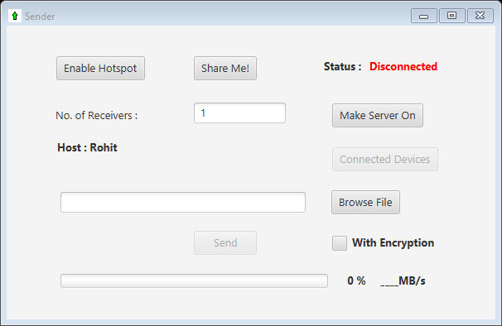

Description:

* Enable Hotspot: Laptop users can enable their hotspot and create network anywhere and share their data. **(Make sure to run the app in administrative mode). (Linux users have to follow on screen instructions to enable hotspot).**
* Share me: Share **‘QT_setup’** to receiver if he/she doesn’t already have it through **QT-web** by clicking on **‘Share Me!’** and putting **“<sender’s_ip>:6789” or “<sender’s hostname>:6789”** in receiver’s browser.
* Make Server On: Start waiting for receivers to connect.
* With Encryption: End to end encryption, For security you can make this on and send files. (May slow down transfer speed).
* Browse Files: You can select files to send.

Steps:

* 1. Enable hotspot or Connect to Ethernet/Other wireless network.
  2. Enter number of receivers and click on Make Server On.
  3. Tell your Hostname/IP to receivers to enter.
  4. Wait for **Waiting…** changes to **Connected**.
  5. Then select receivers after they are connected to you, by clicking on Connected Devices.
  6. Select your files and choose appropriate option for Encryption*.
  7. And Click on Send.

*Encryption: End to end DES encryption is used for transferring confidential files. Encryption may affect transfer speed.

**Receiver Side:**

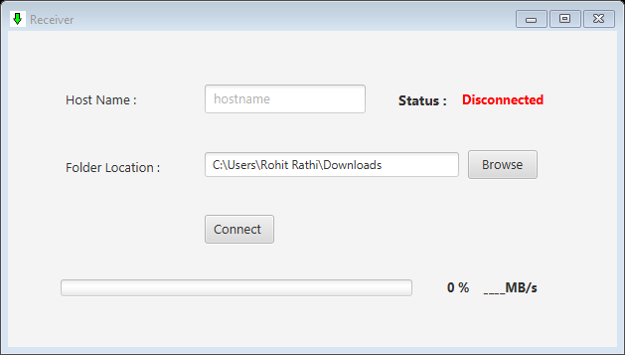

Steps:

1. Host Name: Enter sender’s Hostname/IP address here.
2. Folder location: Choose your folder’s location where you want to receive files.
3. Then After conforming Hostname/IP address click on Connect.
4. Wait for Disconnected changes to Connected.

# **FAQs:**

* **What is “Share Me” ?**

Share Me enables you to share QuickTransfer Setup to other Devices through web!

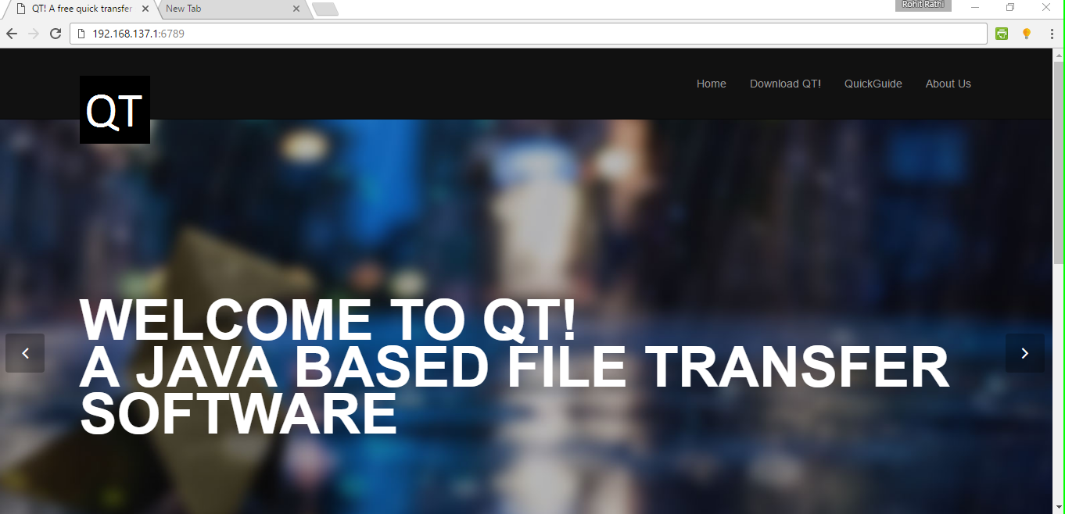

* **What is QTSetup.zip ?**

QTSetup.zip is the archived setup file using which you installed Quick Transfer on your PC. If you don’t have it, you can choose cancel to skip it.

* **Why the receiver is not connecting to the Sender ?**

**It may happen due to following reasons:**

1. Receiver may have entered wrong Hostname/IP address.
2. WiFi connection may have disconnected.
3. There may be another instance of QuickTransfer app running on your pc.
4. More than one user of same hostname may exist in the network, try to use IP address to connect.

**Solutions:**

Try again to connect. If problem still occurs you can check connectivity by pinging server’s Hostname/IP in command prompt.

Ex. ping 192.168.137.1

If error persists, try running the app in **Administrative mode**.

* **Which IP should be used to connection ?**

Generally you can use hostnames to connect to sender.

If hostname doesn’t work choose the IP address of the network to which Sender and Receivers are connected.

(In case more than one common network connection is available, prefer Ethernet for better speed).

* **Can I send Folders through QuickTransfer ?**

Right now, QuickTransfer only allows sending of multiple files.

You can send Folders by creating **zip** **file** on sender’s PC and sending it to the receiver.

* **Is secure and standard Encryption used in QuickTransfer ?**

QuickTransfer provides option of **End to End Secure DES Encryption**. Sender can choose the option of Encryption for sending confidential files. But Encryption may slow down transmission speed for larger file.

* **I have a problem which is not listed here ?**

You can contact our support team at [darkeyedev@gmail.com](mailto:darkeyedev@gmail.com)**.**

**DarkEye Developers**

**Contact us : darkeyedev@gmail.com**