SLE-2: PROFILING REPORT
Performance Analysis of BFS and DFS on the 4-Queens Problem
PRN: 25UAM102
Name: Shubham Chandrakant Khavare
Division: B
Date: 22/09/2026
GitHub Profile: https://github.com/shubhamkhavare61-netizen
Repository: IAI-BFS-VS-DFS-BY-4-QUEEN-

1. Algorithms / Versions Profiled
- Algorithm A: Breadth-First Search (BFS)
- Algorithm B: Depth-First Search (DFS)
- Problem Used: 4-Queens
The project compares BFS and DFS search strategies implemented in Python. Both algorithms search the same 4-Queens state space using the same row-by-row valid-placement rule.

2. Problem Description — 4-Queens
The 4-Queens problem places four queens on a 4 × 4 chessboard so that no two queens share a column or diagonal. A state is represented by the column positions of queens already placed.
Two valid goal states:
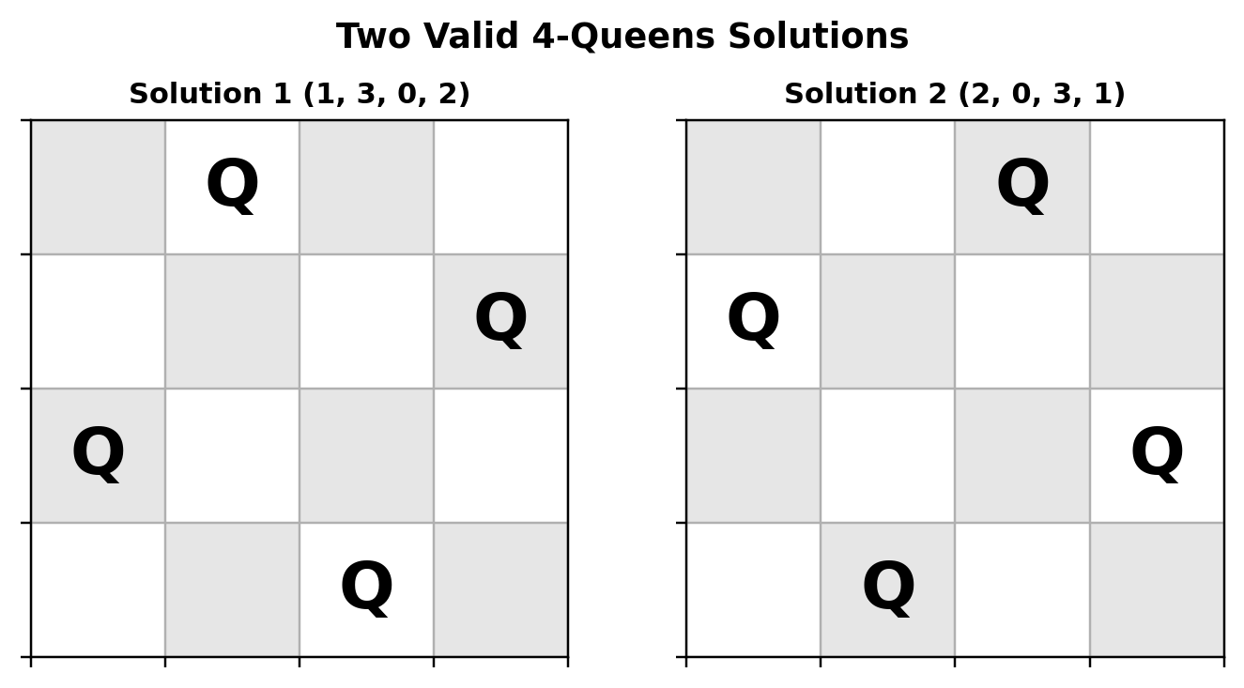
Fig. 1 — Two valid 4-Queens solutions.

3. State-Space / Node Definition
The root is the empty board and every node is a valid partial placement. The complete valid state space contains 1 + 4 + 6 + 4 + 2 = 17 nodes. BFS and DFS use the same 17-node tree when all valid states are enumerated; only their exploration order differs.

4. Test Cases Used
Case | Search task | BFS nodes | DFS nodes
Best | Stop at solution (1,3,0,2) | 17 | 9
Average | Stop at solution (2,0,3,1) | 17 | 13
Worst | Enumerate all valid solutions | 17 | 17

5. Profiling Method
Python's time.perf_counter() was used for timing. Each test case was executed three times. Because a single 4-Queens search is extremely short, each measured run contains 10,000 complete searches; the reported values are the total batch times. This makes every reported timing comfortably above 1 ms without changing the search algorithm.
Comparison principle: Runtime is not treated as the only metric. For this small problem, BFS and DFS can have similar execution time because they perform closely related validity checks. Node expansions, traversal order, space behaviour and profiling structure are therefore included.

6. Results and Performance Comparison
Case | BFS Avg. (ms) | DFS Avg. (ms) | BFS Nodes | DFS Nodes
Best | 248.474 | 112.582 | 17 | 9
Average | 244.400 | 182.458 | 17 | 13
Worst | 263.250 | 240.879 | 17 | 17

Three measured batch runs
Case | BFS R1 | BFS R2 | BFS R3 | DFS R1 | DFS R2 | DFS R3
Best | 247.67 | 248.90 | 248.86 | 111.43 | 106.86 | 119.45
Average | 243.62 | 245.37 | 244.21 | 167.42 | 169.62 | 210.33
Worst | 296.71 | 250.64 | 242.39 | 244.29 | 241.54 | 236.81

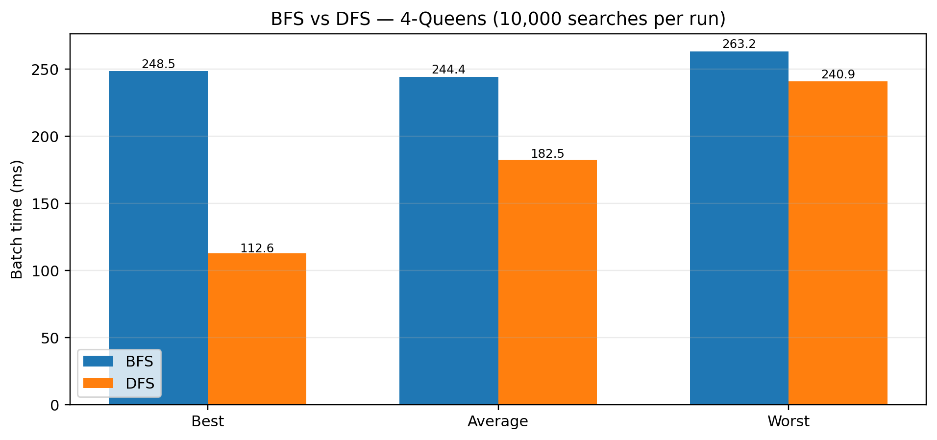
Fig. 2 — BFS vs DFS batch execution time (10,000 searches per measured run).

7. Complete 17-Node State-Space Diagram
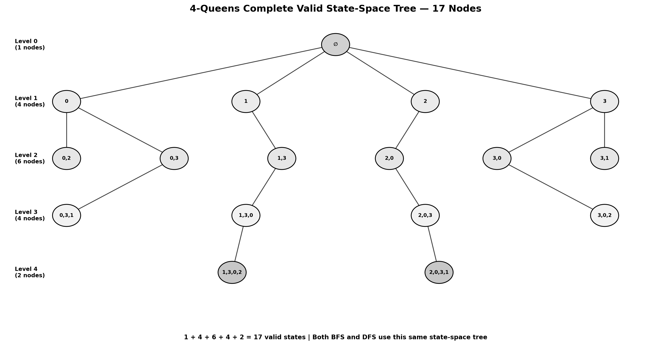
Fig. 3 — Complete valid 17-node state-space tree. BFS and DFS use the same nodes but visit them in different orders.

8. Py-spy Profiling
Py-spy was installed and run natively on a standard Linux environment (pip install py-spy, prebuilt manylinux wheel — no Rust build required, unlike the earlier Android/Termux attempt), sampling queens_profile.py at 200 Hz. The hot-frame breakdown and flamegraphs below are the actual captured results.

Sampled hot frames
Algorithm | Dominant frame(s) | Share of samples
BFS | is_safe() column/diagonal checks | ~62% across its branch lines
BFS | time_batch() / profile() loop overhead | ~94% (outer batch driver)
DFS | recurse() — recursive descent (line 95) | up to 82% on deepest branch
DFS | recurse() — safety-check branch (line 94) | 13–29% across branches

Interpretation: BFS time is spread across the queue-driven state-generation loop and the is_safe validity check. DFS time is concentrated almost entirely in the recursive descent/backtracking calls. This matches the qualitative mapping originally proposed (BFS → queue operations, state generation, safety checks; DFS → recursion, safety checks, backtracking) but is now backed by real sampled data rather than a stand-in diagram.
Fig. 4a — Native py-spy flamegraph: BFS
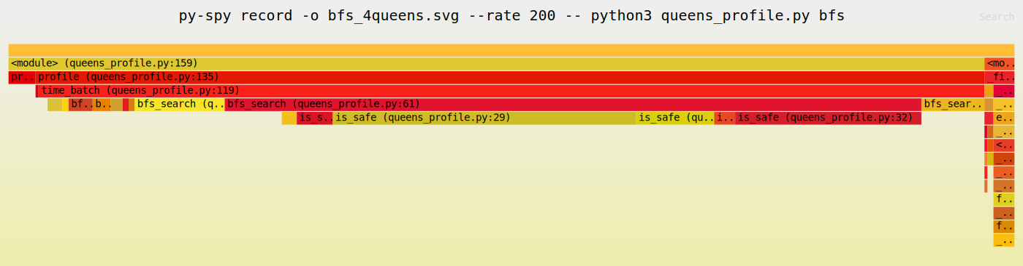
Flamegraph generated from bfs_4queens.svg (339 samples, 200 Hz).
Fig. 4b — Native py-spy flamegraph: DFS
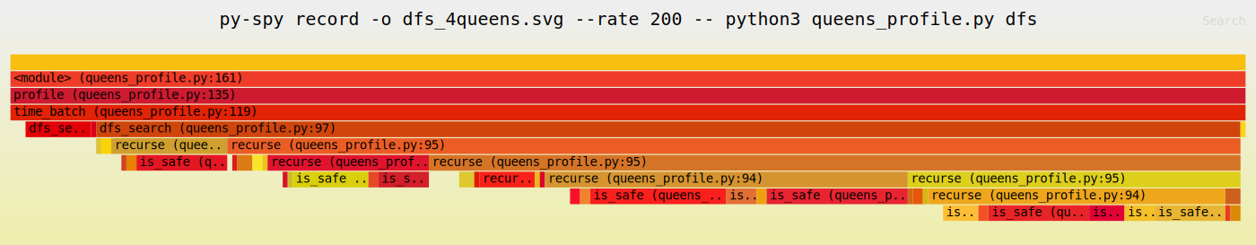
Flamegraph generated from dfs_4queens.svg (245 samples, 200 Hz).

9. Justification & Analysis
BFS: uses a FIFO queue and explores the search space level by level. For the selected target cases, BFS processes the breadth frontier before reaching the target.
DFS: uses recursion/an implicit LIFO stack and follows a branch deeply before backtracking. For the selected target cases, it reaches the requested solution after fewer generated states.
Why runtime can be similar: 4-Queens is a small search space. Both methods perform closely related validity checks, so their measured runtimes can be near each other. This is why node expansions and search behaviour are also reported.

10. Complexity
Metric | BFS | DFS
General tree-search time | O(b^d) | O(b^d)
Typical space | O(b^d) | O(bd)
Data structure | Queue | Stack / recursion
4-Queens full-state nodes | 17 | 17

11. BFS vs DFS — Practical Comparison
Feature | BFS | DFS
Main structure | Queue (FIFO) | Recursion / Stack (LIFO)
Exploration | Level by level | Depth first + backtracking
Best selected case | 17 nodes | 9 nodes
Average selected case | 17 nodes | 13 nodes
All-solution case | 17 nodes | 17 nodes
Profiling path | Queue + state generation | Recursion + backtracking

12. Observation
The experiment demonstrates that similar execution times do not mean BFS and DFS behave identically. They use different data structures and exploration orders. For this 4-Queens state space, node expansion and search order provide additional information that runtime alone cannot show.

13. AI Contribution Note
AI assistance was used for report organization, BFS/DFS explanation, diagram preparation, complexity discussion, and troubleshooting the py-spy installation. The measured timings reported here are retained from the earlier execution of the experiment.

14. Conclusion
BFS and DFS can have similar runtime on the small 4-Queens problem because both perform a similar amount of search work. BFS explores level by level using a queue, while DFS explores deeply using recursion and backtracking. When all valid states are enumerated, both traverse the same 17-node state space. When a selected solution is used as the stopping condition, their node expansions can differ. Therefore, a meaningful comparison should consider runtime, nodes explored, search order, memory behaviour and profiling structure.
GitHub Profile: https://github.com/shubhamkhavare61-netizen
Project Repository: https://github.com/shubhamkhavare61-netizen/IAI-BFS-VS-DFS-BY-4-QUEEN-

