

February 27, 2019

Shubham Jain

A00258743

Assignment

Brief

# Title

## Appointment Management System Using BST and Hashtable

# Classes

* Appointment
* Person
* BST
* HashTable
* Node
* Time
* Date
* MyFrame(Can be multiple)
* MainTest
* Reference

# Abstract

The objective of this project will be to develop an Online Appointment System in Java. The purpose of implementing this application is to create a system through which a person can easily choose and make an online appointment for any purpose just by sitting at home.

Online appointment system aims to improve appointment scheduling by bringing all manual appointment process of the city at one platform, eliminating long waiting lines.

The application will be successfully implemented by using Java programming languages. This application does not aim to target any specific group but every individual who wants to seek help managing appointments and that is why it will be kept in mind to keep the user interface simple and friendly while building this application.

# Features to be Implemented

* Use of Binary Search Tree and Hash-table data structures to insert and search data.
* To view data using an Iterator.
* To use Singleton pattern so that only one instance is used among different frames instead of passing them through constructor.
* Make use of mvc design pattern if possible.
* Make use of any other Java design principles and patterns based on code requirements which would be explained in detail in final report.
* Make use of object oriented concepts such as Aggregation, Polymorphism, Inheritance, Abstraction, Encapsulation etc.

# UML

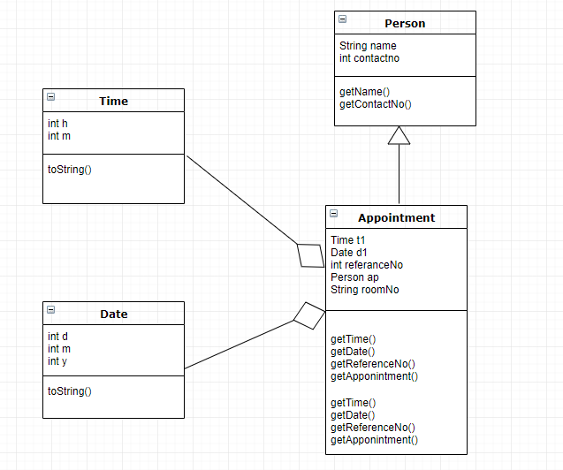

# Use of Binary Search Tree and Hash-table as Data Structures

# Not included in UML as required structure is unknown yet.

# Wireframe

## View All page will use Hash table.

## Find will use Binary Search Tree.

## Create will use insert values in both structures.

