

Shubham Jain

A00258743

Report

Appointment System Using BST and HashTable

# Abstract

The objective of this project was to develop an Online Appointment System in Java. The purpose of implementing this application was to create a system through which a person can easily choose and make an online appointment for any purpose just by sitting at home.

Online appointment system aims to improve appointment scheduling by bringing all manual appointment process of the city at one platform, eliminating long waiting lines.

The application was successfully implemented by using Java programming languages. This application does not aim to target any specific group but every individual who wants to seek help managing appointments and that is why it was kept in mind to keep the user interface simple and friendly while building this application.

# Introduction

Booking appointment online has become a new trend in the past few years and is considered as one of the key processes in the industry. Bailey (1952) considered scheduling system as a trade-off or a compromise between a company and client’s waiting times. Customers who get late for the appointments or who fails to come becomes the reason for the underutilization of a company’s time. Idle time and underutilization of company’s time are also resulted by gaps in the appointment times.

The aim of this project is to create a platform where companies can access/interact efficiently with each other and provide ease and comfort to the clients. It also aims to resolve the problems that companies have to face while taking appointments and keeping files.

# Scope

The scope of the project is limited to the company side. No client can access the platform to generate appointments. Only admin has the right to login and crate a unique reference number for an appointment. He can give the client that reference number and can query appointment data with reference number.

# Limitations and Future Implementation

The biggest limitation being time. This application remains only on server side, database can be implemented and client can be provided an interface to book their own appointment with a person within available time slots.

# Features

* Use of Binary Search Tree and Hash-table data structures to insert and search data.
* Iterator to view data
* Used Singleton Pattern to pass same instance of bst and hashtable.
* MVC pattern implemented to make code more understandable.
* Aggregation of time, date and person class.
* Inheritance of Person and Appointment class.
* Reference number gets automatically generated with 4 numbers followed by 4 other chosen numbers.
* Jtable for representation of data on another frame, use of static variables to retain information.
* Data passing between each frames on button clicks so that the same list is accessed in all frames.
* Efficient memory management to release resources when required eg. Disposing the frame in the background.

# UML

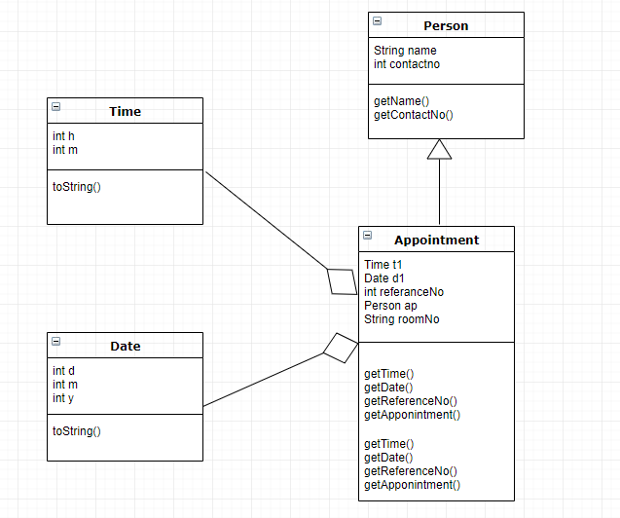

* Created 2 Appointment Classes- BSTAppointment and HashTableAppointment
* BSTree and Hashtable are classes for data structures being used.

# Code Snippets

### Insert in Hash table and BST

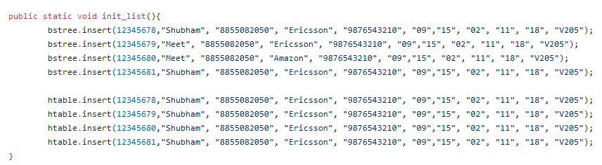

### Singleton Pattern BST and Hash Table



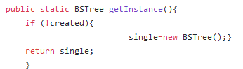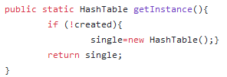

### Iterator BST

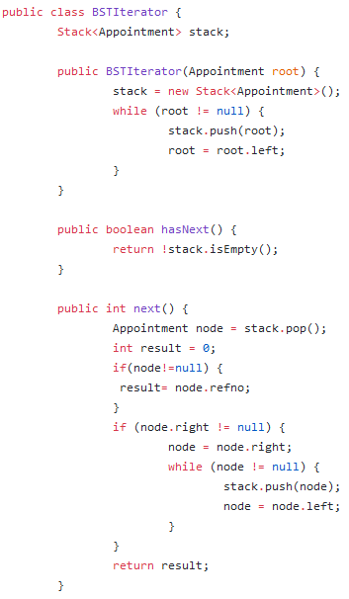

### Search from Hash table and BST



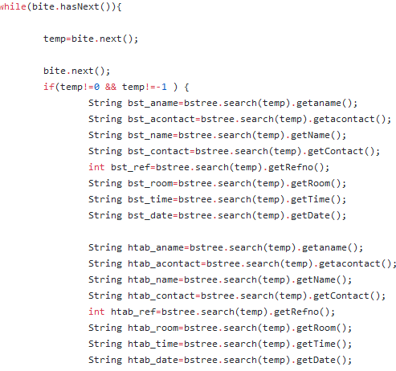

### Aggregation in Appointment Class

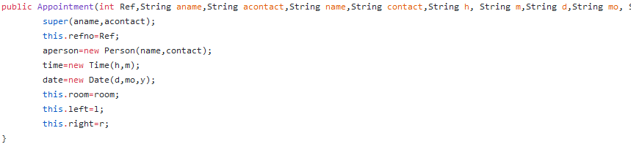

# Screenshots

### Main Frame

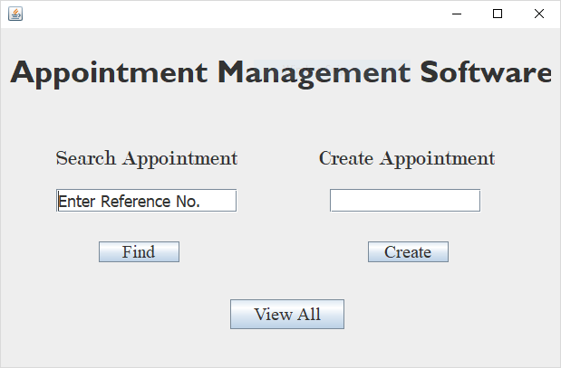

## Create Onclick()

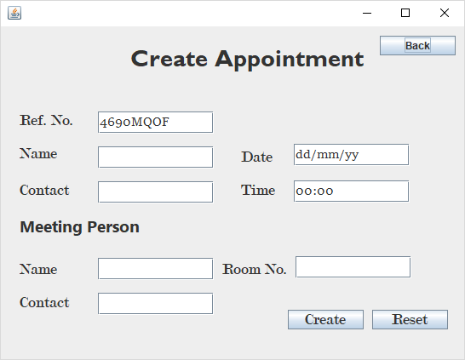

## Find Onclick(Input Reference)- Uses Binary Search Tree

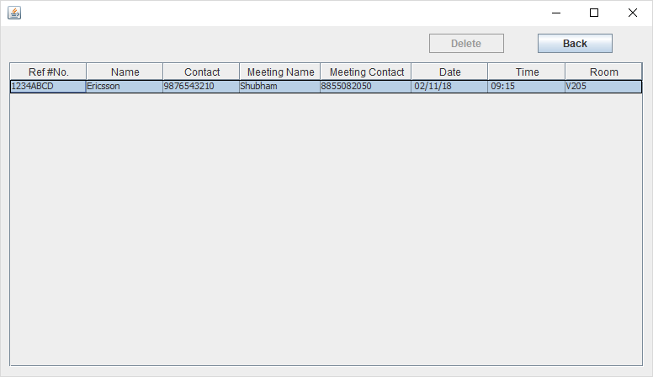

## ViewALL onclick -Uses Hashtable

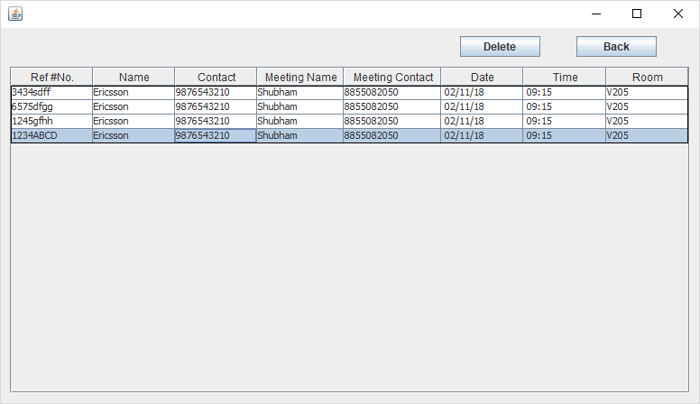

# Performance

Cost of search and insert BST.

Theorem.

Here keys are inserted in random order, then height of tree is (log N), except with exponentially small probability. Thus, search and insert take O(log N) time.

Problem.

Worst-case search and insert are proportional to N. If nodes in order, tree degenerates to linked list.

Cost of search and insert BST.

Theorem.

Ideally all the time complexities should be *O*(1) according to the code.

Problem.

But *O*(1) is achieved only when number of entries is less than number of buckets. In other words if load-factor is less than 1.  
Worst Case is always*O*(*n*), You can go about looking-up all the elements in the list

# Conclusion

A- simple appointment management system is created by using Binary Search Tree and Hash table as data structures, values are iterated using Binary Search Tree and different design patterns are applied. Also object oriented concept are kept in mind as seen in the features.