October 26, 2018

Shubham Jain

A00258743

Assignment 1

Brief

# Title

Appointment Management System

# Classes

* Appointment
* Person
* Linkedlist
* Time
* Date
* MyFrame(Can be multiple)
* MainTest
* Reference

# Brief

The system aims as automating processes of scheduling an appointment.

# UML

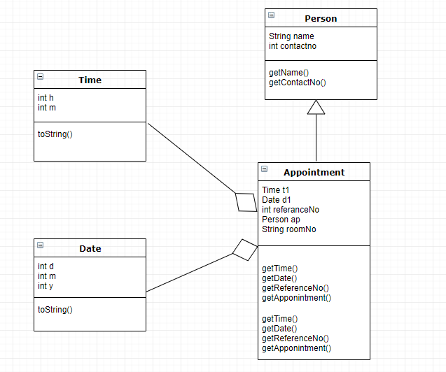

# Wireframe

