Assignment 1

Software Design

Shubham Jain

A00258743

# Abstract

The objective of this project was to develop an Online Appointment System in Java. The purpose of implementing this application was to create a system through which a person can easily choose and make an online appointment for any purpose just by sitting at home.

Online appointment system aims to improve appointment scheduling by bringing all manual appointment process of the city at one platform, eliminating long waiting lines.

The application was successfully implemented by using Java programming languages. This application does not aim to target any specific group but every individual who wants to seek help managing appointments and that is why it was kept in mind to keep the user interface simple and friendly while building this application.

# Introduction

Booking appointment online has become a new trend in the past few years and is considered as one of the key processes in the industry. Bailey (1952) considered scheduling system as a trade-off or a compromise between a company and client’s waiting times. Customers who get late for the appointments or who fails to come becomes the reason for the underutilization of a company’s time. Idle time and underutilization of company’s time are also resulted by gaps in the appointment times.

The aim of this project is to create a platform where companies can access/interact efficiently with each other and provide ease and comfort to the clients. It also aims to resolve the problems that companies have to face while taking appointments and keeping files.

# Scope

The scope of the project is limited to the company side. No client can access the platform to generate appointments. Only admin has the right to login and crate a unique reference number for an appointment. He can give the client that reference number and can query appointment data with reference number.

# Limitations and Future Implementation

The biggest limitation being time. This application remains only on server side, database can be implemented and client can be provided an interface to book their own appointment with a person within available time slots.

# UML Diagram

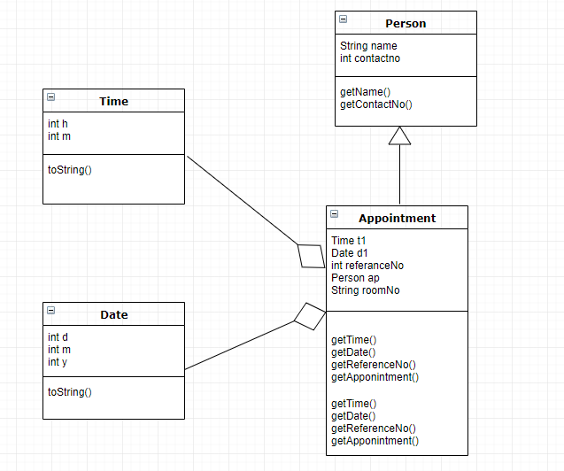

# Features

* Aggregation of time, date and person class.
* Inheritance of Person and Appointment class.
* Reference number gets automatically generated with 4 numbers followed by 4 characters.
* Jtable for representation of data on another frame, use of static variables to retain information.
* Data passing between each frames on button clicks so that the same list is accessed in all frames.
* Efficient memory management to release resources when required eg. Disposing the frame in the background.

# Screenshots

### Main Frame

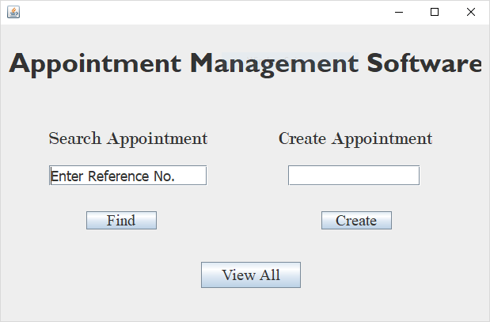

## Create Onclick()

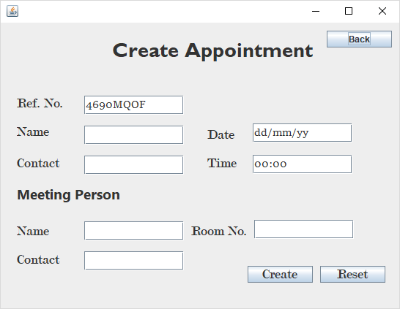

## Find Onclick(Input Reference)

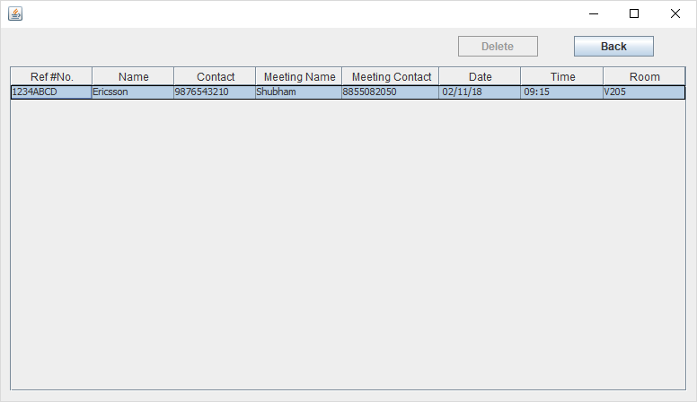

## ViewALL onclick

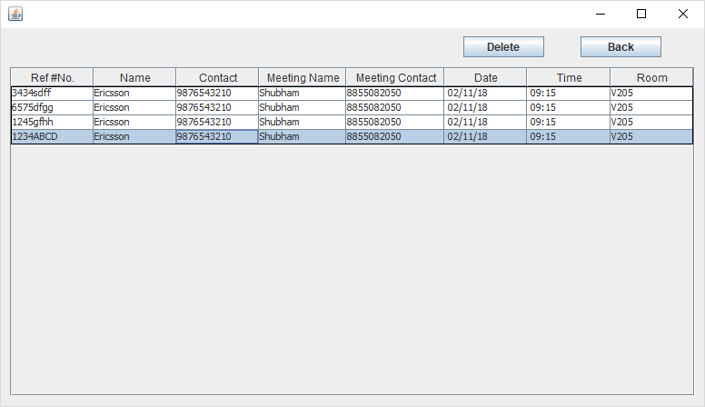

## ViewALL: DELETE onclick() (Notice the selected row gets deleted)

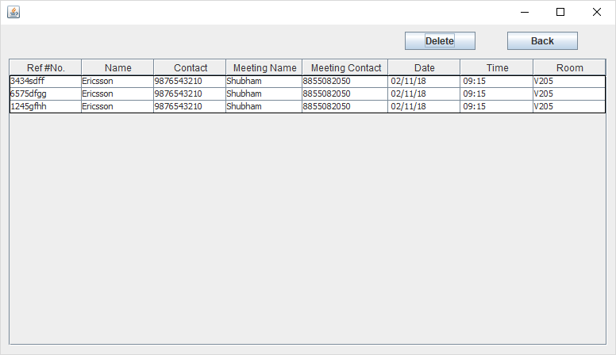

# Code

## MainClass(That runs the frame- LandingFrame)

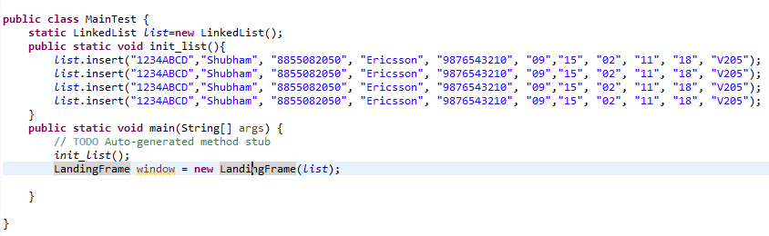

## Code snippet to open DetailFrame which views appointment details

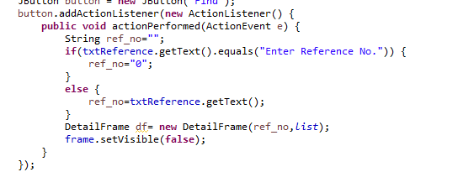

## Code snippet to open MainFrame to add a new appointment

## 

## Code snippet of appointment class constructor where aggregation and inheritance is applied

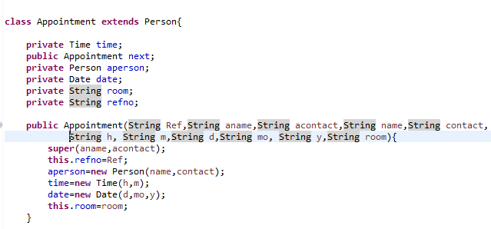

# Conclusion

Usually developing any system comprises of three basic steps planning, design, and the testing phase. After finalizing the basic requirements that should be met by the system, it was also important to decide which java design approach to use for the development of this system. For this purpose, I took help from the web and carefully studied already existed similar web applications. The class diagram was drawn to explain the relationship and behaviour of entities.

The final submission includes all necessary operations needed for generating and assigning appointments with unique reference number that will be used for deleting and querying.