Questions

- Give the output for the following commands:
a. Echo command
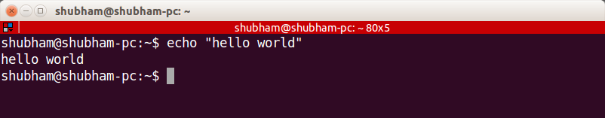
b.List all the files(hidden included) present in the current directory in long format displaying files in reverse order , sorted based on the modification time .

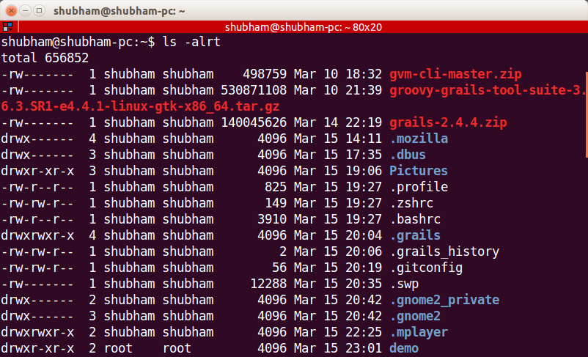

C. Change your current password.

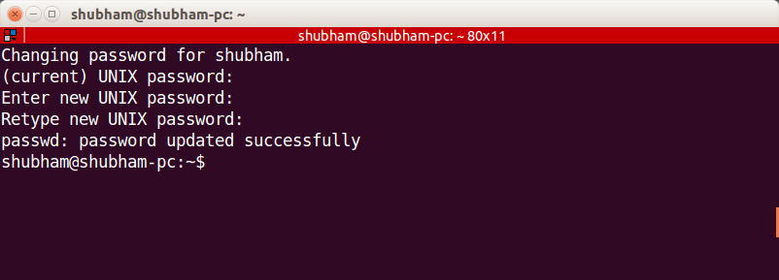

d. How to get the current date
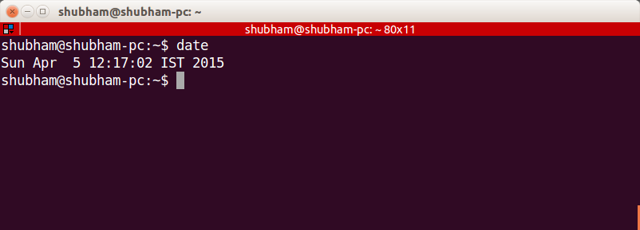

e. How to get the current logged in user

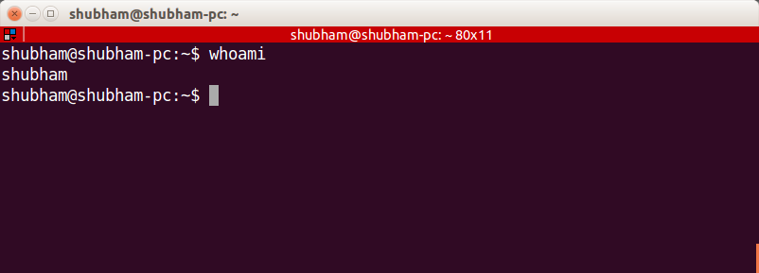

F. How to get the current working directory.

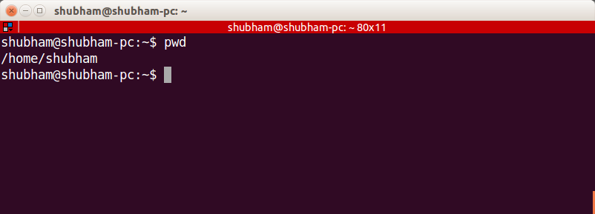

G. How to get the list of all commands that you have typed so far
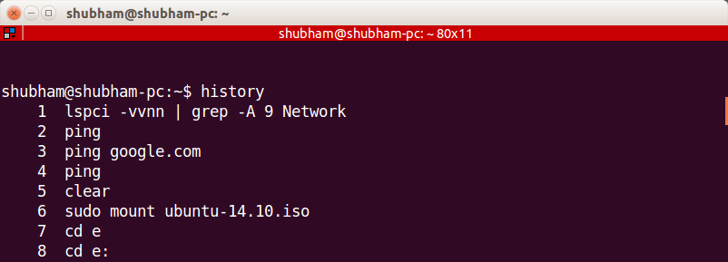

H. To get the information on the tcp ports

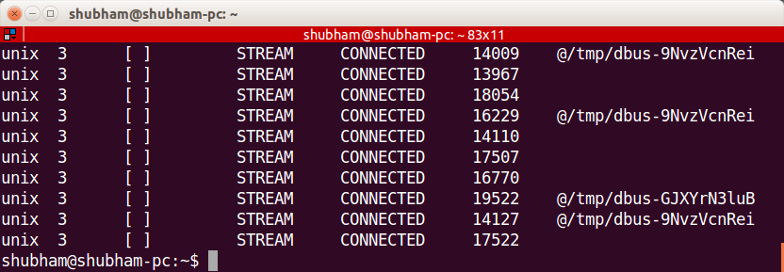
I. To get the information about the running processes.
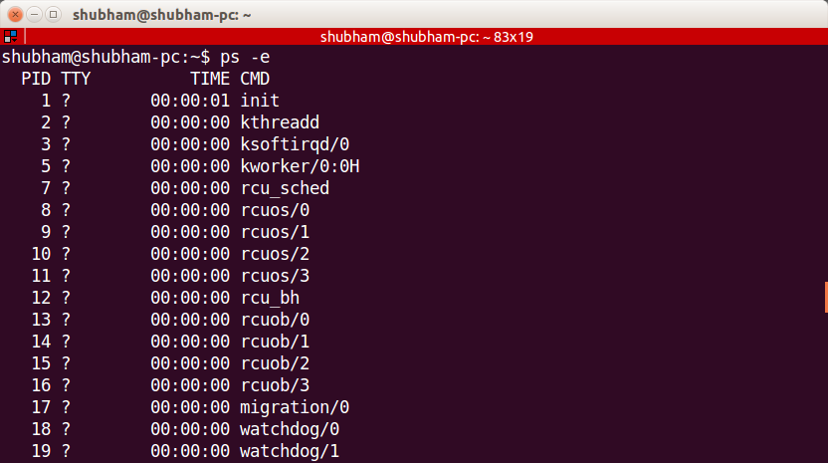

j. Search for a word in a file. (Hint – grep)

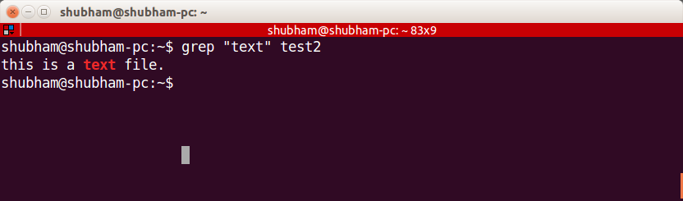

k. Search for a specific process. (Hint - use | with ps )

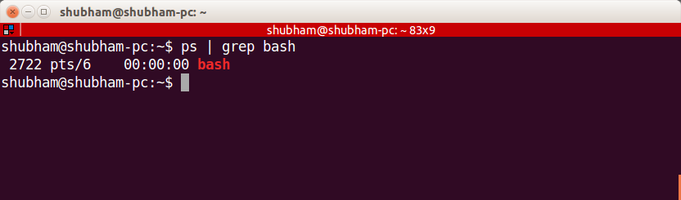

- Create a directory “exercises” inside your home directory. cd to this new directory.
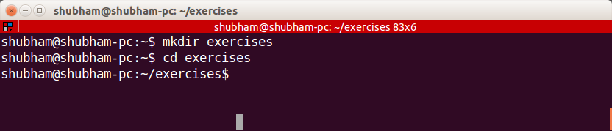
- Create 3 empty files , file1.txt,file2.txt,file3.txt in current directory (exercises).

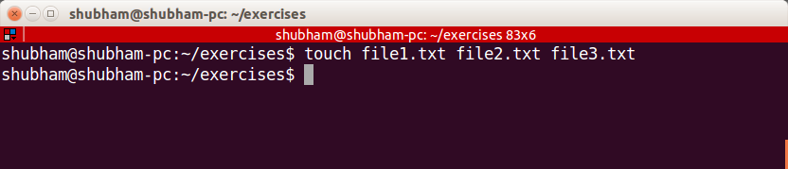

- Add some text to file1.txt and copy this to ~/exercises/files.
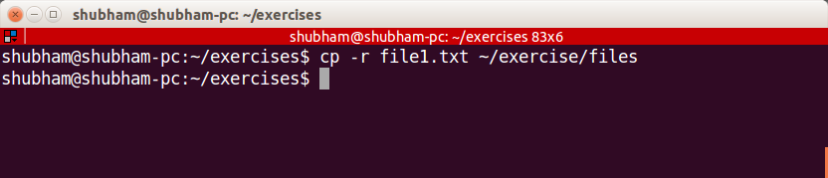

- Copy the entire exercise directory to this files directory.
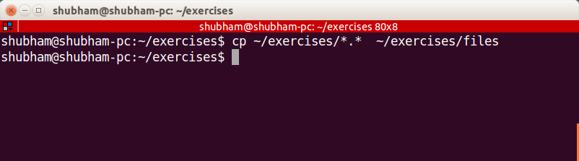
d

- Create a symlink “testlink” in your home directory that points to this file1.txt i.e. ~/exercises/files/file1.txt.

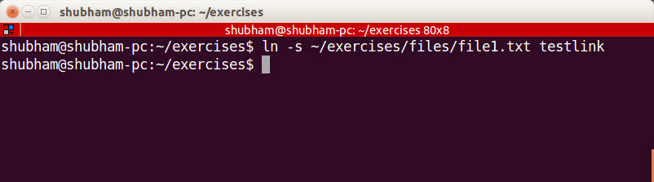

- Try creating a hard link in your home directory that points to “files” directory .
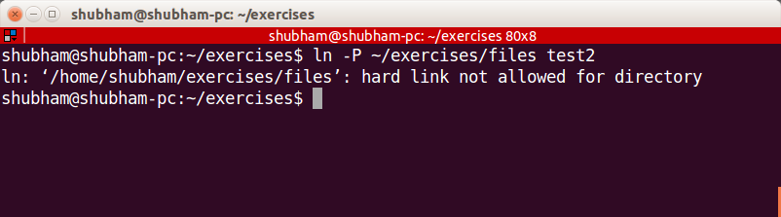
- Difference between soft and hard link.

A hard link creates a case where two or more directory entries contain the same inode number. No additional search is required. The inode is not released until its hard-link count (normally '1') reaches zero.
A symbolic link is, in effect, a special type of file which contains a file-name or directory-name. Upon encountering a symbolic link, a search is made for the target of the symbolic link, using an ordinary search.

- Change permissions for files directory such that nobody other than the user who created the directory, can write/update anything in that directory.

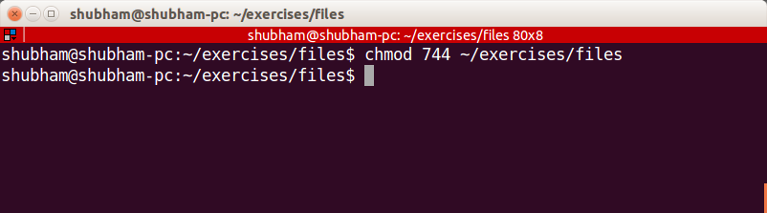

- Create a new user “test”.
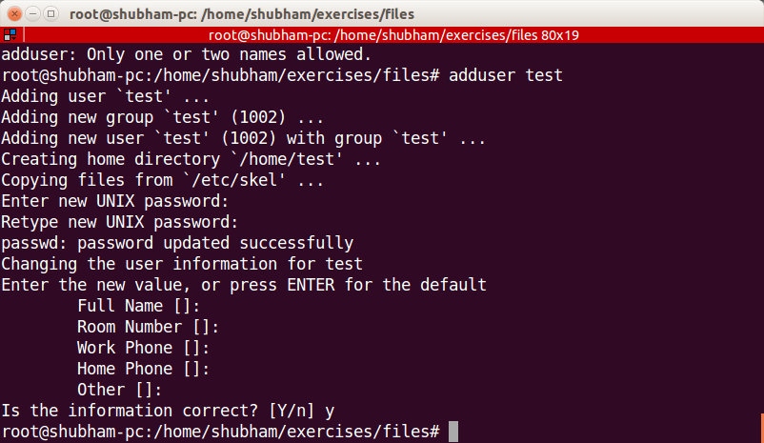

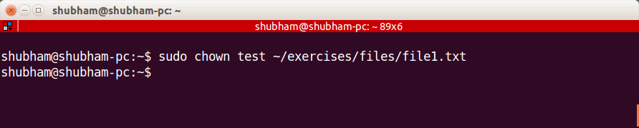
- Change the owner of file1.txt to test

- create following directory structure with single command -
home
|-john
|-work
|-scripts
|-bash

Assume that you are currently in ‘home’ directory.
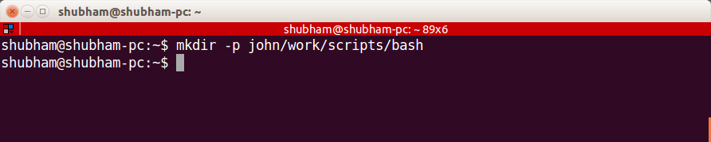
- Try deleting the ~/exercises/files/exercises directory. See what happens.

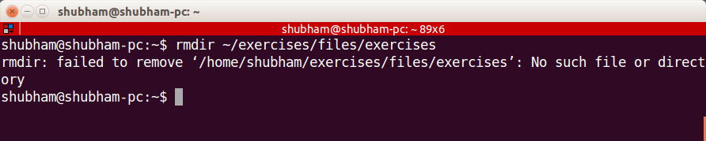

- A file named employees.odt has a mode of rw-r- -r- -. If John is not the file's owner but is a member of the group that owns this file, what can he do with it?
John has read only access. So he can only read the file contents.

- Create an alias for clearing the screen.

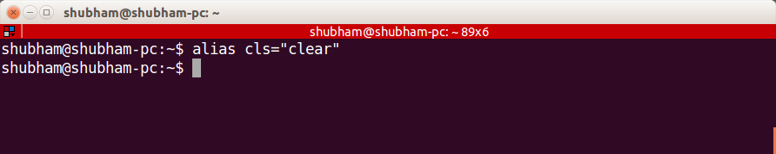

- Create a tar archive of all the files in the current directory.
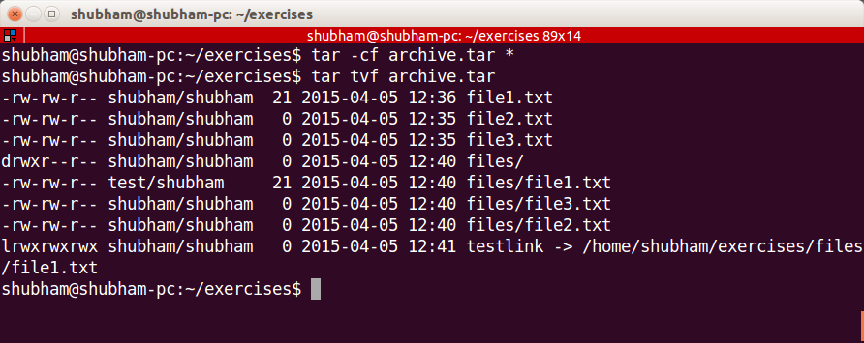

- H ow to find if a jar file contains a particular class file?
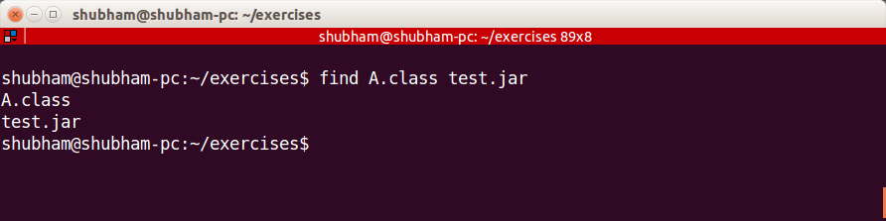

- How to find all jars with given classname.
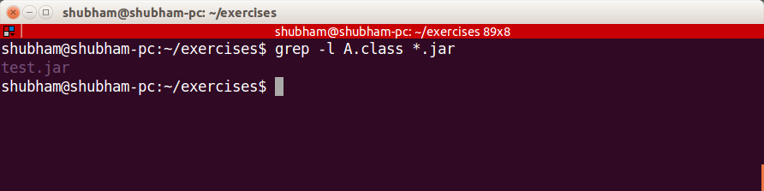

  - How to find files greater than a certain size
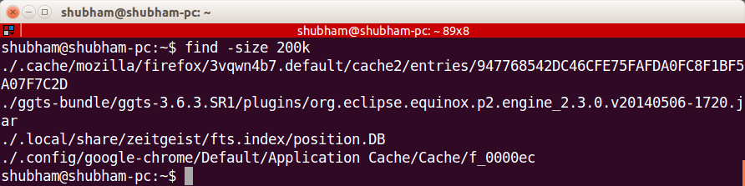

- How do u add and remove a variable in the shell environment.

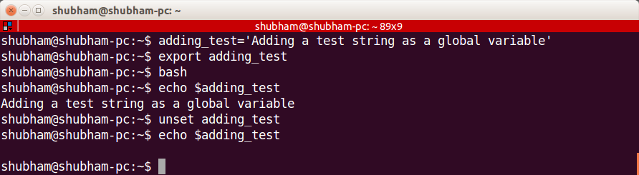

- Install openssh-server on your system

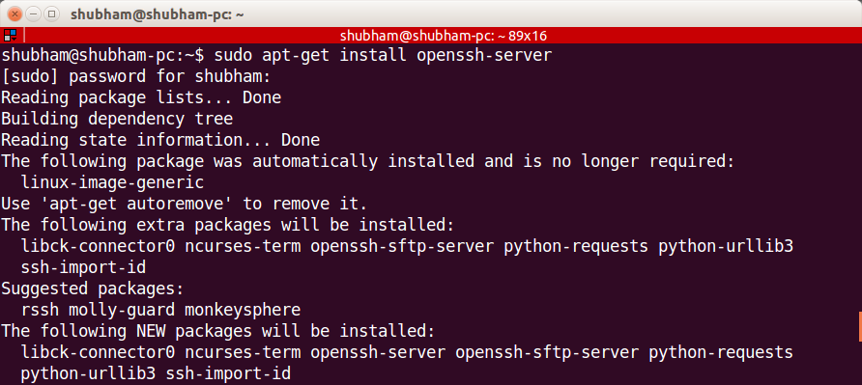

- .try remote login to your friend’s machine using ssh.

- Copy some files from your machine to your friend’s machine. (Hint – scp)

Sorry but unable to do, due to lack of any possible way of doing this since i can’t find any friend with open-Ssh server working at the same time as me.

