Black Box Penetration Testing on Enterprise Network

Executive Summary
A full penetration test was done on the virtual network 192.168.11.0/24 to simulate real-world cyberattack scenarios and provide a safe environment to test exploitation vulnerability, identify security loopholes, and search for hidden flags planted on several host systems. Eight flags were discovered along the process, involving reconnaissance, enumeration, exploitation, privilege escalation, and forensic process. Reconnaissance using Nmap, Nessus, and Nikto identified various hosts, open ports, and running services; some of these could be attacked by well-known exploit techniques: SMB exploits, most notably MS17-010; SQL Injection; insecure web applications (WolfCMS and WordPress); and misconfigured sudo permissions. Metasploit and Sqlmap were the tools used to carry out exploitation and bring the target machines into controlled compromise, along with other tools like steganography analyzers. Each recovery of a flag signified an attack path and, therefore, differentiated the types of vulnerabilities that can be found even in smaller-scale networks. The results emphasize an ongoing requirement for the updating of systems, secure configurations, and access control policies. Recommendations on how to curb future risks and improve security posture were outlined from the test results. Further, the report finds an approach-based reflection on ethical hacking, hence fortifying best practices in reconnaissance, exploitation, and reporting. Besides sharpening technical skills, the activity emphasized teamwork, documentation, and brainstorming to prepare the teams for acute cybersecurity assessments. However, the test has uncovered some more severe vulnerabilities that, if not resolved, may lead to data breaches, abuse of privileges, or even denial of services. Thus, the findings warrant continuous security assessments and proactive defense measures to ensure the existence of a resilient IT infrastructure.

Table of Contents
Introduction 4
Reconnaissance 4
Flag Discovery & Exploitation 6
Flag 1: EternalBlue Exploit 6
Flag 2: Image File 6
Flag 3: Windows Registry Enumeration 7
Flag 4: Exploiting WolfCMS for Remote Code Execution 7
Flag 5: Gain root access 8
DNS Zone Transfer 8
Flag 6: QR Code Analysis 8
Flag 7: SQL Injection and Remote Shell 9
Flag 8: Gain Root access 10
Flag 10: Image File Steganography 11
Mitigation Strategies for Discovered Attacks 12
Conclusion 13
Appendices 15
Appendix: Flag 1 15
Appendix: Flag 2 18
Appendix: Flag 3 19
Appendix: Flag 4 19
Appendix: Flag 5 21
Appendix: Flag 6 22
Appendix: Flag 7 23
Appendix: Flag 8 27
Appendix: Flag 9 28
Appendix: Flag 10 30

Introduction
Penetration Testing or Ethical Hacking is the offensive counterpart to defensive security. Hence, preemptive tests are conducted on information technology systems to exploit their weaknesses as they would in a genuine cyberattack (Mironeanu et al., 2021). It lets the organization know the weaknesses before being exploited by an actual criminal. This report serves as a collection of findings from a complete penetration test run on a simulated enterprise network (192.168.11.0/24). The objective was to identify security vulnerabilities, exploit weaknesses, and steal hidden flags from several target systems. The testing environment consisted of some host machines and services, similar to those provided by real infrastructure settings (Ali, Maghawry, and Badr, 2022). This exercise was meant to project a scenario of ethical hacking where reconnaissance, exploitation, and privilege escalation techniques were used with standard industry tools, including Nmap, Metasploit, Nikto, and SQLMap. Testing mostly took place from Kali Linux, and thus, the black-box testing approach was followed, offering very little information about the target network (Alhamed and Rahman, 2023). Every exploit and testing method followed, every flag stolen was recorded methodically and carefully, including the tools used in the process. Hence, the report briefly focuses on the technical findings but gives room for recommendations to improve the network's security, stressing that prevention or defense is the way forward in today's cyber world.

Reconnaissance
The first phase of the penetration test was based on reconnaissance, targeting live hosts, open ports, and services on the victim network 192.168.11.0/24. All these activities were undertaken with the help of Nmap, Nessus, and Nikto, and then enumeration and exploitation became the next step. Five live hosts were detected using Nmap fast scan (nmap -F):
- 192.168.11.79 (multiple SMB-related ports, including 445/tcp and 49152-49156/tcp)
- 192.168.11.98 (SSH: 22/tcp, Squid proxy: 8008/tcp)
- 192.168.11.199 (FTP: 21/tcp, SSH: 22/tcp, HTTP: 80/tcp, HTTPS: 443/tcp, DNS: 53/tcp)
- 192.168.11.223 (SSH and HTTP open)
- 192.168.11.1 (RDP: 3389/tcp) (own Machine)
Based on the arising consequences, possible threat vectors pinpoint SMB attacks, web attacks, or brute-force attempts against exposed SSH or FTP services.
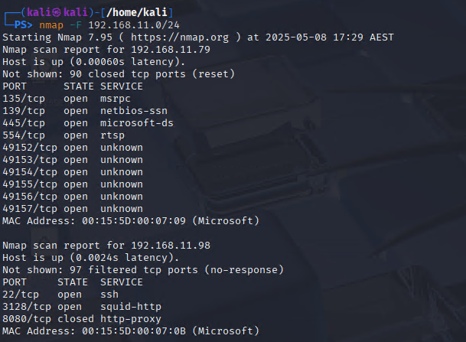
Figure 1: Nmap Scan Result
(Source: Self-Created)
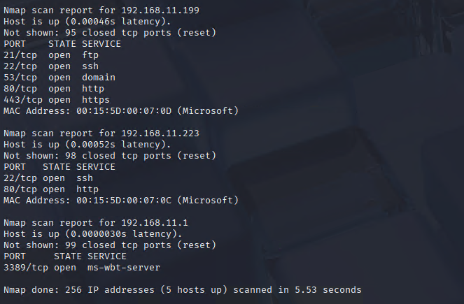
Figure 2: Nmap Scan Result
(Source: Self-Created)
Vulnerability assessment was conducted through Nessus. It classified 192.168.11.199 as the most critical host due to having 53 vulnerabilities with critical severity and 51 with high severity, which included vulnerabilities in outdated SSL/TLS protocols, versions of PHP, and misconfiguration of Apache. Other hosts like 192.168.11.79 and 192.168.11.98 had threats in abundance, ranging between medium risk and high risk.
Nikto was then launched to scan 192.168.11.199, and misconfigurations were reported. On the Apache server, sensitive files such as “phpinfo.php” and “phpMyAdmin” are exposed. Software versions are way out of date (Apache 2.4.6 and PHP/5.4.31), and the headers lack important security directives such as X-Frame-Options and Content-Type. This practically confirms the previously conceived theory that this target web application could be exploited through well-known vulnerabilities and attacks such as remote code execution or credential harvesting.
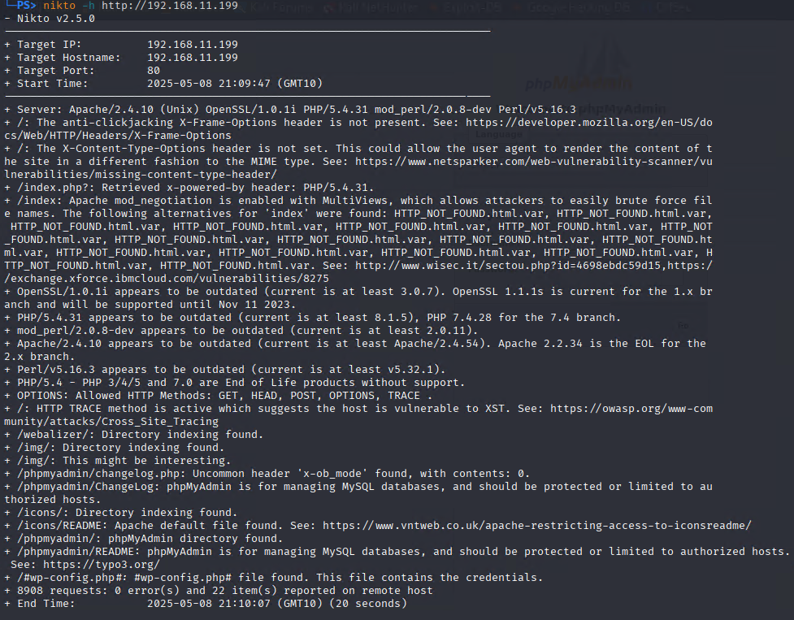
Figure 3: Nikto scan result
(Source: Self-Created)

Flag Discovery & Exploitation

Flag 1: EternalBlue Exploit
Host: 192.168.11.79
According to the Nmap scan, the SMB ports are exposed (45), suggesting a possible vulnerability to MS17-010 (EternalBlue). The ms17_010_eternalblue was configured in Metasploit with RHOST and LHOST values. The exploit went through successfully, and shell Meterpreter access was granted. Furthermore, upon browsing Documents, the encoded file decode.me was discovered within the system. After decoding via Base58, the following flag was recovered: “Marika shattered the Elden Ring not for war, but for will. Her golden law was a cage, and her rebellion was a mirror.”
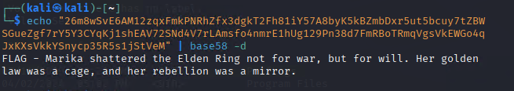
Figure 4: Flag 1
(Source: Self-Created)

Flag 2: Image File
Host: 192.168.11.79
Malina's pursuit of theoretically exploring the same host led to the Pictures directory. Inside the directory was a file called wallpaper.png, which was downloaded. When opening wallpaper.png file discover flag: “The Lands Between offer no mercy. Every grace is a checkpoint, every death a lesson, and every boss a nightmare in golden form.”


Figure 5: Flag 2
(Source: Self-Created)

Flag 3: Windows Registry Enumeration
Host: 192.168.11.79
System had access maintained for interrogating the Windows registry entries. A suspicious registry key was identified, named “FlagsRHere”. Values under this key were extracted by invoking the reg query command, flag: “Let Me Solo Her faced Malenia alone - naked, pot-headed, undefeated. A meme to some, a legend to others, and a symbol to the Tarnished.”
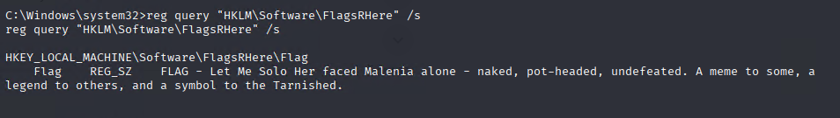
Figure 6: Flag 3
(Source: Self-Created)

Flag 4: Exploiting WolfCMS for Remote Code Execution
Host: 192.168.11.98
The WolfCMS application was found on IP 192.168.11.98; this was the first inspection using the curl command with a configured proxy that exposed the /wolfcms dir in the robots.txt file. As soon as the admin logged into the interface, a login window appeared, where one had to enter the credential username: admin and password: admin. Once logged in with an administrator-level account, used the CMS's file manager to upload a PHP reverse shell script called php-reverse-shell.php. The invocation for the script took place from the web interface. While Netcat was listening on port 5555, the reverse shell was offered. The upgrade with the Python pseudo-terminal allowed for a smooth interaction. Upon tasting the joy of /home/rykard/, found flag.txt: "Godrick the Grafted wears other men’s arms like trophies. But no number of limbs can make a coward into a Lord."
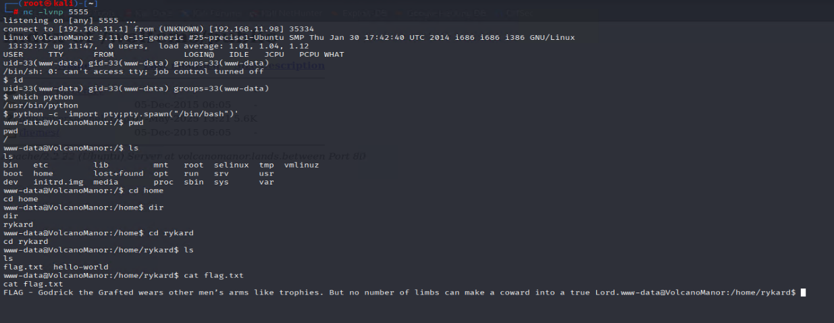
Figure 7: Flag 4
(Source: Self-Created)

Flag 5: Gain root access
Having gotten the initial reverse shell on the target with the www-data privilege, one tried for a privileged escalation to root level. By exploiting known local vulnerabilities and misconfigurations in the systems, the privilege escalation went well into the root level. Now with the root privilege, the root directory was navigated to find the final flag file named flag.txt: “Life fixes death its dignity. She lies beside the dead not in fear, but in faith—her embrace a ritual, her rebellion a whisper.”
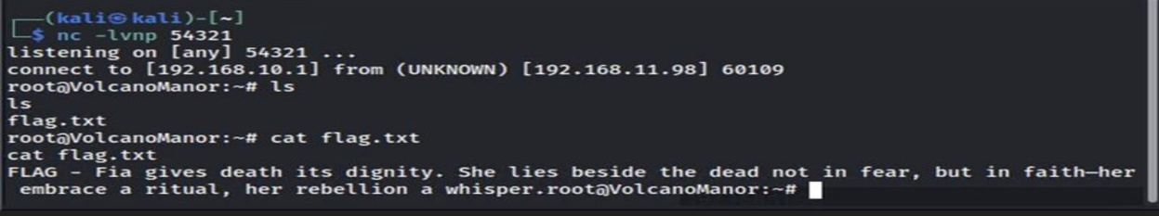
Figure 8: Flag 5
(Source: Self-Created)

DNS Zone Transfer
Host:192.168.11.199

Flag 6: QR Code Analysis
Performing the DNS zone transfer technique on the host 192.168.11.199 yielded information on DNS records for the lands.between domains, entered prisoner.lands.between among the subdomains, where a webpage embedded a QR code image. After scanning the QR code, the flag was revealed: "Ranni's path is not of gold, but of cold moonlight and stolen death. Her fingers reject fate, and her blade rewrites it." This explained the ability to do DNS zone transfer to collect information and use it to find hidden flags in the web environment, thus applying effective reconnaissance and flag identification methods.
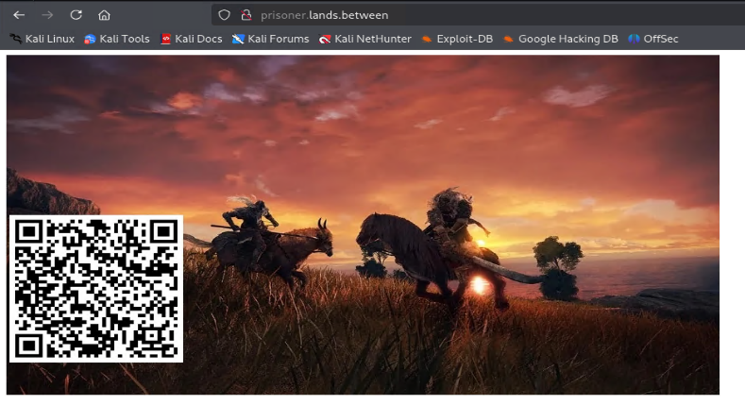
Figure 9: QR Code Image
(Source: Self-Created)
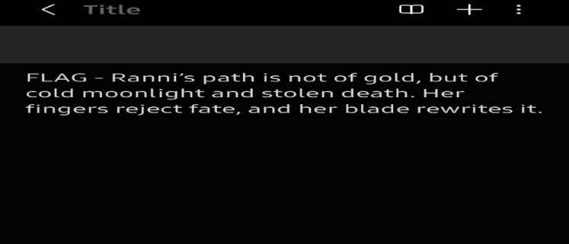
Figure 10: Flag 6
(Source: Self-Created)

Flag 7: SQL Injection and Remote Shell
Host: 192.168.11.199
An exposed web service was detected running OpenDocMan version 1.2.7 that was vulnerable to SQL Injection. Through this vulnerability, the credentials for the WordPress database and deduced the username of the admin along with the encrypted password. After being decrypted, the password was "eldenring". With these credentials, log in to the WordPress admin panel and select the Twenty Seventeen theme editor. Then, with this access, upload the PHP reverse shell script onto the server. Setting up a Netcat listener, the attacker then received a reverse shell connection, allowing command executions on the target system. This demonstrated the critical chained nature of the vulnerabilities, which started with SQL Injection, proceeded to the compromise of credentials and uploading of a web shell, and finally went on to result in full access to the target environment and found file name of flag.txt: “The Tarnished are called back not as heroes, but as failures—chosen by a broken grace to repair a world cursed by its own gods.”
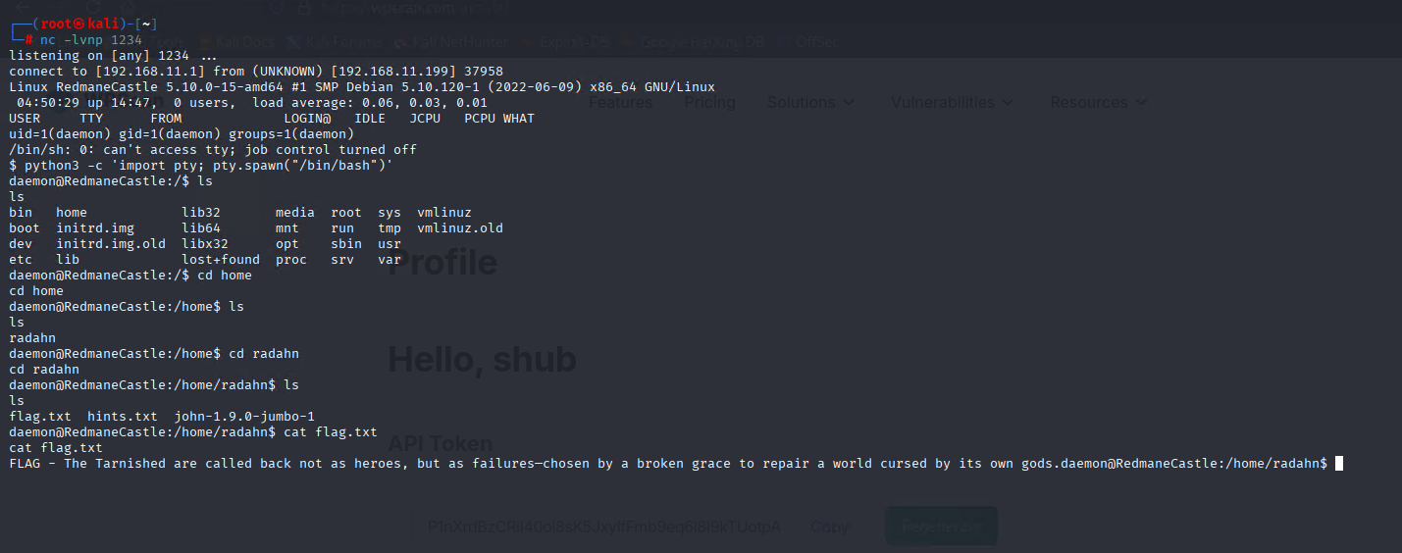
Figure 11: Flag 7
(Source: Self-Created)

Flag 8: Gain Root access
Host: 192.168.11.199
By using the “su root” command and enter password "princess," gained root access into the system. Upon entering the system as root, accessed the root directory and located the file named flag.txt. Upon opening the file, found the flag: “Radagon is Marika, and Marika is Radagon. One body, two wills, divided in purpose, united in punishment. The gods play chess with their own reflections.”
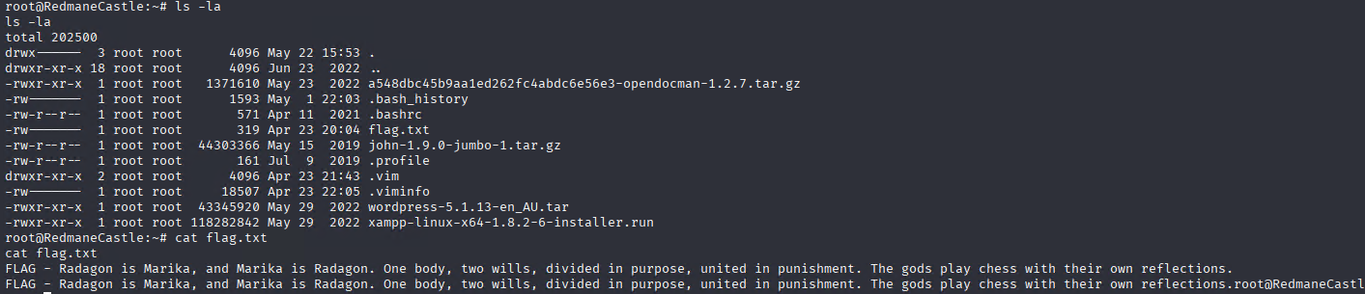
Figure 12: Flag 8
(Source: Self-Created)
Flag 9: File Upload Vulnerability
Host: 192.168.11.223
The website was exploited by exploiting a file upload vulnerability on the target host 192.168.11.223. Then uploaded a PHP reverse shell script via the web interface. Afterward, they triggered the execution of the script, and a connection back to the Netcat listener was established, granting shell access to the system. Now that this foothold was secured, they were able to browse the server filesystem, enter a directory with a flag file, and read the file.txt: “The dung eater seeks defilement eternal, not death. He is not made flesh, and every cursed seed he plants grows in despair.”
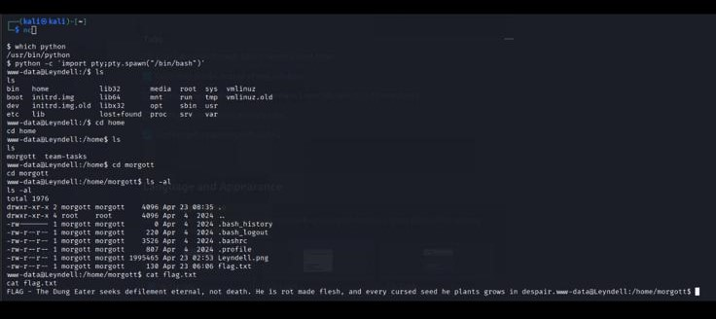
Figure 13: Flag 9
(Source: Self-Created)

Flag 10: Image File Steganography
Host: 192.168.11.223
In /home/mergott/, there is a “.png” file named Leyndell.png. After deeper inspection via steganography, the flag was found hidden within the image, which was traced to the recovery of the flag: “The Erdtree hides more than roots. It is a monument to stagnation, a gilded prison for gods, and a barrier to the truth."
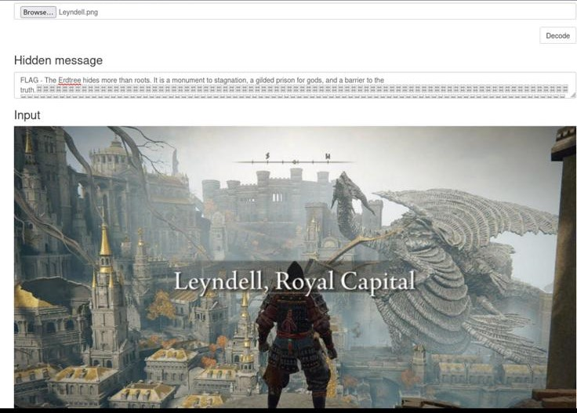
Figure 14: Flag 10
(Source: Self-Created)

Mitigation Strategies for Discovered Attacks
When carrying out a penetration test on the 192.168.11.0/24 network, a lot of crucial security issues were uncovered, such as unpatched vulnerabilities, weak service configurations, outdated systems, and insecure user privileges. In brief, the following are some recommendations to mitigate these risks and to improve the overall security of the network:
- Patch Management and System Hardening:
- Policies should be put in place so that all operating systems and software are kept up-to-date, and security patches applied as needed.
- Unnecessary services and protocols (SMBv1 comes to mind) must not be allowed.
- Permit, through firewall rules, access to only those services needed.
- Secure Authentication and Credential Management:
- Password regulations should be strictly defined, requiring complexity within specific periods of rotation or expiration.
- Multi-factor authentication must be implemented for critical systems and applications.
- Passwords must be kept away from being in any way readable by humans. A salted hash algorithm should be used for hashing.
- Audit user accounts and turn off and delete inactive or default accounts.

- Web Application Security:
- Always sanitize user inputs.
- Use Prepared Statements and Parameterized Queries to prevent SQL Injection.
- Monitor the file upload types and scan the uploaded files to detect any malicious payload-type files.
- Keep a regular hold on applying patches for known security loopholes in CMS platforms, plugins, as well as dependencies.
- Network and DNS Security:
- Allow zone transfers only to authorized accounting servers.
- Use DNSSEC to ensure the integrity and authenticity of DNS data.
- Investigate DNS traffic for suspicious activity.
- Monitoring and Incident Response:
- Constantly monitor logs and network traffics for any sign of exploitation.
- Intrusion detection/prevention systems should be implemented.
- Incident response plans should be designed so breaches can be detected and mitigated quickly.
- Privilege Management:
- Apply the principle of least privilege to all users and processes.
- Patch known local privilege escalation vulnerabilities promptly.
- Monitor for unusual privilege escalations or shell activities.

Conclusion
It is justified because the whole array of cybersecurity incidents entails the manifestation of one or several vulnerabilities on one or several fronts. Exploits such as EternalBlue, SQL injection, cross-site scripting, privilege escalation, and insecure file uploads represent how malicious entities take advantage of vulnerabilities in network services, web applications, or operating systems to commit unauthorized intrusion and access or escalate privileges. Compromise of systems and extraction of sensitive flags in matching demonstration of the real-world effects that these vulnerabilities would create left unchecked (Lawal, 2024). Patch management, authentication controls, and input validation must be maintained and enforced to avoid exploitation. In parallel, a secure configuration of DNS services and network segmentation must be given consideration, as these reduce avenues for an attack and restrict lateral movement inside the networks. Equally worthy of emphasis is the establishment of continuous monitoring and incident response measures so that any detection or mitigation of incidents takes place at an early stage, thus minimizing damage (Staves et al., 2022). Sandboxing should be strata-applied to factor in the privilege level-sandbox shadow restriction-based methodology. In the end, findings place a spotlight upon the multidimensional nature of cybersecurity, a challenge that will require holistic consideration in people, processes, and technology. Security must be one priority for organizations to nurture the culture of awareness in safeguarding the assets. This approach ensures the integrity and confidentiality of the data, thereby increasing the fullest strength of the organizations' resilience in keeping up with the ever-evolving cyber threats to maintain the operations and trust in digital systems.
Reference
Alhamed, M. and Rahman, M.M.H. (2023). A Systematic Literature Review on Penetration Testing in Networks: Future Research Directions. Applied Sciences, [online] 13(12). doi:https://doi.org/10.3390/app13126986.
Ali, A., Maghawry, H.A. and Badr, N. (2022). Performance testing as a service using cloud computing environment: A survey. Journal of Software: Evolution and Process. doi:https://doi.org/10.1002/smr.2492.
Lawal, K. (2024). Security Vulnerabilities in Modern Web Applications: Detection and Prevention. International Journal of Advances in Engineering and Management (IJAEM), [online] 6. doi:https://doi.org/10.35629/5252-06010519.
Mironeanu, C., Archip, A., Amarandei, C.-M. and Craus, M. (2021). Experimental Cyber Attack Detection Framework. Electronics, 10(14), p.1682. doi:https://doi.org/10.3390/electronics10141682.
Staves, A., Anderson, T., Balderstone, H., Green, B., Gouglidis, A. and Hutchison, D. (2022). A Cyber Incident Response and Recovery Framework to Support Operators of ICS and Critical National Infrastructure. International Journal of Critical Infrastructure Protection, 37, p.100505. doi:https://doi.org/10.1016/j.ijcip.2021.100505.

Appendices

Appendix: Flag 1
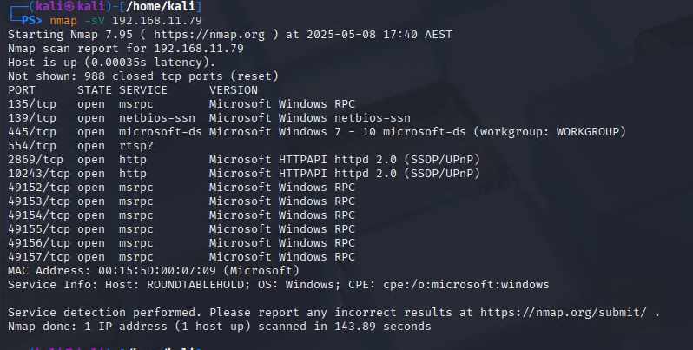
Figure 15: Nmap Scan Result Host 192.168.11.79
(Source: Self-Created)
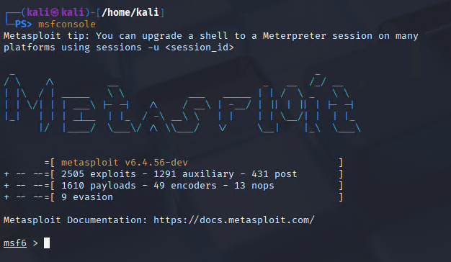
Figure 16: Msf console
(Source: Self-Created)
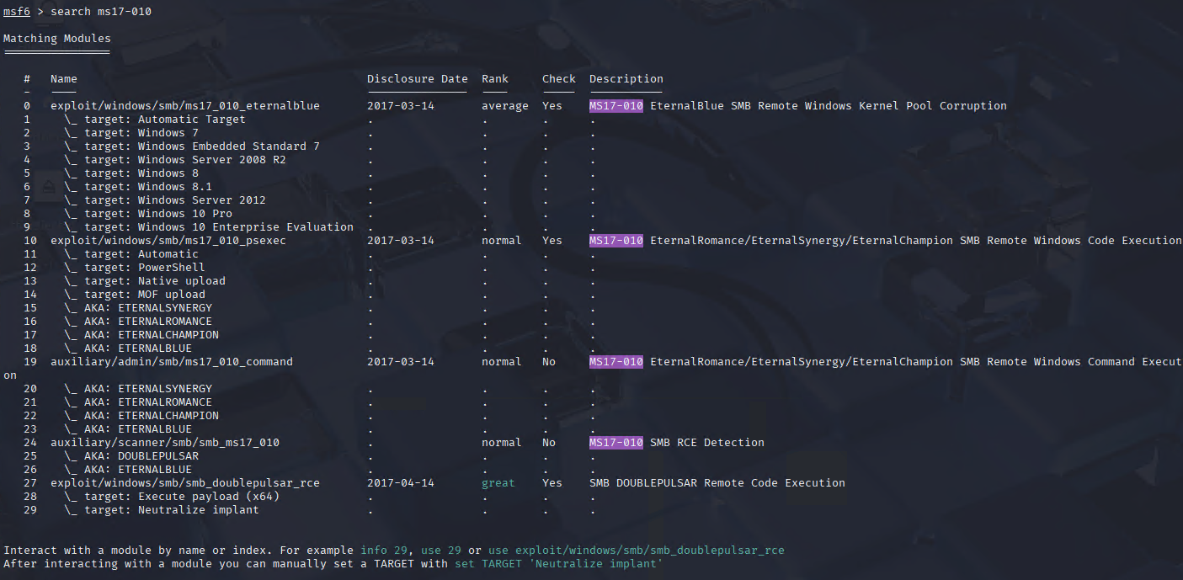
Figure 17: Selecting a module for Vulnerability scanning
(Source: Self-Created)
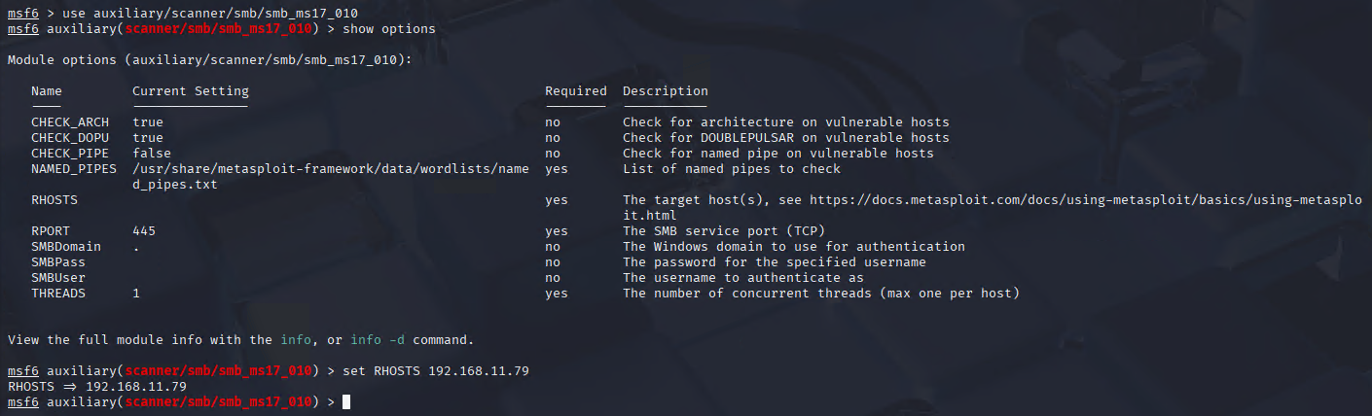
Figure 18: Input RHOST
(Source: Self-Created)
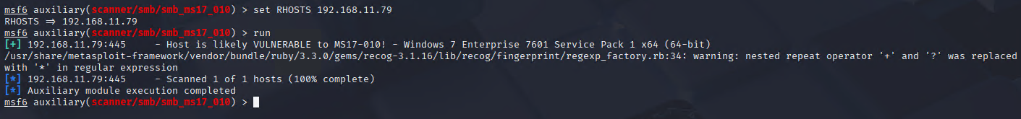
Figure 19: Scan Vulnerability
(Source: Self-Created)
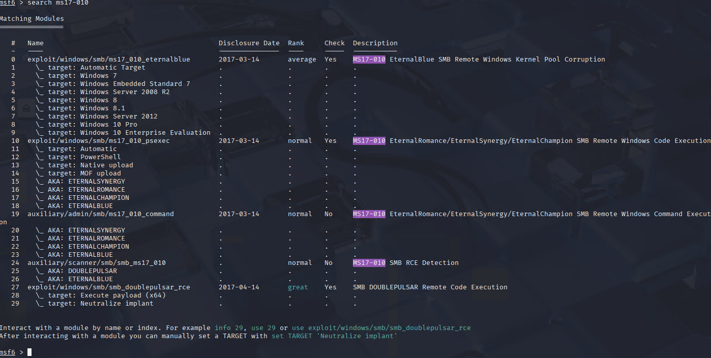
Figure 20: Selecting module for Exploitation
(Source: Self-Created)
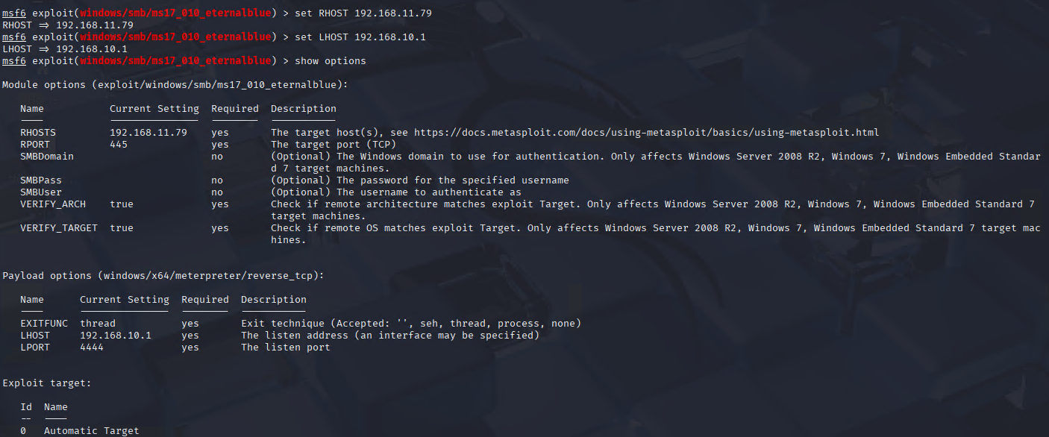
Figure 21: Configuration of Payload
(Source: Self-Created)
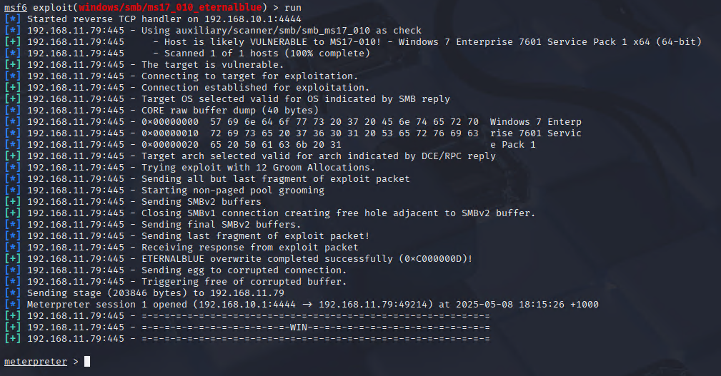
Figure 22: Exploitation successful
(Source: Self-Created)
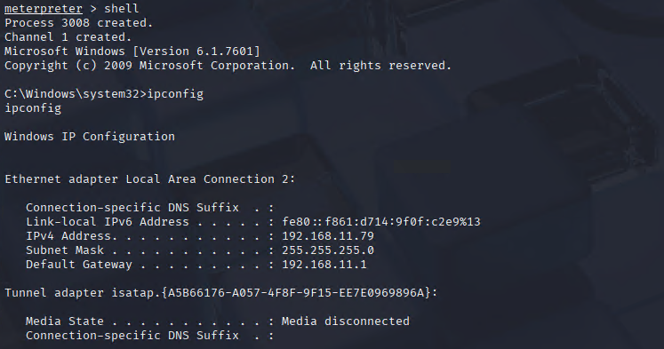
Figure 23: Crawling Directories
(Source: Self-Created)
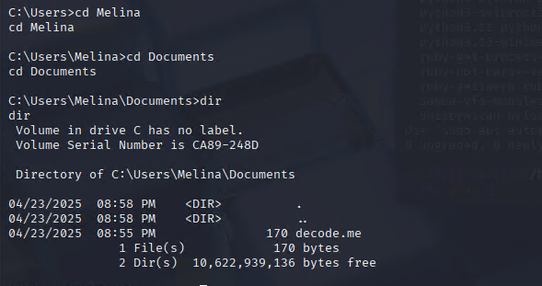
Figure 24: Identify the flag file
(Source: Self-Created)

Figure 25: Decoding the file & Capture the flag
(Source: Self-Created)

Appendix: Flag 2
Figure 26: Download wallpaper.png file
(Source: Self-Created)

Figure 27: Flag Capture
(Source: Self-Created)

Appendix: Flag 3
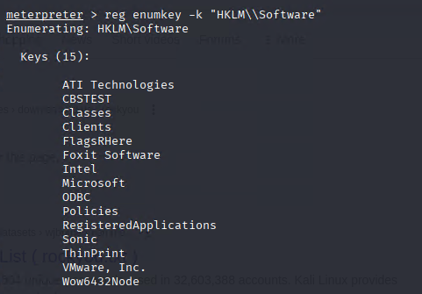
Figure 28: Searching flag in the registry settings
(Source: Self-Created)
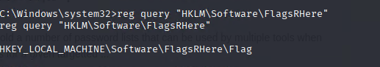
Figure 29: Searching flag in the registry settings
(Source: Self-Created)

Figure 30: Flag Capture
(Source: Self-Created)

Appendix: Flag 4
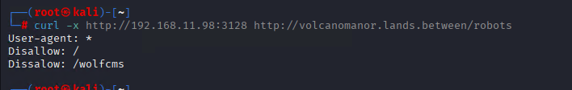
Figure 31: Curl
(Source: Self-Created)

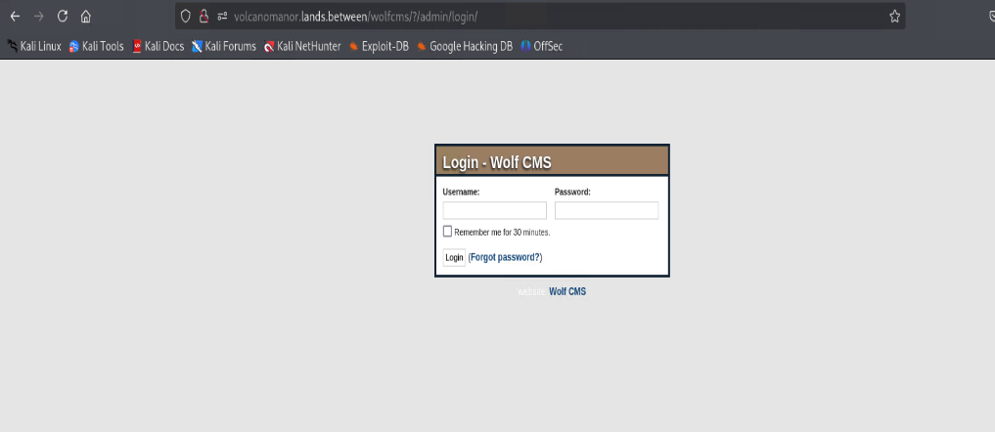
Figure 32: WlofCMS login page
(Source: Self-Created)
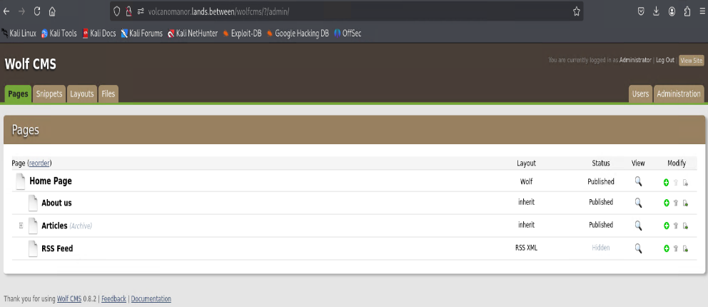
Figure 33: WlofCMS Dashboard
(Source: Self-Created)
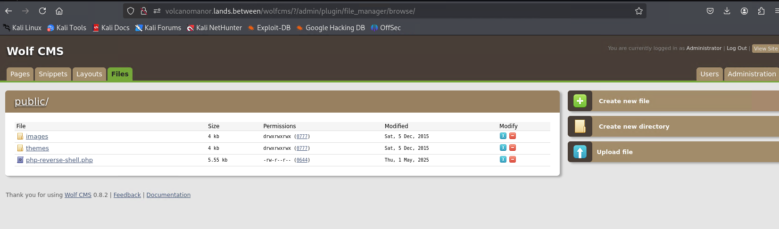
Figure 34: WlofCMS File Manager
(Source: Self-Created)
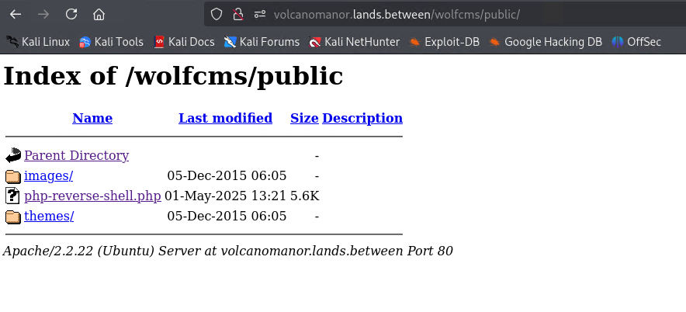
Figure 35: WlofCMS php reverse file uploaded
(Source: Self-Created)
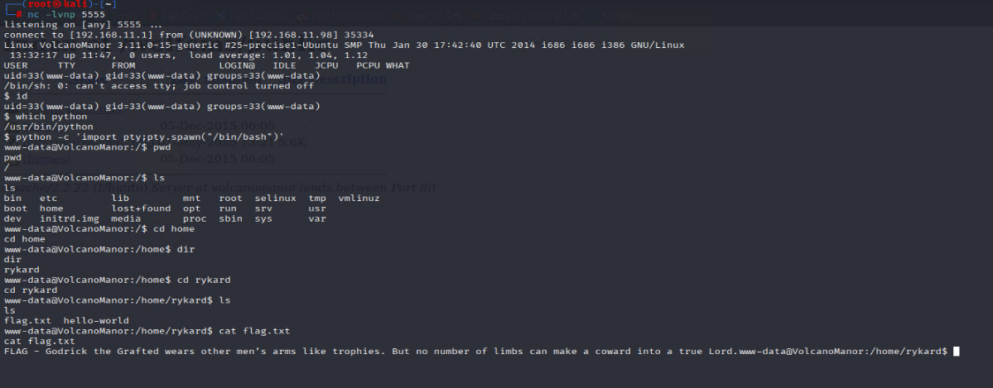
Figure 36: Flag Capture
(Source: Self-Created)

Appendix: Flag 5
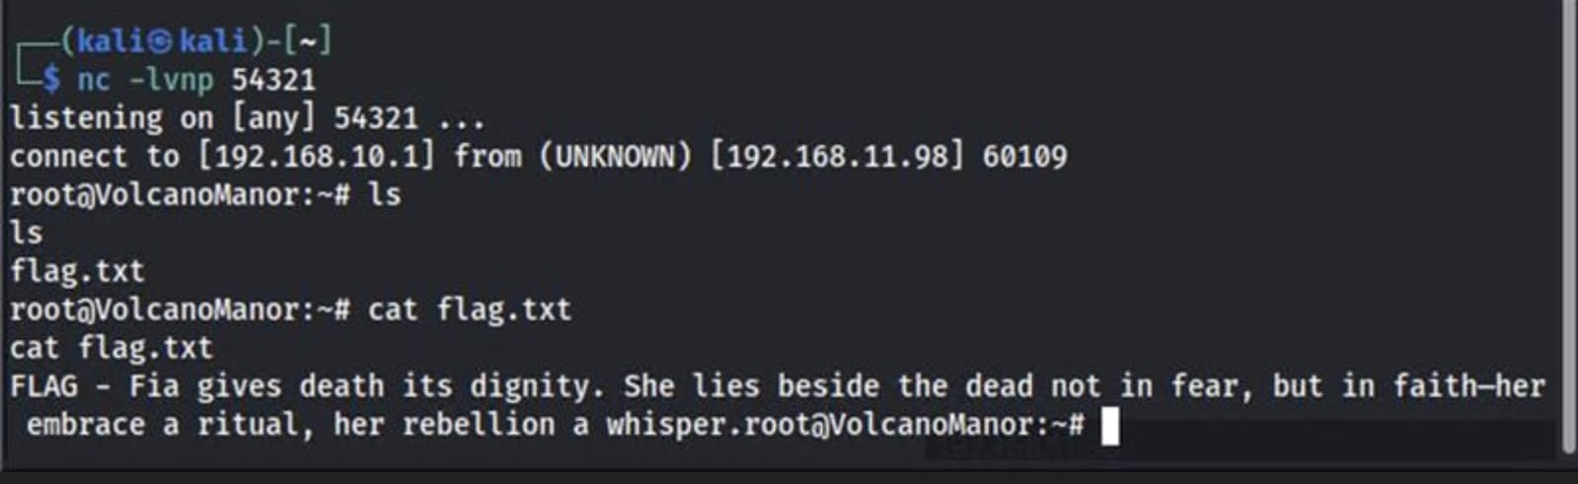
Figure 37: Root Flag Capture
(Source: Self-Created)

Appendix: Flag 6
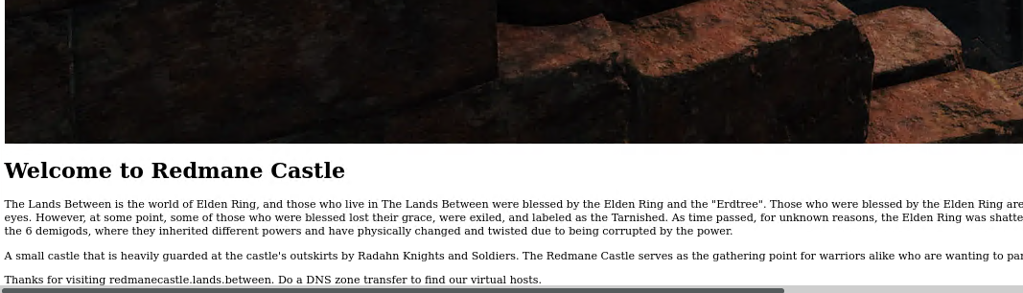
Figure 38: Hint of DNS zone transfer
(Source: Self-Created)
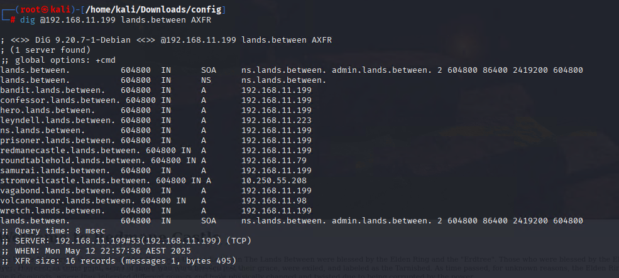
Figure 39: Successfully found Virtual Host
(Source: Self-Created)
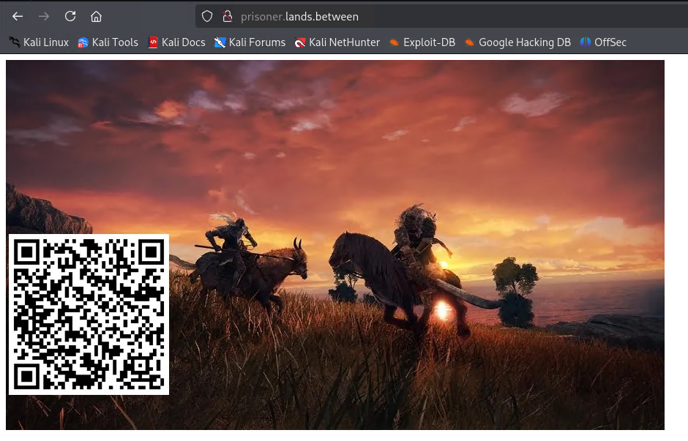
Figure 40: Picture Embedded with QR code
(Source: Self-Created)
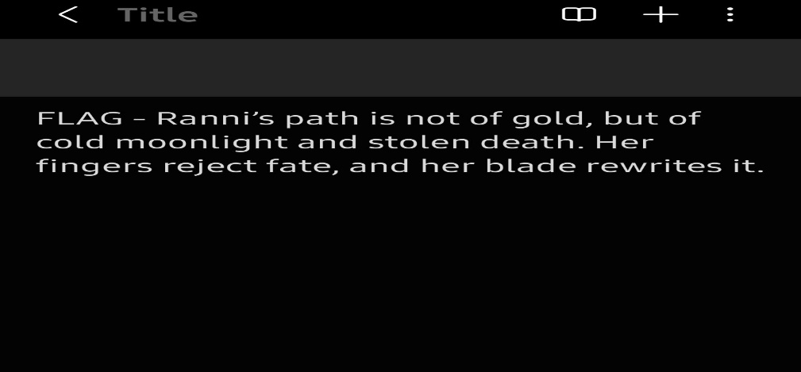
Figure 41: Flag capture after scanning the QR code
(Source: Self-Created)

Appendix: Flag 7
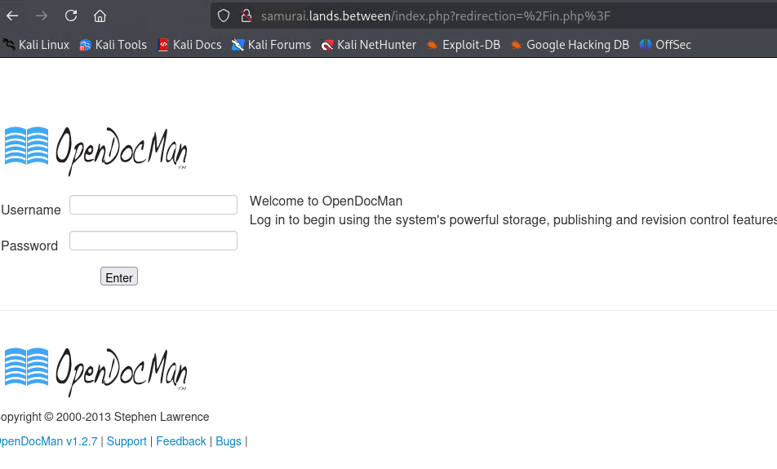
Figure 42: Vulnerable opendocman v1.2.7
(Source: Self-Created)
Figure 43: Searchsploit result of opendocman
(Source: Self-Created)
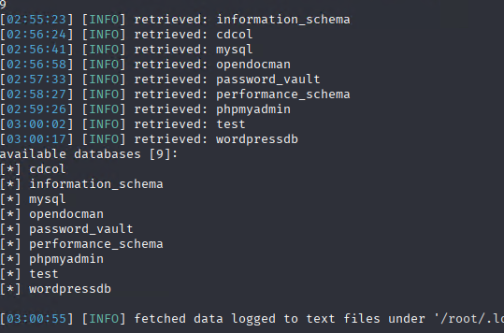
Figure 44: Sqlmap Attack
(Source: Self-Created)
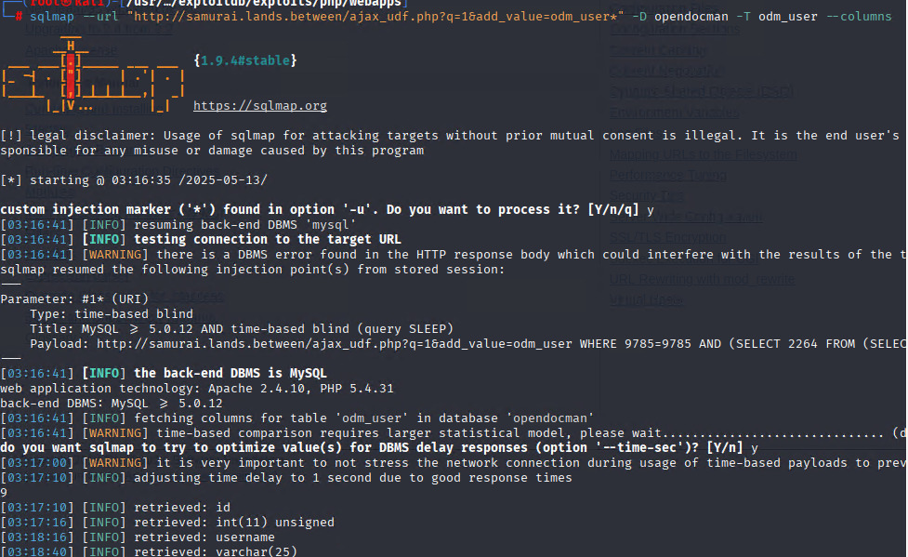
Figure 45: Sqlmap Attack
(Source: Self-Created)
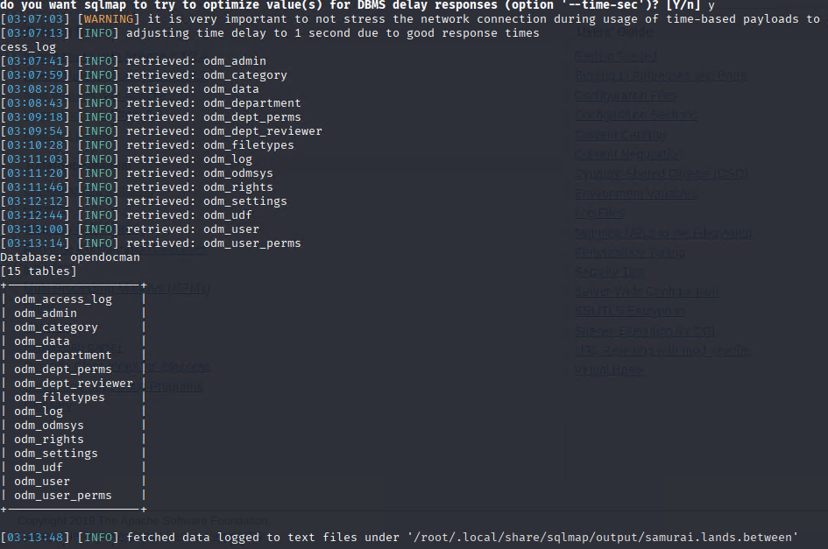
Figure 46: Sqlmap Attack
(Source: Self-Created)
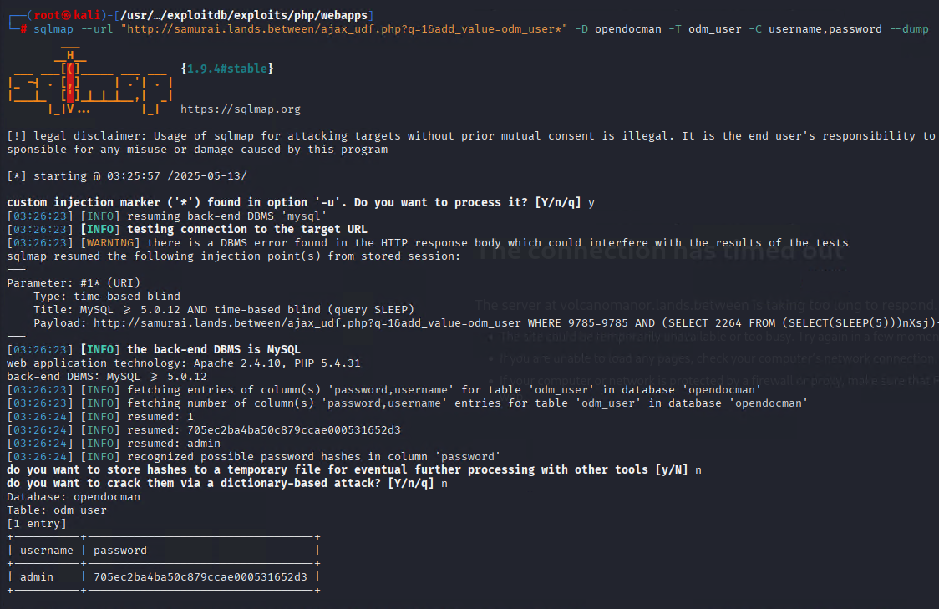
Figure 47: Successful Sqlmap Attack and get username and encrypted password
(Source: Self-Created)
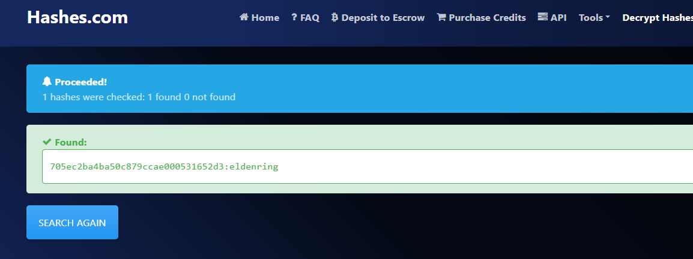
Figure 48: Decrypt password of opendocman, password is “eldenring”
(Source: Self-Created)
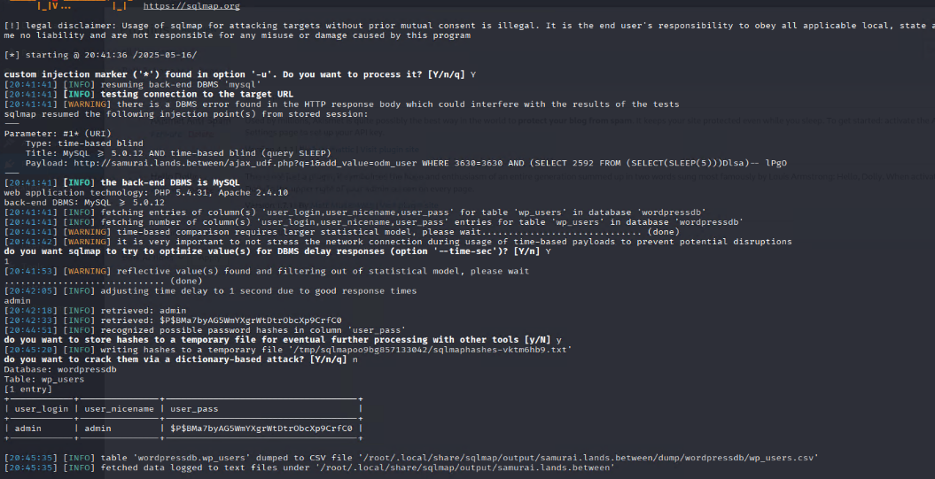
Figure 49: Decrypt password of wordpress, password is “eldenring”
(Source: Self-Created)
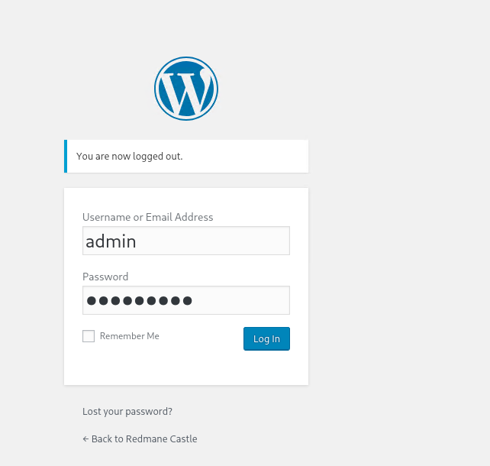
Figure 50: Wordpress Login Page
(Source: Self-Created)
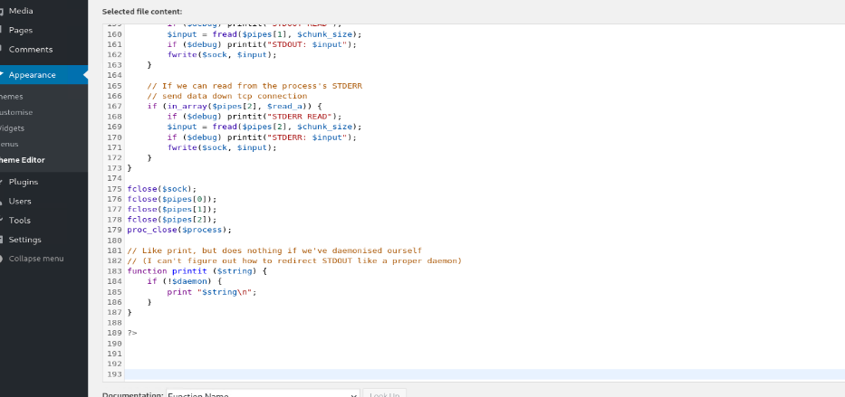
Figure 51: Upload reverse php file theme editor on twenty Seventeen
(Source: Self-Created)

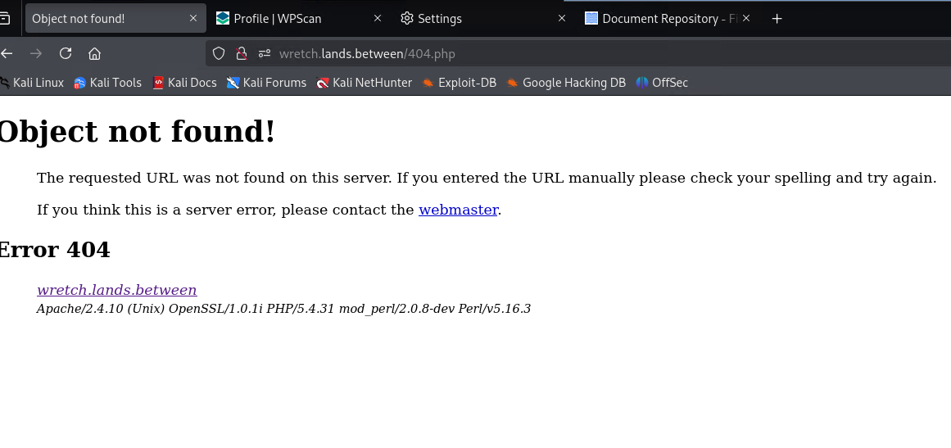
Figure 52: Browse 404.php page to get reverse shell
(Source: Self-Created)

Figure 53: Flag Capture
(Source: Self-Created)

Appendix: Flag 8
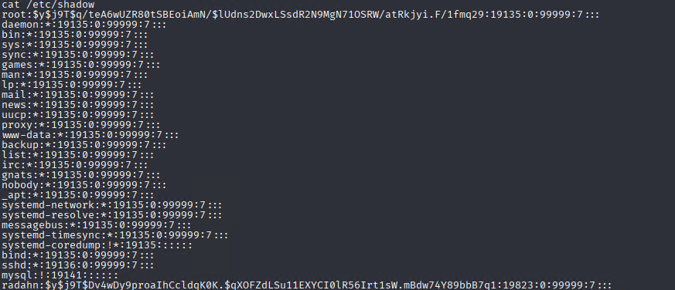
Figure 54: /etc/shadow
(Source: Self-Created)

Figure 55: Flag Capture
(Source: Self-Created)

Appendix: Flag 9
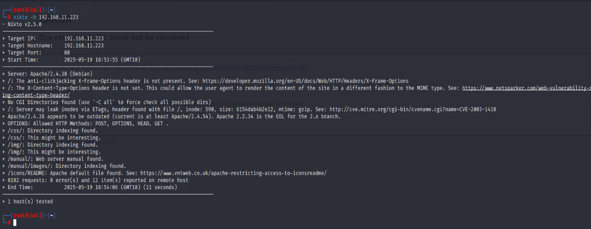
Figure 56: Nikto scan of host 192.168.11.223
(Source: Self-Created)
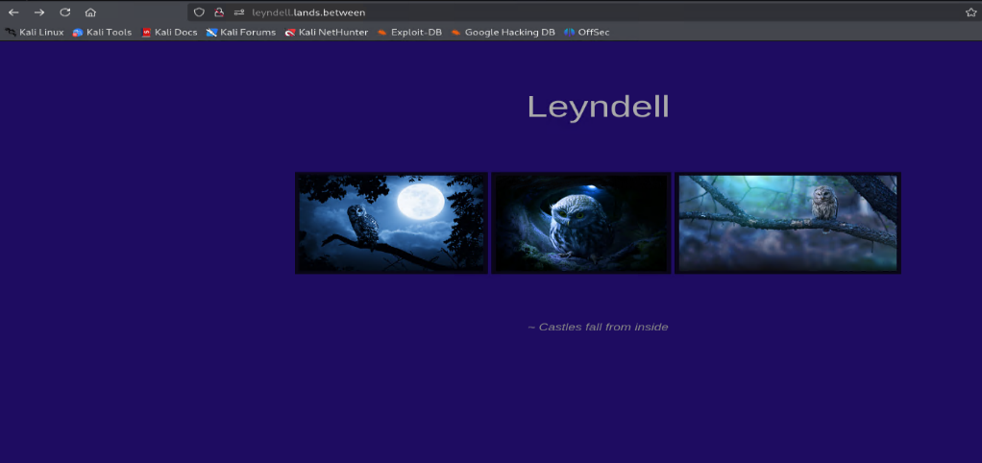
Figure 57: Webpage of 192.168.11.223
(Source: Self-Created)
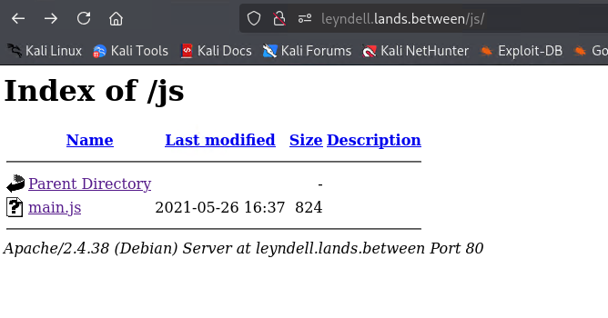
Figure 58: Java script
(Source: Self-Created)
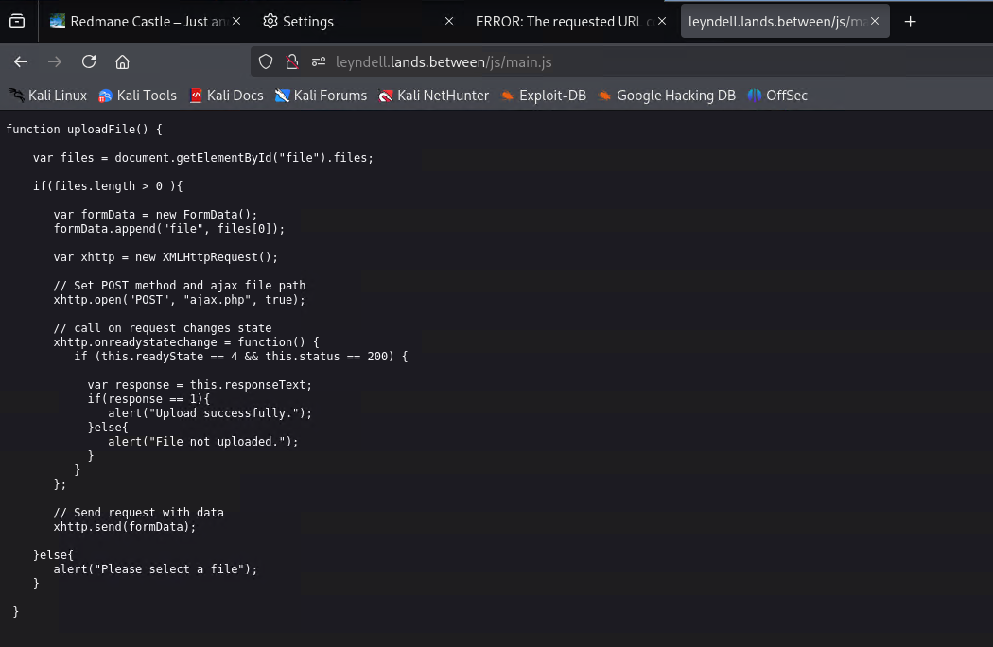
Figure 59: Java script
(Source: Self-Created)


Figure 60: Capture Flag
(Source: Self-Created)

Appendix: Flag 10

Figure 61: Capture Flag
(Source: Self-Created)

