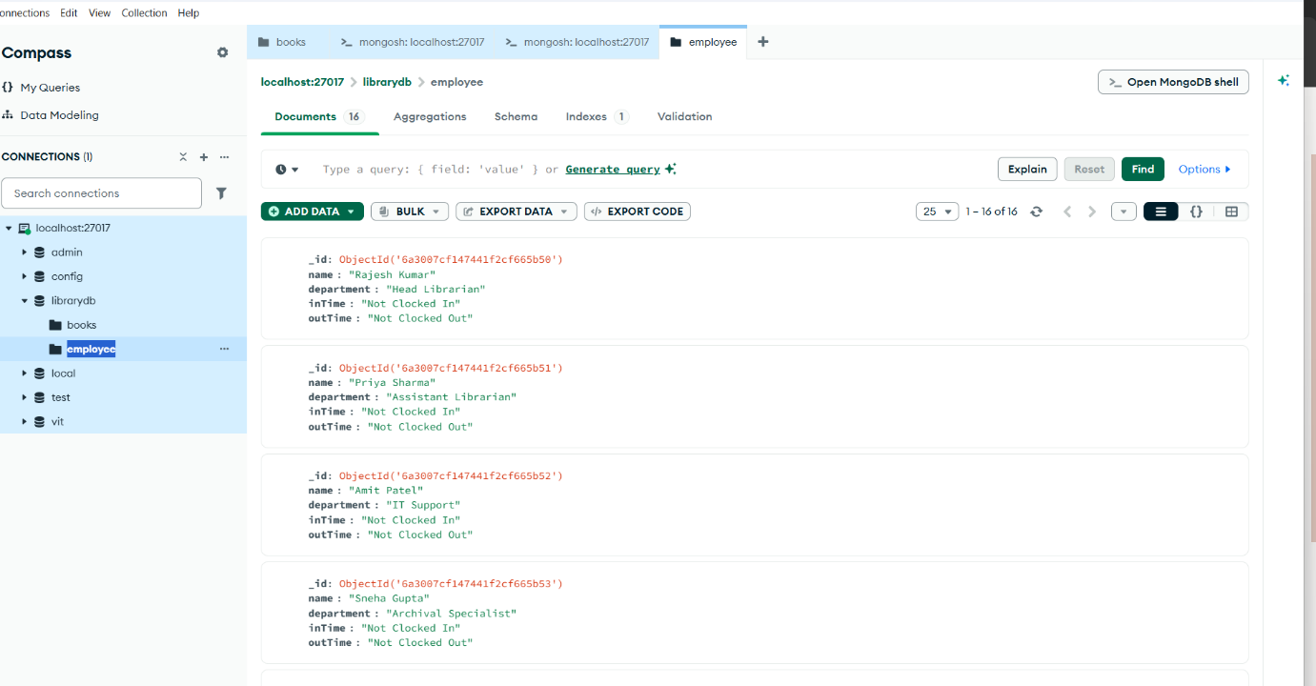
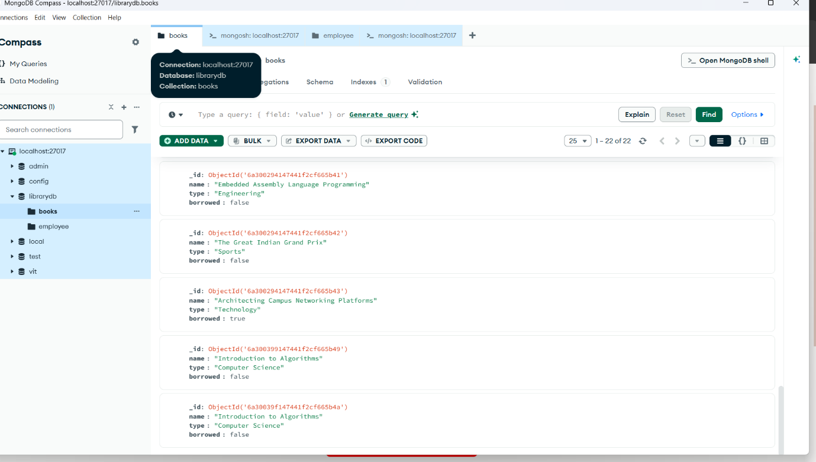
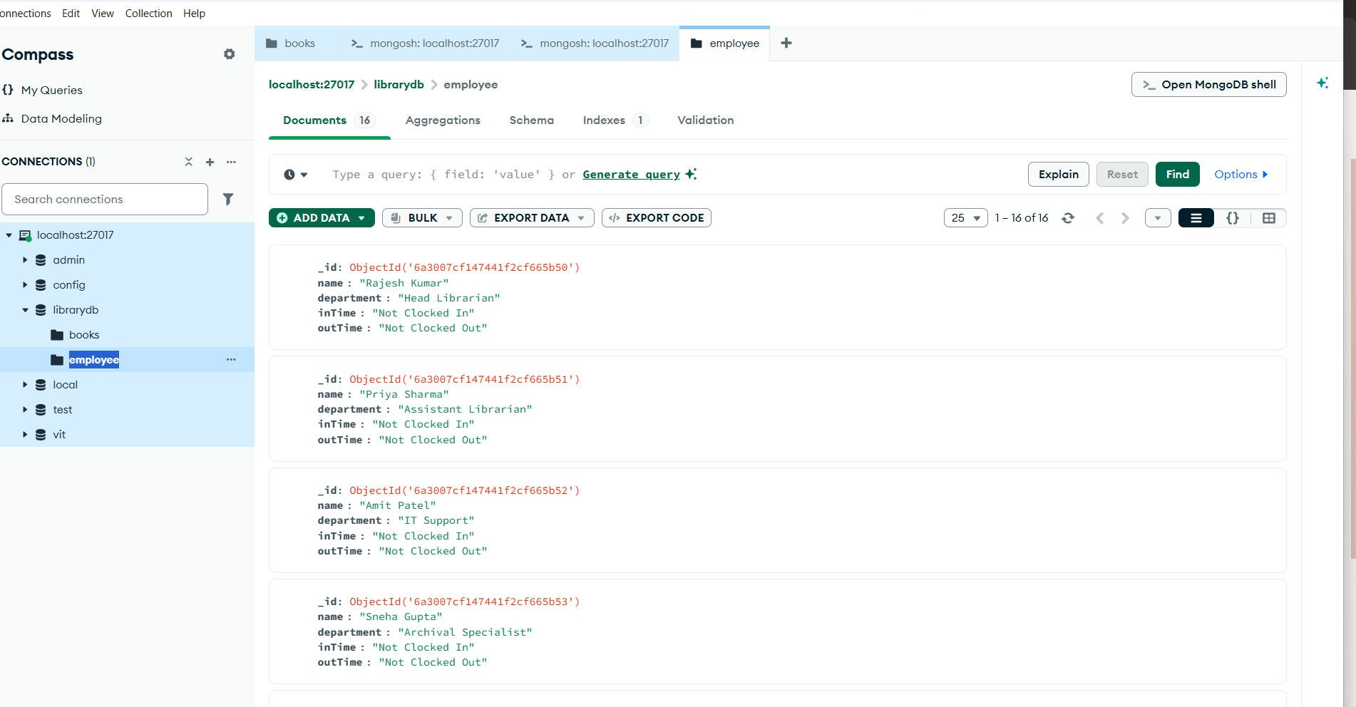db.books.find()
{
_id: ObjectId('6a3000e6d7faf8323324b657'),
name: 'Sweet Sweet Revenge Limited',
type: 'fiction',
borrowed: false,
_class: 'com.example.library.model.Book'
}
db.books.find()
{
_id: ObjectId('6a3000e6d7faf8323324b657'),
name: 'Sweet Sweet Revenge Limited',
type: 'fiction',
borrowed: false,
_class: 'com.example.library.model.Book'
}
db.books.insertMany([
{
"name": "Introduction to Algorithms",
"type": "Computer Science",
"borrowed": false
},
{
"name": "Mastering React and Modern Frontend",
"type": "Software Development",
"borrowed": false
},
{
"name": "The 8051 Microcontroller and Embedded Systems",
"type": "Engineering",
"borrowed": true
},
{
"name": "MongoDB: The Definitive Guide",
"type": "Database Management",
"borrowed": false
},
{
"name": "Competitive Programming and Algorithm Analysis",
"type": "Computer Science",
"borrowed": false
},
{
"name": "The Art of Indian Cinema: Directors and Legends",
"type": "Entertainment",
"borrowed": false
},
{
"name": "Cricket Analytics: Decoding the Game",
"type": "Sports",
"borrowed": true
},
{
"name": "Formula 1: The Anatomy of Speed",
"type": "Sports",
"borrowed": false
},
{
"name": "A Developer's Guide to Peer Learning Systems",
"type": "Software Development",
"borrowed": false
},
{
"name": "Backpacking India: From the Ghats of Rishikesh to Coorg",
"type": "Travel",
"borrowed": false
},
{
"name": "The Secret History of Biryani",
"type": "Culinary",
"borrowed": false
},
{
"name": "Advanced CSS and HTML5 Layouts",
"type": "Web Development",
"borrowed": true
},
{
"name": "Data Structures in Java",
"type": "Computer Science",
"borrowed": false
},
{
"name": "Designing Interactive Web Applications",
"type": "Web Development",
"borrowed": false
},
{
"name": "Thomas Cup: A Historic Triumph",
"type": "Sports",
"borrowed": false
},
{
"name": "JavaScript: The Good Parts",
"type": "Software Development",
"borrowed": true
},
{
"name": "Clean Code: A Handbook of Agile Software Craftsmanship",
"type": "Software Development",
"borrowed": false
},
{
"name": "Embedded Assembly Language Programming",
"type": "Engineering",
"borrowed": false
},
{
"name": "The Great Indian Grand Prix",
"type": "Sports",
"borrowed": false
},
{
"name": "Architecting Campus Networking Platforms",
"type": "Technology",
"borrowed": true
}
])
{
acknowledged: true,
insertedIds: {
'0': ObjectId('6a3003f9c0f7350e313ff000'),
'1': ObjectId('6a3003f9c0f7350e313ff001'),
'2': ObjectId('6a3003f9c0f7350e313ff002'),
'3': ObjectId('6a3003f9c0f7350e313ff003'),
'4': ObjectId('6a3003f9c0f7350e313ff004'),
'5': ObjectId('6a3003f9c0f7350e313ff005'),
'6': ObjectId('6a3003f9c0f7350e313ff006'),
'7': ObjectId('6a3003f9c0f7350e313ff007'),
'8': ObjectId('6a3003f9c0f7350e313ff008'),
'9': ObjectId('6a3003f9c0f7350e313ff009'),
'10': ObjectId('6a3003f9c0f7350e313ff00a'),
'11': ObjectId('6a3003f9c0f7350e313ff00b'),
'12': ObjectId('6a3003f9c0f7350e313ff00c'),
'13': ObjectId('6a3003f9c0f7350e313ff00d'),
'14': ObjectId('6a3003f9c0f7350e313ff00e'),
'15': ObjectId('6a3003f9c0f7350e313ff00f'),
'16': ObjectId('6a3003f9c0f7350e313ff010'),
'17': ObjectId('6a3003f9c0f7350e313ff011'),
'18': ObjectId('6a3003f9c0f7350e313ff012'),
'19': ObjectId('6a3003f9c0f7350e313ff013')
}
}
db.books.find()
{
_id: ObjectId('6a3000e6d7faf8323324b657'),
name: 'Sweet Sweet Revenge Limited',
type: 'fiction',
borrowed: false,
_class: 'com.example.library.model.Book'
}
{
_id: ObjectId('6a3003f9c0f7350e313ff000'),
name: 'Introduction to Algorithms',
type: 'Computer Science',
borrowed: false
}
{
_id: ObjectId('6a3003f9c0f7350e313ff001'),
name: 'Mastering React and Modern Frontend',
type: 'Software Development',
borrowed: false
}
{
_id: ObjectId('6a3003f9c0f7350e313ff002'),
name: 'The 8051 Microcontroller and Embedded Systems',
type: 'Engineering',
borrowed: true
}
{
_id: ObjectId('6a3003f9c0f7350e313ff003'),
name: 'MongoDB: The Definitive Guide',
type: 'Database Management',
borrowed: false
}
{
_id: ObjectId('6a3003f9c0f7350e313ff004'),
name: 'Competitive Programming and Algorithm Analysis',
type: 'Computer Science',
borrowed: false
}
{
_id: ObjectId('6a3003f9c0f7350e313ff005'),
name: 'The Art of Indian Cinema: Directors and Legends',
type: 'Entertainment',
borrowed: false
}
{
_id: ObjectId('6a3003f9c0f7350e313ff006'),
name: 'Cricket Analytics: Decoding the Game',
type: 'Sports',
borrowed: true
}
{
_id: ObjectId('6a3003f9c0f7350e313ff007'),
name: 'Formula 1: The Anatomy of Speed',
type: 'Sports',
borrowed: false
}
{
_id: ObjectId('6a3003f9c0f7350e313ff008'),
name: "A Developer's Guide to Peer Learning Systems",
type: 'Software Development',
borrowed: false
}
{
_id: ObjectId('6a3003f9c0f7350e313ff009'),
name: 'Backpacking India: From the Ghats of Rishikesh to Coorg',
type: 'Travel',
borrowed: false
}
{
_id: ObjectId('6a3003f9c0f7350e313ff00a'),
name: 'The Secret History of Biryani',
type: 'Culinary',
borrowed: false
}
{
_id: ObjectId('6a3003f9c0f7350e313ff00b'),
name: 'Advanced CSS and HTML5 Layouts',
type: 'Web Development',
borrowed: true
}
{
_id: ObjectId('6a3003f9c0f7350e313ff00c'),
name: 'Data Structures in Java',
type: 'Computer Science',
borrowed: false
}
{
_id: ObjectId('6a3003f9c0f7350e313ff00d'),
name: 'Designing Interactive Web Applications',
type: 'Web Development',
borrowed: false
}
{
_id: ObjectId('6a3003f9c0f7350e313ff00e'),
name: 'Thomas Cup: A Historic Triumph',
type: 'Sports',
borrowed: false
}
{
_id: ObjectId('6a3003f9c0f7350e313ff00f'),
name: 'JavaScript: The Good Parts',
type: 'Software Development',
borrowed: true
}
{
_id: ObjectId('6a3003f9c0f7350e313ff010'),
name: 'Clean Code: A Handbook of Agile Software Craftsmanship',
type: 'Software Development',
borrowed: false
}
{
_id: ObjectId('6a3003f9c0f7350e313ff011'),
name: 'Embedded Assembly Language Programming',
type: 'Engineering',
borrowed: false
}
{
_id: ObjectId('6a3003f9c0f7350e313ff012'),
name: 'The Great Indian Grand Prix',
type: 'Sports',
borrowed: false
}
Type "it" for more
db.books.insertMany([
{
"name": "Introduction to Algorithms",
"type": "Computer Science",
"borrowed": false
},
{
"name": "Mastering React and Modern Frontend",
"type": "Software Development",
"borrowed": false
},
{
"name": "The 8051 Microcontroller and Embedded Systems",
"type": "Engineering",
"borrowed": true
},
{
"name": "MongoDB: The Definitive Guide",
"type": "Database Management",
"borrowed": false
},
{
"name": "Competitive Programming and Algorithm Analysis",
"type": "Computer Science",
"borrowed": false
},
{
"name": "The Art of Indian Cinema: Directors and Legends",
"type": "Entertainment",
"borrowed": false
},
{
"name": "Cricket Analytics: Decoding the Game",
"type": "Sports",
"borrowed": true
},
{
"name": "Formula 1: The Anatomy of Speed",
"type": "Sports",
"borrowed": false
},
{
"name": "A Developer's Guide to Peer Learning Systems",
"type": "Software Development",
"borrowed": false
},
{
"name": "Backpacking India: From the Ghats of Rishikesh to Coorg",
"type": "Travel",
"borrowed": false
},
{
"name": "The Secret History of Biryani",
"type": "Culinary",
"borrowed": false
},
{
"name": "Advanced CSS and HTML5 Layouts",
"type": "Web Development",
"borrowed": true
},
{
"name": "Data Structures in Java",
"type": "Computer Science",
"borrowed": false
},
{
"name": "Designing Interactive Web Applications",
"type": "Web Development",
"borrowed": false
},
{
"name": "Thomas Cup: A Historic Triumph",
"type": "Sports",
"borrowed": false
},
{
"name": "JavaScript: The Good Parts",
"type": "Software Development",
"borrowed": true
},
{
"name": "Clean Code: A Handbook of Agile Software Craftsmanship",
"type": "Software Development",
"borrowed": false
},
{
"name": "Embedded Assembly Language Programming",
"type": "Engineering",
"borrowed": false
},
{
"name": "The Great Indian Grand Prix",
"type": "Sports",
"borrowed": false
},
{
"name": "Architecting Campus Networking Platforms",
"type": "Technology",
"borrowed": true
}
])
{
acknowledged: true,
insertedIds: {
'0': ObjectId('6a3006e0c0f7350e313ff014'),
'1': ObjectId('6a3006e0c0f7350e313ff015'),
'2': ObjectId('6a3006e0c0f7350e313ff016'),
'3': ObjectId('6a3006e0c0f7350e313ff017'),
'4': ObjectId('6a3006e0c0f7350e313ff018'),
'5': ObjectId('6a3006e0c0f7350e313ff019'),
'6': ObjectId('6a3006e0c0f7350e313ff01a'),
'7': ObjectId('6a3006e0c0f7350e313ff01b'),
'8': ObjectId('6a3006e0c0f7350e313ff01c'),
'9': ObjectId('6a3006e0c0f7350e313ff01d'),
'10': ObjectId('6a3006e0c0f7350e313ff01e'),
'11': ObjectId('6a3006e0c0f7350e313ff01f'),
'12': ObjectId('6a3006e0c0f7350e313ff020'),
'13': ObjectId('6a3006e0c0f7350e313ff021'),
'14': ObjectId('6a3006e0c0f7350e313ff022'),
'15': ObjectId('6a3006e0c0f7350e313ff023'),
'16': ObjectId('6a3006e0c0f7350e313ff024'),
'17': ObjectId('6a3006e0c0f7350e313ff025'),
'18': ObjectId('6a3006e0c0f7350e313ff026'),
'19': ObjectId('6a3006e0c0f7350e313ff027')
}
}
db.employee.insertMany([
{
"name": "Rajesh Kumar",
"department": "Head Librarian",
"inTime": "Not Clocked In",
"outTime": "Not Clocked Out"
},
{
"name": "Priya Sharma",
"department": "Assistant Librarian",
"inTime": "Not Clocked In",
"outTime": "Not Clocked Out"
},
{
"name": "Amit Patel",
"department": "IT Support",
"inTime": "Not Clocked In",
"outTime": "Not Clocked Out"
},
{
"name": "Sneha Gupta",
"department": "Archival Specialist",
"inTime": "Not Clocked In",
"outTime": "Not Clocked Out"
},
{
"name": "Vikram Singh",
"department": "Security",
"inTime": "Not Clocked In",
"outTime": "Not Clocked Out"
},
{
"name": "Anjali Desai",
"department": "Circulation Desk",
"inTime": "Not Clocked In",
"outTime": "Not Clocked Out"
},
{
"name": "Rohan Mehta",
"department": "Maintenance",
"inTime": "Not Clocked In",
"outTime": "Not Clocked Out"
},
{
"name": "Kavita Reddy",
"department": "Children's Section",
"inTime": "Not Clocked In",
"outTime": "Not Clocked Out"
},
{
"name": "Suresh Iyer",
"department": "Acquisitions",
"inTime": "Not Clocked In",
"outTime": "Not Clocked Out"
},
{
"name": "Neha Verma",
"department": "Event Coordinator",
"inTime": "Not Clocked In",
"outTime": "Not Clocked Out"
},
{
"name": "Manoj Tiwari",
"department": "Security",
"inTime": "Not Clocked In",
"outTime": "Not Clocked Out"
},
{
"name": "Pooja Joshi",
"department": "Reference Librarian",
"inTime": "Not Clocked In",
"outTime": "Not Clocked Out"
},
{
"name": "Arjun Nair",
"department": "IT Support",
"inTime": "Not Clocked In",
"outTime": "Not Clocked Out"
},
{
"name": "Meera Chawla",
"department": "Janitorial Staff",
"inTime": "Not Clocked In",
"outTime": "Not Clocked Out"
},
{
"name": "Karan Malhotra",
"department": "Administration",
"inTime": "Not Clocked In",
"outTime": "Not Clocked Out"
}
])
{
acknowledged: true,
insertedIds: {
'0': ObjectId('6a300750c0f7350e313ff028'),
'1': ObjectId('6a300750c0f7350e313ff029'),
'2': ObjectId('6a300750c0f7350e313ff02a'),
'3': ObjectId('6a300750c0f7350e313ff02b'),
'4': ObjectId('6a300750c0f7350e313ff02c'),
'5': ObjectId('6a300750c0f7350e313ff02d'),
'6': ObjectId('6a300750c0f7350e313ff02e'),
'7': ObjectId('6a300750c0f7350e313ff02f'),
'8': ObjectId('6a300750c0f7350e313ff030'),
'9': ObjectId('6a300750c0f7350e313ff031'),
'10': ObjectId('6a300750c0f7350e313ff032'),
'11': ObjectId('6a300750c0f7350e313ff033'),
'12': ObjectId('6a300750c0f7350e313ff034'),
'13': ObjectId('6a300750c0f7350e313ff035'),
'14': ObjectId('6a300750c0f7350e313ff036')
}
}
db.employee.find()
{
_id: ObjectId('6a300750c0f7350e313ff028'),
name: 'Rajesh Kumar',
department: 'Head Librarian',
inTime: 'Not Clocked In',
outTime: 'Not Clocked Out'
}
{
_id: ObjectId('6a300750c0f7350e313ff029'),
name: 'Priya Sharma',
department: 'Assistant Librarian',
inTime: 'Not Clocked In',
outTime: 'Not Clocked Out'
}
{
_id: ObjectId('6a300750c0f7350e313ff02a'),
name: 'Amit Patel',
department: 'IT Support',
inTime: 'Not Clocked In',
outTime: 'Not Clocked Out'
}
{
_id: ObjectId('6a300750c0f7350e313ff02b'),
name: 'Sneha Gupta',
department: 'Archival Specialist',
inTime: 'Not Clocked In',
outTime: 'Not Clocked Out'
}
{
_id: ObjectId('6a300750c0f7350e313ff02c'),
name: 'Vikram Singh',
department: 'Security',
inTime: 'Not Clocked In',
outTime: 'Not Clocked Out'
}
{
_id: ObjectId('6a300750c0f7350e313ff02d'),
name: 'Anjali Desai',
department: 'Circulation Desk',
inTime: 'Not Clocked In',
outTime: 'Not Clocked Out'
}
{
_id: ObjectId('6a300750c0f7350e313ff02e'),
name: 'Rohan Mehta',
department: 'Maintenance',
inTime: 'Not Clocked In',
outTime: 'Not Clocked Out'
}
{
_id: ObjectId('6a300750c0f7350e313ff02f'),
name: 'Kavita Reddy',
department: "Children's Section",
inTime: 'Not Clocked In',
outTime: 'Not Clocked Out'
}
{
_id: ObjectId('6a300750c0f7350e313ff030'),
name: 'Suresh Iyer',
department: 'Acquisitions',
inTime: 'Not Clocked In',
outTime: 'Not Clocked Out'
}
{
_id: ObjectId('6a300750c0f7350e313ff031'),
name: 'Neha Verma',
department: 'Event Coordinator',
inTime: 'Not Clocked In',
outTime: 'Not Clocked Out'
}
{
_id: ObjectId('6a300750c0f7350e313ff032'),
name: 'Manoj Tiwari',
department: 'Security',
inTime: 'Not Clocked In',
outTime: 'Not Clocked Out'
}
{
_id: ObjectId('6a300750c0f7350e313ff033'),
name: 'Pooja Joshi',
department: 'Reference Librarian',
inTime: 'Not Clocked In',
outTime: 'Not Clocked Out'
}
{
_id: ObjectId('6a300750c0f7350e313ff034'),
name: 'Arjun Nair',
department: 'IT Support',
inTime: 'Not Clocked In',
outTime: 'Not Clocked Out'
}
{
_id: ObjectId('6a300750c0f7350e313ff035'),
name: 'Meera Chawla',
department: 'Janitorial Staff',
inTime: 'Not Clocked In',
outTime: 'Not Clocked Out'
}


