show databases;

create database test;
use test;
create table student(sid int unique not null, sname varchar(30) not null,smarks int not null);

desc student;
insert into student values(101,'Shubham',99);
select * from student;

import java.sql.*;

public class Testing1 {

public static void main(String[] args) {

try{
Class.forName("com.mysql.cj.jdbc.Driver"); //Register

Connection con=DriverManager.getConnection(
"jdbc:mysql://localhost:3306/test","root","root");

Statement stmt=con.createStatement();

ResultSet rs=stmt.executeQuery("select * from student");
// -----------up to this line it contain's one table struc output
while(rs.next()){
System.out.println(rs.getInt(1)+" "+
rs.getString(2)+" "+rs.getInt(3));
}
con.close();
}
catch(Exception e){
System.out.println("Sorry for the inconvinence happened..! "
+ "Check the inputs properly one more time");
}
}

}

101 Shubham 99
102 Arthi 92
103 Anuj 95

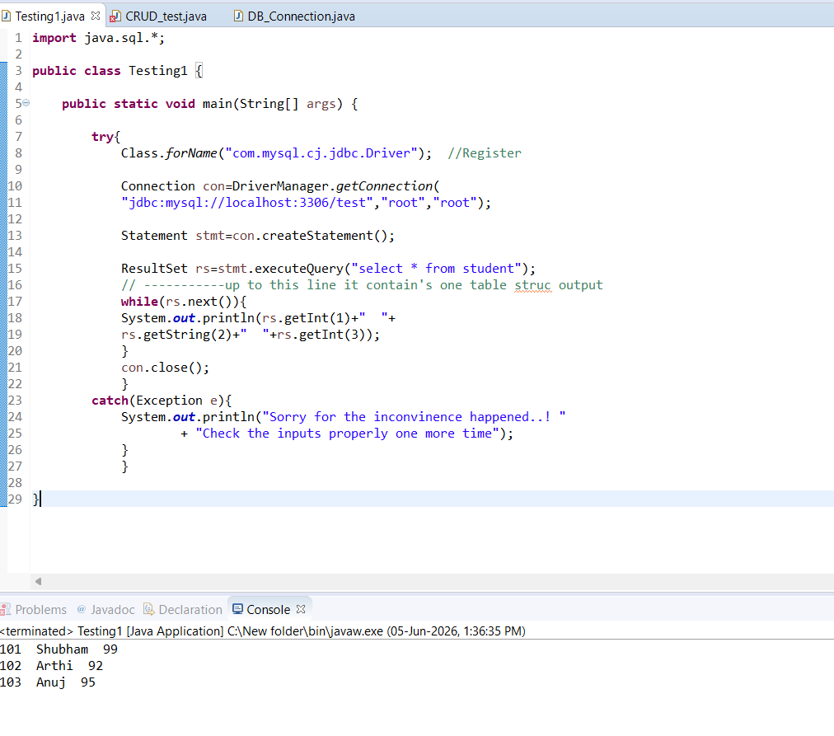

package CRUD;
import java.sql.Connection;
import java.sql.PreparedStatement;
import java.sql.ResultSet;
public class CRUD_Test {

public static void main(String[] args) {
CRUD_Test objTest=new CRUD_Test();
//insert data
objTest.create_data("1", "jinu", "jinu@gmail.com");
objTest.create_data("2", "jawad", "jawad@gmail.com");
//read data
objTest.read_data("2");
//update data
objTest.update_data("2", "22", "jawad2", "jawad2@gmail");
//delete data
objTest.delete_data("1");
}

public void create_data(String sl_no,String name,String email){
DB_Connection obj_DB_Connection=new DB_Connection();
Connection connection=obj_DB_Connection.get_connection();
PreparedStatement ps=null;
try {
String query="insert into user(sl_no,name,email) values (?,?,?)";
ps=connection.prepareStatement(query);
ps.setString(1, sl_no);
ps.setString(2, name);
ps.setString(3, email);
System.out.println(ps);
ps.executeUpdate();
} catch (Exception e) {
System.out.println(e);
}
}

public void read_data(String sl_no){
DB_Connection obj_DB_Connection=new DB_Connection();
Connection connection=obj_DB_Connection.get_connection();
PreparedStatement ps=null;
ResultSet rs=null;
try {
String query="select * from user";
ps=connection.prepareStatement(query);
//ps.setString(1, sl_no);
System.out.println(ps);
rs=ps.executeQuery();
while(rs.next()){
System.out.println("Sl no -"+rs.getString("sl_no"));
System.out.println("name -"+rs.getString("name"));
System.out.println("email -"+rs.getString("email"));
System.out.println("---------------");
}
} catch (Exception e) {
System.out.println(e);
}
}

public void update_data(String sl_no,String new_sl_no,String name,String email){
DB_Connection obj_DB_Connection=new DB_Connection();
Connection connection=obj_DB_Connection.get_connection();
PreparedStatement ps=null;
try {
String query="update user set sl_no=?,name=?,email=? where sl_no=?";
ps=connection.prepareStatement(query);
ps.setString(1, new_sl_no);
ps.setString(2, name);
ps.setString(3, email);
ps.setString(4, sl_no);
System.out.println(ps);
ps.executeUpdate();
} catch (Exception e) {
System.out.println(e);
}
}

public void delete_data(String sl_no){
DB_Connection obj_DB_Connection=new DB_Connection();
Connection connection=obj_DB_Connection.get_connection();
PreparedStatement ps=null;
try {
String query="delete from user where sl_no=?";
ps=connection.prepareStatement(query);
ps.setString(1, sl_no);
System.out.println(ps);
ps.executeUpdate();
} catch (Exception e) {
System.out.println(e);
}

}
}

package CRUD;
import java.sql.Connection;
import java.sql.DriverManager;
public class DB_Connection {
public static void main(String[] args) {
DB_Connection obj_DB_Connection=new DB_Connection();
System.out.println(obj_DB_Connection.get_connection());
}
public Connection get_connection(){
Connection connection=null;
try {
Class.forName("com.mysql.jdbc.Driver");
connection = DriverManager.getConnection("jdbc:mysql://localhost:3306/crud","root", "root");
} catch (Exception e) {
System.out.println(e);
}
return connection;
}
}

