ASSESSMENT

SHUBHAM KRISHNA
24BCI0155
shubham.krishna2024@vitstudent.ac.in
9453174969

Queries with their output on mongoDB (for reference not complete output screenshot pasted)

- db.employees.insertOne({
empId: 106,
name: "Shubham",
age: 20,
department: "Cybersecurity",
salary: 88000,
city: "Lucknow",
experience: 4,
skills: ["Linux","Kali","Networks"],
active: true
});
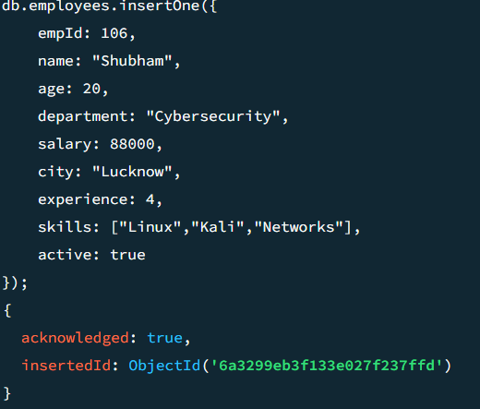

- db.employees.insertMany([
{
empId: 107,
name: "Suhani",
age: 24,
department: "Marketing",
salary: 40000,
city: "Lucknow",
experience: 2,
skills: ["SEO","Content Writing","Negotiation"],
active: true
},
{
empId: 108,
name: "Sumeet",
age: 27,
department: "IT",
salary: 80000,
city: "Bikaner",
experience: 10,
skills: ["Java","Docker"],
active: true
},
{
empId: 109,
name: "Rahul",
age: 29,
department: "HR",
salary: 52000,
city: "Hyderabad",
experience: 6,
skills: ["Payroll","Onboarding"],
active: false
}
]);
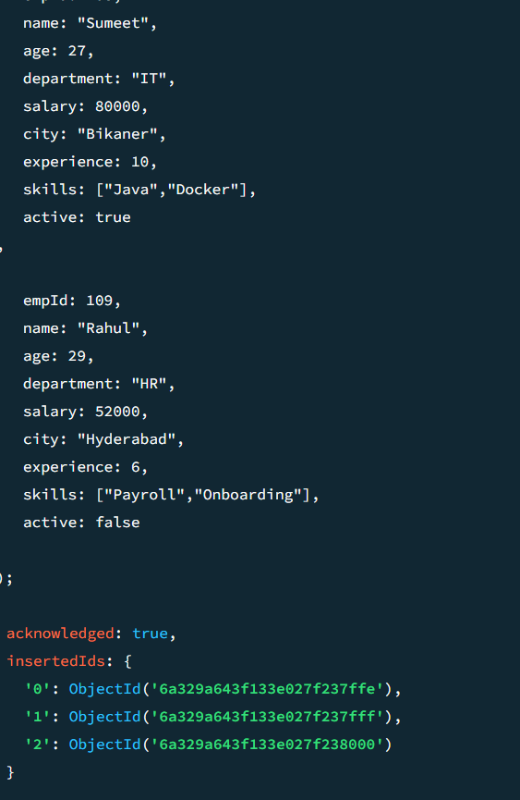

- db.employees.findOne({ department: "IT" });
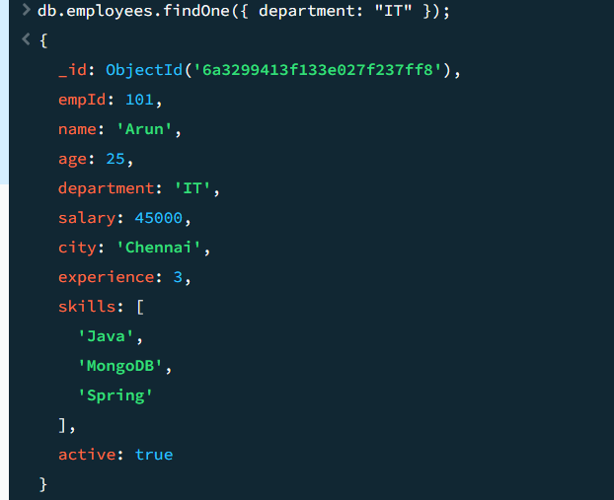

- db.employees.find().pretty();
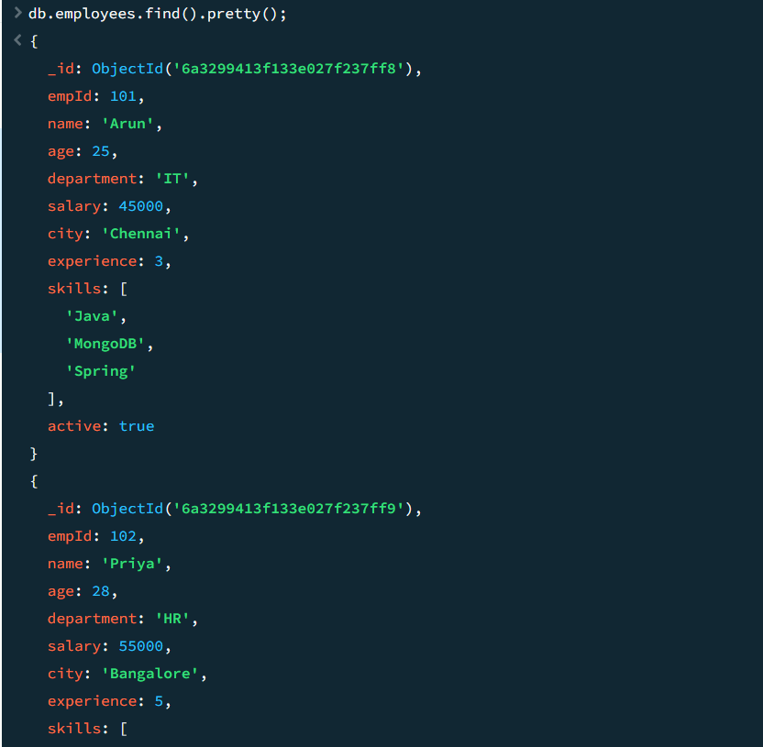
etc

- db.employees.find({}, { name: 1, salary: 1, _id: 0 });
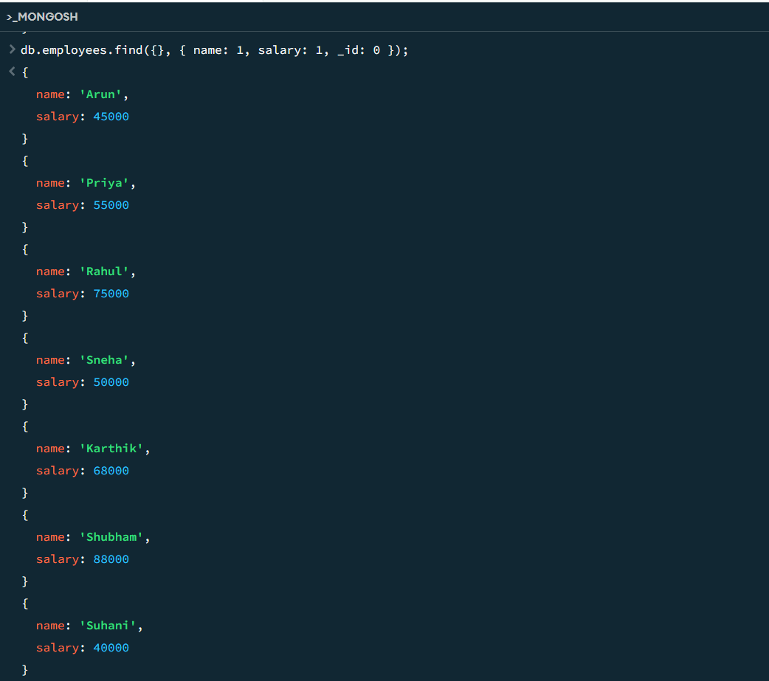

- db.employees.find({ salary: { $eq: 50000 } });
or db.employees.find({ salary : 50000 });
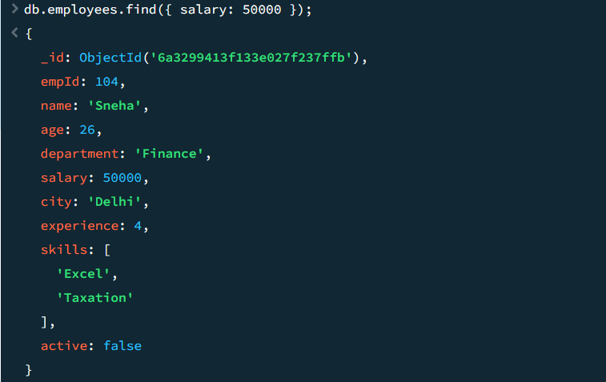
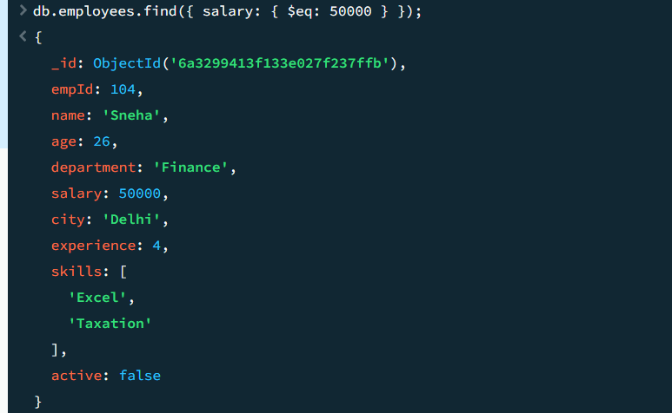

- db.employees.find({ salary: { $lt: 60000 } });
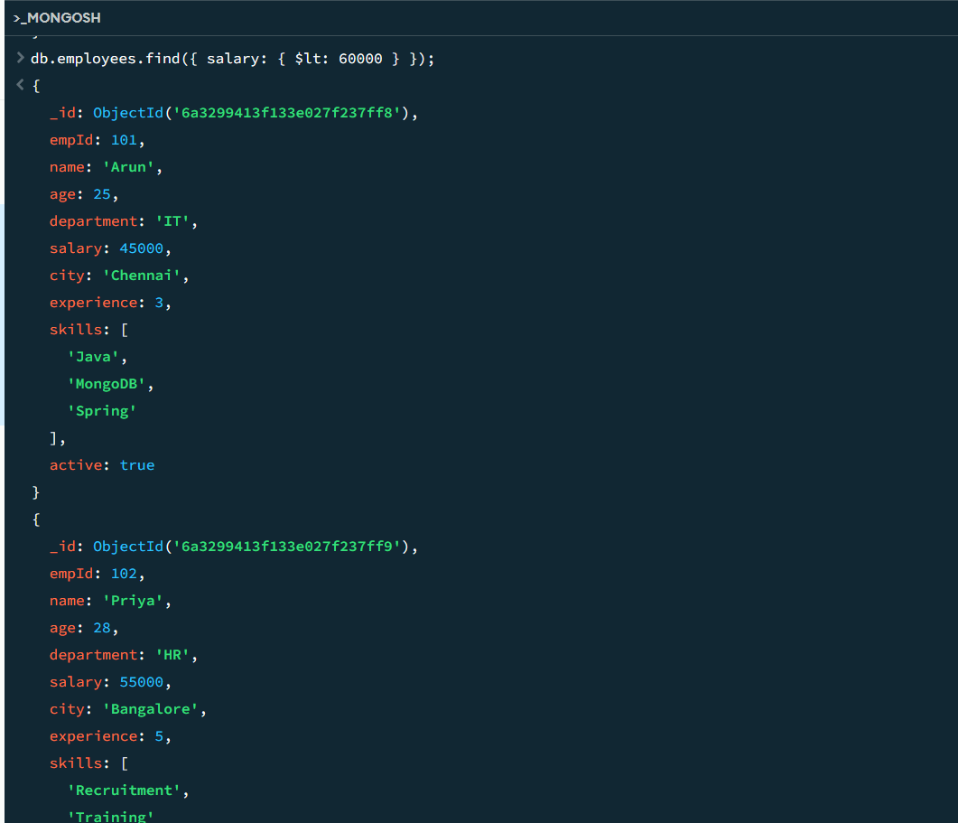

- db.employees.find({ salary: { $gte: 60000 } });
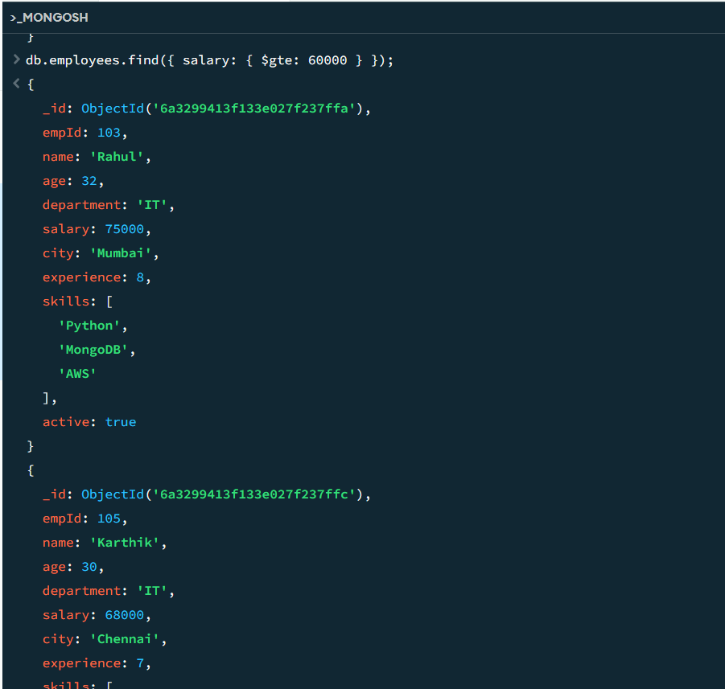

- db.employees.find({ age: { $ne: 30 } });
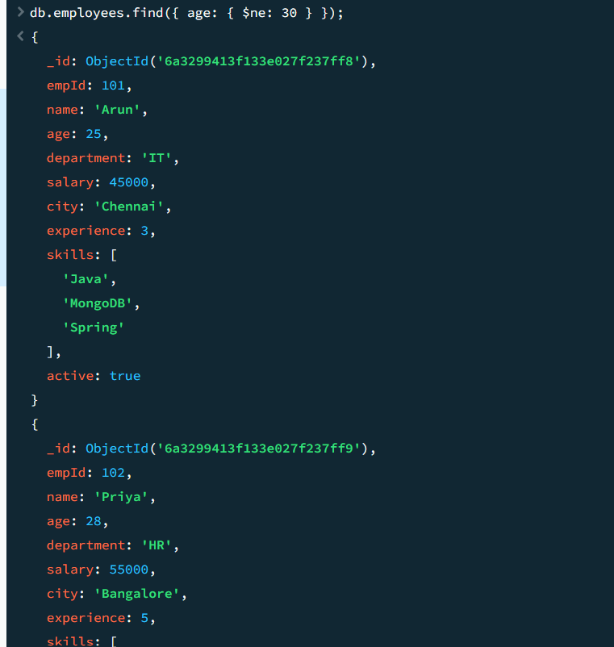

- db.employees.find({ city: { $in: ["Chennai", "Mumbai"] } });
Or db.employees.find({ $or: [{ city: "Chennai" }, { city: "Mumbai" }] });
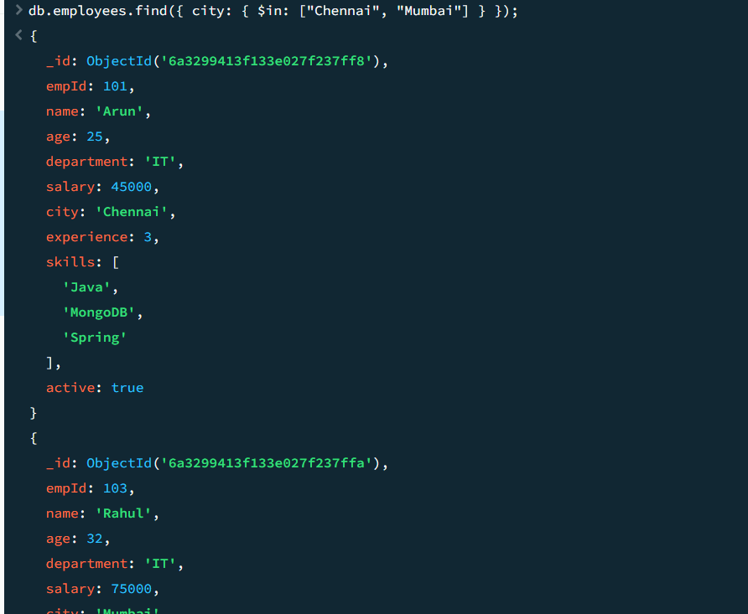

- db.employees.find({ city: { $nin: ["Chennai"] } });
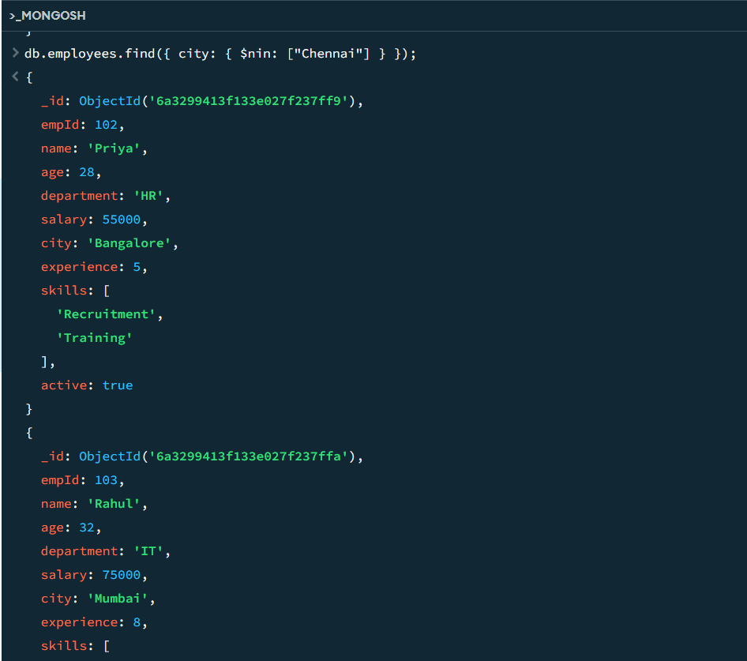

- db.employees.find({ $and: [{ department: "IT" }, { salary: { $gt: 50000 } }] });
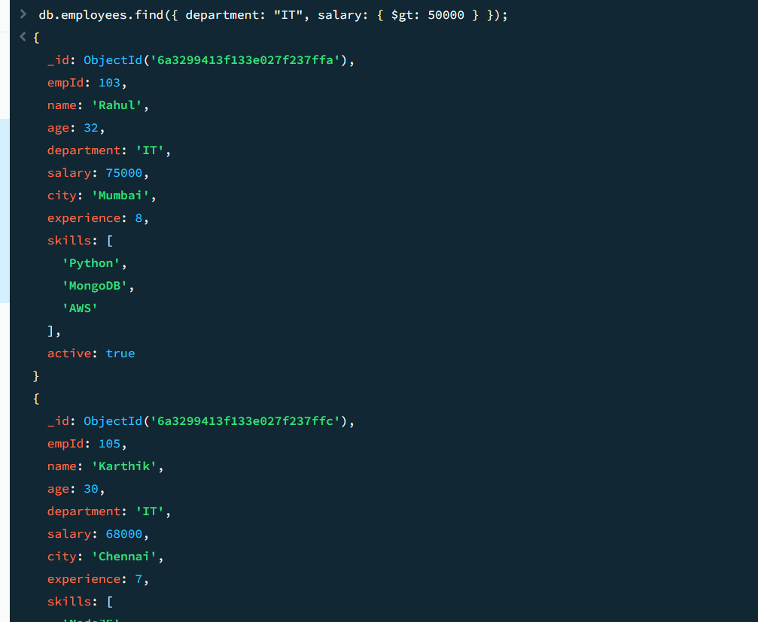

- db.employees.find({ city: { $in: ["Chennai", "Bangalore"] } });
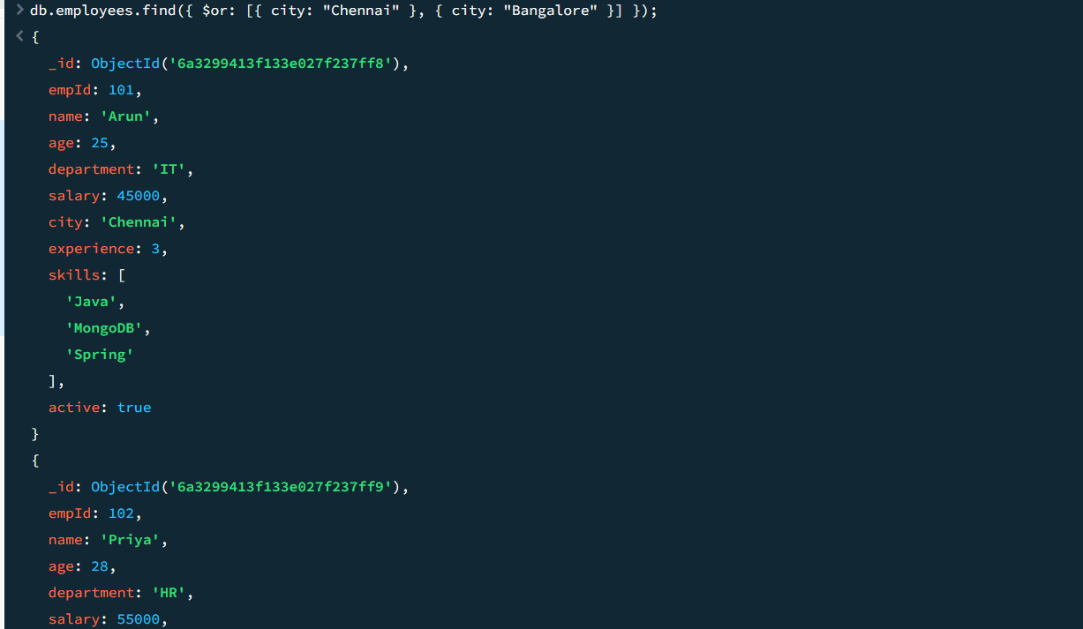

- db.employees.find({ salary: { $not: { $gt: 60000 } } });
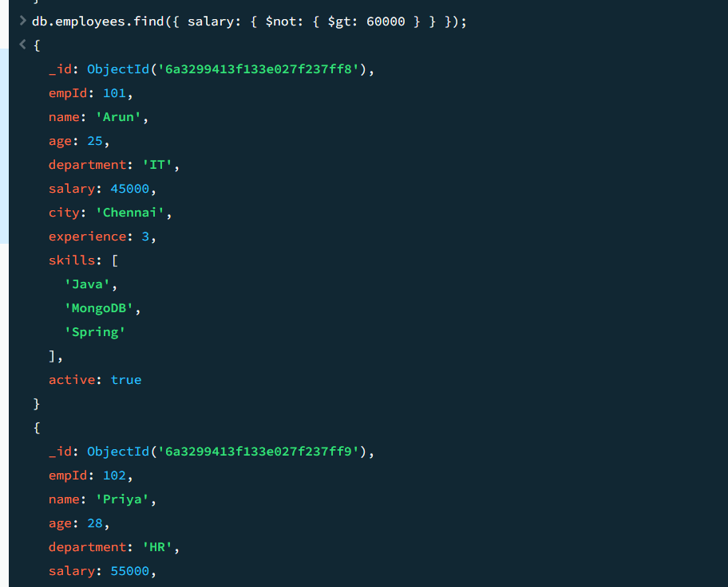

- db.employees.find({ department: { $nin: ["IT", "HR"] } });
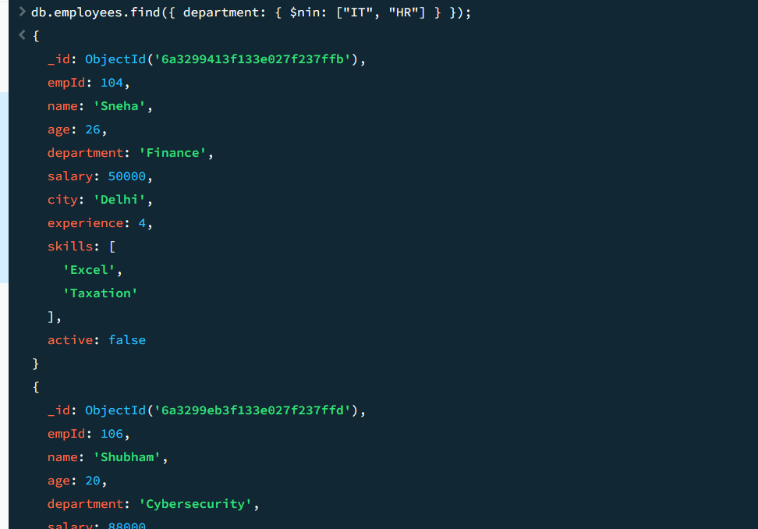

- db.employees.find({ experience: { $exists: true } });
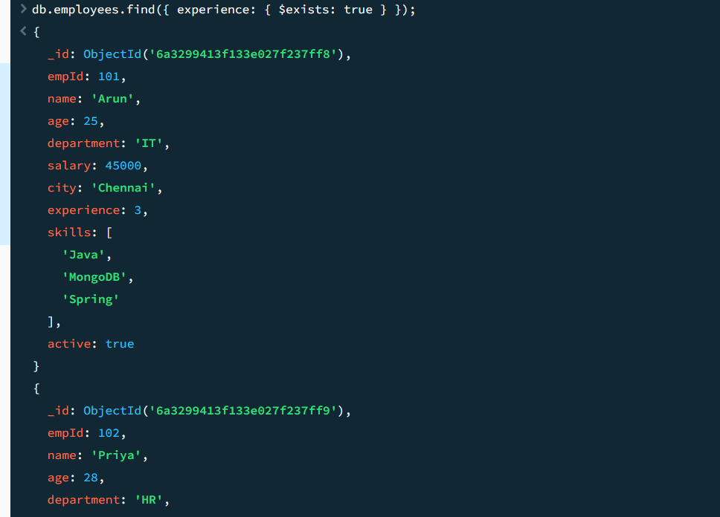

- db.employees.find({ salary: { $type: "int" } });
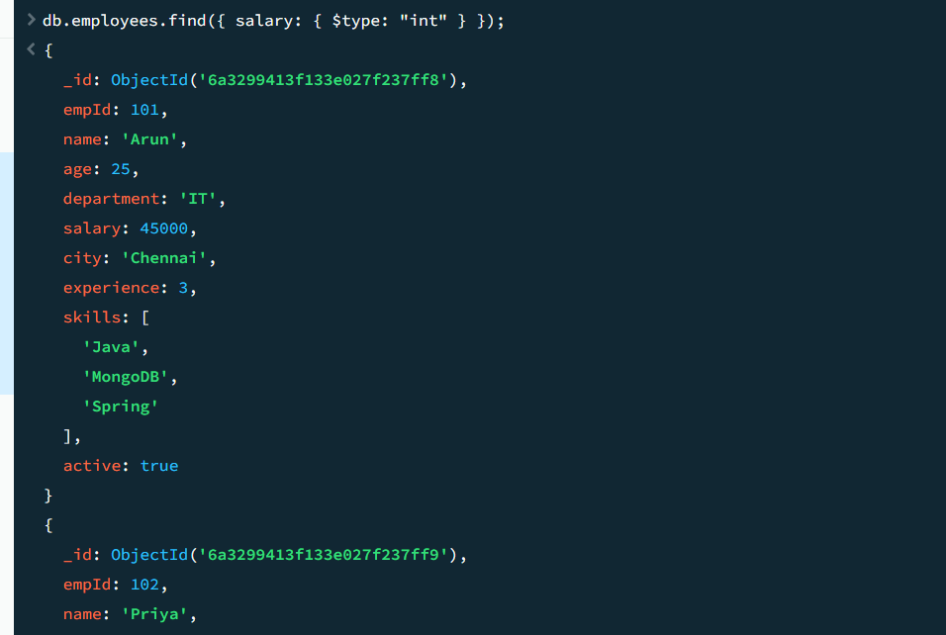

- db.employees.find({ skills: "MongoDB" });
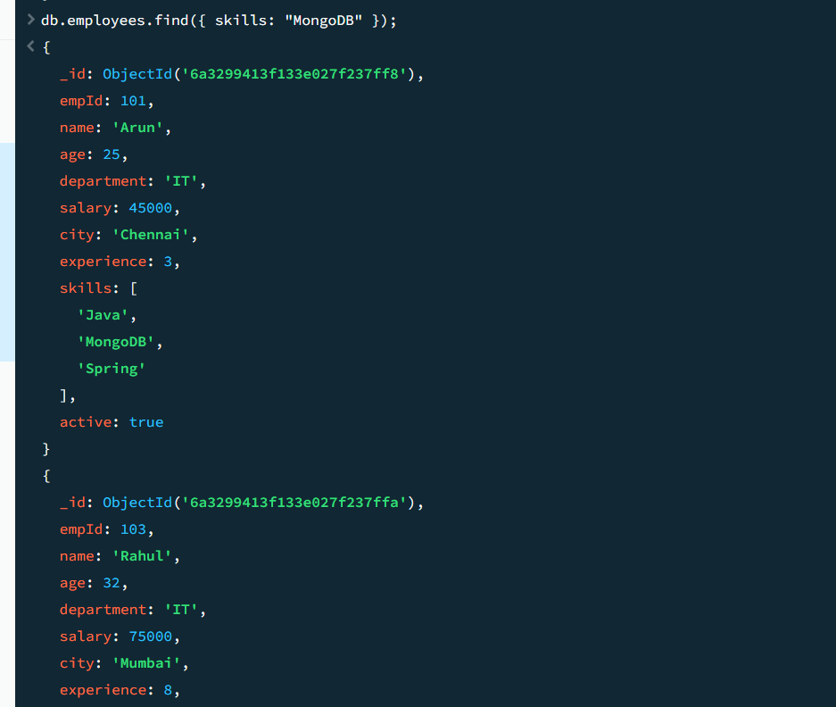

- db.employees.find({ skills: { $all: ["MongoDB", "AWS"] } });
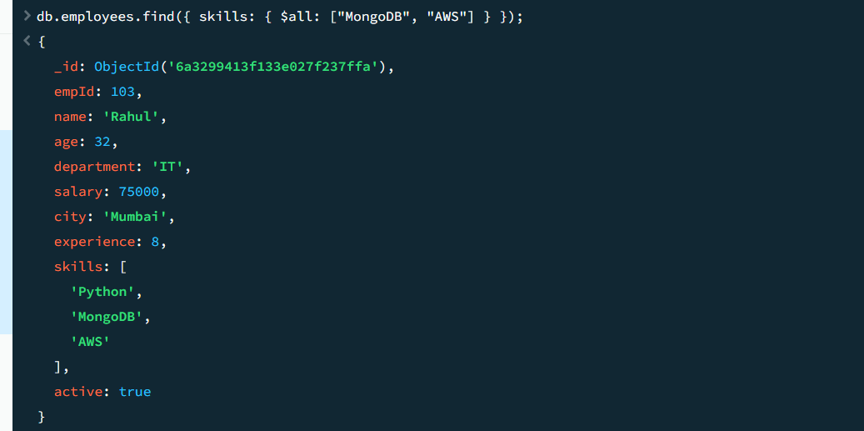

- db.employees.find({ skills: { $size: 3 } });
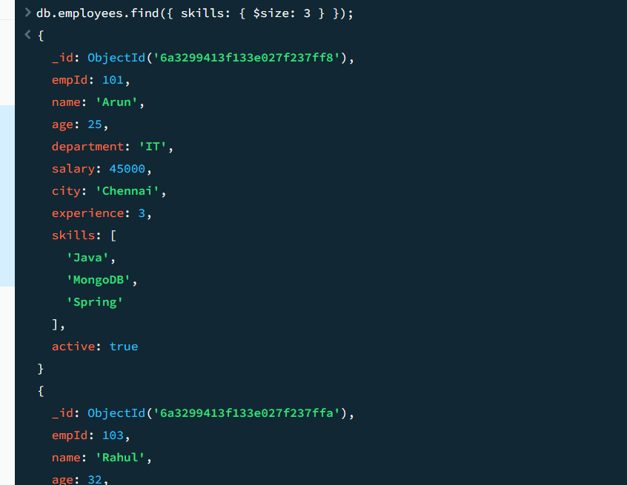

- db.employees.find({ skills: { $elemMatch: { $eq: "Java" } } });
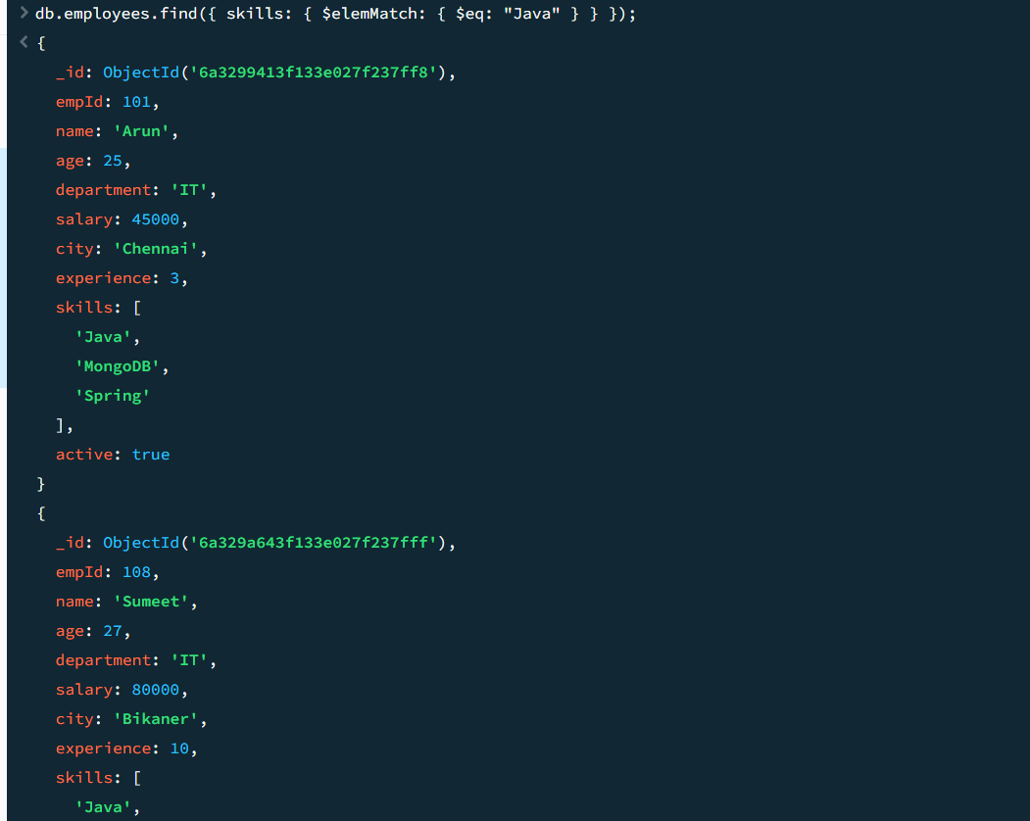

- db.employees.find().sort({ salary: -1 });
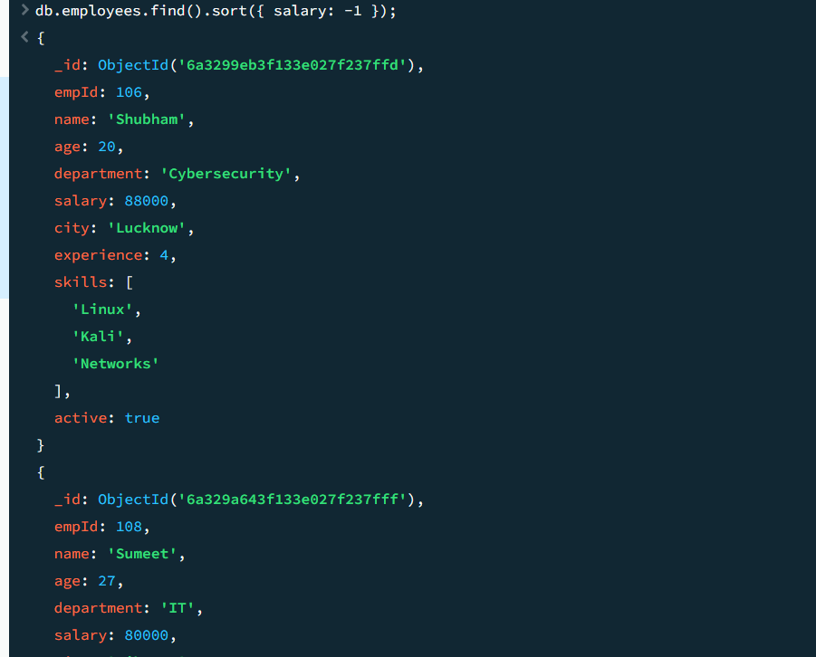

- db.employees.find().sort({ salary: -1 }).limit(3);
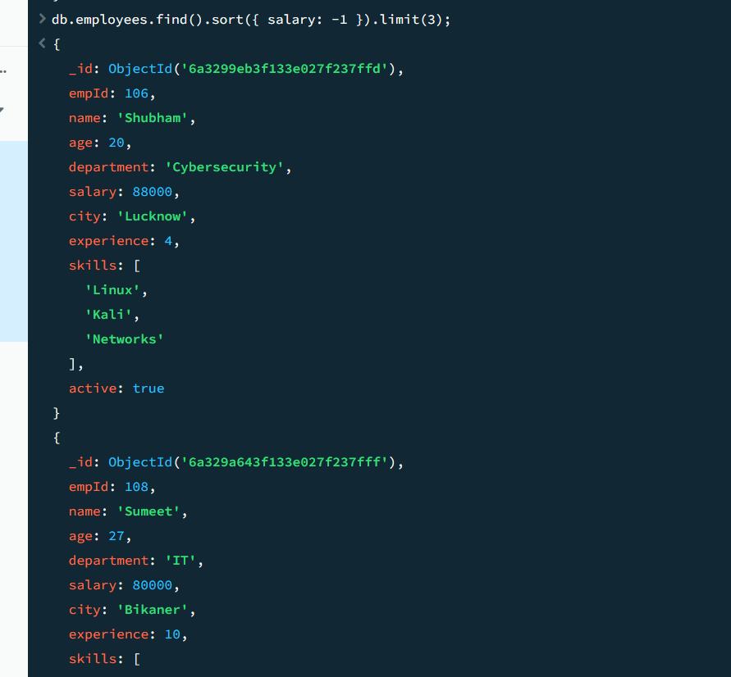

- db.employees.updateOne(
{
empId: 101
},
{ $inc: { salary: 5000 } }
);
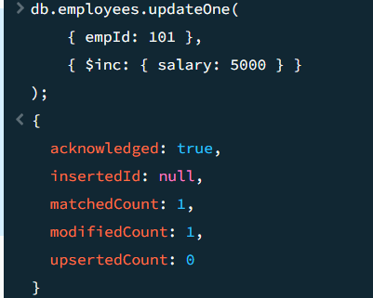
25. db.employees.updateMany(
{
department: "IT"
},
[ { $set:
{
salary:
{ $multiply: ["$salary", 1.10] }
}
}
]
);
