1. Grade Checker
Take a score as input and print the grade based on the following:
90+ : "A"
80-89 : "B"
70-79 : "C"
60-69 : "D"
Below 60 : "F"
here we used a basic if else statement to carry out marks and all.
Code:
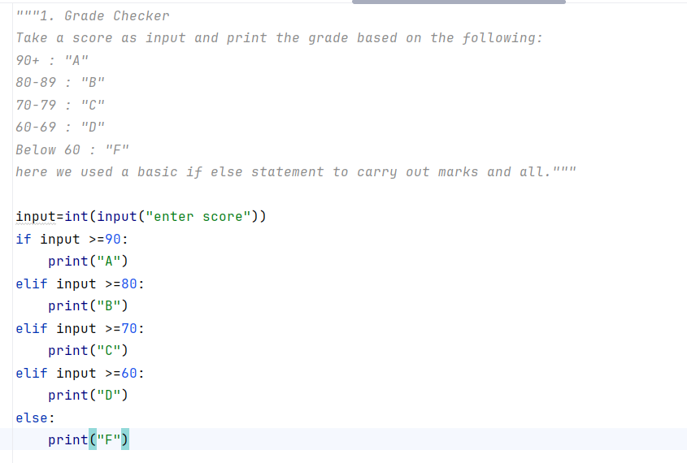
Output:
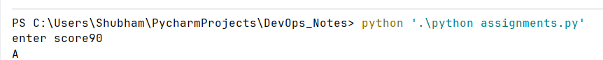

2 Student Grades
Create a dictionary where the keys are student names and the values are their grades. Allow the user to:Add a new student and grade, Update an existing student’s grade,Print all student grades.Used dictionary and basic operations. Using if else:
Code: 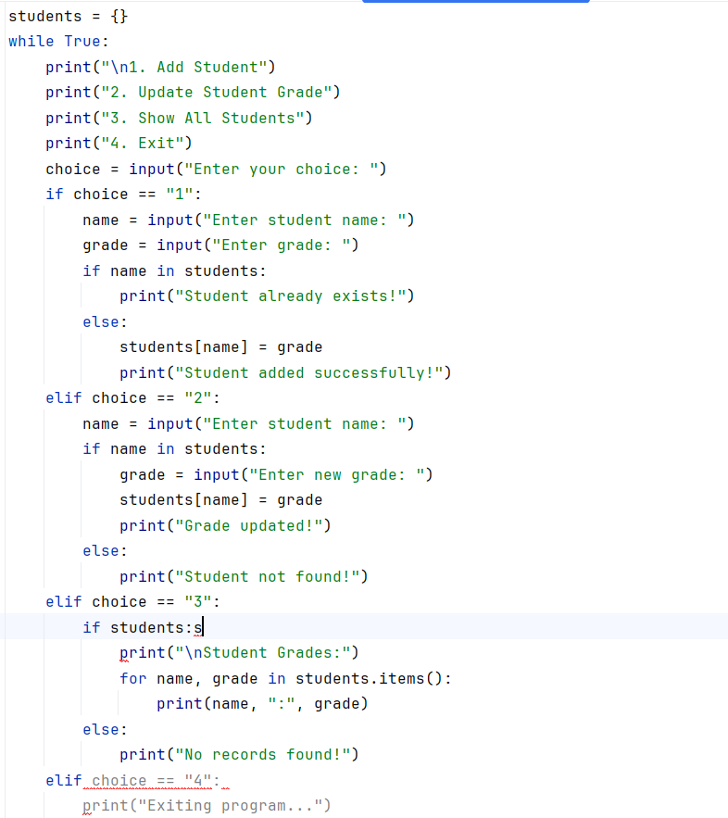

Output:
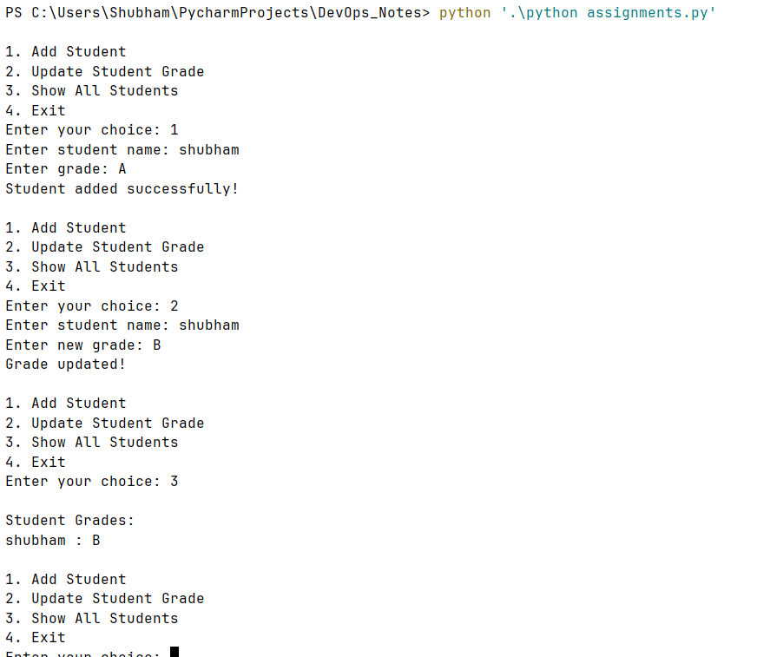
3.Write to a File
Write a program to create a text file and write some content to it.
Using file functions like write and open.
Code: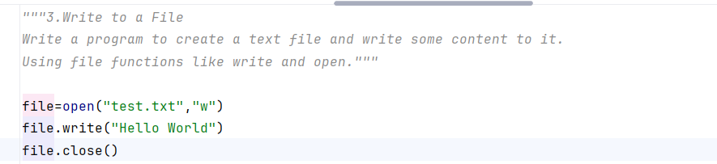
Output:
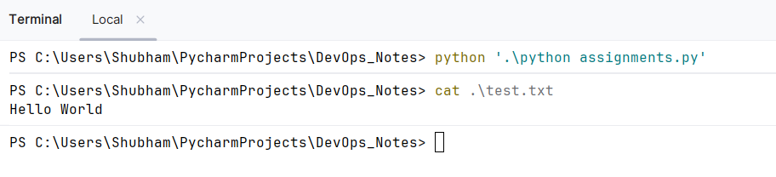

4. Read from a File
We used open in read mode and file.read to read and print to display.
Code:
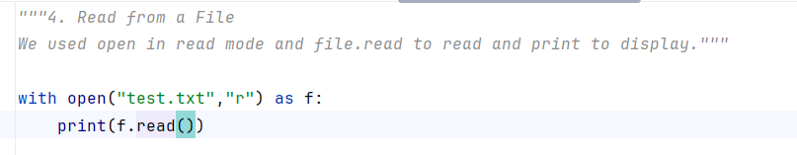
Output: 