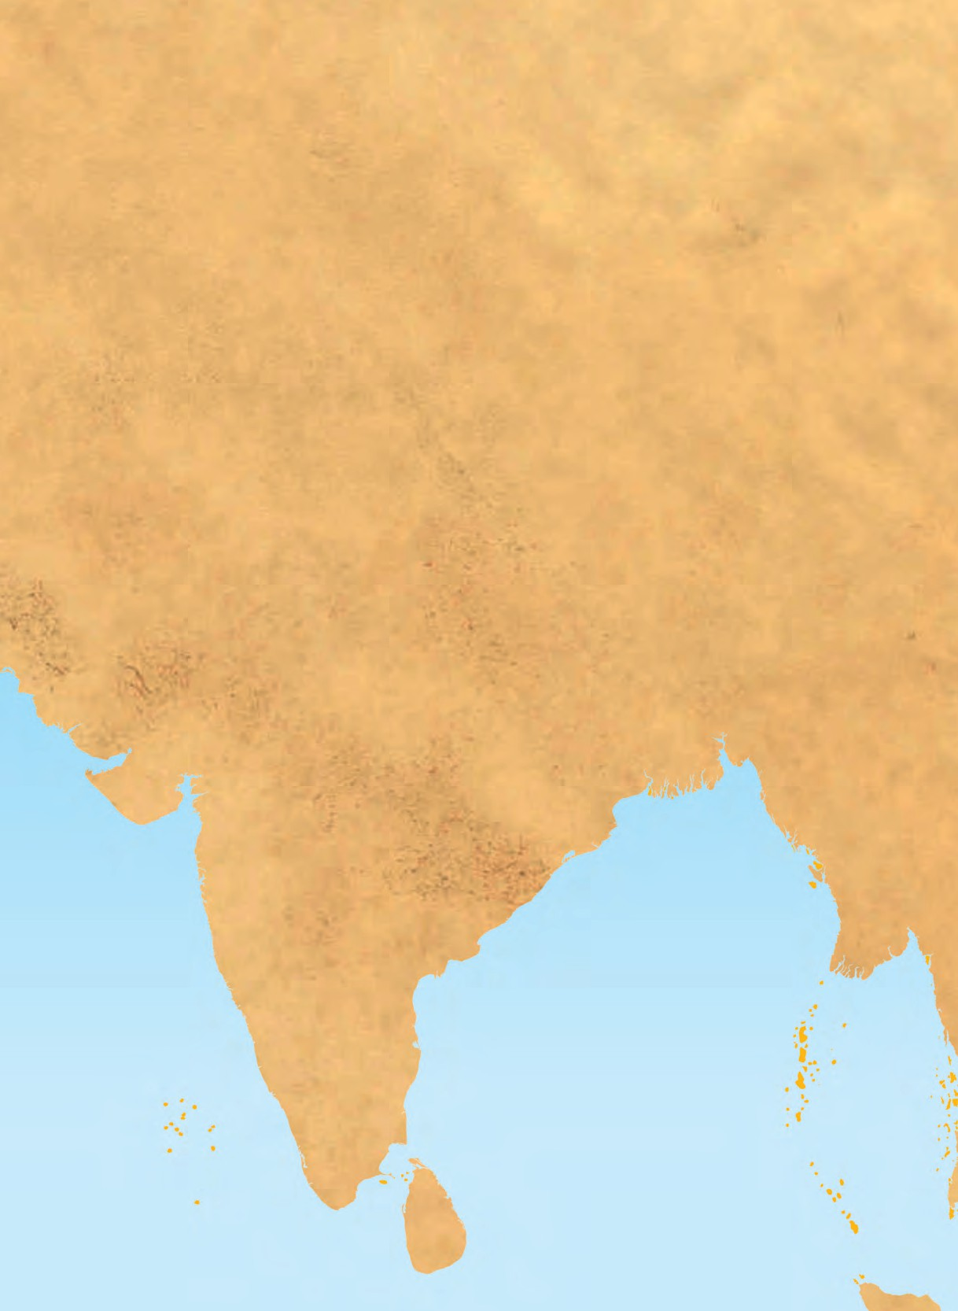




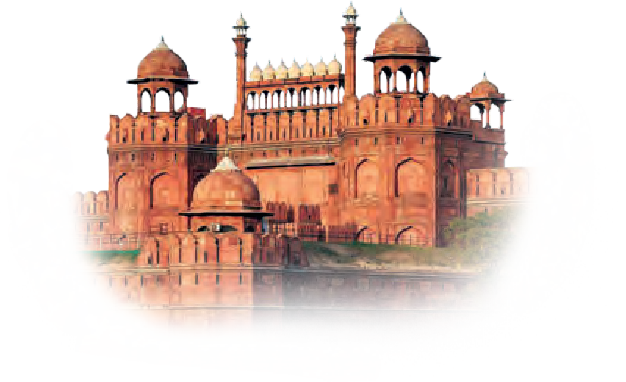







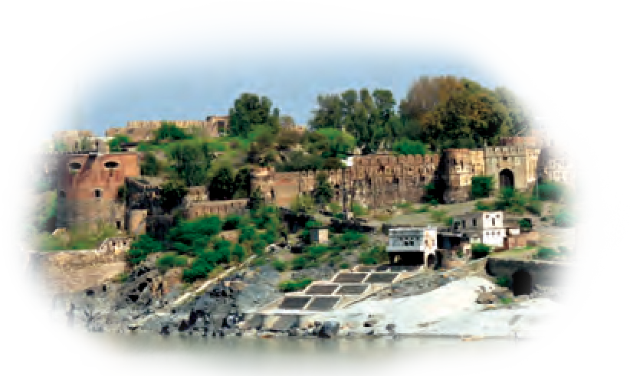
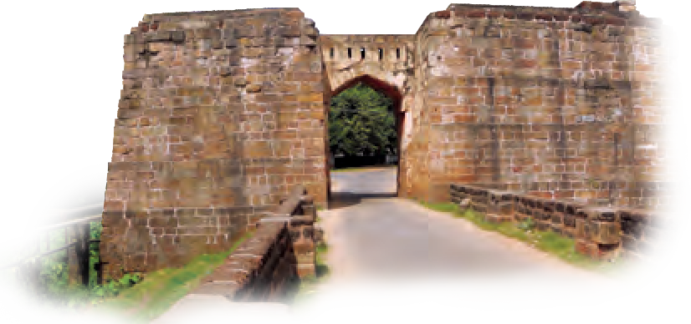
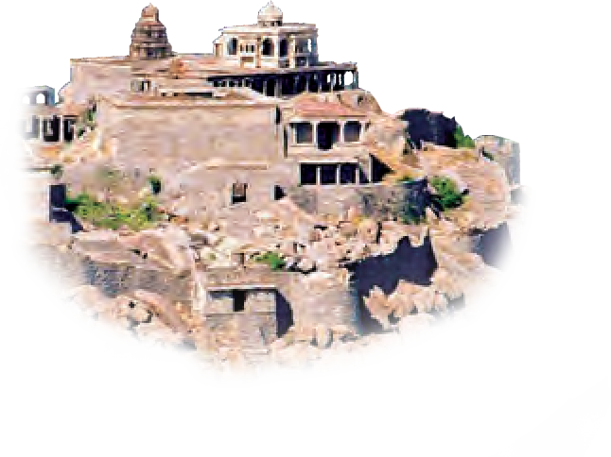







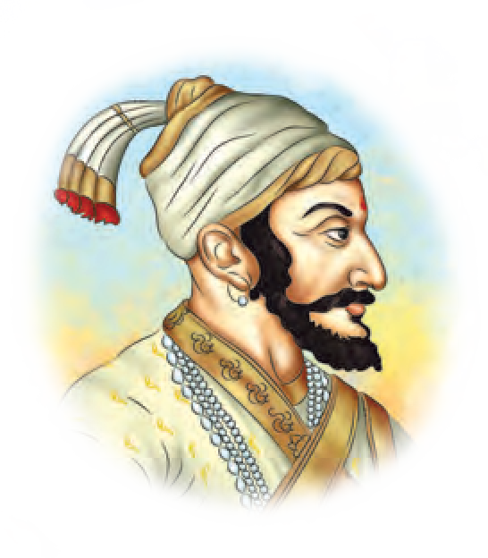


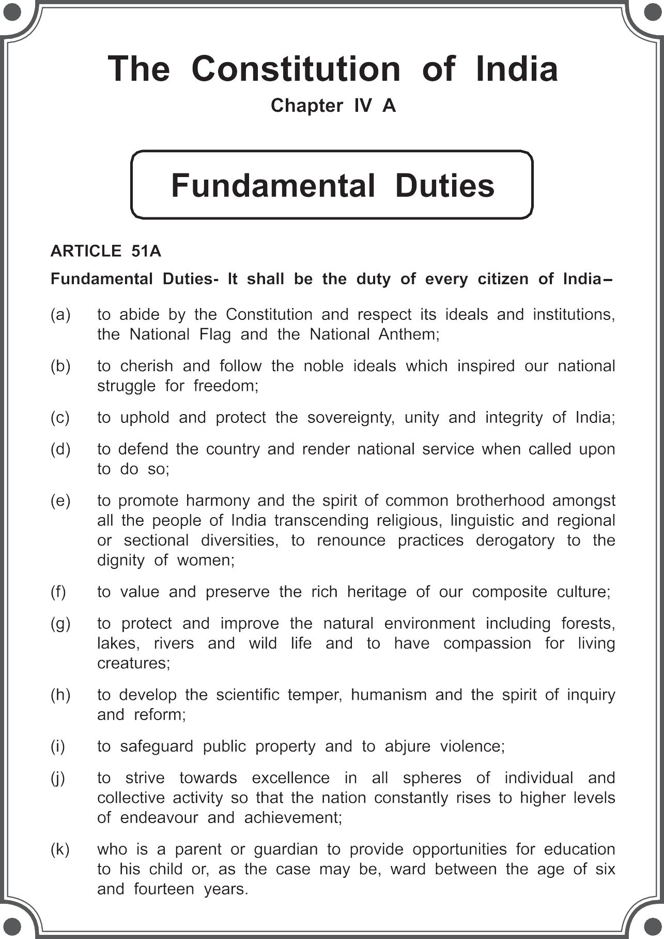





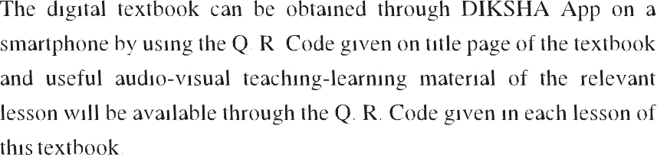

The Coordination Committee formed by GR No. Abhyas - 2116/(Pra.Kra.43/16) SD - 4 Dated 25.4.2016 has given approval to prescribe this textbook in its meeting held on 3.3.2017

HISTORY AND CIVICS
STANDARD SEVEN

Maharashtra State Bureau of Textbook Production and Curriculum Research, Pune - 411 004.

First Edition : 2017 © Maharashtra State Bureau of Textbook Production and Curriculum Research,

Reprint : October 2021
Pune - 411 004.
The Maharashtra State Bureau of Textbook Production and Curriculum Research reserves all rights relating to the book. No part of this book should be reproduced without the written permission of the Director, Maharashtra State Bureau of Textbook Production and Curriculum Research, ‘Balbharati’, Senapati Bapat Marg, Pune 411004.

History Subject Committee : Dr Sadanand More, Chairman Shri. Mohan Shete, Member
Shri. Pandurang Balkawade, Member Dr Abhiram Dixit, Member
Shri. Bapusaheb Shinde, Member Shri. Balkrishna Chopde, Member Shri. Prashant Sarudkar, Member
Shri. Mogal Jadhav, Member-Secretary

Civics Subject Committee :
Dr Shrikant Paranjape, Chairman Prof. Sadhana Kulkarni, Member Dr Mohan Kashikar, Member Shri. Vaijnath Kale, Member
Shri. Mogal Jadhav, Member-Secretary

History and Civics Study Group :
Cartographer :
Shri. Ravikiran Jadhav

Coordination :
Mogal Jadhav
Special Officer, History and Civics
Varsha Sarode
Subject Assistant, History and Civics

Translation :
Shri. Aniruddha Chitnis Shri. Sushrut Kulkarni Smt. Aarti Khatu

Scrutiny :
Dr Ganesh Raut
Prof. Sadhana Kulkarni

Coordination :
Dhanavanti Hardikar
Academic Secretary for Languages

Shri. Rahul Prabhu Shri. Sanjay Vazarekar Shri. Subhash Rathod Smt Sunita Dalvi
Dr Shivani Limaye Shri. Bhausaheb Umate Dr Nagnath Yevale Shri. Sadanand Dongre Shri. Ravindra Patil Shri. Vikram Adsul Smt Rupali Girkar
Dr Minakshi Upadhyay Smt Kanchan Ketkar Smt Shivkanya Patve Dr Anil Singare

Invitees :
Dr Ganesh Raut Dr Somnath Rode
Dr Raosaheb Shelke
Shri. Mariba Chandanshive Shri. Santosh Shinde
Dr Satish Chaple Shri. Vishal Kulkarni Shri. Shekhar Patil Shri. Sanjay Mehta Shri. Ramdas Thakar Dr Ajit Apte
Dr Mohan Khadse
Smt Shivkanya Kaderkar Shri. Gautam Dange
Dr Vyankatesh Kharat Shri. Ravindra Jinde Dr Prabhakar Londhe
Cover and Illustrations : Shri. Devdatta Prakash Balkawade
Santosh J. Pawar
Assistant Special Officer, English

Typesetting :
DTP Section, Textbook Bureau, Pune
Paper : 70 GSM Creamwove

Print Order : N
Printer : M/s.

Production : Sachchitanand Aphale Chief Production Officer Prabhakar Parab, Production Officer Shashank Kanikdale, Assistant Production Officer

Publisher :
Vivek Uttam Gosavi, Controller Maharashtra State Textbook Bureau,

Pictures of forts : Shri. Pravin Bhosale Prabhadevi, Mumbai - 400 025.





Preface
Dear Students,
You have studied History and Civics in Environmental Studies Part I and II from Std III to Std V. The subjects History and Civics are taught separately Std VI onwards. Both the subjects are included in a single textbook. We are happy to place this textbook of Std VII in your hands.
This book is designed in such a way that you will understand the subject clearly, find it interesting and you will get motivated by the work done by our ancestors. We want you to gather knowledge as well as joy when you study it. For that, we have provided coloured pictures and maps in this textbook. Please study each chapter in this textbook carefully. If you do not understand any part, ask your teachers and parents to explain it. The additional information given in the boxes will add to your knowledge. If you consider that history is an interesting subject and is our friend, you will definitely like this subject.
In the History section, we have explained the ‘History of Medieval India’. The textbook has been designed by focusing upon the place and role of Maharashtra in the making of Medieval India. When you study this textbook, we expect that you will develop an awareness of being a citizen of India, and also a sense of duty.
In the Civics part, we have introduced the Constitution of India. The background for creating a new Constitution, the Preamble to the Constitution, the Fundamental Rights and Directive Principles in the Constitution are covered in this part. It explains in simple language, that the government system in our country is run as per the Constitution, laws and rules. We have provided many projects so that your learning becomes more activity-oriented. You will enter the next standard with the feeling that you are the future citizens of the country and will build the future of our country.
When we study History, we come to know about the achievements of our ancestors. When it is coupled with the study of Civics, we understand our duties towards building a nation and a society. That is why the two subjects are studied together.


Pune
Date : 28 March 2017

(Dr. Sunil Magar) Director
Maharashtra State Bureau of Textbook Production and Curriculum Research, Pune.

- For Teachers -
We have already taught the History and Civics textbook for Std VI. In this textbook for Std VII the History of Medieval India is presented.
The special feature of this presentation is that it focuses on Maharashtra. Even though our State is part of the Republic of India, if we study history from the perspective of Maharashtra, we will understand the position, role and contribution of Maharashtra in the History of India, and the students will develop a more mature national feeling. They will understand what our ancestors have done for the nation and it will enhance their awareness of their own responsibilities and duties towards the nation.
In this respect, the foundation of Swaraj by Chhatrapati Shivaji Maharaj in the seventeenth century is very important. To understand the foundation of Swaraj, the situation in India and Maharashtra before the rise of Chhatrapati Shivaji Maharaj should be understood first, so that one gets a perspective on the history of India. That has been our policy while designing this book. We have discussed how, after the demise of Shivaji Maharaj, Maharashtra faced the attacks on his Swaraj and protected it. After they had repulsed the attacks, the Marathas expanded the boundaries of Maharashtra and occupied most of India. The next part covers the expansion of Swaraj into an empire. We all know that the British conquered India and ruled here but it is important to understand how Maharashtra was in the forefront in stopping the British. The British had to compete with the Marathas and they had to conquer India by battling with the Marathas. This evokes a sense of our strength and duty. It is expected that teaching-learning should awaken this feeling in the students’ minds. This view-point is expressed pictorially on the cover showing the expansion of the Maratha power with the help of a broad outline map of India.
In the Civics part, we have introduced the Constitution of India. As it is not possible to teach this subject in one year, it is distributed across two standards. In this standard, the emphasis is on the need for a Constitution, the values enshrined in the Constitution, the Preamble, Fundamental Rights and Duties and the Directive Principles. The administrative machinery and the political procedures laid down in the Constitution will be taken up in Std VIII. In this sense, the Civics portion in the two standards is complimentary. It is arranged in such a way that the students will be able to understand it easily. The contents have been arranged in an innovative way. It is based on constructivism, but going even beyond, priority is given to making the students (responsible) members of the society by removing the apathy towards the political system. The content has been presented in very simple language. It will increase the readability of the book.
While teaching this textbook, teachers should use newspapers, news on television, the analysis by scholars and should help create a comprehensive vision amongst students. If one studies and teaches History and Civics with reference to current affairs, it becomes more meaningful and helps in inculcating values in students.

CONTENTS

No.

History of Medieval India

Chapter

Sources of History......................................................

Page No.
1

- India before the Times of Shivaji Maharaj ............... 5

- Religious Synthesis ................................................... 11

- Maharashtra before the Times of Shivaji Maharaj... 14

- The Foundation of the Swaraj .................................... 19

- Conflict with the Mughals ......................................... 24

- The Administration of the Swaraj .............................. 29

- An Ideal Ruler ........................................................... 33

- The Maratha War of Independence........................... 37

- The Expansion of the Maratha Power....................... 44

- Marathas - The Protectors of the Nation.................. 47

- Progression of the Empire ......................................... 53

- Life of the People in Maharashtra............................. 57
S.O.I. Note : The following foot notes are applicable : (1) © Government of India, Copyright : 2017. (2) The responsibility for the correctness of internal details rests with the publisher. (3) The territorial waters of India extend into the sea to a distance of twelve nautical miles measured from the appropriate base line. (4) The administrative headquarters of Chandigarh, Haryana and Punjab are at Chandigarh. (5) The interstate boundaries amongst Arunachal Pradesh, Assam and Meghalaya shown on this map are as interpreted from the “North-Eastern Areas (Reorganisation) Act. 1971,” but have yet to be verified. (6) The external boundaries and coastlines of India agree with the Record/Master Copy certified by Survey of India. (7) The state boundaries between Uttarakhand & Uttar Pradesh, Bihar & Jharkhand and Chattisgarh & Madhya Pradesh have not been verified by the Governments concerned. (8) The spellings of names in this map, have been taken from various sources.

English History : Standard Seven - Learning Outcomes
Suggested Pedagogical Processes Learning Outcomes
Competency Statements

The
learner be provided opportunities in
The learner-

pairs/groups/ individually and encouraged to:

- identify different sources of history available in books/local environment for example, extracts from manuscripts/ maps/ illustrations/painting/historical monuments/films, biographical dramas, television serials, folkarts dramas and interpret these to understand the time.
- familiarise with the emergence of new dynasties and prepare a timeline to trace important developments during this time.
- enact/dramatise key events of a given historical period/personalities like Emperor Akbar, Chhatrapati Shivaji Maharaj, Bajirao I, Maharani Tarabai, etc.
- reflect on the changes in society during medieval period and compare it with present day time.
- prepare projects: on dynasties/ kingdoms/ administrative reforms and architectural specialties of a period for example, preparing a project on Bhosale, Shinde, Holkars, etc.
- understand the teachings of the sants through Abhangas, bhajans, kirtans etc. Collect information through visits to nearby dargah/gurudwara/ temples, associated with bhakti or sufi cult and discuss the principles of various religions.
- know about India before the times of Shivaji Maharaj, the Maharashtra before the times of Shivaji Maharaj, Maratha war of independence, Peshwa period and the expansion of the Maratha power.

07.73H.01 identifies various sources of History and explains their use for rewriting the History of that period.
07.73H.02 provides examples of sources used to study various periods in history.
07.73H.03 critically examine the Maratha Mughal conflict.
07.73H.04 explains the reasons behind the coronation of Chhatrapati Shivaji Maharaj.
07.73H.05 relates key historical developments during medieval period occurring in one place with another.
07.73H.06 analyses socio-political and economic changes during medieval period.
07.73H.07 analyses administrative measures and strategies adopted by Chhatrapati Shivaji Maharaj for military control.
07.73H.08 describes distinctive developments in style and technology used for construction of temples, tombs and mosques with examples.
07.73H.09 identifies the similarities amongst the teachings of different sants.
07.73H.10 draws inferences from poetry and abhangas of bhakti and sufi sants about existing social order.
07.73H.11 analyses the reasons behind the battle of Panipat
07.73H.12 explains with the historical events of that time that the Maratha power became a dominent power at all India level.

1. Sources of History

We studied ancient Indian history last year. This year, we are going to study the medieval period of Indian history. Broadly, the period from the ninth century CE till the end of the eighteenth century

Material Sources
Memorials

Forts
Physical

Buildings

CE is considered to be the medieval period of Indian history. In this lesson, we are
going to study the sources of medieval
Copper Plates
Sources
Cave Sculptures

history.
Coins
Inscriptions

History gives us a chronological, scientific and systematic account of past events.
Four factors are very important from the viewpoint of history. They are - Individuals, Society, Place and Time. History must be based on authentic evidence or proofs. These proofs are known as the sources of history.
Let us classify these sources into material sources, written sources and oral sources to learn more about them. Let us also evaluate the sources of history.
We have to consider many factors related to the historical event that we want to study. It is necessary to support our study with historical sources. These sources have to be verified. We have to see whether they are authentic. It is necessary to use these sources judiciously and only after a critical analysis.
Forts have an important place among material sources. Some major types of forts are hill forts, forest forts, sea forts and forts on the plains. Monuments include samadhis, graves, veergala and buildings include palaces, ministerial mansions, Queen's quarters (raniwasa) and also houses of common people. They
all provide insights about that period. Looking at them, we come to know about the development of architecture, the economic conditions, the quality of art, style of the building construction and people's standard of living in that particular period.



How do coins narrate history ?
Can you tell ?

Since ancient times, coins like kavadi, damadi, dhela, pai, paisa, ana and rupee were used. Some local idioms or proverbs are based on coins. For example;
* ‘एक फुटकी कवडी देणार नाही.’ Here
phutaki kavadi means ‘the lowest bit of money’.
* सोलह आना सच! means ‘Hundred
percent true !’
Let’s learn.

The coins made by different rulers using metals like gold, silver, copper are important sources of history. From these coins we learn about the rulers, their period, governance, religious ideas,

1

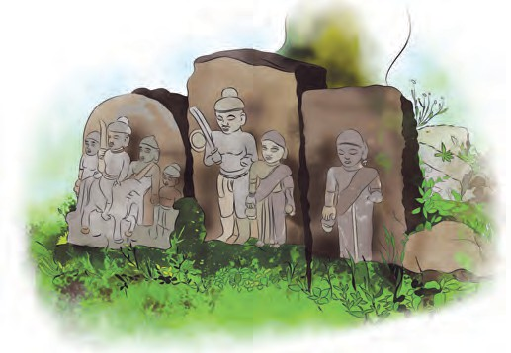

Rashtrakuta, Chola and Yadav kings have been found. An inscription is considered to be a very important and reliable source of history. It helps us to understand features like the language, script, social life of a period. Inscriptions carved on sheets of copper are known as ‘copper plates’. Royal edicts, verdicts, etc. are inscribed on copper plates.

Veergala
personal details, etc. Similarly, we also learn about the financial transactions and economic conditions prevailing at that time. We also see how far metallurgy had advanced in that period. From the images of Ram-Sita on the coins of Emperor Akbar or Shiva Parvati on the coins of Hyder Ali we see the religious co-ordination of those days. The Peshwas used the Arabic or Persian language on their coins. This throws light on the use of language in that period.
An inscription is a carving on a stone, or a wall etc. For example, the inscriptions found in the Brihadishwara temple premises in Tanjavur. Many inscriptions of the period of Chalukya,
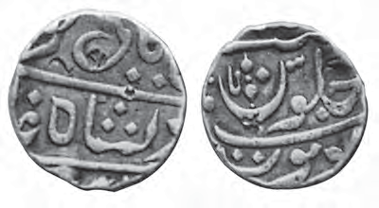
A coin of the Peshwa period

A coin of Hyder Ali
Do you know ?
Chaityas, Viharas, temples, churches, mosques, agiaries, durgahs, mukbaras, gurudwaras, monuments, sculptures, wells, minarets, village boundaries and gates, weapons, utensils, ornaments, clothes, decorative articles, toys, implements, musical instruments are all material sources of history.

Written Sources : We learn about significant historical events in the medieval period from sources like the writing styles of scripts like, Devanagari, Arabic, Persian, Modi etc. as also from the varieties of different languages, bhurja- patras, religious manuscripts, treatises, edicts, decrees, biographies, paintings, etc. We can gather information about the food items, attire, conventions and rules of conduct of the people, festivals and about people’s life etc. from these sources. Sources of this type are called ‘written sources’ of history.
Documents of proceedings in the courts of kings
Geneologies,
Shakavali
Correspondence, Dispatches
Written Sources
Judicial Treatise,
Travelogues Chronicles,
Verdicts, Biographies Orders
of foreign travellers
Tavarikh

, , ,
2

During this period, travellers from other countries came to India. They have written travelogues or accounts of their travels. Some of them are Al Biruni, Ibn Batuta, Niccolao Manucci. Babur’s biography, ‘Shrishivbharat’ or the Sanskrit biography of Shivaji Maharaj composed by the poet Paramanand as well as

Myths Legends
Proverbs
Folk songs

Oral Sources

Powadas

Gatha

Shlokas Abhangas

various other biographies of different rulers and their correspondence help us to understand the policies and administrative systems of the rulers and their diplomatic relations with others.
Tavarikh or Tarikh means the sequence of events. Tavarikhs written by Al Biruni, Ziauddin Barani, Maulana Ahmed, Yahya Bin Ahmed, Mirza Hyder, Bhimsen Saxena, etc. are available.

Bakhar is a type of chronicle that originated in Maharashtra. Chronicles help in understanding aspects like the contemporary political happenings, linguistic transactions, cultural life, social conditions, etc. Many of the chronicles in Marathi were written many years after the events had occurred. As a result, they are seen to rely on hearsays. Some of these chronicles are Mahikavatichi Bakhar, Sabhasad Bakhar, Chitnisachi Bakhar, Bhausahebachi Bakhar, etc. The works of contemporary western historians like Robert Arm, M.C.Sprengel and Grant Duff are also important.

Do this.
Make a collection of powadas, tribal songs.
Present them in the cultural programmes arranged in your school.
Oral sources : We understand various aspects of folk life through folk literature traditionally passed on from generation to
generation. Some examples are - owis, folk songs, powadas, folk tales, legends, and myths. Such type of sources are called ‘oral sources’ of history.

History is written with the help of the three types of sources mentioned above. Even after it has been written down, research on it goes on continuously. New sources and information come to light through this research. Then history has to be rewritten accordingly. We can see that our history books and those of our parents and grandparents, differ to a certain extent.
Do you know ?
The Powada of Tanaji : Given below is an extract from a powada composed by Tulashidas Shahir. He portrays the Kondhana campaign in it. The powada contains beautiful character sketches of Tanaji, Shelarmama, Shivaji Maharaj, Veermata Jijabai, etc.
मामा बोलाया तो लागला । ऐंशी वर्षीचा म्ातारा ।। ‘‘ लगगन राग्ले रायबाचे तो मजला सांगावी ।। माझया तानाजी सुभेदारा । जे गेले गसं्गडाला ।। तयाचे पागिरे पाग्ले । ना्ी पुढारे पाग्ले ।। जयाने आंबारे खाईला । बािा बुजरा लागवला ।।
तयाचे झाड ्ोउगन आंबे बांधले । गिल्ा ्ाती ना्ी आला ।। गसं्गड गिललयाची वाताता ।
िाढू निो तानाजी सुभेदारा ।।
जे गेले गसं्गडाला । ते मरूनशानी गेले ।। तुमचा सपाटा ्ोईल । असे बोलू निो रे मामा ।। आम्ी सूरमदता क्षत्ी । ना्ी गभणार मरणाला ।। ’’



Suggest measures for preserving sources of history.
Say your say !
Evaluating the sources of history : It is necessary to take certain precautions before using these sources of history. We have to examine their authenticity and see which are genuine and which are fake. Their quality can be determined with the help of internal standards. We also have to study the integrity of the writers, their personal interests, the period
in which they live and the political pressures on them. It is also important to see whether they rely on hearsay or give an eyewitness account. We need to consider the exaggerations, metaphors and other literary devices they use. Their information has to be verified with the help of other contemporary sources. The information may be one sided, contradictory or exaggerated. It has to be seen in a proper perspective. The sources have to be subjected to a critical analysis. The author’s impartiality and neutrality are very important in writing history.



Exercise

- Complete the names of the following sources of history.
l d t h b r p a
i i i n m u t
- Let’s write.
  - What do monuments include ?
  - What is a Tarikh ?
  - What qualities of the author are important in the writing of history ?
- Find the odd man out.
  - Material sources, written sources, unwritten sources, oral sources.
  - Monuments, coins, cave sculptures, stories
  - Bhurjapatras, temples, treatises, paintings.
  - Owis, tarikhs, folk tales, myths
- Explain the following concepts.
  - Material sources
  - Written sources
  - Oral sources
- Is it necessary to evaluate sources of history ? Give your opinion.
- Write why in your words.
  - A stone inscription is considered to be an authentic source of history.
  - Oral sources reveal various aspects of people’s lives.
Activity

Visit any museum that is nearby. Gather information about the sources of history from the period that you are studying and record it in your activity book.

2. India before the Times of Shivaji Maharaj

We shall learn about the various ruling powers in India before the times of Shivaji Maharaj in this lesson. Various ruling powers existed in India during that period.
‘Pal’ in the eighth century was a famous dynasty in Bengal. In Central India, the Gurjar-Pratihar power spread up to Andhra, Kalinga, Vidarbha, West Kathewad, Kanauj and Gujarat.
Among the Rajput dynasties in North India, the Gahadwal and the Parmar dynasties were the important ones. Among Rajputs, Prithviraj Chauhan belonging to the Chauhan dynasty was a valiant King. In the first war at Tarai, Prithviraj Chauhan had defeated Muhammad Ghuri. But Muhammad Ghuri defeated Prithviraj Chauhan in the second war at Tarai.
Rajaraj I and Rajendra I belonging to the Chola dynasty in Tamil Nadu were eminent rulers. The Cholas conquered the Maldive Islands and Sri Lanka using their naval strength. King Vishnuvardhan belonging to the Hoysal dynasty in Karnataka had conquered the whole of Karnataka.
During the reign of Govind III of the Rashtrakuta dynasty in Maharashtra, the Rashtrakut power spread from Kanauj up to Rameshwar. Later, Krishna III conquered the region up to Allahabad.
Three dynasties of the Shilahars emerged in Western Maharashtra. One dynasty ruled over Thane and Raigad in North Konkan, the second in South Konkan, while the third dynasty ruled over some parts of the present day Kolhapur, Satara, Sangli and Belgaum districts.
The last prosperous power before the period of Shivaji Maharaj was that of the Yadavas. The capital of Bhillam V of the Yadava dynasty was at Deogiri near Aurangabad. He extended his rule beyond the river Krishna.
The Yadava period is considered to be the golden period of Marathi language and literature. It was in this period that the Mahanubhav Panth and the Varkari movement emerged.

Invasions from the North-West
Local dynasties like the Yadava and Rashtrakuta ruled in Maharashtra. But invaders from the north-west conquered the local dynasties there and established their own rule.
In the meanwhile, the Arab power had emerged in the Middle-east. Arab rulers turned towards India to expand their empire. The Arab General Muhammad- bin-Qasim, attacked the Sindh province in the eighth century. Notwithstanding the resistance of King Dahir, he conquered the province of Sindh. Due to this campaign, the Arabs came into political contact with India for the first time. In the period that followed, Turks, Afghans and Mughals from Central Asia came to India and established their power here.
In the eleventh century CE the Turks began to invade India. Expanding their territories they reached the north western frontier of India. Sultan Mahmud of Ghazni invaded India many times. He plundered the rich temples at Mathura, Vrindavan, Kanauj and Somnath and carried away enormous wealth with him.
The world famous enriched library of the Nalanda University was burnt down by Bakhtyar Khalji.

Sultanate in the North
In 1175 CE and 1178 CE, Sultan Muhammad Ghuri of Ghur from Afghanistan invaded India. He appointed Qutubuddin Aibak to look after the governance of the conquered territories in India. Later, after the death of Muhammad Ghuri in 1206 CE, Aibak began to rule the Indian territories under his rule, independently. Aibak, who was initially a slave, became the ruler of Delhi. He died in 1210 CE.
Harihar was succeeded by his brother Bukka. Bukka brought the region up to Rameshwar under his control.
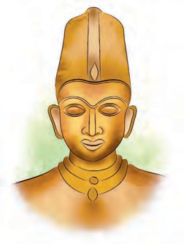
Krishnadevaraya : Krishnadevaraya ascended the throne of Vijaynagar in
1509 CE. He conquered Vijaywada and
Rajmahendri and annexed the regions to his kingdom. He defeated the combined forces of the armies of the Sultans who had united under the leadership of the


Krishnadevaraya
After
Qutubuddin
Aibak,
Iltutmish, Razia, Bulban, Alauddin Khalji, Muhammad-bin-Tughluque, Firuz Tughluque, Ibrahim Lodi and other Sultans ruled over India.
Do you know ?
Bahamani Sultan

Ibrahim Lodi was the last Sultan. He made many enemies because of his peculiar temperament. Daulatkhan Lodi, Governor of Punjab, invited Babur, the ruler of Kabul to fight against Ibrahim Lodi. Babur defeated Ibrahim Lodi in the battle and thus the Sultanate came to an end.

The Kingdom of Vijaynagar
During the reign of Sultan Muhammad- bin-Tughluque of Delhi, there were many revolts in the South against the central power of Delhi. From these revolts arose the formidable Vijaynagar and Bahamani kingdoms.
The brothers Harihar and Bukka, from South India were Sardars in the service of the Delhi Sultanate. Taking advantage of the instability in the South during the reign of Muhammad-bin- Tughluque, they founded the kingdom of Vijaynagar in the South in 1336 CE. Hampi in today’s Karnataka was the capital of this kingdom. Harihar was the first king of Vijaynagar.
Mahmud Shah. During Krishnadevaraya’s reign, the kingdom of Vijaynagar extended from Cuttak in the east up to Goa in the west and from the Raichur Doab in the north up to the Indian Ocean in the south. He died in 1530 CE.
Krishnadevraya was a scholar. He wrote ‘Amuktamalyada’, a Telugu compendium on polity. The Hazar Ram temple and Vitthal temple were built in Vijaynagar during his reign.
The decline of the Vijaynagar kingdom began with the death of Krishnadevaraya. In 1565 CE, at Talikot in the present State of Karnataka, there was a battle between Adilshahi, Nizamshahi, Qutubshahi, Baridshahi on one side and Vijaynagar on the other side. Vijaynagar was defeated. Thereafter, the dominance of Vijaynagar came to an end.

The Bahamani Kingdom
While Muhammad-bin-Tughluque was still reigning, some of his Sardars in the Deccan rose in rebellion against him. The leader of these Sardars, Hasan Gangu, defeated the army of the Sultan of Delhi. A new kingdom, known as the

Bahamani kingdom, came into existence in 1347 CE. Hasan Gangu became the first Sultan of the Bahamani kingdom. He made the city of Gulburga in Karnataka his capital.
Mahmud Gawan : Mahmud Gawan was the Chief Wazir of the Bahamani kingdom. He was a good administrator. He strengthened the Bahamani kingdom. He started paying the soldiers their salaries in cash instead of through land grants. He brought discipline in the army. He introduced many reforms in the land revenue system. He opened a madarsa at Bidar for Arabic and Persian studies.
After the death of Mahmud Gawan, factionism increased among the Bahamani Sardars. The conflict with the Vijaynagar kingdom had an adverse effect on the Bahamani kingdom. The provincial Governors began to act more independently. This led to the disintegration of the Bahamani kingdom into five small powers- Imadshahi of Varhad, Baridshahi of Bidar, Adilshahi of Bijapur, Nizamshahi of Ahmadnagar and Qutubshahi of Golconda.

Mughal Power
In 1526 CE, the Sultanate of Delhi came to an end. Mughal power was established there.
Babur : Babur was the founder of Mughal power. He was the king of Farghana in Central Asia in today’s Uzbekistan. He had heard of the wealth in India. So he planned an invasion of India.
The reigning Sultan of Delhi at that time was Ibrahim Lodi. Daulatkhan Lodi was the Governor of Punjab under the Sultanate. The relationship between Ibrahim Lodi and Daulatkhan Lodi was strained. Daulatkhan Lodi invited Babur to march on India. Taking this opportunity, Babur invaded India. To repel Babur’s invasion, Ibrahim Lodi started with his army. There was a battle between Ibrahim Lodi and
Babur on 21 April 1526 at Panipat. In this battle, Babur made use of an artillery effectively for the first time in India. He defeated Ibrahim Lodi’s army. This is known as the First Battle of Panipat.
After the battle of Panipat, Rana Sanga of Mewad brought all Rajput kings together. There was a battle between Babur and Rana Sanga at Khanua. Babur’s artillery and reserved force played a key role in this battle and Rana Sanga’s army was defeated. Babur died in 1530 CE.



After Babur, Humayun (1530 CE to 1539 CE and from 1555 CE to 1556 CE) ascended the throne. He was defeated by Shershah. Shershah established the Sur dynasty on the throne of Delhi. After Humayun, Akbar (1556 CE to 1605 CE) ascended the throne. There was a battle between Akbar and Hemu at Panipat in 1556 CE. This is the Second Battle of Panipat. Akbar’s ambition was to bring the whole of India under his one central authority. After Akbar, Jahangir (1605 CE to 1628 CE) became the Emperor. During his reign, his wife Nurjahan played an active role in the administration. Jahangir was followed by Shahajahan (1628 CE to 1658 CE) as the Emperor. The next Emperor after Shahajahan, Aurangzeb (1658 CE to 1707 CE) reigned for a very long time. After his death, the Mughal Empire became weak.
Do you know ?
Akbar was the most powerful King of the Mughal dynasty. When he tried to bring India under his central authority, he had to face opposition. Maharana Pratap, Chandbibi, Rani Durgavati struggled against him. Their struggle is noteworthy. Maharana Pratap : After the death of Udaysingh, Maharana Pratap ascended the throne of Mewad. He continued the struggle

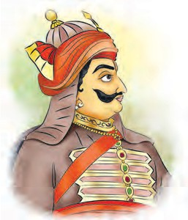
Maharana Pratap
for Mewad’s existence. Till the very end, he struggled with Akbar to maintain his indepedence. He has become immortal in history due to his qualities of valour, courage,
against the Mughals is important in medieval history. After her husband’s death, Durgavati laid down her life while fighting against Akbar, but she did not surrender.
Akbar was well versed and vigilant ruler. His religious policy was liberal and tolerant. He gave equal treatment to people from all religions. He founded Din-i-Ilahi by incorporating noble

self-respect, sacrifice, etc.
Chandbibi : The Mughals attacked Ahmadnagar, the capital of Nizamshah’s kingdom, in 1595 CE. The Mughal army
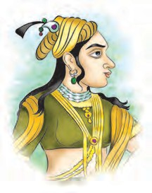
put the fort of Ahmadnagar under siege. Chandbibi, the capable daughter of Husain Nizamshah of Ahmadnagar, bravely defended the fort. At
this time, there was an
principles from all religions, but never compelled anyone to adopt Din-i-Ilahi.
Aurangzeb : Aunrangzeb won the war of succession amongst other sons of Shahjahan and became the Emperor by
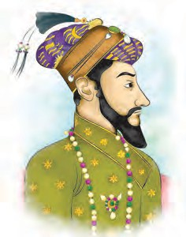
detaining his father in 1658 C.E. Dara Shukoh, the elder son of Shahjahan was famous for religious tolerance. He translated more than

Chandbibi
internal strife among
fifty Upanishadas in

the factions of the Sardars in Nizamshahi’s kingdom. This resulted in the murder of

Aurangzeb
Persian language
when Aurangzeb

Chandbibi. Later, the Mughals captured the fort of Ahmadnagar. But, the Mughals could not bring the entire kingdom of Nizamshahi under their control.
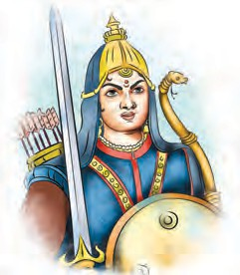
Rani Durgavati : Gondvana can broadly be said to comprise the eastern part of Vidarbha, part of Madhya Pradesh to its north, the western part of today’s Chhattisgarh, northern part of Andhra Pradesh and the western part of Odisha.
Durgavati, born in the dynasty Chandel Rajput became the queen of Gondvana when she was married. She was an excellent administrator. The struggle of Gondvana
became the Emperor, at that time, the
Mughal empire extended from Kashmir in the north up to Ahmadnagar in the south and from Kabul in the west up to Bengal in the east. To this Aurangzeb added Assam in the east, and the regions of Adilshahi of Bijapur in the south and Qutubshahi of Golconda after he ended these kingdoms.
Conflict with the Ahoms : In the thirteenth century CE, the people of the Shaan community settled down in the valley of river Brahmaputra. They established their Kingdom there. They were locally known as Ahom people.
While Aurangzeb ruled, the Ahoms had a prolonged struggle with the Mughals. The Mughals attacked the Ahoms’ region.

queen Durgavati
Rani Durgavati
The Ahoms united under the leadership

of Gadadharsinha. Commander Lachit Borphukan gave an intense battle against the Mughals. The Ahoms used the guerilla technique in the conflict against the Mughals. It became impossible for Mughals to create a strong base in Assam.
Conflict with the Sikhs : The ninth Guru of the Sikhs , Guru Teghbahaddar, protested strongly against Aurangzeb’s
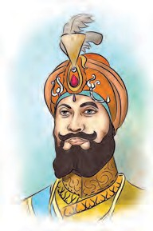
policy of religious intolerance. Aurangzeb imprisoned him and beheaded him in 1675 CE. After him, Guru Gobindsingh became the Guru of the Sikhs.
Guru Gobindsingh organised his followers
Conflict with the Rajputs : Akbar had secured the cooperation of the Rajputs with his policy of amicable relations. Aurangzeb could not obtain the cooperation of Rajputs. After the death of Rana Jaswantsingh of Marwad, Aurangzeb annexed his kingdom to the Mughal empire. Durgadas Rathod crowned Jaswantsingh’s minor son Ajitsingh as the King of Marwad. Durgadas Rathod fought hard against the Mughals. Aurangzeb sent Prince Akbar to Marwad to crush the resistance of Durgadas. Prince Akbar joined hands with Rajputs and rose in revolt against Aurangzeb. An effort was made to seek help from the Marathas in Maharashtra. In this revolt. Durgadas Rathod continued this struggle against the Mughals for the existence of Marwad.

Guru Gobindsingh
and encouraged their

Conflict with the Marathas : In


martial spirit. He organised the Sikh youths into a fighting force called the ‘Khalsa Dal’. Their headquarters were at Anandpur. Aurangzeb sent his army to fight the Sikhs. His army attacked Anandpur. Although the Sikhs fought fiercely, they did not succeed. After that, Guru Gobindsingh came to the Deccan in 1708 CE. There was an attempt on his life when he was at Nanded. Soon after, the Guru succumbed to his wounds.
struggle later on.
Exercise
Maharashtra, Swaraj was established under the leadership of Shivaji Maharaj. In his efforts to establish Swaraj, Shivaji Maharaj had to fight the Mughals too along with the other enemies. Aurangzeb came down to the Deccan after the death of Chhatrapati Shivaji Maharaj with the intention of conquering the whole of South India. But the Marathas offered stiff resistance to Aurangzeb and defended their independence. We shall study this

- Name the following.
  - The Queen of Gondvana –
  - The son of Udaysingh –
  - The founder of Mughal dynasty –
  - The first Sultan of the Bahamani kingdom –
  - The fighting force established by Guru Gobindsingh –
- Find the odd one out.
  - Sultan Mahmud, Qutubuddin Aibak, Muhammad Ghuri, Babur
  - Adilshahi, Nizamshahi, Sultanate,
Baridshahi
  - Akbar, Humayun, Shershah, Aurangzeb
- Answer briefly.
  - How did the kingdoms of Vijaynagar and Bahamani emerge ?
  - What reforms did Mahmud Gawan make?
  - Why did it become impossible for the Mughals to strengthen their base in Assam?

- Write about them briefly in your own words.
  - Krishnadevaraya (2) Chandbibi
(3) Rani Durgavati
- Give reasons.
  - The Bahamani Kingdom disintegrated into five fragments.
- Complete the timeline.
- Rana Sang’s army was defeated.
- Rana Pratap has become immortal in history.
- Aurangzeb imprisoned Guru Teghbahaddar.
- The Rajputs fought against the Mughals.

1336 CE
……. CE
……… CE
1509 CE
Establishment Establishment -------------- Establishment of Vijaynagar of Bahamani of the Mughal
Kingdom Kingdom power

- Using the internet, find out more about any one of the personalities you have studied here, and fill in the box below.
I know this :
Activity
Obtain more information about the personalities mentioned in this chapter. Use reference books, the internet, newspapers, etc. Prepare a collage of the pictures information in your activity book and display it in the history cell.


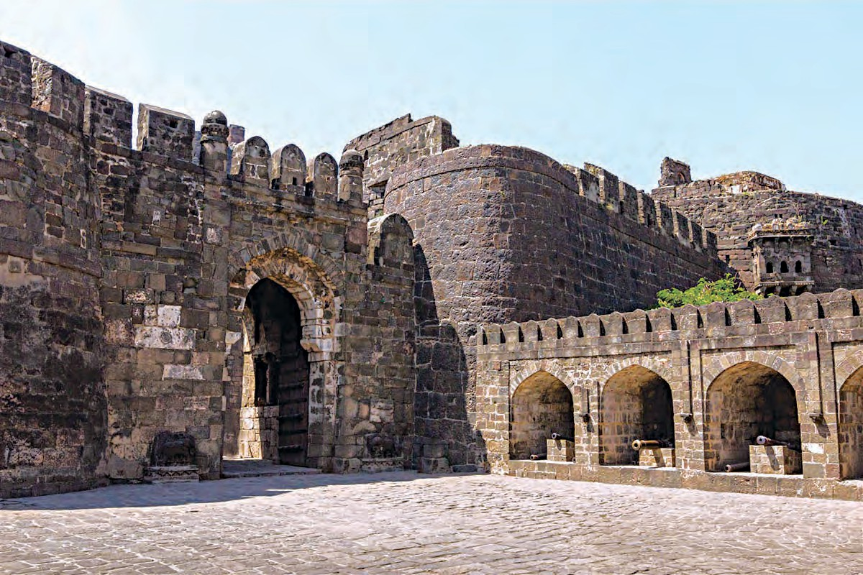
Fort Deogiri

3. Religious Synthesis

Diversity of languages and religions is an important characteristic of the Indian society. Considering this feature, the Indian Constitution has adopted the principle of secularism. In medieval India, too, attempts to bring about religious synthesis in social life were made on the basis of this principle. Among these efforts, the Bhakti movement, Sikhism and the Sufi sect have a significant place. These different streams of thought arose in different parts of India. They emphasized harmony between the different sects and religions along with devotion to God. We shall study them in this chapter.
Initially, rituals and brahmadnyan were greatly emphasized in the Indian religious life. In the medieval period, they gave way
compassion, mercy, etc. Ramanuja and other Acharyas strengthened the base of the Bhakti movement in South India. They told people that God is for all. God does not discriminate. The teachings of Ramanuja had a great impact in North India also.
Sant Ramanand strengthened the Bhakti
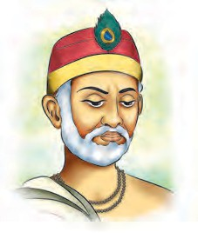
movement in North India. Sant Kabir is a
well-known sant in the Bhakti movement. He did not attach any importance to places of pilgrimage, vratas or idol worship. For him, Truth was God. He taught that all human

to Bhakti Marg - the path of devotion.
Sant Kabir
beings are equal. He

Bhakti Marg did not give undue importance to hierarchies, which further facilitated religious synthesis. In the different regions of India, we find different forms of the path of devotion, according to the local situation there. The Bhakti movement used the common people’s language instead of Sanskrit. This helped the development of regional languages.
Bhakti Movement : It is believed that the Bhakti movement originated in South India. The Naynar and Alawar Bhakti movements emerged in this region. The Naynars were devotees of Shiva, while the Alawars were devotees of Vishnu. There were also attempts to consider Shiva and Vishnu as one and the same and bring them together. ‘Harihar’ idols which depict half Vishnu and half Shiva were produced in this period on a large scale. People belonging to all social strata had participated in these Bhakti movements. They preached values like love of God, humanity,
did not believe in any differences based on caste, creed, sect and religion. He wanted to bring about Hindu and Muslim unity. He criticized the extremely orthodox people in both Hindu and Muslim religions in strong terms.
In Bengal, Chaitany Mahaprabhu underlined the importance of Krishnabhakti. Due to his teachings, people joined the Bhakti movement in transcending the boundaries of caste and creed. Under his influence, Shankaradeva spread the Bhakti movement in Assam. Narsi Mehta was a renowned Vaishnawa Sant in Gujarat. He was an ardent devotee of Krishna. He gave the message of equality. He is known as the first poet of the Gujarati language.
Sant Mirabai stressed the importance of devotion to Krishna. She belonged to the royal family of Mewad. She renounced all pleasures of the royal family and immersed herself in devotion to Krishna. She composed devotional verses in Rajasthani and Gujarati. Her devotional verses give the

11

message of devotion, tolerance and humanity. Sant Sena was an influential Sant. Sant Rohidas was a great Sant. He gave the message of equality and humanity. Surdasa, a great poet of Hindi literature, composed the poetical work ‘Sursagar’. Devotion to Krishna (Krishnabhakti) is the subject of his work. The verses on Krishnabhakti composed by the Muslim
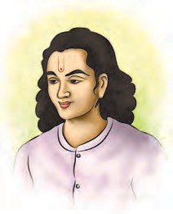
Chakradhar Swami
castes and creeds. He supported equality. He travelled to all parts of Maharashtra preaching in Marathi. He preferred Marathi instead of Sanskrit. This led to the development of the Marathi language. Many

Sant Raskhan are melodious. ‘Ramcharita- Manasa’ of Sant Tulshidas is a beautiful composition expressing devotion to Rama.
In Karnataka, Mahatma Basaveshwar spread the lingayat stream of thought. He opposed the caste system and stressed the
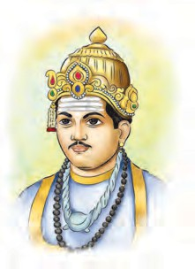
dignity of labour. ‘Kayakave Kailas’ is his well-known saying which means ‘Work is Kailas’ (Work is worship). He encouraged women’s participation in his movement. Men and women belonging to all castes began to
works were composed in Marathi.

This sect mainly spread in the Vidarbha and Marathwada regions of Maharashtra. Riddhipur in Vidarbha is an important place for people of this sect. This sect had reached up to faraway regions like the Punjab and Afghanistan.

Some of the main compositions of the followers of the Mahanubhav Panth are : The treatise ‘Leelacharitra’ compiled by Mhaimbhat describing the deeds of Chakradhar Swami; ‘Dhavale’ of the first Marathi poetess Mahadamba, ‘Sutrapath and Drishtantapath’ compiled by Keshobas, ‘Vacchaharan’ of Damodar Pandit, ‘Shishupalvadha’ of Bhaskarbhat Borikar and ‘Rukmini Swayamvara’ of Narendra.
Do you know ?

Mahatma Basaveshwar
participate in the

religious discussions conducted in the hall ‘Anubhava Mantapa’. Mahatma Basaveshwar conveyed his teachings in the language of the people, i.e., Kannada, through the medium of ‘Vachana’ literature. His work had a great impact on society. His followers have composed their work in Marathi also. Of these compositions, ‘Paramarahasya’ composed by Manmath Swami is very well-known. Great sants in Karnataka include Pamp, Purandardasa and others. They composed many devotional verses in Kannada.
Mahanubhav Panth : In the thirteenth century, Chakradhar Swami founded the ‘Mahanubhav Panth’ in Maharashtra. This sect preaches devotion to Krishna. Shri Govind Prabhu was the Guru of Chakradhar Swami. The followers of Chakradhara included men and women belonging to all



A conversation between a Hindu and a Muslim written by Sant Eknath is important from the viewpoint of religious harmony. The famous quote
of Sant Shaikh Mohammad ‘शेख महंमद अविंध । त्याचे हृद्ी गोविंद ।।’ is an example
of this religious harmony.
Do you know ?
Guru Nanak : Guru Nanak was the founder of Sikhism and the first guru of Sikhs. His work has to be mentioned as a great attempt at religious synthesis. He visited the holy places of both Hindus and

Guru Nanak
Muslims. He had also visited Mecca. He realised that the feeling of devotion is common everywhere. He taught that all persons should be treated equally. His teachings aimed at achieving Hindu-
tenth Guru of the Sikhs. After Guru Gobindsingh, Sikhs regard the ‘Guru Granth Sahib’ as their Guru, as per the orders of Guru Gobindsingh.
The Sufi Sect : This is a sect in Islam. The Sufi saints believed that God is full of love and the only way to reach him is through love and devotion. Their main teachings are love for all living beings, meditation and simple living. Khwaja Moinuddin Chisti, Shaikh

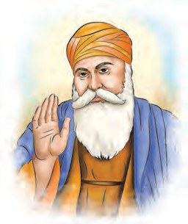
Muslim unity. He emphasized chaste behaviour.
Many people were influenced by the teachings of Guru Nanak. The number of his followers increased day by day. The followers of Guru Nanak are known as ‘Sikhs’ (Shishyas) meaning ‘disciples’. The ‘Aadigrantha’, also known as the ‘Guru Granth Sahib’ is the Holy Book of the Sikhs. The Aadigrantha includes compositions by Guru Nanak, Sant Namdeo, Sant Kabir and other Sants. Guru Nanak was succeeded by nine Gurus of the Sikhs. Guru Gobindsingh was the
Nijamuddin Avaliya were great Sufi Saints. The teachings of Sufi Saints led to unity in the Hindu and Muslim communities. Sufi music has made valuable contribution to Indian music.
The path of Bhakti taught by the Sants was easy to follow for the common people. The Bhakti movement was open to all men and women. The Sants expressed their thoughts in the language of the people. The common people found them close to their heart. The Bhakti movement has contributed greatly to the making of the Indian Culture.



Exercise

- Write the related word.
  - Mahatma Basaveshwar : Karnataka Sant Meerabai : ......................... .
  - Ramananda : North India
Chaitanya Maha Prabhu : ............... .
  - Shri Chakradhar : ................... .
Shankaradeva : ..................... .
- Make a chart to show the people and works related to -
  - Bhakti movement
  - Mahanubhav Panth
  - Sikhism
- Write about it in your own words.
  - Sant Kabir became a renowned Sant in the Bhakti movement.
  - The impact of Mahatma Basaveshwar’s
work on society.

- Complete the following names.
G G S S
G N
M m m M i
R n n K i
P p
Activity
Obtain a devotional song in the tradition of Sufi music and present it in a cultural programme.

4. Maharashtra before the Times of Shivaji Maharaj

At the beginning of the seventeenth century CE, most of the territory in Maharashtra was under the control of Nizamshah of Ahmadnagar and Adilshah of Bijapur. The Mughals had entered Khandesh. Their objective was to expand their power in the south. There were settlements of Siddi people, who had come from Africa, along the coastline of Konkan. The competition and conflict amongst the Portuguese, the British, the French and the Dutch, who had come from Europe, was getting intense during this period. There was stiff competition amongst them to capture the markets for trade. The Portuguese had already established their rule in Goa and Vasai on the western coastline. The British, the Dutch and the French had found an entry through the medium of trading companies by setting up factories. All these powers assessed the strength of other powers, kept themselves safe and tried to dominate as much as possible. This conflict had created instability and insecurity in Maharashtra. These different people from Europe were called ‘Topkar’ on the basis of their customary headgear.
It is necessary to get acquainted with the village (mauja), Kasba and pargana to understand the nature of settlements in that period as also of the officers that formed a link between the rulers and their subjects, and also the markets and the craftsmen. Pargana was made up of many villages. Generally, the headquarters of a pargana was called ‘Kasba’. A village smaller than a Kasba was called ‘Mauja’. Let us get acquainted in brief with Village, Kasba and Pargana respectively.
Village (Mauja) : Most of the people lived in villages. A village was also called mauja. The chief of the village was the
Patil. He used to try to bring maximum land under cultivation. When there was any dispute in the village, the Patil resolved it and made peace. A Kulkarni helped the Patil in his work. The Kulkarni kept the record of the revenue that was collected. There were various artisans in the village. They had hereditary rights regarding their occupation. The peasants gave a share of their agricultural produce to the artisans for the services they rendered to the village community. This share was known as baluta.
Kasba : A kasba was like a big village. It was usually the headquarters of a pargana, e.g., Indapur kasba of Indapur pargana, Wai kasba of Wai pargana were the headquarters of those parganas. Agriculture was the main occupation. There were skilled artisans like carpenters, blacksmiths, etc. in a kasba. There was usually a market (peth) adjacent to a kasba. The Shete and Mahajan were the watandars of the peth. Every village did not necessarily have a peth. The setting up of a peth was the job of the Shetes and the Mahajans. For that, they received some land from the government and some rights from the villagers. The Mahajan maintained the accounts of the peth.


As per the order of Veermata Jajabai, a peth was established in Pashan near Pune. It was called Jijapur. Malpura, Khelpura, Paraspura, Vithapura, in Aurangabad are also new peths established in the name of Maloji, Kheloji, Parasoji and Vithoji respectively. ‘Shivapur’ adjacent to ‘Khed’ was a peth established in the name of Shivaji Maharaj.
Do you know ?


Let’s learn.
The words ‘Budruk’ and ‘Khurd’ are used to show that the two villages are different. The original town is ‘Budruk’ and the new one is ‘Khurd’. For example, Vadgaon Budruk and Vadgaon Khurd.
Pargana : Many villages together made a pargana. But the number of villages was not the same in all parganas. For example, the Pune pargana was a big pargana. It consisted of 290 villages. There were 64 villages in the Chakan pargana. The Shirwal pargana was small. It had only 40 villages. The Deshmukh and the Deshpande were the watandar officers of the pargana. The Deshmukh was the chief of patils in a pargana. The Deshmukh did at the pargana level, what the Patil did at the village level. The Deshpande was the chief of all Kulkarnis in the pargana. The Deshpande did at the pargana level, the work that Kulkarnis did at the village level. These watandar officers were the link between the people and the government.
In case of enemy invasion or drought, these watandars represented the grievances of the people to the government. Sometimes, these officers misused their powers. They collected more money from the people than was due or did not remit the money so collected to the government in time. On such occasions, the people suffered harassment.


Vatan is an Arabic word. In Maharashtra, it is used is refer to hereditary land for which the holder does not have to pay revenue.
Do you know ?

The calamity of a famine :
Agriculture was dependent on rainwater.
If it did not rain, crops would fail. The prices of foodgrains rose. It became difficult for the people to get foodgrains and other things. There was no fodder for the cattle. Water became scarce. It became difficult for people to live in the village. They were forced to leave the village. A famine was a great calamity for the people.
A great famine occurred in Maharashtra in 1630 CE. People were greatly distressed due to this famine. It has been described in these words – ‘People were ready to sell themselves for a piece of bhakri, but there was nobody to buy them’. There was a severe scarcity of foodgrains. Entire families were destroyed. Cattle and farm animals died. Agriculture was devastated. The famine put an end to industries. All financial transactions came to a standstill. People had to wander to faraway regions in search of a livelihood. It was a great challenge to bring back to normalcy, the devastated life of the people.
The work of the Varkari movement : Society was greatly influenced by blind beliefs and rituals. People had become fatalistic and inert. They had lost all initiative. The condition of the common people was miserable. In such circumstances, the Sants in Maharashtra endeavoured to inspire the masses.
In Maharashtra, the tradition of Sants which began with Sant Dnyaneshwar and Sant Namdeo was carried on by Sants coming from various strata of the society. People from all strata of society were part of the Sant tradition. For example, Sant Chokhamela, Sant Goroba, Sant Sena, Sant Sawata, Sant Narhari, Sant Shaikh Muhammad, etc. Sant Chokhoba’s wife Sant Soyrabai, and sister Sant Nirmalabai, Sant Muktabai, Sant Janabai,

Sant Kanhopatra, Sant Bahinabai Siurkar and other women were also among them. Pandharpur was at the centre of the Sant movement. Vitthal was the object of their worship. On the banks of the river Chandrabhaga at Pandharpur, the Sants and pilgrims (varkari) used to rejoice in their devotion (bhakti). There, equality was propagated through bhajans, keertans, and unity meals (kala).
Sant Namdeo : He was a great Sant of the Varkari movement. He was a skilled organiser. He performed excellent keertans
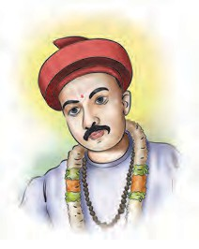
as well. He awakened the sense of equality in men and women belonging to all castes through the medium of keertans. His pledge was ‘नाचू कीर्तनाचे रंगी । ज्ानदीप लावू जगी ।।’ His abhanga compositions are well-known. Many

Sant Namdeo
way of worship and conduct which the common people could follow easily. He gave the prestige of a religion to the Varkari movement. Though his life was spent in extremely adverse circumstances, he never lost the calm of his mind and never harboured bitterness. His ‘Pasayadaan’ in Dnyaneshwari uplifts the mind. The poetic compositions of his brothers Sant Nivruttinath and Sant Sopandev and sister Muktabai are well- known.
Sant Eknath : He was a great Sant of
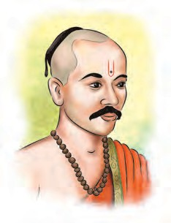
the Bhakti movement in Maharashtra. His compositions are many and diverse. They include abhanga, gavalana, bharud, etc. He has stated Bhagvat Dharma in detail and in a simple manner. He has portrayed

Sants as well as common people were
Sant Eknath
people’s life in

influenced by his teachings. He went up to the Punjab, propagating his thoughts. His compositions are included in the ‘Guru Granth Sahib’ of Sikhs. He propagated the message of Bhagwat religion in all quarters. He built a memorial to Sant Chokhamela at Pandharpur. His work is unforgettable.
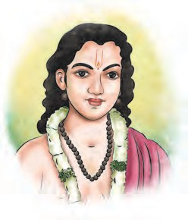
Sant Dnyaneshwar : He was a great Sant in the Varkari movement. He wrote the ‘Bhavartha-deepika’ or ‘Dnyaneshwari’ which elucidates the meaning of the
Sanskrit ‘Bhagavad Geeta’. He also composed the ‘Amrutanubhav’.
He preached the importance of the path of devotion through his works and compositions.
Sant Dnyaneshwar He showed a simple
Bhavarth Ramayana through the story of Ram. He explained in Marathi, the Bhakti part of the Sanskrit work ‘Bhagwat’. His abhangas show the warmth of devotion. He demonstrated through his own conduct that there is no need to renounce worldly matters for attaining the highest truth, Paramarth. He was a teacher of the people in the true sense of the term. He believed that our Marathi language was inferior to no other language. He asked the Sanskrit Scholars
forcefully. ‘संसककृर वाणी देवे केली । ररी प्ाककृर काय चोरापासुनन झाली ?’ He heavily criticised those who hated other religions.
Sant Tukaram : He belonged to Dehu near Pune. His compositions or abhangas are very pleasing and lucid, reaching the greatest poetic heights. His ‘Gatha’ is a precious treasure of the Marathi language. He asks us to find

God by showing love to the unhappy and the tormented in the following lines : ‘जे का रंजले गांजले । तयांसी म्हणे जो आपुले । रोनच साधु ओळखावा । देव रेथेनच जाणावा ।।’ With this viewpoint, he threw in the river Indrayani, the documents of the loans that people had borrowed from him and
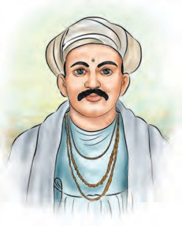
freed many poor families from the bonds of loan. He criticized the
hypocrisy and superstition in the society in very strong terms. He stressed that devotion (Bhakti)
of Maharashtra.
There was a deterioration of ethics and religion in the society. At such a time, the Sants came forward to protect the society. They taught the true meaning of religion. They showed the path of devotion by living amongst people and sharing their joys and sorrows. Some orthodox and dogmatic people opposed them. But the Sants believed that facing this opposition was a part of their duty. Sant Tukaram has explained the mark of a true Sant in these words – ‘रुका म्हणे रोनच संर । सोशी जगाचे आघार ।।’
The Sants elucidated the complex
dharma of the scholars (Shastris and

Sant Tukaram
should be coupled
Pandits) in the language of the people.

with morality. His teachings can be summed up as ‘जोडोननया धन उतरम वयव्हारे । उदास नवचारे वेच करी ।।’ Some dogmatic people opposed the social awakening that he had undertaken, and sank his abhangas in the Indrayani. Sant Tukaram faced the opposition with noble courage.
Sant Tukaram’s disciples and associates were of different castes and creeds. They include Navji Mali, Gavnarshet Wani, Santaji Jagnade, Shivba Kasar, Bahinabai Siurkar and Mahadajipant Kulkarni. An important task completed by Gangarampant Maval and Santaji Jagnade was writing down the abhangas of Sant Tukaram.
Work of Sants : Sants gave the message of equality to people. They taught humanity. They preached that people should live together in harmony, unity and love. Their work resulted in social awakening. They taught how to live in the face of foreign invasions, drought-like situations or any other natural calamities. Their teachings proved to be a big support for people. Their work created self-confidence among the people
They prayed to God using simple, everyday terms. They took the view that all are equal before God. They taught society to do away with the pride arising out of caste and varna and see everyone as God’s children. A characteristic of the Sants was that they did not forget their duties on the path of devotion. They found God in their work. Sant Sawata said, ‘कांदा मुळा भाजी । अवघी नवठाई माझी ।।’ This statement refers to farm work but applies to work in all walks of life. The Sants carried on with their duties even as they were engaged in devotion, teaching and composing verses. They developed the moral sensibilities of the society.



Collect more information about the Pandharpur vari and discuss the following topics.
- In which month do the Varkaris go on the vari ?
- How is the Vari planned ?
Let’s discuss.
Ramdas Swami : He was from Jamb in Marathwada. He explained the

17

importance of physical fitness to the people, ‘मराठा नररुका मेळवावा । म्हाराष्ट्र धम्त वाढवावा ।’ This message of Ramdas Swami is famous. He gave practical education

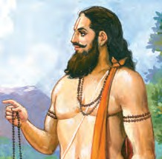
Ramdas Swami
He propagated the worship of Ram and Hanuman. He travelled far and wide to propagate his thoughts.
Inspiration for independence during foreign rule : Such was the political, social, cultural, situation, etc. in Maharashtra before the times of Shivaji Maharaj. In that period, Maharashtra was

and lessons in good conduct through his works like Dasbodh, Karunashtaka, Manache Shlok. He stated the importance of people’s movement and organisation and founded the Samarth Sampradaya. Chaphal was the centre of this Sampradaya.
under the control of Adilshahi and other powers. It was not independent. Even so, some personalities and streams of thought were dreaming of freedom. Among them, Shahaji Maharaj, who is considered to be a visionary of Swaraj was on the forefront.



Exercise

- Complete the following chart.

 | Village (Mauja) | Kasba | Pargana
What it means | .............. | ........... | .............
Officers | .............. | ........... | .............
Example | .............. | ........... | .............
- Write the meaning.
  - Budruk -
  - Balut -
  - Vatan -
- Find out and write.
  - People from Africa who had settled along the Konkan coastline -
  - The author of ‘Amrutanubhav’ -
  - Sant Tukaram’s place -
  - He composed Bharuds -
  - He explained the importance of physical fitness -
  - Women Sants -
- Write about these personalities and their work in your own words.
  - Sant Namdeo (2) Sant Dnyaneshwar
(3) Sant Eknath (4) Sant Tukaram
- Why were droughts a great calamity for the people ?
Activities
  - Plan how you will help a Varkari
Dindi.
  - Dress up as Sants and present their compositions.

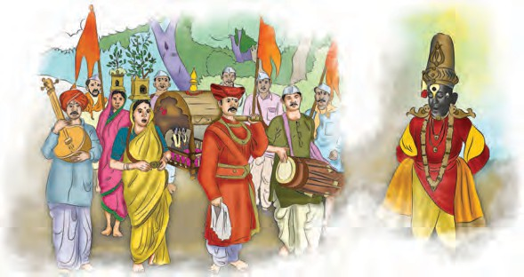

5. The Foundation of the Swaraj

In the first half of the seventeenth century, an epoch making personality emerged in Maharashtra - Chhatrapati Shivaji Maharaj. He established Swaraj by challenging the unjust ruling powers here. Shivaji Maharaj was born at the Shivneri fort near Junnar in Pune district on the day of Phalgun Vadya Tritiya in the Shaka year 1551, that is on 19 February 1630. In this chapter, we will study how he founded Swaraj.
Shahajiraje : Shahajiraje, the father of Shivaji Maharaj was a pre-eminent Sardar in the Deccan. The Mughals had launched a campaign to conquer the Nizamshahi Kingdom. The Adilshah of Bijapur allied with the Mughals in this campaign. Shahaji Maharaj did not wish
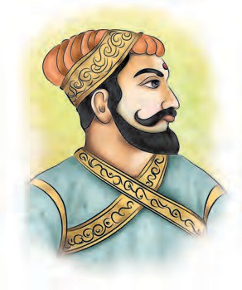
the Mughals to get an entry into the South. So he tried to save Nizamshahi by
offering stiff resistance to the Mughals. But he could not
withstand the combined might
and the neighbouring areas in Karnataka to Shahajiraje.



Jahagir or jagir means the right to enjoy the revenue of a region. The Sardars in the service of rulers used to get the revenue of the region as income instead of getting salaries directly. The region was chosen in such a way that the revenue would be equal to the salary.
Do you know ?
Shahajiraje was valiant, courageous, intelligent and a great political expert. He was an excellent archer. He was also an expert in using the sword, patta and spear. He loved his subjects. He had won many regions in Maharashtra, Karnataka and Tamil Nadu. South India was in awe of him. While Shivaji and Jijabai were at Bengaluru, he had arranged for providing excellent education to Shivaji so as to enable him to become a king. He himself aspired to establish Swaraj by ousting the powers of foreign people. That is why, he is known as Swaraj visionary. He sent Shivaji and Jijabai from Bengaluru to Pune with loyal and competent

Shahajiraje
of the Mughals
associates.

and the Adilshah. The Nizamshahi was defeated and came to an end in 1636 CE.
After the Nizamshahi was wiped out, Shahajiraje became a Sardar of the Adilshah of Bijapur. The region comprising Pune, Supe, Indapur and Chakan parganas located between the Bheema and Neera rivers was vested in Shahajiraje as a jagir. This was continued by the Adilshah, and he also granted the jagir of Bengaluru
Veermata Jijabai : Jijabai was the daughter of the great Sardar Lakhujiraje Jadhav of Sindkhedraja in Buldhana district. At a young age, she had received military training as well as education in various subjects. She helped and encouraged Shahaji Maharaj to realise his dream of establishing Swaraj. She was a competent and visionary political expert. She constantly guided Shivaji in the mission of establishing Swaraj. At times,

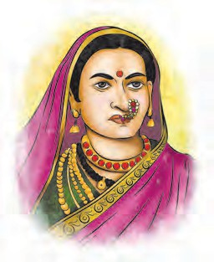
Veermata Jijabai
she undertook the task of giving verdicts for resolving the problems of people. She was very particular about giving excellent education to Shivaji. She instilled in him values like modesty, truthfulness, oratory,
Bapuji Mudgal, Narhekar Deshpande brothers, Kavji Kondhalkar, Jiva Mahala, Tanaji Malusare, Kanhoji Jedhe, Bajiprabhu Deshpande and Dadaji Narasprabhu Deshpande. On the strength of these associates, Shivaji Maharaj undertook the cause of the Swaraj.


vigilance, courage and fearlessness. She saw that he was trained in the usage of weapons and inspired in him, the will to win and the dream of Swaraj.

Find more information about these associates of Shivaji Maharaj : Jiva Mahala, Tanaji Malusare and Bajiprabhu Deshpande.
Do this.

Shivaji’s Companions and Associates : Shivaji Maharaj started the work of founding the Swaraj in the Maval region. The Maval terrain is full of hills and valleys and is not easily accessible. Shivajiraje made use of these geographical features of Maval very skilfully for the purpose of the foundation of the Swaraj. He created a feeling of trust and affection in the minds of the people. Many companions and associates joined him in his work of founding the Swaraj. Among them were Yesaji Kank, Baji Pasalkar,

Bara Maval : (1) Pavan Maval
(2) Hirdas Maval (3) Gunjan Maval
(4) Paud Valley (5) Muthe Valley
(6) Mose Valley (7) Kanand Valley
(8) Welwand Valley (9) Rohid
Valley (10) Andar Maval (11) Nane Maval (12) Korbarse Maval
Maval valley in the Sahyadris was a region in the Pune jagir of Shivaji Maharaj. It is also known as ‘Bara Maval’.
Always remember -

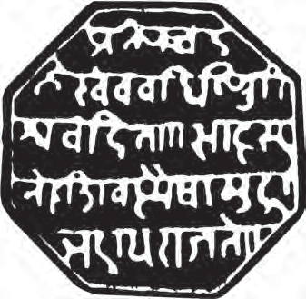
Royal seal (Rajmudra)
Royal seal (Rajmudra) : The objective of Shivaji Maharaj of establishing Swaraj is clearly expressed in his royal seal. The following Sanskrit lines are inscribed on this royal seal (Rajmudra).
प्रतिपच्चंद्रलेखेव वत्धिष्णुतवधिश्ववचंतििा ।। शाहसूनोः तशवस्यैषा मणुद्रा भद्रा् राजिे ।।
Meaning : ‘This seal will grow in splendour like the new moon. This seal of Shivaji, the son of Shahaji, receiving homage from the whole world denotes the welfare of the people.’
The meaning of this inscription on the seal is important from many angles. Through this inscription, Maharaj has expressed his gratitude towards his father,

his confidence that Swaraj would expand continuously, his own experience of the respect that the Seal, that is, Swaraj commanded from all, his commitment to the welfare of his subjects, and the certainty of ruling over his land independently. This short inscription covers the entire concept of Swaraj.


Observe the official seal of our country.
What features do you observe ?
In which places is the official seal used ?
Let’s learn.
Towards the establishment of Swaraj : The forts situated within the jagir of Shivaji Maharaj were not under his control, but were under the control of Adilshah. In those days, forts were of special significance. With a firm hold over a fort, it was possible to control the surrounding area. If one had forts, one ruled the land. Therefore, Shivaji Maharaj decided to acquire the forts that were within his own jagir. Such an attempt to capture the forts amounted to challenging the Adilshahi power. He captured the forts of Torana, Murumbdev, Kondhana and Purandar, and laid the foundation of Swaraj. He repaired the fort Murumbdev and renamed it Rajgad. Rajgad was the first capital of the Swaraj.

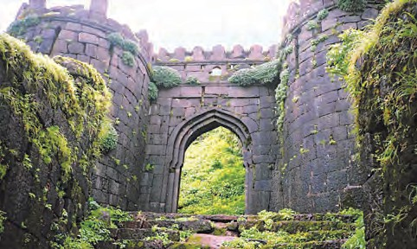
Fort Rajgad - Pali Gate
There were the Mores of Javali, the Ghorpades of Mudhol, the Sawants of Sawantwadi, and other Sardars in the Adilshahi. They were opposed to the cause of the founding of Swaraj. It was necessary to bring them and other likeminded Sardars under control for the purpose of founding the Swaraj.
The capture of Javali : Chandrarao More of Javali in Satara district was a powerful Sardar in the Adilshahi. He opposed the founding of the Swaraj. Shivaji Maharaj attacked Javali and captured that region in 1656 CE. He established his post there. Then he also captured Raigad. He attained a huge amount of wealth from Javali. After this victory, his activities in Konkan increased. He built the Pratapgad fort in the Javali valley. In this way, the conquest of Javali increased his strength in all respects. After this, Shivaji Maharaj captured Kalyan and Bhiwandi on the Konkan Coast. There he came into contact with the Siddi, Portuguese and British powers on the Western Coast. Shivaji Maharaj realised that in order to fight these powers, it was necessary to have a strong naval force. Therefore, he concentrated on building a navy.
Defeat of Afzalkhan : Shivaji Maharaj had started capturing the forts in his jagir and the surrounding area in the Adilshahi territory. He had crushed the opposition of the Mores of Javali. The work of founding the Swaraj had gathered momentum on the Konkan coast. All these matters were a challenge to the Adilshahi. At that time, the Badi Sahiba was looking after the administration of the Adilshahi. She sent Afzalkhan, a powerful and experienced Adilshahi General, to curb Shivaji Maharaj.

Afzalkhan came from Bijapur to Wai. He knew the Wai region well. A meeting of Shivaji Maharaj and Afzalkhan took place on 10 November 1659 at the foot of Pratapgad near Wai. At the meeting, Afzalkhan attempted treachery. In retaliation, Shivaji Maharaj killed Afzalkhan. He routed the Adilshahi army.
Shivaji Maharaj paid compensation to the soldiers who were wounded in the battle. He rewarded those who had fought well. Those soldiers and officers of Afzalkhan’s army who fell into the hands of Shivaji Maharaj’s army were given a good treatment.
The expedition of Siddi Jauhar : After the annihilation of Afzalkhan, Shivaji Maharaj captured the Adilshahi forts of Panhala, Vasantgad and Khelna. He renamed Khelna as ‘Vishalgad’.
Shivaji Maharaj had posed a big challenge before the Adilshahi. Therefore, the Adilshah sent Siddi Jauhar, the Sardar of the Karnul region, against Shivaji Maharaj in 1660 CE. The Adilshah gave Siddi the title ‘Salabatkhan’. Rustum-e- Jaman, Baji Ghorpade and Afzalkhan’s son Fazalkhan were also there to help Siddi Jauhar. In these circumstances, Shivaji Maharaj took shelter in the Panhala fort. Siddi’s soldiers laid siege to the fort for about five months. Shivaji Maharaj found himself trapped inside the fort. Netoji Palkar tried to raise the siege by attacking Siddi’s army from outside, but he couldn’t succeed in it as his forces were meagre. Siddi showed no signs of relenting. So, Shivaji Maharaj opened talks with him. This led to slackness in the siege round Panhalgad.
Shivaji Maharaj took advantage of this situation.
On this occasion Shiva Kashid, a brave youth came forward. He resembled Shivaji Maharaj in looks. He dressed up like Shivaji Maharaj and sat in a palanquin. The palanquin left by the ‘Raj- dindi’ gate. It was captured by the Siddi’s army. It was a difficult situation. Shiva Kashid sacrificed himself on this occasion for Swaraj. In the meanwhile, Shivaji Maharaj left the fort using another difficult route. He was accompanied by Baji Prabhu Deshpande, Bandal Deshmukh and some chosen soldiers. The Siddi came to know that Shivaji Maharaj has escaped the siege round Panhalgad and proceeded to Vishalgad. His army pursued Shivaji Maharaj. Shivaji Maharaj entrusted the responsibility of stopping Siddhi’s army at the foot of Vishalgad to Bajiprabhu Deshpande. Bajiprabhu Deshpande checked Siddi’s army at the Ghod pass near Gajapur. He fought with the greatest valour. Bajiprabhu died a hero’s death in this battle. Because Bajiprabhu’s army held Siddi’s army at bay, Shivaji Maharaj could proceed to Vishalgad. While going to Vishalgad, Maharaj also crushed the opposition of the Adilshahi Sardars Dalvi of Palwan and Surve of Shringarpur. Maharaj reached Vishalgad safely.
While Shivaji Maharaj was trapped at Panhala, Aurangzeb, who had ascended the throne of Delhi, had sent Shaistakhan, a Mughal Sardar to the Deccan. He had invaded the Pune province. The conflict with Adilshahi continued even as the Mughal army invaded the Swaraj. Maharaj realised that it would not be prudent to fight two enemies at one and the same time. Therefore, after reaching Vishalgad safely, he entered into a treaty with the Adilshah. As per the treaty, he returned the fort of Panhala to the Adilshah.



Exercise

- Find the odd man out.
  - Pune, Supe, Chakan, Bengaluru
  - Jadhavs of Phaltan, Mores of Javali, Ghorpades of Mudhol, Sawants of Sawantwadi
  - Torana, Murumbdev, Sinhgad, Sindhudurg
- Write about in your words:
  - The efforts Veermata Jijabai took for Shivaji Maharaj’s education.
  - Shivaji Maharaj started his work of founding Swaraj in the Maval region.
- List the companions and associates of Shivaji Maharaj.
- Find out and write.
  - Why Shahaji Maharaj is termed a
Swaraj visionary.
  - Shivaji Maharaj paid attention to building a Navy.
  - Shivaji Maharaj entered into a treaty with the Adilshah.
  - How Shivaji Maharaj escaped from Panhalgad.
Activities
- Describe a fort you have seen. Suggest measures for conserving a historical site.
- Find out what a 7/12 extract means and relate it to the words in the chapter.



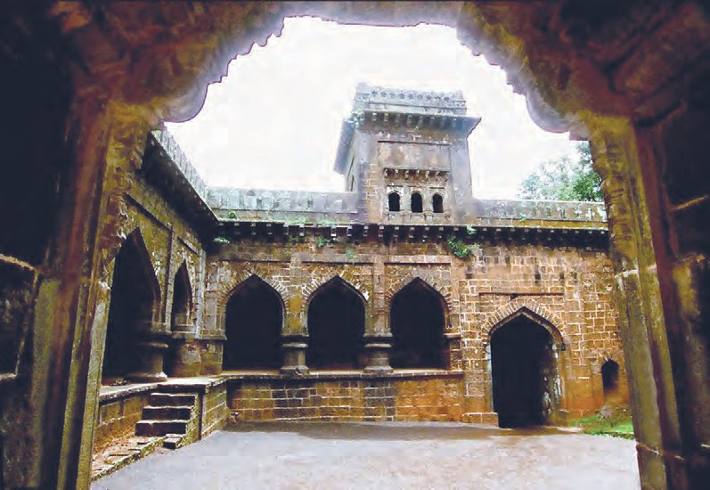
Fort Panhala - Teen Darwaja

6. Conflict with the Mughals

So far, Shivaji Maharaj had successfully fought the Adilshahi; but for expanding the Swaraj, conflict with the Mughals was inevitable. The Mughals posed a great threat to the Swaraj even as it began to expand. Maharaj triumphed over this threat too. He regained his forts and territories from the Mughals. He got himself crowned. He took up a campaign of the South. We shall learn about all these events in this chapter.
Shaistakhan’s Invasion : In February 1660, Shaistakhan left from Ahmadnagar and entered the Pune province. He raveged the territory of the Swaraj by sending small units of his army to the neighbouring areas. He encamped at Chakan. Firangoji Narsala, the Killedar of the fort of Chakan offered a strong resistance to Shaistakhan’s army. Finally, the Mughals captured the fort of Chakan.
Shaistakhan set up his camp at Lal Mahal in Pune where Shivaji Maharaj had lived in his childhood. Khan sent his forces in the regions around Pune. These forces looted the people. Two years passed, but he would not think of leaving Pune. Naturally, this had an adverse effect on the people’s morale. In these circumstances, Maharaj drew up a bold plan.
Shivaji Maharaj decided to raid Lal Mahal secretly under his own leadership. On 5 April 1663, Maharaj raided Lal Mahal at night with a select band of soldiers. In this raid, Shaistakhan lost his fingers. He suffered great humiliation. He left Pune and shifted his camp to Aurangabad. Due to this episode, he incurred the displeasure of Aurangzeb. Aurangzeb transferred him to the province
of Bengal. The successful attack on Shaistakhan had an impact on the people and their faith in the capability of Maharaj was strengthened even further.

Can you tell ?
If you want to visit the city of Surat, what route will you take ? Show it with the help of a map.
Visualise how Shivaji Maharaj must have reached Surat.

The Surat Campaign : In three years’ time, Shaistakhan had ravaged large territories of the Swaraj. It was necessary to make good this loss. For this, Shivaji Maharaj devised a plan for teaching the Mughals a lesson. Surat was a big trade centre and port under Mughal control. The British and Dutch had their factories there. Maximum revenue was being generated by this city for the Emperor. It was a rich city. Maharaj marched on Surat. Inayat Khan, the Subhedar of Surat could not put up any resistance. Maharaj obtained plenty of wealth from Surat without bothering the common people. His campaign of Surat was completely successful. This campaign was a stunning blow to Emperor Aurangzeb’s prestige.
Jaisingh’s Invasion : With a view to curbing the increasing activities of Shivaji Maharaj, Aurangzeb sent Mirzaraja Jaisingh, an experienced and powerful Rajput Sardar. Jaisingh came to Pune. He started rallying all the forces against Shivaji Maharaj. To the Portuguese of Goa and Vasai, the Dutch of Vengurla, the British of Surat and the Siddis of

Janjira, Jaisingh suggested that they should start a naval campaign against Maharaj.
Jaisingh drew up a plan of capturing the forts in possession of Maharaj. Mughal forces were sent to various parts of the Swaraj. They ravaged the territories of the Swaraj. Maharaj endeavoured to resist the Mughals. Jaisingh and Dilerkhan laid siege to the fort of Purandar. When the Mughals put the fort of Purandar under siege, Murarbaji Deshpande fought with the greatest of courage. He died a hero’s death. Considering the seriousness of the situation, Maharaj began talks for a treaty with Jaisingh. He met Jaisingh personally. A treaty between Jaisingh and Maharaj was signed in June 1665. It is known as the ‘Treaty of Purandar’. In accordance with the terms of the treaty, Maharaj gave to the Mughals, twenty-three of his forts and the adjoining territories yielding an annual revenue of four lakh hons. He also assured the Mughals of help against the Adilshahi. The Treaty was ratified by Aurangzeb.


Find out how Shivaji Maharaj escaped from his house arrest at Agra.
Gather information.
Agra visit and escape : After the Treaty of Purandar, Jaisingh launched a campaign against the Adilshahi. Maharaj helped Jaisingh but this campaign of Jaisingh was not successful. Jaisingh and Aurangzeb felt that Shivaji Maharaj ought to be kept away, at least for some time, from the Deccan politics. Jaisingh proposed to Shivaji Maharaj that he should visit Agra and meet the Emperor. He guaranteed the safety of Shivaji Maharaj. Shivaji Maharaj set out for Agra. He was accompanied by Prince Sambhaji and a
few of his trusted people who were ready to risk their lives for him.
Shivaji Maharaj reached Agra. Aurangzeb did not treat him with due honour at his court. Maharaj gave vent to his rage. The Emperor then put him under house arrest. Undeterred by this action of the Emperor, Maharaj devised a plan of escaping from this house arrest. He adroitly escaped from Agra and reached Maharashtra safely after a few days. He reached Rajgad. While returning from Agra, he had left Sambhaji Raje at Mathura. Later, Prince Sambhaji was brought safely to Rajgad. While Maharaj was away from Swaraj, Veermata Jijabai and the associates of Shivaji Maharaj looked after the administration of Swaraj.
On the offensive against Mughals : Immediately after returning from Agra, Maharaj did not want any conflict with the Mughals. However, he wanted to recapture the forts and territories given to the Mughals as per the Purandar treaty. For this, he prepared a comprehensive and bold plan. It was his strategy to capture the forts by sending a well- equipped army on the one hand, and on the other hand, to keep the Mughals unstable by invading the territories of the Deccan under their control. Maharaj attacked the Mughal territories of Ahmadnagar and Junnar. Then, he recaptured several forts such as Sinhgad, Purandar, Lohagad, Mahuli, Karnala, and Rohida, one after the other. Then Maharaj attacked Surat for a second time. While returning from Surat, he fought a great battle with the Mughals at Vani-Dindori in Nashik district. Maharaj defeated the Mughal Sardar Daudkhan in the great battle. After that, Moropant Pingale captured Triambakgad near Nashik.

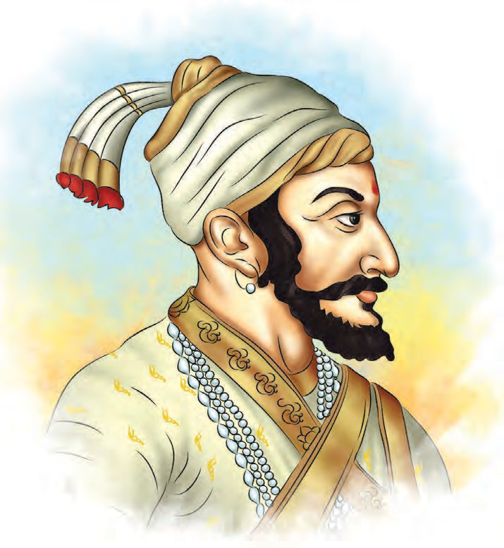
Thus Shivaji Maharaj was successful in the offensive that he had launched against the Mughals. Sardars such as Tanaji Malusare, Moropant Pingale, Prataprao Gujar etc. made a valuable contribution in these offensives. Krishnaji Anant Sabhasad, a contemporary chronicler, thus describes this campaign : ‘(He) took as many as twenty-seven forts in four months and earned a great reputation for himself ’.
Maharaj ascended the throne of Swaraj. He now became the Chhatrapati of the Swaraj. As a symbol of sovereignty, the Rajyabhisheka shaka (the coronation era) was started. Maharaj became the founder of a new era. On the occasion of the coronation, special coins were minted – a gold coin called Hon and a copper coin called Shivrai with the legend ‘Shri Raja Shivachhatrapati’ inscribed on them. Thereafter, all royal correspondence

 |  | Chhatrapati | Shivaji Maharaj
Coronation : | The | founding of the | (Rajpatra) | carried | the | words,

Maratha Swaraj involved a relentless struggle for over thirty years. Maharaj realised that now it was necessary for the Swaraj to win general recognition as a sovereign independent State. For this, a formal coronation was necessary. On 6 June 1674, he had himself coronated at Raigad by Gagabhatt, a learned Pandit.
‘Kshatriyakulaavantansa Shri Raja Shivachhatrapati’. A dictionary showing Sanskrit alternatives for Persian words was prepared. It is known as Rajya-vyavahara-kosha.

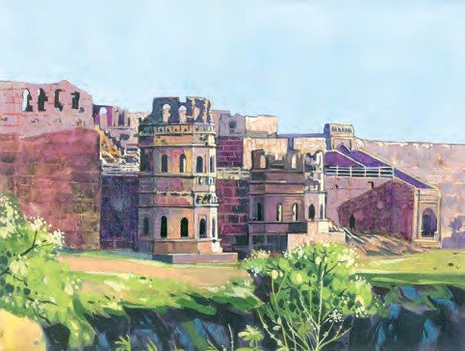
Fort Raigad


Which Indian King started a new calendar ?
Remember this-
Some equivalent words in the Rajya-vyavahara-kosha are worth mentioning. For example,
उदा., वकताब - पदवी, फमामान - राजपत्र, जामीन - प्रवतभूती, हाली - सांप्रत,
माजी - पूवमा, वफलहाल - ततकाळ, वाहवा - उततम,
वकूब - प्रज्ा, बेवकूफ - मूढ, दसतपोशी - हसतसपशमा,
मुलाखत - दशमान, कदमपोशी - पादसपशमा, झूट - वमथ्ा, कौलनामा - अभ्,
फतेह - ववज्, वफ्ामाद - अन्ा्वातामा, वशलेदार - सवतूरगी.
Do you remember ?
The coronation of Shivaji Maharaj was a revolutionary event in the history of Medieval India. While explaining the importance of this event, Sabhasad (a contemporary chronicler) writes, ‘It was no mean achievement for a Maratha King to become such a great Chhatrapati.’
Shortly after this, on 24 September 1674 Shivaji Maharaj had his second coronation performed under the guidance of Nischalpuri Gosavi. There were two traditions of religious ceremonies in India

- Vedic and Tantric. Maharaj honoured both the traditions and had two coronation ceremonies performed.

Do you know ?
Prince Sambhaji Raje was 17 years old at the time of the coronation of Shivaji Maharaj. He has described the coronation ceremony in the treatise ‘Budhabhushanam’. It is based on his own experience.
Without measuring or counting, plenty of money, clothes, elephants, horses were donated to the great scholars who had come to attend the coronation ceremony from different regions.
Thus, Shivaji Maharaj spread his fame in different directions.

Do you know ?
An extremely valuable and grand throne was made for the coronation of Shivaji Maharaj. There were eight bejewelled pillars on eight sides of the throne. This throne made of thirty-two ‘mann’ of gold had been studded with precious jewels.
Learn about the unit ‘mann’ from your teacher.

The Campaign of the South : Three years after the coronation, in October 1677, Chhatrapati Shivaji Maharaj undertook a campaign of the South. He went to Golconda. There he called on the Qutubshah. He entered into a treaty of

friendship with him. Later, Maharaj won Bengaluru, Hoskote in Karnataka, Jinji Vellore, etc. forts in today’s Tamil Nadu and some other territories of Adilshah. He appointed Raghunath Narayan Hanamante the chief administrator to look after these conquered territories.
Vyankoji, the half-brother of Shivaji Maharaj, was then ruling at Tanjavur. Shivaji Maharaj tried to get him to participate in the activities of the Swaraj. After Vyankoji Raje, the rulers of Tanjavur encouraged art and learning. The Saraswati Mahal library there is world famous.
In this campaign of the South, Maharaj had annexed the fort of Jinji in Tamil Nadu to his Swaraj. This proved to be of great importance in later years. When the Mughal Emperor stayed put in Maharashtra to destroy Swaraj, the then Chhatrapati Rajaram Maharaj had to
administration of Swaraj from there.
Soon after the victorious campaign of the south, Shivaji Maharaj passed away on Raigad on 3 April 1680. His death at the age of fifty was a great loss for Swaraj. A great era came to an end.

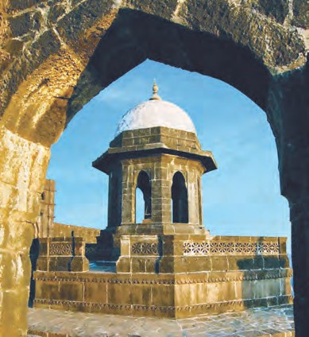
The Samadhi of Shivaji Maharaj - Raigad


leave Maharashtra for reasons of safety. At that time, he took shelter in this southern fort of Jinji and ran the

Exercise

- Arrange in chornological order.
  - Southern campaign of Shivaji Maharaj
  - Raid on Lal Mahal
  - Escape from Agra
  - Coronation
  - Treaty of Purandar
  - Shaistakhan’s invasion
- Find the names from the chapter.
  - A dictionary containing Sanskrit words -
  - He won Trimbakgad -
  - This Sardar was defeated at Vani- Dindori -
  - A place where the British Dutch and French had their factories -
- Write about these in your own words.
  - The Coronation of Shivaji Maharaj
  - Escape from Agra
  - Shivaji Maharaj’s campaign of the South
  - Shivaji Maharaj’s preparation for the coronation
- Give reasons.
  - Shivaji Maharaj entered into the Treaty of Purandar.
  - Shivaji Maharaj took an aggressive stand against the Mughals.
Activities
- How do you prepare for the special programmes on Independence Day/ Republic Day ? Make a list with help of your teacher.
- Visit a historical place in your neighbourhood and write a report on your visit.

7. The Administration of the Swaraj

Shivaji Maharaj founded Swaraj. He had himself crowned. After the coronation, Maharaj accomplished ‘Dakshin Digvijay’, the conquest of the South. The Swaraj expanded comprising large areas of Nashik, Pune, Satara, Sangli, Kolhapur, Sindhudurg, Ratnagiri, Raigad and Thane districts of Maharashtra. It also included parts Andhra Pradesh and Tamil Nadu States. To ensure the smooth management of the affairs of the Swaraj and to ensure people’s welfare, Shivaji Maharaj set up an efficient administration. We shall get some information about it in this chapter.
Ashtapradhan Mandal (Council of Eight Ministers) : At the time of his coronation, Shivaji Maharaj appointed a council of eight ministers. The administration was divided into eight departments. A Head was appointed for each department. These eight Heads of department constituted the Ashtapradhan Mandal. Maharaj alone had the power to appoint a minister or to remove him from

Ashtapradhan Mandal of Shivaji Maharaj
his position. The ministers were answerable to Maharaj for the administration of their respective departments.
Shivaji Maharaj selected the Council on the basis of their merit and achievements. He did not give them jagirs, vatans or gifts or fiefs. They were paid handsome salaries instead.
The policy regarding agriculture : Agriculture was the main occupation in villages. Maharaj knew the importance of agriculture. That was why he paid attention to the welfare of farmers. He entrusted the responsibility of organizing the land revenue system to his capable and experienced office bearer Annaji Datto. He warned the officers that they should not collect more revenue than the amount that was fixed. He encouraged peasants to bring uncultivated land under cultivation. If the crop was lost due to excessive rains or drought, or if an enemy army had devasted the area of the village, remissions were granted in land revenue and other

 | Name of the Minister | Designation | Work
1. | Moro Trimbak Pingle | Pradhan | Running the administration and making arrangements for the conquered territories
2. | Ramchandra Nilkanth Muzumdar | Amatya | Keeping the accounts of the State
3. | Annaji Datto | Sachiv | Preparing royal edicts
4. | Dattaji Trimbak Waknis | Mantri | Correspondence
5. | Hambirrao Mohite | Senapati | Organisation of the Army and protection of the kingdom
6. | Ramchandra Trimbak Dabir | Sumant | Foreign relations
7. | Niraji Rawaji | Nyayadhish | Dispensing justice
8. | Moreshwar Panditrao | Panditrao | Looking after religious matters

taxes. Maharaj had instructed his officers to provide peasants with bullocks, ploughs and good seeds for sowing.
Village economy of that period : Agriculture was the backbone of the rural economy. In villages, many occupations developed to supplement agriculture. Artisans in the village produced goods and fulfilled the needs of the local people. In this sense, a village was a self-sufficient unit. Farmers gave a definite share from their produce to artisans. This share was called ‘Baluta’.
Trade and business : Maharaj knew that a kingdom does not prosper without an increase in trade. Merchants bring novel goods as also certain necessities into a kingdom. Goods become available in plenty. Trade prospers adding to wealth. The view that Maharaj took of merchants is seen in the Ajnyapatra where merchants are described as follows: ‘Merchants are the ornaments of the kingdom and the glory of the king.’
It was the policy of Maharaj to protect industries. An excellent example of this is the salt industry. He protected the salt industry in Konkan. At that time, traders imported salt from the Portuguese territory and sold in Swaraj. That affected the local trade in Konkon areas. So, Maharaj charged heavy duty on the salt imported into Swaraj from the Portuguese territory. The intention was that the salt imported from the Portuguese territory would then cost more and as a result, its import would decrease and the sale of the local salt would increase.
The Military Organisation : There were two main divisions of the army of Shivaji Maharaj : infantry and cavalry. In the infantry there were officers such as the Havaldar, Jumledar, etc. The chief of the infantry was called Sarnobat. He
was the highest officer in the infantry.

In the cavalry, there were two types of cavalrymen, namely Shiledars and Bargirs. The Shiledar had his own horse and weapons. The bargir was provided with a horse and weapons by the State. In the cavalry, bargirs were more in number. The ranks of the cavalry officers were similar to those of the infantry officers. The highest officer in the cavalry was the Sarnobat. Netoji Palkar, Prataprao Gujar, Hambirrao Mohite were some of the famous Sarnobats of the cavalry.

Let’s learn.
Obtain information about the Armed Forces of India.
State the names of the three Armed Forces.
What is the designation of the head of each Force ?
Who is the Head of all the three Forces ?
Intelligence Department : It was necessary to protect the Swaraj from its enemies. For this, it was necessary to get precise and timely information about the movements of the enemy. It was the job of the intelligence department to obtain information about the movements of the enemies and submit it to Maharaj. The intelligence service of Maharaj was very efficient. Bahirji Naik was the Head of the intelligence department. He was extremely skilled in his job. He collected accurate and detailed information about Surat before the raid on Surat.
Forts : Forts were of great importance in the medieval age. Possession of a fort made it possible to keep an eye on the surrounding area. In case of foreign invasion it was possible to protect the people taking shelter in the fort. It was


possible to stock the fort with foodgrains, war materials, ammunition and military garrison. The importance of forts in the foundation of Swaraj is well stated in the Ajnyapatra : ‘This kingdom was created by the late revered and exalted Majesty forts alone.’

Do you know ?
The description of the building of forts by Shivaji Maharaj in the treatise ‘Budhabhusanam’ composed by Chhatrapati Sambhaji Maharaj is remarkable. It is as follows:
‘Shivaji Maharaj built many impenetrable forts on the ridge of plateaus in the Sahyadri mountain range, in many places from Karnataka up to Baglan. The intention behind it was to protect this earth. Under his successful leadership, these forts were built from the banks of the river Krishna up to the sea in all the four directions. In the Rayari fort, Raje Chhatrapati Shivaji Maharaj remained on the forefront among all kings and was victorious’.
There were about 300 forts in the Swaraj. Maharaj spent a considerable amount of money on the building and repairs of these forts. He built hill forts like Pratapgad, Pavangad and Rajgad. There was a Killedar, a Sabnis and a Karkhanis on every fort. The Karkhanis looked after the storage of foodgrains and

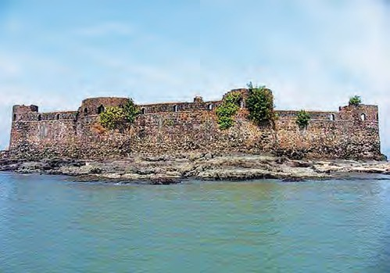
Fort Padmadurg
its foundation. A sea fort called Padmadurga was built in front of Rajapuri in order to counter the Siddi power. About this fort, Maharaj has said in a letter that by constructing Padmadurga, he had set up ‘another Rajapuri to overshadow the Rajapuri of the Siddi.’
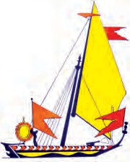
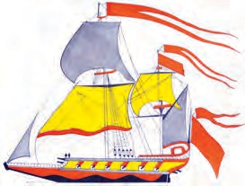
Navy : Enemies on the west coast of India, the Portuguese of Goa, the Siddi of Janjira and the British factors of Surat and Rajapur, created obstacles in the work of expanding the Swaraj. It was necessary to curb their activities and to protect the west coast. For this purpose, Maharaj raised a navy. He realised that the one who has a navy, controls the sea Maharaj had great foresight.

the maintenance of war material on the fort.
Gurab
Galbat


Sea forts : Maharaj knew the importance of sea forts, too. One of the sea forts that he built was Sindhudurga at Malwan. It is an excellent sea fort. To give strength to the construction of the fort, five khandis of lead was poured into

Obtain information about the warships in the Indian Navy and make a collection of the pictures of ships.
Do this.

There were four hundred ships of various kinds in his navy. They included battle ships like the gurab, galbat and pal. Ships were built in the creek of Kalyan Bhivandi, Vijaydurga and Malvan Maynak Bhandari and Daulatkhan were the chief naval Commanders.
Concern for the welfare of his subjects : Maharaj did not work only with the limited ambition of conquering enemy territories and establishing
objective was to make his subjects independent. He was aware that if his subjects were to really get the joy of freedom, it was necessary to have a disciplined administration, take comprehensive care of people’s welfare and protect the conquered territories.
Maharaj was not merely a ruler, he was a watchful administrator who cared for his people’s welfare. This is clearly seen in his administration of the State.


dominance like other things. His main
Exercise

1. Can you tell ?
4. Complete the chart.

- A Council with eight departments -
- Bahirj Naik was the Head of this department -
- The sea fort built by Maharaj near Malvan -
- He looked after the war materials on the fort -
- Write about it in your own words.

Activities
Havaldar
------
------
Military Organisation

Cavalry

------
------

  - Shivaji Maharaj’s policy regarding agriculture
  - Shivaji Maharaj - a ruler concerned about the welfare of his subjects.
- Give reasons.
  - Shivaji Maharaj established the Council of Eight Ministers.
  - Shivaji Maharaj raised a navy.
- Interview a person in your neighbourhood who has served in the armed forces.
- Visit a market in your town. List the items prepared/grown in the neighbourhood and those that come from outside.

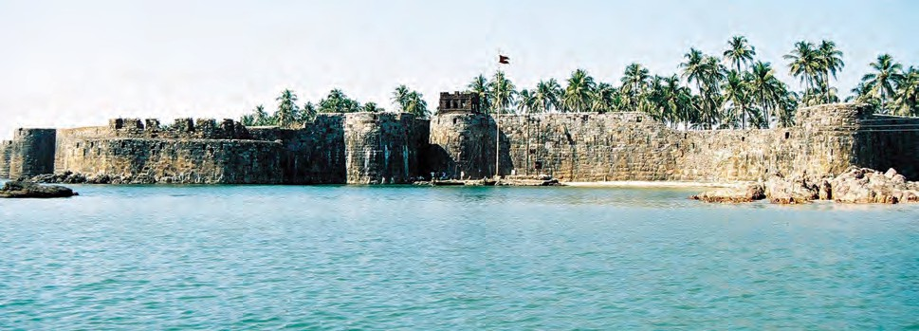
Fort Sindhudurg

8. An Ideal Ruler

Before the foundation of Swaraj, Maharashtra was under the domination of the Adilshahi, Siddi, Portuguese and Mughal powers. Shivaji Maharaj struggled against these powers. He faced all kinds of adverse circumstances. He founded an independent and sovereign Swaraj. He set up a system for the administration of this Swaraj. He turned Swaraj into a Surajya, a kingdom that sought the welfare of all. Maharaj created a new order with his capability. In the course of the conflict for the founding of the Swaraj, he himself had to face many grave dangers. Events like the meeting with the Afzalkhan, the seige of Panhala, the attack on Shaistakhan, the escape from Agra, all involved a great amount of risk. Shivaji Maharaj emerged successful in all these events. No harm came to him.



Think about it.
Shivaji Maharaj could establish Swaraj due to his loyal and dedicated associates.
Collect proverbs from different languages that state the importance of friendship. For example, A friend in need is a friend indeed.
Organisational Skill : Maharaj inspired the people around him to work for the Swaraj. His organisational skill was unparalleled. With this skill, he drew around himself brave people who were also extremely loyal. These close associates of Maharaj performed their duty, even by risking their own lives. There are many instances of this in the founding of the Swaraj - Jiva Mahala,
who killed Bada Sayyad at a critical moment during the meeting with Afzalkhan; Shiva Kashid who crossed the siege of Panhalagad in the disguise of Shivaji Maharaj; Bajiprabhu Deshpande, who blocked the advances of the enemy on the way to Vishalgad; Murarbaji Deshpande, who defended the fort of Purander, Tanaji Malusare, who sacrificed his life while conquering Sinhagad; Hiroji Farjand and Madari Meheter, who risked their lives during the escape of Maharaj from Agra, etc. Maharaj took great care of his associates. For example, Kanhoji Jedhe was associated with Maharaj in the work of the Swaraj from the very beginning. When the ageing Kanhoji fell ill, Maharaj told him not to neglect his medicines or treatment on any account.
Caring for the ryot : While establishing the Swaraj, Maharaj had to constantly struggle against his enemies. His subjects suffered due to enemy invasions. At such times, Maharaj used to take utmost care to protect the ryot. At the time of Shaistakhan’s campaign, Maharaj warned the Deshmukh of the Rohida valley not to fail in his duty towards the ryot. He told Deshmukh to visit every village and shift people to a safe place down the ghats. He strictly told him not to delay even for a moment. He further warned the Deshmukh that if he did not thus take care of the ryot, the Mughal army would take the people prisoner and then it would be seen as the Deshmukh’s doing. Maharaj also saw to it that the soldiers did not in any way cause any harm to the ryot.
Policy regarding the army : Maharaj maintained a strict discipline in the army.


He was particular about paying the salaries of the army in time. He made arrangements to pay the salaries of soldiers in cash. In various kingdoms in Medieval India and elsewhere, there was a system of making payments to soldiers in the form of jagirs. Maharaj set this practice aside. There was a strict order to the army that any valuables collected during the campaigns in enemy territories were to be deposited with the Government. Soldiers were honoured for their bravery in a campaign. He looked after the maintenance of the families of soldiers who died in battle. He took care of the wounded soldiers, he treated well the enemy soldiers who had surrendered themselves or who had been captured.

Do you know ?
If war broke out during the period of sowing-growing-reaping of crops, there would be no limit to the loss of farmers. Not only would the movements of army interfere with the work of sowing, but the soldiers would cut off and take away standing crops or would destroy them. They would rob the houses of farmers. Shivaji Maharaj had ordered the officers to prohibit his soliders from such actions. The letter written by Chhatrapati Shivaji Maharaj in 1674 CE to his military officers is very important in this regard. It shows how minutely Shivaji Maharaj thought about the discipline in the army.
“If you harass and trouble the subjects belonging to different castes by robbing them of their grains, fodder, grass, vegetables, etc., those subjects would leave their houses and migrate elsewhere. Many of them would starve

to death. It would be as if you are more atrocious than the Mughals. There would be great uproar.”
A policy of tolerance : Maharaj had to struggle against his enemies - the Adilshah, the Mughals and the Siddis. They were Islamic powers. While Maharaj struggled against them, he considered the Muslims in the Swaraj as his own subjects. At the time of the meeting with Afzalkhan, Siddi Ibrahim was a trusted servant in his army. Siddi Hilal was a Sardar in the army of Maharaj. Daulatkhan was an important officer in the navy of the Swaraj.
Maharaj followed a tolerant religious policy. In the enemy territories that he conquered, he continued the facilities that had been given to the Muslim places of worship. His contemporary historian Khafikhan writes about the tolerant religious policy of Maharaj; ‘Shivaji had framed strict rules for his soldiers that during the campaigns, they should not harm a mosque. If they came in possession of a copy of the Holy Quran, they should hand over the same, with reverence, to a Muslim.’
The inspiration for freedom : The efforts that Maharaj made to establish the Swaraj have a special value. It is the value of freedom. He aimed at establishing and maintaining an independent and sovereign existence that did not accept the dominance of any other power. While struggling against the foreign powers, Maharaj inspired others too, for freedom. When Chhatrasal, who was in the service of the Mughals, came to see Maharaj, Maharaj inspired him to create an independent kingdom in Bundelkhand.

Greatness of Maharaj’s work :
Maharaj established Swaraj while fighting

against many enemies. This action itself proves that he was a pioneer of a new era. But besides this action, many other noble qualities are found in his personality.
Maharaj was very intelligent. He had mastered many arts. He was conversant with many languages and scripts. The teachings of his parents towards the establishment of Swaraj and ethics were deeply instilled in his mind. There was a blend of character and strength, nobility and valour in his personality. He had innumerable qualities like leadership, management, foresight, political diplomacy, effective policy about regional and military administration, commitment to truth and justice, attitude of equality, visualisation of future activities, the skill of seeing his planned ventures through, rising over the calamities without giving up, alertness, vigilance and so on.

He used to punish those severely who would misbehave with women. He used to take care of all sections of the society like farmers, craftsmen, soldiers, traders, merchants, etc. He used to harbour the same respect for people of other religions that he had for people of his own religion, without any discrimination. He even established family bonds with them. He brought back into swadharma, their original religion, persons who had converted to another religion though there was an opposition to such a reconversion at that time. At that time, there was opposition on religious grounds to crossing the seas. Yet he built sea forts like Singhudurg and created a navy. This means that he had made preparation for countering foreign invasions that came from the sea. He became the ruler of Swaraj officially through his coronation, he later, had a second Coronation from

How is the waste in your area managed ?
State the name of the machinery that looks after waste management.
Can you tell ?
a different religious perspective. All these actions show his revolutionary aspects in the field of religion.
When there were threats to Swaraj, he would face them with or without his associates. Due to this, even his associates were ready to sacrifice their lives for Swaraj. Of course, his greatness was not confined to the quality of facing calamities bravely and fearlessly. He wanted to have an ethical, qualitative base to the Swaraj. That is why he would give orders, even regarding minor issues along with the important ones. The order that prohibited soldiers from taking vegetables from the fields of the peasants by force, is exemplary from this point of view. The restrictions on the cutting of trees enforced by him are also noteworthy.


Think about it.
Why is it necessary to grow trees ?
He had ordered that the garbage on the fort should be burnt in an allotted space without dumping it elsewhere, and vegetables should be grown on its ash. It becomes clear from this fact that he would pay close attention to the minutest details while establishing Swaraj. He was not just a warrior, but also a sculptor who created a new, independent, ethical and cultured society. His greatness is comprehensive.


In our national movement, Maharaj was a great source of inspiration. In his struggle for equality, Mahatma Jotirao Phule described in his powadas the greatness of Shivaji Maharaj. Lokmanya Tilak brought about national awakening through the medium of Shivajayanti celebrations. Lala Lajpatrai has written a book about the greatness of Maharaj. The great Tamil poet Subramanyam Bharati has written a

Do you know ?
Mahatma Jotirao Phule composed a Powada in 1869 CE on Shivaji Maharaj. A part of it is given here.
।। शिवाचा गजर जयनामाचा झेंडा रोशवला ।।
।। क्षेत्याचा मषेळा मावळ्ाचा शिकार खषेळला ।। मातषे पायीं ठषेवी डोई गव्व नाहीं काडीचा । आशिवाद्व घषेई आईचा ।।
आलाबला घषेई आवडता होतो शजजीचा । पवाडा गातो शिवाजीचा ।।
कुळवाडी - भूषण पवाडा गातो भोसलयाचा । छत्रपती शिवाजीचा ।।३।।



- Find it from the chapter.
Exercise
  - Grave dangers in the life of Shivaji Maharaj.
  - They risked their life at the time of Maharaj’s escape from Agra.
  - What warning did Shivaji Maharaj issue to the Deshmukh of Rohida Valley ?
  - What inspiration can future generations draw from the life of Shivaji Maharaj?
- Write about it in your own words.
  - What warning did Shivaji Maharaj issue to his soldiers to avoid any loss to the ryot ?
  - How do we know that the religious policy of Shivaji Maharaj was that of tolerance ?
poem about an imaginary incident in which Shivaji Maharaj talks to his associates. Vishwakavi Rabindranath Tagore has written a long poem on Maharaj. Tagore sees his efforts to found Swaraj as efforts for realizing a noble cause. Sir Jadunaath Sarkar has praised his achievements in his book ‘Shivaji and His Times’. Pandit Jawaharlal Nehru has said that Maharaj did not belong to Maharashtra alone, he belonged to the whole Indian nation. he
was a symbol of many virtues, more especially of love of country.
All Indian languages have works that talk about him as an ideal ruler and a source of inspiration.
Future generations too, will continue to look upon this work of Shivaji Maharaj of founding the Swaraj and turning it into Surajya as a source of inspiration, as an ideal. Shivaji Maharaj was a great national hero.

  - Explain Shivaji Maharaj’s policy regarding the army.
- Give one word for.
  - An important officer in the navy of
Swaraj -
  - A Tamil poet who composed a poem on Shivaji Maharaj -
  - He created an independent kingdom in Bundelkhand -
  - He composed a Powada on the greatness of Shivaji Maharaj -
Activities
- Tell how you help your friend in his need.
- List the places named after famous personalities.

9. The Maratha War of Independence

After the death of Chhatrapati Shivaji Maharaj, the Marathas fought with great valour with the Mughals under the leadership of Chhatrapati Sambhaji Maharaj, Chhatrapati Rajaram Maharaj and Maharani Tarabai to protect the Swaraj. This long war that lasted for twenty seven years is called the ‘Maratha War of Independence’. In 1682 CE Emperor Aurangzeb himself led the invasion of South. Even then, despite enormous difficulties, the Marathas emerged victorious in this struggle. This war is an exciting and glorious period in the history of India. In this chapter, we shall learn about this war of independence.
The word ‘Maratha’ used here means the ‘people who speak Marathi’ or ‘Maharashtrian people’.

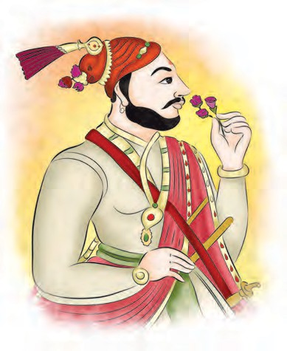
Sambhajiraje speaking... Present a role play.
Chhatrapati Sambhaji Maharaj
Do this.

Chhatrapati Sambhaji Maharaj :
Sambhaji Maharaj was the eldest son of
Chhatrapti Shivaji Maharaj. He was born on 14 May 1657 on the Purandar Fort. After Shivaji Maharaj, he became the Chhatrapati. At this time, the Marathas were battling against the Mughals. During the same period, Emperor Aurangzeb's son Shahajada Akbar rebelled against his father. The Emperor crushed his rebellion. Then Akbar came to the Deccan to take shelter with Sambhaji Maharaj. Then the Emperor himself descended on the South in 1682 CE to vanquish Akbar. He had with him a huge army and a powerful artillery. He asked the Siddi of Janjira to undertake an expedition against the Marathas. He also won over the Portuguese to his side. Consequently, Sambhaji Maharaj had to face many adversaries at one and the same time.
The reign of Sambhaji Maharaj marks the first chapter of the Maratha War of Independence after Shivaji Maharaj. Shivaji Maharaj had given him excellent education in civil administration and military campaigns. Sambhaji Maharaj had begun to take interst in the administration of the State and the command of the army from the age of fourteen years. While he was still a prince, he had led attacks on many territories of the Mughals and the Adilshah. Then French traveller Abbe Carrey says about his battle skills, “Even though the prince is young, he is courageous and brave like his father was famous for….”
When Sambhaji Maharaj became Chhatrapati, the war with the Mughals became fiercer. Aurangzeb wanted to occupy regions from Kabul to Kannyakumari and create a grand unified Mughal empire. His dream was to destroy the Maratha State completely using his


military and financial prowess. But Sambhaji Maharaj shattered his dreams with his bravery and military skills. Troops of the Maratha army attacked many of the Mughal territories. Though the Emperor’s generals tried very hard for a long time, they couldn’t win the Maratha fort of Ramsej near Nashik. Thus, Sambhaji Maharaj’s valour brought Aurangzeb to his knees. Once he removed his turban in frustration and threw it on the floor. He made a vow that until he had vanquished Sambhaji, he would not wear his turban. Sambhaji Maharaj had rendered Aurangzeb helpless to this extent.

Do you know ?
Aurangzeb thought that once the Maratha forts were captured, their rule too, would come to an end. So he put a siege around Ramsej fort near Nashik. Aurangzeb’s army was huge. The Maratha army was small. But they fought with perseverance. The siege continued for the next five years. This bravery of a handful Maratha soldiers was unparalleled. This resistance offered by the Marathas made Aurangzeb realise the difficulty of fighting with them.
Campaign against the Siddi : The Siddi of Janjira used to harass the people in the Maratha territory. He used to raid, burn, and loot the Maratha territory and commit atrocities. Sabhasada has described him as a rat in the house. Sambhaji Maharaj started a campaign against him in 1682 CE. His army laid a siege to Siddi’s Dandarajpuri fort, and battered the fort of Janjira with the artillery. But at the same time, the Mughal army invaded Swaraj. Sambhaji Maharaj had to abandon the Janjira campaign and turn back.
Campaign against the Portuguese : The Portuguese of Goa joined hands with the Emperor against Sambhaji Maharaj. So, Sambhaji Maharaj decided to teach a lesson to the Portuguese. He attacked the Revdanda fort of the Portuguese in 1683 CE. To counter this, the Portuguese laid a siege to the Fonda fort of the Marathas on the Goa border. The Marathas broke through the siege and attacked Goa. In this battle, Yesaji Kank showed great valour. The Portuguese Governor got wounded and retreated. Sambhaji Maharaj followed him. The Portuguese were in deep trouble. At this time, Sambhaji Maharaj got the news that the Mughals had attacked South Konkan. Therefore, he had to abandon the winning campaign of Goa and return to fight with the Mughals.
The end of Adilshahi and Qutubshahi : Aurangzeb did not succeed in his campaign against the Marathas. Therefore, he suspended that campaign. Then he turned towards the kingdoms of Adilshah and Qutubshah and conquered them.
The wealth and army of both the kingdoms was now acquired by the Mughals and it made Aurangzeb even stronger. Then he concentrated all his might on defeating the Marathas. He attacked their territory from all sides. The Maratha army General Hambirrao Mohite got killed during an encounter with the Mughal army. Due to this blow the military strength of Sambhaji Maharaj was weakened.
Administration of Sambhaji Maharaj : Even though Sambhaji Maharaj was busy fighting on various battle fronts, he did not ignore his administrative responsibilities. He continued the prompt justice and revenue system, which was a characteristic of Chhatrapati Shivaji

Maharaj’s era. He severely punished the landlords who harassed common people and who rebelled against the Swaraj. He gave administrative powers to Maharani Yesubai. He gave her, her own stamp. He continued the legacy of Shivaji Maharaj’s welfare policies.

Sambhaji Maharaj knew Sanskrit and many other languages well. He studied many ancient books on polity and wrote their gist in a book called ‘Budhbhushanam’.

Chhatrapati Shivaji Maharaj. He was born on 24 February 1670 on Raigad. He became Chhatrapati after the death of Sambhaji Maharaj. Now Aurangzeb thought that his
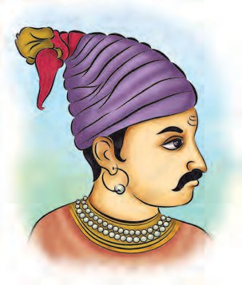
dream of winning the Maratha kingdom would be realised. He sent Zulfikarkhan to put Raigad under siege. That time Rajaram Maharaj and his wife Maharani Tarabai and

Chhatrapati Rajaram Maharaj
Do you know ?
Sambhaji Maharaj composed ‘Budhbhushanam’ in the Sanskrit language. The second chapter of this book discusses polity. It includes information about the virtues of a king, prime minister, princes and their education and functions, the advisers to the king, forts and the goods and materials needed on a fort, the army, the duties of a king, espionage, etc.

Sambhaji Maharaj’s wife

Death of Sambhaji Maharaj : Aurangzeb was trying very hard to defeat Sambhaji Maharaj. He had placed Mukarrabkhan in charge of the Kolhapur province. Mukarrabkhan learnt that Sambhaji Maharaj was at Sangameshwar in Konkan. He raided the place and captured Sambhaji Maharaj. When Sambhaji Maharaj was taken to the Emperor, he faced him fearlessly. By the Emperor’s orders, he was brutally put to death on 11 March 1689. This Maratha Chhatrapati did not compromise his self respect and faced his death nobly and bravely. The Marathas took inspiration from his sacrifice and intensified their fight against the Mughals.

Chhatrapati Rajaram Maharaj :
Rajaram Maharaj was the second son of
Maharani Yesubai and his son Shahu were on Raigad. It was risky for all members of the royal family to stay at one place. Maharani Yesubai tackled this unprecedented calamity very bravely. Resolving that, she would not surrender to the Mughals under any conditions, she took many important political decisions on Raigad. It was decided that Rajaram Maharaj should escape from Raigad and if necessary, go to a far off place like Jinji. It was decided that the fight to defend Raigad would continue under the leadership of Maharani Yesubai. Maharani Yesubai chose to make Rajaram Maharaj and not her own son the Chhatrapati. Her decision is a shining example of her love for Swaraj and her extreme selflessness. She kept the Maratha Chhatrapati secure without regard for her own life or that of her son.


Find Jinji on a map of India.
Let’s find out.
Rajaram Maharaj leaves for Jinji : On 5 April 1689 Rajaram Maharaj escaped from the besieged Raigad with a few of his associates. He decided to go


south to Jinji. The Jinji fort was invincible. It was not an easy task for the Mughals to capture this fort. Rajaram Maharaj took his faithful Sardars like Pralhad Niraji, Khando Ballal, Rupaji Bhosale and managed to reach Jinji.
The Movements of the Marathas : It was difficult to defend the Raigad fort against the might of the Mughals. The Mughals captured Raigad in November 1689 and arrested Maharani Yesubai and Shahu. While going to Jinji, Rajaram Maharaj had assigned the duty to fight against the Mughals to Ramchandrapant Amatya, Shankaraji Narayan Sachiv, Santaji Ghorpade and Dhanaji Jadhav.
From the Maratha point of view, the situation was critical. Aurangzeb had enticed many Maratha Sardars to his side by giving them watans and jagirs. Rajaram Maharaj also used the same tactics to thwart the Mughal plans. It was promised that if a Maratha Sardar captured Mughal territory it would be given to him as a jagir. Due to this promise, many capable Maratha Sardars came forward. They started invading the Mughal territory with vigour and defeated Mughal Generals. Santaji and Dhanaji were at the forefont in these actions. Against their surprise attacks and guerrilla tactics, the enormous amount of war material and heavy artillery of the Mughals were of little use. The Mughal forces were at their wits’ end. On one occasion, Santaji Ghorpade and Vithoji Chavan even cut and carried away the golden pinnacle of the Emperor’s own tent in a surprise attack.
Siege of Jinji : Once Raigad was captured. the Emperor sent Zulfikarkhan to the South on the campaign of Jinji. He laid siege to the fort of Jinji. The

Do you know ?
The Mughal soldiers were so scared of Dhanaji that when their horse baulked while drinking water, they would say: “Why, do you see Dhanaji in the water ?”
Marathas defended the fort bravely for nearly eight years. The Mughal forces engaged in the siege were fiercely attacked from outside by Santaji and Dhanaji. Rajaram Maharaj escaped through the siege, and returned to Maharashtra. Later Zulfikarkhan captured the fort of Jinji.
The return of Rajaram Maharaj to Maharashtra gave a boost to the Maratha activity. The Marathas attacked the Mughal territories of Khandesh, Varhad and Baglan. Rajaram Maharaj inspired hundreds of brave Maratha warriors like Santaji and Dhanaji with his understanding nature and statesmanship. He motivated them to protect the Swaraj and thus performed a very valuable task. But even as all this was taking place, Rajaram Maharaj died on 2 March 1700 on Sinhgad after a short period of illness.
Rajaram Maharaj was thoughtful and kind-hearted. He brought together all the capable people in the Maratha empire. He united them created a new enthusiasm amongst them. After the death of Sambhaji Maharaj, he fought against Aurangzeb for 11 years with great courage and tenacity. Rajaram Maharaj’s greatest achievement is that he protected Swaraj in those extremely difficult times. While describing Rajaram Maharaj, noted historian Riyasatkar G. S. Sardesai has used the adjective ‘Sthirbuddhi’ (Level Headed). He cannot be described in better words than these.



Do this.
Interview the women in your neighbourhood who have made great achievements in various fields.
Maharani Tarabai : After the death of Chhatrapati Rajaram Maharaj, Aurangzeb thought that he had won the war against the Marathas. But it was not so. Aurangzeb was winning battle after battle, but he could not win the war. Maharani Tarabai, the capable wife of Rajaram Maharaj, came forward to lead the Swaraj movement in the extremely unfavourable circumstances.

Contemporary Mughal historian Khafikhan describes Maharani Tarabai as an intelligent and knowledgeable woman. Her management of the army and administration had won renown even during the rule of her husband.
After the death of Chhatrapati Rajaram Maharaj, Maharani Tarabai continued the
Swaraj struggle bravely with the help of her Sardars. Aurangzeb captured Satara and Panhala from the Maratha territory, but at the same time the Marathas dashed up to the Mughal areas of Madhya Pradesh and Gujarat. Tarabai expanded the war areas further. Sardars like Krishnaji Sawant, Khanderao Dabhade, Dhanaji Jadhav and Nemaji Shinde opened battles against Mughals on various fronts outside Maharashtra. This was a sign of change in the outcome of the war.
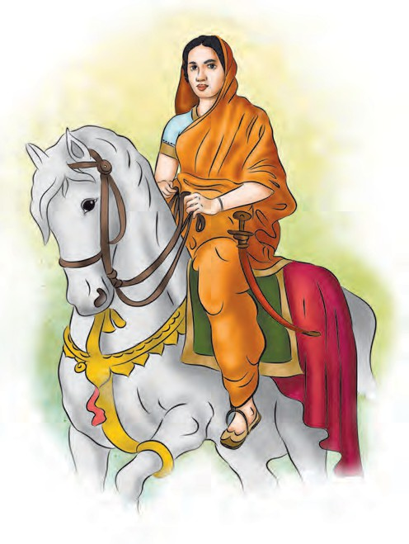

Maharani Tarabai fought for seven years. She kept the Maratha kingdom strong. She took charge of the administration singlehandedly and encouraged the Sardars to participate in the mission of Swaraj. Maratha Sardars fought against the Mughals up to Sironje, Mandsaur and Malwa. Khafikhan has recorded that Rajaram’s wife Tarabai achieved great things and displayed the
Maharani Tarabai

Do you know ?
Maharani Tarabai used the Guerrilla technique very effectively. Marathas were comparatively weaker than Aurangzeb in army power. Aurangzeb used his army to put siege to the forts to capture them. Marathas used to fight for the fort as long as they could. But when the rainy season approached, Killedar of the fort pretended to side with Aurangzeb. A bribe was accepted from Aurangzeb and the fort was handed over to him. The Killedar used to deposit this bribe amount in the Maratha treasury. When Aurangzeb repleted the wealth, grains and ammunition on the fort, Tarabai used to capture that fort again. This strategy of Tarabai is described as ‘Safe deposit locker system’.


qualities of leadership of the army and management of campaigns. It added force to the Maratha campaigns.

Do you know ?
While describing Tarabai’s great achievements, Poet Devdatta (who was the son of Paramanand, the author or Shivbharat) says,
ताराबाई रामराणी । भद्रिाली िोपली । गदल्ी झाली दीनवाणी । गदल्ीशाचे गेले पाणी ।
रामराणी भद्रिाली । रणरंगी क्ुद्ध झाली । प्रयतनाची वेळ आली । मुगल ्ो सांभाळा ।।
Thus, Maharani Tarabai kept up the legacy of valour inherited from Chhatrapati Shivaji Maharaj.
Due to the forceful campaigns of the Marathas, Aurangzeb was frustrated. The
Mughal-Maratha fight had continued for
25 years. Still the Mughals could not defeat the Marathas. In these circumstances, Emperor Aurangzeb died in 1707 CE at Ahmednagar. The Maratha War of Independence ended with his death.
This Maratha war for independence was the fight between the Mughal Emperor’s greed to expand his empire and the spirit of independence of the Marathas. The Marathas emerged victorious in it. After the death of Aurangzeb, they led others in filling the vacuum in the political arena. They controlled the throne of Delhi, ran the affairs of almost all parts of Hindusthan and protected it. Therefore, the 18th century is known as the century of the Marathas. In the next chapters, we will see the achievements of the Marathas in that century.


Malojiraje

Shahajiraje (1594 CE to 1664 CE)
Sambhaji
Chhatrapati Shivaji Maharaj (1630 CE to 1680 CE)
Vyankoji
Chhatrapati Sambhaji Maharaj (1657 CE to 1689 CE)
Chhatrapati Rajaram Maharaj (1670 CE to 1700 CE)
Chhatrapati Shahu Maharaj (1682 CE t o 1749 CE)
Chhatrapati Shivaji
Chhatrapati Sambhaji
(Son of Tarabai) (Son of Rajasbai)
Chhatrapati Ramraja (Adopted
1750 CE t o 1777 CE)
Ramraja (Adopted by Satara gadi)
THE FAMILY TREE OF THE BHONSALES



Exercise

  - Choose the correct option.
- Aurangzeb was frustrated by his bravery.
  - Shahajada Akbar
  - Chhatrapati Sambhaji Maharaj
  - Chhatrapati Rajaram Maharaj
- They cut the golden pinnacles the Emperor’s tent.
  - Santaji and Dhanaji
  - Santaji Ghorpade and Vithoji Chavan
  - Khando Ballal and Rupaji Bhosale
- He fought bravely in the Goa battle.
  - Yesaji Kank
  - Nemaji Shinde
  - Pralhad Niraji

  - Find in the text in the lesson and write answers.
- Why did Sambhaji Maharaj return halfway from the Janjira Campaign ?
- Why did Sambhaji Maharaj decide to teach a lesson to the Portuguese ?
- To whom did Rajaram Maharaj entrust the responsibility of protecting the Swaraj when he went to Jinji.
- Devdatta has described Maharani Tarabai’s valour in these words.

  - Give reasons.
- Aurangzeb turned his attention towards Adilshahi and Qutubshahi kingdoms.
- After the death of Sambhaji Maharaj, the Marathas intensified their war with the Mughals.
- It was decided that the Raigad fort should be fought under the leadership of Maharani Yesubai.

Activity

Show Goa, Bijapur, Golconda, Jinji, Ahmadabad and Ahmednagar on a map of India.

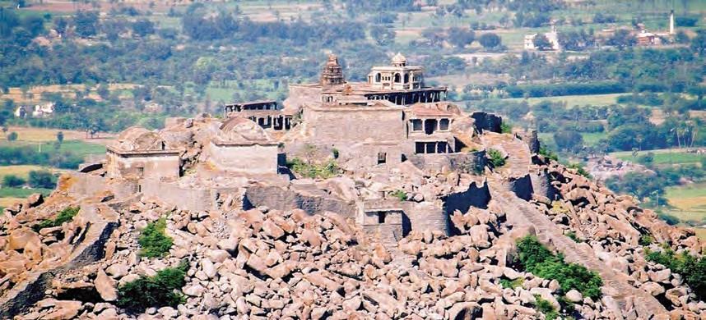
Fort Jinji

10. The Expansion of the Maratha Power

At the beginning of the Maratha war of independence, the Mughals were on the offensive whereas the Marathas were on the defensive. This situation however was reversed at the end of the war of independence. The Mughals were thrown on the defensive against the Marathas. In the latter half of the eighteenth century, the Marathas subdued the Mughals and extended the Maratha power to cover practically the whole of India. We shall study this in the present chapter.
Release of Shahu Maharaj : After the death of Emperor Aurangzeb, there ensued a struggle among his sons for the throne of Delhi. Prince Azamshah was in the South. At once, he marched towards Delhi to seize the imperial throne. Prince Shahu was in his captivity. Azamshah believed that if Shahu Maharaj was released, there would arise a conflict between him and Maharani Tarabai for the gadi of the Maratha Chhatrapati. Azamshah felt that this would sap the Maratha strength and therefore, released Shahu Maharaj.
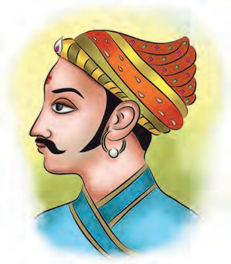
Coronation of Shahu Maharaj : Immediately after his release, Shahu Maharaj marched towards Maharashtra. He was joined by some Maratha Sardars, but Maharani

Shahu Maharaj
Tarabai did not accept his claim to the throne. The armies of Shahu Maharaj and Maharani Tarabai fought a battle at Khed on the bank of the Bheema. Shahu Maharaj
won the battle. He captured Satara. He got himself crowned. Satara became the capital of the Maratha kingdom.
For a while, the mutual opposition between Maharani Tarabai and Shahu Maharaj continued. Maharani Tarabai proclaimed her minor son Shivaji II as the Chhatrapati at Pahnala in 1710 CE. This gave rise to an indendepent Maratha Kingdom at Kolhapur besides the one at Satara.
The early part of Shahu Maharaj’s life was spent in Mughal camps. So, he had seen Mughal politics from close quarters. He knew the finer points of Mughal and especially North Indian politics.
He knew the strengths and weaknesses of the Mughal empire very well. Also, he was acquainted with the influential people in the Mughal Court. All these factors helped him deciding the new direction of Maratha politics in the changing circumstances.
Aurangzeb’s successors had given up his policy of destroying the Maratha power. So the Marathas adopted a new policy. Instead of fighting with the Mughal power, they decided to protect it and expand their own empire in that role. They believed that restoring an old temple is as good as building a new one.
The Mughal power faced the threat of the Irani and Afghani invaders from the north-west and also of the local Pathan, local Rajput, Jat and Rohilas rulers. The internal competition and tussle in the court had also weakened the Mughal power. Due to all these the Delhi Court needed the help of the Marathas.
Balaji Vishwanath : After Shahu Maharaj was released by the Mughals, he

made Balaji Vishwanath, a Peshwa. Balaji hailed from Shrivardhan, in Konkan. He was competent and experienced. He convinced many Sardars that Shahu Maharaj was the real heir of the Maratha empire and made them join hands with him.
Kanhoji Angre was the chief of Maratha Navy. He chose to side with Maharani Tarabai and attacked the territories of Shahu Maharaj. This gave rise to a difficult situation. Under these circumstances, Shahu Maharaj sent Balaji to fight against Kanhoji Angre. Balaji avoided the war and won Kanhoji over to Shahu Maharaj’s side.
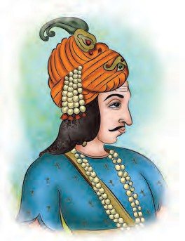
Chauthai and Sardeshmukhi rights : After strengthening the position of Shahu Maharaj in Maharashtra, Balaji turned his attention to the politics in the North. The Delhi court, after the death of Emperor Aurangzeb, was marked by bickering and confusion. The Sayyid brothers, Abdulla (Hasan) and Hussein Ali had become very influential. With their help, in 1719 CE Balaji obtained from the Mughal Emperor, the grants or sanads to collect chauthai and sardeshmukhi from the Mughal territory in the Deccan. These sanads gave the Marathas the rights to collect one fourth part (chauthai) and one tenth part (sardeshmukhi) of the revenue from the Mughal territory in the Deccan.
Bajirao I : After the death of Balaji Vishwanath, Shahu Maharaj appointed Balaji’s son, Bajirao I the Peshwa in 1720 CE. He expanded the Maratha Empire during his term of
Nizam’s defeat at Palkhed : The Mughal emperor Farukhsear appointed Nizam – ul – Mulk the Subhedar of Deccan. In 1713 CE Nizam tried to establish his separate existence at Hyderabad. The Emperor had given the Marathas the rights to recover Chauthai-Sardeshmukhi from the Mughal areas. Nizam was against it. He captured some part of the Pune Pargana. Bajirao decided to checkmate the Nizam. He defeated the Nizam at Palkhed near Aurangabad. The Nizam accepted the Maratha right to collect Chauthai- Sardeshmukhi.
As the Mughal power had become weak, Bajirao knew that there was more scope to expand the empire towards northern side. Shahu Maharaj supported his policy.
Malwa : Malwa in todays Madhya Pradesh was part of the Mughal empire. Bajirao sent Malharrao Holkar, Ranoji Shinde and Udaji Pawar under the leadership of his brother Chimajiappa to Malwa. There, they strengthened the posts.
Bundelkhand: Bundelkhand means some part of today’s Madhya Pradesh and Uttar Pradesh - areas around Jhansi, Panna and Sagar.
King Chhatrasal had established his own kingdom in Bundelkhand. The Mughal Subhedar Mohmmad Khan Bangush of Allahabad attacked Bundelkhand and had defeated Chhatrasal. Chhatrasal appealed to Bajirao for help.
Bajirao took a large army and went to Bundelkhand. He defeated Bangush. Chhatrasal honoured Bajirao. This is how Marathas established their supremacy in Malwa and Bundelkhand.
Bajirao demanded from the Emperor the office of the Subhedar of Malwa. As the Emperor declined this demand, Bajirao

Bajirao I
20 years.


marched on Delhi in 1737 CE. The Mughals were taken by surprise.

Do you know ?
Chhatrasal wrote a letter to Bajirao. In that he wrote, जो गत आह गजेंद्र की वह गत आई है आज. बाजी जान बुंदेल की, बाजी राखो लाज. (My situation is like
the elephant whose leg is caught by the crocodile. You are the only one who can save me.)
The battle of Bhopal : The Emperor felt uneasy on account of Bajirao’s Delhi expedition. He invited the Nizam to protect Delhi. Nijam marched against Bajirao with his huge army. Bajirao defeated him at Bhopal. Nizam agreed to secure the sanad of Malwa subhedari for the Marathas from the Badshah.
The defeat of Portuguese : The territories of Vasai and Thane on the Konkan coast were in the possession of the Portuguese. The Portuguese rulers oppressed their subjects. Bajirao sent his brother Chimajiappa to subdue the
Portuguese. Chimaji conquered Thane and the adjacent areas. In 1739 CE, he laid siege to the Vasai fort. The fort was very strong. The Portuguese had a powerful artillery. In spite of all this, Chimaji continued the siege with perseverance and forced the Portuguese to surrender. The fort of Vasai and large parts of the Portuguese territory passed into the hands of the Marathas.
Death of Bajirao : Nadirshah, the Emperor of Iran, invaded India. Following the order of Shahu Maharaj, Bajirao set out for the North with a big army to defend the Mughal power. By the time he reached Burhanpur, Nadirshah had returned to Iran with an enormous booty looted from Delhi. In April 1740, Bajirao breathed his last at Raverkhedi on the banks of the Narmada.
Bajirao was a great General. With his valour, he established the Maratha supremacy in the North. He won status for the Maratha power as a formidable power in the whole of India.


In his time, the Shinde, Holkar, Pawar, Gaikwad families attained prominence.

Exercise

- Write the meaning.
  - Chauthai -
  - Sardeshmukhi -
- Write the answer in one word.
  - Balaji was from this town in Konkan
..............
  - He ruled Bundelkhand ..............
  - Bajirao died at this place ..............
  - He defeated the Portuguese ..............
- Write about them in your own words.
  - Kanhoji Angre
  - The Battle of Palkhed
  - Balaji Vishwanath
  - Bajirao I
- Give reasons.
  - Two separate Maratha States were formed.
  - Azamshah released Chattrapati Shahu Maharaj from his custody.
  - Delhi needed the help from the Marathas.
Activity
Get a biography of Maharani Tarabai and present an inspiring event in her life.

11. Marathas – The Protectors of the Nation

After Bajirao I, Shahu Maharaj appointed his son Balaji Bajirao alias Nanasaheb the Peshwa. Following the invasion of Nadirshah, there was instability in Delhi. In these circumstances, Nanasaheb tried to stabilize the Maratha rule in the North. Ahmadshah Abdali posed a challenge to the Marathas at Panipat. We shall learn about these developments in this chapter.
Situation in the North : The region to the north-west of Ayodhya province at the foothills of the Himalayas was called Rohilkhand in the 18th century. The Pathans who had migrated from Afghanistan had settled in this region. They were known as Rohillas. The Rohillas had wrought havoc in the Doab region of the Ganga and Yamuna rivers. The Nawab of Ayodhya invited the Marathas to subdue the Rohillas. The Marathas chastised the Rohillas.
Conflict with the Afghans : Ahmadshah Abdali, the ruler of Afghanistan, was attracted by the riches of India. He marched on the Punjab in 1751 CE. There was anarchy in the Mughal territory. The Mughals were facing the threat of Abdali’s invasion. In these circumstances, the Mughals found it necessary for their own protection, to seek the help of the Marathas. The Emperor was sure of the Maratha strength and integrity. There was no other power strong enough to protect Delhi. Therefore, the Emperor entered into a treaty with the Marathas in April 1752. According to this treaty, the Marathas agreed to protect the
Afghans. In return, the Marathas were to get cash money, the right to collect chauthai in the territories of the Punjab, Multan, Rajputana, Sindh and Rohilkhand and the Subhedari of Ajmer and Agra provinces.
As per the treaty, the Peshwa sent the Shinde-Holkar armies for the protection of Delhi on behalf of the Chhatrapati. When Abdali learnt that the Marathas were marching to Delhi, he went back to his country. Because the threat of Abdali was thus thwarted due to the Marathas, the Emperor gave them Chauthai rights to the Mughal subhas. These subhas included Kabul, Kandahar and Peshawar. Though the subhas were previously a past of the Mughal empire, now they were part of Abdali’s Afghanistan. As per the treaty, it was a duty of the Marathas to win the subhas back from Abdali and annexe them to the Mughal Empire. Abdali however, wanted to bring under Afghan control, the region up to the Punjab. So a conflict between the Marathas and Abdali was imminent and inevitable.
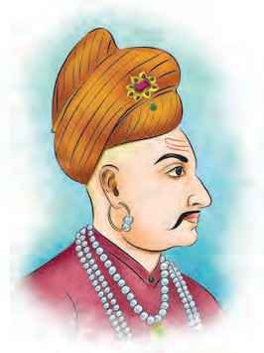
Raghunathrao, brother of the Peshwa Nanasaheb, accompanied by Jayappa
Shinde and Malharrao Holkar, undertook the campaign of North India to combat Abdali.
The local rulers in the north saw the Marathas from the South as their competitors. They did

Mughal power from enemies like the
Peshwa Nanasaheb
not take into account

Rohillas, the Jats, the Rajputs and the
the broad vision of the Marathas and

remained neutral, offering no help to the Marathas. They did not like the Maratha supremacy and interventions in the Delhi court. Surajmal Jat and Rani Kishori were the only ones who helped the Marathas wounded in the battle of Panipat.
Also, some of the orthodox sects in the North saw Marathas as people belonging to other religions. They, too, left aside the broad vision of the Marathas. They persuaded Abdali to invade India with a view to reducing the Maratha might. They expected that Abdali would defeat the Marathas and drive them away back to the South, beyond the river Narmada.
The Maratha standard on Attock : Najibkhan was a Rohilla chief. He found it hard to tolerate the Maratha supremacy in the North. At the behest of Najibkhan, Abdali invaded India again. This was the fifth time he had invaded India. He captured Delhi. He returned to Afghanistan with a huge booty. Raghunathrao and Malharrao Holkar marched to the North again. They captured Delhi. Then, driving out Abdali’s officers, they captured the Punjab. The Marathas pursued Abdali’s soldiers right up to Attock in 1758 CE. The Maratha standard was raised at Attock. Attock is in present day Pakistan. From Attock, the Marathas pushed the campaign up to Peshawar. However, they did not make proper arrangements to look after this newly conquered territory.
Dattaji’s valour : To get a firm hold over the Punjab and to crush Najibkhan, the Peshwa sent Dattaji Shinde and Janakoji Shinde to the North. Dattaji went to the North. Keeping Dattaji engaged in
to come to his help. On receiving the message from Najibkhan, Abdali invaded India again. Dattaji and Abdali confronted each other at Buradi Ghat on the banks of the Yamuna. A fierce fight ensued. Dattaji showed tremendous valour. He met with a heroic death in this battle.

Do you know ?
Dattaji fought very bravely. At last, he was severely wounded and collapsed on the battleground. Najib Khan Rohilla’s adviser Qutub Shah stepped down from his elephant and came towards Dattaji. He asked Dattaji, ‘क्ों पटेलजी, हमारे साथ तुम और
भी लढेंगे?’ Dattaji was in a wounded state. But after hearing these words of Qutub Shah, he replied with pride, ‘हाँ, बचेंगे तो और भी लढेंगे ।’


Sadashivraobhau : Nanasaheb sent his cousin Sadashivraobhau and eldest son Vishwasrao to the North to crush Abdali. Sadashivraobhau was Chimajiappa’s son. He had with him, a
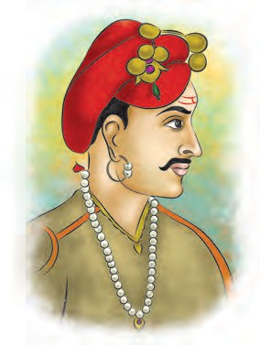
huge army and a powerful artillery.
Ibrahimkhan Gardi was the chief of the artillery. He had defeated the Nizam in the battle of Udgir in 1760 CE, on the
strength of this

negotiations, Najibkhan established
contacts with Abdali. He requested Abdali
Sadashivraobhau
artillery.

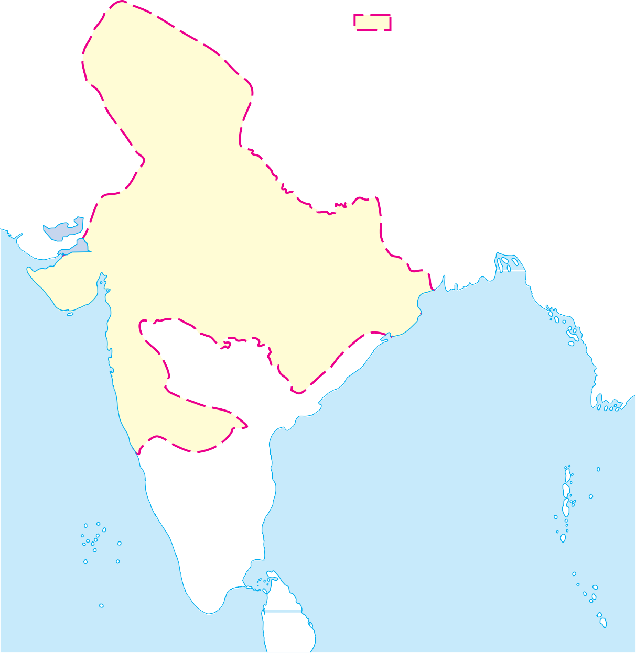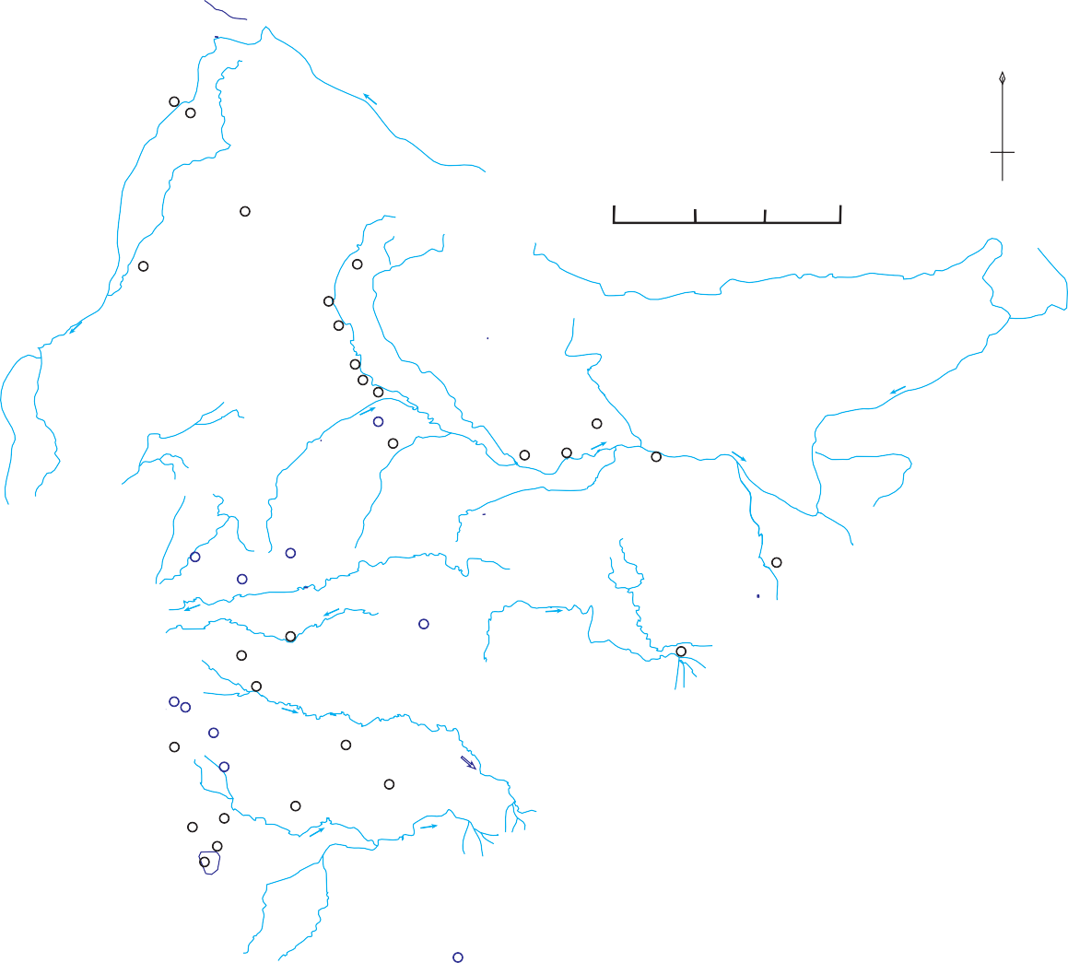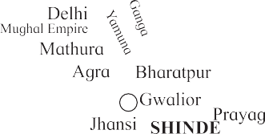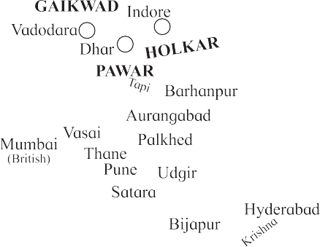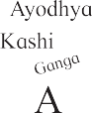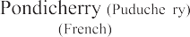

The Battle of Panipat : In his campaign of the North, Sadashivraobhau captured Delhi. The armies of the Marathas and Abdali confronted each other at Panipat. On 14 January 1761, the Marathas opened the battle by attacking Abdali’s army. This was the Third Battle of Panipat. Vishwasrao fell a victim to an enemy bullet in the battle. When Sadashivraobhau learnt this, he fiercely
attacked the enemy in a frenzy. He disappeared in the battle fray. Seeing that their leader had disappeared, the Maratha soldiers lost courage. At that very moment, the reserve contingents of Abdali launched an attack on the Marathas with a fresh vigour. The Marathas were defeated. A whole generation of young men in Maharashtra was killed. Many brave Sardars fell on the battlefield. The

49


Do you know ?
Approximately 1,50,000 people were killed in the battle of Panipat. One letter describes this in a poetic way.
‘‘दोन मोत्ये गळाली. सत्ावीस मोहोरा हरवल्ा ! आणि रूप्ये, खुदादा णि्ी गयेल्ा ्ाची गि्ीच नाही.’’
Marathas believed that an outsider like Abdali had no moral right to rule here. The Marathas fought at Panipat with the broad perspective that India is for Indians.
Sadashivraobhau had explained the broad, all-inclusive viewpoint of the Marathas in his correspondence with the rulers in the North, saying that they were all native to the land and Abdali was an enemy from a foreign country. But the rulers in the North did not respond favourably to him and took a neutral attitude. Naturally, the Marathas had to shoulder the responsibility of protecting India. We can say that the Marathas were the first in our history to realise that India was one country and it was necessary for all to lend support to the king irrespective of his religion.
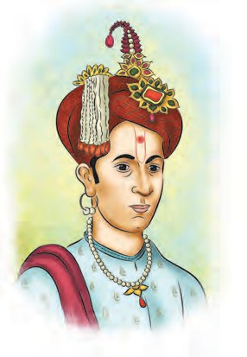
Peshwa Madhavrao : After the death of Peshwa Nanasaheb, his son Madhavrao succeeded him to the office of the Peshwa.
Madhavrao kept the Nizam and Hyder Ali at bay. He established the supremacy of the Marathas in the North again.
After the defeat of the Marathas at Panipat, the Nizam once again resumed his anti-Maratha
activities. He Peshwa Madhavrao
invaded the Maratha territory. Madhavrao defeated the Nizam at Rakshasbhuvan near Paithan.
Hyder Ali was the Sultan of Mysore. Taking advantage of the Maratha defeat at Panipat, Hyder Ali attacked their territory in Karnataka. The Marathas defeated Hyder in a battle at Moti Talav near Srirangapattan. He then agreed to cede the region north of the river Tungabhadra to the Marathas.

Peshwa Madhavrao died in 1772 CE. In the history of the Marathas, he is described as an honest, hard-working, determined administrator who was keen on public welfare. The death of this capable Peshwa was an irreparable loss to the Maratha State.

Do you know ?
Peshwa Madhavrao provided special attention towards the welfare of farmers. He dug many wells in Pune and increased the water supply to the city. Administrators like Nana Phadnavis and judges like Ramshastri Prabhune emerged under his rule. He reformed the judiciary for better justice to the common people. He started artillery and ammunition factories. He also established a mint to make coins.
The two Peshwas who succeeded Peshwa Madhavrao, namely Narayanrao and Sawai Madhavrao, did not live long. During their term, Peshwa was in the grip of family feuds. Raghunathrao, who had once raised the Maratha standard at Attock, sought shelter with the British to satisfy his greed for power. This led to a war between the Marathas and the British.

Hyder Ali died in 1782 CE. After him his son Tipu became the Sultan of Mysore. He was a skilled warrior, a scholar and a poet. He used his competence to increase the might of his Kingdom. He established contact with French and shook the foundation of British supremacy. He died in 1799 CE in a battle against the British.

The Maratha Supremacy Rises Once Again : The Maratha prestige in the North had suffered a severe setback because of the debacle at Panipat. Madhavrao dispatched Mahadji Shinde, Tukoji Holkar, Ramchandra Kanade and Visajipant Biniwale to re-establish the Maratha rule in the North. The Maratha army defeated the Jats, the Rohillas and the Rajputs. The Marathas restored the Emperor Shah Alam to the throne of
Balaji Vishwanatha
Bajirao I
Chimajiappa
Balaji alias Nanasaheb
Ramchandra
Raghunathrao Janardan
Sadashivraobhau
Bajirao II

Nanasaheb (adopted)
Vishwasrao
Madhavrao Yeshwantrao Narayanrao (Peshwa) (Peshwa)
Sawai Madhavrao (Peshwa)
THE FAMILY TREE OF THE PESHWAS
Delhi under their own protection. The Maratha power was revived in the North.
The Marathas suffered a heavy loss in the battle of Panipat. Abdali’s army also suffered losses. He did not benefit financially in the battle. In fact, Abdali or his descendants did not muster enough courage to invade India again. They realised that only the Marathas had the strength and capacity to control the anarchy in the North. They expressed their wish that the Marathas should protect the Empire. They sent a messenger to Pune to establish cordial relations. It is important to note that the Marathas overcame the great defeat at Panipat and successfully revived their supremacy in the politics of the North. Malharrao Holkar, Ahilyabai Holkar and Mahadji Shinde had a lion’s share in all this.



Exercise

- Name them.
  - They came from Afghanistan ...
  - They settled at the foothills of the Himalayas…
  - The brother of Nanasaheb Peshwa…
  - The chief of Jats at Mathura…
  - Defeated Nijam at Rakshasbhuvan near Paithan…
- Write in brief about.
  - Raising the Maratha standard at Attock.
  - Conflict with the Afghans
  - The after effects of the battle of Panipat.
- Arrange chronologically.
  - The battle of Rakshasbhuvan.
  - The death of Tipu Sultan.
  - The death of Madhavrao Peshwa
  - The battle of Panipat
  - The battle of Buradi Ghat
- Find the names of people in the chapter :
N n D
N

Activity

Find more information about the battle of Panipat on the internet and make a presentation in your class.

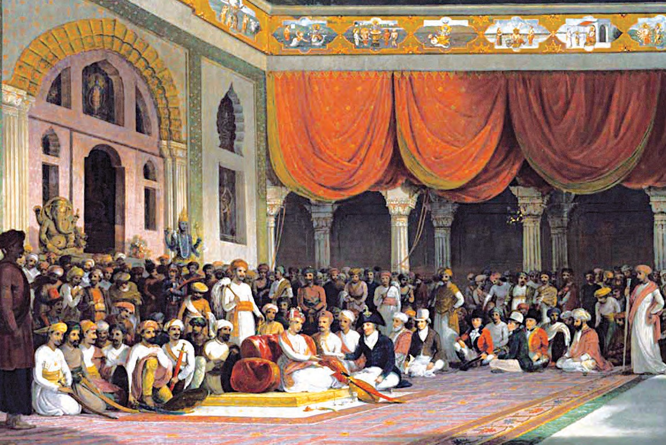
The Court of Sawai Madhavrao Peshwa

12. Progression of the Empire

Till now we have learnt about the rise of the Maratha power and its expansion. We studied the developments from the foundation of the Swaraj till its expansion into an empire. In this chapter, we take a brief review of the Sardar families, who gave their valuable contribution for expanding the Maratha kingdom in the northern parts of India.
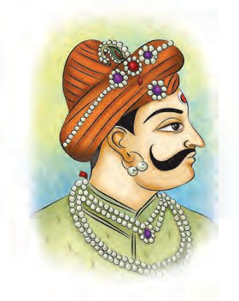
The Holkars of Indore : Malharrao was the founder of the Holkar rule at Indore. He served the Maratha state for a
long time. He was well-versed in guerrilla warfare. He proved his valour in the northern campaigns of the Marathas at the time of Bajirao I and Nanasaheb Peshwa. He was instrumental in
of the Indore administration. She was a capable, astute and excellent administrator. She made new laws for agricultural cess, revenue collection etc. and put the affairs of the State in order. She strove to bring more land under cultivation, digging wells for farmers, promoting trade and industry, building lakes and tanks.
She built temples, Ghats, Maths, Dharamshalas, drinking water facilities at all important places of pilgrimage in the four quarters of India. This effort of hers was important for the cultural integration of the country. She looked into judicial matters personally and dispensed justice. She was very generous. She had great love of books. She ruled ably for twenty- eight years and enhanced the Maratha prestige in the North. She brought peace and order to her Kingdom and made her people happy. Yashwantrao Holkar tried to save the Maratha Kingdom when it was on the decline.

Malharrao Holkar
establishing the
The Bhosales of Nagpur : Parasoji

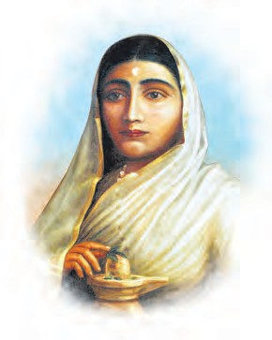
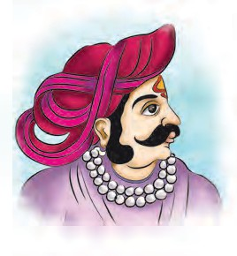
Maratha supremacy in Malwa and Rajputana. He proved to be of great help to Peshwa Madhavrao in reviving the Maratha prestige in the North after the defeat at Panipat. Punyashloka Ahilyabai Holkar was the
wife of Khanderao, who was
Malharrao’s son. Khanderao died in
was given the jagir of Varhad and
Gondawan during the reign of Shahu Maharaj. Among the Bhosales of Nagpur, Raghuji was the bravest and the most capable. He brought the area surrounding

the battle of
Raghuji Bhosale
Tirucherapalli and

Kumbheri. After a few days,
Malharrao also passed away. After him, Ahilyabai assumed the reins

Ahilyabai Holkar
Arcot in the South under Maratha dominance. Shahu Maharaj had assigned to him the chauthai rights of Bengal, Bihar and Odisha. He brought these territories under the Maratha dominance. In 1751 CE the Bhosales of Nagpur won


the Odisha territory from Ali Vardi Khan. Till 1803 CE Marathas dominated Odisha.

Do you know ?
The Maratha ditch – The British at Kolkata used to fear the Bhosales from Nagpur. So, to protect the city of Kolkata from a possible Maratha attack, they dug a ditch around the city. That ditch came to be known as the Maratha ditch.

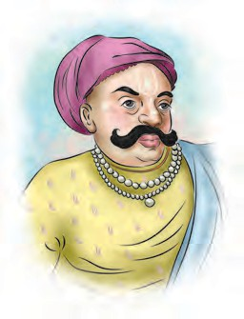
The Shindes of Gwalior : Bajirao I
had rightly judged the capabilities of Ranoji Shinde and made him a Sardar in the North. After Ranoji’s death, his sons Jayappa, Dattaji and
Mahadji, too, proved their valour
politics at Delhi, when they felt that the Marathas might have become weak after the battle of Panipat. They managed to get Diwani rights of Bengal province and wanted to capture the Emperor of Delhi. In these adverse circumstances, Mahadji Shinde defeated the British and reinstated the Emperor on the throne. The emperor was pleased with his bravery and conferred the title of ‘Vakil – i – Mutlak (Chief agent of the emperor) upon him, which meant that he had the authority of civil and military rights. He accepted that position on behalf of the minor Peshwa Savai Madhavrao. Due to this, the Marathas gained full control of the Empire. It was very difficult to save the tottering empire. Mahadji managed the difficult affairs with strong determination and looked after the Delhi affairs during 1784 CE to 1794 CE.
The heirs of Najib Khan, responsible for the Panipat battle, were still plotting against the Marathas in Rohilkhand. Najib’s grandson Ghulam Kadir captured the Red Fort and tortured the Emperor and his begums for their wealth. He gouged

Mahadaji Shinde
and strengthened
out the Emperor’s eyes and took hold of

the Maratha rule in North India.
Peshwa Madhavrao conferred the family title on Mahadji. Mahadji was a brave General and an astute statesman. Mahadji was instrumental in re-establishing the Maratha supremacy and prestige in North India after the Maratha defeat at Panipat. He realised that the guerilla tactics of the Marathas would not be suitable for the warfare in the plains of the North. He trained his army and modernised his artillery under the guidance of a French military expert de Boigne. With the help of this trained army, he subdued the Rohillas, the Jats, the Rajputs and the Bundellas.
The British began to take interest in the
the royal treasure. In these circumstances, Mahadji defeated Kadir. He confiscated the wealth from him and returned it to the emperor. He reinstated the Emperor on the throne of Delhi. Thus, Mahadji recovered the Maratha prestige which was lost after the battle of Panipat. He controlled the politics of India by putting the Emperor under Maratha control.
Due to the family feuds amongst the Peshwas, Raghunathrao opted to go to the British camp. He wanted to become a Peshwa with the help of the British. It was not acceptable to the Maratha Statesmen. This led to an inevitable conflict between the Marathas and the British. The conflict between the two great powers. The

Marathas and the British would finally decide who the ruler of India would be.
From Mumbai, the British marched on the Marathas via Borghat. The Maratha army gathered under the leadership of Mahadaji Shinde. The Marathas blocked the supply of foodgrains to the British, using guerrilla tactics. Both the armies met at Wadgaon (on today’s Pune-Mumbai Road). The British were defeated in this battle and were forced to surrender the custody of Raghunathrao to the Marathas.
Delhi was under Maratha control till 1803 CE. When we note that the British conquered India after battling with the Marathas, we understand the importance of Mahadaji’s achievements. After setting in order, the affairs of Delhi, Mahadaji came to Pune. He died at Wanawadi near Pune where a memorial is built to him.
Like the Shindes, the Holkars and the Bhosales, some other prominent Maratha Sardars also rendered noteworthy service to the Maratha Raj.
Khanderao Dabhade and his son Trimbakrao laid the foundation of Maratha power in Gujarat. After the death of Khanderao, his wife Umabai routed the Mughal Sardar of Ahmadabad. She conquered the fort there.
Later, the Gaikwads made Vadodara in Gujarat a seat of their power. The Pawars of Dhar and Dewas in Madhya Pradesh rendered valuable assistance to the Shindes and the Holkars in expanding the Maratha power in the North.
The Maratha State was in disarray after the death of Peshwa Madhavrao. Nana Phadanvis, the famous administrator of the Peshwas and a Maratha statesman,
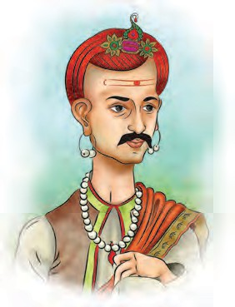
set right the affairs of the State with the help of
Mahadaji. While Mahadaji was busy restoring
the Maratha supremacy in the North, Nana managed the affairs of the

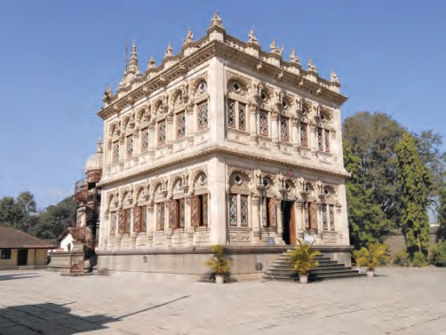
Nana Phadnavis
South. In this,

Shinde Chhatri, Wanawadi, Pune
The navy raised by Shivaji Maharaj was strengthened by Kanhoji Angre and his son Tulaji. With this strong navy, they contained the naval powers of the Portuguese, the British and the Siddhis. They defended the coastline of the Maratha State.
he was helped by the Patwardhans, Haripant Phadke, the Rastes and other Sardars. As a result of this, Maratha supremacy was established in the South.
The Holkars of Indore, Bhosales of Nagpur, Shindes of Gwalior, Gaikwads of Vadodara brought glory to the Maratha power on the basis of their valour, leadership qualities and capability. They were the pillars of the Maratha power in its last phase.
The Maratha Sardars were successful in establishing the influence of the Maratha power both in North and South India. After the death of Mahadaji Shinde

and Nana Phadanavis, the Maratha power began to wane.
At that time, Bajirao II, the son of Raghunathrao was the Peshwa. He did not have leadership qualities and had many vices. He was unable to unite the Maratha Sardars. The internal strife between the Sardars weakened their power.
During the reign of Bajirao II, the Maratha influence in the North and South waned further. The British replaced the Marathas.
The British captured Pune in 1817 CE


and hoisted their flag ‘Union Jack’ there.
In 1818 CE the British defeated Marathas in the battle of Ashti in Solapur district and finally the Maratha power came to an end. This event marks a major change in the History of India. After this, the British managed to gain control over a major part of India. India came into contact with the Western world. That led to many changes in India’s social system. Many old things became redundant or were pushed aside. This was a major transformation. A major change took place. The medieval period of Indian history came to an end. The Modern period began.

Exercise

- Answer in one word.
  - She took the charge of the Indore administration.
  - The most capable and brave man in Bhosale family of Nagpur.
  - He reinstated the Emperor on the throne of Delhi.
  - He managed the politics in South.
- Arrange chronologically.
  - The battle of Ashti.
  - Maratha dominance over Odisha.
  - The British flew the Union Jack in Pune.

- Write briefly.
  - The work done by Ahilyabai Holkar.
  - The valour shown by Mahadji Shinde.
  - The Maratha rule in Gujarat.
- Discuss the reasons behind the end of Maratha rule.
Activity
Create a pictorial chart to show the families that contributed to the expansion of the Maratha power. Exhibit it in your school.

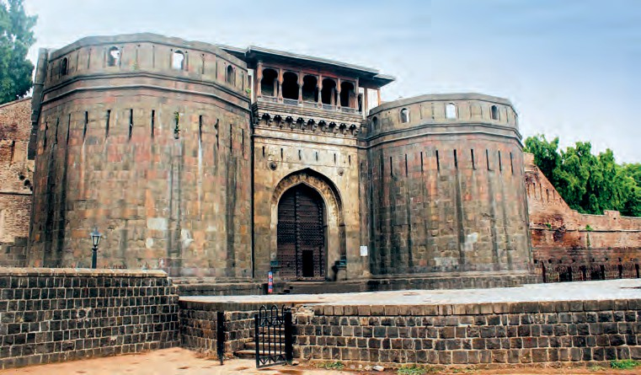
Shaniwarwada, Pune

13. Life of the People in Maharashtra

The Hindawi Swaraj formed by Chhatrapati Shivaji Maharaj was a State for the people, founded with the noble intention of the welfare of common people, removal of oppression and the protection of Maharashtra Dharma. In the period after Shivaji Maharaj, Maratha power spread to all parts of India. It lasted for about 150 years.
We gathered information about the Maratha administration in the last few chapters. In this chapter, we shall study the social conditions and life of the people in that period.

Social conditions : Agriculture and occupations based on agriculture were the major sources of production at the village level. The Patil was responsible for the protection of the village and the Kulkarni handled the revenue. The Patil received land as inam for his work as a Patil. He also received a part of the village revenue. The balutedars were paid in kind (in the form of objects, foodgrains, etc.) for the work they did for the village people. The village occupations were divided into kali and pandhari. Peasants worked in their fields in the kali (land, earth or soil) and others, in pandhari - within the village precincts. It was considered important to conduct the affairs of the village with mutual understanding. Joint family system was prevalent.

There were twelve balutedars such as the blacksmith, carpenter, potter, goldsmith, etc. in a village. They worked for the village people.
Do you know ?
Customs and traditions : Child marriages were prevalent. It was acceptable to have many wives. There are a few examples of widow marriages in this period. To perform the last rites, burning, burial and immersion methods were used as per tradition. Muhurta, or auspicious occasions were sought for every little thing, and also to open battles. People believed in dreams and omens. ‘Anushthans’ were performed to avoid the wrath of gods and planets. Charitable deeds were also done for the same purpose. People believed in astrology. There was a general lack of a scientific attitude and offerings to god (navas) were considered more important than medical treatment.
Standard of living : A majority of people lived in villages. The villages were mostly self-sufficient. Only salt had to be imported from other places. The needs of farmers were limited. They grew jowar, bajra, wheat, ragi (nachani), maize, rice and other grains in their fields. The daily diet consisted of bhakari, onion, chutney and an accompaniment. Barter system was used for everyday transactions. Village houses were simple mud and brick constructions. Wadas with one or two storeys were seen in cities. Rice, dal, chapatis, vegetables, salads, milk and dahi products were mainly included in the rich people’s diet. Men wore a dhoti, kurta, angarakha and mundase. Women wore nine-yard sarees and blouses.
Festivals : People celebrated Gudhi Padwa, Nagpanchmi, Bail-pola, Dasara, Diwali, Makarsankrant, Holi, Eid and other festivals. In the Peshwa period, Ganeshotsava was celebrated in many homes. The Peshwa himself being a

57

devotee of Ganesha, these celebrations acquired importance. Every year these celebrations lasted from Bhadrapad Chaturthi up to Anant Chaturdashi.
Dasara being considered as one of the three and a half most auspicious occasions, many new things were started on this day. Weapons were offered puja, and it was customary to cross the boundaries ceremoniously (seemollanghana) and distribute ‘apta’ leaves on Dasara. The Marathas launched their campaigns after Dasara. During Diwali, Balipratipada and Bhau-beej celebrations had special importance. In most of the villages, fairs were held. Wrestling bouts were a common feature of the fairs, (jatras). Gudhis were raised to celebrate Gudhi Padwa. Celebrations included entertainment programmes like songs and dances. Tamasha was a popular form of entertainment.

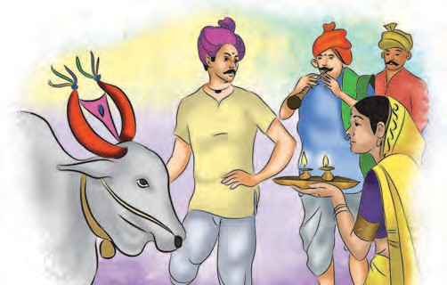
Bailpola
Education : Pathshalas and madarasas were the institutes that imparted education. Reading, writing and arithmetic was taught at home. The modi script was used in most transactions.
Travels and communication : Transport was carried out by roads, through ghats and across bridges on rivers. Cloth, foodgrains, groceries were transported by loading them on the backs of bullocks. Small boats were used in rivers. Messengers and camel riders carried letters to and fro.

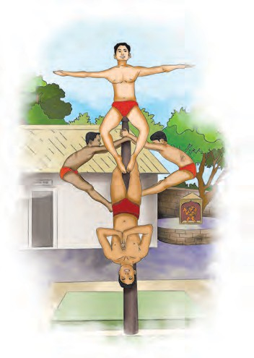
Sports : Various sports were popular in this period. They were a means of entertainment. Wrestling and martial arts were very popular. Mallakhamb, dand, lathi, dandpatta, bothati were practised. Hututu, kho-kho, atyapatya were the popular outdoor games and chess, ganjifa, dice were popular indoor games.
Mallakhamb
Religion and conduct : The two major religions seen in this period were Hindu and Muslim. Chhatrapati Shivaji Maharaj had a liberal religious policy. The general understanding was that everyone should follow their own religion and should not impose it on others. The government gave grants to pathshalas, temples, madarasas and mosques. Followers of both religions took part in the celebration of each other’s festivals. Varkari, Mahanubhav, Datta, Nath and Ramdasi panths were prevalent.
Women’s life : Women’s life in those days was full of hardships. Their world was confined to the house of first their father, and then their husband. Their education was neglected. Only a few exceptional women had achieved any progress in literacy, administration and battle skills. They include Veermata Jijabai, Maharani Yesubai, Maharani Tarabai,

58

Umabai Dabhade, Gopikabai, Punyashlok Ahilyabai. Customs like child marriage, unequal marriage, widowhood, keshwapan, sati, polygamy had imposed harsh restrictions on the way women lived.
The period from 1630 CE to 1810 CE is broadly defined as Maratheshahi. Let us review the art and architecture of this period in brief.
Sculpture : We find references to restoration of Kasba Ganapati Mandir, building of the Lal Mahal, construction on Rajgad and Raigad, building of sea forts, etc. that are related to architecture. Hiroji Indulkar was a famous architect of that period.
While setting up a village, the usual pattern was : roads cutting one another at right angles, stone construction along the sides and extensive ghats (steps) along the river bank. During the Peshwa period, a drinking water supply system was built like the one at Ahmadnagar and Bijapur. The Peshwas built underground pipes, small dams, gardens and courts, tanks, fountains, etc. The Mastani Talav at Diveghat, Hadapsar near Pune city is worth a mention in this regard.
Shaniwarwada and Vishrambagwada in Pune, Sarkarwada in Nashik, Raghunathrao Peshwa’s wada at Kopargaon, the wadas of the Satara Chhatrapati, as also the old wadas at Wai, Menvali, Toke, Shrigonde, Pandharpur are symbols of the medieval wada culture.
Baked as well as unbaked bricks were used to build the wadas. Wooden columns, rafts, boards, dressed stones, arches, finely prepared lime, round tiles for the roof, mud and bamboo were all used in the construction. The wadas were decorated with sketches, paintings, wooden sculptures and mirrors.
Temples : The temples of this period are build in the Hemadpanti style of the
Yadav period. The shikhar of the Ambabai temple at Kolhapur, the temples on the Jotiba hill, Shambhu Mahadev temple at Shikhar-Shinganapur, Ghrishneshwar temple at Verul are excellent specimens of sculpture. The Bhavanidevi temple on Pratapgad and the Saptkoteshwar temple at Goa were built by Shivaji Maharaj. Other temples of the Peshwa period are
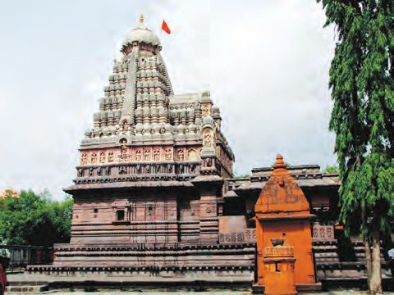
Ghrishneshwar Temple
the Kalaram temple at Nashik, the Shiva temple at Trimbakeshwar, the Shiva temples at Kaygaon and Toke on the confluence of the Godavari and Pravara, and the Mohiniraj temple at Newase.
Ghat : Stone ghats built on a river or at the confluence of rivers are characteristic of Maratheshahi. The most remarkable specimen of a ghat is the one at Toke, Pravara Sangam on the confluence of the Godavari and Pravara. In a flight of steps, there would be one wide step at regular intervals. This would lend beauty to the entire ghat construction. Strong bastions were built at regular intervals so as to prevent damage due to water currents.
Painting : The paintings on the walls of Shaniwarwada are the important ones of the Peshwa period. Ragho, Tanaji, Anuprao, Shivram, Mankoji are some of the important painters of this period. The painter Gangaram Tambat was famous at the time of Sawai Madhavrao Peshwa.

The Peshwas encouraged painting. Wadas in the Pune, Satara, Menvali, Nashik, Chandwad and Nipani regions during the Peshwa period had paintings on their walls. Temples at Pandeshwar, Morgaon, Pal, Benwadi, Pashan near Pune have paintings on the walls. The themes of those paintings were Dashavatara, Ganapati, Shankar, Rampanchayatana, mythological stories, Ramayana, Mahabharata, festivals and so on. At Jamod in Vidarbha, Jin Charitra paintings adorned the Jain temple. Illustrations in the pothis, minatures, portraits, scenes, etc. were also painted.


Sculpture : Important specimens include the sculpture of the meeting between Mallamma Desai and Shivaji Maharaj at the time of his Karnataka campaign, the sculpture at Bhuleshwar temple including sculptures of individuals and animals (e.g., elephant, peacock, monkey), the sculptures on the Toke temple and the idols within, the Trishund Ganapati temple in Pune, the memorial to Punyashlok Ahilyabai in
Madhya Pradesh, the sculptures at the Mohiniraj temple at Newase.
Metal idols : The Peshwas had specially commissioned the metal idols of Parvati and Ganapati in the Parvati temple for the purpose of Puja. Wooden sculptures were also seen.
Literature : Important forms of literature include the compositions of the Sants, mythological narratives, ‘teeka’ literature, owi, abhanga, treatises, narrative poems, biographies, aaratis of deities, powadas, bakhars, historical letters, etc.
Drama : At Tanjavur in the South, Marathi plays has emerged near the end of the seventeenth century. Sarfoji Raje encouraged this art. Songs, music and dance were prominent parts of these plays. So far we reviewed the medieval period of history and the rise and expansion of the Maratha power. Next
year, we shall study the modern period.

Exercise

- Complete the chart.
Sr.  No. | Point | At the time of Shivaji Maharaj | Today
1. | Transactions | ................ | ...............
2. | Houses | ................ | Permanent, well  - constructed cement-concrete multi-storeyed houses
3. | Transportation | ................ | Bus, railway, aeroplanes
4. | Entertainment | ................ | ...............
5. | Script | ................ | ...............

Write the name
One who protects the town
One who works in the fields
One who holds the vatan
One who manages the revenue of
the town

- Which undesirable customs are prevalent in today’s society ? Suggest measures for their eradication.
- Make a detailed note about the festivals celebrated in your area.
- Use the following points to compare life in the era of Shivaji Maharaj and today’s life.

Activity
Gather information about the capable women of our country and read it aloud in your class, e.g. information on P.V. Sindhu, Sakshi Malik.


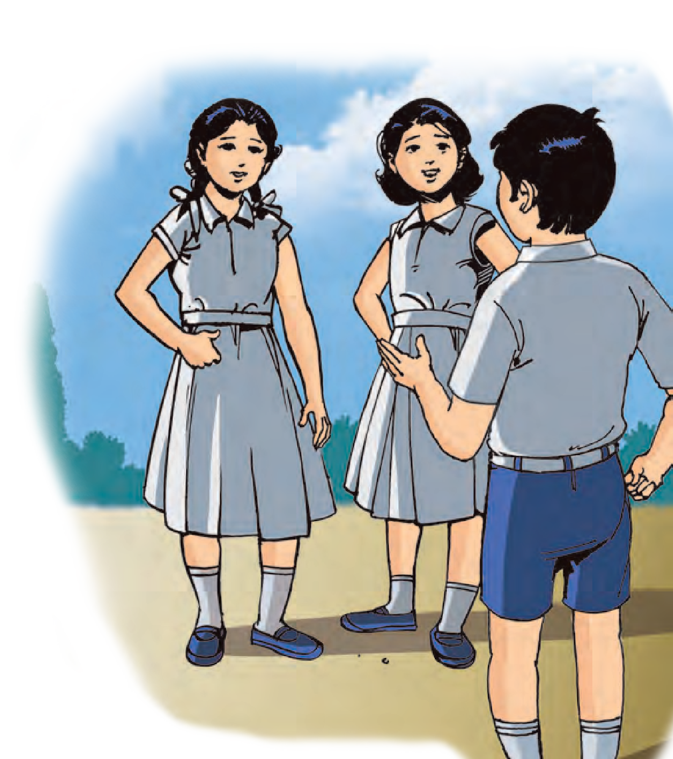



CIVICS
- Contents -
Our Constitution

Page No.
No. Chapter

- Introduction to our Constitution ................
- Preamble to the Constitution .....................
- Features of the Constitution ......................

63
68
72

76
Fundamental Rights – Part I .....................
Fundamental Rights – Part II ....................
Directive Principles of .............................. State Policy and Fundamental Duties
4.
5.
6.
80
83

English Civics : Standard Seven - Learning Outcomes

Suggested Pedagogical Processes | Learning Outcomes
The learner be provided opportunities in pairs/groups/ individually and encouraged to:  - participate in a discussion based on the concepts like democracy, equality, The State Government, gender, media and advertising.  - prepare posters with the help of drawings; pictures on the significance of the Constitution, the Preamble, right to equality and struggle for equality.  - collect the information about the Constitution.  - discussion about the Fundamental Rights.  - perform a role play or presentation with songs and poems about issues such as equality in democracy, discrimination faced by girls etc.  - discuss about guiding principles and Fundamental Duties regarding similarities and differences. | The learner-  07.73H.13 explains the significance of equality in democracy.  07.73H.14 distinguishes between political equality, economic equality, and social equality.  07.73H.15 interprets social, political and economic issues in one’s own region with reference to the right to equality.  07.73H.16 differentiates between local government and State Government.  07.73H.17 describes the characteristics of democratic governance.  07.73H.18 understands that the rights mentioned in the Constitution have special protection by the courts.  07.73H.19 understands that everyone is equal before law.  07.73H.20 understands that the guiding principles are not guarded by the judiciary system, yet they are obligatory on the Government.  07.73H.21 explains Fundamental Rights and Duties with the help of suitable examples.  07.73H.22 understands that knowledge about Fundamental Rights can be used in reality for infringement of rights, protection of rights and nurturing the rights.

1. Introduction to our Constitution

Let’s revise a few things !
In the Civics textbooks of the previous classes, we saw many reasons why rules are necessary in our lives. We follow norms and rules in order that the activities in the family, our school, our village or city are carried out smoothly. There are no rules in a family. However, there are norms about the behavior of members in a family. There are rules in a school regarding admission, uniform and studies. Different competitions also have their own rules. The administration of our village or city is also carried out in accordance with rules. Similarly, the administration of our country is carried out through a system of rules. The rules regarding family, school, village or city are limited in nature. But the rules or provisions about the administration of a country are much wider in scope.
Do you wish to ask the questions that puzzled Sameer and Vandana ?
- Where can we find all the rules according to which the administration of the country is carried out ?
- Who makes those rules ?
- Is it binding on us to follow them ?
See whether you find the answers to these questions in the following text.

The Meaning of Constitution
The book in which all the provisions regarding the administration of a the country are mentioned together in a systematic way is called a Constitution. This makes the Constitution a written document of the provisions related to the administration of the country. Government is established by the representatives
elected by the people. It is bound to carry out the administration of the country as per the provisions of the Constitution. The rules and provisions in the Constitution are the basic or fundamental law of the land. While making laws, the government is bound to follow the Constitution. If it does not do so, then the Judiciary can declare those laws null and void or unconstitutional.

Provisions in the Constitution
The provisions in the Constitution are about different things, e.g., citizenship, the rights of citizens, the relationship between citizens and the State, subjects of the laws to be made by the governments, elections, restrictions on government, jurisdiction of the State, etc.

Almost all countries have accepted the principle of governance according to a Constitution. Yet the nature of the Constitutions of different countries is different. There are differences of history, social structures, culture, traditions, etc. between the countries. Similarly, their needs and objectives also might be different. Each country tries to create a Constitution that is not only suited to its needs and objectives, but also is in tune with its distinct nature.

Let’s find out.
Find out some information about the Constitution of any one country of your choice with the help of the following points :
- Name of the country.
- Year of the making of the Constitution.
- Two features of the Constitution.


The administration of countries like America (USA) and England (UK) is carried out as per their respective Constitutions. But these two Constitutions are different.
The American Constitution came into force in 1789. It is a written Constitution and has only 7 articles. Even after 225 years, the American
government Constitution.
follows
the
same
England has a long history of several centuries. The rules of running the country here are found in the form of conventions, norms and traditions. Yet they are followed meticulously. The Magna Carta of 1215 marks the beginning of the development of the English Constitution. Even though there are certain written rules, the English Constitution is considered to be primarily unwritten.
Do you know ?
Necessity of a Constitution : There are several advantages of governing a country with the help of rules or provisions included in a Constitution.
- Government has to function within a set of rules. This reduces the possibility of the misuse of the power and authority they have been given.
- A Constitution includes the rights and freedoms of the citizens. Government cannot take away these rights. Therefore, people’s rights and freedoms are safeguarded.
- Running a country as per the provisions of the Constitution is the same as establishing the rule of law. Then there is no scope for the misuse of power, or high-handed administration.
- If a country is run as per the Constitution, the faith that the common people have in the government increases. They then become keen on
participating in the activities of the government. Democracy is strengthened due to the increased participation of the people.
- Constitution presents some political ideals before the country. The nation is also bound to act in that direction. It creates an atmosphere conducive to attain world peace and security and preservation of human rights.
- Since the constitution also includes the list of citizens’ duties, it fixes the responsibility of the citizens as well.

What is administration ?
What is included in the administration of a country ?
Government has to make laws relating to several subjects, such as defending the boundaries, protecting the people from external aggression, eradication of poverty, creating employment, education and health services, encouragement to commerce and industries, protection of the weaker sections, making policies for the progress of women, children and the tribal people, etc. Government has to bring about desirable changes in the society by implementing laws. In short, governments in modern times have to take decisions related to different issues right from space research to public cleanliness. This is governance or administration.
Having understood the meaning of Constitution and governance, we shall now see how the Indian Constitution was made.
Background to the making of the Constitution : The process of the making of the Indian Constitution started in 1946. The leaders of the freedom movement insisted that Independent India will be governed not by the laws made by the British, but by laws made by Indians themselves. A Committee was established to prepare the Constitution of Independent

India. It came to be known as the Constituent Assembly.
Constituent Assembly : India became independent on August 15, 1947. Before that, the British ruled over India. They had divided India into provinces like Bombay, Bengal and Madras for the convenience of administration. The administration in these provinces was carried out by peoples’ representatives. Similarly, the local princes were carrying out the administration in some areas.
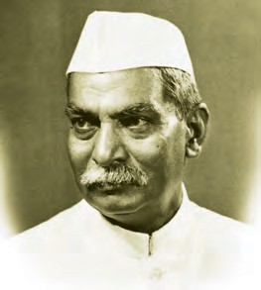
Such areas were known as princely states and their chiefs were known as princes. The representatives of the provinces and the princely states were included in
We are proud of it : Decisions in the Constituent Assembly were made on the basis of debate and discussion. A respect for opposing viewpoints and acceptance appropriate suggestions was
characteristic of the working the Constituent Assembly.
of a of
It took 2 years, 11 months and 17 days to complete the writing of the Constitution.
There were 22 parts, 395 articles and 8 schedules in the original Constitution.
It was discussed Article by Article. Many amendments were suggested by different members. Dr Babasaheb Ambedkar handled the task of presenting the draft, answering the various questions raised on it, making changes in the draft as per the suggestions of the Constituent Assembly and making every provision of the Constitution flawless. Due to his contribution towards the making of the Constitution, Dr Babasaheb Ambedkar is called the ‘Architect of the Indian Constitution.’

Dr Rajendra Prasad
Assembly.
the Constituent

There were a total of 299 members in the Constituent Assembly. Dr Rajendra Prasad was the President of the Constituent Assembly.

The contribution of Dr Babasaheb Ambedkar :

Dr Babasaheb Ambedkar was the Chairman of the Drafting Committee. He

Some of the well-known members of the Constituent Assembly were Dr Rajendra Prasad, Pandit Jawaharlal Nehru, Dr Babasaheb Ambedkar, Sardar Vallabhbhai Patel, Maulana Abul Kalam Azad, Sarojini Naidu, J. B. Kripalani, Rajkumari Amrit Kaur, Durgabai Deshmukh, Hansaben Mehta, and others. The noted legal expert, B. N. Rau was appointed as the Constitutional Adviser on legal matters.
Do you know ?
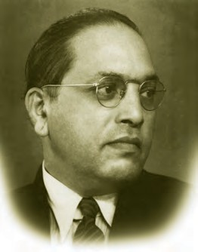
had studied in depth, the
Constitutions of different countries of the world. He studied and contemplated day and night to draft our Constitution.
The draft

Dr Babasaheb Ambedkar
Constitution prepared by him

was presented to the Constituent Assembly.

The Constituent Assembly enacted the Constitution and adopted it on 26th November 1949. Therefore, 26th November is observed as ‘Constitution Day.’
The country began to be governed
according to the provisions of the Constitution from 26th January 1950. The Indian Republic came into existence from this day. Therefore, 26th January is celebrated as ‘Republic Day.’

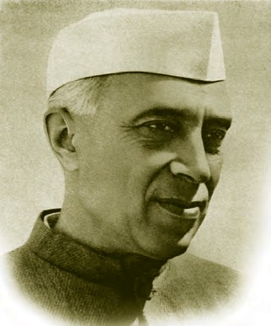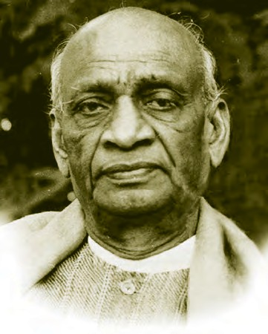
Pandit Jawaharlal Nehru Sardar Vallabhbhai Patel

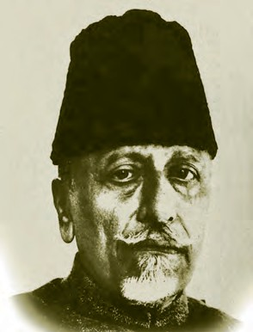
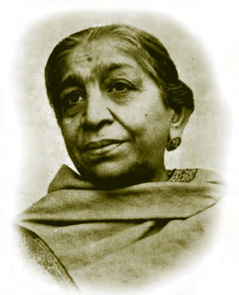

Maulana Azad
Sarojini Naidu



You would like your class to run according to rules, wouldn’t you ? Which rules would you like to include in your list of rules ? Prepare a list of rules for your class.
Do this.
Dr
Babasaheb
Ambedkar’s
contribution was in a wide range of fields like water conservation, foreign policy, national security, journalism, economics, social justice, etc.
Do you know ?

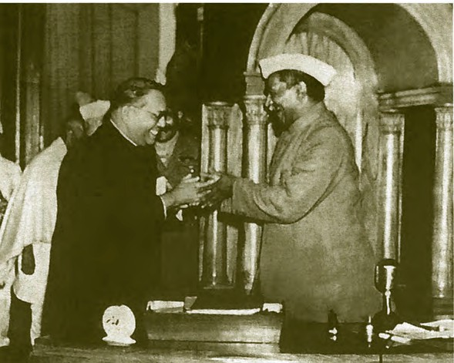


- Explain the following concepts :

Dr Babasaheb Ambedkar presenting the draft of the Indian Constitution to Dr Rajendra Prasad, President of the Constituent Assembly

Exercise
  - Provisions of the Constitution
  - Constitution Day
- Discuss.
  - A Constituent Assembly was established.
  - Dr Babasaheb Ambedkar is called the ‘Architect of the Indian Constitution’.
  - What is included in the administration of a country ?
- Choose the right option.
  - The Constitution of this country is primarily unwritten.
    - America (b) India
(c) England (d) None of the above
  - Who was the President of the Constituent Assembly?
    - Dr Babasaheb Ambedkar
    - Dr Rajendra Prasad
    - Durgabai Deshmukh
    - B. N. Rau
  - Who among these was not a member of the Constituent Assembly ?
    - Mahatma Gandhi
    - Maulana Azad
    - Rajkumari Amrit Kaur
    - Hansaben Mehta
  - Who was the Chairman of the Drafting Committee ?
    - Dr Rajendra Prasad
    - Sardar Vallabhbhai Patel
    - Dr Babasaheb Ambedkar
    - J. B. Kripalani
- Answer the following questions.
  - On what subjects does the Government have to make laws ?
  - Why do we celebrate 26th January as Republic Day ?
  - What are the advantages of running a country as per the provisions of the Constitution ?
Activities
- Several committees were established for the effective functioning of the Constituent Assembly. Find out more information about them and discuss the role of different committees.
- Prepare a report on how you celebrated Constitution Day in your school.
- Make a collection of the photos of the members of the Constituent Assembly.

2. Preamble to the Constitution

We learnt this in the previous chapter:
The Constitution is an important document clarifying the rules of administration.
The Constituent Assembly made the Constitution of India.
Our representatives have to carry out the administration as per the law laid down by the Constitution.
Our Constitution is the fundamental and the highest law of the land. There are definite aims or purposes in making any law. Basic provisions in the law are made after clarifying these objectives. A systematic arrangement of all the aims and objectives of a law is the Preface to the law. The Preface to the Indian Constitution is called the ‘Preamble’. The Preamble sets out the objectives of our Constitution.


Read the Preamble to our Constitution. Make a list of the important words in it. Where else do you come across these words ?
Do this.
We all are Indian citizens. The Preamble tells us what we all have to achieve as a people. The values, thoughts and ideas in it are noble. The entire Constitution lays down the provisions through which these goals are to be realised.
The Preamble begins with the words, ‘We, the people of India’. It talks about the resolve of the Indians to constitute
India into a ‘Sovereign, Socialist, Secular, Democratic Republic’. We shall now understand the meaning of each of these terms.
- Sovereign State : India was ruled by Britain for a long period. The British rule ended on 15th August 1947. Our country became independent. India became sovereign. We are now free to take decisions as we think fit in our own country. The word sovereign means that a State is not under the control of a foreign power.
The most important goal of our freedom struggle was to acquire sovereignty. Sovereignty means the ultimate authority to govern yourself. In a democracy, sovereignty rests with the people. The people elect their representatives and grant them the permission to exercise sovereign authority on their behalf. Thus the Constitution reflects the principle of popular sovereignty and the government elected by the people makes laws on behalf of the people.
- Socialist State : A Socialist State is such a State where the gap between the rich and the poor is minimum. All have a right over the wealth of the country. It is ensured that wealth is not concentrated in the hands of a few people.
- Secular State : The Preamble states secularism as one of our goals. In a secular State, all religions are considered as equal.
No one religion is considered to be the State religion. The citizens are free to follow their own religion. State cannot discriminate among citizens on the basis of religion.



We have endeavoured to preserve the multi-religious nature of our society. We cannot exercise the rights given to us by our Constitution, in an unrestrained manner. The same is true of religious freedom as well. Whenever we celebrate our festivals, we are required to be concerned about public cleanliness, health and the environment.
Do you know ?

- Democratic State : In a democracy, the sovereign power is in the hands of the people. Government makes decisions and draws up policies in keeping with the people’s wishes. Government has to take important financial, social and other decisions to promote common welfare. All the people are not able to come together and take such decisions on a day-to-day basis. Therefore, elections are conducted after a fixed period when voters elect their representatives. These representatives sit in the institutions created by the Constitution like the Parliament or Legislature and the Executive. They take decisions for the entire population as per the procedure laid down by the Constitution.
- Republic : Along with being a democracy, we are a Republic. All public positions in a Republic are elected by the people. No public position is occupied on the basis of hereditary succession.
The positions like the President, the Prime Minister, the Governor, the Chief Minister, the Mayor, the Sarpanch, etc. are public positions. Any Indian citizen fulfilling the prescribed age criterion can get himself/herself elected to any of these positions. In a monarchy, these positions may be occupied by members of a single family following the principle of heredity.

The Preamble has guaranteed the Indian citizens the three values of Justice, Liberty and Equality. It has enjoined upon the Indian citizens to practise these values and make laws in keeping with these values. Let us understand these values :
Discuss.
Read what Deepa has written on the topic : ‘My Family’.
Democracy does not only imply elections. My parents do all household work together. We also participate in it. We ensure that we talk cordially with each other. Even if we happen to fight, we try to listen to each other’s views by stopping the fight as soon as possible. If any change has to be made, even the grandparents are consulted. Anuja wants to take up agricultural research as her career. Her decision was appreciated by everybody.
Do you think that Deepa’s house functions in a democratic way ? Which features of democracy can be found in this passage ?
- Justice : Justice implies removal of injustice and ensuring that everybody has the opportunity for progress. Establishing justice is adopting such policies that will promote public good. Three types of justice are talked of in the Preamble. They are as follows:
  - Social Justice : There should be no discrimination among individuals on the basis of caste, creed, race, language, region, place of birth or sex. As human beings, all have the right to the same dignity and respect, the same status.
  - Economic Justice : Poverty leads to the evils of hunger, hunger-deaths or malnourishment. If poverty is to be eradicated, everyone should have the right to a source of livelihood so as to look after oneself and one’s family. Our

69

Constitution has given this right to every citizen without any discrimination.
  - Political Justice : We have adopted universal adult franchise to enable equal participation in the running of the country. Accordingly, all citizens completing 18 years of age have the right to vote in elections.
- Liberty : Liberty implies that there should be no coercive, unfair restrictions upon us and that there should be an atmosphere conducive to the development of our inherent capacities. In a democracy, citizens enjoy libery. In fact, democracy becomes mature only if citizens enjoy freedom.
Freedom of thought and expression is the most fundamental freedom for an individual. Everyone is free to express their own views and opinions. A give and take of ideas enhances the spirit of cooperation and unity amongst us. Similarly, it also enables us to understand the various dimensions of any problem.
The liberty of belief, faith and worship implies religious freedom. Every Indian citizen is free to act as per the teachings of their religion or the religion of their choice. It implies the freedom of celebrating the festivals and the freedom of faith and worship.
- Equality : The Preamble guarantees the Indian citizens an equality of status and of opportunity.
It means that all have equal human status and there will be no discrimination based on caste, creed, race, sex, place of birth, etc. The guarantee of equal status means not to discriminate between people in terms of high-low, superior-inferior. The Preamble has given great importance to equality of opportunity as well. All
will get the opportunities for development without any discrimination.
Discuss.
Some statements regarding freedom have been given below for discussion. Express your views.
While publicly celebrating our festivals, we need to follow some rules. That does not restrict our freedom.
Freedom means behaving in a responsible way, not as per our whims and fancies.
The Preamble to our Constitution refers to a unique ideal or principle. It is the goal of promoting fraternity among the citizens and to assure the dignity of the individual.
Fraternity : The makers of the Constitution believed that merely guaranteeing justice, freedom and equality would not lead to establishing equality in Indian society. No amount of laws would help us achieve these goals if fraternity is lacking among Indians. Hence the promotion of fraternity has been included in the Preamble as a goal. Fraternity implies a ‘we-feeling’ towards one another. It creates a feeling of empathy. People become more understanding towards each others’ problems and needs.
Fraternity is closely related to human dignity. Human dignity implies equal respect to each individual as a human being. It does not depend upon the criteria of caste, creed, race, sex, language, etc. Just as we would like to be treated with dignity and respect by others, we should also treat others with the same dignity and respect.


When every individual respects another and honours their freedom and rights, dignity of the individual will get established. In such an atmosphere, fraternity will grow automatically. The task of bringing about a new society based on the values of justice and equality

Exercise

- Find the following words in the grid.

F | A | Y | Q | A | R | O | K | J | I
R | G | Z | E | L | F | K | M | L | L
A | E | G | P | S | H | M | Y | N | D
T | F | P | R | E | A | M | B | L | E
E | E | A | Z | C | H | I | J | I | M
R | D | O | P | U | J | A | B | K | O
N | I | M | E | L | K | P | S | Q | C
I | H | N | Z | A | R | C | O | T | R
T | C | G | F | R | G | H | G | K | A
Y | B | N | Q | H | I | E | F | J | C
Y | A | A | P | S | L | S | I | F | Y
  - A sense of ‘we-feeling’ and empathy towards fellow citizens
  - A system in which Sovereign power is in the hands of the people
  - Introduction to the Constitution
  - A system in which all religions are considered equal
- Answer the following questions.
- What are the provisions in a secular Constitution?
- What is meant by adult franchise ?
- What right does economic justice ensure ?
- How will human dignity be established in a society?
will be facilitated. The Preamble to the Constitution of India guides us to this very goal.
The Preamble ends with a mention of the fact that the people of India have given the Constitution to themselves.

- How should we make use of our freedom ? Write your views about it.
- Explain the following concepts.
  - Socialist State
  - Equality
  - Sovereign State
  - Equality of opportunity
- Make a list of the key words in the Preamble. Look for their meanings in a dictionary. Prepare a chart in the following way:

Keyword | Pronunciation | Dictionary Meaning
Activities
- Visit your Tehsil office with your teacher to understand how a vote is cast and how the electronic voting
machine works.

- Make a list of newspapers available in your locality.

3. Features of the Constitution

In the last two lessons, we studied how our Constitution was made. We studied its Preamble and understood terms like Sovereign, Socialist, Secular, Democratic, Republic. The goals expressed in the Preamble are the characteristic features of our Constitution as well. Apart from these, the Constitution also has other features. We shall try to understand these in the present chapter.
Federalism : One of the important features of our Constitution is the federal system. In countries with large territories and huge populations, government is run by a federal system. Ruling a large territory from a single capital city is not only difficult, but may also lead to the neglect of some far-flung areas. People residing there cannot participate in the affairs of the Government. Therefore, Governments function at two levels in a federation. The Government at the Centre carries out tasks like defence of the entire country, foreign policy, establishing peace, etc. It is also called ‘Union Government’ or ‘Federal Government’. It carriers out the administration of the entire country.
The Government that oversees the administration of the region that we live in is called State Government. It looks after the administration of a particular State. For example, Government of Maharashtra looks after the administration of the State of Maharashtra.
The system of running the administration of a country cooperatively by the Governments at two levels, making laws about different subjects is called federalism.
Separation of Powers : The Constitution has divided the subjects for making laws between the Union
Government and the State Governments. Let us see which Government is entrusted with what subjects. Our Constitution has given three lists of various subjects.
The first list is called Union List. It contains 97 subjects on which the Union Government makes laws. The State List is for the State Governments to legislate upon. It contains 66 subjects. Apart from these two lists, there is a Concurrent List, which contains 47 subjects. Both Governments can make laws on subjects included in this list. If a subject comes up that is not included in any of the lists, the Union Government is entitled to make laws on it. These powers are termed as Residuary Powers.

The Indian enables
division of powers in the
Constitution
is
unique.
It
the Union Government and
the State Government to bring about the country’s progress by cooperating with each other. This also encourages participation of citizens in the administration of the country.
Do you know ?

Who deals with what subjects -
- Subjects with the Union Government : Defence, foreign relations, war and peace, currency, international trade, etc.
- Subjects with the State Government : Agriculture, law and order, local government, health, prison administration, etc.
- Subjects with both the Governments : Employment, environment, economic and social planning, personal law, education, etc.

72


Union Territories : In India, there is a Union Government, 28 State Governments and 9 Union Territories. The Union Government controls the Union Territories. Following are the nine Union Territories : New Delhi, Daman and Diu, Puducherry, Chandigarh, Dadra and Nagar Haveli, Andaman and Nicobar

Make a list of the north-eastern Indian States. Name their capital cities.
Do this.
Do you know ?
Islands, Jammu and Kashmir, Ladakh and Lakshadweep.

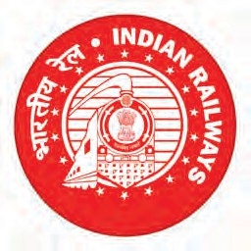
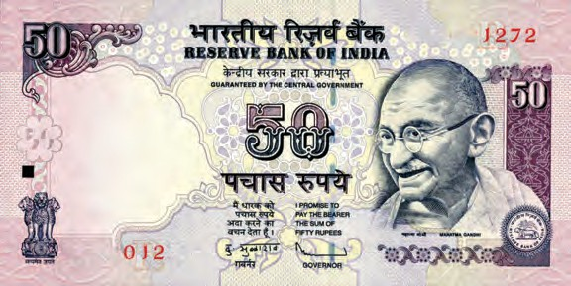
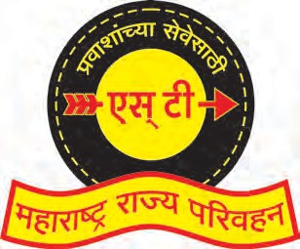

Parliamentary System of Government : The Indian Constitution has provided for a parliamentary system of Government. In such a system, the Parliament, i.e. the Legislature has the highest decision-making power. Indian Parliament includes the President, Lok Sabha or the House of the People and Rajya Sabha or the Council of States. The Council of Ministers that runs the administration emerges from the Lok Sabha and is answerable to the Lok

Currency note

You have surely seen currency notes. The words ‘Guaranteed by the Central Government’ are printed on currency notes.
If you have seen the badge on the uniform of a policeman, it reads ‘Maharashtra Police.’
You must have surely come across the following : ‘Indian Railways’ and
‘Maharashtra State Road Transport Corporation’.
This means that in our country, Government functions at two levels. One is the Central Government, and the other is the State Government e.g., Maharashtra State Government, Karnataka State Government, etc.

Maharashtra Police
Indian Railways
Maharashtra State Road Transport Corporation

Sabha for all its decisions. In Parliamentary Democracy, the discussion and debates that take place in the Parliament have great significance.
Independent Judiciary : The Indian Constitution has created an independent Judiciary. The disputes that cannot be resolved mutually are referred to the Judiciary. The Court hears both the contesting parties, looks into the injustice if any, and gives its judgement. This has to be done impartially.
The Constitution has made several provisions to ensure that the Judiciary
remains more and more independent. For example, Judges are appointed by the President and not by the Government. It is not easy to remove the Judges from their office.
Single Citizenship : The Indian Constitution has granted a single citizenship to all Indians. That is ‘Indian Citizenship.’
Process of Amending the Constitution : There comes up a need to make changes or amendments in the provisions of the Constitution due to changing circumstances. But frequent

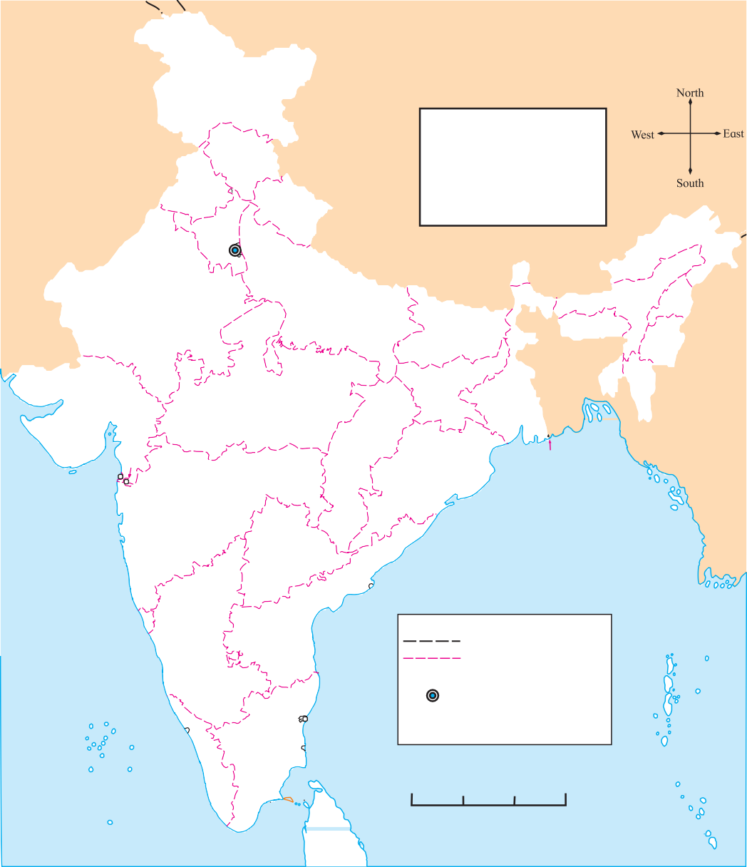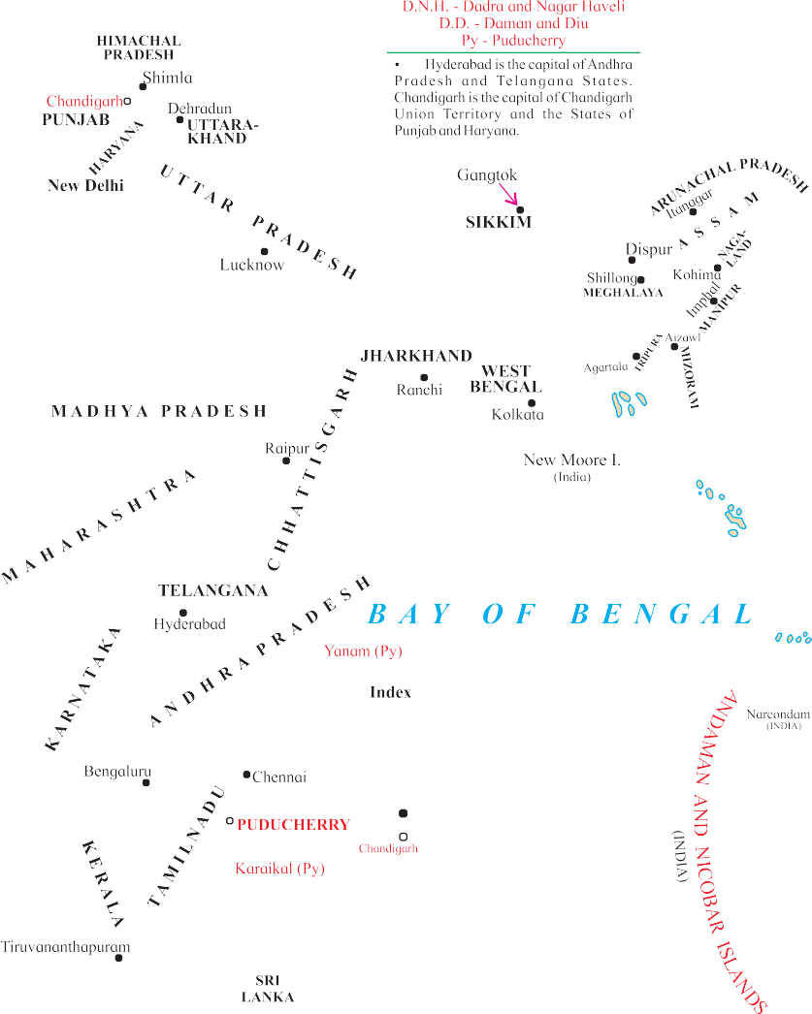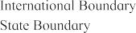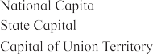

amendments to the Constitution may lead to a situation of instability. The procedure for amendment is specified in the Constitution itself so as to ensure that an amendment is made only after giving it a careful consideration. The procedure for amendment in the Constitution is unique. It is neither too difficult, nor too easy. More scope has been provided for giving more consideration and thought to important amendments. The procedure is also flexible to ensure that general amendments can be brought about easily.



How many amendments have been made to the Indian Constitution till date?
Find out .


Election Commission : You must have read about the Election Commission in the newspapers. Since India has adopted a democratic form of government, people have to elect their representatives periodically. For this, the elections have to be conducted in a free and fair atmosphere. Only then will the citizens be able to elect

Can you tell ?

- Who is the current Chief Election Commissioner ?
- What do you understand by ‘Code of Conduct’ for Elections ?
- What is a Constituency ?
a candidate of their choice without any fear or pressure. If the government were to conduct elections, there might be no guarantee of such free, fair and just atmosphere for the elections. Hence, the Constitution has entrusted the responsibility of conducting elections to an independent machinery. This machinery is known as the Election Commission. The responsibility of conducting all elections in India rests with the Election Commission.
The Indian Constitution has some important characteristic features. In this chapter, we have studied only some of the important features. Another important feature of our Constitution is the exhaustive provision of fundamental rights. We shall study these in the next chapter.

Exercise

- Prepare a table to show the separation
of powers in a Federal Government. (2) What do you understand by Residuary
Powers ?
Union List
(1)
(2)
(3)

State List
(1)
(2)
(3)

Concurrent List
(1)
(2)
(3)

- Why has the Constitution created an independent Judiciary for India ?
  - Hold a group discussion on the merits and demerits of an independent judicial system.

  - Find out about the Electronic Voting

- Find one word for.
  - Machinery for the governance of the entire country -
  - Machinery for conducting elections -
  - The third list of subjects for making laws -
- Answer the following questions.
  - Why does the Government function at two levels in a federation ?
Machine (EVM) and discuss the advantages of conducting elections with the EVM.
Activity
Establish an Election Commission in your class, decide upon the positions you would like to fill through elections. Then conduct elections under the guidance of this Commission.

4. Fundamental Rights - Part I
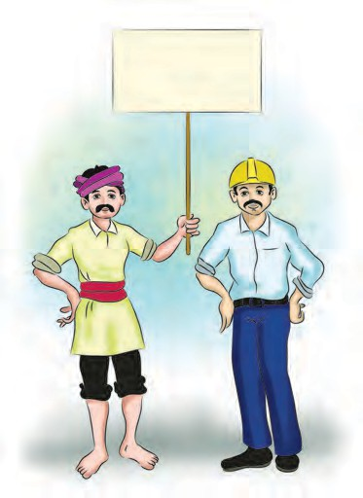
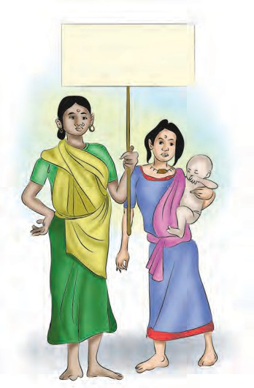
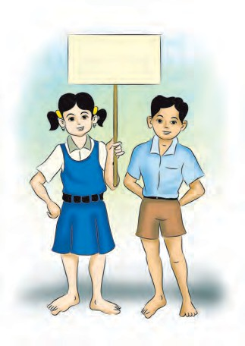
We must get the assurance of a minimum wage. It is our right !
Education is our right.
We have a right over our forests and its resources !


You must have seen such placards in newspapers and elsewhere. In a rally or a march, sometimes a certain demand is made, asserting it to be their right.
Let’s find out.
You must be aware of children’s rights. Can you name two important rights of children ?
We are aware of terms like women’s rights, rights of tribals, rights of farmers and so on. There emerge some questions regarding these rights:
- What are the uses of rights ?
- Do they have to be given by somebody ?
- Can rights be taken away ?
- If rights are taken away, who should we contact for redressal ?
We get rights at birth. Every newborn baby has a right to live. The entire society and government takes efforts to ensure that the baby is in the best of health. Only when all individuals get protection from injustice, exploitation, discrimination and deprivation, will they be able to develop their skills and qualities. Demanding one’s rights is insisting on creating an atmosphere conducive to the development of the self as well as the entire society. The Indian Constitution has guaranteed equal rights to all citizens in order to create this conducive atmosphere. These rights are fundamental rights. As

they are included in the Constitution, they have the status of law. It is imperative for everybody to abide by these rights.

Use your imagination and write.
Do you have pet animals like dogs, cats, cows, buffaloes or goats? You surely take good care of them and love them.
If these animals could speak, what rights do you think they would ask from you ?


Our Rights as mentioned in the Constitution :
Do you know ?

The Constitution prevents the State from conferring titles that nurture inequality and draw wedges in social unity. But the State does confer awards like Padmashree, Padmabhushan, Padmavibhushan, etc. for distinguished contribution in different fields. Bharat Ratna is the greatest civilian honour or award of our country.
Medals of honour like Paramveer Chakra, Ashok Chakra, Shaurya Chakra are awarded for remarkable service in the armed forces.
Such awards don’t bestow any special rights or privileges upon those who receive them. It is only a recognition of their contribution.
Let us understand the rights of Indian citizens included in the Constitution.

Right to Equality : According to the right to equality, the State cannot discriminate among citizens as superior- inferior or as men-women and cannot give different treatment or privileges to anybody. The same law applies equally to all. Many laws give us protection. For example, we have protection from arrest without warrant. Also the State cannot discriminate while extending such protection.

What are the advantages of equality before law and equal protection of the laws ?
Let’s discuss.
that was prevalent in our country has been abolished by law. The practice of untouchability in any form is a cognizable offence. This practice has been abolished in order to establish equality in Indian society. The Constitution has also abolished titles that create an artificial hierarchy among people. For example, titles like Raja, Maharaja, Raobahadur, etc. have been abolished.

What other things are included in the right to equality ?
The State cannot discriminate against any citizen on grounds of religion, caste, race, sex, descent or place of birth or residence for government employment. The inhuman practice of untouchability
Right to Liberty : This is a very important right given by the Constitution. It gives a guarantee of all the freedoms necessary from the point of view of the individual. As Indian citizens, we have the right to -
- freedom of speech and expression
- freedom to assemble peaceably
- freedom to form associations or unions
- freedom to move freely throughout the territory of India.

- freedom to reside and settle in any part of the territory of India.
- freedom to practise any lawful profession, or to carry on any occupation, trade or business of one’s choice.



Do this.
Following are the actions of A, B and C. Which kind of freedom do you connect them with ?
‘A’ established ‘Adivasi Cooperation Forum’ to solve the problems of the tribal people.
‘B’ decided to move his father’s bakery production from Goa to Maharashtra.
‘C’ found some lacunae in the new tax policy of the Government. He wrote an article about it and sent it to a newspaper for publication.


The Constitution has given us many rights. But we have to exercise these responsibly. We should take care that others do not get affected by our behaviour. We have the freedom of expression but we cannot speak or write anything that might incite anybody to violence.
Do you know ?
The right to liberty in the Constitution has guaranteed us the freedom of speech and movement, and it has also provided us security to keep us safe. This legal protection has been given to everybody equally. It is not denied to anybody. For example, we all have a right to life. It appears to be simple, but it has a deep significance. It implies getting a guarantee to live; availability of a conducive environment for living. Nobody can take
away another’s life. No person can be arrested and detained without any reason.

There
are
some
rights
supplementary to the right to life. For example, nobody can be punished twice for the same offence. Before being punished, the allegations against a person have to be proved. The courts have to perform this task. The police collect evidence against the accused and put up the case in the court. Even if a person accepts that he has committed a crime, he is not punished immediately. The allegations have to be proved legally. This judicial process takes time, but it is necessary so that an innocent person does not get punished.
Think about it.
The right to liberty now also includes the Right to Education. All children between 6 and 14 years of age are entitled to get education as a Fundamental Right. This ensures that no child will be deprived of education.
Right against Exploitation : The right against exploitation implies the right to prevent exploitation.
While the Constitution has banned all types of oppression through the right against exploitation, it has made a special provision to prevent the exploitation of children. Accordingly, it is prohibited to employ children under 14 years of age in hazardous places. Children cannot be employed or made to work in factories and mines.
Exploitation includes bonded labour or forcing somebody to work against his/ her wish, treating somebody like a slave,



denying them legitimate compensation, making them do excessive or strenuous work, starving them or ill-treating them. Generally women, children, the weaker sections of society and powerless people are exploited. This right enables us to stand up against any kind of exploitation.

Children are not employed here. Workers are paid daily here.
You see such boards in shops and hotels. In what way are they related to the above rights in the Constitution ?
Let’s discuss.

The Government has made many laws in order to prevent exploitation and to enable every individual to enjoy their freedom. Some laws have been mentioned below. Find out if there are more such laws and discuss them.
Minumum Wages Act - Provisions relating to working hours, rest hours, etc. in factories.
The Protection of Women from Domestic Violence Act : .................
Let’s discuss.

Exercise
In this chapter we studied the rights to liberty and equality and the right against exploitation. In the next chapter, we shall study some more fundamental rights in the Constitution.

1. | Answer the following questions | in | 4. | Complete | the | following | graphical
 | brief. |  |  | description.


  - What do you understand by ‘fundamental rights’ ?
  - Name the awards that are conferred by the Government upon people for their distinguished contribution in different fields.

Freedom of speech

Activities
Right to Liberty

Freedom of movement

Freedom of profession

- Why is it prohibited to employ children under 14 years of age in hazardous places ?
- Why has the Constitution given equal rights to all Indian citizens ?
- Prepare a picture strip on the right to liberty.
- Correct and rewrite the following sentences.
  - No one gets rights at birth.
  - Government can deprive you of a job by discriminating on the basis of religion, sex, place of birth.
- Collect news clippings about certain important rights like the right to information, right to education, etc.

- If you find small children working on construction sites in your neighbourhood, talk to them and their parents about their problems and present the problems in your class.

5. Fundamental Rights - Part II

In the last chapter we studied some fundamental rights guaranteed by the Indian Constitution. We studied the rights of liberty, equality and the right against exploitation. In this chapter, we shall also learn about the right to freedom of religion, cultural and educational rights and we shall get acquainted with the judicial protection available for the fundamental rights.
Right to Freedom of Religion : India, we know, is an important secular country in the world. We have studied it in the previous classes. But you must be curious to know what the Indian Constitution says about it, isn’t it ? It is included in our right to freedom of religion. According to it, each Indian citizen is free to practise any religion and to establish institutions for religious reasons.
In order to broaden the scope of the right to freedom of religion, two things are not permitted:
- State cannot impose religious taxes that might be used to encourage a particular religion. That is, our Constitution forbids religious taxes.
- Religious education cannot be made compulsory in educational institutions that receive aid from the State.
Cultural and Educational Rights : We can see that there is a great diversity of festivals, food and ways of life in our country. You may have noticed the differences in the different wedding ceremonies that you attended. All these things are part of the cultures of the different communities. Our Constitution has given the different communities the right to preserve their cultural uniqueness.
According to this right, people are not only free to preserve their own language, script and literature, but also make efforts towards their promotion. They can establish institutions for the development of their language.

Find out and discuss.
How many official languages are listed in the Constitution ?
Which institutions have been established by the Maharashtra State Government for the further development of the Marathi language ?

Do you think that all the work of the government and the courts should be done in Marathi in Maharashtra ? What should be done to do so ?
Let’s discuss.

Right to Constitutional Remedies : In case of encroachment of fundamental rights, the Indian citizens’ right to get judicial remedies is also a fundamental right. This is called the Right to Constitutional Remedies. This means the Constitution itself has provided for legal remedies in case people’s rights get violated. So, it becomes a constitutional duty of the courts to protect the rights of the people.
Sometimes the rights that are guaranteed to us by the Constitution may get encroached upon and we are not able to exercise our rights. This is called an infringement of our rights. The court considers our complaint, investigates it and in case it is convinced that rights

have indeed been infringed upon and injustice has been done to the aggrieved individual, the court gives an appropriate verdict.
perform an action that is its duty to perform in public interest.
- Prohibition : To prevent a subordinate court from exceeding its jurisdiction.
- Quo Warranto : To restrain a person from acting in an office to which he is not entitled.
- Certiorari : To order the removal of a law suit from a subordinate court to a superior court.

Writs as Constitutional Remedies : Courts have powers to issue various kinds of writs to protect the rights of the citizens.
Some instances of infringement of rights :
Arresting reason.
an
individual without
Preventing a person from leaving a village or a town without giving a valid reason.
Refusing food, water or medicines to jail inmates.
Is
the
reaction
of
this
Government official right or wrong ? An officer tells a woman who presents all the documents for getting
the benefits of a scheme for destitutes,
“You don’t look like a destitute” and refuses her the benefits of the scheme. In this instance, do you think the
woman’s right has been infringed ?
Where should she go to get redressal ?
  - Habeas Corpus : Protection from unlawful arrest and detention.
  - Mandamus : The order of the Courts (the Supreme Court or the High Court) commanding the government to
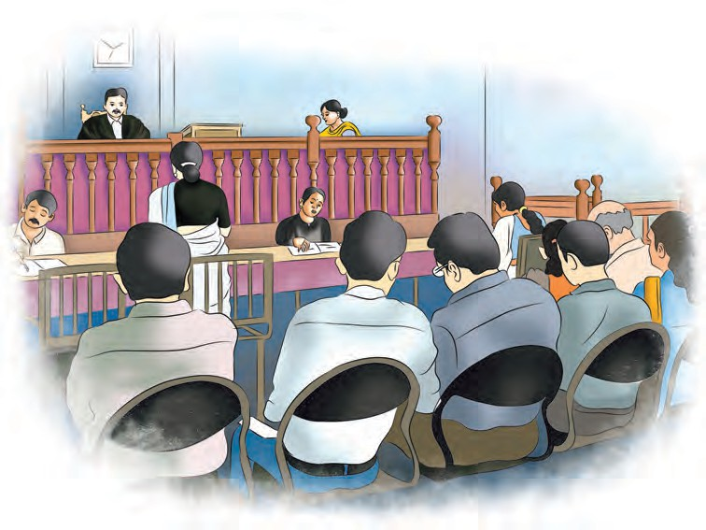
Inside a court

Because the fundamental rights are thus protected by the courts, citizens are able to exercise their rights. They can fulfil their roles as alert, responsible and
active citizens. While considering fundamental rights, we also need to remember our duties. In the next chapter, we shall study our fundamental duties.



Exercise

- Write about the following.
  - The Constitution prevents the imposition of religious taxes.
  - What is meant by Right to Constitutional Remedies ?
- Find one appropriate word -
  - Protection from illegal arrest and detention -
  - To restrain a person from acting in an office to which he is not entitled -
  - The order of the Supreme Court or the High Court commanding the government to perform an action that is its duty to perform -
  - The order preventing a subordinate court from exceeding its jurisdiction -
- State the reason why we are free to practise the following.
  - All Indian citizens can celebrate all festivals joyfully, because …..
  - We can make efforts towards the preservation and propagation of our language, its script and literature, because …..
- Fill in the blanks with appropriate words.
  - We can approach the in
case of infringement of our rights.
  - ............ education cannot be made compulsory in educational institutions that get aid from the State.
Activity
Organise an interview in your school of a judge, a lawyer or a police officer.



6. Directive Principles of State Policy and Fundamental Duties

In the last two chapters, we studied the fundamental rights guaranteed by our Constitution. We learnt what rights Indian citizens enjoy. We also learnt that our rights have judicial protection. We understood the importance of fundamental rights in our individual and public lives. With this background, we shall now understand what the Directive Principles of State Policy are.
Fundamental rights put restrictions on the power of the government. A few such restrictions upon the State are listed below.
    - State shall not discriminate between and among citizens on the basis of caste, religion, race, language or sex.
    - State shall not deny anybody equality before the law and equal protection of the law.
    - No person shall be deprived of his life.
    - State shall not impose any religious taxes.
The Constitution has given express instructions to the State about what policies it should undertake. This is in the nature of giving directives or guidelines about how to achieve the goals expressed in the Preamble. Hence they are called as Directive Principles of State Policy.

Why were the Directives included ?
When India won independence, we faced a great challenge of establishing order and carrying out smooth administration. Eradication of poverty, backwardness and illiteracy had to be urgently pursued. The task of nation building had to be undertaken. For this, new policies had to be drawn up, and their implementation had to be undertaken.
The goal of people’s welfare had to be achieved. In short, India had to be transformed into a developed and progressive nation. The Constitution has specified the subjects to which the Union and State Governments should give priority in their policies for people’s welfare through the Directive Principles of State Policy. Each Directive contains a subject for the State Policy. The makers of the Indian Constitution had realised that it would require a lot of resources if all these policies were to be implemented at the same time. That is the reason why they did not make the directives binding upon the State like the fundamental rights. They expected that States should implement them slowly and steadily.

Some important Directive Principles of State Policy :
- The State should secure adequate means of livelihood to all citizens without any gender discrimination.
- The State should secure equal pay for equal work for both men and women.
- The State should secure the improvement of public health.
- The State shall endeavour to protect and improve the environment and safeguard the forests and wild-life of the country.
- The State shall protect all monuments of historic interest and national importance.
- The State shall promote with special care the educational and economic interests of the weaker sections of the people, especially the Scheduled Castes and Tribes.

- The State shall offer public assistance to citizens in cases of unemployment, old age, sickness, etc.

- The State shall secure a uniform civil code applicable to the entire country.

There is a directive to ensure ‘equal pay for equal work.’
Which principles and ideals of the Constitution will be realised with this directive ? Why does it happen that inspite of doing the same work, women are paid less than men ?
Can you tell ?
What else do you think the Government should do for students ? Make a list of your demands. How would you convince others that your demands are just ?
we cannot go to the courts if a Directive is not implemented by the Government, we can put pressure on the Government in various ways to make a policy in order to meet these goals.


Directive Principles of State Policy and Fundamental Rights are two sides of the same coin. Due to Fundamental Rights, citizens get the most needed liberty, while Directive Principles of State Policy create an atmosphere conducive to the growth of democracy. Even though

Apart from the above directives, there are others that specify what the State should do in order to bring about the welfare of the people. A few issues have been listed below. Find out the directive that is relevant in these contexts with the help of your teacher. For example, Foreign Policy : It should be the policy of the State to endeavour to secure the promotion of international peace and security.
- Girl’s Education : ....................
- Upbringing of children in a healthy and happy atmosphere : ...............
- Improvement in agriculture : .........
Do this.

Fundamental Duties
In a democracy, citizens have a dual responsibility. They should not only be vigilant that their rights are not unfairly restricted, but should also fulfil some duties and responsibilities. The Constitution has made several provisions through the Fundamental Rights and the Directive Principles of State Policy for the people’s welfare. The benefits of the various schemes of the Government cannot reach all people if they do not fulfil their Fundamental Duties. For example, the Government has implemented several projects under its Swachch Bharat Scheme, but people, too, need to change their habits that make public places dirty. In order that the Indian citizens become conscious of their responsibilities, Fundamental Duties were included in the Constitution. The Fundamental Duties of the Indian citizens are as follows :
Which improvements will be possible with the following facilities offered by the Government ?
- Public toilets
- Clean water supply
- Vaccination of children
To abide by the Constitution and respect the National Flag and the National Anthem.

To cherish and follow the noble ideals which inspired our national struggle for freedom.
To uphold and protect the sovereignty, unity and integrity of India.
To defend the country, and to render national service when called upon to do so.
To promote harmony and the spirit of common brotherhood transcending diversities; to renounce practices derogatory to the dignity of women. To value and preserve the rich heritage of our composite culture.
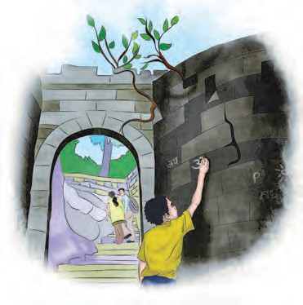
To protect and improve the natural environment, and to have compassion for living creatures.

A boy scribbling on a historical structure
To develop the scientific temper, humanism and spirit of inquiry and reform.
To safeguard public property and to abjure violence.
To strive towards excellence in all spheres of individual and collective activity so that the nation constantly rises to higher levels of endeavour and achievement.
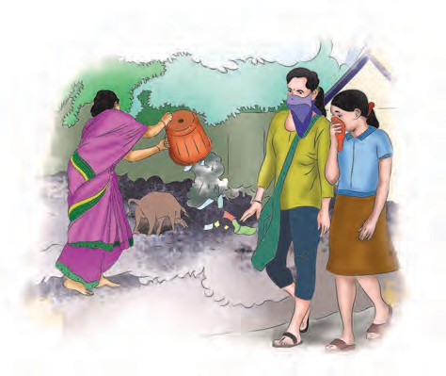
Every citizen of India who is a parent or guardian should provide opportunities of education to his or her child or ward between the age of six and fourteen years.

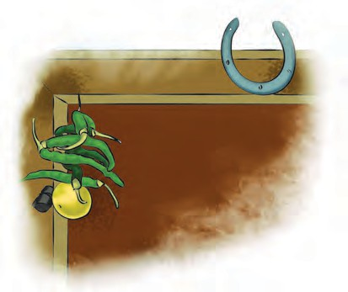
Hanging lemon, chillies

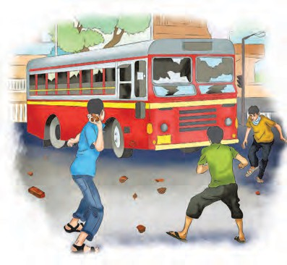
Damaging a public bus A woman emptying a garbage can on the street

Which of the Fundamental Duties are not being followed in the situations above ?

The river in our village does not look like a river at all! What an amount of plastic waste!
Even if anybody tells me, I will never throw any waste in the river.
That is all right, but what to do about those deafening sounds?
People just don’t seem to realise these things while celebrating festivals!

We should also be insistent
on our responsibilities as citizens.

It is our duty to protect the resources and public property of our country.



  - Let us start step by step... Let us make a few resolutions.
  - Let us tell girls and boys to go to school.
  - Let us use the different facilities in school responsibly.
  - Let us be proud of our country.
  - Let us participate in the festivals of different religions.
  - Let us celebrate them by avoiding pollution of the environment.
  - Let us use public facilities properly and take good care of the same.
  - Let us perform all the tasks that we have undertaken honestly, always striving for excellence.

Which duties are reflected in the dialogues above? Is there a relationship between rights and duties ?
What do you think happens when we follow our duties ?

What do you think ?
Girls and boys between the ages 6 and 14 have got the right to education. All the girls and boys in this age group should be in school. Yet many girls and boys are not able to go to school because of many reasons. They have to work to help their parents earn a living for the family. Do you think that it is unfair to such children to insist that they go to school ?
At the beginning of the Civics section, we got introduced to the goals and characteristic features of the Indian Constitution. We also considered the rights of the Indian citizens and the legal protection guaranteed to these rights by the Constitution. We understood the Directive Principles of State Policy and the Fundamental Duties of Indian citizens.


Next year, we shall study the administration of our country.

Exercise

- List the restrictions on the powers of the Government.

- Say ‘Yes’ or ‘No’.
  - The jobs advertised in the newspaper are for men and women both.
  - Men and women doing the same work in a factory get different wages.
  - Government implements various schemes for the improvement of public health.
  - The State shall protect all monuments of historic interest and national importance.
- Tell why -
  - The State shall protect all monuments of historic interest.
  - A pension scheme is implemented for old people.
  - Free and compulsory education has been made available to children in the age group 6 to 14.
- Say right or wrong. Correct and write the wrong ones.
  - Not to let the National Flag fall down on the ground.
  - To stand at attention while the National Anthem is playing.
  - To carve or paint our names on the walls of a historic place like a fort.

  - To give lesser wages to women than to men for the same work.
  - To keep public places clean.
- Write about the following.
  - The Directive Principles of the Constitution enumerated in the textbook.
  - The provision of a uniform civil code for citizens in the Directive Principles of the Indian Constitution.
  - Why is it said that the Directive Principles and Fundamental Rights are two sides of the same coin ?
- What are the ways in which citizens can conserve the environment ? Write with examples.
Activities
  - Education is our right. Form groups and discuss our duties in this respect.
  - The State shall protect all monuments of historic interest and national importance. This is one of the Directive Principles. Find out the efforts made by the State about the conservation and protection of forts and make a chart.
  - Gather information about the schemes implemented by the Government for children’s health.

Muhammad- bin-Qasim invaded Sindh
88

Timeline - From the 8th century to the 19th century
Review of Major Events
Read the sequence of events from the bottom upward.

Warkari Panth
Mahanubhav Panth
Khalji

Establishment of Bahamani Dynasty

Establishment of Vijaynagar Dynasty

The reign of Adilshahi, Nizamshahi, Qutubshahi, Baridshahi, Imadshahi

Emperor Akbar’s conflict with Maharana Pratap, Chandbibi and Rani Durgavati

Beginning of

Maharani Tarabai’s reign
Chhatrapati Rajaram Maharaj

Chhatrapati Sambhaji Maharaj

Coronation ceremony of Chhatrapati Shivaji Maharaj

Foundation of Swaraj
Reign of Chhatrapati Shivaji

The reign of Bajirao II
Swaraj to Empire
Sawai Madhavrao Peshwa
Narayanrao Peshwa

Madhavrao Peshwa

The battle of Panipat

Nanasaheb Peshwa

Marathas defeated
Marathas defeated by the British

Rajput - Gahadwal and Parmar dynasties
Gurjar - Pratihar Kingdom
Pal Dynasty
Rashtrakuta Dynasty Pandya Dynasty
8th Century

Shilahar Dynasty

Chola Dynasty

9th Century

Raja Jaipal
- Sabuktagin Conflict

10th Century
Mahmud of Ghazni invaded India

Turks invaded India

Hoysala Dynasty

11th Century
Muhammad Ghuri invaded India and defeated Prithviraj Chauhan. End of the Chauhan Kingdom
Yadava Dynasty
12th Century
Dynasty

The reign of Iltutmish, Sultana Razia, Bulban.
Qutubuddin Aibak became the Sultan of Delhi.

13th Century

Tughluque Dynasty in Delhi.
Transfer of capital from Delhi to Deogiri and then back to Delhi.
Timur invaded India

14th Century

15th Century
the Mughal rule.
The reign of Babur, Humayun.

End of the Sultanate at Delhi

16th Century
Maharaj
Great famine in Maharashtra
Mughal-Sikh conflict
Aurangzeb Shahajahan Jahangir
17th Century
Portuguese Power

Peshwa Bajirao I

The reign of Chhatrapati Shahu Maharaj

18th Century

19th Century

