1. Export the Response, Resolution and SC Task list from SNOW.
2. Open the response excel.
3. Add a column “hasException”.
4. Filter the “hasBreached” column and mark true for exception received.

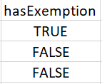

1. Mark false for all other entries.
2. Open Resolution steps repeat the steps from step 3 to step 5.
3. Place the files in Input folder with naming Incident_Response, Incident_Resolution and SC_Task
4. Now open the command line or PowerShell.
5. Run the command: java -jar .\MonthlySLAData.jar
6. Now format the styling and data.