🏠 House Price Prediction
Project Report
Shubham Lipne
AICTE | IBM SkillsBuild Academic Internship — Data Analytics with AI (BharatCares)

1. Project Overview
This project is a full-stack machine learning web application that predicts house prices from two features: the area of the house (in square feet) and the number of rooms. It combines a trained regression model, a REST API backend, and an interactive web frontend into a single end-to-end pipeline.

2. Objective
- Build a regression model that estimates house price from area and number of rooms.
- Expose the model through a REST API so it can be consumed by any client.
- Provide an interactive UI for users to enter house details and get an instant price estimate.
- Package the project so it can be trained, run, and reproduced end-to-end from source.

3. Dataset
The dataset (data/house_price.csv) contains 47 samples with three columns: area (sq ft), rooms, and price. It was split into 37 training rows and 10 test rows for model evaluation.

4. Tech Stack
Layer | Tools
Machine Learning | scikit-learn, numpy
Backend | Flask, flask-cors
Frontend | Streamlit, Plotly
Data Handling | pandas, matplotlib

5. Methodology

5.1 Data Preparation
The dataset was loaded with pandas and split into an 80/20 train-test split using scikit-learn's train_test_split (random_state=42 for reproducibility).

5.2 Model Training
A Linear Regression model (scikit-learn) was trained on the two input features — area and rooms — to predict price. Linear Regression was chosen for its interpretability and strong fit on this dataset.

5.3 Evaluation
The trained model was evaluated on the held-out test set using Mean Absolute Error (MAE), Root Mean Squared Error (RMSE), and R² score.

6. Results
Metric | Value
MAE | 18,222.7
RMSE | 23,738.3
R² Score | 0.9484
Coefficient — Area | 78.975
Coefficient — Rooms | 48861.1989
Intercept | 860.8949

An R² score of 0.9484 indicates that area and number of rooms together explain roughly 95% of the variance in house price for this dataset.

6.1 Price vs. Area Visualization
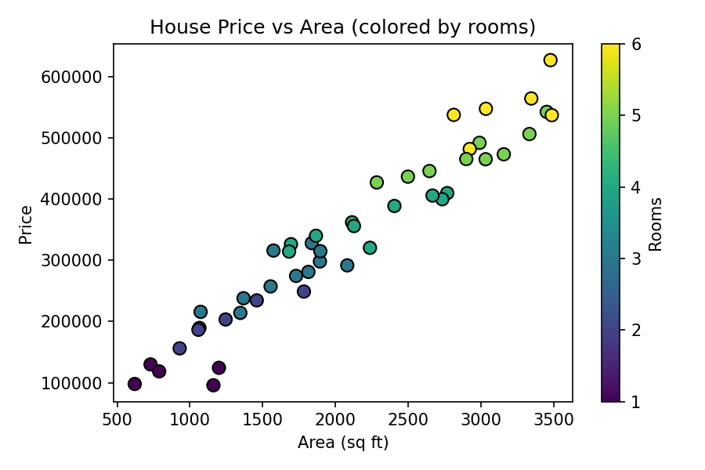

7. System Architecture
The project follows a simple three-tier architecture:
- train_model.py trains the Linear Regression model on data/house_price.csv and saves it to model/model.pkl.
- backend/app.py (Flask) loads model.pkl and exposes /health, /model-info, and /predict REST endpoints.
- frontend/ui.py (Streamlit) collects user input, calls the /predict endpoint, and displays the estimated price along with a chart of the training data.

8. How to Run
- Install dependencies: pip install -r requirements.txt
- Train the model: python train_model.py
- Start the backend: cd backend && python app.py
- Start the frontend: cd frontend && streamlit run ui.py

9. Conclusion
This project demonstrates a complete, reproducible machine learning workflow — from data preparation and model training, through serving predictions via a REST API, to a user-facing web interface — applied to the task of house price prediction.

