**PRN – 230945920053**

**SDM Module End –**

1. **Create EC2 Instance**

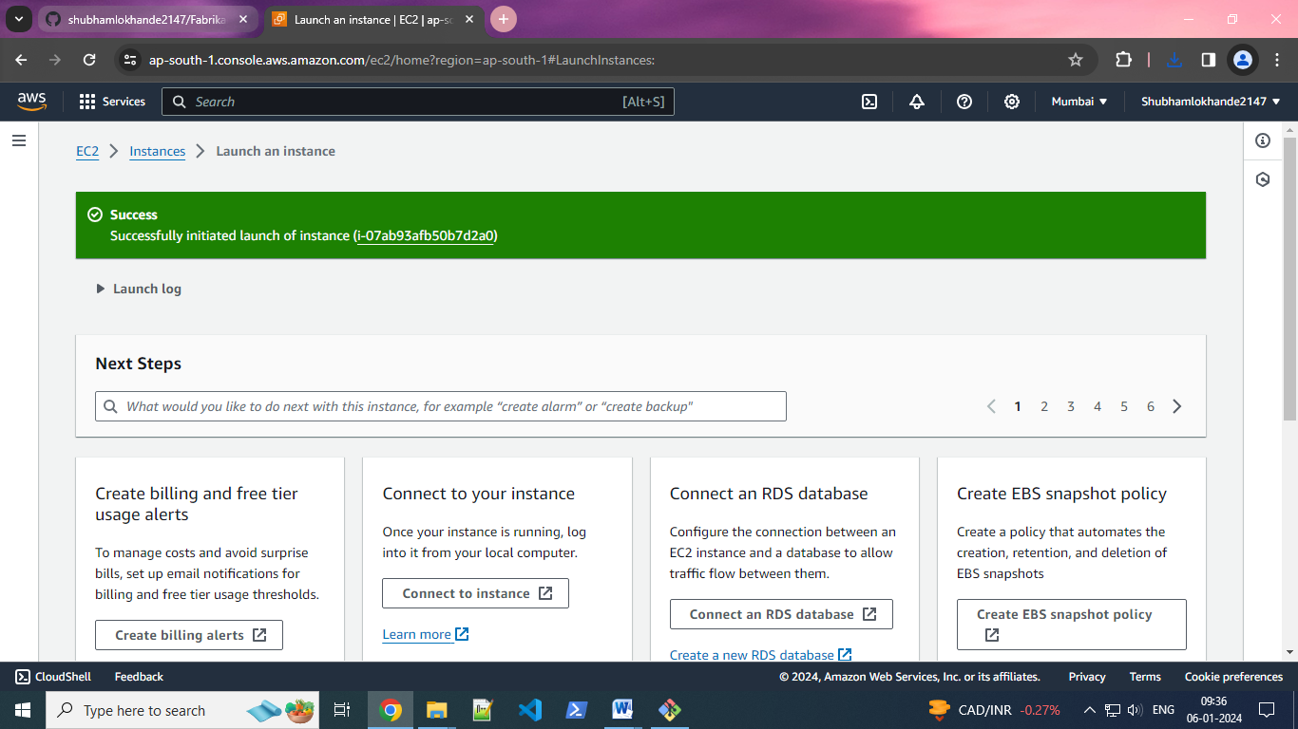

**2)instance is running and connect -**

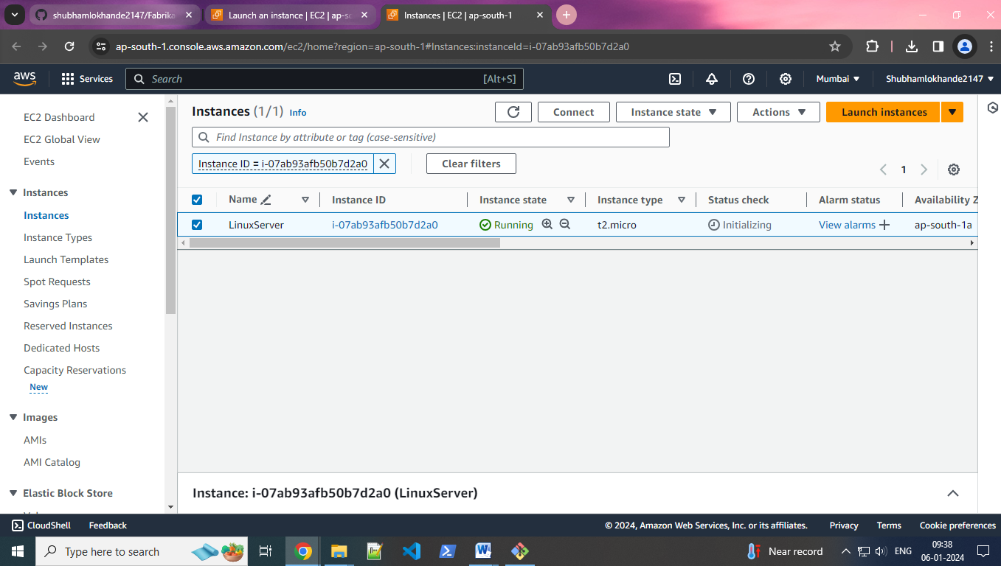

**3)virtual machine is launch -**

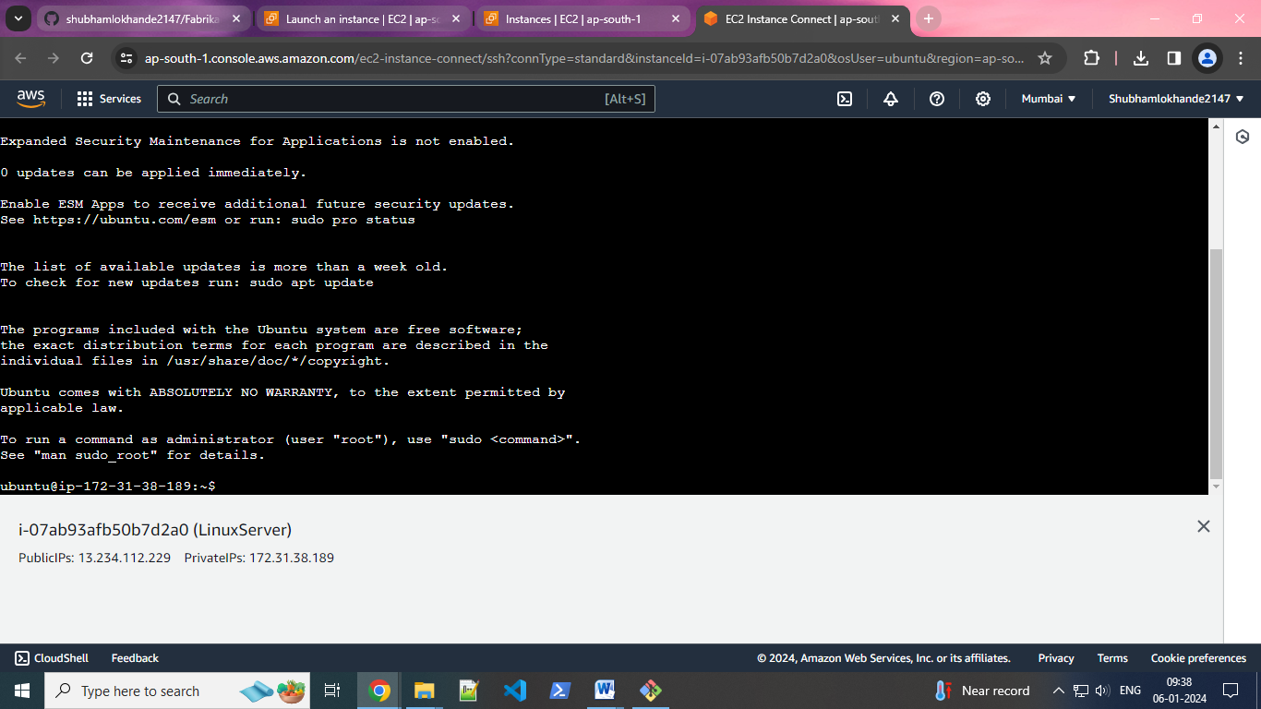

**4) sudo apt update command -**

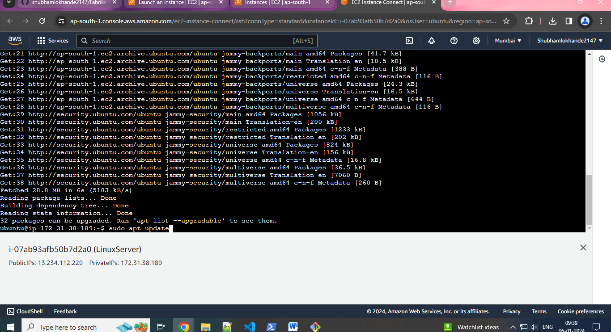

**5) check docker is install or not -**

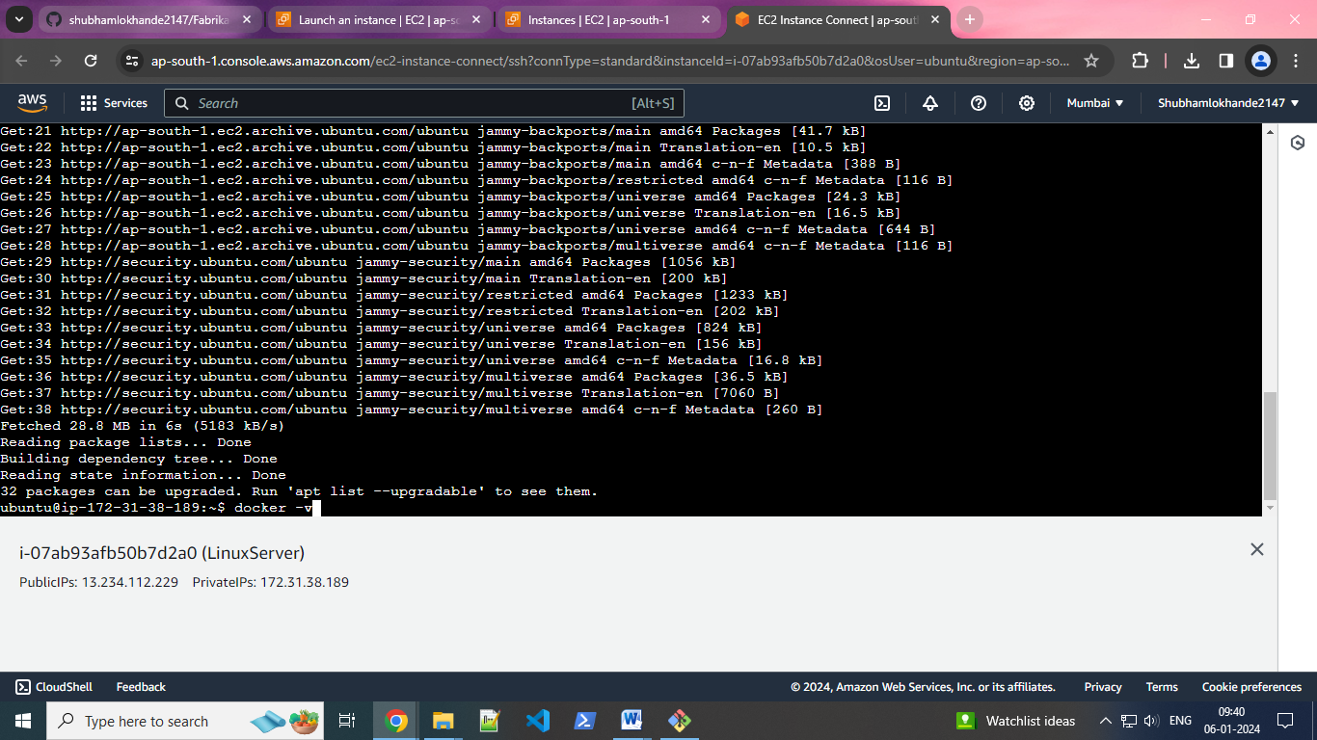

**6) sudo apt install docker.io -**

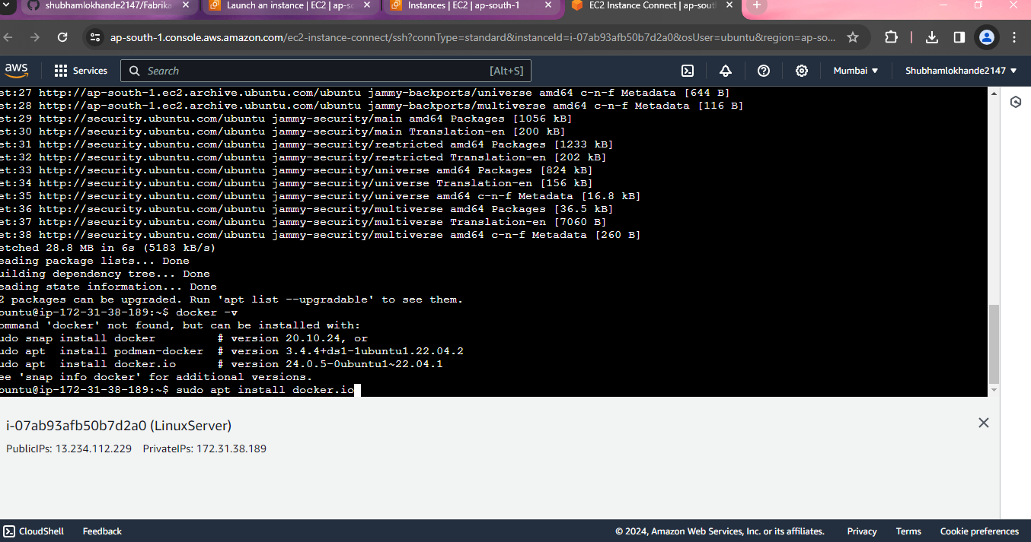

**7) install docker -**

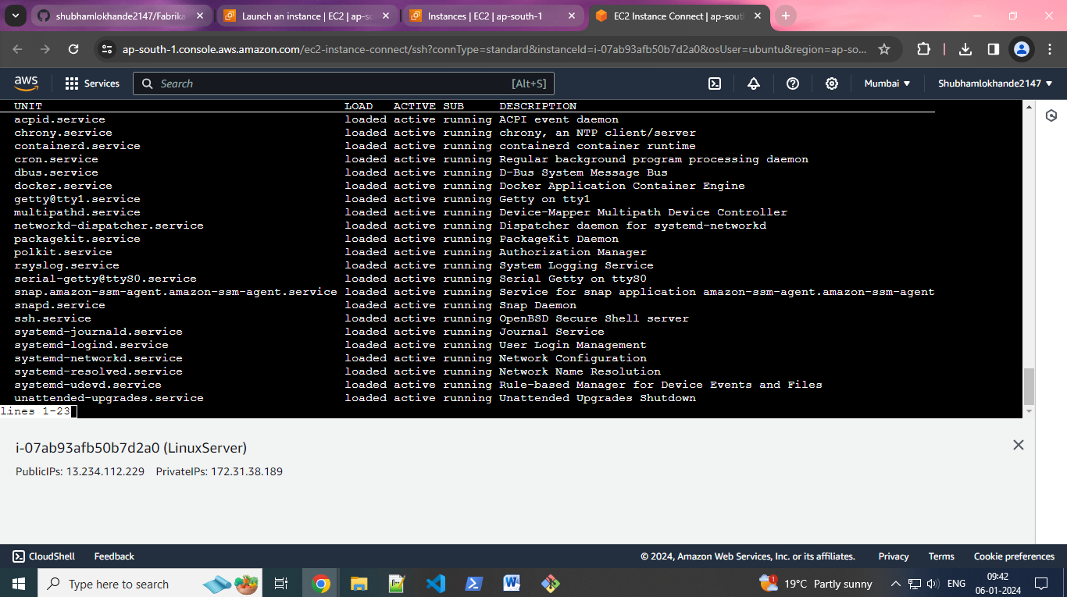

**8) git clone repository -**

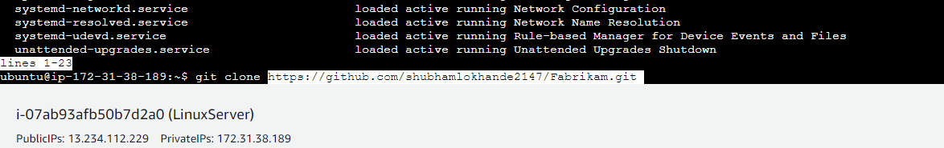

**9) Fabrikam Repository is clone -**

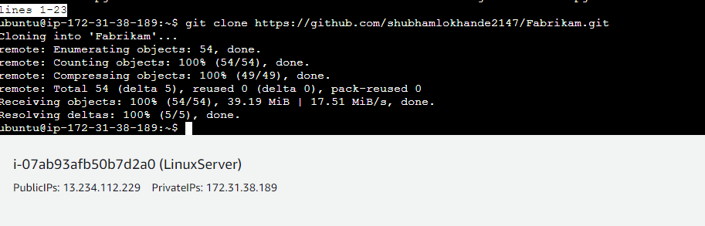

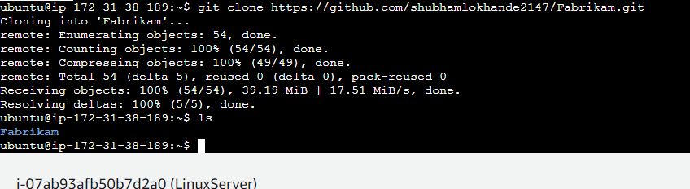

**10) cd Repository -**

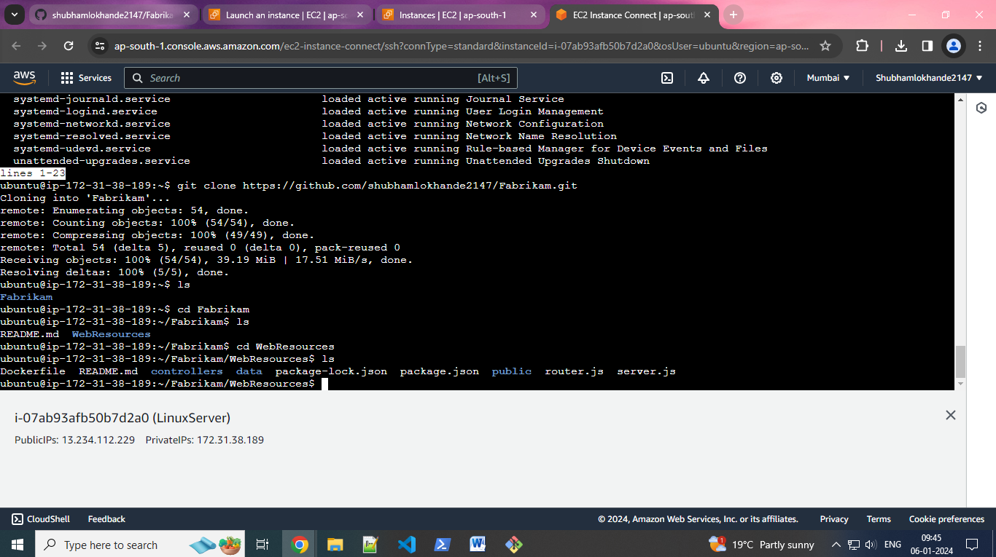

**11) build docker image -**

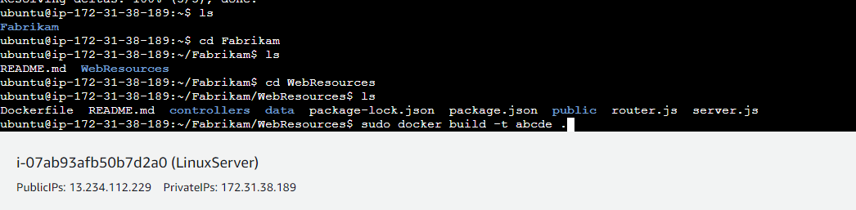

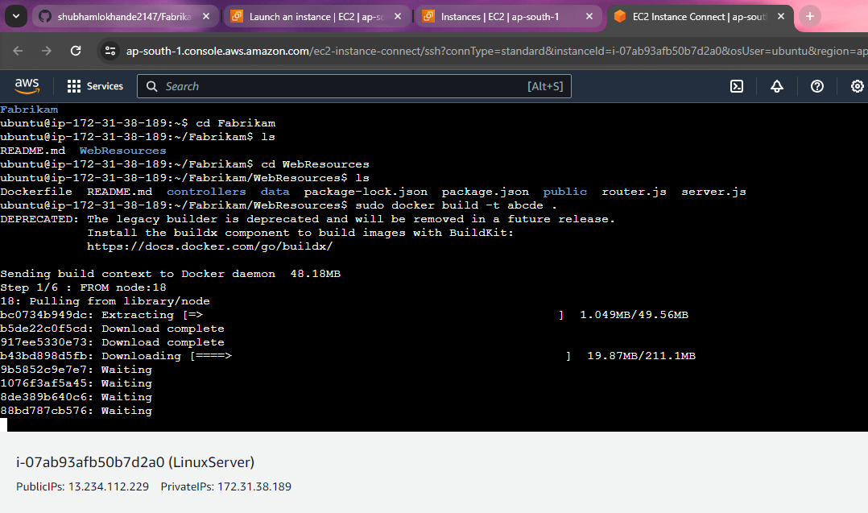

**12)images is created -**

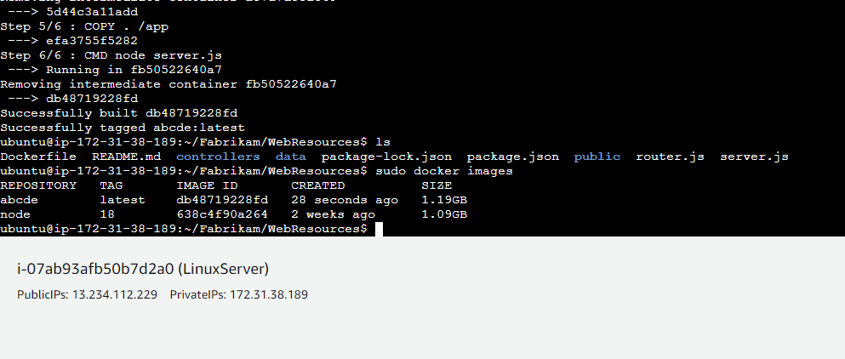

**13)run image -**

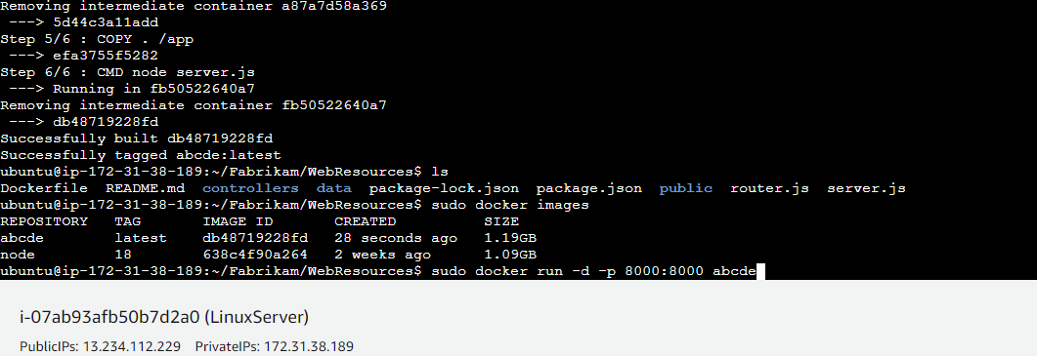

**14)container is created -**



**15)firewall configuration -**

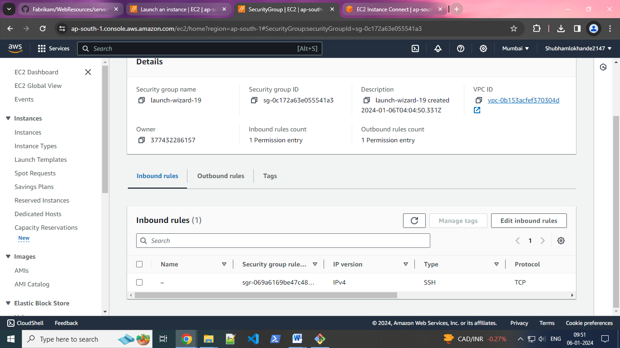

**16)set Inbound rule as All Trafic and AnyIPV4 -**

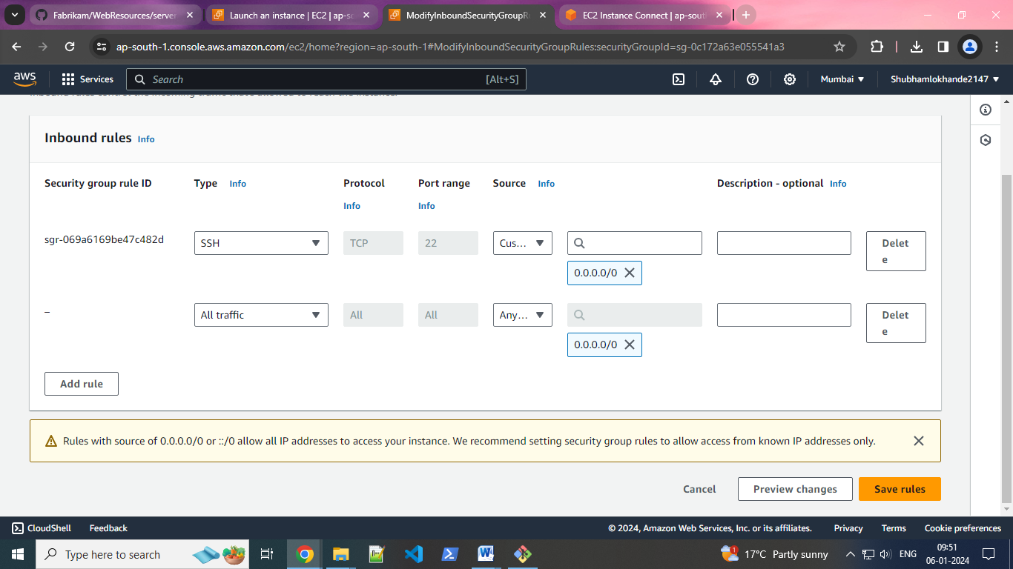

**17)IP address copy and paste in url ,then see hosting website -**

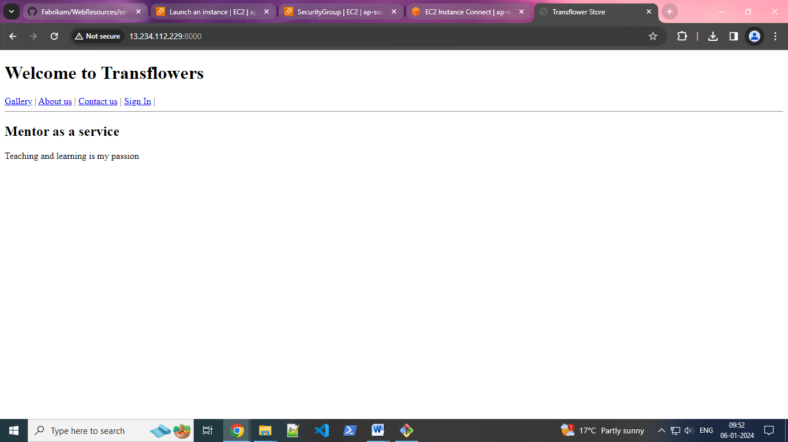

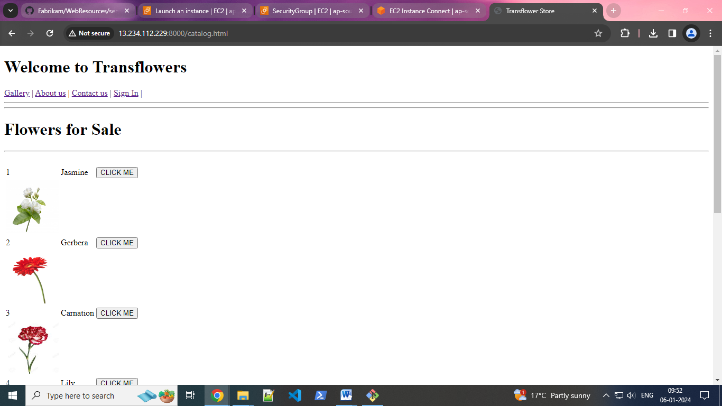

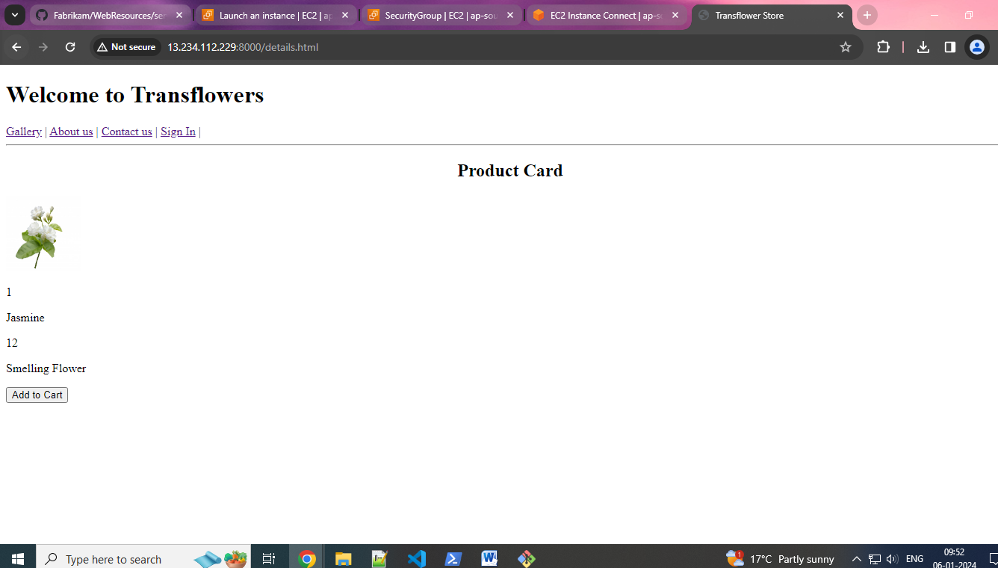

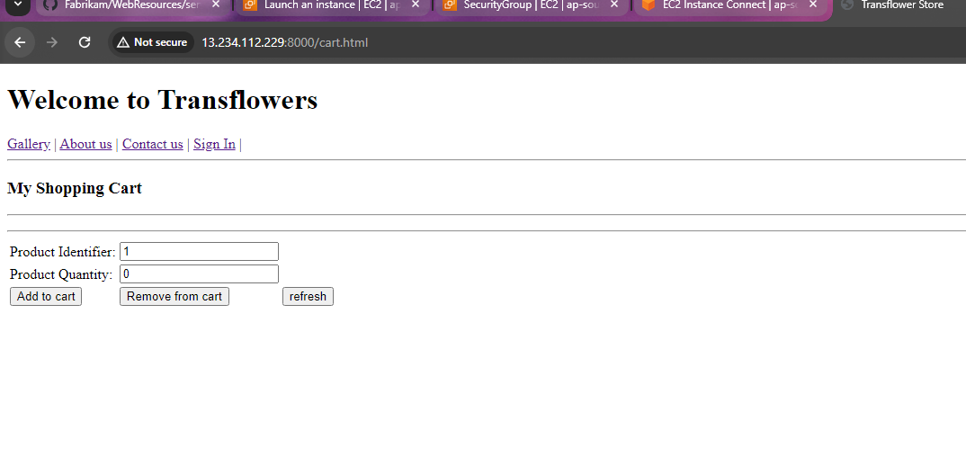

**18)stop dosker using “sudo service docker stop “-**

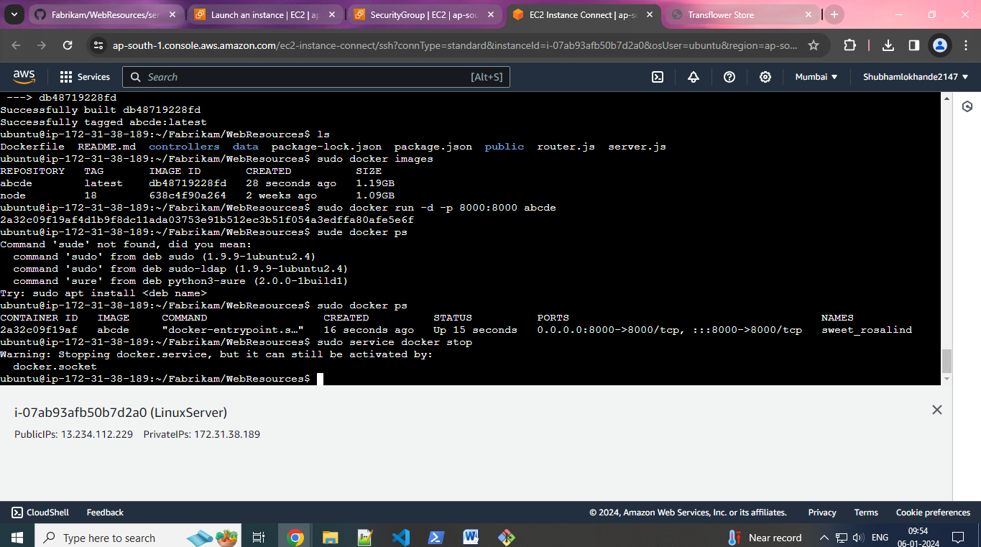

**19)stop docker here -**

