Problem Statement

Implement a recursive method to generate the nth Fibonacci number.

The Fibonacci series consists of the first two numbers as 0 and 1 and the subsequent numbers are the sum of the previous two numbers. Implement the logic inside findFibonacci() method.

Fibonacci numbers – 0, 1, 1, 2, 3, 5, 8, 13, 21, 34, …

Test the functionalities using the main method of the Tester class.

\**Sample Input and Output**

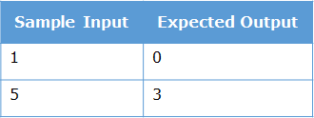

//----------------------------------------------------------------

Problem Statement

Implement a recursive method to find the sum of the Harmonic Progression given below.

1+1/2+1/3+1/4+1/5+1/6+…+1/n

Implement the logic inside findHPSum() method. You need to find the sum based on the value of num passed to the method.

E.g. - If the value of num is 3, you need to find the sum of 1+1/2+1/3.

Test the functionalities using the main method of the Tester class.

**Sample Input and Output**

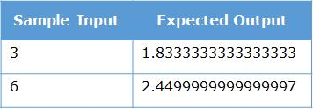

//--------------------------------------------------------------------------

Peter and Maria went for a movie one day. In the multiplex, the tickets were issued on first-come-first-serve basis and people were standing behind each other waiting for their turn. So they went to the back and stood behind the last person waiting for the ticket.







