Here I am taking one country from each continents in the world where I have took China, United States, Brazil,New Zealand,Egypt,Germany So here I am showing what temperature we were predicted but what is the actual temperature now and what will be the temperature in future for particular country

1 China

1.1 Graph for Current temperature in china :-

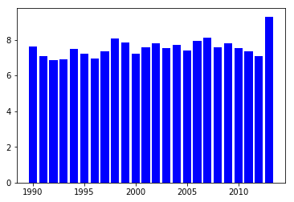

Here we can see that there are some ups and downs till 2012. So here we can see that in 1992, There was a lowest temperature is marked and this ups and downs were marked till 2012. but in 2013 as we can see that temperature changed drastically because in 2013 deforestation is made by human activities and because of increasing population in china they were trying to produce more energy which were generate greenhouse gases.

1.2 Graph for temperature that was predicted previously for current years

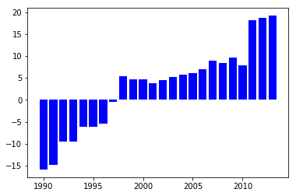

Graph for future predictions in china:-According to current predictions we have found that from 1990 to 1997 they have predicted temperature in minus between 0 to -15 but actual temperature were in between 0 to 8 for those years means that global warming is started early before 90`s and following up by those predictions they predicted from 1998 to 2010 predictions was quite accurate but they are predicted temperature for 2011 to 2013 was to high than actual predictions and was not accurate because earlier from 1990

to 1997 they found results which have increasing trends.

1.3 Graph for temperature predicted for future analysis

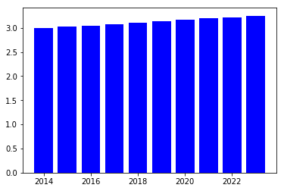

Here we have predicted data for upcoming years. After predicting data for upcoming years we have got some astonishing predictions followed by increasing trend that temperature will again go down in 2014 which is around 2.8 degree Celsius and have slightly upward trend till 2022 so here we can say that temperature is totally unpredictable for china so we just cannot rely on mathematical predictions

2 United States

2.1 Graph for Current temperature in United States :-

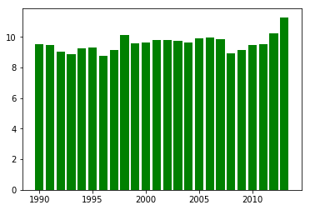

Here we can see that there are continuation in temperature till 2012 and slightly upward trend in 2013. So here we can see that in 2008, There was a lowest temperature is marked .Now united states considered as a superpower country so they produce more power energy and now they have already did deforestation and reserved some limited space for forest so in 2013 we can see that there is a upward trend for temperature

2.2 Graph for temperature that was predicted previously for current years

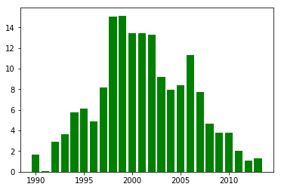

As we can see that all the predicted temperature for current year are wrong as we can see they have predicted lowest temperature in 1991 which is almost 0 degree Celsius and predicted 15 degree Celsius in 1998 and 1999 which is too high than current temperature there are lots and lots of variation from 1990 to 2013 so here we can say that from 1990 to 2013 temperature was unpredictable because of increasing population and and generating hugh amount of energy

2.3 Graph for temperature predicted for future analysis

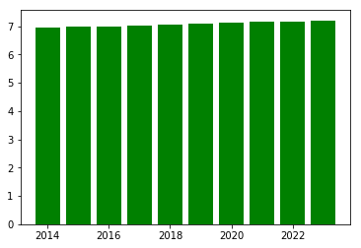

Here we have predicted data for upcoming years. After predicting data for upcoming years we have got some predictions followed by increasing trend that temperature will again go down in 2014 followed by 2013 which is around 6.9 degree Celsius and have slightly upward trend till 2022 so here we can say that temperature is totally unpredictable for united states because day by day global warming is increasing for live example recently in 2019 hurricane dorian destroyed 13000 houses in Bahamas .

3 Egypt

3.1 Graph for Current temperature in Egypt

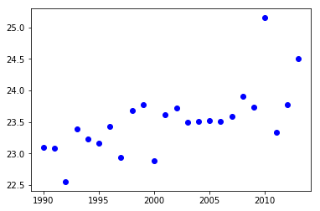

In Egypt we can see that there is a variation between temperature where lowest temperature is marked in 1992 and highest temperature is marked in 2010. After 1992 and before 2010 there is a slightly variations between temperature but in after 2009 temperature increased drastically which is almost 26 degree Celsius but astonishing thing is in 2011 there is a strongly downward trend that we found and then there are again upward trend is there

3.2 Graph for temperature that was predicted previously for current years

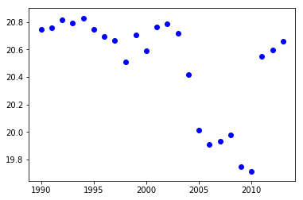

When we were predicted temperature for current years we got to know that till 2008 predicted temperature for current year are closest to actual temperature but we can see that in 2010 prediction happened totally opposite as they were predicted 19.5 but the actual average temperature in 2010 was 25.9 which has hugh difference

3.3 Graph for temperature predicted for future analysis

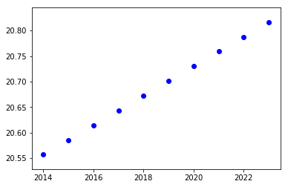

When we predicted temperature for future we found increasing trend and saying that after 2022 as well there are chances to follow upward trends. In **Egypt** is already exposed with a different types of natural disaster which includes coastal and Earthquakes,river floods, sand storms, and water scarcity. From **last** 20 years, and have killed nearly 1500 people and with $346.7 millions of economic damage.

4 New Zealand

4.1 Graph for Current temperature in New Zealand

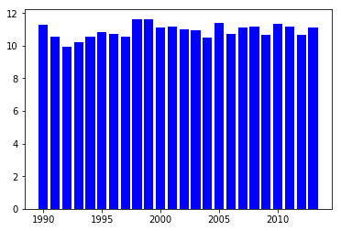

Here we have predictions for New Zealand so we can see that there is a slight variation in temperature by following years.Where highest temperature is marked 11 degree Celsius and the lowest is almost 10 so we can say that this is safest country where they have a good air quality with very few amount of greenhouse gases

4.2 Graph for temperature that was predicted previously for current years

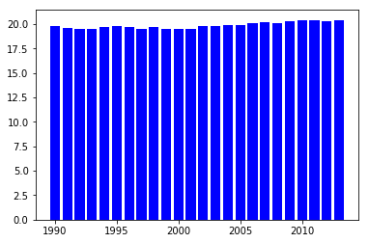

Here we found that predicted temperature is almost accurate for current years because of their slight variations

4.3 Graph for temperature predicted for future analysis

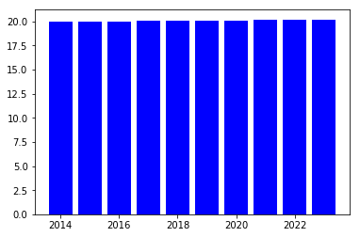

Here we found that there is no drastical changes in new Zealand`s temperature in upcoming years and found this country is most safest country according to our data so new Zealand is not over populated country like china and united state.so they do not generate hugh amount of energy as they generate limited amount of energy .

4 Germany

4.1 Graph for Current temperature in Germany

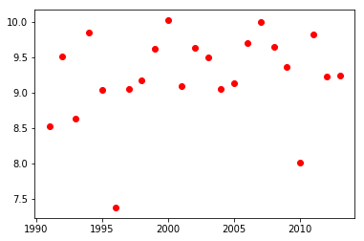

Here we have data plot for Germany where we have found some variation in temperature where we can see that all the years have totally different temperature so it is very difficult to predict the temperature in Germany.

4.2 Graph for temperature that was predicted previously for current years

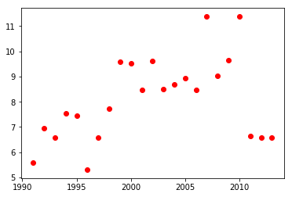

Predicted temperature for current year is slightly different where there are some point where they predicted accurate temperature as you can in 1996 they were predicted temperature which is around 5.5 and actual temperature was 6.5.In contrast, In 2010 predicted temperature was more than 11 degree Celsius but where as actual temperature was just 8 degree Celsius which is totally different.

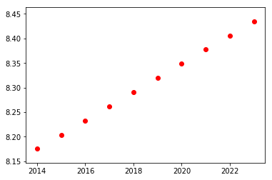

Here we can see that Following year 2012 and 2013 we got to know that there are slightly upward trend according to 2014 because temperature in 2012 and 2013 is around 9 degree Celsius.so it is going to decrease in 2014

5 Brazil

5.1 Graph for Current temperature in Germany

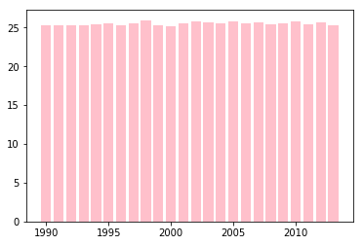

5.2 Graph for temperature that was predicted previously for current years

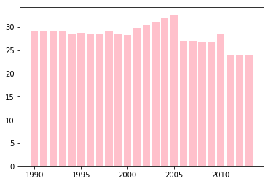

5.3 Graph for temperature predicted for future analysis

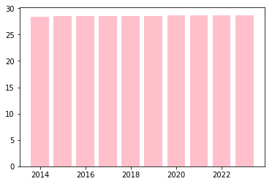

After all the predictions we have found that Brazil has linear trend there is almost no variations between temperature as we all know they have reserved almost half of their area for forest which is 56.6% so they have balanced nature.

Story:-

After predicting future temperature for each each country from each continent we have found that there are so many variation in temperature of Egypt and Germany .In contrast, New Zealand and Brazil mark themselves as a safest countries where brazil have 56.6 percent of area covered by forest and they have balanced nature so even if they are releasing greenhouse gases so that will not be problematic for them in future as you can see this in the graph