1.Connect to a MySQL or PostgreSQL database using SQLAlchemy and pandas, then use pd.read_sql() to load the entire 'restaurants' table (imagine Zomato backend) into a DataFrame and display the first 5 rows.
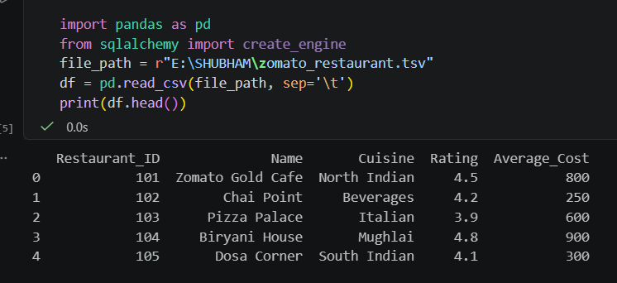
===========================================================================
2.Use pd.read_sql_query() to fetch only the 'name' and 'rating' columns from a 'movies' table (think BookMyShow-like data) where rating is above 8, and print the resulting DataFrame. Write a custom SQL SELECT query as the first argument to pd.read_sql_query().
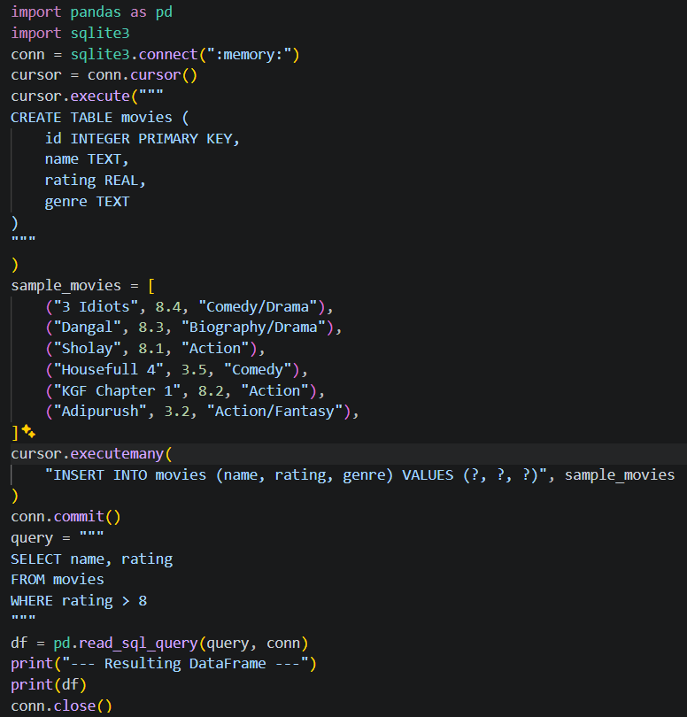
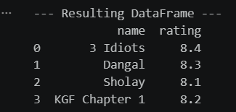
===========================================================================
3.Read a JSON dataset from the URL https://jsonplaceholder.typicode.com/users using pandas, convert it into a DataFrame, and print the usernames column.Use pd.read_json() directly with the URL.
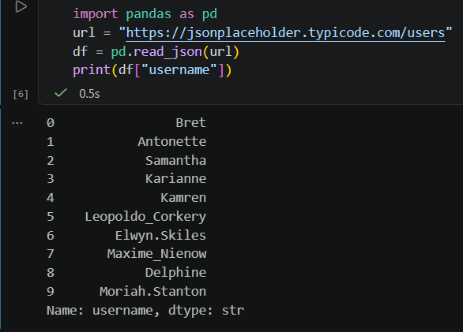
===========================================================================
4.You have two CSV files: 'orders.csv' (order_id, user_id, amount) and 'users.csv' (user_id, username). Load both into DataFrames using pathlib for file paths, then merge them on 'user_id' to show a combined table with username and amount.
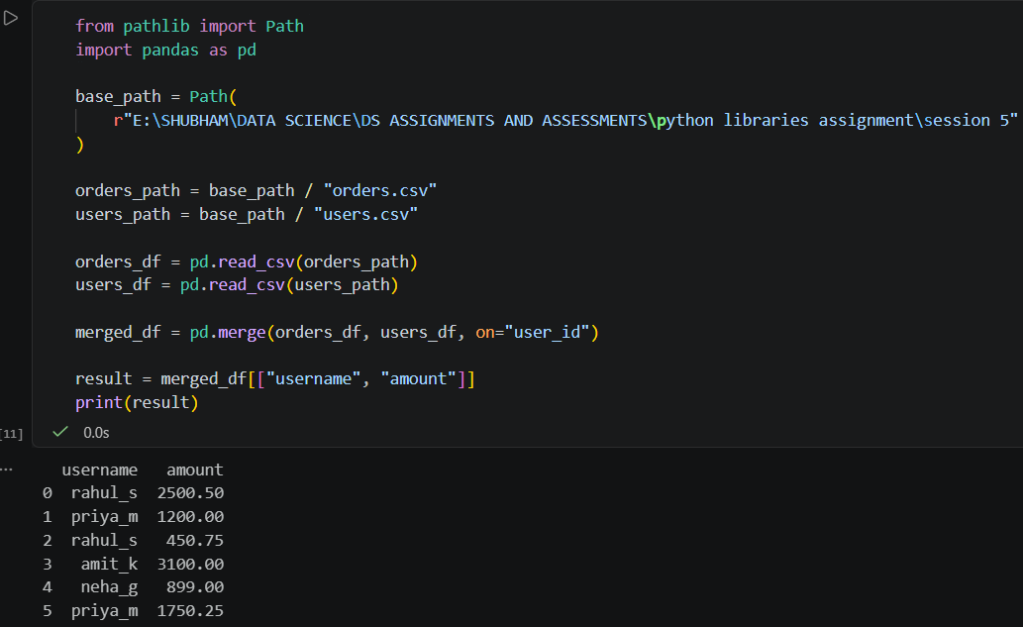
===========================================================================
5.Concatenate two DataFrames representing 'today_orders' and 'yesterday_orders' (each with columns: order_id, item, price), and display the combined DataFrame. Use pd.concat() and reset the index after concatenation.
