- Download a small sample of your recent Zomato order history as a CSV (or create a mock CSV with restaurant names and order dates), then use pandas' duplicated() function to find and print any duplicate orders based on restaurant name and date.
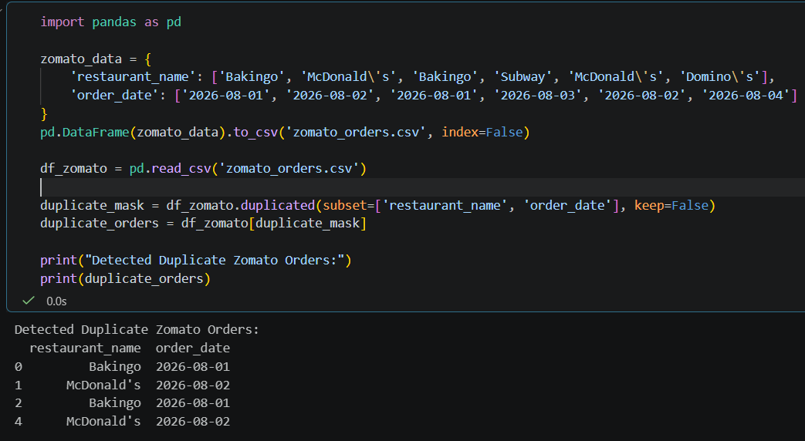

- Given a list of Flipkart product reviews with some duplicate entries, use value_counts() in pandas to identify which review texts are repeated most often and display the top 3 most common duplicate reviews.
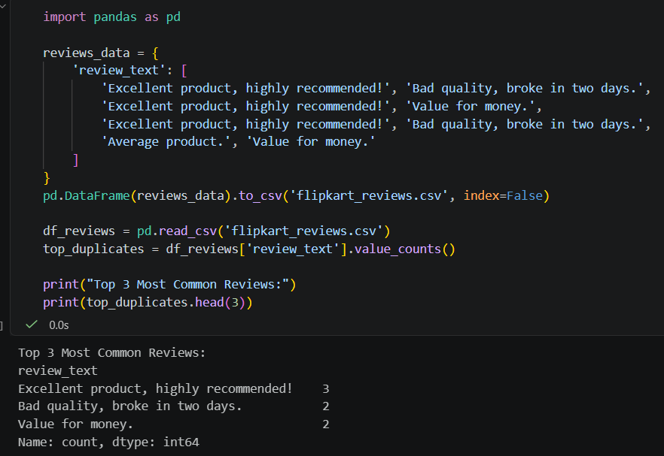

- Create a DataFrame with mock data for Spotify playlists, including playlist names and creator usernames, where some rows are exact duplicates. Use drop_duplicates() to remove duplicate playlists and print the cleaned DataFrame.
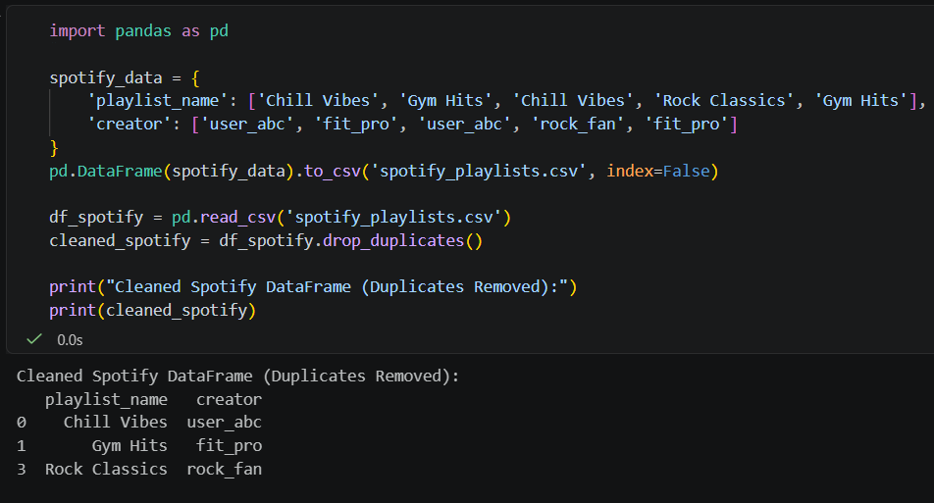
===========================================================================

- Suppose you have a DataFrame of Instagram usernames where some entries have typos (like 'insta_queen', 'insta-queen', 'instaqueen'). Use the replace() function to standardize all these variants to 'instaqueen'.
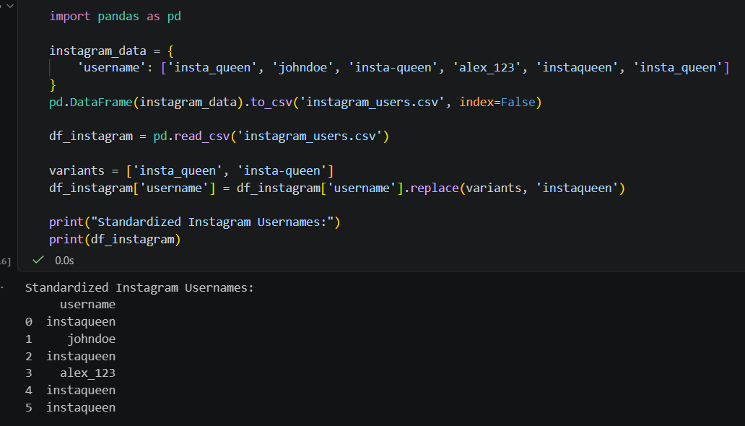

- You have a DataFrame column for payment status from a Paytm-like app with mixed values: 'Yes', 'yes', 'Y', 'No', 'no', 'N', and some with extra spaces. Write code to unify this column so all paid statuses become 1 and all unpaid statuses become 0, trimming whitespace and fixing capitalization where needed. Use str.strip(), str.lower(), and map/replace methods in pandas.
