AI Assignment 1
Code :
career_advisory :-
reset_facts_learned,
dash,
writeln("Welcome to Career Advisory System for IIIT-D B.Tech students!"),
writeln("This system helps you to choose most optimal career."),
writeln("Please give valid and accurate answers for the system to be most effective."),
dash,
career(_).

% so that current execution will not conflict with previous execution of the code.
reset_facts_learned :-
retractall(answered(_, _)).

dash :-
writeln("-------------------------------------------------------------------------------------------------------------------------------------------------------------------").

option(research) :-
writeln("A Reseacher").

option(job) :-
writeln("A Job").

option(others) :-
writeln("You want Non-tech").

option(yes) :-
writeln("Yes").

option(no) :-
writeln("No").

option(cse) :-
writeln("CSE").

option(csam) :-
writeln("CSAM").

option(csss) :-
writeln("CSSS").

option(csd) :-
writeln("CSD").

option(csai) :-
writeln("CSAI").

option(ece) :-
writeln("ECE").

query(cgpa) :-
writeln("Please enter you CGPA").

query(career_interest) :-
writeln("In what type of career you are interested in?").

query(btp_done) :-
writeln("Have you done some kind of BTP during the B.Tech or has some kind of research work?").

query(branch) :-
writeln("Choose branch :- ").

query(enterpreneur) :-
writeln("Have you done Minor in Entrepreneurship?").

query(aptitude) :-
writeln("Do you have good aptitude skills?").

query(social_sciences) :-
writeln("Do you like social sciences?").

query(gk) :-
writeln("Are you good in General knowledge and current affairs?").

query(artist) :-
writeln("Do you like drawings, sketches or colors?").

query(Course, _ , Answer) :-
answered(Course, Answer), !.
query(Course, Name, Answer) :-
\+ answered(Course, _),
write("Have you done the course "),
write(Name),writeln("?"),
generate_options([yes, no], 1),
read(Index),
find_option(Index, [yes, no], Selection),
asserta(answered(Course, Selection)),
Selection = Answer.

print_career(software_engineer) :-
dash,
writeln("You have pretty good coding skills with interest in dev. and codes, so you may opt for Software Engineering "),
dash.

print_career(data_scientist) :-
dash,
writeln("You have a decent CGPA with interest in coding, Data Mining and likes to visualize , so you may go for Data Scientist."),
dash.

print_career(research) :-
dash,
writeln("You have a awesome CGPA and also have good experience in research.\nSo, you may go for Research/Higher Studies."),
dash.

print_career(cryptographer) :-
dash,
writeln("You like to play with numbers and have already some taste of decoding codes, so you may opt for Cryptographer."),
dash.

print_career(statistician) :-
dash,
writeln("You like to play with numbers and have shown some interest in data analytics, so you may opt for Statistician."),
dash.

print_career(ml_ai) :-
dash,
writeln("You have very good experience in AI and ML and decent coding skills, so you may opt for ML/AI engineer."),
dash.

print_career(robotic_engineer) :-
dash,
writeln("You have decent coding skills and have some hands on experience in robos and ml, so you may opt for Robotics"),
dash.

print_career(hardware_design) :-
dash,
writeln("You have good knowledge in signals and hardware and have played with it, so you may go for Hardware Design/Engineer"),
dash.

print_career(philosopher) :-
dash,
writeln("You have good knowledge about philosophy and done relevant courses, so you may go for Philosopher"),
dash.

print_career(economist) :-
dash,
writeln("You have pretty good knowledge about economics and done relevant courses and have decent grades ,so you may opt for Economist"),
dash.

print_career(economics) :-
dash,
writeln("You have great interest in visuals and photography and done relevant courses, so you may opt for Photographer"),
dash.

print_career(enterpreneurship) :-
dash,
writeln("You have done Minor in Entrepreneur which shows your interest in Entrepreneurship, so enjoy this new career and achieve great heights."),
dash.

print_career(civil_services) :-
dash,
writeln("You have good aptitude skills and great interest in social sciences and are upto date with current world, so you may go for Civil services"),
dash.

print_career(artist) :-
dash,
writeln("You like to play with sketches, colors and shades so go for Artist"),
dash.

% Career options are :- Research, Job, Non-tech like civil_services, enterpreneurship.
career(research) :-
cgpa(CGPA),
CGPA > 9,
career_interest(research),
ask(btp_done, Answer, [yes, no]),
(
(
Answer = no,
dash,
writeln("Research career is not suitable for you.\nBut since you have good CGPA, so we would be exploring job career too."),
dash,
retract(answered(career_interest, research)),
asserta(answered(career_interest, job)),
career(job)
);
(
Answer = yes,
print_career(research)
)
).

career(job) :-
cgpa(CGPA),
(
(
CGPA > 6,
career_interest(job),
branch(_),
field(_)
);
(
retractall(answered(career_interest, job)),
asserta(answered(career_interest, others)),
career(others)
)
).

career(others) :-
career_interest(others),
(
(
enterpreneur(yes),
print_career(enterpreneurship)
);
(
cgpa(CGPA),
CGPA >= 8, aptitude(yes),
social_sciences(yes),
gk(yes),
print_career(civil_services)
);
(
artist(yes),
print_career(artist)
);
(
writeln("Sorry, unable to find suitable career for you.")
)
).

% field means career relevant to your branch. If no suitable career is found by current branch then we explore other carrer options like enterpreneurship, civil_services.
field(cse) :-
branch(cse),
(
(
query(dmg, "Data Mining", yes),
query(dbms, "DBMS", yes),
query(dsa, "Data Structures and Algorithms", yes),
print_career(data_scientist)
);
(
query(ada, "Analysis and Design of Algorithms", yes),
query(ap, "Advanced Programming", yes),
query(se, "Software Engineering", yes),
print_career(software_engineer)
);
(
options_in_other_branches
);
(
retractall(answered(career_interest, job)),
asserta(answered(career_interest, others)),
career(others)
)
).

field(csam) :-
branch(csam),
(
(
query(nt, "Number Theory", yes),
query(ac, "Applied Cryptography", yes),
print_career(cryptographer)
);
(
query(spa, "Stochastic Processes and Applications", yes),
query(da, "Data Analystics", yes),
query(ps, "Probablity and Statistics", yes),
print_career(statistician)
);
(
query(dmg, "Data Mining", yes),
query(dbms, "DBMS", yes),
query(dsa, "Data Structures and Algorithms", yes),
print_career(data_scientist)
);
(
options_in_other_branches
);
(
retractall(answered(career_interest, job)),
asserta(answered(career_interest, others)),
career(others)
)
).

field(csai) :-
branch(csai),
(
(
query(ml, "Machine Learning", yes),
query(ai, "Artificial Intelligence", yes),
query(ip, "Introduction to Programming", yes),
print_career(ml_ai)
);
(
query(ada, "Analysis and Design of Algorithms", yes),
query(ap, "Advanced Programming", yes),
query(se, "Software Engineering", yes),
print_career(software_engineer)
);
(
options_in_other_branches
);
(
retractall(answered(career_interest, job)),
asserta(answered(career_interest, others)),
career(others)
)
).

field(ece) :-
branch(ece),
(
(
query(cnt, "Nonlinear and Adaptive Control of Robotic Systems", yes),
query(ip, "Introduction to Programming", yes),
query(ml, "Machine Learning", yes),
print_career(robotic_engineer)
);
(
query(ss, "Signals & Systems", yes),
query(dc, "Digital Circuits", yes),
query(eld, "Embedded Logic Design", yes),
print_career(hardware_design)
);
(
options_in_other_branches
);
(
retractall(answered(career_interest, job)),
asserta(answered(career_interest, others)),
career(others)
)

).

field(csss) :-
branch(csss),
(
(
query(pt, "Philosophy of Technology", yes),
query(i_p, "Introduction to Philosophy", yes),
print_career(philosopher)
);
(
query(gmt, "Game Theory", yes),
query(em, "Econometrics", yes),
query(me,"Macroeconomics", yes),
print_career(economist)
);
(
options_in_other_branches
);
(
retractall(answered(career_interest, job)),
asserta(answered(career_interest, others)),
career(others)
)
).

field(csd) :-
branch(csd),
(
(
query(ag, "Animation & Graphics", yes),
query(py, "Photography", yes),
query(vn,"Visualization", yes),
print_career(photographer)
);
(
query(gmt, "Game Theory", yes),
query(em, "Econometrics", yes),
query(me,"Macroeconomics", yes),
print_career(economist)
);
(
options_in_other_branches
);
(
retractall(answered(career_interest, job)),
asserta(answered(career_interest, others)),
career(others)
)

).

options_in_other_branches :-
\+ answered(other_branches, _),
asserta(answered(other_branches, yes)),
answered(branch, B),
select(B, [cse, csam, csss, csd, csai, ece ], Rest_branches),
retractall(answered(branch, _)),
dash,
writeln("Sadly, there are no career options in your branch, You may try choosing another branch which you may like and has interest"),
ask(branch, BRANCH, Rest_branches),
field(BRANCH).

ask(Question, Answer, Options) :-
query(Question),
generate_options(Options, 1),
read(Index),
find_option(Index, Options, Selection),
asserta(answered(Question, Selection)),
Selection = Answer.

find_option(1, [Head|_] , Head).
find_option(Index, [_|Tail], Result) :-
Nextindex is Index - 1,
find_option(Nextindex, Tail, Result).

generate_options([],_).
generate_options([Head|Tail], Index) :-
write(Index), write(' '),
option(Head),
Nextindex is Index + 1,
generate_options(Tail, Nextindex).

enterpreneur(Answer) :-
answered(enterpreneur, Answer), !.
enterpreneur(Answer) :-
\+ answered(enterpreneur, _),
ask(enterpreneur, ANSWER, [yes, no]),
Answer = ANSWER.

aptitude(Answer) :-
answered(aptitude, Answer), !.
aptitude(Answer) :-
\+ answered(aptitude, _),
ask(aptitude, ANSWER, [yes, no]),
Answer = ANSWER.

social_sciences(Answer) :-
answered(social_sciences, Answer), !.
social_sciences(Answer) :-
\+ answered(social_sciences, _),
ask(social_sciences, ANSWER, [yes, no]),
Answer = ANSWER.

gk(Answer) :-
answered(gk, Answer), !.
gk(Answer) :-
\+ answered(gk, _),
ask(gk, ANSWER, [yes, no]),
Answer = ANSWER.

artist(Answer) :-
answered(artist, Answer), !.
artist(Answer) :-
\+ answered(artist, _),
ask(artist, ANSWER, [yes, no]),
Answer = ANSWER.

branch(Branch) :-
answered(branch, Branch), !.
branch(Branch) :-
\+ answered(branch, _ ),
ask(branch, BRANCH, [cse, csam, csss, csd, csai, ece]), Branch = BRANCH.

career_interest(CI) :-
answered(career_interest, CI), !.
career_interest(CI) :-
\+ answered(career_interest, _),
(
(
cgpa(CGPA), CGPA > 9 , ask(career_interest, Ci, [research, job, others]), CI = Ci
);
(
% CGPA is not suitable for Research career so taking job as interest
CI = job,
asserta(answered(career_interest, job))
)
).

cgpa(CGPA) :-
answered(cgpa, CGPA ), !.
cgpa(CGPA) :-
\+ answered(cgpa, _),
query(cgpa),
read(Cgpa),
(
(
(Cgpa > 10 ; Cgpa < 0), writeln("Invalid CGPA!\nTry again!"), cgpa(CGPA)
);
(
CGPA is Cgpa,
asserta(answered(cgpa, CGPA))
)
).

/*
Shubham Mittal
2018101
Assignment-1
References
https://iiitd.ac.in/sites/default/files/docs/education/2020/2020-June-B.Tech(CSSS)-Regulations.pdf
https://iiitd.ac.in/sites/default/files/docs/education/2019/2019-August-B.Tech(CSD)-Regulations.pdf
https://www.collegedekho.com/careers/sociologist
https://github.com/shivamgupta1/Career-Counsellor-expert-system
https://www.collegedekho.com/careers/sociologist
*/

ScreenShots :
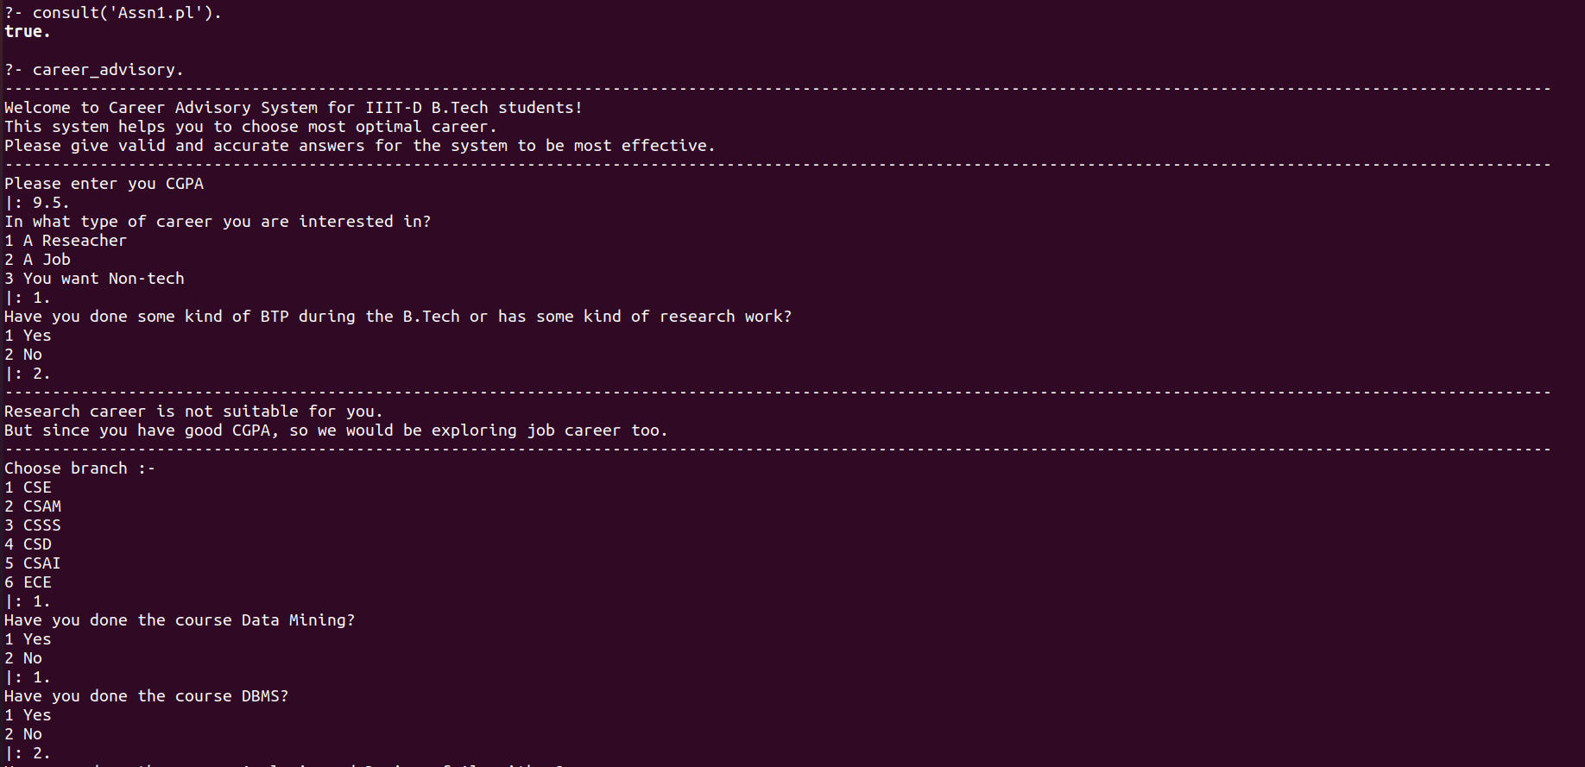
Run 1:
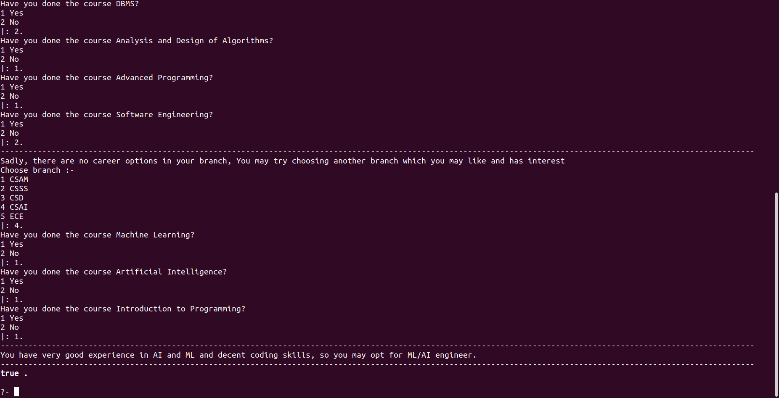

Run 2:
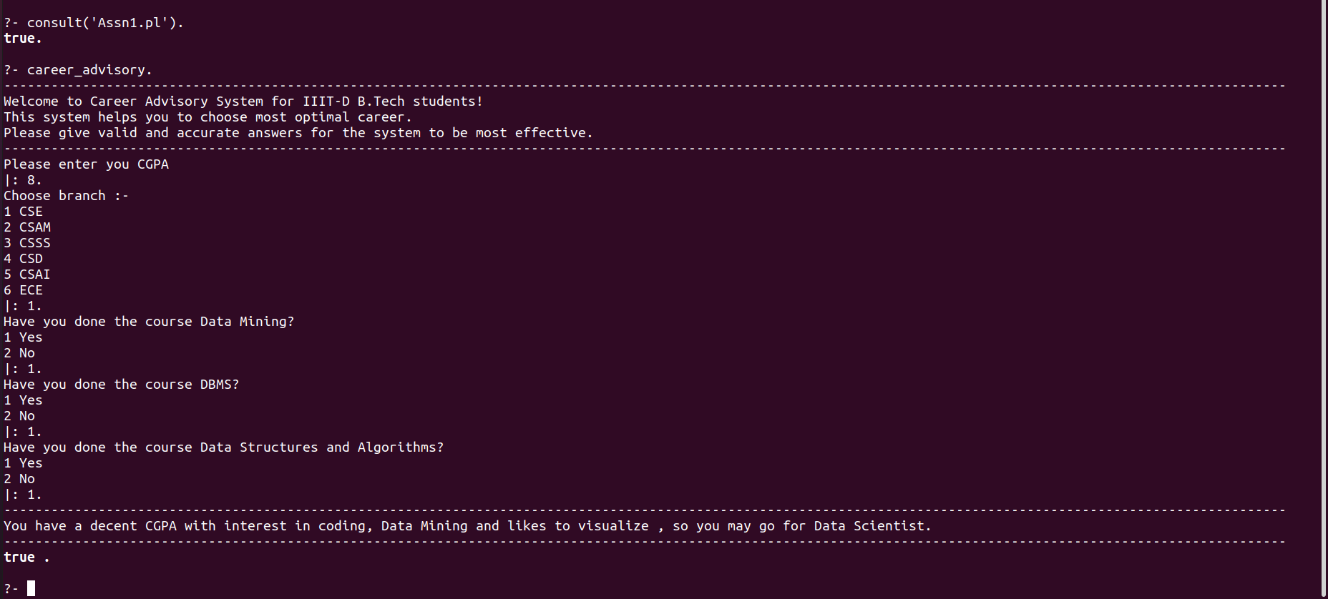

Run 3:
