Methodology:-
- json is converted into dataframe
- dataframe is pre-processesed to validate data, cleaning up, remove all useless columns.
- If date of any row is invalid then that row is removed.
- Rows whose dates are outside start_date and end_date are removed.
- Rows are sorted by dates.
- 3 dataframes are created from the dataframe above.(For confirmed, recovered, deceased) and ‘status’ column is removed from those 3.
- Count of confirmed, recovered, deceased cases in all states is assumed to be an integer and if found not integer then it is replaced by zero so that we can perform integer operations on that.
Assumptions :-
- states = ['ap', 'ar', 'as', 'br', 'ct', 'ga', 'gj',
'hp', 'hr', 'jh', 'ka', 'kl', 'mh', 'ml', 'mn',
'mp', 'mz', 'nl', 'or', 'pb', 'rj', 'sk', 'tg',
'tn', 'tr', 'up', 'ut', 'wb']
- uts = ['an', 'ch', 'dd', 'dl', 'dn', 'jk', 'la', 'ld', 'py']
- Delhi is a Union territory.
- ‘un’ column is removed from dataset.
- in Q1_1, ‘tt’ is not used, all states and Uts are considered.
- start_date and end_date format – YYYY-MM-DD and dates are assumed to be valid, otherwise proper message will be displayed.
- In Q_3, start_date is considered as origin.
- If some state in missing in a row, then its value is assumed to be zero.

Output :
2018101 and 2018261

Q1_1 :-

confirmed_count: 4110214 recovered_count: 3177666 deceased_count: 70095

Q1_2 :-

confirmed_count: 188193 recovered_count: 163785 deceased_count: 4538

Q1_3 :-

confirmed_count: 1072055 recovered_count: 800359 deceased_count: 30813

Q1_4 :-

Confirmed :-
Highest affected State is: ['mh']
Highest affected State count is: 883862

Recovered :-
Highest affected State is: ['mh']
Highest affected State count is: 636574

Deceased :-
Highest affected State is: ['mh']
Highest affected State count is: 26275

Q1_5 :-

Confirmed :-
Lowest affected State is: ['mz']
Lowest affected State count is: 1062

Recovered :-
Lowest affected State is: ['mz']
Lowest affected State count is: 713

Deceased :-
Lowest affected State is: ['mz']
Lowest affected State count is: 0

Q1_6 :-

Confirmed :-
Day: 2020-06-23
Count: 3947

Recovered :-
Day: 2020-06-20
Count: 7725

Deceased :-
Day: 2020-06-16
Count: 437

Q1_7 :-

State Active_Cases
ap 100880
ar 1525
as 28404
br 16735
ct 22320
ga 4945
gj 16266
hp 2023
hr 14912
jh 14980
ka 100224
kl 21867
mh 221013
ml 1374
mn 1872
mp 15687
mz 349
nl 701
or 25856
pb 15870
rj 14996
sk 561
tg 32405
tn 51580
tr 5905
up 59963
ut 7649
wb 23390

Q3 :-

0.5298536209553159 12.2142692053709 -146.1371340523883 12.305528285274049 9.138674884437597 0.19023332599603787

Q3 plots
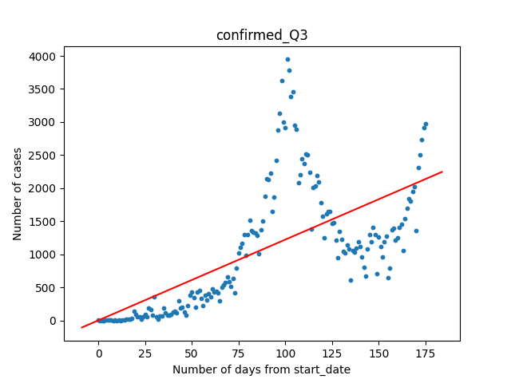
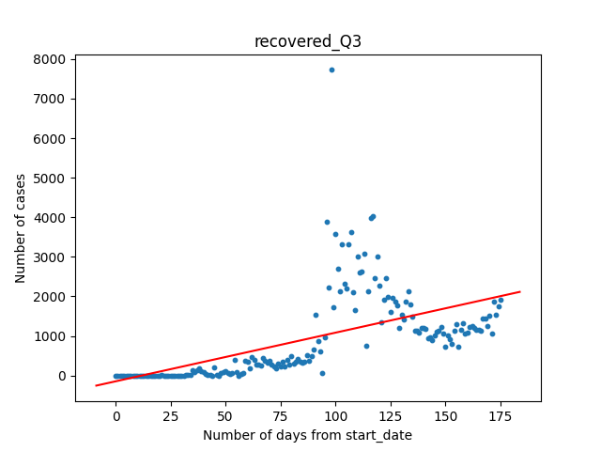

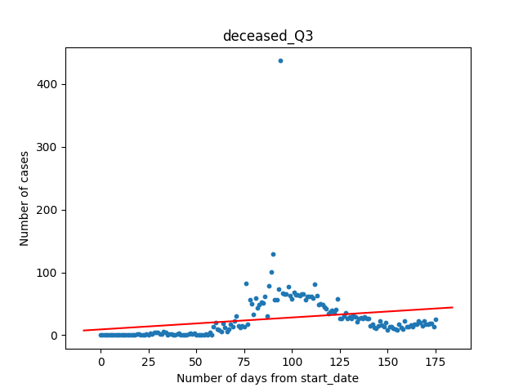

Q2_1 plots :
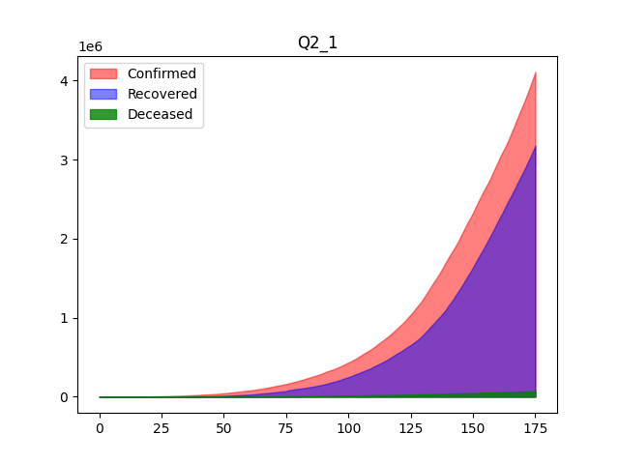
Q2_2 plot:
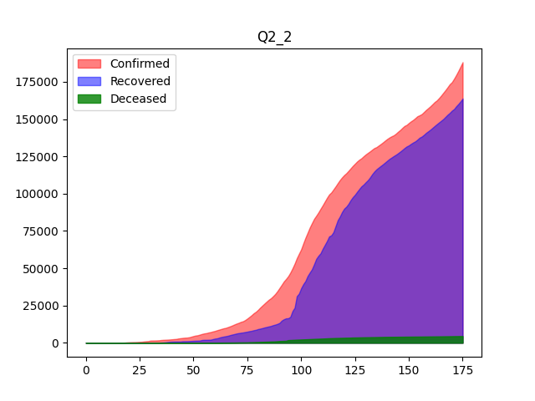
Q2_3:
