Abstract

In today's competitive environment, the security concerns have grown tremendously. In the modern world, possession is known to be 9/10'ths of the law. Hence, it is imperative for one to be able to safeguard one's property from worldly harms such as thefts, destruction of property, people with malicious intent etc. Due to the advent of technology in the modern world, the methodologies used by thieves and robbers for stealing has been improving exponentially. Therefore, it is necessary for the s the improvement in mass media and various forms of communication, it is now possible to monitor and control the environment to the advantage of the owners of the property. surveillance techniques to also improve with the changing world.  
the improvement in mass media and various forms of communication, it is now possible to monitor and control the environment to the advantage of the owners of the property. The latest technologies used in the fight against thefts and destruction are the video surveillance and monitoring. By using the technologies, it is possible to monitor and capture every inch and second of the area in interest. However, so far, the technologies used are passive in nature in the monitoring systems only help in detecting the crime participate in stopping or curbing the crime while it takes place. Therefore, we have developed a methodology to detect the motion in a video stream environment and this is an idea to ensure that the monitoring systems not only actively participate in stopping the crime.

**Introduction**  
In recent years, motion detection has attracted a great interest from computer vision researchers due to its promising applications in many areas, such as video surveillance, traffic monitoring or sign language recognition. However, it is still in its early developmental stage and needs to improve its robustness when applied in a complex environment: Several techniques for moving object detection have been proposed among them the three representative approaches are temporal differencing, background subtraction and optical flow.

Temporal differencing based on frame difference, attempts to detect moving regions by making use of the difference of consecutive frames (two or three) in a video sequence. This method is highly adaptive to dynamic environments, but generally does a poor job of extracting the complete shapes of certain types of moving objects. Background subtraction is the most commonly used approach in presence of still cameras. The principle of this method is to use a model of the background and compare the current image with a reference. In this way the foreground objects present in the scene are detected.

**Problem Statement**

Developing a solution for identification rendering a human face in videos on real time basis.By using this technique we can identify miscellaneous activity in such areas where we can’t personally present.

**Literature Survey**

The research conducted so far for object detection and tracking objects in video surveillance system are discussed in this chapter. The set of challenges outlined above span several domains of research and the majority of relevant work will be reviewed in the upcoming chapters. In this section, only the representative video surveillance systems are discussed for better understanding of the fundamental concept. Tracking is the process of object of interest within a sequence of frames, from its first appearance to its last. The type of object and its description within the system depends on the application. During the time that it is present in the scene it may be occluded by other objects of interest or fixed obstacles within the scene.

A tracking system should be able to predict the position of any occluded objects. Object tracking systems are typically geared towards surveillance application where it is desired to monitor people or vehicles moving about an area. There are two district approaches to the tracking problem, top-down and another one is bottom-up. Top-down methods are goal oriented and the bulk of tracking systems are designed in this manner. These typically involve some sort of segmentation to locate region of interest, from which objects and features can be extracted for the tracking system. Bottom-up respond to stimulus and have according to observed changes.

The top-down approach is most popular method for developing surveillance system. System has a common structure consisting of a segmentation step, a detection step, and a tracking step.

As per the description in Chapter 1, object tracking has a lot of application in the real world. But it has many technological lacunae still exist in the methods of background subtraction. In this section, some previous works is discussed for frame difference that use of the pixel-wise differences between two frame images to extract the moving regions, Gaussian mixture model based on background model to detect the object and finally background subtraction to detect moving regions in an image by taking the difference between current and reference background image in a pixel-by-pixel, and previous works done for the background modeling. After the detection scenario is over, tracking part is done. Once the interesting objects have been detected it is useful to have a record of their movement over time. So tracking can be defined as the problem of estimating the trajectory of an object as the object moves around a scene. It is necessary to know where the object is in the image at each instant in time. If the objects are continuous observable and their sizes or motion does not vary over time, then tracking is not a hard problem.

In general surveillance systems are required to observe large area like airports, shopping malls. In these scenarios, it is not possible for a single camera to observe the complete area of interest because sensor resolution is finite and structures in the scene limit the visible area. Therefore, surveillance of wide areas requires a system with the ability to track objects while observing them through multiple cameras. But here no discussion about multiple camera network is done.

**Use Case Diagram**

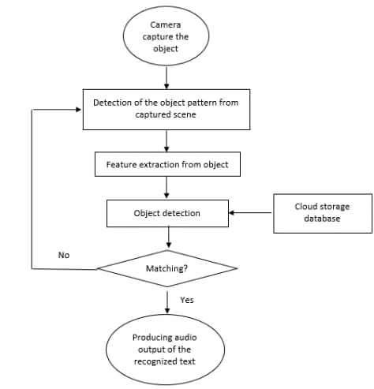

**References**

* A motion detection system in python and Opencv IEEE Paper (Suraiya Parveen &Javeria Shah) Jamia Hamdard University, New Delhi.
* Emotion Detection using image processing in python( raghav Puri,archit Gupta, manas sikri, Mohit Tiwari, Nitish Pathak, Shivendra goeal) Bharti Vidyapeeth’s College of Engineering , New Delhi , India.
* MATEC web of Conference 2017.
* Phillipp Wagner July 2012(Face recognition with Python.
* An Intelligent motion detection using Opencv , International journal of scientific research in science , engineering and technology.
* A survey on object detection and tracking algorithm by Rupesh Kumar Rout , CSE Department NITRourkela.
* Real time abnormal function detection in surveillance video by Massachusetts Institiute of technology Cambridge University.