**Farming Web Assistant**

T.E. Phase I Mini Project report submitted in partial fulfilment of the requirements of the degree of

**Bachelor of Engineering (B.E.)**

in

**INFORMATION TECHNOLOGY**

by

|  |  |
| --- | --- |
| **Reenav Hemaria** | **EU1194028.** |
| **Shubham Kerkar** | **EU1194042.** |
| **Siddhesh Chavan**  **Aishwarya Ingale** | **EU1194007.**  **EU1194033.** |

Under the guidance of

|  |
| --- |
| **Ms. Linda John** |
| Assistant Professor |



**Department of Information Technology**

**St. John College of Engineering and Management, Palghar**

**University of Mumbai**

2021–2022

# CERTIFICATE

This is to certify that the T.E. Mini Project entitled **“Farming Web Assistant”** is a bonafide work of **“Reenav Hemaria” (EU1194028 ), “ Shubham Kerkar” (EU1194042), “Siddhesh Chavan”(EU1194007)** and **“Aishwarya Ingale” (EU1194033)** submitted to University of Mumbai in partial fulfilment of the requirement for the award of the degree of **“Bachelor of Engineering”** in **“Information Technology”** during the academic year 2021–2022.

| **Ms. Linda John** |
| --- |
| Project Guide |

| **Mrs. Anita Chaudhari** | **Dr. G.V. Mulgund** |
| --- | --- |
| Head of Department | Principal |

ii

**B.E. Project Report Approval**

This Mini Project report entitled ***Farming Web Assistant*** by ***Reenav Hemaria, Shubham Kerkar, Siddhesh Chavan, Aishwarya Ingale*** is approved for the degree of ***Bachelor of Engineering*** in ***Information Technology*** from ***University of Mumbai***.

### Examiners

1.

2.

Date:

Place: Palghar

**Declaration**

We declare that this written submission represents our ideas in our own words and where others’ ideas or words have been included, we have adequately cited and referenced the original sources. We also declare that we have adhered to all principles of academic honesty and integrity and have not misrepresented or fabricated or falsified any idea/data/fact/source in our submission. We understand that any violation of the above will be cause for disciplinary action by the Institute and can also evoke penal action from the sources which have thus not been properly cited or from whom proper permission has not been taken when needed.



---------------------------------------

Signature

**Reenav Hemaria** (**EU1194028.)**

---------------------------------------

Signature

**Shubham Kerkar** (**EU1194042.)**

---------------------------------------

Signature

**Siddhesh Chavan** (**EU1194007.)**

---------------------------------------

Signature

**Aishwarya Ingale** (**EU1194033.)**

Date:

**Abstract**

*Farming is the prime occupation in India. Even After All the Hard Work and The Production Done by The Farmers, In Today’s Market, The Farmers Are Cheated by the middlemen and take all the high margin profits, So the farmers don’t get better rates for their own products. Hence there arises a need to help the farmers to get better profits for their products. This project will be developed for the same purpose to eliminate the middlemen and farmers can directly sell on it.*

*Farmers and Consumers will have to first register themselves into the system. In farmers login sellers can add their products for sale and the consumers/buyers can buy the product directly from the farmers. So, the farmers will get better rates since the middleman is eliminated.*

*This application will be made with the help of HTML,BS, CSS, ReactJS. The proposed application will have two logins, one for farmers and other for the consumers. The database of this application will be created using Firebase.*

***Keywords—*** *consumers, farmers, products*

**Table of Contents**

|  |  |  |
| --- | --- | --- |
|  | **Abstract** | **v** |
|  | **List of Figures** | **vii** |
|  | **List of Tables** | **viii** |
|  | **List of Abbreviations** | **ix** |
| **Chapter 1** | **Introduction** | **1** |
|  | 1.1 Objectives | 2 |
|  | 1.2 Scope | 2 |
| **Chapter 2** | **Review of Literature** | **3** |
|  | 2.1 Agro Bidding - A Smart Dynamic System for Enhancement of Farmer’s Lifestyle | 3 |
|  | 2.2. A Study of Blockchain Technology in Farmer’s Portal. | 4 |
|  | 2.3 Implementing E-Commerce model for Agricultural Produce: A Research Roadmap | 4 |
|  | 2.4 Implementing E-Commerce model for Agricultural Produce: A Research Roadmap | 5 |
|  | 2.5 An Efficacious E-Portal for Rancher to Buy Seeds and Humus. | 5 |
| **Chapter 3** | **Requirements Gathering and Planning** | **6** |
|  | 3.1 Requirement Elicitation | 6 |
|  | 3.1.1 Use case Diagram | 6 |
|  | 3.2 Dataflow Diagrams (DFDs) | 7 |
|  | 3.2.1 Level 0 DFD | 7 |
|  | 3.2.2 Level 1 DFD | 8 |
|  | 3.3 Feasibility Study | 9 |
|  | 3.3.1 Technical Feasibility | 9 |
|  | 3.3.1.1 Hardware Requirements | 9 |
|  | 3.3.1.2 Software Requirements | 9 |
| **Chapter 4** | **Report on Present Investigation** | **10** |
|  | 4.1 Proposed System | 10 |
|  | 4.1.1 Block diagram of Proposed System | 11 |
|  | 4.2 Implementation | 12 |
|  | 4.2.1 Pseudo code | 13 |
|  | 4.2.2 Screenshots of the output with description | 20 |
| **Chapter 5** | **Technologies Used** | **25** |
| **Chapter 6** | **Results and Discussions** | **26** |
| **Chapter 7** | **Conclusion and Future Work** | **27** |
|  | **References** | **28** |
|  | **Acknowledgments** | **29** |

**List of Figures**

|  |  |  |
| --- | --- | --- |
| **Figure No.** | **Figure Name** | **Page No.** |
| 3.1.1 | Use case Diagram | 6 |
| 3.2.1 | Level 0 DFD | 7 |
| 3.2.2 | Level 1 DFD | 8 |
| 4.1.1 | Proposed System | 11 |
| 4.2.1 | Pseudo code | 13 |
| 4.2.2 | Screenshots of the output with description | 20 |

**List of Abbreviations**

|  |  |
| --- | --- |
| **SJCEM** | St. John College of Engineering and Management |
| **JS** | JavaScript |
| **CSS** | Cascading Style Sheet |
| **HTML** | Hyper Text Markup Language |
| **BS** | Bootstrap |

**Chapter 1**

**Introduction**

* Portal for farmer to sell product at better rate System is to help farmers to update farm product related information in the website.
* It enables farmers to sell their product direct to customer or farmers can do direct delivery of product to the seller/consumer.
* It will help both the farmer as well as the customer where the customer can save some money and the farmer will gain extra profit.
  1. **Motivation**
* The Farmers are Cheated by the middlemen and take all the high margin profits, therefore the farmers don’t get better rates for his or her own products.
* This project are developed for a similar purpose to eliminate the middlemen and farmers will directly sell on that.
* Farmers and shoppers will need to initial register themselves into the system. In farmers login sellers will add their products available and therefore the consumers/buyers can purchase the merchandise directly from the farmers.
* So, the farmers can get better rates since the middleman is eliminated.
  1. **Problem Statement**
* Farm Fresh aims to connect the farmers directly to the Consumers.
* Currently, Farmers are not getting good rates cause of the middleman.
* So our Farm fresh eliminates the middleman and connect farmers directly to consumers.

**1.3 Objectives**

The objectives are as follows:

* Farmer can sell the product by himself no need of the agent is required to sell the product
* To give the better rate to the farmer from the whole seller or from any user
* Also farmer can deliver the product by himself only so that he can get more profit rather than deliver by the agent.

**1.4 Scope**

This Portal can be further upgraded adding more features, where different sellers can sell their agriculture related products such as fertilizers and agriculture tools, etc.

A more advanced way of this portal can be made by providing farmers to sell their products to other countries.

Also another feature may contain that the buyer can see the location of farmer product.

Adding an secure socket layer would prevent data’s from third parties. More graphics can be added to attract users.

# Chapter 2

**Review of Literature**

## Agro Bidding - A Smart Dynamic System for Enhancement of Farmer’s Lifestyle

The global reach of online auction market places for the buyers and sellers to overcome geographical constraints and purchase products anytime from anywhere over the internet. The online auction market provides the consumers with great advantage of low prices, greater product selection and greater efficiency compared to the usual traditional offline markets. The use of online auction system makes use of the decision making assistance tool that results in greater buyer’s certainty towards their choice of the seller’s and product that they make. The decision making assistance tool consists of three parts that is product information signals, seller’s rating scores and seller’s shilling activities Here all type of user can go and analyze the data of different field and get maximum profit for future investment. This web application system will be a online auction system which consists of the seller, buyer of consumer products.

## A Study of Blockchain Technology in Farmer’s Portal

Blockchain an open, disseminated and decentralized ledger that evidences transactions involving two parties capably in a confirmable and stable way (Iansiti, Lakhani 2017). In the above given definition, open means the blockchain is accessible to one and all, disseminated means that there is no single party control and decentralized means there is no central third party available, capable means it is fast and more scalable than the conventional technologies, confirmable means that everyone can check the validity of the information and stable means that the data is nearly immutable that is it is nearly impossible to change or tamper the data or information. They verify and validate the identities and chronological events. They guide every action, transactions that have taken place among individuals, communities, organizations and nations as well. In this era of digitization, the way maintained and regulated these type of data must be changed, it must be highly secure and the blockchain is the solution to this.

**2.3 PORTAL FOR FARMER TO SELL PRODUCT AT BETTER RATE**

Portal for farmer to sell product at better rate System is to help farmers to update farm product related information in the website. Portal for farmer to sell product at better rate System is farmer product management website application which helps farmers to get best price for farming products. It will also help farmers to improve their product and profit. It enables farmers to sell their product direct to customer or farmers can do direct delivery of product to the seller. Farmers can view labors profile and they direct by the farmer. The Farmers Portal of the Department of Agriculture & Co-operation is a platform or farmers to seek any information related to agriculture. Detailed information on agricultural storage, crops, extension activities, selling the product, interaction with the buyers or wholesaler to get better rate, etc. We are developing an ‘CHATBOT’ for a rapid communication purpose for customer. And also we are adding weather broadcast report in this portal for farmer for corps production. The farmer can be deal with the customer directly so the price of the products offered by the farmer to the customer will also be affordable to customer, it will help both the farmer as well as the customer where the customer can save some money and the farmer will gain extra profit..

**2.4 Implementing E-Commerce model for Agricultural Produce: A Research Roadmap**

The internet has led to the miraculous change in society and across the world. The internet has changed the definition of communication, marketing, education, healthcare, etc. Usage of the internet in the agricultural sector may bring revolution in the economy and improvise the livelihood of the farmers. Agricultural ECommerce facilitates the possibilities of new types of business models by providing farmer to consumer, consumer to farmer, farmer to business and business to consumer services. The implementation of E-Commerce is expected to be more profitable, transparent and competitive[1]. The objectives of E-Commerce include removal of intermediaries benefitting growers and consumers, cross-boundary selling, easy delivery, and price transparency. Agricultural E-Commerce benefits the growers to present their yield in a wider market irrespective of the physical distance and reach the consumer directly. Successful implementation of E-Commerce for agricultural products will help to improve the financial status of the growers and economic growth of the country.

**2.5 An Efficacious E-Portal for Rancher to Buy Seeds and Humus.**

Agriculture is known as skill of cultivating plant or crops. A large population in our nation majorly depends on farming to satisfy their daily needs. Our Indian farming system has been increased with many new technologies to produce maximum farm products and globally India offered with the second position. This portal is developed to view the details of seeds from several part of the area so that farmers can know the details of seeds with their cost at this site instead of searching in other websites. We knew that farmers are built as the backbone of India. They are spending larger amount of cost for producing the products at every season but there is no benefit for them at the period of farm yielding. So for these issues there are many technologies were emerged for farmers and also there are numerous web application and mobile application were available in the market. Our nation is an agriculture based country with rapid growth. This paper is to suggest a solution for a problem such as some web pages are inefficient to use and they could not be able to access without any third person. The portal can be accessed at their dependable languages. This was developed in PHP and enable this system to combine the scrapped web elements from the existing web sites. Here they could be able to buy the fertilizers at optimal price.

# Chapter 3

**Requirement Gathering and Planning**

## Requirement Elicitation

* + 1. **Use Case Diagram**

***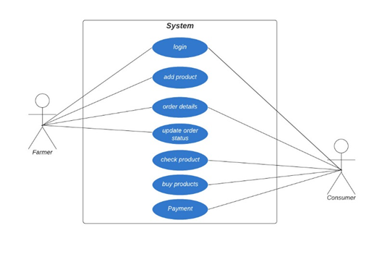***

***Figure 3.1.1:* Use Case Diagram**

## Dataflow Diagrams (DFDs)

* + 1. **Level 0 DFD**

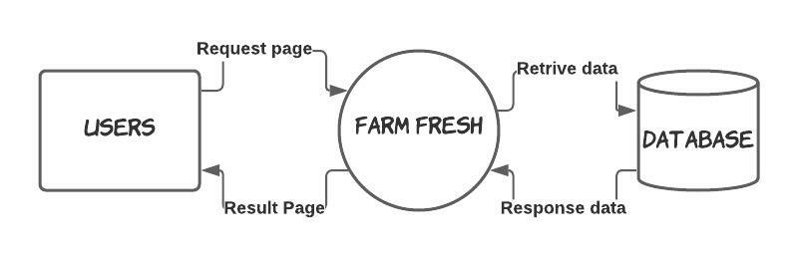

***Figure 3.2.1:* Level 0 DFD**

## Level 1 DFD

**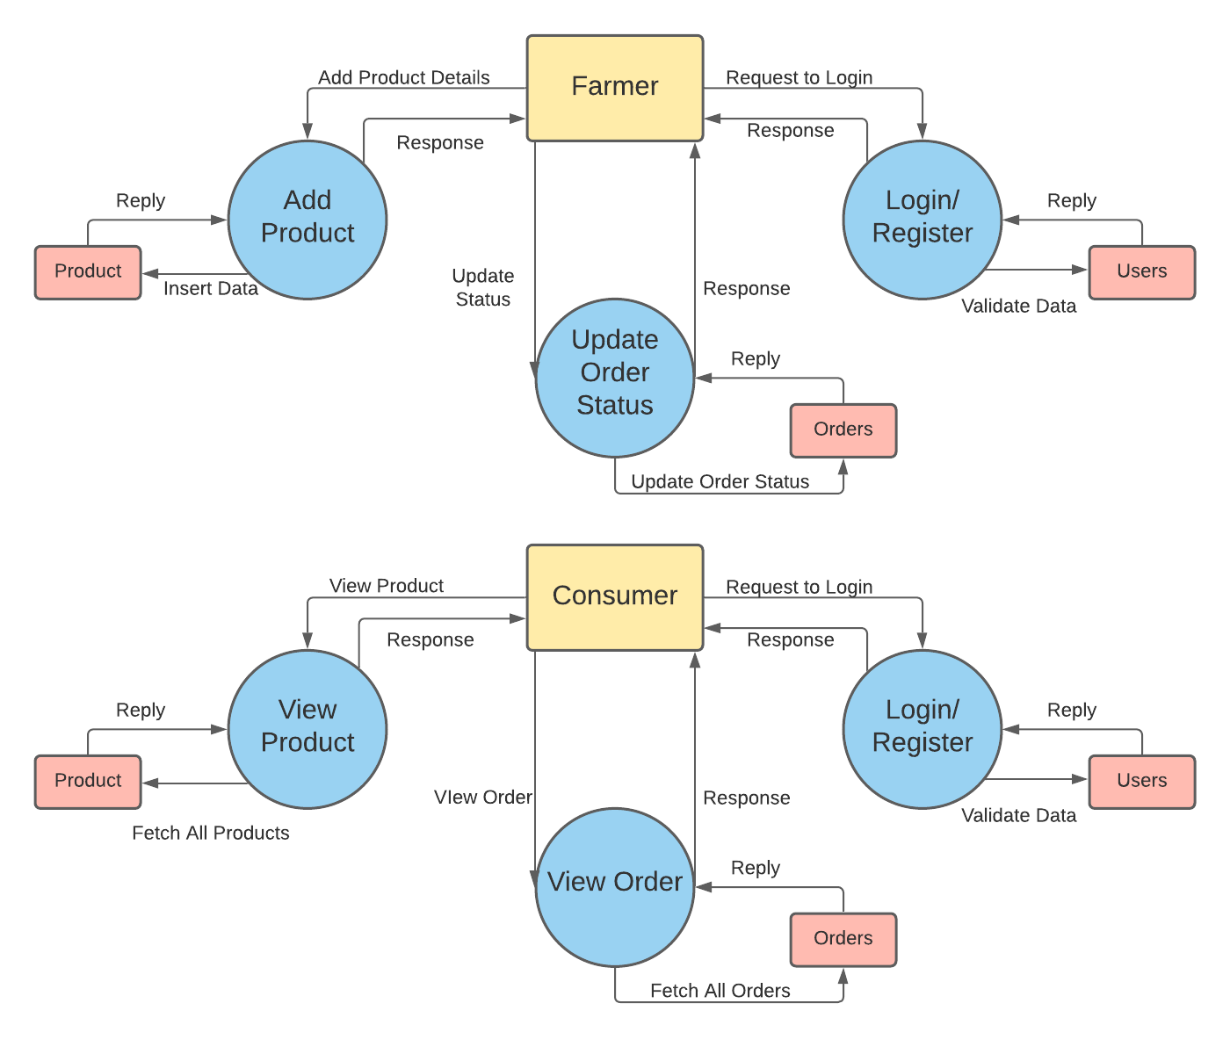**

***Figure 3.2.2:* Level 1 DFD**

## Feasibility Study

* + 1. **Technical Feasibility**
       1. **Hardware Requirements**

**-**4GB RAM minimum.

-i3 Processor minimum.

-OS (windows).

* + - 1. **Software Requirements**

- Browser (Google Chrome).

-Firebase (Database).

-VS Code (To Implement Code).

# Chapter 4

**Report on Present Investigation**

## Proposed System

* + - In this system, we are taking product details from the farmer like the Product Image, Name, Price, Quantity.
    - The System helps the Farmer to sell their products.
    - Consumers can view the products added by the farmers and can buy the products directly from the farmers.

## Block diagram of Proposed System

## D:\Reenav\WD Project\Report\Grp03_BlockDiagram.png

***Figure 4.1.1:* Block Diagram of Proposed System**

## Implementation

* + - We have prepared the database which contains attributes like the Product Image, Name, Price, Quantity.
    - This Details are shown on Consumer side for them to buy the products.
    - After Order has been placed the product details from product database along with information of seller and consumer is sent to the Order database.
    - Farmers can change the Order Status in order table and updated status can be viewed by Consumers.

## Pseudo code

## 

***Figure 4.2.1.1:* Routing.**

## 

## 

## *Figure 4.2.1.2:* Authentication of User

## 

## *Figure 4.2.1.3:* Storing Image in Firebase

## 

## *Figure 4.2.1.4:* Adding Products in Database

## 

## *Figure 4.2.1.5:* Deleting Product in Database

## 

## *Figure 4.2.1.6:* Adding in Cart

## 

## *Figure 4.2.1.7:* Adding Product details in Orders and Removing from Products

## 

## *Figure 4.2.1.8:* Updating Status

## Screenshots of the output with description

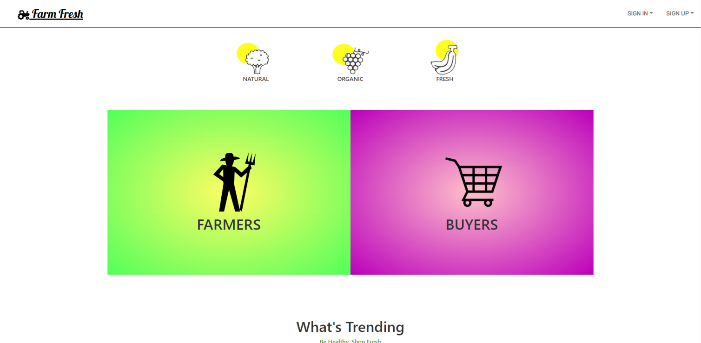

***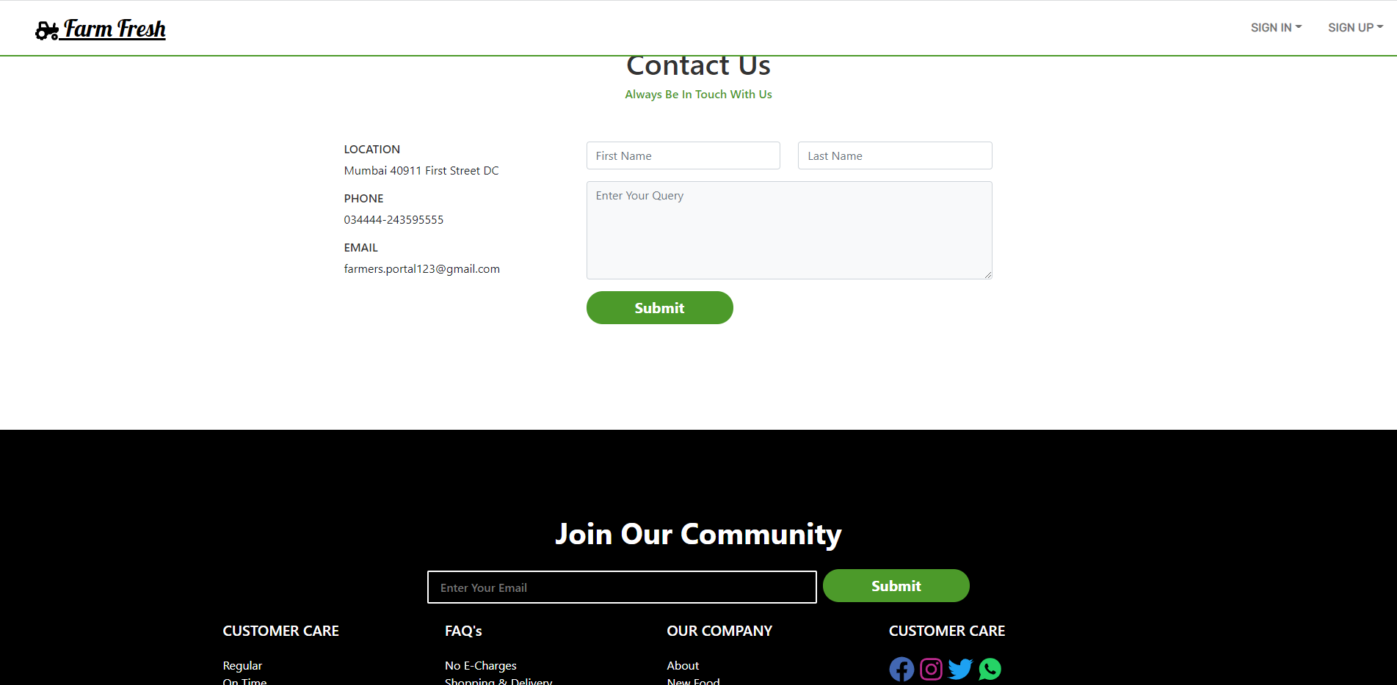***

***Figure 4.2.2.1***

**Farm Fresh (Home page)**

Home of the system where all features are enlisted

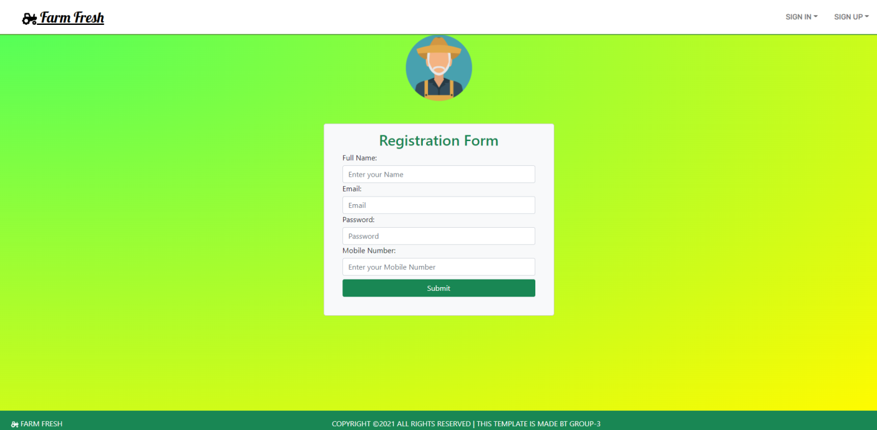

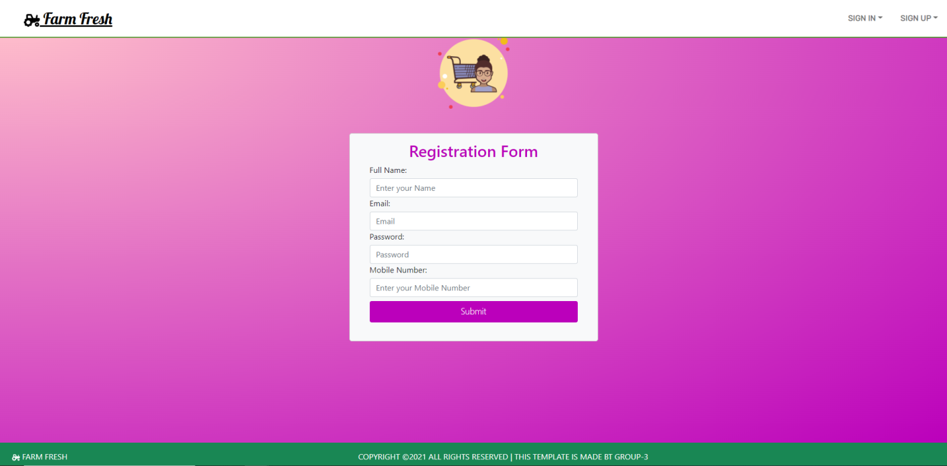

***Figure 4.2.2.2***

**Sign Up page**

Sign up Pages for Farmer and Consumer can be seen here.

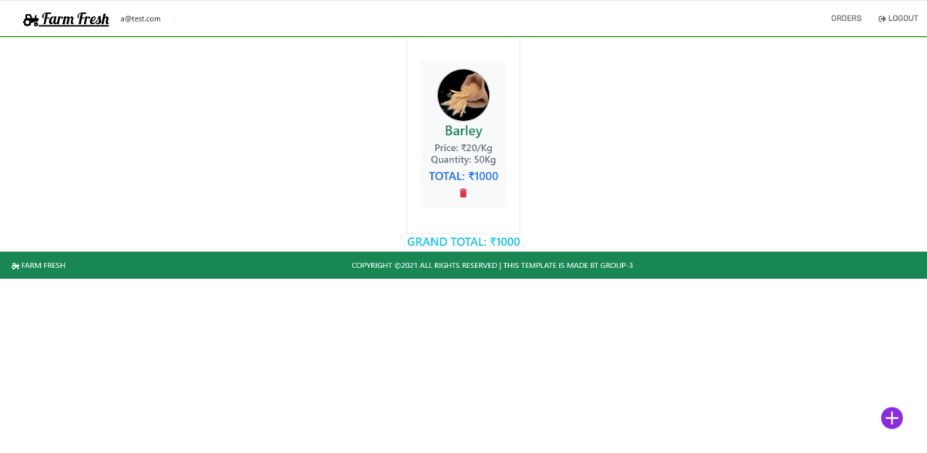

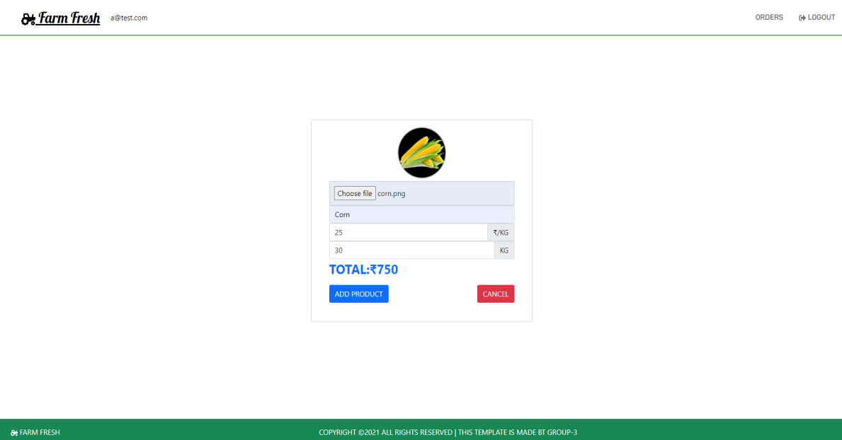

***Figure 4.2.2.3***

**Add Product Page**

List of all Added products and Add products page in Farmer Side can be seen here

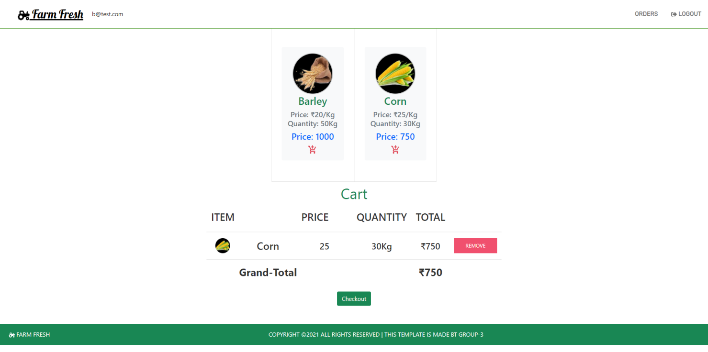

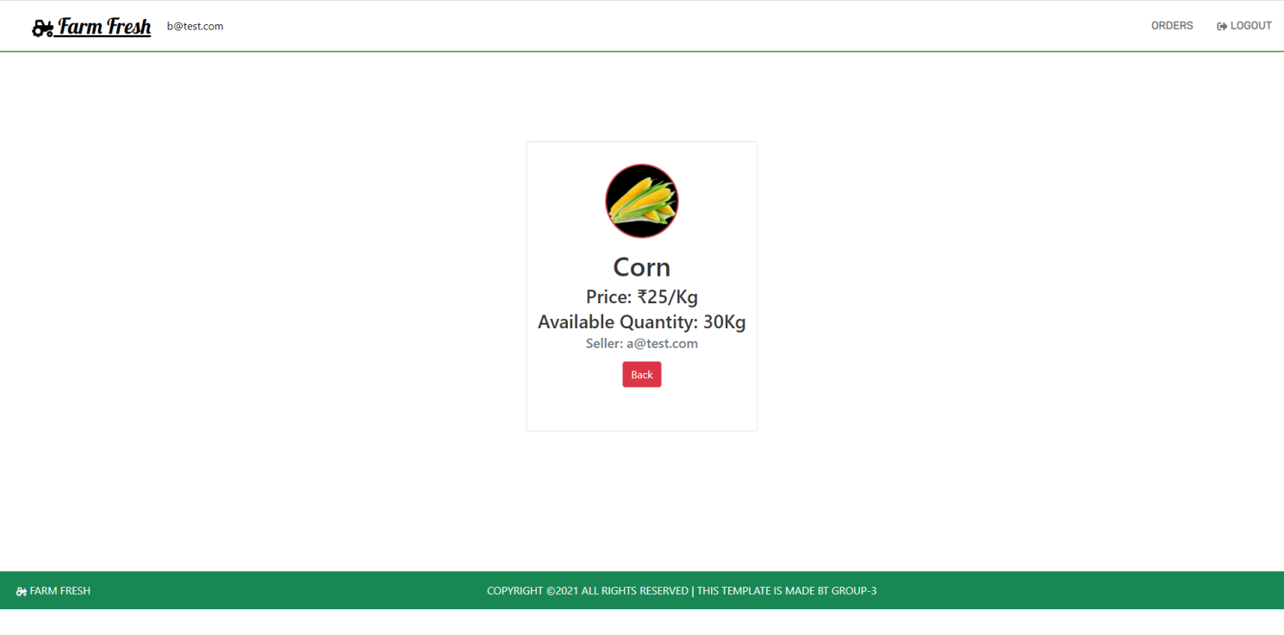

***Figure 4.2.2.4***

**View Product and Cart**

Product details such as price, owner, description and Cart on consumer side can be seen here

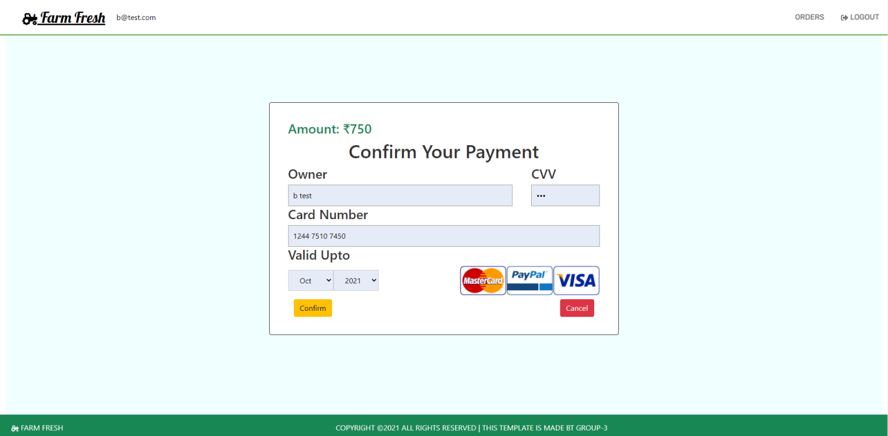

***Figure 4.2.2.5***

**Payment Gateway**

Payment Gateway on Consumer side can be seen here

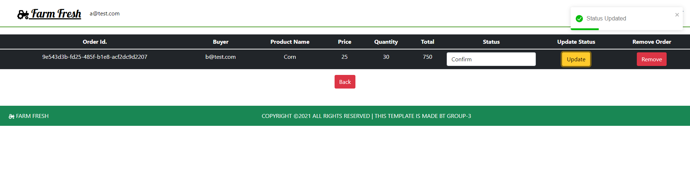

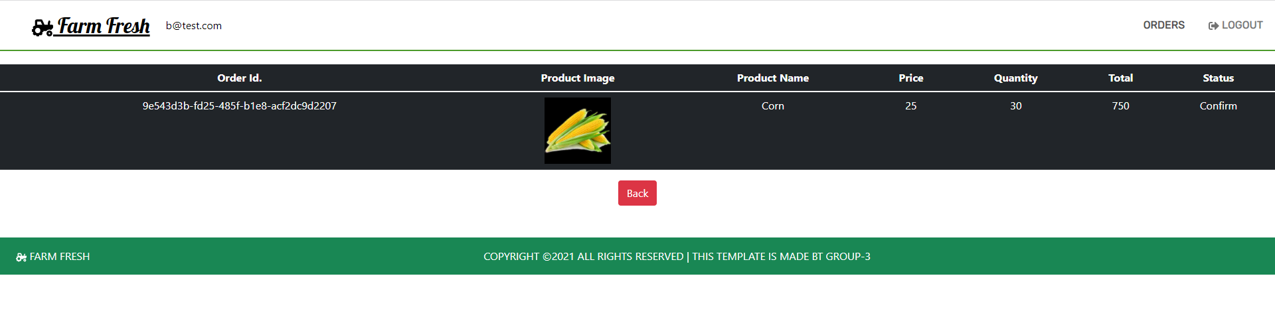

***Figure 4.2.2.6***

**Order page**

Farmers can Update the Status of the received order and Consumer can view details of order placed.

# Chapter 5

**Technologies Used**

## Technologies Used

# ReactJS:- React is a free and open-source front-end JavaScript library for building user interfaces or UI components. It is maintained by Facebook and a community of individual developers and companies. React can be used as a base in the development of single-page or mobile applications.

# HTML:- The HyperText Markup Language, or HTML is the standard markup language for documents designed to be displayed in a web browser. It can be assisted by technologies such as Cascading Style Sheets and scripting languages such as JavaScript.

# CSS:- Cascading Style Sheets is a style sheet language used for describing the presentation of a document written in a markup language such as HTML. CSS is a cornerstone technology of the World Wide Web, alongside HTML and JavaScript.

# Bootstrap:- Bootstrap is a free and open-source CSS framework directed at responsive, mobile-first front-end web development. It contains CSS- and JavaScript-based design templates for typography, forms, buttons, navigation, and other interface components.

# Firebase:- Firebase is a platform developed by Google for creating mobile and web applications. It was originally an independent company founded in 2011. In 2014, Google acquired the platform and it is now their flagship offering for app development.

# Chapter 6

**Results and Discussion**

# Agriculture is the utmost important area especially in the mellowing country like India.

# Use of information technology in agriculture can change the scenario of decision making and framers can yield in a better way.

# In this project, we will suggested for to farmer to get the better profit for the farmer to sell product with the help of this project directly to the customer or a user.

# We have also discussed that he can deliver the product by himself only to get the better rate too. So this will be the better project for the farmer for his profit.

# Chapter 7

**Conclusion and Future Work**

# The portal is for the growth of farmer and increases their important in marketing field.

# This Portal can be further upgraded adding more features, where different sellers can sell their agriculture related products such as fertilizers and agriculture tools, etc.

# Future Work

# A more advanced way of this portal can be made by providing farmers to sell their products to other countries. Also another feature may contain that the buyer can see the location of farmer product.

# Adding an secure socket layer would prevent data’s from third parties. More graphics can be added to attract users.

# References

1. Agricultural Marketing S.S. Acharya Isbn - 81-7188-387-7 Pages-259.
2. Agricultural Marketing Information And Research Network.(Agmarket.Nic.In).
3. E-FARMING, G. H. Raisoni College of Engineering and Management, Pune, India.
4. Agricultural Marketing S.S. Acharya ISBN - 81-7188-387-7.

# Chunlin Luo, Jian Liu- “Dynamic Pricing for Perishable Products by Fuzzy Decision”, IEEE.

# International Conference on Service Operations and Logistics, and Informatics 12-15 oct,2008.

# Acknowledgement

Today, we cannot find appropriate words that will express deep sense of gratitude and satisfaction. We are indebted to our inspiring guide **Ms. Linda John** who have extended all the valuable guidance, along with **Mrs. Anita Chaudhari (**HOD IT Dept.) in helping and giving constant encouragement through various difficult stages for development of the project.

We express our sincere gratitude to our respected principal **Dr. G. V. Mulgund** for encouragement and facilities provided to us. We would also like to acknowledge the patience that our ever-beloved parents have shown during our efforts and the encouragement we have received from them.

Thus, we have fully obliged and convey our thanks to the teaching and as well as non-teaching staff of the department. Special thanks to all the lab assistants for helping us with problems developed in the lab and assisting, helping us to solve any problems generated on the spot. Last but not the least we would like to thank all direct and indirect identities of the college with whom we took the strides for this successful project.