Guided Capstone Project Report

The current price of Big Mountain Resort is $81.

Currently it has the highest ticket price in its state Montana as compared to its competitors in the same state.

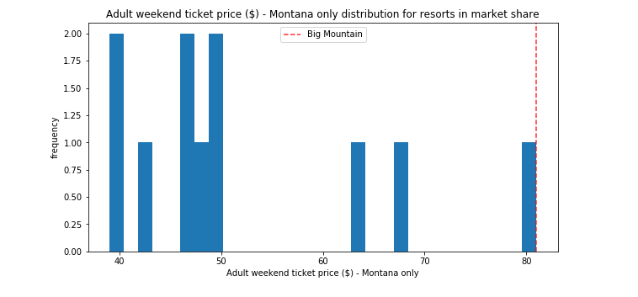

Below figure mentioned the Big mountain resort ticket price as compared to its competitors along different states of country USA.

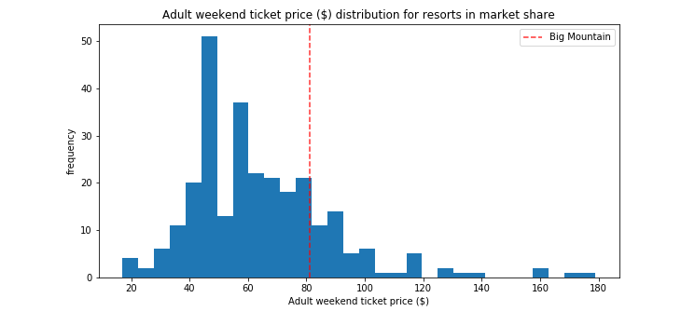

When comparing the ticket price of Big Mountain Resort with other competitors in the USA as per the overall facilities provided by the resorts, there is a prediction that our ticket prices are worth $94. This is an overall 16% increase over our current ticket price.

Also, it has been seen that people are willing to pay more for certain facilities and less for others. Such as it is found that closing down 1 runs will not have any effect on the ticket price or revenue for the resort. Also increasing the vertical drop, chair lifts, runs and snow making in acres shows a significant increase in the ticket prices for the resort.

As we have seen that we are the highest charging resort in our state, but we are also providing much better facilities at the current ticket price. There is almost 16% room for us to increase our ticket prices based on the current scenario. The resort can thus charge their customers a ticket price of $89 which an almost 10% increase to the current ticket prices.