The Electricity Grid is a network that conjoins different forms of power generation to be distributed for commercial or industrial usage, and is composed of three main sections: generation, transmission and distribution, and consumption. The primary focus of this paper, rather than to focus on all of the components of the grid, is to identify and analyze methods of energy generation. The current US electrical grid utilizes multiple different sources of energy production; some of these forms include: petroleum, coal, nuclear power, natural gas, and renewable energy. Amongst these sources, petroleum, coal, and natural gas dominate the market by about 82% of total energy generation (see Figure 1).

Figure 1. Bar graph representation of energy sources contribution to the California electricity grid.

However, as awareness of global warming and greenhouse emissions impact arise, government and institutions are starting to shift towards emission-free generating sources like solar and wind. These renewable sources (RS) currently account for less than 10% of the electrical grid, according to 2015 Quadrennial Technology Review. RS are primarily composed of solar, wind, geo-thermal, biomass, and hydropower. Increasing the usage of these RS not only reduces the amount of fossil fuels needed to supply the grid but in some cases can provide a decentralized electricity distribution. Assessing the disadvantages associated with these sources reflect the high cost of producing renewables compared to fossil fuels, and the difficulty with making the available energy to supply the grid during off peak times due to their cyclical nature (more detail will be provided in the next chapter). Later in this paper we will point out drawbacks that have limit the expansion of RS.

Since the main focus of this project is regarding Nuclear Power it is worth describing more in detail. Although it does not fall under the category of renewable energy, it is considered a source of clean energy. Nuclear power plants (NPPs) have the ability to provide large amount of base load energy to grid but as mentioned before, RS penetration creates a hostile environment for base load power sources. Some other disadvantages associated with NPPs includes it’s high cost, the public’s perception, and the time frame needed for plant construction. In order to efficiently move in the direction of clean energy, the disadvantages of these clean energy sources need to be addressed. In respond to this issue, NPPs capable of load following or the introduction of nuclear-renewable hybrid energy systems (NR-HES) are being proposed (more on this later). All in all, energy production methods should be reliable, clean, and affordable yet none of the methods currently being employed meet these criteria.

A preliminary analysis of the three main energy production methods is performed in the following section to identify some of the strengths and weaknesses of each method.

**Fossil Fuels**

Around two thirds of the energy produced in the US comes from burning fossil fuels (1). There cheap construction and operating costs, and their ability to put produce a variable amount of electricity has made them the main energy production source in the world. The ability to quickly ramp up to full power and lower down in low demand scenarios makes them reliable. Fossil fuels have obvious drawbacks in that they release pollutants to the ambient environment. This all comes at a price. Around 30% of all GHG produced in the US comes from the burning of fossil fuels for electricity. It is well known that these GHG affect climate change around the world and cause not only environmental impact but also health related issues. The WHO estimates that the upwards of seven million people die every year (2).

**Renewables**

While only contributing to a small percentage of all the electricity in the US, renewables (mainly wind and solar) have the potential to address all the criteria for an ideal energy source except for their cyclical nature. This means they only star producing when the wind is blowing or the sun is shining, etc. (3). Due to this dependence on weather, some renewables cannot be incorporated all across the US and the rate of energy production cannot be controlled. For example, if the primary source of energy for a particular region is solar energy, it is expected that these panels will be able to handle periods of little to no sunlight. Although solar energy can still be collected during this time, is lowers the overall efficiency of the system. This is especially significant for solar which produces large amounts of energy at low demand hours often leading to negative pricing of electricity which negatively impacts all energy production methods. innovations are being made to make solar and wind production more efficient or cheaper. In the last thirty years, the cost of wind and solar energy has decreased by over a factor a ten.  Furthermore, in order to better integrate renewables with other technologies, an efficient energy storage method can mitigate the excess energy production renewables bring and these can range from battery storage to heat storage in fire bricks.

**Nuclear**

Nuclear energy produces electricity in a reliable rate but does not produce GHG. Unfortunately, growing penetration of renewable energy in the grid have made base load power plants inefficient and therefore increasingly expensive. Also, these plants can cost upwards of $5-10 billion and delays in construction can significantly affect this estimate. As pointed out at the beginning of this document, increasing contributions of erratic energy sources (mainly from renewables) has made base load power plants less economical as prices fluctuate more frequently while nuclear energy production remains constant.

Just from a preliminary analysis of the main methods of energy production, it is clear that any of them individually will not be able to provide the necessary electricity to the grid while also meeting all three criteria originally listed. While there are many new technologies and techniques being researched that could bolster the strength of these energy production methods, an ideal solution to the clean energy issue should use multiple energy production methods in tandem to capitalize on the benefits of each and increase reliability through diversification.

***Our Proposal***

To deal with the previously mentioned challenges, we need the ability to “load follow” or match the energy output to the demand to prevent financial losses from excess energy being supplied to the grid when demand is low. To fix these issues, we will propose a nuclear-renewable integrated energy system consisting of an advanced nuclear reactor, specifically a molten salt reactor, coupled with a secondary industry process (hydrogen production) and a solar and wind farm. We will now describe each of the constituents in our NR-HES (see Figure 2).

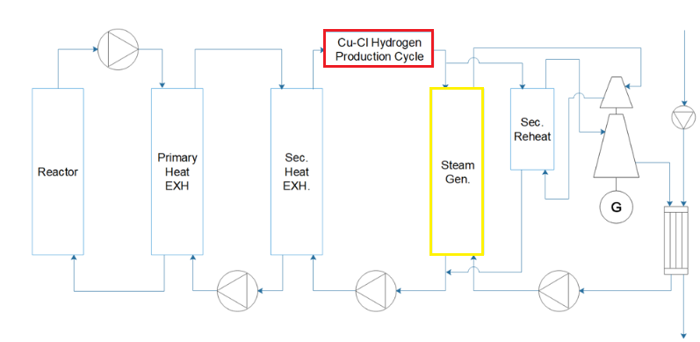

Advanced Nuclear Reactor (ANN)

A molten salt reactor is a generation IV fission reactor and it is based on the molten salt reactor experiment carried in the 1960s at the Oak Ridge National Laboratory. This class of reactors has many advantages compared to current pressurized water and boiling water reactors where the main advantage is that it uses a liquid fuel salt rather than solid fuel rods and that it operates at higher temperatures than currently operated commercial reactors. This and other advantages make it an ideal candidate as a heat supplier for a secondary process to take place, heat that otherwise would be wasted. Worth mentioning, is the negative connotation associated with nuclear base systems. This type of reactor uses liquid fuel which is inherently more safe and because of its physical and chemical properties, it can shut itself down in case of an accident.

Secondary Industry Process – Hydrogen Production

There are many methods to produce hydrogen, be it electrolysis, radiolysis, thermolysis, photo biological and many others. Many of these processes require extreme high temperatures to break down water into its constituents which our chose ANN cannot supply. Because of this there has been increasing research in new production methods with lower heat requirements. For our system we chose a Copper-Chloride (Cu-Cl) thermochemical cycle (See Figure A1) due to the low heat requirements (around 530 C).

Renewables – Solar and Wind

The system will be fit with an industry standard Solar and Wind farm. These farms will supply energy when available and the ANN and HP will work together to allow full supply of renewables by increasing the production of hydrogen this way not oversupplying the grid. This type of systems will prevent power plants from selling electricity at a loss and thus save the plant money throughout the year.

Although the concept has been increasingly researched and companies are starting to patent variations of these systems, that there are no existing NR-HES in the world operating. While most of these patents are filed from major industry leaders such as General Electric, Hitachi, Mitsubishi and Toshiba, they are vastly different in design specifications. Some of these differences are in their design interconnections, energy generating sources, and the methods in which energy is transferred from the generating source to the industry process.

APPENDIX

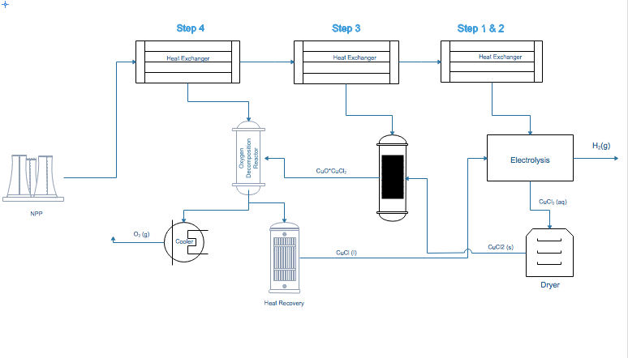

Figure A1. Cu-Cl Thermochemical Hydrogen Production process. The ANN provides thermal energy to three heat exchangers this way providing heat to every step of the hydrogen production process.