***Fundamentals for Supercritical Steam Generator***

In order to figure out the outlet temperature of the steam generator the following heat transfer to supercritical water correlation was used:

$$Nu_{b}=0.0061 Re_{b}^{0.904}\overline{{Pr}_{b}^{0.684}}{\left(\frac{ρ_{w}}{ρ_{b}}\right)}^{0.564}$$

Where:

* $Nu$- Nusselt Number

$$Nu= \frac{hD}{k}$$

Where:

* $h$ is the heat transfer coefficient ($W/m^{2}K)$
* $D$ is the diameter ($m$)
* $k$ is the thermal conductivity ($W/m K$)
* $Re$- Reynolds Number

$$Re= \frac{GD}{μ}$$

Where:

* $G$ is the mass flux $(kg/m^{2}s)$
* $D$ is the diameter ($m)$
* $μ$ is the dynamic viscosity ($Pa*s$)
* $Pr$- Averaged Prandtl Number

$$Pr=\frac{μc_{p}}{k}$$

Where:

* $μ$ is the dynamic viscosity ($Pa*s$)
* $c_{p}$ is the specific heat ($J/kg K$)
* $k$ is the thermal conductivity ($W/m K$)
* $ρ$- Density of water and bulk respectively ($kg/m^{3}$)

Knowing the average Nusselt number we are able to solve for the average heat transfer coefficient ($h$):

$$h= \frac{Nu*k}{D}$$

All the physical variations of water due to phase transitioning’s are taking into account in this value. It is also worth mentioning that since this is a supercritical steam generator there is a direct two phase transition as long as the working fluid is above its critical temperature (368C). This average heat transfer coefficient can then be use to estimate the temperature of the generated steam at a specific mass flow rate by the following relation:

$$Q=UA\left(∆T\right)=h\left(∆T\right)=∆H*m$$

$$T_{2}=\frac{Q}{h}+T_{1}$$

In order to automatize the process some assumptions where made. Mass flow rate stays the same throughout the steam generator water loop. Pressure drops through the steam generator are negligible.

***How Load Following is Achieved***

Since our last deliverable, the method by which we load follow has changed significantly. While we initially wanted to siphon molten salt heat from the tertiary loop we ran into the following problems. This method made it such that the molten salt going into the electricity generation side was lower which then decreased the temperature of the steam going into the turbine. This created the following issues:

* Thermal efficiency of the turbine would decrease since the difference between the T_hot and T_cold is smaller (recall that Carnot efficiency is 1-Tcold/Thot
* There would always be a loss in energy as the molten salt has to travel through hydrogen production first
* Heat transfer between the molten salt and water decreases as the salt gets colder
* Assumptions for the steam temperature at different points had to be made and it is possible that these assumptions weren’t completely valid with changing temperatures

Now instead, the molten salt will be siphoned off toward the hydrogen production side. For example, instead of putting 50% of the heat into the steam generation first and then the latter lower quality heat into the energy production, 50% of the salt flow is split between the two functions such that both systems receive high quality heat. As we looked into the hydrogen production side, we came across a concern that hydrogen production couldn’t simply be ramped up and down just based on the amount of heat we put into that system. To better explain this, we look into one of the steps in hydrogen production that basically forces us to heat up chemicals to a certain temperature to get the reaction flowing. This means that if we undersupply heat, we get no generation and if we oversupply heat, we would get the same amount of generation as if we supplied the bare minimum.

To circumvent this issue, we turned to a rather simple solution. The idea was that instead of having one large hydrogen production line, we’d have several smaller hydrogen production lines such that we can input variable amounts of heat (or salt flow percentage). In this system, we can load follow to discrete points. That is to say that if we have 10 hydrogen production lines that can each take 5% of the overall salt flow, then we can off load 50% of the overall salt flow to hydrogen production in discrete increments of 5%. With a greater number of smaller hydrogen production lines, better load following can be achieved but the economic viability of our system will decrease the more production lines we include. We will further look into the economic viability and explore the trade-off between highly accurate load following and financial capital necessary.

***Graphs***

The graph below shows the relationship between the electricity generated and the percentage of the molten salt that goes toward the energy generation side. Currently, this relationship assumes that the efficiency of the turbine converting steam into the blade’s kinetic energy stays constant throughout all mass flow rates.

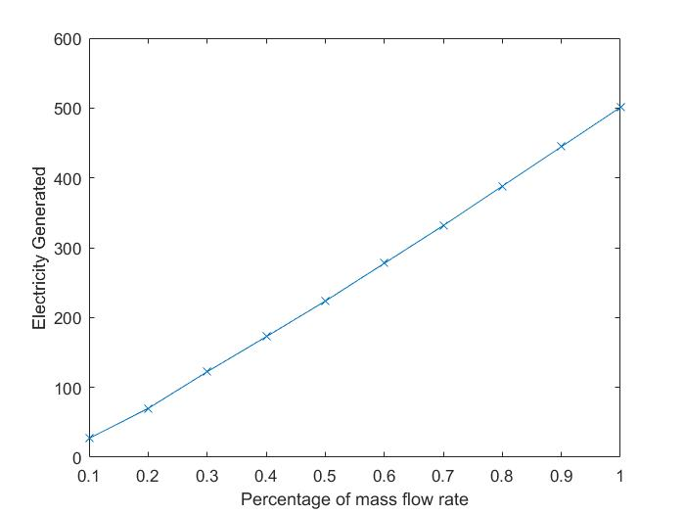

The graph below shows the relationship between the mass flow rate of the water/steam and the percentage of molten salt (which is equivalent to the percentage of thermal energy used) that’s diverted to the energy generation side. Interestingly, this relationship is also rather linear.

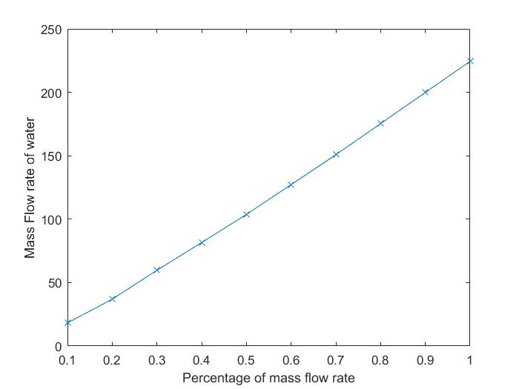

With all this information, the following graph can be generated. The energy generation ratio is the ratio between the net* electricity generated thermal energy lost by the salt (or gained by the water/steam). We notice that below 40% of the mass flow rate, the thermal energy to electric energy generation rapidly falls which brings into question the economic benefit of producing electricity below this 40% mass flow rate regime. This idea will be taken further into consideration when we look into the economic viability of running at different electricity/hydrogen production regions.

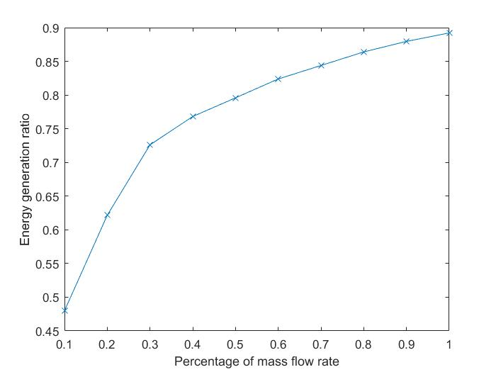

* there are about 15 MWe of electricity used by pumps and other equipment which we assume to stay more or less constant even when the mass flow rates are decreased

***MSR-Hydrogen Design***

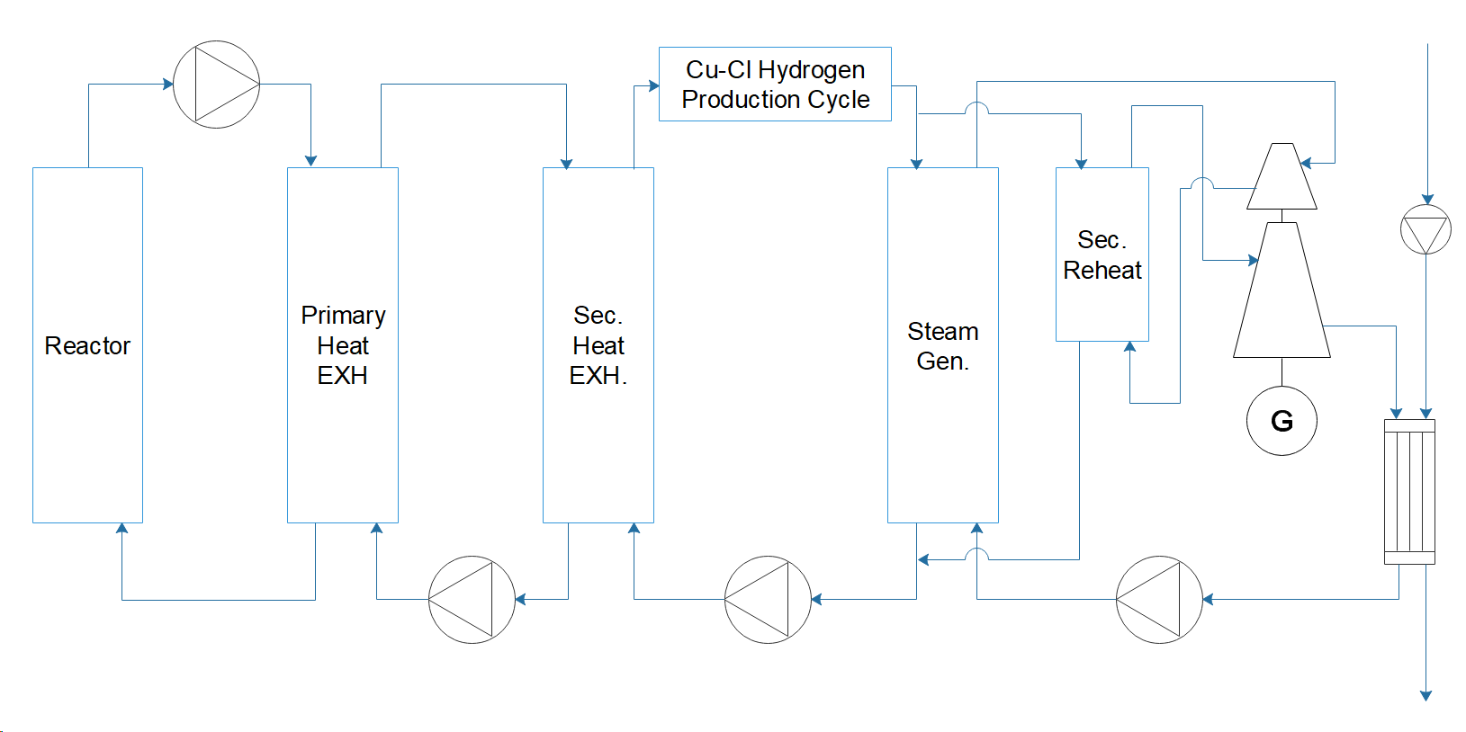

Two power modules emit a total of 1114 MWth and 500 MWe. This means a 45% approximate overall plant efficiency. This is equivalent to fuel consumption of 224 kg of fissile uranium per year. The properties of each of the loops are in Table 1.

|  |  |  |  |  |  |  |
| --- | --- | --- | --- | --- | --- | --- |
|  | **Mass flow (kg/s)** | **Hot**  **C** | **Hot**  **bar** | **Cold**  **C** | **Cold**  **bar** | **Fluid** |
| **Fuelsalt** | 2994 | 704 | 10.5 | 564 | 4.0 | NaF-BeF2-ThF4-UF4 76/12/9.5/2.5 |
| **Secondary Salt** | 1534 | 621 | 10.5 | 454 | 20.0 | NaF-BeF2 57/43 |
| **Tertiary Salt** | 1414 | 598 | 12.0 | 344 | 1.0 | NaNO3-KNO3 55/45 |
| **Steam Main** | 225 | 538 | 248 | 288 | 260 | - |
| **Steam Reheat** | 162 | 538 | 38 | 343 | 39 | - |

**Turbine Island**

* **STF-D1050 (single reheat) Turbine**

Pressure: Up to 360 bar and up to 650 C from main steam

Reheat Temperature: Up to 670 C

Frequency: 50 and 60 Hz

Output: <1200 MW

Steam Turbine Efficiency: up to 54%

* **Gigatop 2-Pole Generator**

Power Factor: 0.8 to 0.9

Apparent Power 590 MVA to 1400 MVA

Efficiency: Up to 99%

Terminal Voltage 18 kV to 27 kV

* **Condenser**

Condenser Vacuum Type: Single

Condenser Thermal Load (MW): 1820

Absolute Pressure at Turbine/Condenser Connection (mbar abs): 55

Max Condensate O2 Content at 100% Load (ppm): 20

Circulating Water

Circulating Water Temperature Design (C): 25

Circulating Water Nature: Seawater, Once-through

Circulating Water Flow (m^3/s): 63

Circulating Water Temperature Rise (c): 7

Tubes

Exchange Surface (m^2): 76000

Material: Titanium

Length (m): 16.5

Tube to Tube sheet Joint: Expanded/Welded

Weights

Operating (tons): 2200

Water Filling (tons): 3600

Dimensions

Hotwell Bottom to Turbine (m): 13