Reactor Loop’s Parameters:

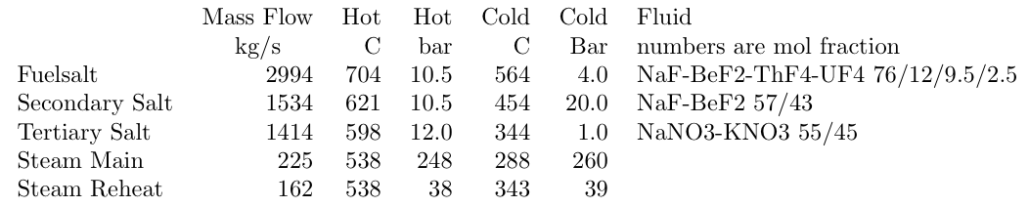

The reactor will be coupled to the hydrogen production process by implementing two heat exchangers in the tertiary loop. One of the heat exchanger is the reactors heat transfer to the steam generator and the second heat exchanger will be the indirect connection from the reactor to the hydrogen process. The tertiary salt will transfer heat to a water loop in the hydrogen process. This water loop will carry the necessary heat for the whole hydrogen plant this way eliminating cost and increasing safety.

Safety and Licensing

Currently the US Department of Energy in collaboration with the National Renewable Energy Laboratory (and other organizations) have started a program entitled Hydrogen, Fuel Cells, and Infrastructure Technologies (HFCIT) which, among other tasks, are preparing reviewing and promulgate hydrogen codes and standards needed to expedite hydrogen infrastructure development including incorporation to nuclear reactor facilities. The next image is the overall structure of the program taken from “Nuclear Energy for Hydrogen Generation through Intermediate Heat Exchangers” by Bahman Zohuri:

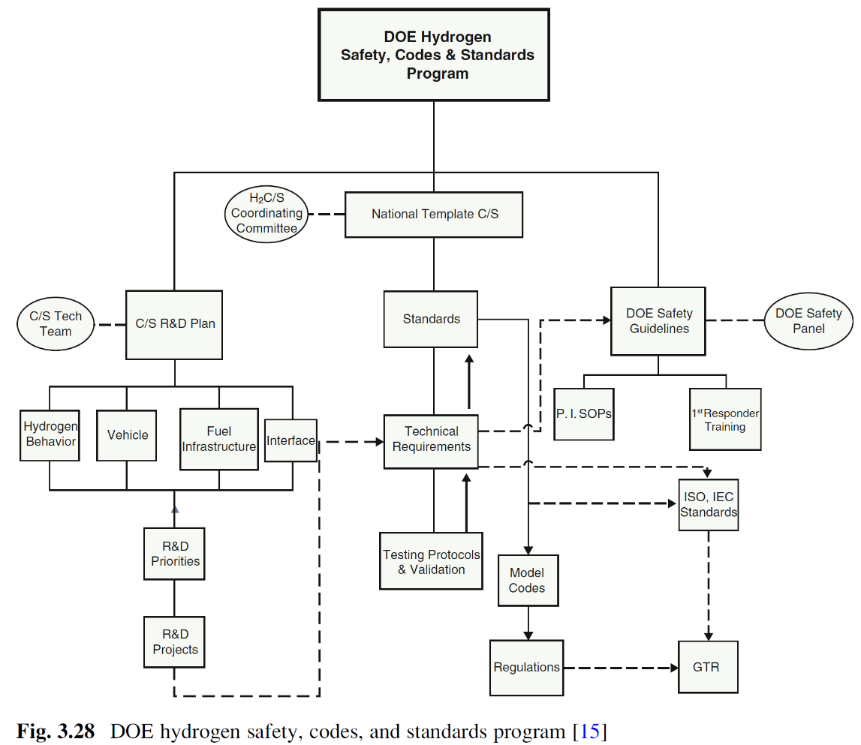

**Figure 1: Overview**

**Figure 2: Reactor Flow Diagram**

**Figure 3: Cu-Cl Hydrogen Production Flow Diagram**