Deliverables:
1. Multi-Tenant Deployment & Dynamic Domain Mapping
Deliverables:
• kubectl get all -n <namespace> for all users.

• Proof of access via curl/browser.
https://user1.example.com/
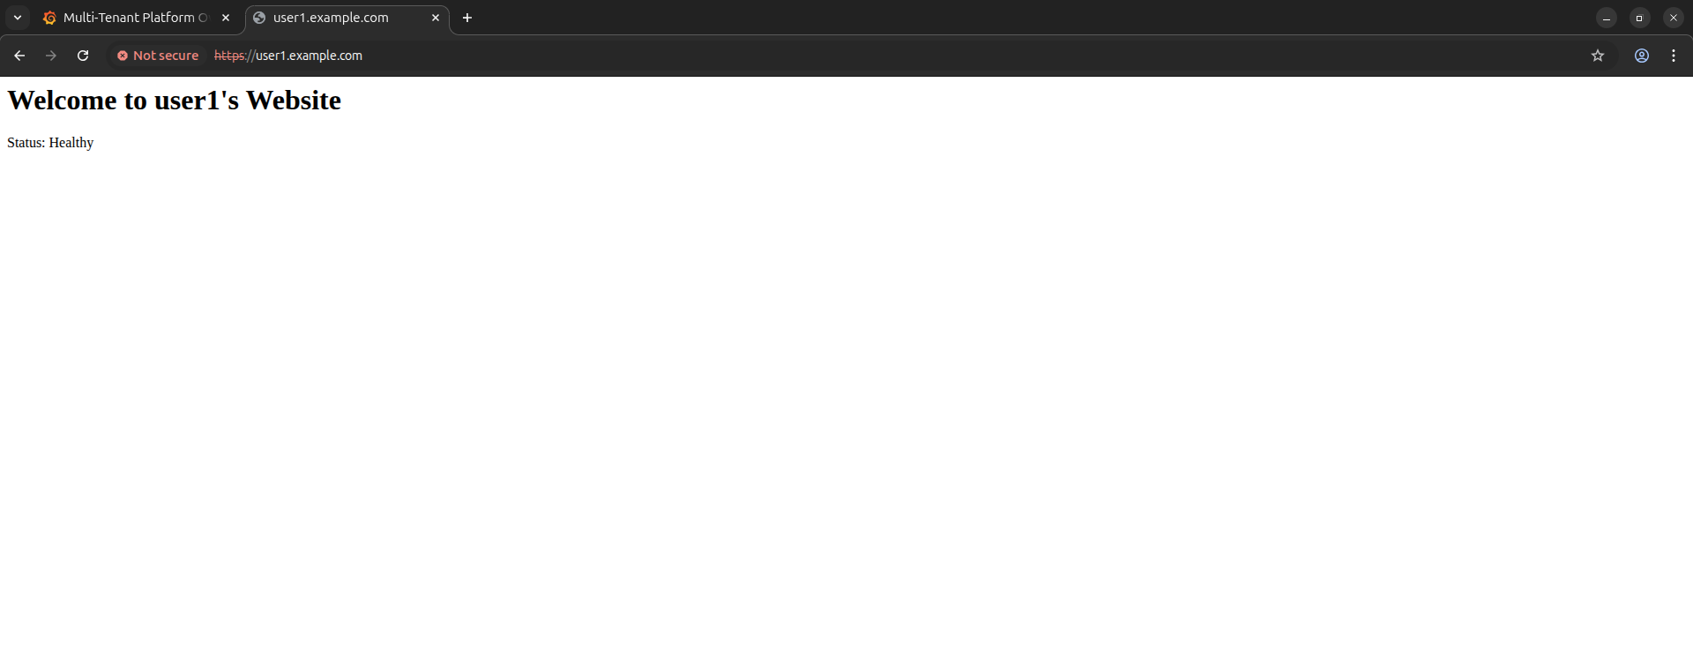
Https://user2.example.com/
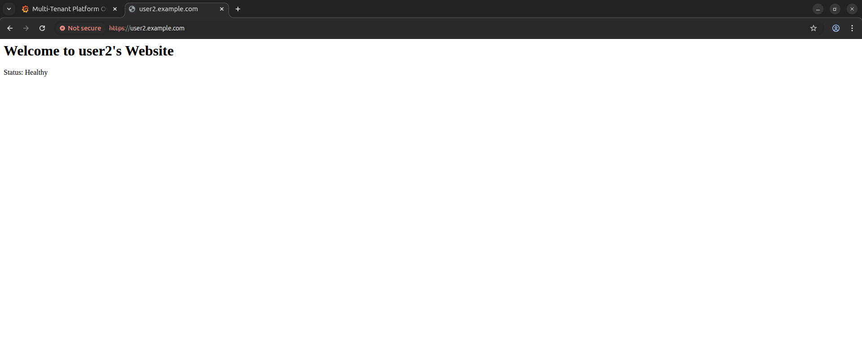
https://user3.example.com/
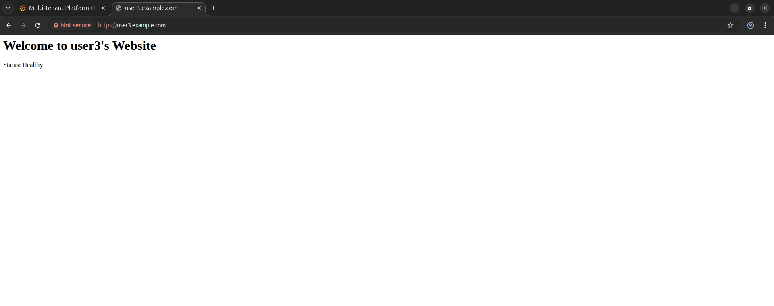
• Short explanation of dynamic domain mapping approach.
• Per-tenant ingress: Every user has their own Ingress resource within a dedicated namespace, allowing independent domain configuration.
• Shared gateway: A central NGINX Ingress Controller routes incoming requests by reading the Host header (e.g., user1.example.com) and directing traffic to the correct namespace.
• Hot-swappable setup: New domains can be added seamlessly by applying a new ingress manifest—no need for cluster-wide changes or restarts.
• Namespace isolation: Each tenant manages their own TLS/SSL secrets, ensuring secure and isolated certificate handling.

2. CI/CD Pipeline with Rollback & Event Trigger

Logs/screenshots of successful deployment, rollback, and event trigger.
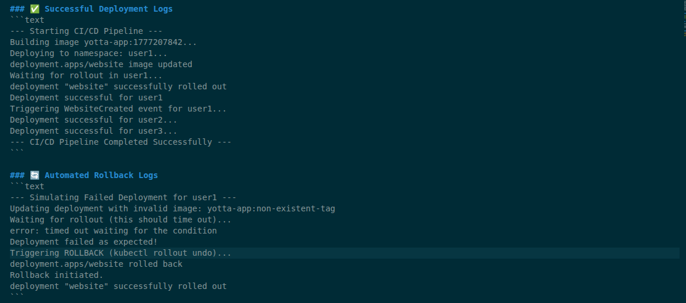
Event Trigger Proof (Kafka Logs)

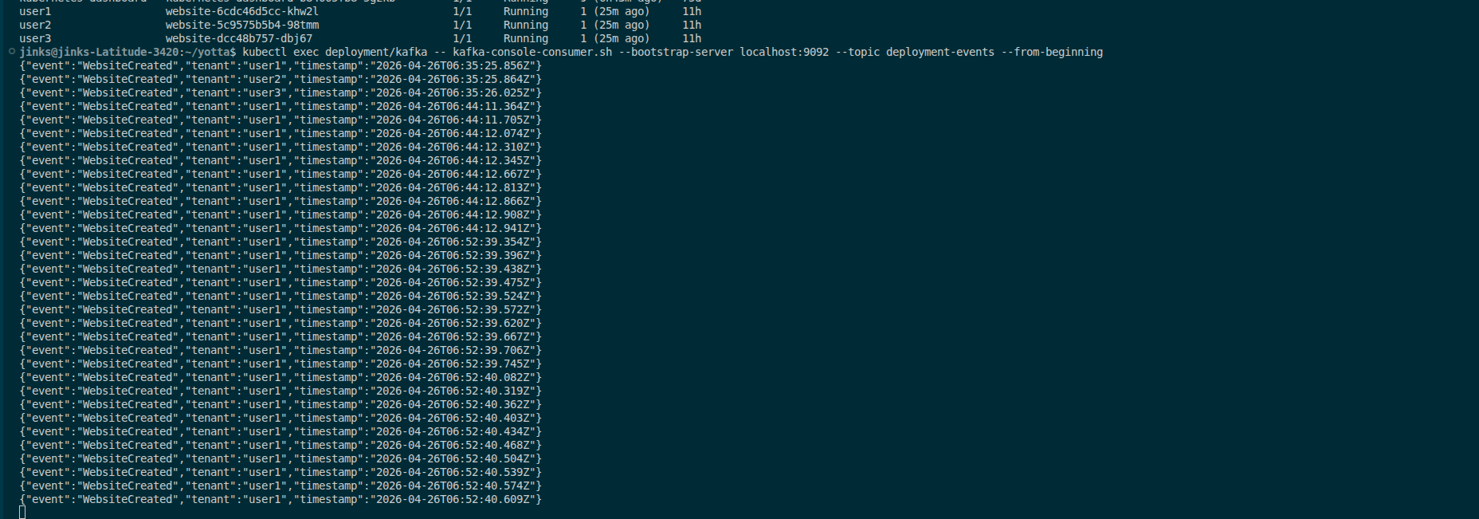

3. Scaling, Resource Optimization & Observability
• Screenshots/logs showing scaling and HPA metrics.
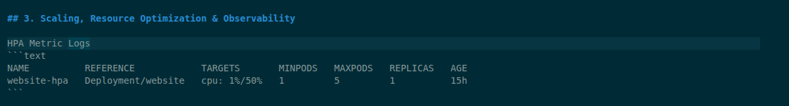
• Notes explaining scaling strategy and resource allocation.
1. Scaling Strategy (Horizontal Autoscaling)
We use the HorizontalPodAutoscaler (v2) to dynamically adjust capacity based on real-time CPU utilization. The system is configured to maintain an average CPU usage of 50%, automatically scaling workloads from 1 to 5 replicas during traffic spikes. To ensure high availability, a PodDisruptionBudget with minAvailable: 1 is applied per tenant, guaranteeing that at least one pod remains operational during updates or scaling events.
2. Resource Allocation (Multi-Tenant Containment)
Each tenant is isolated within its own namespace (e.g., user1, user2), providing clear logical separation. We enforce strict resource boundaries using ResourceQuotas at the namespace level (for example, 2 CPUs and 2Gi RAM), preventing any single tenant from monopolizing cluster resources. Additionally, pods are configured with well-defined resource requests (guaranteed allocation) and limits (maximum usage), ensuring predictable performance and stable scheduling, even in constrained environments like Minikube.
4. Kafka Event-Driven Pipeline
Screenshot showing events published/consumed.
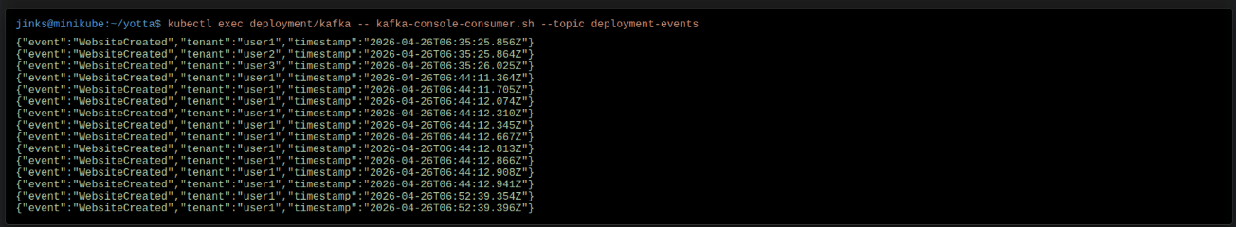
Kafka integration
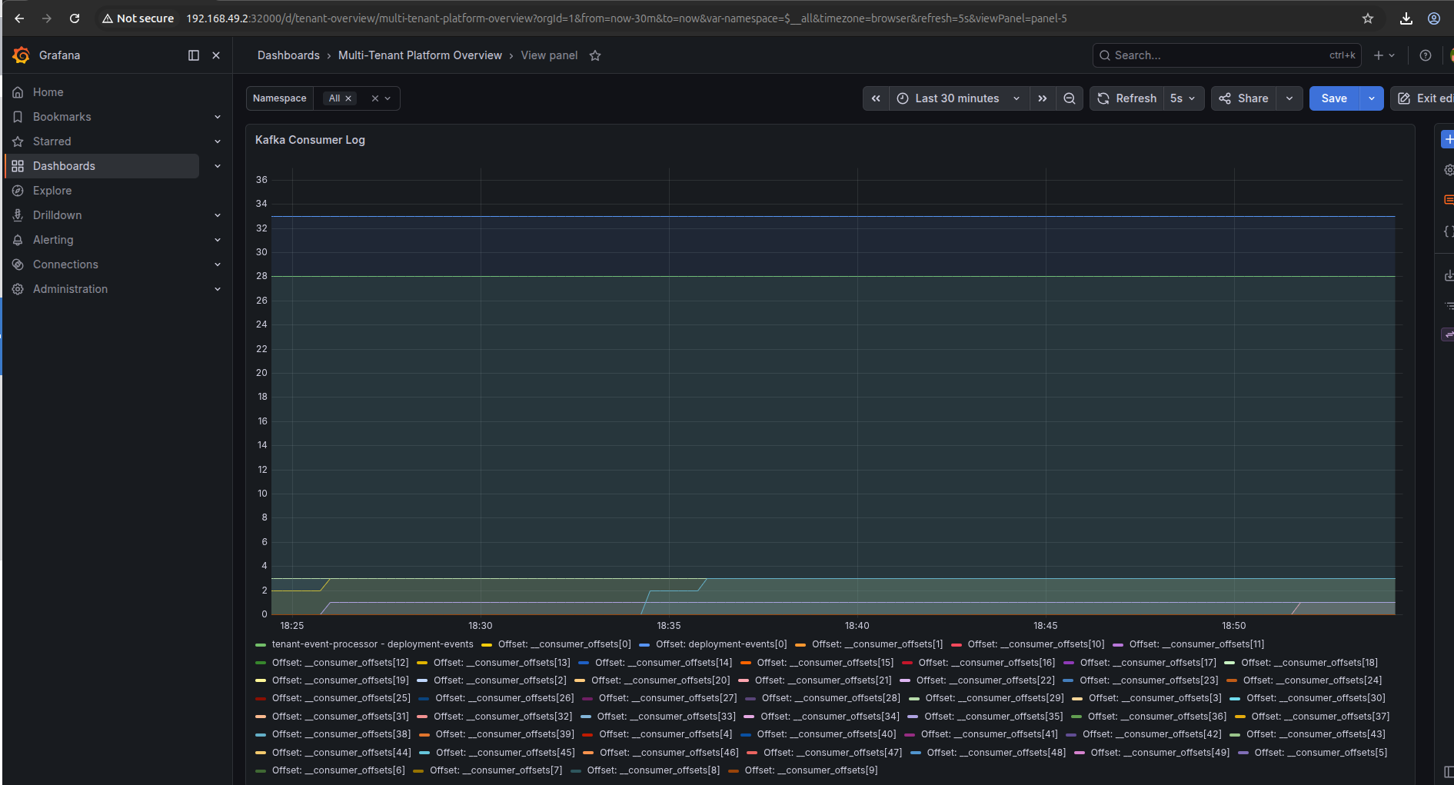

Observability dashboards
