## VISVESVARAYA TECHNOLOGICAL UNIVERSITY BELAGAVI-590018, KARNATAKA



### A MINI PROJECT REPORT

ON

## “FIFA 23 PLAYER MANAGEMENT SYSTEM”

Submitted in partial fulfillment of requirements for the award of 5th semester,

### BACHELOR OF ENGINEERING IN

**COMPUTER SCIENCE & ENGINEERING**

Submitted By:

**Parmekar Shubham Rajendra**

**(USN: 1KT20CS052)**

**Inao Lakhong Singpho**

**(USN: 1KT21CS401)**

Under the Guidance of

### Mrs. Savita Patil &Ms. Sushma M,

### Associate Professor,

#### Department of Computer Science & Engineering



**DEPARTMENT OF COMPUTER SCIENCE & ENGINEERING**

**SRI KRISHNA INSTITUTE OF TECHNOLOGY**

**BENGALURU-90**

**2022-23**

BANGALORE – 560 090

**DEPARTMENT OF COMPUTER SCIENCE & ENGINEERING**



# CERTIFICATE

This is to certify that the mini project entitled “FIFA 23 PLAYER MANAGEMENT SYSTEM” as a part of 18CSL58 laboratory, is bonafide work carried out by PARMEKAR SHUBHAM RAJENDRA bearing USN:1KT20CS052 and INAO LAKHONG SINGPHO bearing USN:1KT21CS401 partial fulfillment for the award of degree in bachelor of Engineering in Computer Science Engineering from Visvesvaraya Technological University, Belagavi during the academic year 2021-22. It is certified that all the corrections/suggestions indicated for internal assessment have been incorporated in reports submitted in the department Library. This mini project report has been approved as it satisfies the academic requirements in respect of the mini project report prescribed for award of said degree.

Signature of Internal Guide Signature of the HOD Signature of Principal

**Mrs. SAVITA PATIL & Dr. SHANTHARAM NAYAK Dr. MAHESHA K**

**Ms. SUSHMA M**

Assistant professor Professor & head Principal

Dept. of. CSE, SKIT Dept. of. CSE, SKIT SKIT, Bangalore

Name of the Examiner Signature with date

**ABSTRACT**

Managing the ever increasing numbers of players in different parts of the world is a huge task. This project is aimed at developing a desktop-based application named ‘FIFA 23 player management system’ for managing players using a robust database at the backend and a Web based GUI at the frontend.

The application will allow users to track complete details about a player starting from his personal details, going through club and nationality information to right down to his technicalities at each position in footballing world. The software also allows users to view the whole list of players, teams and footballing statistics at once, thereby helping them build their perspective. Users have the privilege to add new players to a particular team, and to modify their records when the player decides to retire. FIFA 23 player management system also allows users to access players based on their rating other than their preferential position of playing thus guiding managers to build a strong positional team by selecting best rated player at each position. In conclusion, this application will come extremely handy in maintaining player spread across different teams and nations.

# ACKNOWLEDGEMENT

The satisfaction and euphoria that accompany the successful completion of any task would be incomplete without the mention of the people who made it possible, whose constant guidance and encouragement crowned our effort with success.

I express my sincere gratitude to our Principal **Dr. Mahesha K**, Sri Krishna Institute of Technology for providing facilities.

I wish to place on record my gratitude to **Mr. Shantaram Naik**, Head of the Department, Computer Science and Engineering, Sri Krishna Institute of Technology, Bangalore for providing encouragement and guidance.

I consider it a privilege and honor to express my sincere gratitude to my guide **Mrs. Savita B Patil & Ms. Sushma M,** Associate Professor, Department of Computer Science & Engineering for their valuable guidance throughout the tenure of this seminar work and whose support and encouragement made this work possible.

I wish to thank the faculty of the Computer Science and Engineering department whose suggestions have enabled me to surpass many of the seemingly impossible hurdles.

Thank you.

# TABLE OF CONTENTS

#### Sl. No. CHAPTERS PAGE NO.

1. Introduction 1
2. System Requirement 2
3. Design of the project 4
4. Implementation 11
5. Screenshots 16

Conclusion 23

Bibliography 24

|  |  |  |
| --- | --- | --- |
|  | **LIST OF FIGURES** |  |
| **Sl. No.** | **Figures** | **PAGE NO.** |
| 2.1 | Memory consumption by brackets web editor | 2 |
| 2.2 | Memory consumption by chrome | 2 |
| 2.3 | Project size on disk | 3 |
| 2.4 | Wamp web server size on disk | 3 |
| 2.5 | Memory consumption by local server (Wamp) | 3 |
| 3.1 | ER Diagram | 5 |
| 3.2 | Relational schema | 6 |
| 3.3 | Player table structure | 7 |
| 3.4 | Player stats table structure | 7 |
| 3.5 | Salary table structure | 8 |
| 3.6 | Position table structure | 8 |
| 3.7 | Club table structure | 8 |
| 3.8 | Delete logs trigger structure | 9 |
| 3.9 | Update logs trigger structure | 9 |
| 3.10 | Insert logs trigger structure | 9 |
| 3.11 | Stored procedures structure | 10 |
| 5.1 | Search input for stored procedures | 16 |
| 5.2 | Search result using stored procedure from frontend | 16 |
| 5.3 | Search result using stored procedure from backend | 17 |
| 5.4 | Selecting table for insertion | 17 |
| 5.5 | Successful insert instance page | 18 |
| 5.6 | Selecting table to modify record | 18 |
| 5.7 | Modifying records in real time | 19 |
| 5.8 | Selecting categories for deleting record | 19 |
| 5.9 | Successful deletion instance | 20 |
| 5.10 | Delete triggers table | 20 |

|  |  |  |
| --- | --- | --- |
| 5.11 | Insert triggers table | 20 |
| 5.12 | Update triggers table | 21 |
| 5.13 | Player club table | 21 |
| 5.14 | Player salary table | 21 |
| 5.15 | Player position table | 22 |
| 5.16 | Player stats table | 22 |
| 5.17 | Player’s table | 22 |

**LIST OF TABLES**

**Sl. No. Table Name Page No.**

* 1. Player table structure 7
  2. Player stats table structure 7
  3. Salary table structure 8
  4. Position table structure 8
  5. Club table structure 8
  6. Player club table 21
  7. Player salary table 21
  8. Player position table 22
  9. Player stats table 22
  10. Player’s table 22

**Chapter 1**

**INTRODUCTION**

The project titled “**FIFA 23 Player management system**” is player management software for monitoring and accessing players based on their FIFA 23 PC/XBOX Game ratings. This project is developed using HTML, CSS and JavaScript for front-end and PHP, MySQL for back-end, which focuses on basic operation like adding a new player, new statistics, searching players with detailed information and edit as they grow their skills.

This project is a web based application designed and developed to help user’s access players and organize teams. This software is easy to use, and it features a familiar and well- thought-out attractive user interface, combined with strong searching, insertion, and deletion with procedure capabilities.

Analysing players have been a huge task performed by professional scouting agents who are spread around the world. From personal details to football technicalities, FIFA 23 Management system allows easy maintenance record of such skilled youth talent.

**Chapter 2**

**SYSTEM REQUIREMENT**

One of the most difficult tasks is that, the selection of the software, once system requirement is known is determining whether a software package fits the requirements. After initial selection further security is needed to determine the desirability of software compared with other candidates. This section first summarizes the application requirement question and then suggests more detailed comparisons.

### Hardware Requirement

* + 1. 32/64-bit processor
    2. i5 or greater intel processor chip
    3. 2.1 or more GHz processor

### Software Requirement

1. Windows 10 or higher version OS
2. WAMPP web server
3. Brackets web editor

### 2.1 Software and Executables memory size:

brackets

Fig 2.1 Memory consumption by brackets web editor



Fig 2.2 Memory consumption by Microsoft Edge

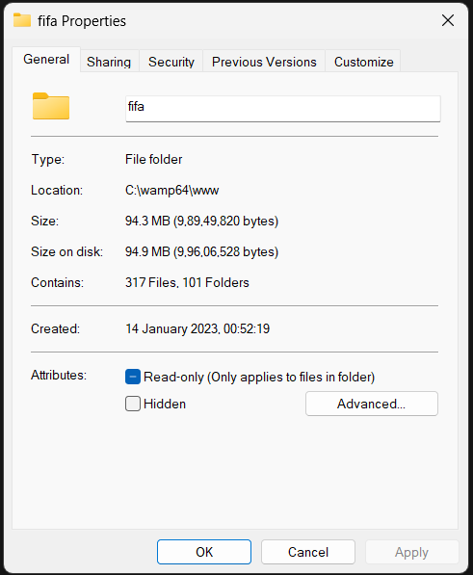

Fig 2.3 Project size on disk

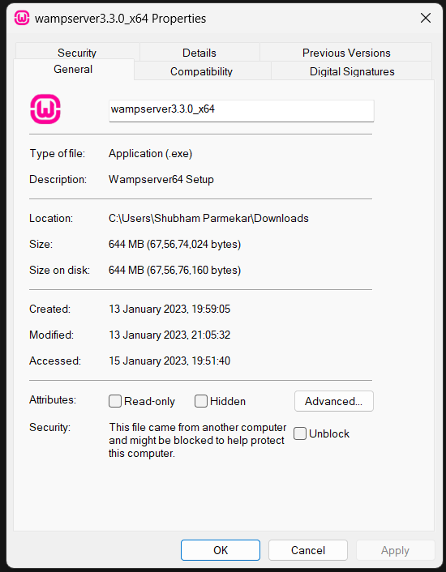

Fig 2.4 Wamp web server size on disk



Fig 2.5 Memory consumption by local server (Wamp)

## Chapter 3

**DESIGN OF THE PROJECT**

To analyse and access players on a daily basis can be hectic and huge effort demanding task. To help users, managers, staffs and scouting agents in football world, FIFA 23 player management system provides effortless player management system to help users to analyse, improve, train and access plays on a daily basis.

#### Description of the Project:

This project consists of player details, which describes about player biodata such as age and nationality. It also consists of player stats which describes about players technical skills. It also consists of tables containing details such as player earnings, club information and preferred position of playing. It also provide a strong searching, updating, deleting and inserting operations with a user friendly web based UI.

The project also helps the users to keep track of the player details in a computerized way without any trouble. The project contains **7 stored procedures** and **3 triggers** per table. Stored procedures are used in search engine. Every time the user searches through the database, a procedure is called and the results is collected and displayed for the user in a structured manner. It also has 3 trigger namely “**Insert, Delete and Update**” triggers assigned separately to each table. Whenever operations such as insert or delete or update is performed on any table, these triggers are automatically called, and the logs are captured into 3 separate tables, individually for each trigger. Hence use of triggers provides users to trace back all the latest as well as the oldest changes into any table at any point of time.

This project is a simple prototype of managing larger numbers of players across different nations with different skill sets and attributes. It helps to access players and thus aids in building a strong positional team. It also helps in monitoring player growth.

* 1. **ER Diagram:**

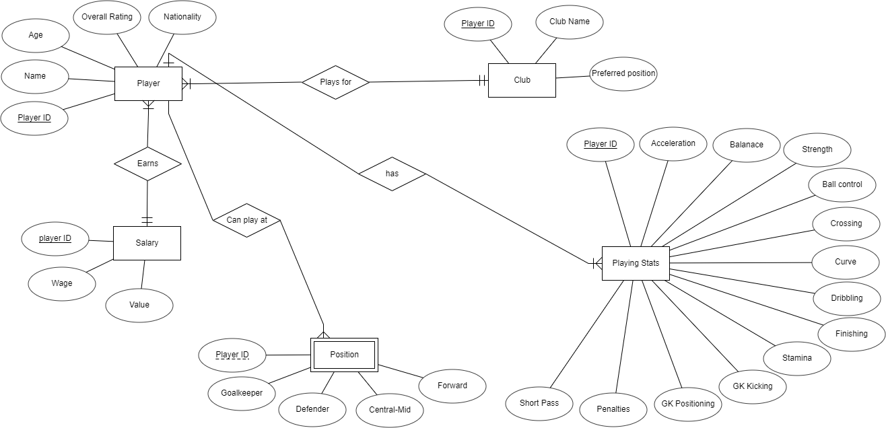

Fig 3.1 ER Diagram

### Schema Diagram:

#### Player

**Playing Stats**

|  |  |  |  |  |
| --- | --- | --- | --- | --- |
| Player ID | Name | Age | Overall rating | Nationality |

|  |  |  |  |  |  |  |
| --- | --- | --- | --- | --- | --- | --- |
|  |  | | | | | |
|  | **Position**  Player ID  **Salary** | Goalkeeper | Defender | Central-Mid | | Forward |
|  | Player ID | | Wage | | Value | |
|  |

|  |  |  |  |  |  |  |  |  |
| --- | --- | --- | --- | --- | --- | --- | --- | --- |
|  | Player ID | Acceleration | Balance | Ball control | Curve | Crossing | Dribbling | Finishing |

|  |  |  |
| --- | --- | --- |
| **Club** |  |  |
| Player ID | Club | Preferred position |

Fig 3.2 Relational schema

### Table Structures:

#### Player details

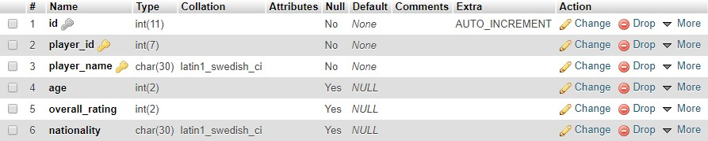

Fig 3.3 Player table structure

The player table consists of 6 columns. Player_id and player_name are primary keys and player_id have references of other tables as well. To insert data, player_id should exist in this table before inserting into other tables.

#### Stats details

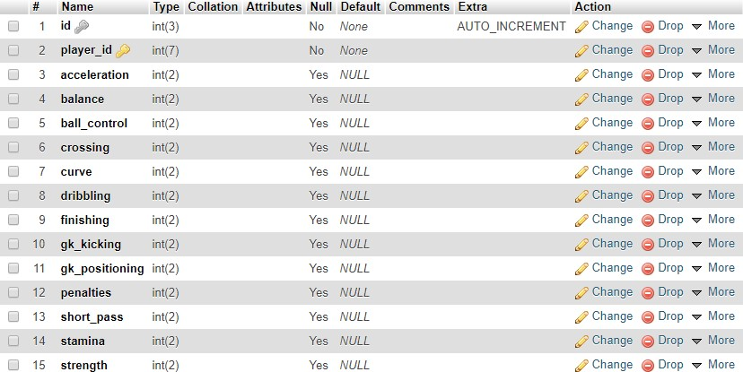

Fig 3.4 Player stats table structure

Player stats table consists of 14 attributes, among which, player_id is primary key and also has a foreign key reference to “player” table. It is designed to contain all the football technicalities of a player.

#### Salary details

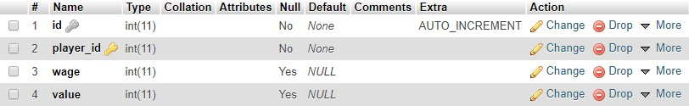

Fig 3.5 Salary table structure

The salary table consists player_id as primary key and also have a foreign key reference to “player” table. It is designed to store player weekly wage and his current value in the market.

#### Position details

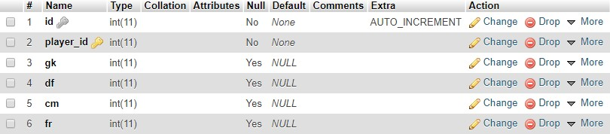

Fig 3.6 Position table structure

The position table also have player_id as primary key and a foreign key reference to “player” table. It is designed to store the positions a player can play, if so, then how well he does on a scale of rating from 0 to 99. It helps user to access player based on positional play and decide the best position for a player.

#### Club details

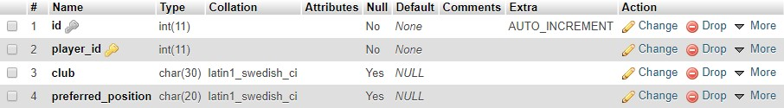

Fig 3.7 Club table structure

The club details table has club information and the preferred position of a player at that club. It also have player_id as primary key and also a foreign key reference on “player” table.

#### Delete logs

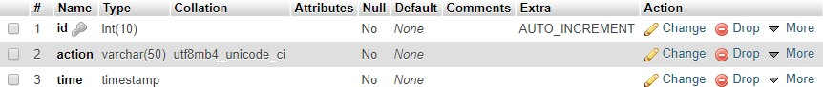

Fig 3.8 Delete logs trigger structure

The delete logs table consists of 3 columns. ID column is unique and set to auto increment. Action column contain the action along with table name. Time column contains the time at which the trigger was automatically invoked based on the action.

#### Update logs

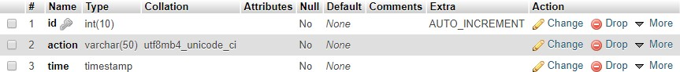

Fig 3.9 Update logs trigger structure

The Update logs table consists of 3 columns. ID column is unique and set to auto increment. Action column contain the action along with table name. Time column contains the time at which the trigger was automatically invoked based on the action.

#### Insert logs

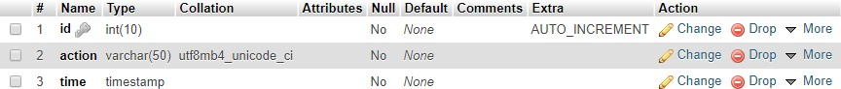

Fig 3.10 Insert logs trigger structure

The Insert logs table consists of 3 columns. ID column is unique and set to auto increment. Action column contain the action along with table name. Time column contains the time at which the trigger was automatically invoked based on the action.

#### Stored procedures

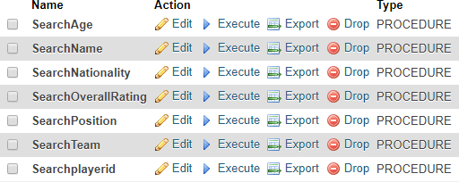

Fig 3.11 Stored procedures structure

There are 7 stored procedures present inside search page on the web application. These are called whenever any search instance occur on the web page. The results of the stored procedures are then displayed on the UI in a tabular structure.

## Chapter 4

**IMPLEMENTATION**

### Stored procedures:

The Stored procedures are executed using PHP and MySQL in the application file.

The result of stored procedure is shown in Fig 5.2.

**Use**: Use of stored procedures allows modular programming, reduces network traffic, faster execution, and can be used as security mechanism.

Given below is a code snippet of implementation of all the 7 stored procedure present inside the web application.

#stored procedures

$spforage = mysqli_query($conn, "CREATE DEFINER=`root`@`localhost` PROCEDURE

`SearchAge`(IN `page` INT(11)) NOT DETERMINISTIC CONTAINS SQL SQL

SECURITY DEFINER SELECT player_name,age,overall_rating,nationality FROM personal_details WHERE personal_details.age = page;");

$spfornationality = mysqli_query($conn, "CREATE DEFINER=`root`@`localhost` PROCEDURE `SearchNationality`(IN `page` VARCHAR(30)) NOT DETERMINISTIC CONTAINS SQL SQL SECURITY DEFINER SELECT * FROM personal_details WHERE

personal_details.nationality=page;");

$spforoverallrating = mysqli_query($conn, "CREATE DEFINER=`root`@`localhost` PROCEDURE `SearchOverallRating`(IN `page` INT(11)) NOT DETERMINISTIC CONTAINS SQL SQL SECURITY DEFINER SELECT * FROM personal_details WHERE

personal_details.overall_rating = page;");

$spforteam = mysqli_query($conn, "CREATE DEFINER=`root`@`localhost` PROCEDURE

`SearchTeam`(IN `page` VARCHAR(30)) NOT DETERMINISTIC CONTAINS SQL SQL SECURITY DEFINER SELECT

pd.player_name,pd.overall_rating,pd.age,pd.nationality,od.club FROM personal_details pd,other_details od WHERE od.club = page AND pd.player_id = od.player_id ORDER BY pd.player_id;");

$spforname = mysqli_query($conn, "CREATE DEFINER=`root`@`localhost` PROCEDURE

`SearchName`(IN `page` VARCHAR(30)) NOT DETERMINISTIC CONTAINS SQL SQL

SECURITY DEFINER SELECT * FROM personal_details WHERE player_name = page");

$spforplayerid = mysqli_query($conn, "CREATE DEFINER=`root`@`localhost` PROCEDURE `Searchplayerid`(IN `page` INT(11)) NOT DETERMINISTIC CONTAINS SQL SQL SECURITY DEFINER SELECT * FROM personal_details WHERE player_id = page;");

$spforposition = mysqli_query($conn, "CREATE DEFINER=`root`@`localhost` PROCEDURE `SearchPosition`(IN `page` VARCHAR(11)) NOT DETERMINISTIC CONTAINS SQL SQL SECURITY DEFINER SELECT pd.player_name, pd.overall_rating, od.preferred_position, p.gk, p.df, p.cm, p.fr FROM personal_details pd, other_details od, position p WHERE od.preferred_position = page AND p.player_id = od.player_id AND p.player_id = pd.player_id GROUP BY pd.player_id;");

### Inserting new records:

The insert page allows users to select the table to insert values into [Fig 5.4]. It then asks users to input required data columns for the particular table and upon successful insertion, a new page is displayed [Fig 5.5] with appropriate message. Upon failure, another page is displayed with appropriate message and a possible solution.

Given below is the code snippet of the insert page which is execute in the application using PHP and MySQL.

$sql = "INSERT INTO $dbname.personal_details (player_id, player_name, age,overall_rating,nationality) VALUES

('$spid','$spname','$spage','$spoverallrating','$spnationality')";

if ($conn->query($sql) === TRUE) {

(Inside into_other_details.php)

<?php

$sql = "INSERT INTO $dbname.other_details (player_id, club, preferred_position) VALUES ('$spid','$spclub','$sppreferredposition')";

### Updating existing records:

The update page allows users to look at a selected table and edit the table live on frontend. The user first selects the table he/she wants to modify [Fig 5.6]. Upon selection, a new page is created with respective table. This table consists of editable rows that can be modified and result can be seen real time [Fig 5.7].

Given below is a code snippet of implementation of update page. It is created using PHP, MySQL and JavaScript. Use of JavaScript makes the UI more flexible by providing real time data interaction.

if ($input['action'] === 'edit')

{

$sql = "UPDATE personal_details SET player_name ='" . $input['player_name'] . "',age ='" . $input['age'] . "',overall_rating ='" . $input['overall_rating'] . "', nationality='" .

$input['nationality'] . "'" ." WHERE player_id='" . $input['player_id'] . "'";

mysqli_query($con,$sql);

}

$choices = $_POST["choices-single-defaul"];

if($choices=='PERSONAL DETAILS'){ header("Location:test_personal_details/inline-table-edit.php");

}

else if($choices=='PLAYER EARNINGS'){ header("Location:test_player_salary/inline table-edit.php");}else if($choices=='PLAYER POSITION'){ header("Location:test_player_position/inline-table-edit.php");

}else if($choices=='PLAYER CLUB'){ header("Location:test_player_club/inline-table

edit.php");

### Deleting existing records:

The delete page allows users to delete data based on categories like age, nationality, player ID, name and overall rating [Fig 5.8]. Choosing from different categories provides better user-database interface. Upon deletion, a new page is displayed with appropriate message [Fig 5.9] and upon failing, a new page with error information and possible solutions.

Given below is a code snippet of implementation of delete page. It is created using PHP and MySQL.

$sql = "DELETE FROM personal_details WHERE player_name=\"$spname\"";

$sql = "DELETE FROM personal_details WHERE age=\"$spages\"";

$sql = "DELETE FROM personal_details WHERE nationality=\"$spnationality\"";

$sql = "DELETE FROM personal_details WHERE overall_rating=\"$spoverallrating\"";

$sql = "DELETE FROM personal_details WHERE player_id=\"$spid\"";

### Triggers:

The trigger page allows users to look at the database log of operations such as delete, update and insert.

**Use:** To improve data integrity, trigger can be used. When an action is performed on data, it is possible to check if the manipulation of the data concurs with the underlying business rules, and thus avoids erroneous entries in a table.

Given below is a code snippet of implementation of trigger page. It is created using PHP, MySQL and HTML. Use of HTML makes the UI show database logs in a structured manner.

echo " <h1>INSERT TRIGGERS</h1>";

$sql = "SELECT * FROM insert_logs ORDER BY id";

echo " <h1>UPDATE TRIGGERS</h1>";

$sql = "SELECT * FROM update_logs ORDER BY id";

echo " <h1>DELETE TRIGGERS</h1>";

$sql = "SELECT * FROM delete_logs ORDER BY id";

## Chapter 5

**SCREENSHOTS**

### Stored procedures:

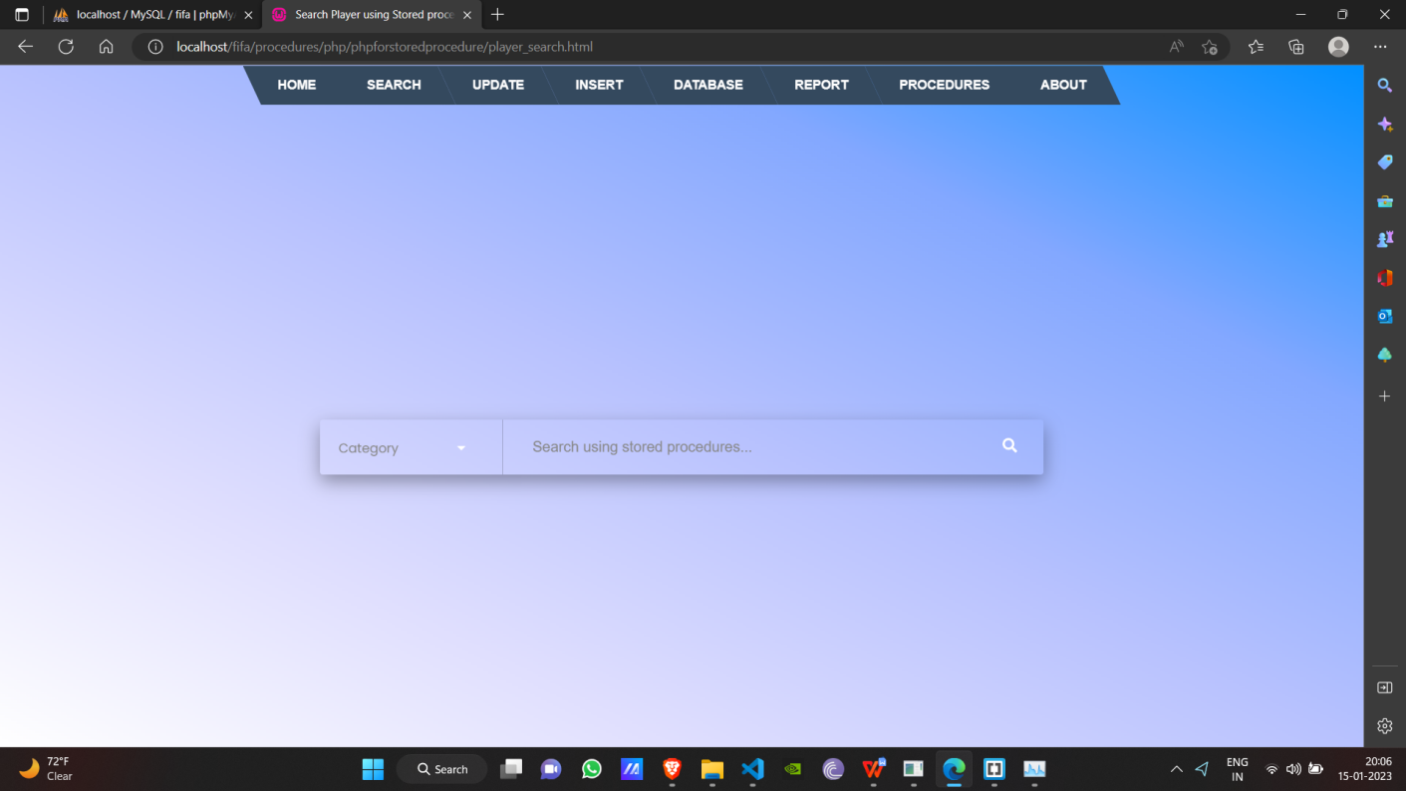

Fig 5.1 Search input for stored procedures.

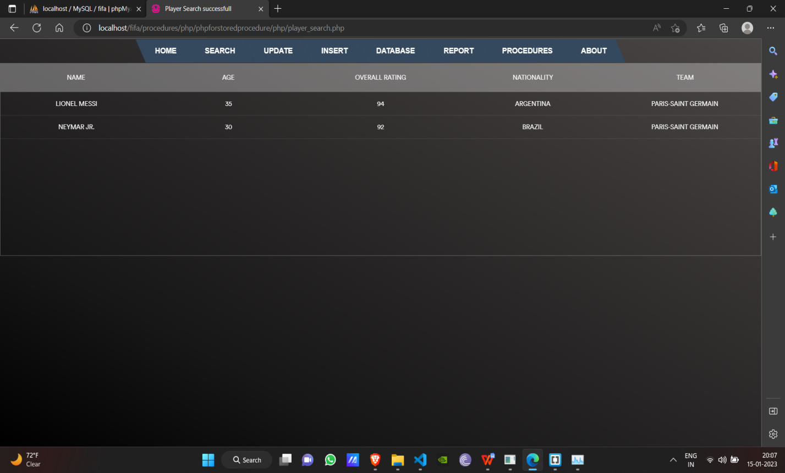

Fig 5.2 Search result using stored procedure from frontend.

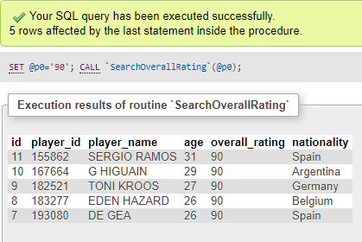

Fig 5.3 Search result using stored procedure from backend.

### Inserting new records:

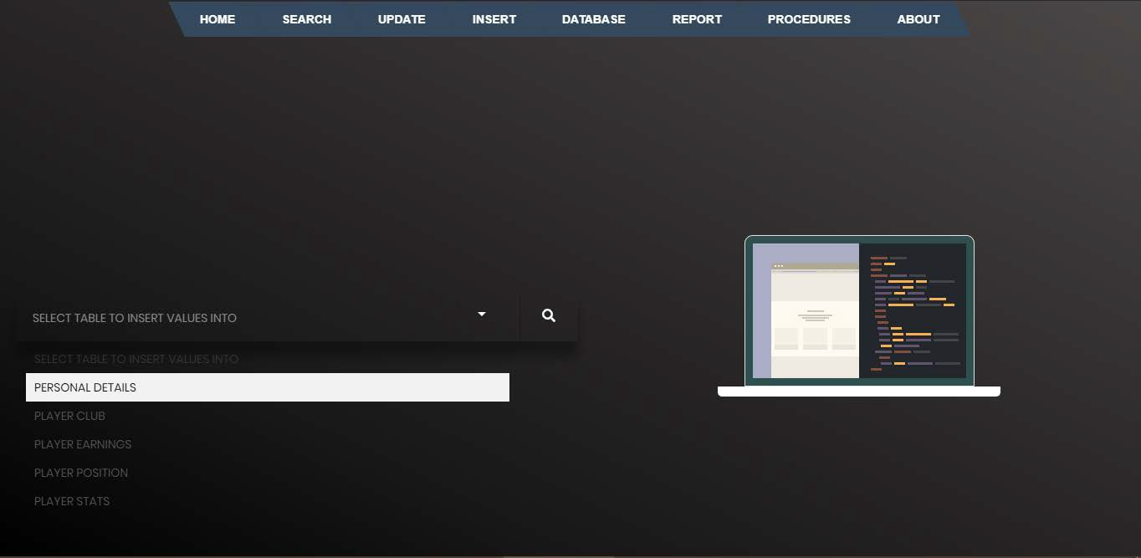

Fig 5.4 Selecting table for insertion

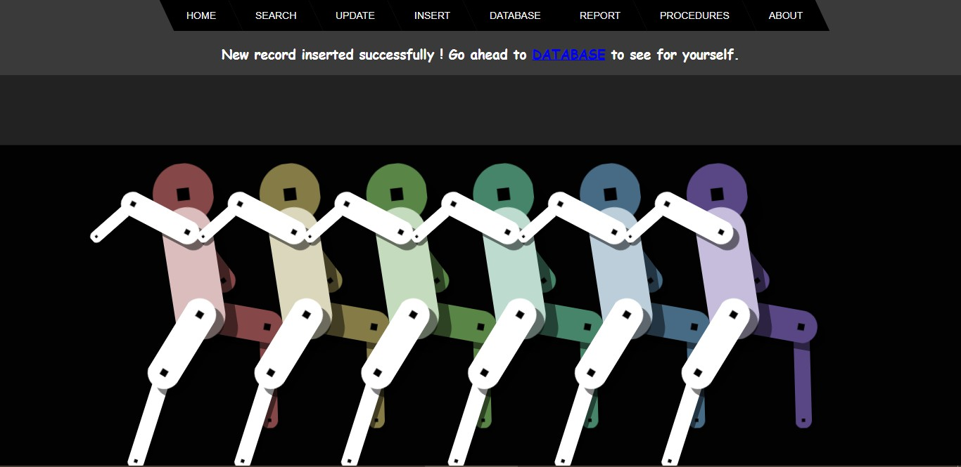

Fig 5.5 Successful insert instance page

### Update existing records:

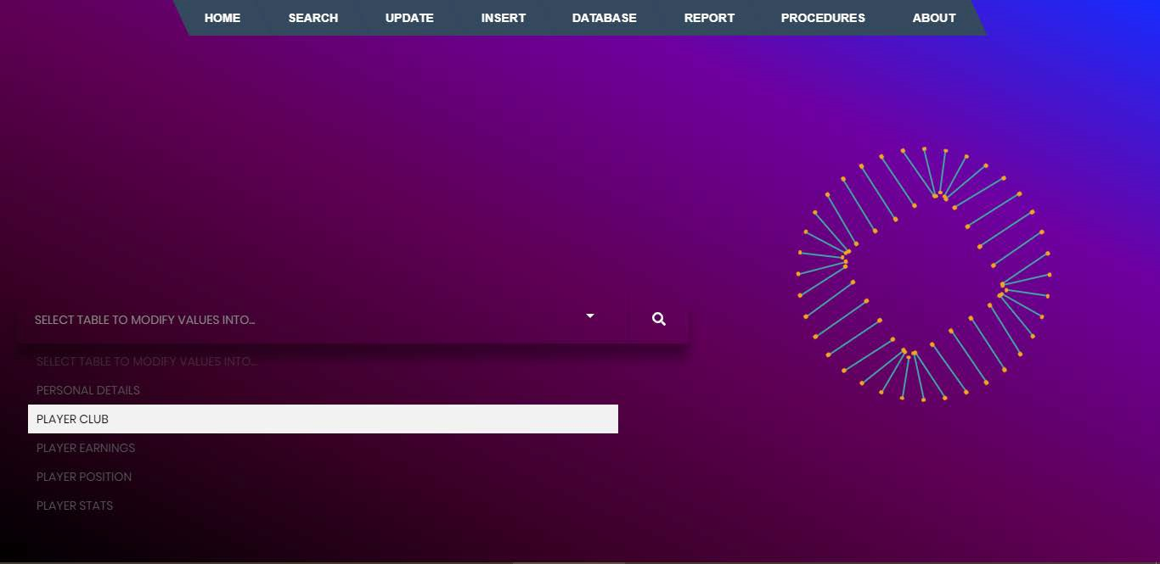

Fig 5.6 Selecting table to modify record

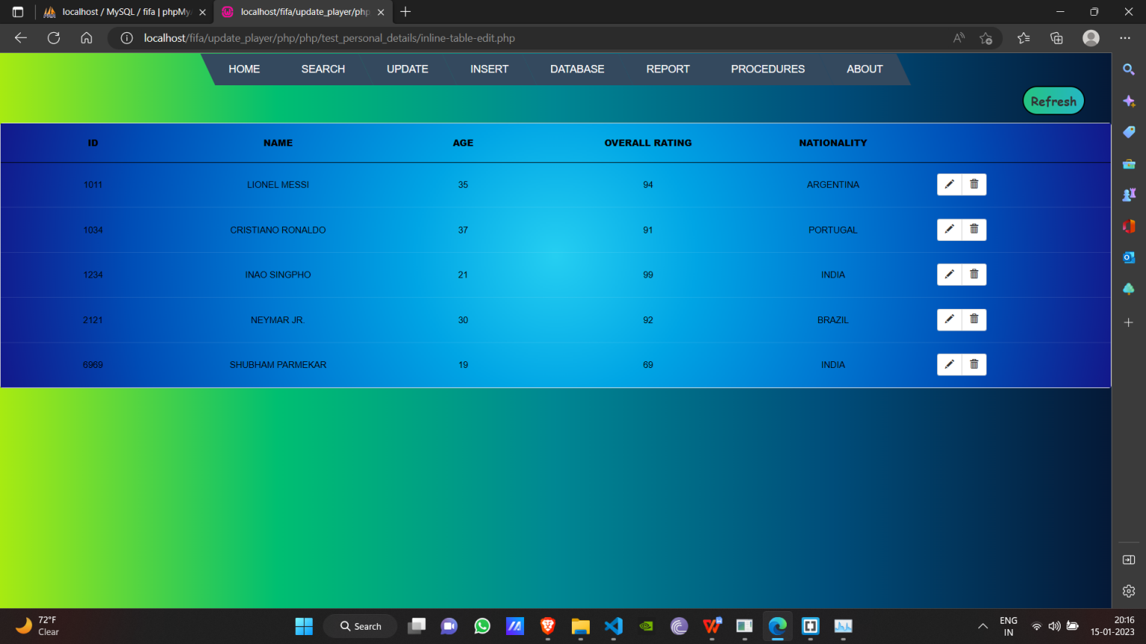

Fig 5.7 Modifying records in real time

### Deleting records:

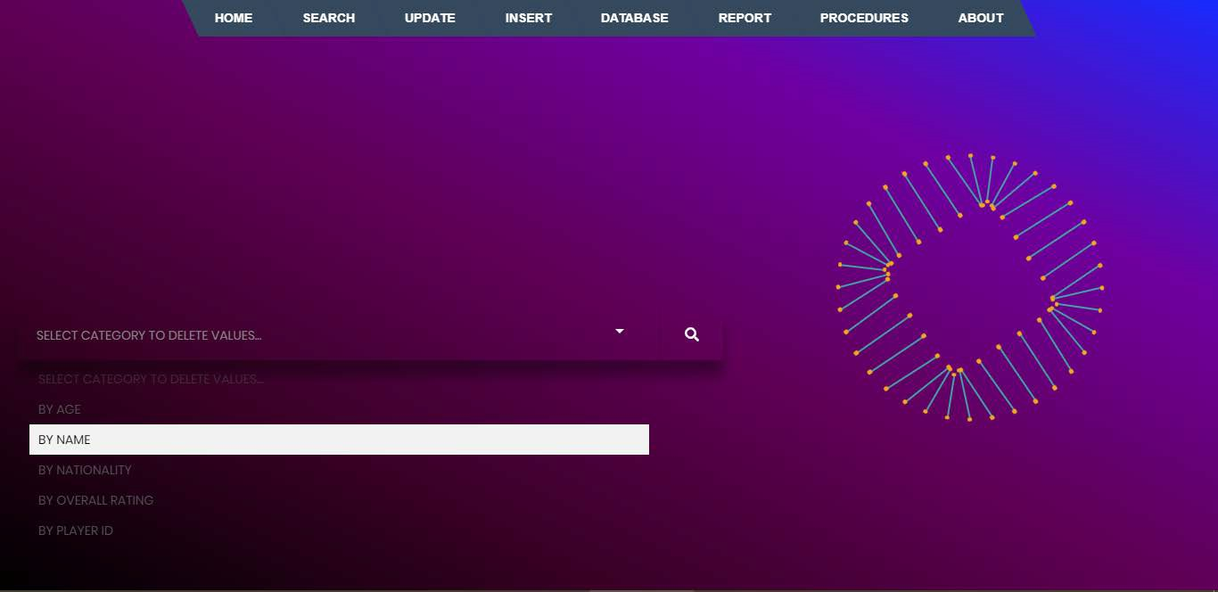

Fig 5.8 Selecting categories for deleting record

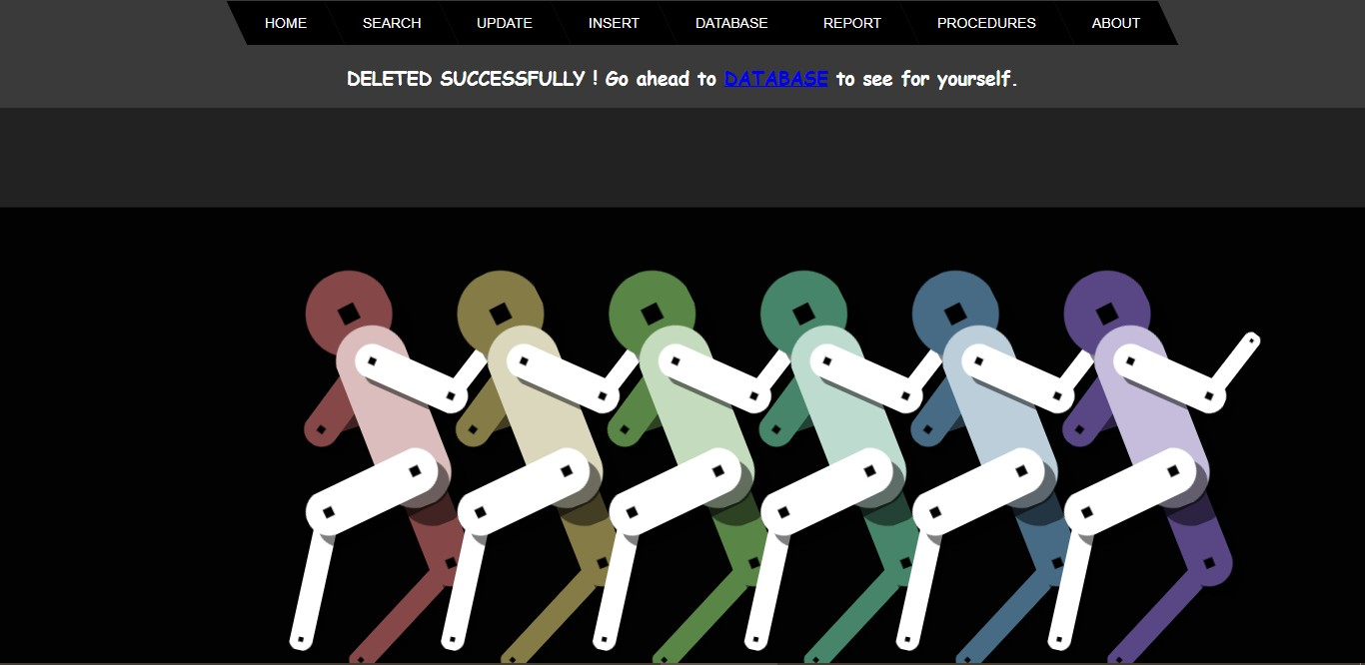

Fig 5.9 Successful deletion instance

### Triggers:

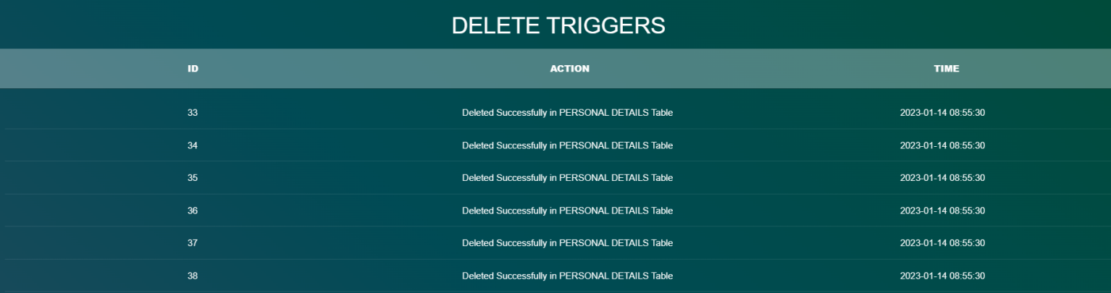

Fig 5.10 Delete triggers table

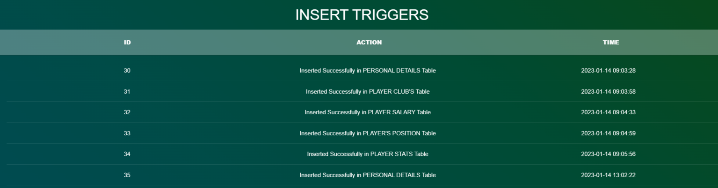

Fig 5.11 Insert triggers table

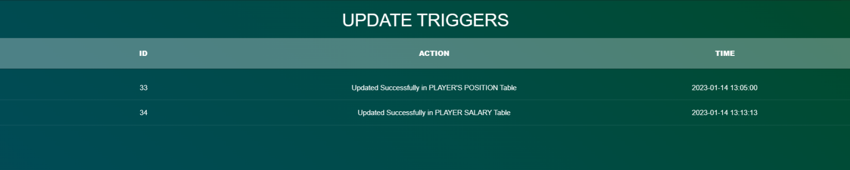

Fig 5.12 Update triggers table

### Database tables:

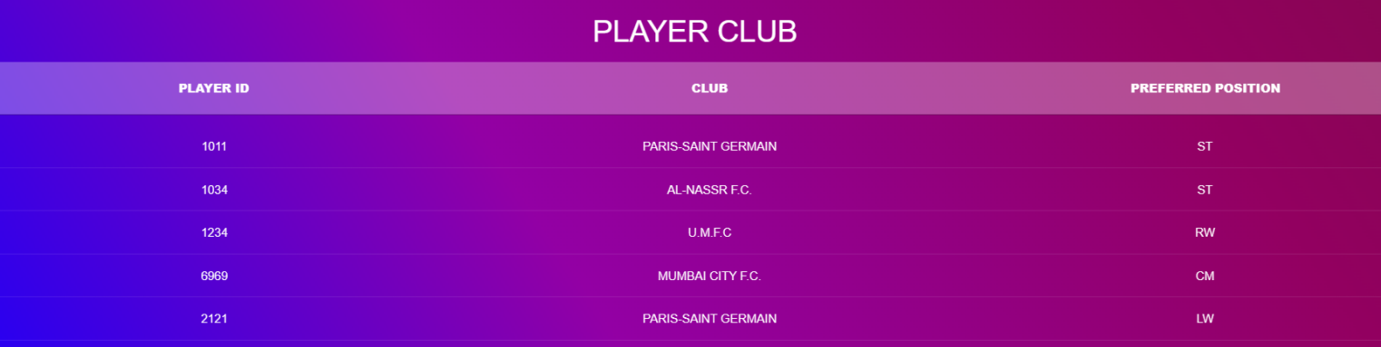

Fig 5.13 Player club table

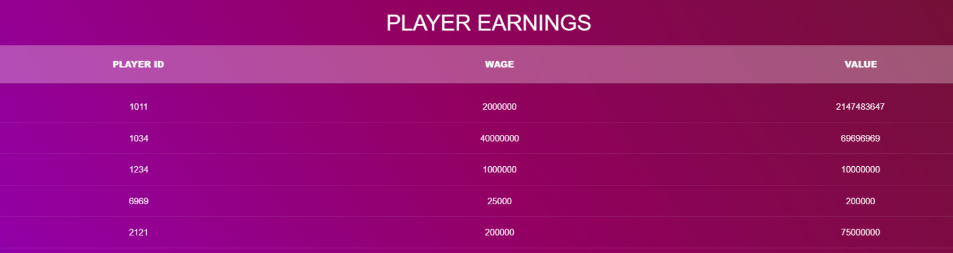

Fig 5.14 Player salary table

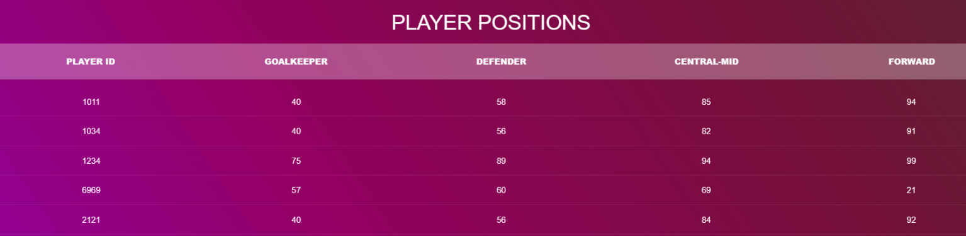

Fig 5.15 Player position table

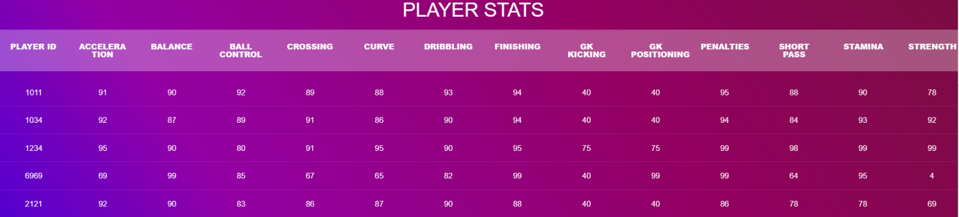

Fig 5.16 Player stats table

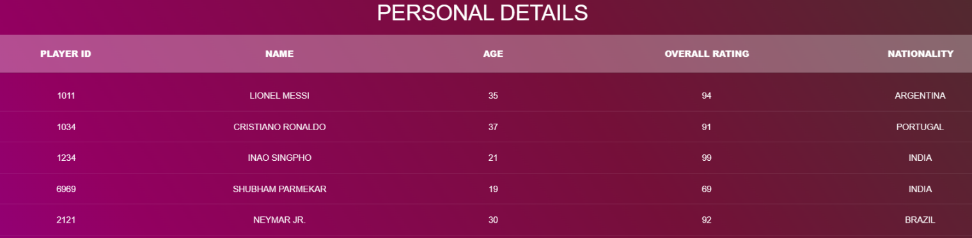

Fig 5.17 Player’s table

# CONCLUSION

This project is developed to nurture the needs of a user/scouting agent to monitor players and inspect their technicalities from every aspect on a football field. This is a computerized version of player management system which will benefit the players as well as the staff of a club.

In this entire process one can search player details, add new skilled players, Update ratings and view all the player statistics. The software takes care data and carefully stores all the player information. It provides security and encapsulation by the use of stored procedures.

# FUTURE SCOPE

There is a future scope of this project is to help managers and club staffs to get out the best youth talent across the world. Features like predicting players rating based on their current performances and training sessions helps team staffs to judge players according to the club’s needs.

# BIBLIOGRAPHY

* + 1. Database System Model, Languages, Design and Application Programming, Ramez Elmasri and ShamKant B. Navathe, 7th edition, 2017, Pearson.
    2. Database Management System, Ramakrishnan, and Gehrke, 3rd edition, 2014, Mc- GrawHill.

Websites Referred:

* [https://stackoverflow.com/search?q=insert+table](https://stackoverflow.com/search?q=insert%2Btable)
* [https://stackoverflow.com/search?q=view+table](https://stackoverflow.com/search?q=view%2Btable)
* [https://stackoverflow.com/search?q=search+from+table](https://stackoverflow.com/search?q=search%2Bfrom%2Btable)
* [www.quora.com](http://www.quora.com/)
* [https://www.codeproject.com/search.aspx?q=php+code+for+radio+buttons&x=0&y= 0&sbo=qa](https://www.codeproject.com/search.aspx?q=php%2Bcode%2Bfor%2Bradio%2Bbuttons&amp;x=0&amp;y=0&amp;sbo=qa)
* [https://www.codeproject.com/Articles/38808/Overview-of-SQL-Server-database- Triggers](https://www.codeproject.com/Articles/38808/Overview-of-SQL-Server-database-Triggers)
* [https://www.techrepublic.com/article/determine-when-to-use-stored-procedures-vs- sql-in-the-code/](https://www.techrepublic.com/article/determine-when-to-use-stored-procedures-vs-sql-in-the-code/)
* <https://codepen.io/>
* <https://www.uplabs.com/>
* [https://www.ibm.com/support/knowledgecenter/en/SS6NHC/com.ibm.swg.im.dashdb](https://www.ibm.com/support/knowledgecenter/en/SS6NHC/com.ibm.swg.im.dashdb.sql.ref.doc/doc/c0004100.html)

[.sql.ref.doc/doc/c0004100.html](https://www.ibm.com/support/knowledgecenter/en/SS6NHC/com.ibm.swg.im.dashdb.sql.ref.doc/doc/c0004100.html)

* <https://www.w3schools.com/html/default.asp>
* <https://www.w3schools.com/css/default.asp>
* <https://www.w3schools.com/php/default.asp>
* [https://www.ibm.com/support/knowledgecenter/en/SSEPEK_10.0.0/apsg/src/tpc/db2z](https://www.ibm.com/support/knowledgecenter/en/SSEPEK_10.0.0/apsg/src/tpc/db2z_storedprocedure.html)

[_storedprocedure.html](https://www.ibm.com/support/knowledgecenter/en/SSEPEK_10.0.0/apsg/src/tpc/db2z_storedprocedure.html)