**IE 410 – INTRODUCTION TO ROBOTICS**

**Lab-1 report**

**Team M410:**

201901011 – HIMANSHU DUDHATRA

201901024 – DHAVALSINH RAJ

201901100 – SHUBHAM PATEL

201901145 – GARGEY PATEL

**ROS installation process**

* **Run following commands in terminal to install ROS in ubuntu**
* **Setup your computer to accept software from packages.ros.org.**

sudo sh -c 'echo "deb http://packages.ros.org/ros/ubuntu $(lsb_release -sc) main" > /etc/apt/sources.list.d/ros-latest.list'

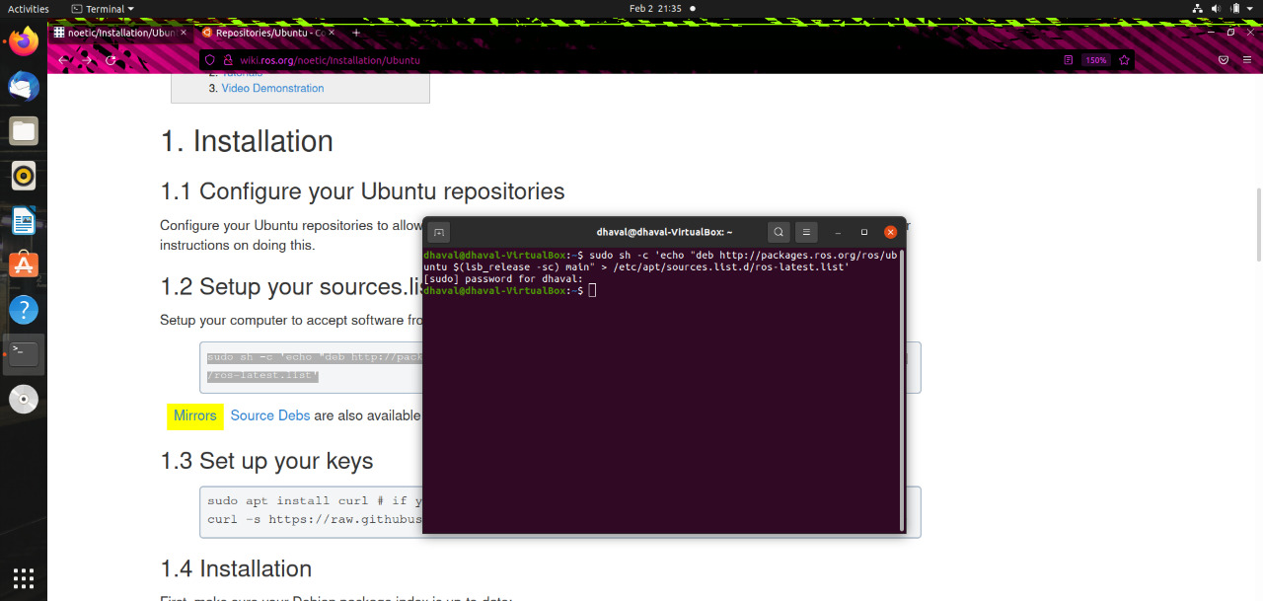

* **Setup your keys**

sudo apt install curl # if you haven't already installed curl

curl -s https://raw.githubusercontent.com/ros/rosdistro/master/ros.asc | sudo apt-key add –

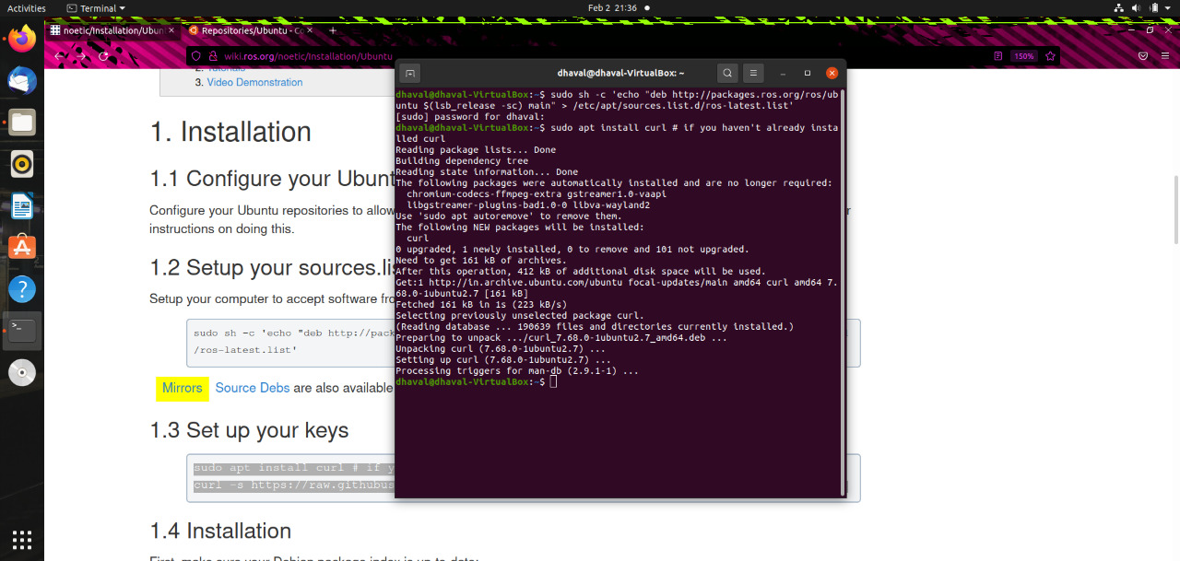

* **Installation**

sudo apt update

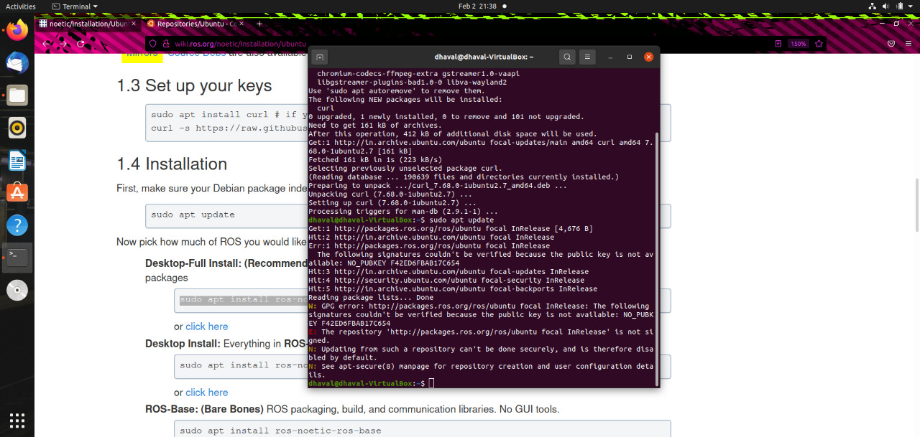

**Desktop full install**

sudo apt install ros-noetic-desktop-full

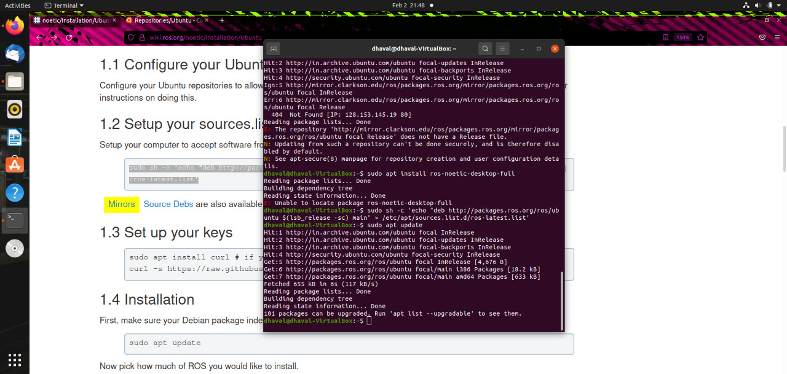

* **Environment setup**

echo "source /opt/ros/noetic/setup.bash" >> ~/.bashrc

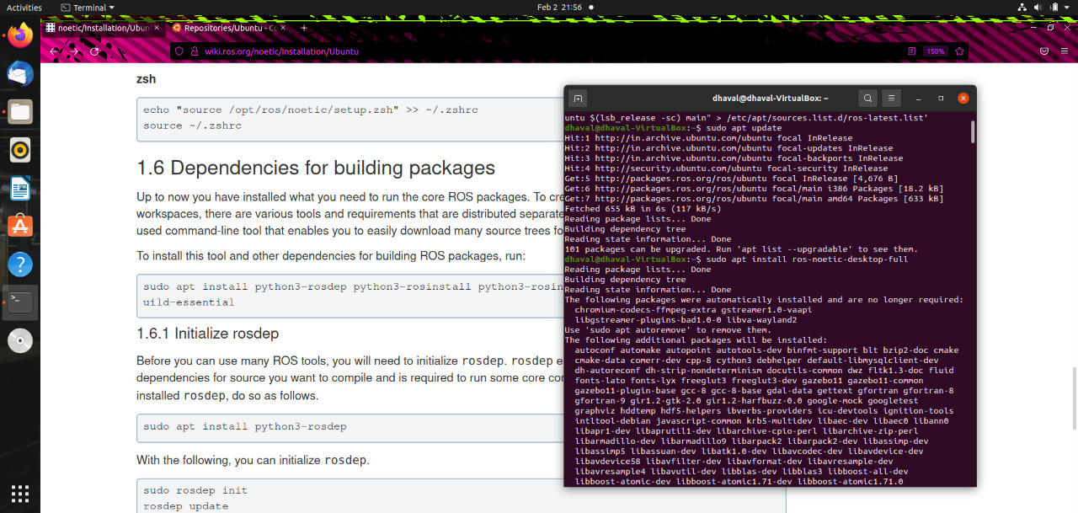

**Python codes**

e1.py :

#Printing sentences

**print**("Hello world")

**print**("Welcome to IE 410 - Introduction to Robotics")

e2.py :

#Arithmetic operations

a = **5**

b = **2**

**print**("a is", a, "and", "b is", b) #printing a and b

**print**("a+b is", a+b) #printing value of a+b

**print**("a-b is", a-b) #printing value of a-b

**print**("a*b is", a*b) #printing value of a*b

**print**("a/b is", a/b) #printing value of a/b

**print**("a%b is", a%b) #printing value of a%b

**print**("a^b is", a**b) #printing value of a^b

e3.py :

#printing array and sum of its element

array = [**10**,**20**,**30**,**40**,**50**]

**print**("Array elements are",array) #printing array elements

sum = **0**

**for** i **in** array:

sum = sum + i

**print**("Sum of its elements is",sum)

e4.py :

#Sum of n natural numbers

n = **10**

**if** n < **0**:

**print**("Enter a positive number")

**else**:

sum = **0**

**while**(n > **0**):

sum += n

n -= **1**

**print**("The sum of n numbers is", sum)

e5.py :

#String

string = " IE410 Introduction To Robotics "

split_string = string.split() #splits string

**print**(split_string)

joined_string = '-'.join(split_string) #join string

**print**(joined_string)

Code output:

