**IE 410 – INTRODUCTION TO ROBOTICS**

**Lab-2 report**

**Team M410:**

201901011 – HIMANSHU DUDHATRA

201901024 – DHAVALSINH RAJ

201901100 – SHUBHAM PATEL

201901145 – GARGEY PATEL

* In this lab, we will use ROS and python to use Turtlesim.
* We will use following commands for turtlesim.
* Creating ROS workspace

Commands to create and build a catkin workspace:

$ mkdir -p ~/catkin_ws/src

$ cd ~/catkin_ws/

$ catkin_make

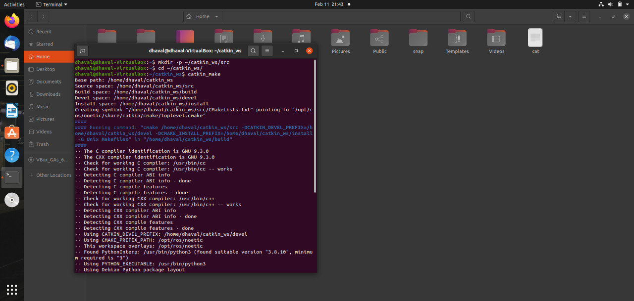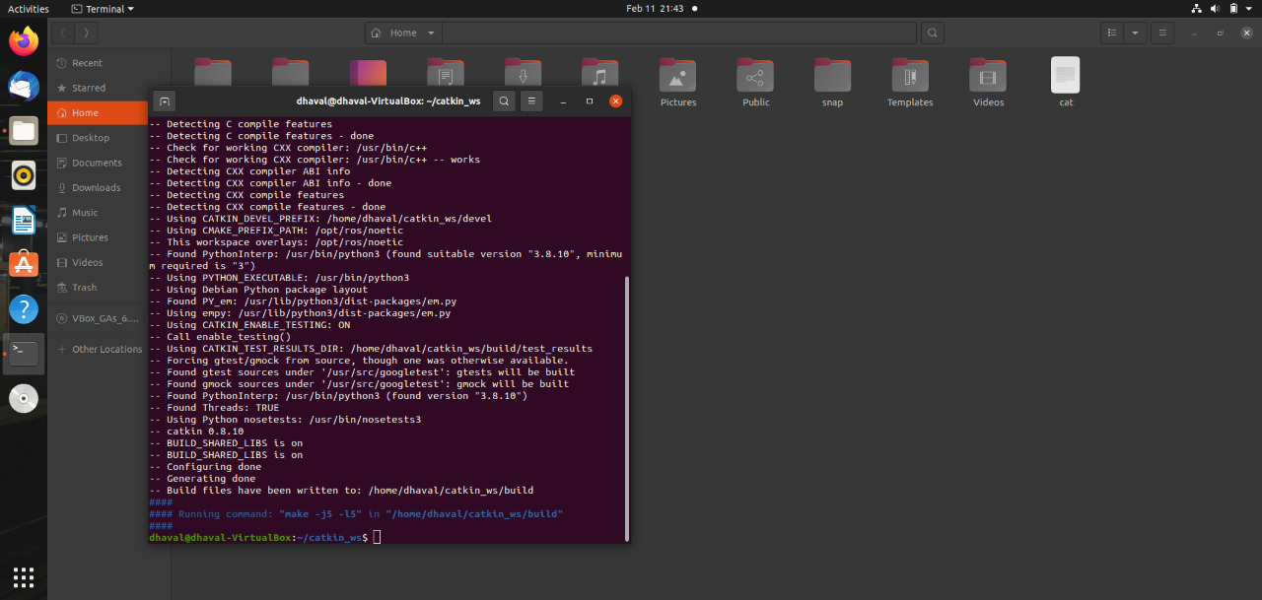

We need to setup new.*sh file and command is given below.

$ source devel/setup.bash

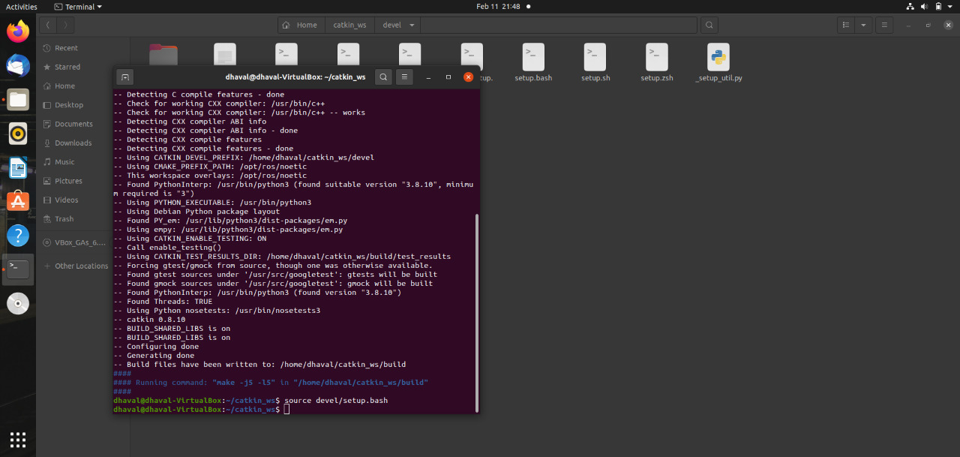

To make sure your workspace is properly overlayed by the setup script, make sure ROS_PACKAGE_PATH environment variable includes the directory you are in.

$ echo $ROS_PACKAGE_PATH

/home/youruser/catkin_ws/src:/opt/ros/kinetic/share

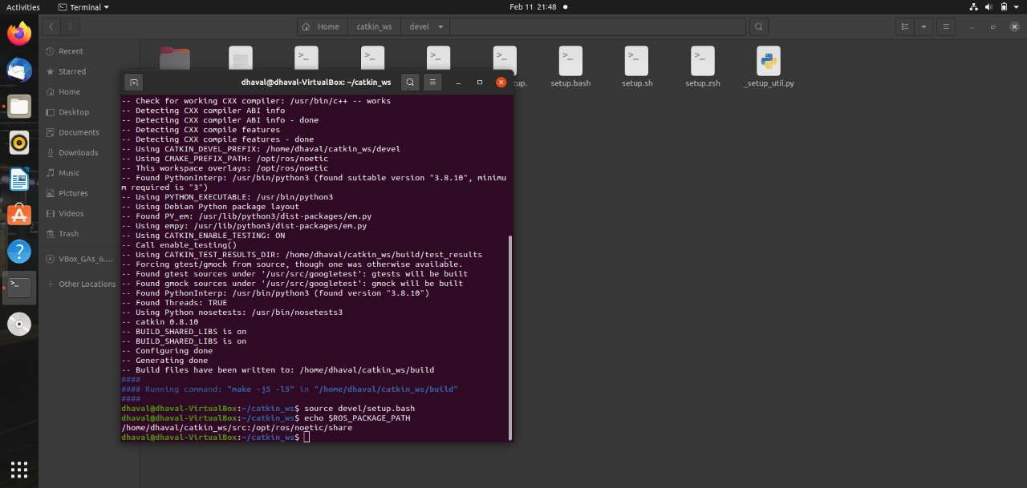

* roscore is the first thing you should run when using ROS. To run this type run $ roscore command.

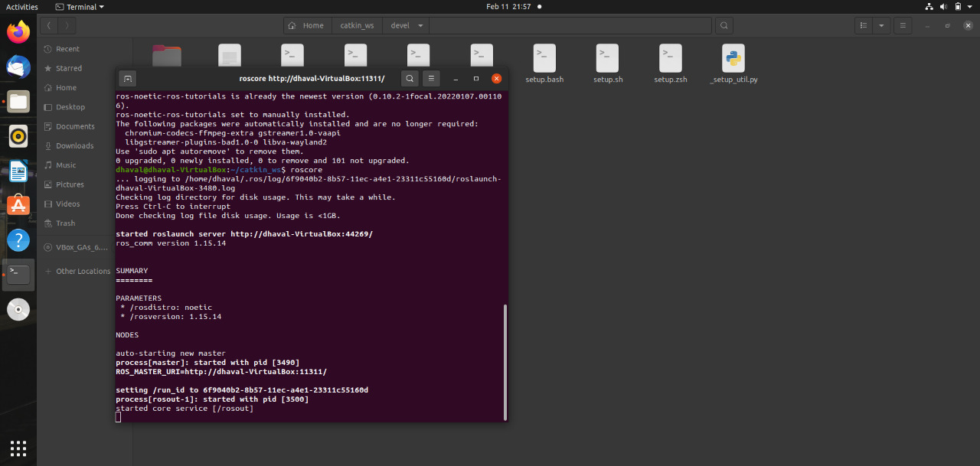

* rosnode displays information about the ROS nodes that are currently running. The $ rosnode list command lists these active nodes:

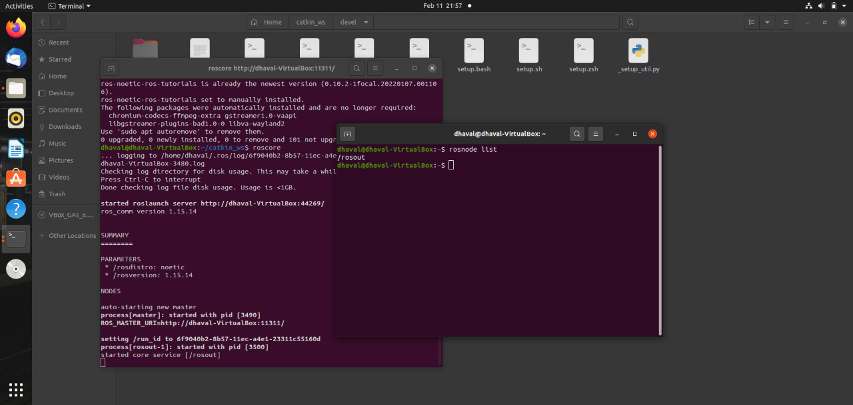

* To run the turtlesim_node in the turtlesim package by using rosrun type $ rosrun turtlesim turtlesim_node command.

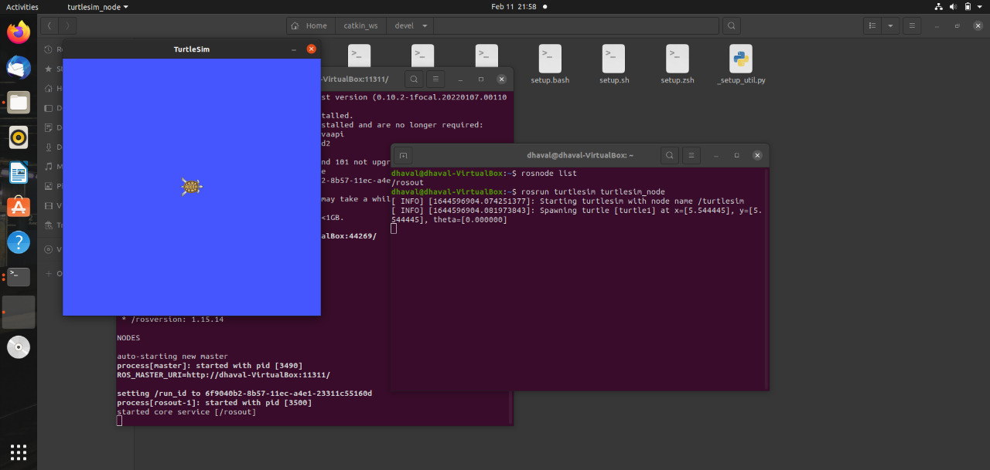

* In new terminal, type command $ rosnode list .

