**IE 410 – INTRODUCTION TO ROBOTICS**

**Lab-5 report**

**Running talker and listener codes**

**Team M410:**

201901011 – HIMANSHU DUDHATRA

201901024 – DHAVALSINH RAJ

201901100 – SHUBHAM PATEL

201901145 – GARGEY PATEL

**CPP**

* **Change directories to your beginner_tutorials package you created in your catkin workspace previous tutorials:**

roscd beginner_tutorials

* **Create a**src**directory in the beginner_tutorials package directory:**

mkdir -p src

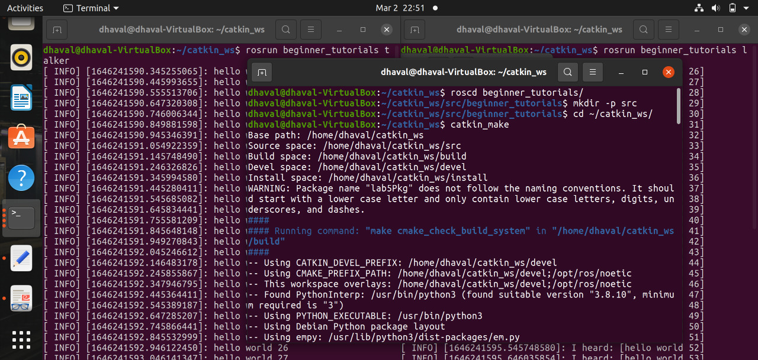

* **Talker.cpp**

/*

* Copyright (C) 2008, Morgan Quigley and Willow Garage, Inc.

*

* Redistribution and use in source and binary forms, with or without

* modification, are permitted provided that the following conditions are met:

* * Redistributions of source code must retain the above copyright notice,

* this list of conditions and the following disclaimer.

* * Redistributions in binary form must reproduce the above copyright

* notice, this list of conditions and the following disclaimer in the

* documentation and/or other materials provided with the distribution.

* * Neither the names of Stanford University or Willow Garage, Inc. nor the names of its

* contributors may be used to endorse or promote products derived from

* this software without specific prior written permission.

*

* THIS SOFTWARE IS PROVIDED BY THE COPYRIGHT HOLDERS AND CONTRIBUTORS "AS IS"

* AND ANY EXPRESS OR IMPLIED WARRANTIES, INCLUDING, BUT NOT LIMITED TO, THE

* IMPLIED WARRANTIES OF MERCHANTABILITY AND FITNESS FOR A PARTICULAR PURPOSE

* ARE DISCLAIMED. IN NO EVENT SHALL THE COPYRIGHT OWNER OR CONTRIBUTORS BE

* LIABLE FOR ANY DIRECT, INDIRECT, INCIDENTAL, SPECIAL, EXEMPLARY, OR

* CONSEQUENTIAL DAMAGES (INCLUDING, BUT NOT LIMITED TO, PROCUREMENT OF

* SUBSTITUTE GOODS OR SERVICES; LOSS OF USE, DATA, OR PROFITS; OR BUSINESS

* INTERRUPTION) HOWEVER CAUSED AND ON ANY THEORY OF LIABILITY, WHETHER IN

* CONTRACT, STRICT LIABILITY, OR TORT (INCLUDING NEGLIGENCE OR OTHERWISE)

* ARISING IN ANY WAY OUT OF THE USE OF THIS SOFTWARE, EVEN IF ADVISED OF THE

* POSSIBILITY OF SUCH DAMAGE.

*/

// %Tag(FULLTEXT)%

// %Tag(ROS_HEADER)%

#include "ros/ros.h"

// %EndTag(ROS_HEADER)%

// %Tag(MSG_HEADER)%

#include "std_msgs/String.h"

// %EndTag(MSG_HEADER)%

#include <sstream>

/**

* This tutorial demonstrates simple sending of messages over the ROS system.

*/

int main(int argc, char **argv)

{

/**

* The ros::init() function needs to see argc and argv so that it can perform

* any ROS arguments and name remapping that were provided at the command line.

* For programmatic remappings you can use a different version of init() which takes

* remappings directly, but for most command-line programs, passing argc and argv is

* the easiest way to do it. The third argument to init() is the name of the node.

*

* You must call one of the versions of ros::init() before using any other

* part of the ROS system.

*/

// %Tag(INIT)%

ros::init(argc, argv, "talker");

// %EndTag(INIT)%

/**

* NodeHandle is the main access point to communications with the ROS system.

* The first NodeHandle constructed will fully initialize this node, and the last

* NodeHandle destructed will close down the node.

*/

// %Tag(NODEHANDLE)%

ros::NodeHandle n;

// %EndTag(NODEHANDLE)%

/**

* The advertise() function is how you tell ROS that you want to

* publish on a given topic name. This invokes a call to the ROS

* master node, which keeps a registry of who is publishing and who

* is subscribing. After this advertise() call is made, the master

* node will notify anyone who is trying to subscribe to this topic name,

* and they will in turn negotiate a peer-to-peer connection with this

* node. advertise() returns a Publisher object which allows you to

* publish messages on that topic through a call to publish(). Once

* all copies of the returned Publisher object are destroyed, the topic

* will be automatically unadvertised.

*

* The second parameter to advertise() is the size of the message queue

* used for publishing messages. If messages are published more quickly

* than we can send them, the number here specifies how many messages to

* buffer up before throwing some away.

*/

// %Tag(PUBLISHER)%

ros::Publisher chatter_pub = n.advertise<std_msgs::String>("chatter", 1000);

// %EndTag(PUBLISHER)%

// %Tag(LOOP_RATE)%

ros::Rate loop_rate(10);

// %EndTag(LOOP_RATE)%

/**

* A count of how many messages we have sent. This is used to create

* a unique string for each message.

*/

// %Tag(ROS_OK)%

int count = 0;

while (ros::ok())

{

// %EndTag(ROS_OK)%

/**

* This is a message object. You stuff it with data, and then publish it.

*/

// %Tag(FILL_MESSAGE)%

std_msgs::String msg;

std::stringstream ss;

ss << "hello world " << count;

msg.data = ss.str();

// %EndTag(FILL_MESSAGE)%

// %Tag(ROSCONSOLE)%

ROS_INFO("%s", msg.data.c_str());

// %EndTag(ROSCONSOLE)%

/**

* The publish() function is how you send messages. The parameter

* is the message object. The type of this object must agree with the type

* given as a template parameter to the advertise<>() call, as was done

* in the constructor above.

*/

// %Tag(PUBLISH)%

chatter_pub.publish(msg);

// %EndTag(PUBLISH)%

// %Tag(SPINONCE)%

ros::spinOnce();

// %EndTag(SPINONCE)%

// %Tag(RATE_SLEEP)%

loop_rate.sleep();

// %EndTag(RATE_SLEEP)%

++count;

}

return 0;

}

// %EndTag(FULLTEXT)%

* **Listner.cpp**

/*

* Copyright (C) 2008, Morgan Quigley and Willow Garage, Inc.

*

* Redistribution and use in source and binary forms, with or without

* modification, are permitted provided that the following conditions are met:

* * Redistributions of source code must retain the above copyright notice,

* this list of conditions and the following disclaimer.

* * Redistributions in binary form must reproduce the above copyright

* notice, this list of conditions and the following disclaimer in the

* documentation and/or other materials provided with the distribution.

* * Neither the names of Stanford University or Willow Garage, Inc. nor the names of its

* contributors may be used to endorse or promote products derived from

* this software without specific prior written permission.

*

* THIS SOFTWARE IS PROVIDED BY THE COPYRIGHT HOLDERS AND CONTRIBUTORS "AS IS"

* AND ANY EXPRESS OR IMPLIED WARRANTIES, INCLUDING, BUT NOT LIMITED TO, THE

* IMPLIED WARRANTIES OF MERCHANTABILITY AND FITNESS FOR A PARTICULAR PURPOSE

* ARE DISCLAIMED. IN NO EVENT SHALL THE COPYRIGHT OWNER OR CONTRIBUTORS BE

* LIABLE FOR ANY DIRECT, INDIRECT, INCIDENTAL, SPECIAL, EXEMPLARY, OR

* CONSEQUENTIAL DAMAGES (INCLUDING, BUT NOT LIMITED TO, PROCUREMENT OF

* SUBSTITUTE GOODS OR SERVICES; LOSS OF USE, DATA, OR PROFITS; OR BUSINESS

* INTERRUPTION) HOWEVER CAUSED AND ON ANY THEORY OF LIABILITY, WHETHER IN

* CONTRACT, STRICT LIABILITY, OR TORT (INCLUDING NEGLIGENCE OR OTHERWISE)

* ARISING IN ANY WAY OUT OF THE USE OF THIS SOFTWARE, EVEN IF ADVISED OF THE

* POSSIBILITY OF SUCH DAMAGE.

*/

// %Tag(FULLTEXT)%

#include "ros/ros.h"

#include "std_msgs/String.h"

/**

* This tutorial demonstrates simple receipt of messages over the ROS system.

*/

// %Tag(CALLBACK)%

void chatterCallback(const std_msgs::String::ConstPtr& msg)

{

ROS_INFO("I heard: [%s]", msg->data.c_str());

}

// %EndTag(CALLBACK)%

int main(int argc, char **argv)

{

/**

* The ros::init() function needs to see argc and argv so that it can perform

* any ROS arguments and name remapping that were provided at the command line.

* For programmatic remappings you can use a different version of init() which takes

* remappings directly, but for most command-line programs, passing argc and argv is

* the easiest way to do it. The third argument to init() is the name of the node.

*

* You must call one of the versions of ros::init() before using any other

* part of the ROS system.

*/

ros::init(argc, argv, "listener");

/**

* NodeHandle is the main access point to communications with the ROS system.

* The first NodeHandle constructed will fully initialize this node, and the last

* NodeHandle destructed will close down the node.

*/

ros::NodeHandle n;

/**

* The subscribe() call is how you tell ROS that you want to receive messages

* on a given topic. This invokes a call to the ROS

* master node, which keeps a registry of who is publishing and who

* is subscribing. Messages are passed to a callback function, here

* called chatterCallback. subscribe() returns a Subscriber object that you

* must hold on to until you want to unsubscribe. When all copies of the Subscriber

* object go out of scope, this callback will automatically be unsubscribed from

* this topic.

*

* The second parameter to the subscribe() function is the size of the message

* queue. If messages are arriving faster than they are being processed, this

* is the number of messages that will be buffered up before beginning to throw

* away the oldest ones.

*/

// %Tag(SUBSCRIBER)%

ros::Subscriber sub = n.subscribe("chatter", 1000, chatterCallback);

// %EndTag(SUBSCRIBER)%

/**

* ros::spin() will enter a loop, pumping callbacks. With this version, all

* callbacks will be called from within this thread (the main one). ros::spin()

* will exit when Ctrl-C is pressed, or the node is shutdown by the master.

*/

// %Tag(SPIN)%

ros::spin();

// %EndTag(SPIN)%

return 0;

}

// %EndTag(FULLTEXT)%

* **Now we will run** $ roscore **command in new terminal**

$ roscore

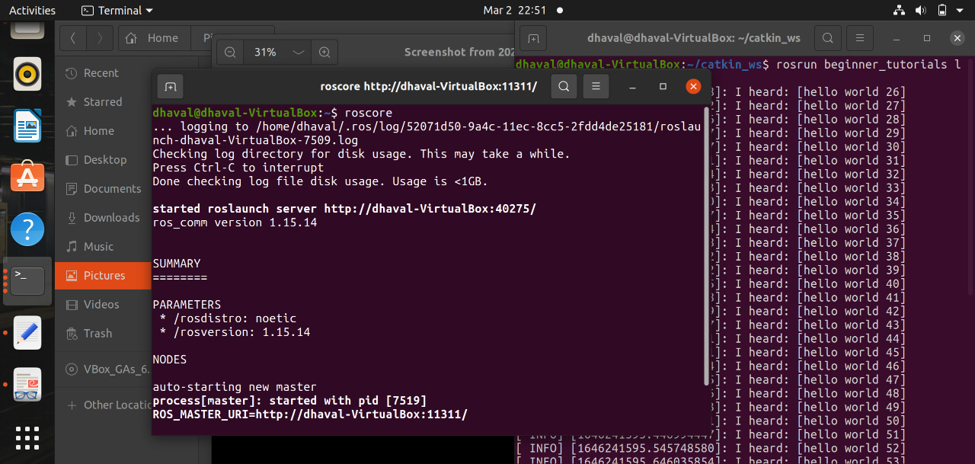

* **Now we will run publisher and subscriber in different terminal windows**

$ rosrun beginner_tutorials talker

$ rosrun beginner_tutorials listener

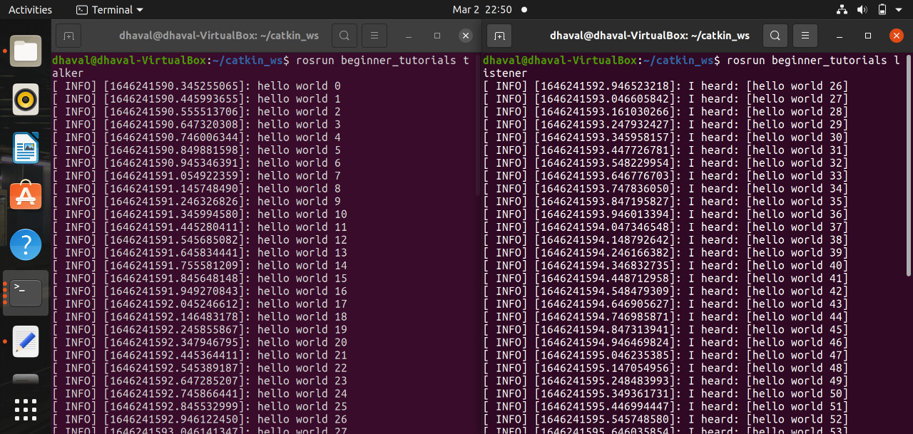

**PYTHON**

* **First lets create a 'scripts' folder to store our Python scripts in:**

$ mkdir scripts

$ cd scripts

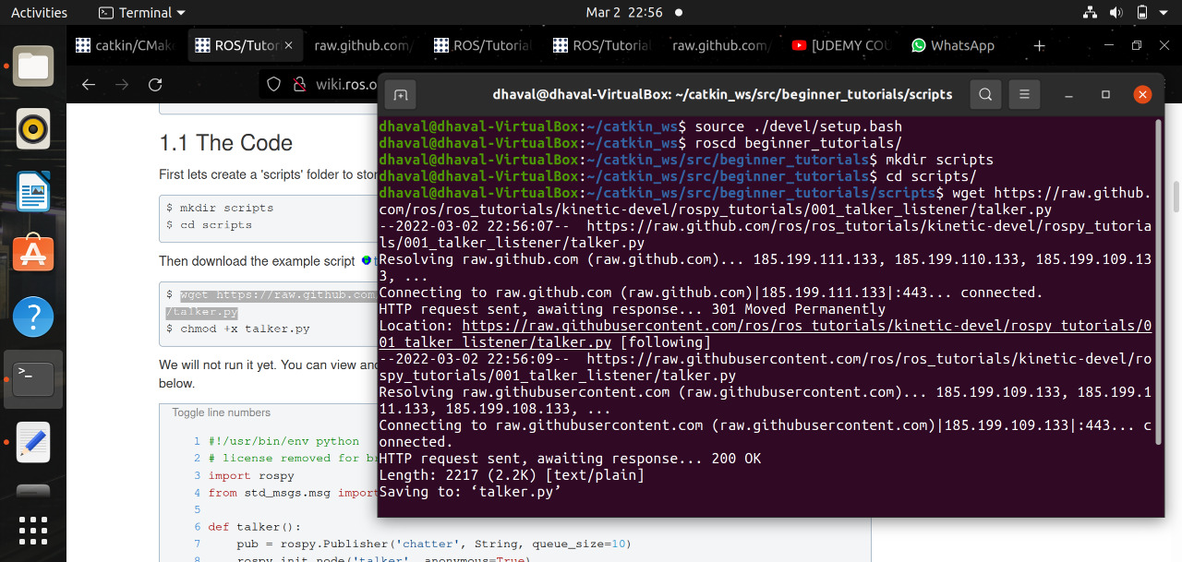

* **Talker.py**

#!/usr/bin/env python

# Software License Agreement (BSD License)

#

# Copyright (c) 2008, Willow Garage, Inc.

# All rights reserved.

#

# Redistribution and use in source and binary forms, with or without

# modification, are permitted provided that the following conditions

# are met:

#

# * Redistributions of source code must retain the above copyright

# notice, this list of conditions and the following disclaimer.

# * Redistributions in binary form must reproduce the above

# copyright notice, this list of conditions and the following

# disclaimer in the documentation and/or other materials provided

# with the distribution.

# * Neither the name of Willow Garage, Inc. nor the names of its

# contributors may be used to endorse or promote products derived

# from this software without specific prior written permission.

#

# THIS SOFTWARE IS PROVIDED BY THE COPYRIGHT HOLDERS AND CONTRIBUTORS

# "AS IS" AND ANY EXPRESS OR IMPLIED WARRANTIES, INCLUDING, BUT NOT

# LIMITED TO, THE IMPLIED WARRANTIES OF MERCHANTABILITY AND FITNESS

# FOR A PARTICULAR PURPOSE ARE DISCLAIMED. IN NO EVENT SHALL THE

# COPYRIGHT OWNER OR CONTRIBUTORS BE LIABLE FOR ANY DIRECT, INDIRECT,

# INCIDENTAL, SPECIAL, EXEMPLARY, OR CONSEQUENTIAL DAMAGES (INCLUDING,

# BUT NOT LIMITED TO, PROCUREMENT OF SUBSTITUTE GOODS OR SERVICES;

# LOSS OF USE, DATA, OR PROFITS; OR BUSINESS INTERRUPTION) HOWEVER

# CAUSED AND ON ANY THEORY OF LIABILITY, WHETHER IN CONTRACT, STRICT

# LIABILITY, OR TORT (INCLUDING NEGLIGENCE OR OTHERWISE) ARISING IN

# ANY WAY OUT OF THE USE OF THIS SOFTWARE, EVEN IF ADVISED OF THE

# POSSIBILITY OF SUCH DAMAGE.

#

# Revision $Id$

## Simple talker demo that published std_msgs/Strings messages

## to the 'chatter' topic

import rospy

from std_msgs.msg import String

def talker():

pub = rospy.Publisher('chatter', String, queue_size=10)

rospy.init_node('talker', anonymous=True)

rate = rospy.Rate(10) # 10hz

while not rospy.is_shutdown():

hello_str = "hello world %s" % rospy.get_time()

rospy.loginfo(hello_str)

pub.publish(hello_str)

rate.sleep()

if __name__ == '__main__':

try:

talker()

except rospy.ROSInterruptException:

pass

* **Lister.py**

#!/usr/bin/env python

# Software License Agreement (BSD License)

#

# Copyright (c) 2008, Willow Garage, Inc.

# All rights reserved.

#

# Redistribution and use in source and binary forms, with or without

# modification, are permitted provided that the following conditions

# are met:

#

# * Redistributions of source code must retain the above copyright

# notice, this list of conditions and the following disclaimer.

# * Redistributions in binary form must reproduce the above

# copyright notice, this list of conditions and the following

# disclaimer in the documentation and/or other materials provided

# with the distribution.

# * Neither the name of Willow Garage, Inc. nor the names of its

# contributors may be used to endorse or promote products derived

# from this software without specific prior written permission.

#

# THIS SOFTWARE IS PROVIDED BY THE COPYRIGHT HOLDERS AND CONTRIBUTORS

# "AS IS" AND ANY EXPRESS OR IMPLIED WARRANTIES, INCLUDING, BUT NOT

# LIMITED TO, THE IMPLIED WARRANTIES OF MERCHANTABILITY AND FITNESS

# FOR A PARTICULAR PURPOSE ARE DISCLAIMED. IN NO EVENT SHALL THE

# COPYRIGHT OWNER OR CONTRIBUTORS BE LIABLE FOR ANY DIRECT, INDIRECT,

# INCIDENTAL, SPECIAL, EXEMPLARY, OR CONSEQUENTIAL DAMAGES (INCLUDING,

# BUT NOT LIMITED TO, PROCUREMENT OF SUBSTITUTE GOODS OR SERVICES;

# LOSS OF USE, DATA, OR PROFITS; OR BUSINESS INTERRUPTION) HOWEVER

# CAUSED AND ON ANY THEORY OF LIABILITY, WHETHER IN CONTRACT, STRICT

# LIABILITY, OR TORT (INCLUDING NEGLIGENCE OR OTHERWISE) ARISING IN

# ANY WAY OUT OF THE USE OF THIS SOFTWARE, EVEN IF ADVISED OF THE

# POSSIBILITY OF SUCH DAMAGE.

#

# Revision $Id$

## Simple talker demo that listens to std_msgs/Strings published

## to the 'chatter' topic

import rospy

from std_msgs.msg import String

def callback(data):

rospy.loginfo(rospy.get_caller_id() + 'I heard %s', data.data)

def listener():

# In ROS, nodes are uniquely named. If two nodes with the same

# name are launched, the previous one is kicked off. The

# anonymous=True flag means that rospy will choose a unique

# name for our 'listener' node so that multiple listeners can

# run simultaneously.

rospy.init_node('listener', anonymous=True)

rospy.Subscriber('chatter', String, callback)

# spin() simply keeps python from exiting until this node is stopped

rospy.spin()

if __name__ == '__main__':

listener()

* **Now making talker.py and listener.py executable:**

$ chmod +x talker.py

$ chmod +x listener.py

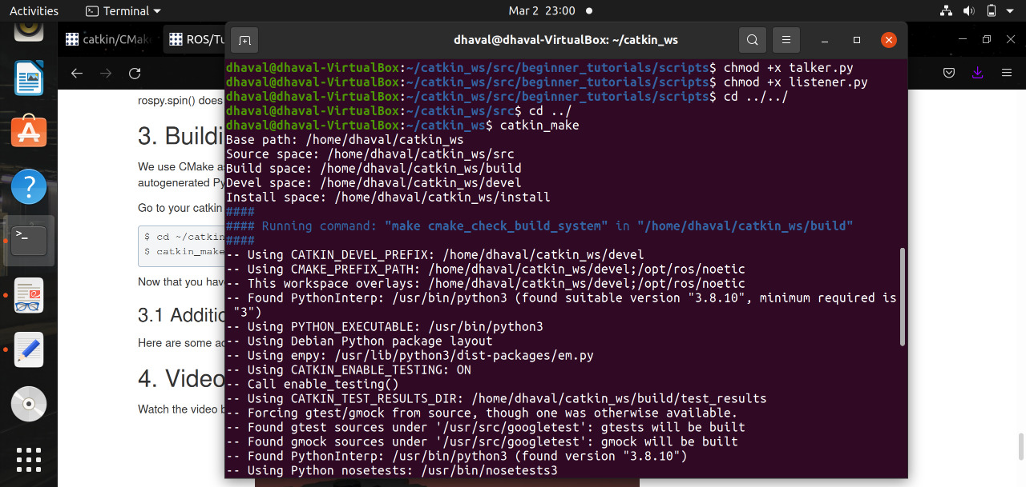

* **Now we will run** $ roscore **command in new terminal**

$ roscore

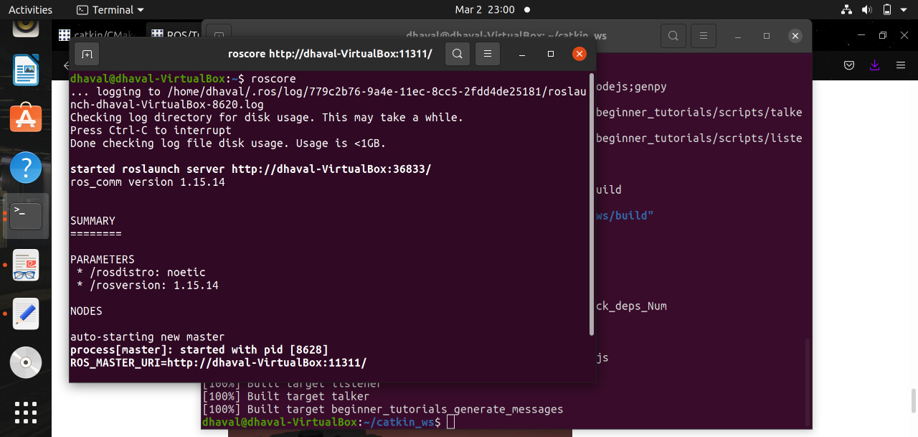

* **Now we will run publisher and subscriber in different terminal windows**

$ rosrun beginner_tutorials talker.py

$ rosrun beginner_tutorials listener.py

