**IE 410 – INTRODUCTION TO ROBOTICS**

**Lab-6 report**

**Controlling Turtlesim Node using Python code, implementing P controller and implementing PID controller.**

**Team M410:**

201901011 – HIMANSHU DUDHATRA

201901024 – DHAVALSINH RAJ

201901100 – SHUBHAM PATEL

201901145 – GARGEY PATEL

* **Creating Catkin package**

First go to the ‘src’ folder of catkin workspace that we have created.

$ cd catkin_ws/src

Now create a catkin package named linuxsquad_pkgforlab4 by using the command given below.

$ catkin_create_pkg beginner_tuts std_msgs rospy roscpp

Now we will execute catkin_make.

$ catkin_make

Now we need to source the generated setup file.

$ source devel/setup.bash

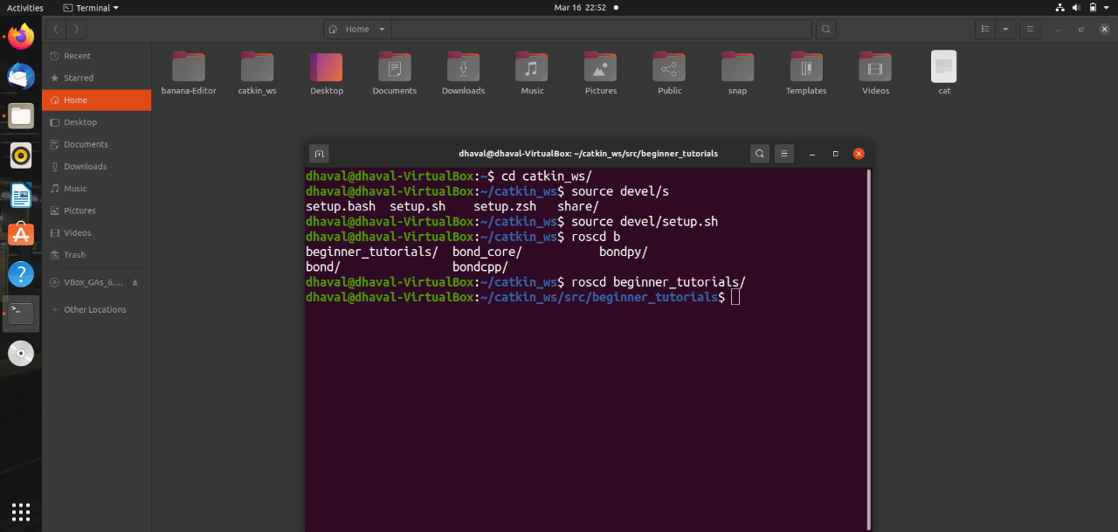

* **Turtlesim_move.py and Turtlesim_cleaner.py**

Now, we will change the directory to linuxsquad_pkglab6 and then will create a scriptsdirectory in the linuxsquad_pkglab6 directory. Follow these commands.

$ roscd linuxsquad_pkgforlab6

$ mkdir scripts

$ cd scripts

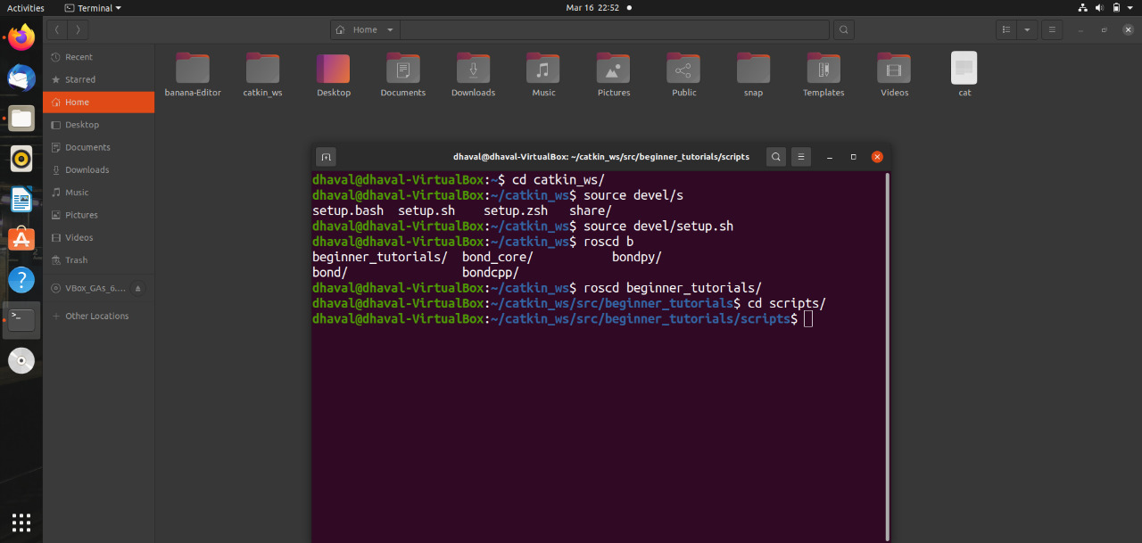

* Turtlesim_cleaner.py

#!/usr/bin/env python

import rospy

from geometry_msgs.msg import Twist

from turtlesim.msg import Pose

import math

import time

from std_srvs.srv import Empty

x=0

y=0

yaw=0

def poseCallback(pose_message):

global x

global y, yaw

x= pose_message.x

y= pose_message.y

yaw = pose_message.theta

#print "pose callback"

#print ('x = {}'.format(pose_message.x)) #new in python 3

#print ('y = %f' %pose_message.y) #used in python 2

#print ('yaw = {}'.format(pose_message.theta)) #new in python 3

def move(speed, distance, is_forward):

#declare a Twist message to send velocity commands

velocity_message = Twist()

#get current location

global x, y

x0=x

y0=y

if (is_forward):

velocity_message.linear.x =abs(speed)

else:

velocity_message.linear.x =-abs(speed)

distance_moved = 0.0

loop_rate = rospy.Rate(10) # we publish the velocity at 10 Hz (10 times a second)

cmd_vel_topic='/turtle1/cmd_vel'

velocity_publisher = rospy.Publisher(cmd_vel_topic, Twist, queue_size=10)

while True :

rospy.loginfo("Turtlesim moves forwards")

velocity_publisher.publish(velocity_message)

loop_rate.sleep()

#rospy.Duration(1.0)

distance_moved = abs(0.5 * math.sqrt(((x-x0) ** 2) + ((y-y0) ** 2)))

print (distance_moved);

if not (distance_moved<distance):

rospy.loginfo("reached")

break

#finally, stop the robot when the distance is moved

velocity_message.linear.x =0

velocity_publisher.publish(velocity_message)

def rotate (angular_speed_degree, relative_angle_degree, clockwise):

global yaw

velocity_message = Twist()

velocity_message.linear.x=0

velocity_message.linear.y=0

velocity_message.linear.z=0

velocity_message.angular.x=0

velocity_message.angular.y=0

velocity_message.angular.z=0

#get current location

theta0=yaw

angular_speed=math.radians(abs(angular_speed_degree))

if (clockwise):

velocity_message.angular.z =-abs(angular_speed)

else:

velocity_message.angular.z =abs(angular_speed)

angle_moved = 0.0

loop_rate = rospy.Rate(10) # we publish the velocity at 10 Hz (10 times a second)

cmd_vel_topic='/turtle1/cmd_vel'

velocity_publisher = rospy.Publisher(cmd_vel_topic, Twist, queue_size=10)

t0 = rospy.Time.now().to_sec()

while True :

rospy.loginfo("Turtlesim rotates")

velocity_publisher.publish(velocity_message)

t1 = rospy.Time.now().to_sec()

current_angle_degree = (t1-t0)*angular_speed_degree

loop_rate.sleep()

if (current_angle_degree>relative_angle_degree):

rospy.loginfo("reached")

break

#finally, stop the robot when the distance is moved

velocity_message.angular.z =0

velocity_publisher.publish(velocity_message)

def go_to_goal(x_goal, y_goal):

global x

global y, yaw

velocity_message = Twist()

cmd_vel_topic='/turtle1/cmd_vel'

while (True):

K_linear = 0.5

distance = abs(math.sqrt(((x_goal-x) ** 2) + ((y_goal-y) ** 2)))

linear_speed = distance * K_linear

K_angular = 4.0

desired_angle_goal = math.atan2(y_goal-y, x_goal-x)

angular_speed = (desired_angle_goal-yaw)*K_angular

velocity_message.linear.x = linear_speed

velocity_message.angular.z = angular_speed

velocity_publisher.publish(velocity_message)

#print velocity_message.linear.x

#print velocity_message.angular.z

print ('x=', x, 'y=',y)

if (distance <0.01):

break

def setDesiredOrientation(desired_angle_radians):

relative_angle_radians = desired_angle_radians - yaw

if relative_angle_radians < 0:

clockwise = 1

else:

clockwise = 0

print (relative_angle_radians)

print( desired_angle_radians)

rotate(30 ,math.degrees(abs(relative_angle_radians)), clockwise)

def gridClean():

desired_pose = Pose()

desired_pose.x = 1

desired_pose.y = 1

desired_pose.theta = 0

moveGoal(desired_pose, 0.01)

setDesiredOrientation(degrees2radians(desired_pose.theta))

move(2.0, 9.0, True)

rotate(degrees2radians(20), degrees2radians(90), False)

move(2.0, 9.0, True)

rotate(degrees2radians(20), degrees2radians(90), False)

move(2.0, 1.0, True)

rotate(degrees2radians(20), degrees2radians(90), False)

move(2.0, 9.0, True)

rotate(degrees2radians(30), degrees2radians(90), True)

move(2.0, 1.0, True)

rotate(degrees2radians(30), degrees2radians(90), True)

move(2.0, 9.0, True)

pass

def spiralClean():

vel_msg = Twist()

loop_rate = rospy.Rate(1)

wk = 4

rk = 0

while((currentTurtlesimPose.x<10.5) and (currentTurtlesimPose.y<10.5)):

rk=rk+1

vel_msg.linear.x =rk

vel_msg.linear.y =0

vel_msg.linear.z =0

vel_msg.angular.x = 0

vel_msg.angular.y = 0

vel_msg.angular.z =wk

velocity_publisher.publish(vel_msg)

loop_rate.sleep()

vel_msg.linear.x = 0

vel_msg.angular.z = 0

velocity_publisher.publish(vel_msg)

if __name__ == '__main__':

try:

rospy.init_node('turtlesim_motion_pose', anonymous=True)

#declare velocity publisher

cmd_vel_topic='/turtle1/cmd_vel'

velocity_publisher = rospy.Publisher(cmd_vel_topic, Twist, queue_size=10)

position_topic = "/turtle1/pose"

pose_subscriber = rospy.Subscriber(position_topic, Pose, poseCallback)

time.sleep(2)

#move(1.0, 2.0, False)

#rotate(30, 90, True)

go_to_goal(1.0, 1.0)

#setDesiredOrientation(math.radians(90))

except rospy.ROSInterruptException:

rospy.loginfo("node terminated.")

* Turtlesim_move.py

#!/usr/bin/env python

import rospy

from geometry_msgs.msg import Twist

import math

import time

from std_srvs.srv import Empty

def move(speed, distance, is_forward):

#declare a Twist message to send velocity commands

velocity_message = Twist()

#get current location

if (speed > 0.4):

print('speed must be lower than 0.4')

return

if (is_forward):

velocity_message.linear.x =abs(speed)

else:

velocity_message.linear.x =-abs(speed)

distance_moved = 0.0

loop_rate = rospy.Rate(10) # we publish the velocity at 10 Hz (10 times a second)

cmd_vel_topic='/cmd_vel_mux/input/teleop'

velocity_publisher = rospy.Publisher(cmd_vel_topic, Twist, queue_size=10)

t0 = rospy.Time.now().to_sec()

while True :

rospy.loginfo("Turtlesim moves forwards")

velocity_publisher.publish(velocity_message)

loop_rate.sleep()

t1 = rospy.Time.now().to_sec()

#rospy.Duration(1.0)

distance_moved = (t1-t0) * speed

print(distance_moved)

if not (distance_moved<distance):

rospy.loginfo("reached")

break

#finally, stop the robot when the distance is moved

velocity_message.linear.x =0

velocity_publisher.publish(velocity_message)

def rotate (angular_speed_degree, relative_angle_degree, clockwise):

velocity_message = Twist()

velocity_message.linear.x=0

velocity_message.linear.y=0

velocity_message.linear.z=0

velocity_message.angular.x=0

velocity_message.angular.y=0

velocity_message.angular.z=0

angular_speed=math.radians(abs(angular_speed_degree))

if (clockwise):

velocity_message.angular.z =-abs(angular_speed)

else:

velocity_message.angular.z =abs(angular_speed)

angle_moved = 0.0

loop_rate = rospy.Rate(10) # we publish the velocity at 10 Hz (10 times a second)

cmd_vel_topic='/cmd_vel_mux/input/teleop'

velocity_publisher = rospy.Publisher(cmd_vel_topic, Twist, queue_size=10)

t0 = rospy.Time.now().to_sec()

while True :

rospy.loginfo("Turtlesim rotates")

velocity_publisher.publish(velocity_message)

t1 = rospy.Time.now().to_sec()

current_angle_degree = (t1-t0)*angular_speed_degree

loop_rate.sleep()

print('current_angle_degree: ',current_angle_degree)

if (current_angle_degree>relative_angle_degree):

rospy.loginfo("reached")

break

#finally, stop the robot when the distance is moved

velocity_message.angular.z =0

velocity_publisher.publish(velocity_message)

def go_to_goal(x_goal, y_goal):

global x

global y, z, yaw

velocity_message = Twist()

cmd_vel_topic='/turtle1/cmd_vel'

while (True):

K_linear = 0.5

distance = abs(math.sqrt(((x_goal-x) ** 2) + ((y_goal-y) ** 2)))

linear_speed = distance * K_linear

K_angular = 4.0

desired_angle_goal = math.atan2(y_goal-y, x_goal-x)

angular_speed = (desired_angle_goal-yaw)*K_angular

velocity_message.linear.x = linear_speed

velocity_message.angular.z = angular_speed

velocity_publisher.publish(velocity_message)

print('x=', x, 'y=',y)

if (distance <0.01):

break

if __name__ == '__main__':

try:

rospy.init_node('turtlesim_motion_pose', anonymous=True)

#move (0.3, 0.5 , False)

time.sleep(1.0)

rotate (90, 90 , True)

except rospy.ROSInterruptException:

rospy.loginfo("node terminated.")

* Testing

Turtlesim_cleaner.py

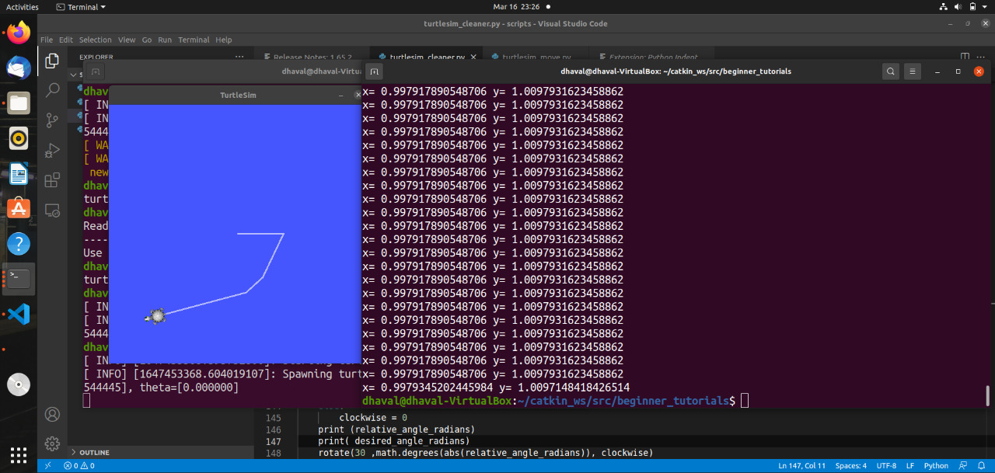

Turtlesim_move.py

